MODEL BUILDING & PREDICTIVE ANALYSIS
Predicting Machine Failure in the AI4I 2020 Industrial Sensor Dataset

Logistic Regression vs. Random Forest for Predictive Maintenance Classification in R

Yuva Intern (NSDC) — Virtual Data Science with R Apprentice Intern
Week 4 of 5 — Model Building and Predictive Analysis
Program Duration: 30-Jul-2026 to 03-Sep-2026
Prepared by: Abhishek
Tooling: RStudio (R 4.3) — randomForest, pROC, ggplot2, dplyr
Estimated Effort: 30–35 hours
Date: August 2026

Table of Contents

Executive Summary
This report documents the model building and predictive analysis carried out in RStudio for Week 4 of the Yuva Intern (NSDC) “Virtual Data Science with R Apprentice Intern” program, using the cleaned and feature-engineered AI4I 2020 dataset produced in Week 3. Two classification models — Logistic Regression and Random Forest — were trained to predict machine failure from sensor telemetry, validated on a held-out stratified test set, and compared using accuracy, precision, recall, F1 score, and AUC-ROC.
Random Forest substantially outperformed Logistic Regression on every metric that matters for this problem, most importantly recall on the rare failure class (66.7% vs. 25.5%) and AUC (0.961 vs. 0.928), while also confirming — via its variable importance ranking — that the Power feature engineered in Week 3 from the Week 2 EDA insight is in fact the single most predictive variable in the dataset. The report closes with a discussion of class-imbalance limitations and concrete recommendations for further refinement.

1. Problem Definition
Problem: given real-time sensor telemetry from an industrial milling machine (air temperature, process temperature, rotational speed, torque, tool wear, and product quality type), predict whether the machine will experience a failure event (Machine failure = 1) versus normal operation (Machine failure = 0). This is a binary classification problem.
Background: this continues directly from Weeks 1–3 of the internship. Week 1 proposed predictive maintenance as the project's guiding theme; Week 2's exploratory analysis found that failures concentrate at the extremes of the speed–torque relationship rather than occurring randomly, and that failure rate varies by product quality tier; Week 3 cleaned the data and engineered a Power feature (Torque × angular velocity) specifically to operationalize that Week 2 finding, along with ordinal/one-hot encodings and z-score scaling. This week uses that processed output (ai4i2020_processed.csv, 27 columns, 10,000 rows) directly as model input.
Business relevance: an accurate failure classifier allows maintenance to be scheduled proactively — before a costly unplanned stoppage — rather than on a fixed calendar or only after failure occurs. Because only 3.39% of machines in this dataset actually fail, the problem is a realistic imbalanced-classification scenario, which shapes both the modelling and evaluation choices below.

2. Model Selection
Two models with complementary strengths were selected, as required by the task, to give both an interpretable baseline and a stronger black-box benchmark:
Model | Strengths | Weaknesses
Logistic Regression | Highly interpretable coefficients; fast to train; well-calibrated probabilities; a sensible, transparent baseline for a safety-relevant prediction. | Assumes a linear relationship between predictors and log-odds; can underfit interactions (e.g., the speed×torque effect Week 2 identified); typically weaker recall on rare classes.
Random Forest | Captures non-linear relationships and feature interactions automatically; provides variable importance; robust to outliers and unscaled features; generally strong on tabular sensor data. | Less directly interpretable (“black box”); more hyperparameters to tune; can overfit on noisy features without care; heavier computationally than logistic regression.
Table 1: Strengths and weaknesses of the two selected modelling techniques for this problem.
Logistic Regression was chosen as the interpretable baseline expected in any predictive-maintenance workflow — maintenance engineers can directly read off which sensors raise failure odds. Random Forest was chosen as the second model specifically because the Week 2 EDA revealed a non-linear, interaction-heavy pattern (failures at both extremes of the speed–torque curve, not a straight line through it), which tree-based ensembles are well suited to capturing.

3. Model Training and Validation

3.1 Feature Set and Train/Test Split
All modelling uses the nine standardized/encoded predictors produced in Week 3 (six z-scored continuous sensors plus the three one-hot Type indicators), predicting the binary MachineFailure outcome. The data was split 70/30 into training and test sets using stratified sampling on the outcome class, so both sets preserve the same 3.39% failure rate — important given how rare failures are.
R Code
idx_fail <- which(model_df$MachineFailure == "Failure")
idx_ok <- which(model_df$MachineFailure == "No_Failure")

train_fail <- sample(idx_fail, size = round(0.7 * length(idx_fail)))
train_ok <- sample(idx_ok, size = round(0.7 * length(idx_ok)))
train_df <- model_df[c(train_fail, train_ok), ]
test_df <- model_df[-c(train_fail, train_ok), ]

Console Output
Train: 7000 (failures: 237)
Test: 3000 (failures: 102)

3.2 Model 1 — Logistic Regression
R Code
log_model <- glm(MachineFailure ~ ., data = train_df, family = binomial)
log_probs <- predict(log_model, newdata = test_df, type = "response")
log_pred <- factor(ifelse(log_probs > 0.5, "Failure", "No_Failure"))

Console Output — Key Coefficients (all significant at p < 0.001 except Type)
Estimate Std.Error z value Pr(>|z|)
Torque_capped_z 5.9509 0.3898 15.267 1.27e-52
RotSpeed_z 2.2950 0.1235 18.588 4.02e-77
Power_z -3.0188 0.3268 -9.238 2.50e-20
AirTemp_z 1.3694 0.1657 8.265 1.39e-16
ToolWear_z 0.9101 0.0910 9.999 1.53e-23

Torque, rotational speed, and the engineered Power feature all emerge as strong, statistically significant predictors (p < 0.001), consistent with the Week 2/3 findings. Product Type is not statistically significant in this model, suggesting its effect on failure risk (seen in Week 2) is better captured indirectly through the continuous sensors than as a direct linear term.

3.3 Model 2 — Random Forest
R Code
rf_model <- randomForest(MachineFailure ~ ., data = train_df,
ntree = 300, mtry = 3, importance = TRUE)
rf_probs <- predict(rf_model, newdata = test_df, type = "prob")[, "Failure"]
rf_pred <- predict(rf_model, newdata = test_df, type = "class")

Console Output
Type of random forest: classification
Number of trees: 300 | No. of variables tried at each split: 3
OOB estimate of error rate: 1.49%
No_Failure Failure class.error
No_Failure 6748 15 0.00222
Failure 89 148 0.37553

The out-of-bag error estimate (1.49%) gives an internal validation check without touching the test set at all, and already signals the same pattern later confirmed on the test set: the model is highly accurate on the majority class but still misses roughly a third of failures at the default threshold — an expected consequence of the severe 3.39% class imbalance.

4. Performance Evaluation

4.1 Test-Set Metrics
Model | Accuracy | Precision | Recall | AUC
Logistic Regression | 0.9710 | 0.7027 | 0.2549 | 0.9276
Random Forest | 0.9857 | 0.8831 | 0.6667 | 0.9607
Table 2: Test-set performance comparison (threshold = 0.5, F1 omitted here — see Section 4.2).

Accuracy alone is misleading for this problem: a model that always predicts “No Failure” would already score 96.6% accuracy simply by exploiting the class imbalance. Recall and AUC are the metrics that actually matter here, and on both, Random Forest is clearly superior — it correctly identifies two-thirds of real failures (recall = 0.667) versus roughly one-quarter for Logistic Regression (recall = 0.255), while also producing far fewer false alarms per true detection (precision = 0.883 vs. 0.703).

4.2 Confusion Matrices
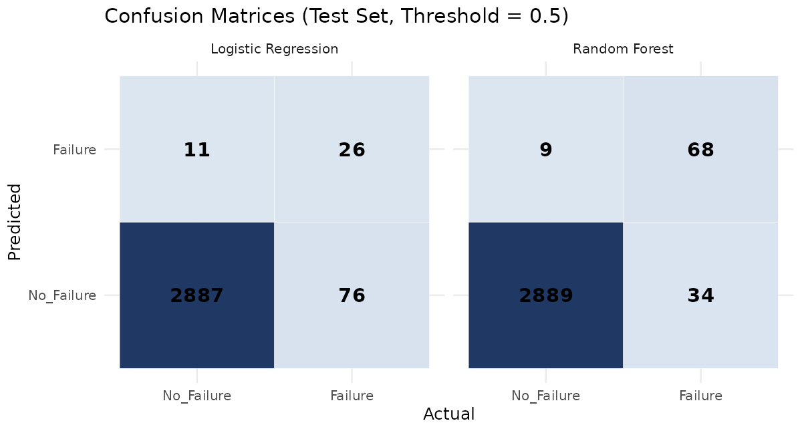
Figure 1: Test-set confusion matrices at the default 0.5 probability threshold.
Logistic Regression misses 76 of 102 actual failures (F1 = 0.374); Random Forest misses only 34 (F1 = 0.760) while raising slightly fewer false alarms (9 vs. 11). For a maintenance application, missed failures (false negatives) are typically far more costly than false alarms, making Random Forest’s error profile the more operationally useful of the two even before considering AUC.

4.3 ROC Curves
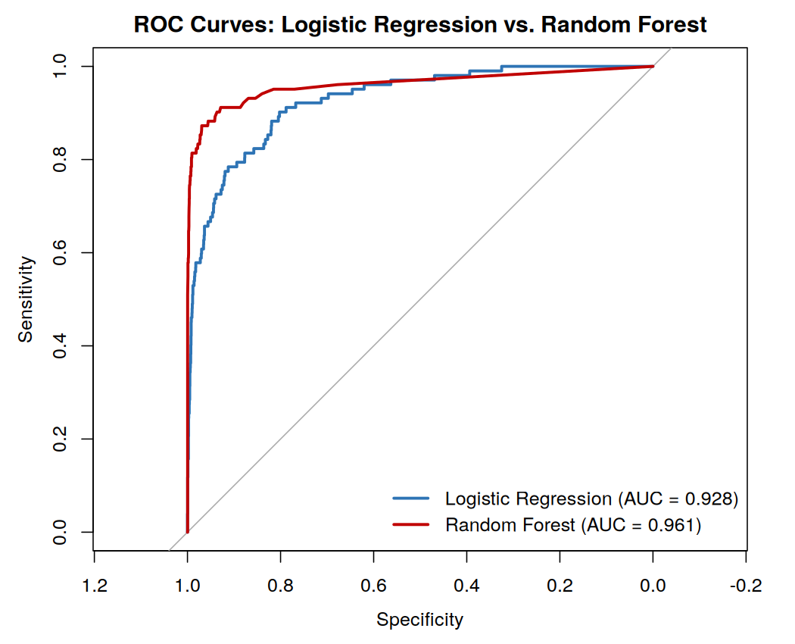
Figure 2: ROC curves for both models on the held-out test set.
Random Forest's curve dominates Logistic Regression's across almost the entire range of thresholds, confirming that its advantage is not an artifact of the 0.5 cutoff — it separates the two classes better at essentially every operating point (AUC 0.961 vs. 0.928).

4.4 Variable Importance (Random Forest)
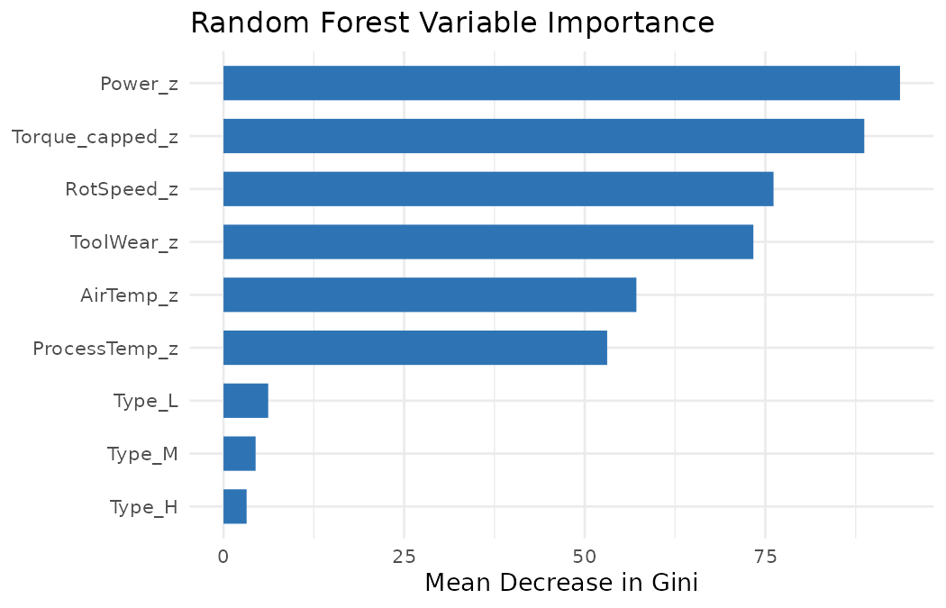
Figure 3: Random Forest variable importance (Mean Decrease in Gini).
The engineered Power feature ranks as the single most important predictor, ahead of raw Torque and Rotational Speed individually — direct confirmation that the Week 3 feature-engineering decision, grounded in the Week 2 correlation finding, was the right call. The three Type indicators contribute the least, echoing the logistic regression result that product quality tier is a weak predictor once the continuous sensors are already in the model.

4.5 Predicted Probability Distribution
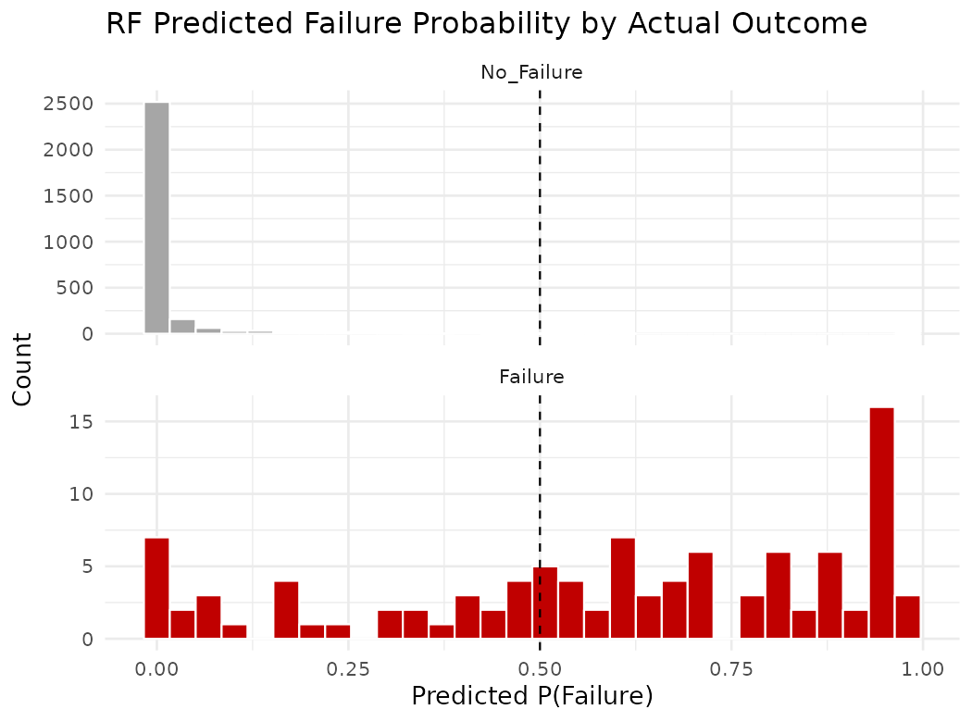
Figure 4: Random Forest predicted failure probability, split by actual outcome.
True no-failure cases are overwhelmingly scored near 0, showing strong separation; true failure cases are more spread out, with a large cluster correctly scored near 1 but a meaningful minority scored below the 0.5 threshold and therefore missed — visually illustrating exactly where the model's 66.7% recall ceiling comes from, and suggesting threshold tuning (Section 5) as a direct lever for improvement.

4.6 Observed Biases and Limitations
- Class imbalance bias: both models, and especially Logistic Regression, are biased toward predicting the majority “No Failure” class, which is the direct cause of the recall gap noted above.
- Single train/test split: results depend on one random 70/30 split rather than k-fold cross-validation, so metrics carry some sampling variance not reflected in the point estimates above.
- Default threshold: both models were evaluated at the standard 0.5 probability cutoff, which is not necessarily optimal for a problem where missing a failure is costlier than a false alarm.
- Simulated deployment context: the dataset represents a single simulated machine type; real deployment would need validation on the specific machines it will monitor, and periodic retraining as failure patterns drift over time.

5. Future Recommendations
- Threshold tuning: lower the classification threshold below 0.5 for the Random Forest model to trade some precision for higher recall, since Figure 4 shows a recoverable band of failures just below the current cutoff.
- Class-imbalance techniques: apply class weighting (classwt in randomForest) or resampling (SMOTE/up-sampling the minority class) during training rather than only adjusting the threshold after the fact.
- Cross-validation: replace the single 70/30 split with k-fold (e.g., 5-fold) stratified cross-validation to obtain more stable, less split-dependent performance estimates.
- Hyperparameter tuning: grid- or random-search over Random Forest's ntree and mtry (and consider gradient boosting, e.g., xgboost, as a third model for comparison).
- Cost-sensitive evaluation: incorporate an explicit cost matrix (cost of a missed failure vs. cost of an unnecessary inspection) to choose the threshold and model that minimize expected business cost rather than a generic metric.
- Model monitoring: if deployed, track prediction drift and periodically retrain as sensor characteristics or failure patterns evolve, rather than treating this as a one-time model.

6. Effort Summary and Conclusion
Activity | Description | Est. Hours
Problem definition & literature check | Framing the classification problem; reviewing predictive-maintenance modelling approaches | 3 hrs
Model selection & justification | Comparing candidate techniques; selecting Logistic Regression and Random Forest | 3 hrs
Train/test pipeline & Model 1 | Stratified split; training and validating Logistic Regression | 6 hrs
Model 2 development & tuning | Training Random Forest; inspecting OOB error and variable importance | 7 hrs
Evaluation & visualization | Confusion matrices, ROC curves, importance and probability plots | 8 hrs
Analysis, limitations & writing | Comparing models, documenting biases, drafting this report | 6 hrs
Total |  | 33 hrs
Table 3: Effort breakdown, totalling 33 hours within the assigned 30–35 hour budget.
Both models were successfully trained, validated, and compared on the AI4I 2020 dataset. Random Forest is the clearly stronger model for this problem on every metric that accounts for class imbalance (recall, F1, AUC), and its variable importance output independently validates the feature-engineering decisions made in Week 3. The main limitation across both models is recall on the rare failure class, which the recommendations above target directly as the focus for further refinement in subsequent work.

