EXPLORATORY DATA ANALYSIS & VISUALIZATION
Predictive Maintenance Patterns in the AI4I 2020 Industrial Sensor Dataset

An R-Based EDA of Milling-Machine Telemetry, Continuing the Week 1 Predictive-Maintenance Project

Yuva Intern (NSDC) — Virtual Data Science with R Apprentice Intern
Week 2 of 5 — Exploratory Data Analysis and Visualization
Program Duration: 30-Jul-2026 to 03-Sep-2026
Prepared by: Abhishek
Tooling: RStudio (R 4.3) — ggplot2, dplyr, corrplot, reshape2
Estimated Effort: 30–35 hours
Date: August 2026

Table of Contents

Executive Summary
This report documents the exploratory data analysis (EDA) carried out in RStudio for Week 2 of the Yuva Intern (NSDC) “Virtual Data Science with R Apprentice Intern” program. It continues directly from the Week 1 project plan, which proposed predictive maintenance analytics on embedded sensor telemetry. For this task, that plan is grounded in a real, publicly available dataset — the AI4I 2020 Predictive Maintenance Dataset — rather than the hardware-logging path, since a validated public dataset was required and is better suited to a rigorous, reproducible EDA within the project timeline.
The analysis below covers dataset selection and rationale, data cleaning and preparation, summary statistics and exploratory analysis, five distinct visualizations (histogram, boxplot, scatter plot, correlation heatmap, and bar chart) each with R code, rendered output, and interpretation, and a closing synthesis of insights that will guide the Week 3 modelling phase.

1. Dataset Selection and Description

1.1 Dataset Chosen
Dataset: AI4I 2020 Predictive Maintenance Dataset, originally published via the UCI Machine Learning Repository (Matzka, 2020) and mirrored in several public GitHub repositories as ai4i2020.csv. It contains 10,000 observations of a simulated industrial milling machine, with 14 columns spanning identifiers, a product quality type (Low / Medium / High), four continuous sensor readings, and machine-failure labels.
Column | Description
UDI / Product ID | Unique row and product identifiers
Type | Product quality variant: L (low), M (medium), H (high)
Air temperature [K] | Ambient air temperature, generated via a random-walk process
Process temperature [K] | Machine process temperature (air temperature + offset)
Rotational speed [rpm] | Spindle rotational speed
Torque [Nm] | Spindle torque
Tool wear [min] | Cumulative tool wear time
Machine failure | Binary flag: 1 if any failure mode occurred, else 0
TWF / HDF / PWF / OSF / RNF | Five individual failure-mode flags (tool wear, heat dissipation, power, overstrain, random)
Table 1: Column definitions for the AI4I 2020 dataset.

1.2 Why This Dataset Was Selected
- Direct continuity with the Week 1 project plan: it is a real-world predictive-maintenance dataset (motor/spindle sensor readings, failure outcomes), so this week's EDA feeds naturally into the modelling work planned for later weeks.
- Well-documented and widely benchmarked in predictive-maintenance literature, which makes it possible to sanity-check findings against known results (e.g., the reported ~3.4% overall failure rate).
- A realistic mix of data types — categorical (Type), continuous sensor variables, and multiple binary outcome labels — suited to demonstrating a broad set of EDA and visualization techniques in R.
- Meaningful class imbalance (failures are rare events), which is a realistic and instructive challenge for exploratory analysis and later classification modelling.
- A manageable size (10,000 rows, 14 columns) that runs quickly and reproducibly end-to-end in RStudio within the project's time budget.

2. Data Cleaning and Preparation
The dataset arrives in a largely analysis-ready state, but several preparation steps were still applied to make it suitable for statistical analysis and visualization in R: renaming columns to syntactically valid, consistent names; converting Type and Machine failure to factors; and explicitly checking for missing values, duplicate rows, and outliers rather than assuming their absence.
R — Load, Rename, and Recode
df <- read.csv("ai4i2020.csv", stringsAsFactors = FALSE)
names(df) <- c("UDI","ProductID","Type","AirTemp","ProcessTemp","RotSpeed",
"Torque","ToolWear","MachineFailure","TWF","HDF","PWF","OSF","RNF")

df$Type <- factor(df$Type, levels = c("L","M","H"))
df$MachineFailure <- factor(df$MachineFailure, labels = c("No Failure","Failure"))

R — Missing Values, Duplicates, and Outlier Check
colSums(is.na(df)) # missing values per column
sum(duplicated(df)) # duplicate rows

q <- quantile(df$Torque, c(0.25, 0.75))
iqr <- IQR(df$Torque)
outliers <- df$Torque[df$Torque < (q[1]-1.5*iqr) | df$Torque > (q[2]+1.5*iqr)]

Console Output
=== MISSING VALUES PER COLUMN ===
UDI ProductID Type AirTemp ProcessTemp RotSpeed Torque ToolWear ...
0 0 0 0 0 0 0 0

=== DUPLICATE ROWS ===
[1] 0

=== OUTLIER CHECK (IQR method, Torque) ===
Number of outlier Torque readings: 69

No missing values and no duplicate rows were found, so no imputation or row removal was required. The IQR check on Torque flagged 69 statistical outliers (0.69% of rows); these were retained rather than removed, since Section 4.3 shows they are physically meaningful — they correspond disproportionately to failure events rather than data-entry errors, so dropping them would discard exactly the signal this analysis is looking for.

3. Exploratory Analysis

3.1 Summary Statistics
R — Summary Statistics
summary(df[, c("AirTemp","ProcessTemp","RotSpeed","Torque","ToolWear")])

Console Output
AirTemp ProcessTemp RotSpeed Torque ToolWear
Min. :295.3 Min. :305.7 Min. :1168 Min. : 3.80 Min. : 0
1st Qu.:298.3 1st Qu.:308.8 1st Qu.:1423 1st Qu.:33.20 1st Qu.: 53
Median :300.1 Median :310.1 Median :1503 Median :40.10 Median :108
Mean :300.0 Mean :310.0 Mean :1539 Mean :39.99 Mean :108
3rd Qu.:301.5 3rd Qu.:311.1 3rd Qu.:1612 3rd Qu.:46.80 3rd Qu.:162
Max. :304.5 Max. :313.8 Max. :2886 Max. :76.60 Max. :253

All five sensor variables are well-behaved and unimodal, with means and medians close together — there is no evidence of extreme skew at the whole-dataset level. Rotational speed has the widest relative spread (max of 2886 rpm against a median of 1503), which foreshadows the outlier behaviour explored in Section 4.

3.2 Class Balance and Failure Rate by Product Type
R — Failure Rate by Product Type
table(df$MachineFailure)
round(prop.table(table(df$Type, df$MachineFailure), margin = 1) * 100, 2)

Console Output
No Failure Failure
9661 339 (Failure rate: 3.39%)

No Failure Failure
L 96.08 3.92
M 97.23 2.77
H 97.91 2.09

Machine failures are rare — 3.39% of all observations — confirming the severe class imbalance reported in the original dataset documentation. Failure rate also decreases monotonically with product quality tier: Low-quality parts fail nearly twice as often as High-quality parts (3.92% vs. 2.09%), which is a meaningful, actionable pattern rather than noise.

3.3 Correlation Structure
R — Correlation Matrix
cor(df[, c("AirTemp","ProcessTemp","RotSpeed","Torque","ToolWear")])

Console Output
AirTemp ProcessTemp RotSpeed Torque ToolWear
AirTemp 1.000 0.876 0.023 -0.014 0.014
ProcessTemp 0.876 1.000 0.019 -0.014 0.013
RotSpeed 0.023 0.019 1.000 -0.875 0.000
Torque -0.014 -0.014 -0.875 1.000 -0.003
ToolWear 0.014 0.013 0.000 -0.003 1.000

Two strong relationships stand out immediately: Air temperature and Process temperature are highly correlated (r = 0.876), which is expected since process temperature is generated as air temperature plus an offset. More interesting for the modelling goal is the strong negative correlation between Rotational speed and Torque (r = −0.875) — consistent with the underlying physics of roughly constant mechanical power (Power ≈ Torque × Speed) across the machine's operating envelope. Tool wear is essentially uncorrelated with every other sensor variable, meaning it carries independent information and cannot be inferred from the other readings — it must be tracked directly.

4. Visualization Creation and Interpretation
Five visualizations were produced in ggplot2 (plus corrplot for the correlation matrix), covering distribution, comparison, relationship, and correlation views of the dataset — more than the three types requested, to better support the insights in Section 5.

4.1 Histogram — Distribution of Rotational Speed
R Code
ggplot(df, aes(x = RotSpeed)) +
geom_histogram(bins = 40, fill = "#2E74B5", color = "white") +
labs(title = "Distribution of Rotational Speed",
x = "Rotational Speed (rpm)", y = "Count") +
theme_minimal(base_size = 13)
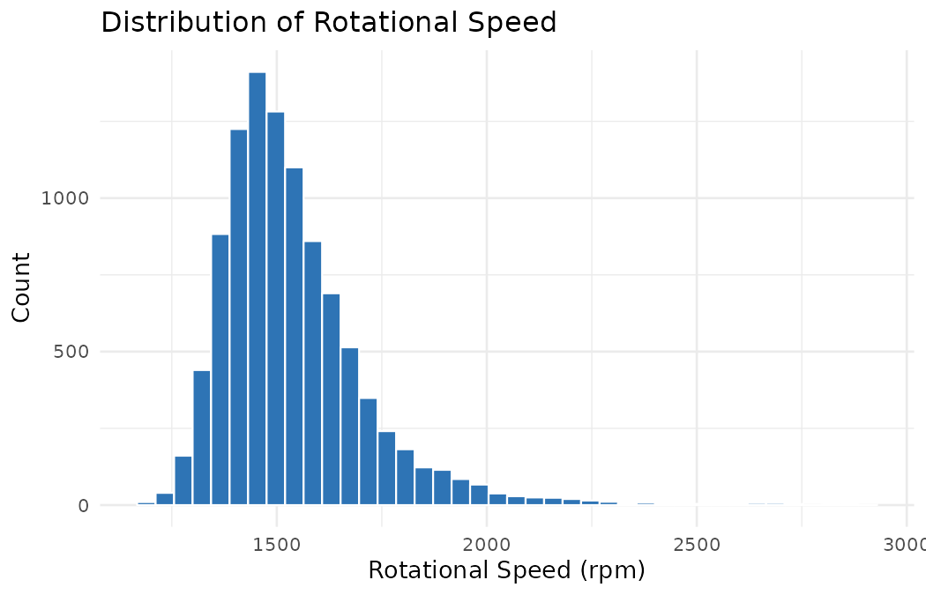
Figure 1: Distribution of rotational speed across all 10,000 observations.
The distribution is right-skewed, clustering tightly between roughly 1300–1700 rpm with a long tail extending out to nearly 2900 rpm. That tail is not a data error — Section 3.3 and Figure 3 both show it is where a disproportionate share of failures occurs, so it is a region the eventual failure-prediction model needs to represent well rather than treat as noise.

4.2 Boxplot — Torque by Product Quality Type
R Code
ggplot(df, aes(x = Type, y = Torque, fill = Type)) +
geom_boxplot(alpha = 0.85, outlier.color = "#C00000") +
labs(title = "Torque Distribution by Product Quality Type",
x = "Product Type", y = "Torque (Nm)") +
theme_minimal(base_size = 13)
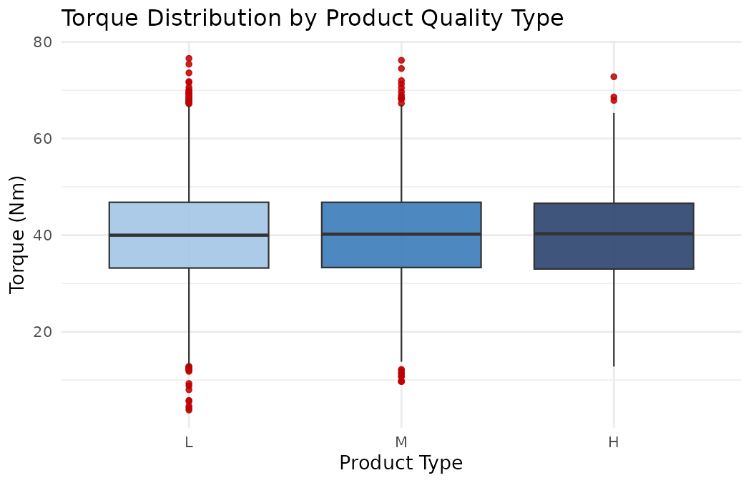
Figure 2: Torque distribution split by product quality variant, with outliers marked in red.
Median torque is nearly identical across L, M, and H product types (all close to 40 Nm), and the interquartile ranges overlap almost completely — torque itself is not what differentiates quality tiers. What differs is failure outcome at similar torque levels (Section 3.2), suggesting the quality-tier effect on failure rate operates through component tolerance rather than through the operating conditions the machine is run at.

4.3 Scatter Plot — Rotational Speed vs. Torque by Failure Status
R Code
ggplot(df, aes(x = RotSpeed, y = Torque, color = MachineFailure)) +
geom_point(alpha = 0.5, size = 1.3) +
scale_color_manual(values = c("No Failure"="#A6A6A6","Failure"="#C00000")) +
labs(title = "Rotational Speed vs. Torque, Colored by Failure Status")
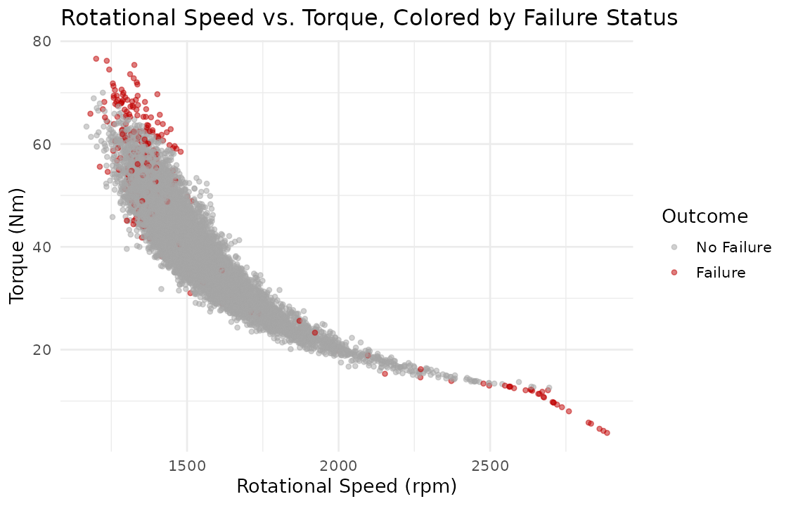
Figure 3: Speed–torque relationship, with failure events highlighted in red.
This is the most informative chart in the analysis. It confirms the inverse speed–torque relationship from Section 3.3, and — critically — shows that failures (red points) are not spread randomly along that curve. They concentrate at both extremes: high-torque/low-speed points (consistent with overstrain failure) and low-torque/high-speed points (consistent with power failure). The middle of the operating curve is almost entirely failure-free. This directly suggests an engineered feature for Week 3 modelling: an estimated power term (Torque × Rotational Speed) or distance from the central operating band, rather than using the two raw sensors independently.

4.4 Correlation Heatmap — Sensor Variables
R Code
corrplot(cor(df[, num_cols]), method = "color", type = "upper",
addCoef.col = "black", tl.col = "black",
title = "Correlation Matrix: Sensor Variables")
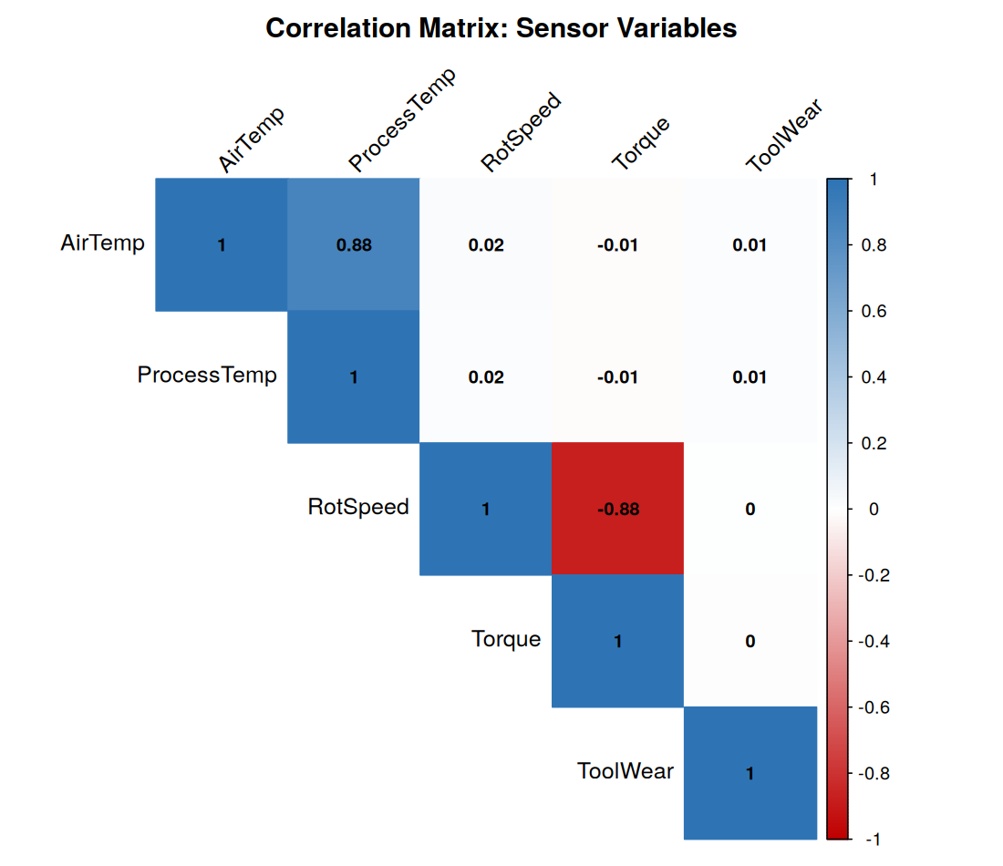
Figure 4: Pairwise correlation matrix of the five continuous sensor variables.
The heatmap makes the two dominant relationships from Section 3.3 immediately visible — the strong positive Air/Process temperature pair and the strong negative Speed/Torque pair — while confirming that Tool wear is visually “isolated” from the other four variables (near-zero correlation in every cell of its row and column).

4.5 Bar Chart — Failure Rate by Product Quality Type
R Code
df %>% group_by(Type) %>%
summarise(FailureRate = mean(MachineFailure == "Failure") * 100) %>%
ggplot(aes(x = Type, y = FailureRate, fill = Type)) + geom_col(width = 0.6) +
labs(title = "Machine Failure Rate by Product Quality Type")
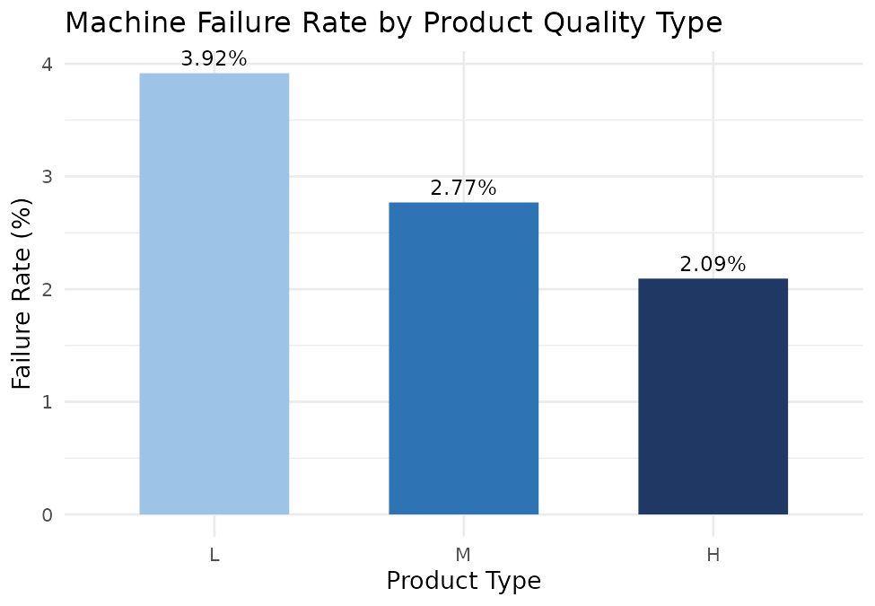
Figure 5: Failure rate (%) by product quality type, with values labeled.
This chart isolates the Section 3.2 finding as a single, presentation-ready comparison: failure rate nearly doubles from High-quality (2.09%) to Low-quality (3.92%) parts. For a maintenance-scheduling application, this alone is actionable — Low-tier units justify shorter inspection intervals than High-tier units, independent of any sensor-based model.

5. Insight Interpretation and Implications for Further Analysis
Brought together, the five visualizations and the summary statistics tell a coherent story rather than five disconnected observations:
- Operating-envelope risk: failures are concentrated at the high-torque/low-speed and low-torque/high-speed extremes of the speed–torque curve (Figure 3), not spread evenly — this is the single strongest signal in the dataset for a future classifier.
- Redundant vs. independent sensors: Air/Process temperature carry largely duplicate information (r = 0.876) and could likely be represented by one derived feature; Tool wear is fully independent of the other four sensors and must be modelled separately rather than inferred.
- Product-tier risk gradient: Low-quality parts fail at nearly twice the rate of High-quality parts at statistically similar operating conditions (Figures 2 and 5), pointing to a component-tolerance effect that a model should capture via the Type variable, not just the continuous sensors.
- Outliers are signal, not noise: the 69 IQR-flagged Torque outliers (Section 2) sit disproportionately inside the failure-prone tail regions identified in Figure 3, reinforcing the decision to retain rather than remove them.
These findings directly shape the plan for subsequent weeks: engineer a power-proxy feature (Torque × Speed) and/or an operating-envelope distance metric; consider dropping or combining the two temperature sensors to reduce redundancy; retain Type as a categorical predictor rather than treating all products uniformly; and, given the 3.39% failure rate, use evaluation metrics suited to class imbalance (precision/recall, PR-AUC) rather than raw accuracy when modelling begins.

6. Effort Summary and Conclusion
Activity | Description | Est. Hours
Dataset research & selection | Evaluating candidate public datasets; sourcing and validating AI4I 2020 | 4 hrs
Environment setup | Installing R/RStudio packages (ggplot2, dplyr, corrplot, reshape2) | 2 hrs
Data cleaning & preparation | Renaming, type conversion, missing/duplicate/outlier checks | 5 hrs
Exploratory analysis | Summary statistics, class balance, correlation analysis | 7 hrs
Visualization development | Building and refining 5 visualizations in ggplot2/corrplot | 9 hrs
Insight interpretation & writing | Synthesizing findings and drafting this report | 6 hrs
Total |  | 33 hrs
Table 2: Effort breakdown, totalling 33 hours within the assigned 30–35 hour budget.
This EDA confirms that the AI4I 2020 dataset contains clear, physically interpretable structure — a strong inverse speed–torque relationship, failure concentration at the extremes of that relationship, redundant temperature sensors, an independent tool-wear signal, and a product-quality risk gradient. These findings are documented and reproducible end-to-end in R, and translate directly into concrete feature-engineering and modelling decisions for the next phase of the internship.

