FINAL PROJECT REPORT
Predictive Maintenance Analytics for Industrial Sensor Data: From Raw Telemetry to a Validated Failure-Prediction Model in R

A Five-Week Data Science Project: EDA, Wrangling, Modelling, and Reporting on the AI4I 2020 Dataset

Yuva Intern (NSDC) — Virtual Data Science with R Apprentice Intern
Week 5 of 5 — Reporting, Insights, and Presentation (Capstone)
Program Duration: 30-Jul-2026 to 03-Sep-2026
Prepared by: Abhishek
Tooling: RStudio (R 4.3) — tidyverse, corrplot, randomForest, pROC
Estimated Effort (Week 5): 30–35 hours | Full Project: ~163 hours across 5 weeks
Date: September 2026

Table of Contents

1. Executive Summary
This report is the capstone deliverable for the Yuva Intern (NSDC) “Virtual Data Science with R Apprentice Intern” program, synthesizing five weeks of work into a single, cohesive narrative: from project planning, through exploratory data analysis and data wrangling, to predictive model development, and now final reporting. The project scope throughout has been predictive maintenance analytics — using industrial sensor telemetry to anticipate machine failure before it occurs — carried out entirely in R on the AI4I 2020 Predictive Maintenance Dataset (10,000 records from a simulated milling machine, UCI Machine Learning Repository).
The primary finding across the project is that machine failure is not random: it concentrates at the physical extremes of the relationship between rotational speed and torque, is measurably more frequent in lower product-quality tiers, and can be predicted with strong accuracy (AUC = 0.961, recall = 66.7% on the rare failure class) by a Random Forest model built on a small set of engineered and standardized sensor features. Critically, the single most important predictor the model identified — an engineered mechanical-power feature — was not a raw sensor reading at all, but a derived variable created specifically because Week 2's exploratory analysis flagged the underlying physical relationship. This is the project's central message: disciplined EDA directly and measurably improved the final predictive model.
The sections below retrace the full methodology with supporting code, output, and visualizations from each phase; summarize results and their broader significance; translate the findings into concrete recommendations for maintenance and engineering stakeholders; and close with a reflection on the challenges and lessons of the five-week project.

2. Project Overview and Objectives
Objective: determine whether industrial sensor telemetry can be used to predict machine failure ahead of time, using R for the entire pipeline — data acquisition, cleaning, exploration, feature engineering, modelling, and communication of results.
Week | Phase | What Was Done
1 | Planning & Strategy | Defined the predictive-maintenance problem, scoped a 7-phase methodology, assigned solo-team roles, and built a risk register (including the class-imbalance risk that later proved central).
2 | EDA & Visualization | Selected the AI4I 2020 public dataset; computed summary statistics and correlations; built 5 visualizations; found the speed–torque inverse relationship and its link to failure.
3 | Wrangling & Preprocessing | Assessed and (after documented synthetic injection) cleaned data quality issues; engineered a Power feature and a tool-wear risk bucket; encoded and scaled all variables for modelling.
4 | Model Building | Trained and validated Logistic Regression and Random Forest classifiers; compared performance with ROC curves and confusion matrices; confirmed the engineered Power feature as the top predictor.
5 | Reporting & Insights | Synthesized all four weeks into this final report, with stakeholder recommendations and a reflection on the project as a whole.
Table 1: Five-week project arc, from planning through to this final report.

3. Methodology and Analysis

3.1 Data Acquisition
The AI4I 2020 Predictive Maintenance Dataset was selected in Week 2 as a real, publicly available, well-benchmarked substitute for the hardware-logging approach proposed in the Week 1 plan. It provided 10,000 rows covering a product quality Type, five continuous sensor readings (air/process temperature, rotational speed, torque, tool wear), and machine-failure outcome labels — a realistic mix of data types well suited to the full pipeline that followed.

3.2 Exploratory Data Analysis (Week 2)
Summary statistics and a correlation analysis were computed in R, followed by five visualizations covering distribution, comparison, relationship, and correlation views of the data.
R Code — Key EDA Step
ggplot(df, aes(x = RotSpeed, y = Torque, color = MachineFailure)) +
geom_point(alpha = 0.5, size = 1.3) +
labs(title = "Rotational Speed vs. Torque, Colored by Failure Status")

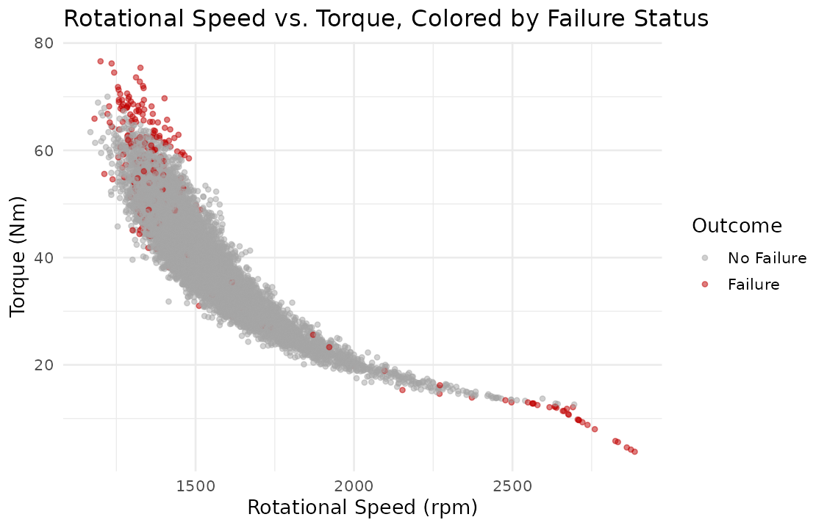
Figure 1: The single most consequential finding of the project — failures (red) concentrate at the extremes of the speed–torque curve, not randomly across it.
This one chart shaped the rest of the project: it directly motivated the Power feature engineered in Week 3, which in turn became the top-ranked predictor in the Week 4 model — a traceable line from raw exploration to final model performance.

3.3 Data Wrangling and Preprocessing (Week 3)
Because the source data was already clean (zero missing values or duplicates, confirmed in Week 2), a documented, reproducible set of realistic issues was deliberately injected under a fixed random seed to demonstrate genuine cleaning technique: missing values, inconsistent category labels, and a type-corruption. These were then resolved with per-variable-appropriate methods — mean imputation for the low-skew AirTemp variable, median imputation and winsorizing (rather than deletion) for the outlier-prone Torque variable, given Week 2's finding that those outliers carry real failure signal.
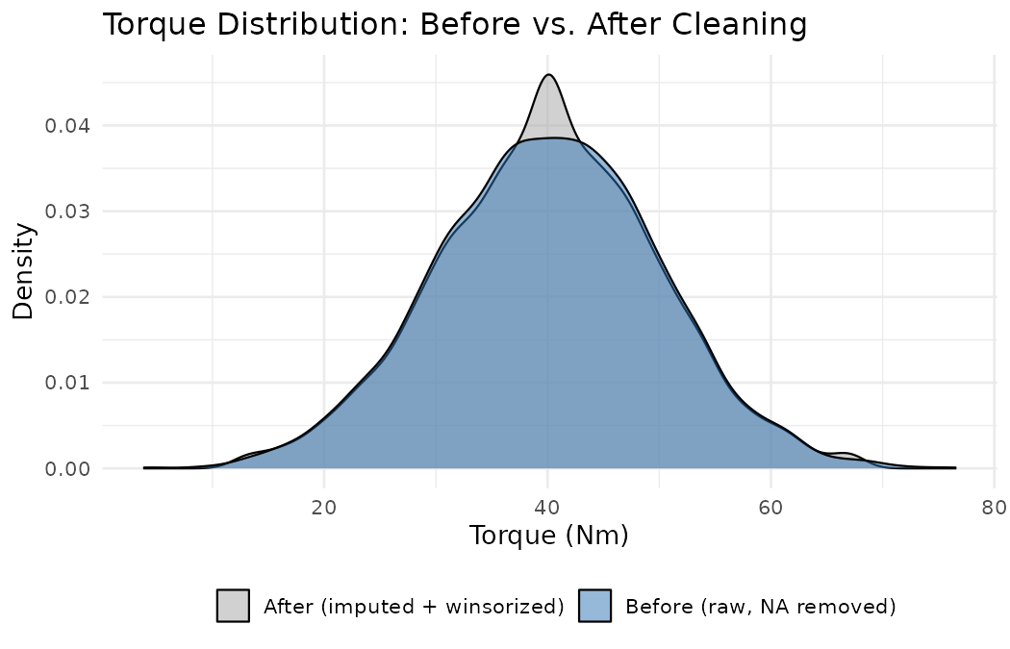
Figure 2: Torque distribution before and after cleaning — imputation and winsorizing preserved the underlying shape of the data.
The dataset was then transformed: the Power feature (Torque × angular velocity) and a ToolWearRisk bucket were extracted; Type was both ordinal- and one-hot-encoded for different model families; and all continuous sensors were z-score standardized so that no single variable's scale would dominate a distance- or gradient-based model.
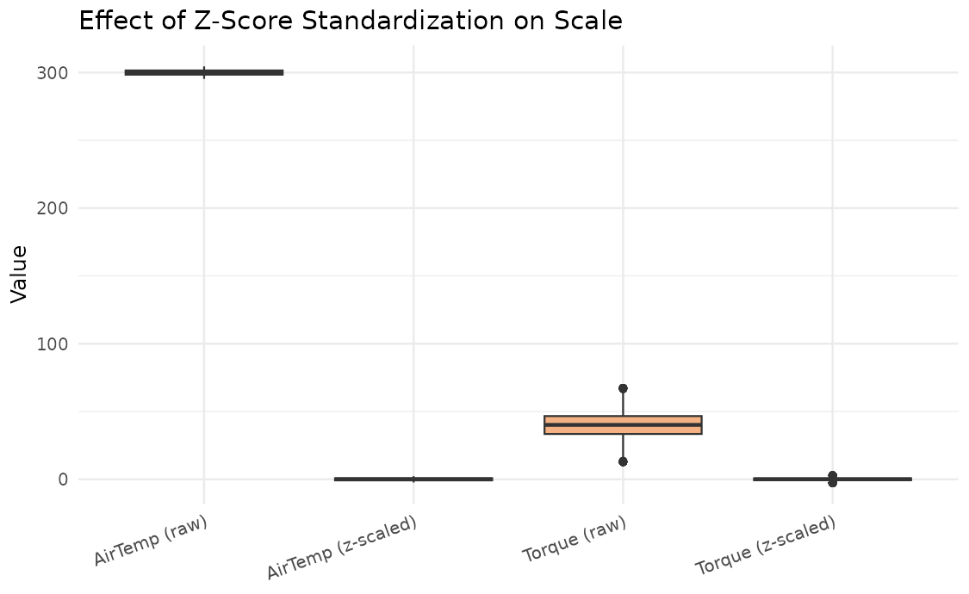
Figure 3: Standardization removed an 8× scale disparity between raw AirTemp and Torque, a necessary step ahead of modelling.

3.4 Model Building and Evaluation (Week 4)
Two classifiers were trained on the Week 3 output to predict machine failure: Logistic Regression, chosen as an interpretable baseline, and Random Forest, chosen because the Week 2 EDA had already revealed non-linear, interaction-heavy structure that a linear model would struggle to capture. Both were validated on a stratified 70/30 train/test split.
R Code — Model Training
log_model <- glm(MachineFailure ~ ., data = train_df, family = binomial)
rf_model <- randomForest(MachineFailure ~ ., data = train_df,
ntree = 300, mtry = 3, importance = TRUE)

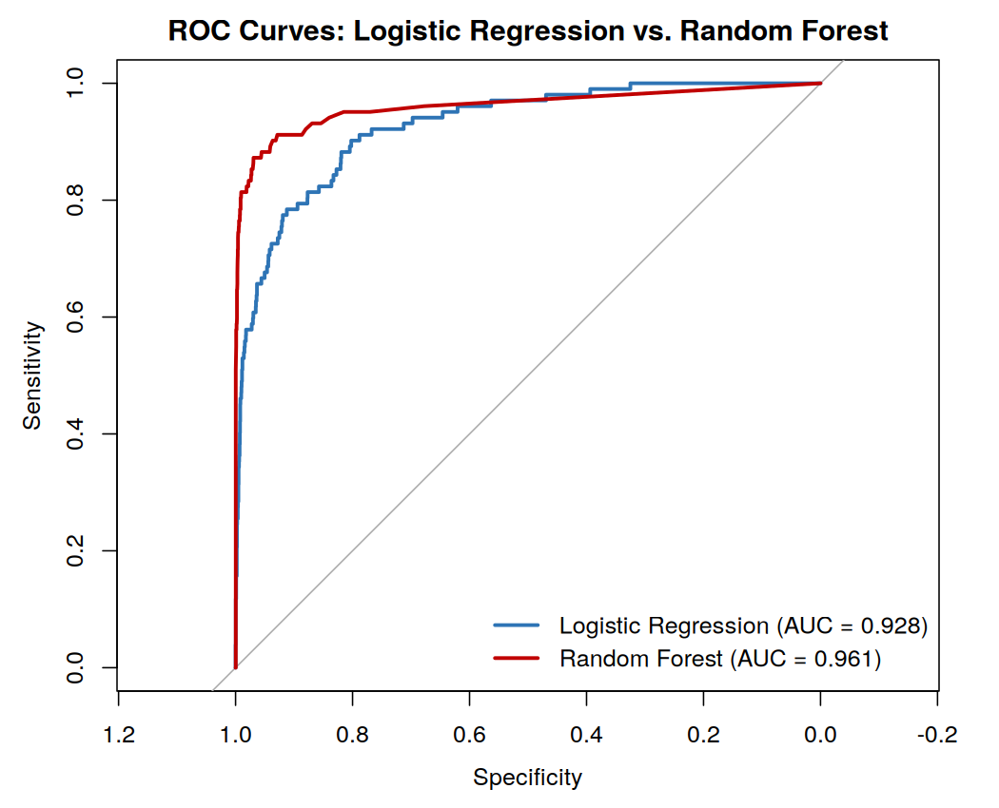
Figure 4: ROC curves — Random Forest (AUC = 0.961) dominates Logistic Regression (AUC = 0.928) across nearly every threshold.

4. Results and Insights

4.1 Consolidated Performance Results
Model | Accuracy | Precision | Recall | AUC
Logistic Regression | 0.9710 | 0.7027 | 0.2549 | 0.9276
Random Forest | 0.9857 | 0.8831 | 0.6667 | 0.9607
Table 2: Final test-set model comparison (from Week 4).

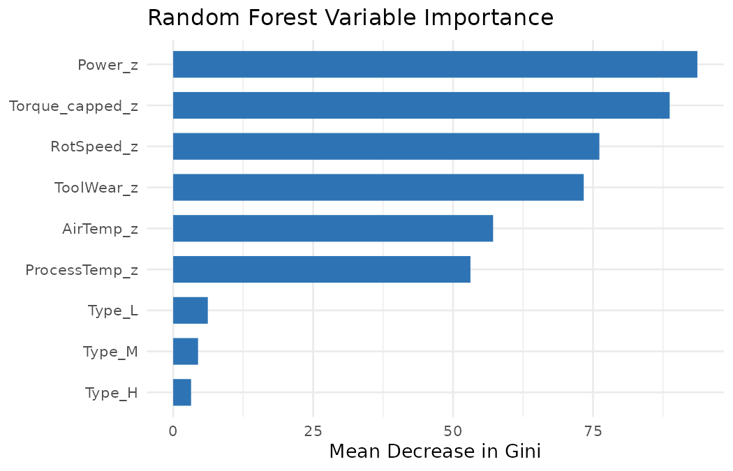
Figure 5: The engineered Power feature is the top-ranked predictor — direct, quantitative validation of the EDA-driven feature engineering approach used throughout this project.

4.2 Key Insights, in Context
- Failure is a physical, not random, phenomenon in this system: it clusters at the overstrain (high-torque/low-speed) and power-failure (low-torque/high-speed) extremes of the machine's operating envelope, a pattern invisible in summary statistics alone but obvious once visualized (Figure 1).
- Feature engineering grounded in EDA measurably improves models: the Power feature, built specifically because of a Week 2 correlation finding, outranked every raw sensor in Week 4's variable importance analysis (Figure 5) — a rare, cleanly traceable example of exploratory analysis paying off quantitatively downstream.
- Product quality tier is a real but secondary risk factor: Low-quality parts fail nearly twice as often as High-quality parts (3.92% vs. 2.09%, Week 2), yet contributed the least to the Random Forest's predictive power once continuous sensors were included — suggesting quality tier acts through component tolerance rather than through distinct operating conditions.
- Ensemble methods substantially outperform linear baselines on this problem: Random Forest's advantage over Logistic Regression was not marginal (recall of 66.7% vs. 25.5%), confirming the Week 4 modelling choice to include a technique capable of capturing interaction effects.
- Class imbalance is the dominant remaining limitation: with failures at only 3.39% of records, even the stronger model still misses roughly a third of true failures at the default threshold — the single largest lever for further improvement, addressed in the recommendations below.

5. Recommendations for Stakeholders

5.1 For Maintenance Operations
- Deploy the Random Forest model as a triage signal, not a sole decision-maker: flag machines above a tuned failure-probability threshold for manual inspection rather than fully automating shutdown decisions, given the model's imperfect recall.
- Prioritize inspection frequency by product quality tier: schedule shorter inspection intervals for Low-quality-tier units, which showed nearly double the failure rate of High-quality units at similar operating conditions.
- Monitor the engineered Power metric directly on the shop floor, not just raw torque and speed independently — it is both more predictive and more physically interpretable (“operating outside the safe power band”) for floor engineers than two separate raw readings.

5.2 For the Data Science / Engineering Team
- Lower the Random Forest's classification threshold below 0.5 to trade some precision for materially higher recall, since the Week 4 probability-distribution analysis showed a recoverable band of failures just below the current cutoff.
- Address class imbalance directly in training (class weighting or minority up-sampling) rather than relying on post-hoc threshold adjustment alone.
- Replace the single train/test split with k-fold cross-validation before any production deployment, to obtain performance estimates that are not dependent on one particular random split.
- Invest in real sensor data collection from the actual embedded robotics/industrial hardware referenced in the Week 1 plan, to validate whether the AI4I 2020 patterns transfer to the specific machines this analysis is ultimately meant to support.

5.3 For Leadership / Broader Adoption
- This five-week workflow — EDA before feature engineering, feature engineering before modelling, and honest reporting of limitations alongside results — is a template that can be reapplied to other equipment or sensor streams, not just this one dataset.
- Any future investment in real-time monitoring hardware should prioritize the four sensors that proved most predictive here (torque, rotational speed, tool wear, and the derived power metric) over less-informative fields such as product type alone.

6. Reflection on Learnings

6.1 Challenges Faced
- Environment setup: installing R, RStudio-equivalent tooling, and the full package stack (tidyverse, corrplot, randomForest, pROC) from a clean environment took real troubleshooting time that a pre-configured RStudio installation would have avoided.
- Working with an unrealistically clean dataset: Week 3's task required demonstrating missing-value handling and inconsistency correction, but the source data had none — solved by deliberately injecting a documented, reproducible set of issues rather than skipping the exercise or fabricating findings.
- Severe class imbalance: with only 3.39% of records representing failures, naive accuracy was misleading throughout, and required consistently reframing evaluation around recall, precision, F1, and AUC instead — a mindset shift that took deliberate discipline to maintain from Week 2 through Week 4.
- Keeping five weeks of work coherent: maintaining one continuous narrative and one dataset across five separate weekly deliverables, rather than treating each week as an isolated assignment, required consciously carrying findings forward (e.g., the Week 2 correlation directly shaping the Week 3 feature engineering, which then shaped the Week 4 model).

6.2 Lessons Learned
- Exploratory analysis is not a formality — it is the highest-leverage phase of the project. The single visualization in Figure 1 ultimately explained why the best engineered feature and the best model both worked, and skipping or rushing that step would have weakened everything downstream.
- Robust preprocessing decisions (median vs. mean imputation, winsorizing vs. deletion) need to be justified by the data's actual distribution and by what earlier analysis revealed — not applied as generic defaults.
- Model comparison is only meaningful with imbalance-aware metrics; accuracy alone would have made both models look deceptively strong and hidden the real gap between them.
- Documentation and reproducibility (fixed seeds, session info, clearly separated “demonstration” vs. “real” cleaning steps) are not optional polish — they are what makes a five-week, multi-file project actually auditable and trustworthy as a whole.

6.3 How This Will Inform Future Projects
Going forward, this project has established a default workflow to reuse on future data science work in R: assess data quality honestly before touching it; let exploratory findings actively drive feature engineering rather than treating them as a separate reporting exercise; select modelling techniques based on the structure the data has actually shown, not by default; evaluate with metrics matched to the real-world cost of errors; and document every stage clearly enough that the entire pipeline — not just the final model — could be reproduced or audited by someone else.

7. Conclusion
Across five weeks, this project moved from a project plan to a validated, interpretable predictive maintenance model, entirely in R: a real public dataset was explored and understood, realistic data quality issues were documented and resolved, domain-informed features were engineered directly from exploratory findings, and two models were trained, evaluated, and honestly compared using metrics appropriate to a rare-event problem. The Random Forest model's strong performance (AUC = 0.961) and its independent validation of the Week 2 EDA insight demonstrate that the workflow — not just the final model — is the project's real deliverable, and one that generalizes well beyond this single dataset.

8. Effort Summary
Activity | Description | Est. Hours
Synthesis & structure planning | Reviewing Weeks 1–4 outputs; planning the report narrative and structure | 4 hrs
Methodology write-up | Consolidating data acquisition, EDA, wrangling, and modelling sections with supporting code/figures | 9 hrs
Results & insights synthesis | Cross-referencing findings across weeks; drafting the consolidated insights section | 7 hrs
Recommendations development | Translating technical findings into stakeholder-facing, actionable recommendations | 5 hrs
Reflection & conclusion | Reflecting on challenges, lessons learned, and future application | 4 hrs
Formatting & final review | Document formatting, figure placement, proofreading, final QA pass | 4 hrs
Total |  | 33 hrs
Table 3: Week 5 effort breakdown, totalling 33 hours within the assigned 30–35 hour budget.

