CoreCart
Synopsis, Flowchart Diagram and Complete Project Documentation
ASP.NET Core MVC / Web API • Entity Framework Core • SQL Server
Prepared for academic / CV / project-report use
Project Name | CoreCart
Project Type | E-Commerce Web Application
Technology Stack | ASP.NET Core MVC / Web API, EF Core, SQL Server, Bootstrap / HTML / CSS / JavaScript
Primary Users | Customer, Admin
Key Modules | Authentication, Product Catalog, Search, Cart, Wishlist, Checkout, Orders, Inventory, Reports
Goal | To build a secure and scalable online shopping platform with complete buying and admin workflows

1. Project Synopsis
CoreCart is a full-stack e-commerce web application developed using ASP.NET Core to provide a modern online shopping experience. The system enables customers to register, explore products, search and filter items, add products to cart or wishlist, place orders, and track purchase history. On the administrative side, the application provides a dashboard for managing products, categories, brands, stock, users, and orders.
The project is designed to demonstrate end-to-end web application development with secure authentication, business workflows, database design, and a responsive interface. It is suitable for academic submission, interview discussion, portfolio display, and CV inclusion.
2. Problem Statement
Traditional shopping systems require customers to visit physical stores, compare items manually, and depend on limited stock visibility. Store owners also face difficulty in managing inventory, customer orders, and product data efficiently. CoreCart addresses these issues by centralizing product discovery, online ordering, and administrative monitoring into a single web-based solution.
3. Objectives
- To build a secure and user-friendly e-commerce website for online buying and selling.
- To implement customer-facing workflows such as registration, search, cart, wishlist, and checkout.
- To provide an admin panel for managing products, categories, orders, and stock.
- To maintain accurate order records and support future expansion such as payment gateway integration and real-time notifications.
- To showcase practical use of ASP.NET Core, EF Core, SQL Server, and role-based authorization.
4. Scope of the Project
The scope of CoreCart includes customer account management, product browsing, product filtering, cart and wishlist handling, checkout, order creation, order history, and administrative control over the core business entities. The initial version may use a dummy payment flow, but the architecture is designed so that a real payment gateway, email service, invoice PDF, or SignalR notifications can be added later.
5. Proposed System Modules
Module | Description
User Authentication | Registration, login, logout, password management, role-based access.
Home & Navigation | Homepage banners, featured products, category shortcuts, promotional sections.
Product Catalog | Product listing, product details, categories, brands, product images, pricing, stock.
Search & Filters | Search by keyword, filter by category/brand/price, sort by latest or price.
Cart & Wishlist | Add/remove items, update quantity, move items between wishlist and cart.
Checkout | Shipping address, order summary, payment method, place order.
Order Management | Order history, status tracking, order details, cancellation (optional).
Admin Dashboard | Overview of users, products, orders, stock, and sales.
Inventory | Stock quantity, out-of-stock handling, low-stock monitoring.
Reports | Sales reports, order reports, product-wise summaries, user activity overview.

6. System Flowchart
The flowchart below summarizes the main CoreCart workflow. It shows how a customer enters the platform, authenticates, browses the catalog, adds products to cart, checks out, completes payment, and tracks orders. It also shows the administrative path used to manage products, inventory, orders, and reports.
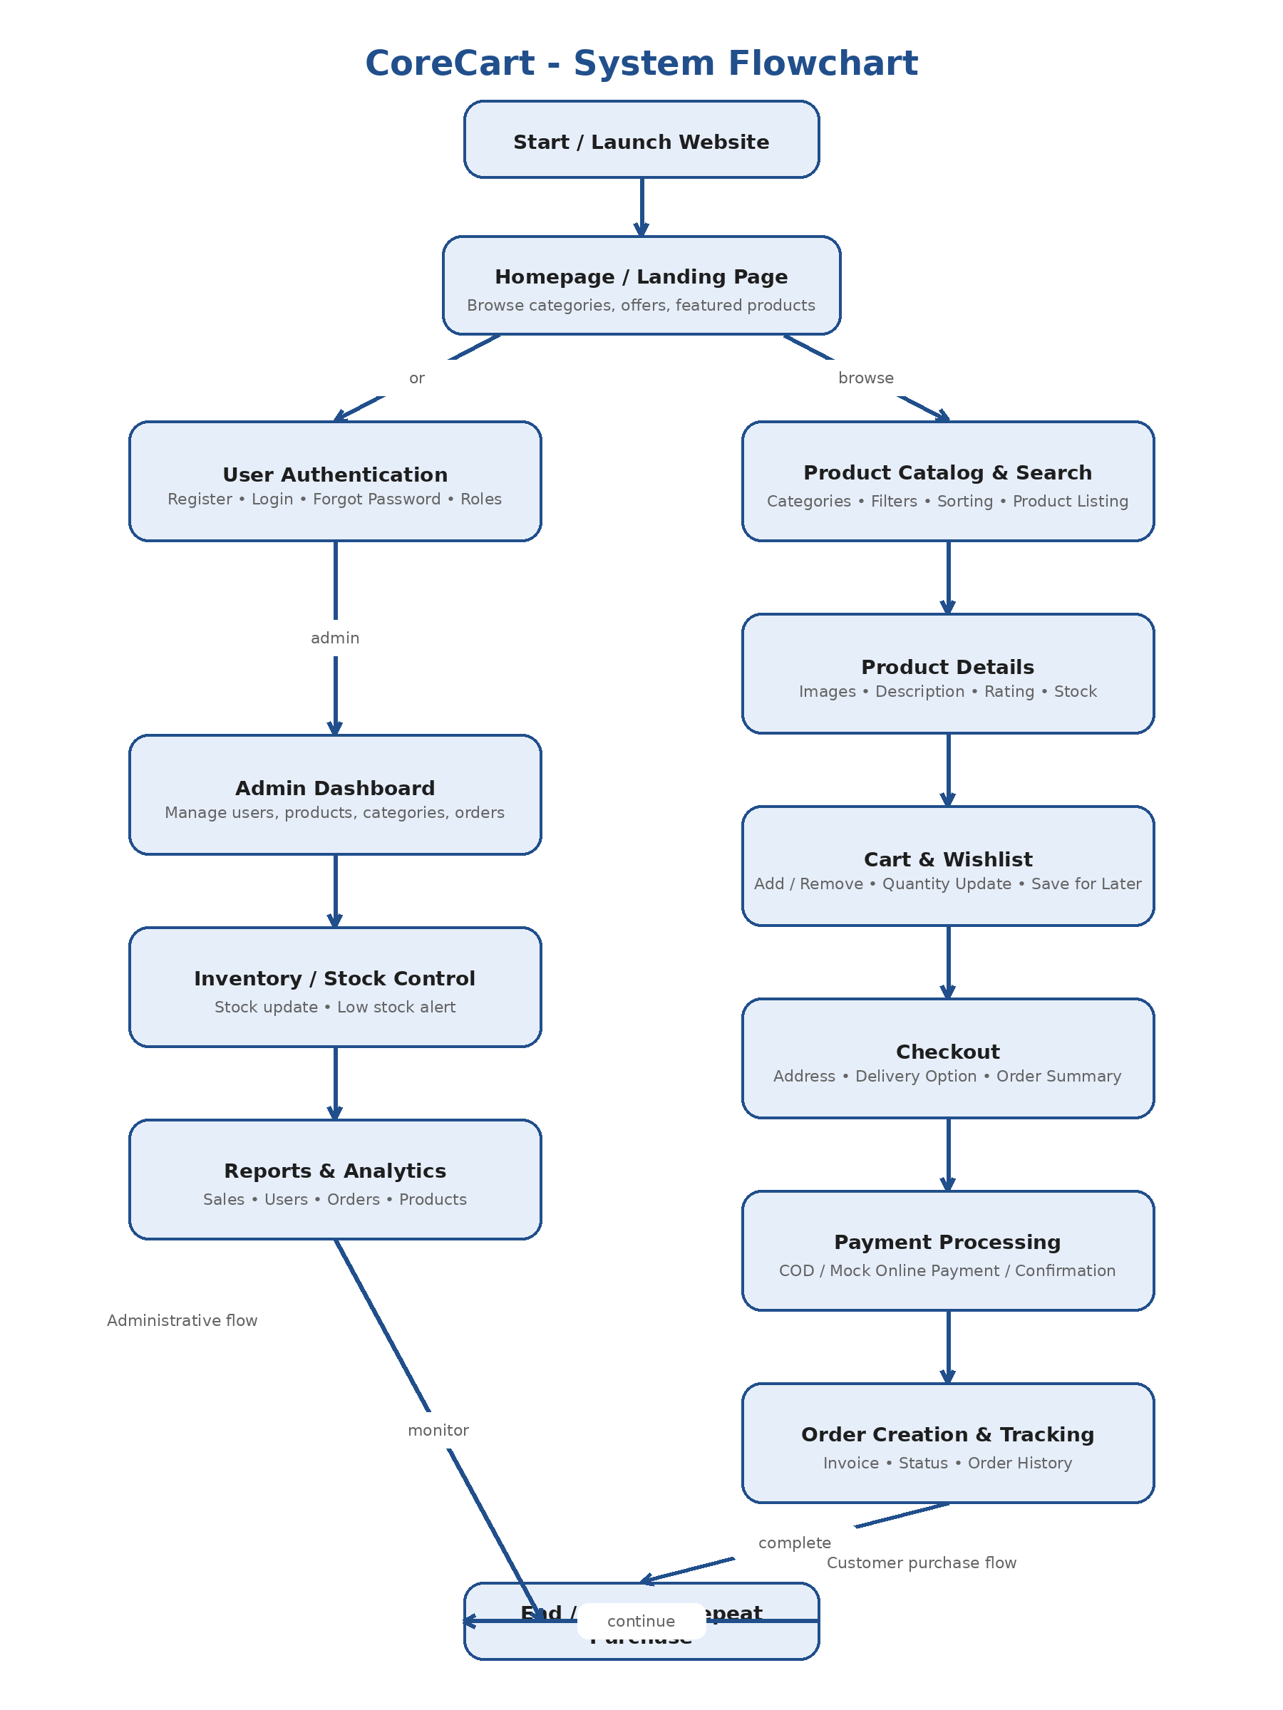
Figure 1. CoreCart system flowchart
7. Functional Requirements
- Customers shall be able to register and log in securely.
- Customers shall be able to browse products by category and brand.
- Customers shall be able to search, filter, and sort products.
- Customers shall be able to add products to cart and wishlist.
- Customers shall be able to update cart quantity and remove items.
- Customers shall be able to place orders through checkout.
- Administrators shall be able to manage products, categories, brands, users, and orders.
- Administrators shall be able to update stock levels and monitor low-stock items.
- The system shall maintain order records and customer purchase history.
8. Non-Functional Requirements
- Security: authentication, password protection, role-based authorization, server-side validation.
- Performance: fast search, optimized product listing, efficient database queries.
- Scalability: modular architecture to support new modules such as coupons or online payment.
- Usability: responsive UI, clear navigation, simple checkout process.
- Reliability: proper exception handling, data consistency, and stable order processing.
- Maintainability: layered architecture, reusable services, and clean database relationships.
9. Technology Stack
Layer | Technology
Frontend | Razor Views / HTML / CSS / Bootstrap / JavaScript
Backend | ASP.NET Core MVC or ASP.NET Core Web API
ORM / Data Access | Entity Framework Core
Database | SQL Server
Authentication | ASP.NET Core Identity / Cookie Auth / Role-based Authorization
Tools | Visual Studio, Git, GitHub, Postman
10. System Architecture
CoreCart follows a layered architecture. The presentation layer provides the user interface and handles incoming requests. The business layer processes validations and application logic such as checkout, stock update, and order creation. The data access layer communicates with SQL Server through Entity Framework Core. This structure improves separation of concerns and makes testing, maintenance, and future upgrades easier.
11. Database Design
Suggested primary tables for the first version are listed below.
Table | Purpose | Key Fields
Users | Stores customer and admin account data | UserId, FullName, Email, PasswordHash, Role
Categories | Stores product categories | CategoryId, CategoryName, Description
Brands | Stores brand information | BrandId, BrandName
Products | Stores product details | ProductId, CategoryId, BrandId, Name, Price, StockQty
ProductImages | Stores image references | ImageId, ProductId, ImageUrl, IsPrimary
CartItems | Stores customer cart items | CartItemId, UserId, ProductId, Quantity
WishlistItems | Stores wishlist entries | WishlistId, UserId, ProductId
Orders | Stores order headers | OrderId, UserId, OrderDate, TotalAmount, Status
OrderItems | Stores ordered product lines | OrderItemId, OrderId, ProductId, Quantity, UnitPrice
Addresses | Stores shipping addresses | AddressId, UserId, AddressLine, City, State, Pincode
Payments | Stores payment details | PaymentId, OrderId, PaymentMethod, PaymentStatus, TransactionRef

12. Process Description
12.1 Customer Flow
- User registers or logs in.
- User browses products from the homepage or category pages.
- User applies search, filter, or sorting options to narrow the results.
- User opens a product details page and reviews stock, images, rating, and description.
- User adds product to cart or wishlist.
- User proceeds to checkout, selects address and payment option, and places the order.
- The system creates order and order item records, updates stock, and shows confirmation.
12.2 Admin Flow
- Admin logs in through the authorized panel.
- Admin manages categories, brands, and products.
- Admin updates stock availability and product pricing.
- Admin reviews incoming orders and changes order status such as packed, shipped, or delivered.
- Admin monitors summary reports for products, users, and sales.
13. Validation and Security
The project should use server-side validation to prevent invalid input and maintain data integrity. User passwords should never be stored in plain text. Role-based authorization must protect admin-only functions. Anti-forgery validation, input sanitization, error logging, and proper exception handling should be added to strengthen the application.
14. Testing Strategy
- Unit testing of service logic such as total amount calculation and stock updates.
- Integration testing for checkout and order creation.
- UI testing for login, cart, and product management flows.
- Database testing for foreign keys, constraints, and transaction consistency.
- Manual testing of responsive design, navigation, and validation messages.
15. Advantages of the System
- Reduces manual effort in product selling and stock tracking.
- Provides better customer convenience through anytime browsing and ordering.
- Centralizes products, orders, users, and reports in one system.
- Demonstrates real-world business logic suitable for interviews and portfolio use.
16. Limitations
- Initial version may use mock payment instead of a real payment gateway.
- Delivery tracking can be basic unless integrated with courier APIs.
- Recommendation engine and personalized marketing may not be included in the first release.
17. Future Enhancements
- Online payment gateway integration.
- Coupon and discount engine.
- Email and SMS notifications.
- Invoice PDF generation.
- Real-time order updates using SignalR.
- Multi-vendor marketplace support.
- Dashboard charts and advanced analytics.
18. Resume / CV Description
CoreCart – E-Commerce Web Application
Developed a full-stack e-commerce platform using ASP.NET Core, Entity Framework Core, and SQL Server with product catalog, cart, wishlist, checkout, order tracking, inventory handling, and role-based admin dashboard.
19. Conclusion
CoreCart is a practical and interview-ready e-commerce project that demonstrates backend logic, database modeling, secure authentication, UI flow, and complete order management. It is an ideal project for a resume because it combines common industry requirements with modular architecture and clear business value.

