**AWS RDS Overview**

* RDS stands for Relational Database Service
* It’s a managed DB service for DB use SQL as a query language.
* It allows you to create databases in the cloud that are managed by AWS
* Postgres
* MySQL
* MariaDB
* Oracle
* Microsoft SQL Server
* Aurora (AWS Proprietary database)

**Advantage over using RDS versus deploying DB on EC2**

* RDS is a managed service:
  + Automated provisioning, OS patching
  + Continuous backups and restore to specific timestamp (Point in Time Restore)!
  + Monitoring dashboards
  + Read replicas for improved read performance
  + Multi AZ setup for DR (Disaster Recovery)
  + Maintenance windows for upgrades
  + Scaling capability (vertical and horizontal)
  + Storage backed by EBS (gp2 or io1)
* BUT you can’t SSH into your instances

**RDS Backups**

* Backups are automatically enabled in RDS
  + Automated backups:
  + Daily full backup of the database (during the maintenance window)
  + Transaction logs are backed-up by RDS every 5 minutes
  + ability to restore to any point in time (from oldest backup to 5 minutes ago)
  + 7 days retention (can be increased to 35 days)
* DB Snapshots:
  + Manually triggered by the user
  + Retention of backup for as long as you want

**RDS – Storage Auto Scaling**

* Helps you increase storage on your RDS DB instance dynamically
* When RDS detects you are running out of free database storage, it scales automatically
* Avoid manually scaling your database storage
* You have to set Maximum Storage Threshold (maximum limit for DB storage)
* Automatically modify storage if:
  + Free storage is less than 10% of allocated storage
  + Low-storage lasts at least 5 minutes
  + 6 hours have passed since last modification
* Useful for applications with unpredictable workloads
* Supports all RDS database engines (MariaDB, MySQL, PostgreSQL, SQL Server, Oracle)

**RDS Read Replicas for read scalability**

* Up to 5 Read Replicas
* Within AZ, Cross AZ or Cross Region
* Replication is ASYNC, so reads are eventually consistent
* Replicas can be promoted to their own DB
* Applications must update the connection string to leverage read replicas

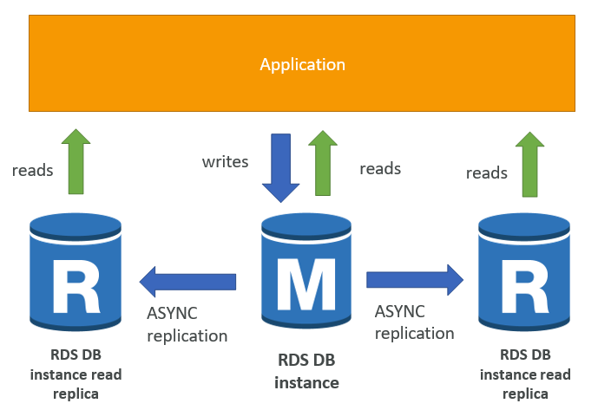

RDS Read Replicas – Use Cases

* You have a production database that is taking on normal load
* You want to run a reporting application to run some analytics
* You create a Read Replica to run the new workload there
* The production application is unaffected
* Read replicas are used for SELECT (=read) only kind of statements (not INSERT, UPDATE, DELETE)

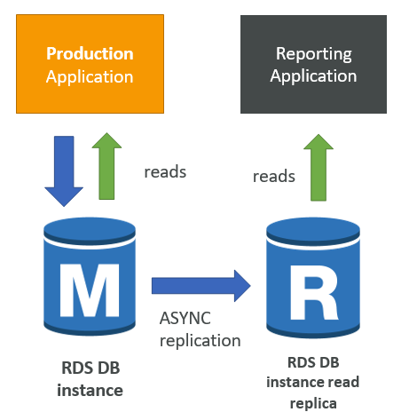

**RDS Read Replicas – Network Cost**

* In AWS there’s a network cost when data goes from one AZ to another
* For RDS Read Replicas within the same region, you don’t pay that fee

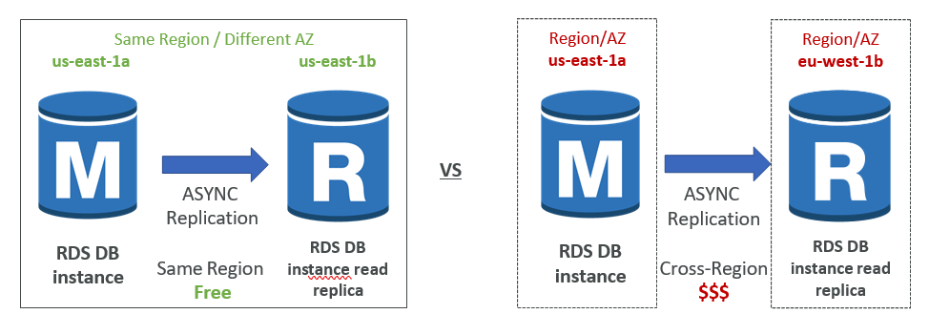

**RDS Multi AZ (Disaster Recovery)**

* SYNC replication
* One DNS name – automatic app failover to standby
* Increase availability
* Failover in case of loss of AZ, loss of network, instance or storage failure
* No manual intervention in apps
* Not used for scaling
* Multi-AZ replication is free
* Note:The Read Replicas be setup as Multi AZ for Disaster Recovery (DR)

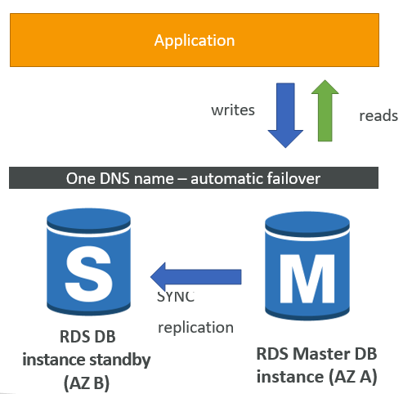

**RDS – From Single-AZ to Multi-AZ**

* Zero downtime operation (no need to stop the DB)
* Just click on “modify” for the database
* The following happens internally:
* A snapshot is taken
* A new DB is restored from the snapshot in a new AZ
* Synchronization is established between the two databases

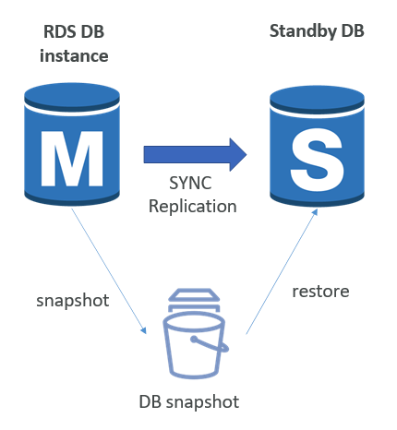

**RDS Security - Encryption**

* At rest encryption
  + Possibility to encrypt the master & read replicas with AWS KMS - AES-256 encryption
  + Encryption has to be defined at launch time
  + If the master is not encrypted, the read replicas cannot be encrypted
  + Transparent Data Encryption (TDE) available for Oracle and SQL Server
* In-flight encryption
  + SSL certificates to encrypt data to RDS in flight
  + Provide SSL options with trust certificate when connecting to database
  + To enforce SSL:
    - PostgreSQL: rds.force_ssl=1 in the AWS RDS Console (Parameter Groups)
    - MySQL: Within the DB:

GRANT USAGE ON *.* TO 'mysqluser'@'%' REQUIRE SSL;

**RDS Encryption Operations**

* Encrypting RDS backups
  + Snapshots of un-encrypted RDS databases are un-encrypted
  + Snapshots of encrypted RDS databases are encrypted
  + Can copy a snapshot into an encrypted one
* To encrypt an un-encrypted RDS database:
  + Create a snapshot of the un-encrypted database
  + Copy the snapshot and enable encryption for the snapshot
  + Restore the database from the encrypted snapshot
  + Migrate applications to the new database, and delete the old database

**RDS Security – Network & IAM**

* Network Security
  + RDS databases are usually deployed within a private subnet, not in a public one
  + RDS security works by leveraging security groups (the same concept as for EC2 instances) – it controls which IP / security group can communicate with RDS
* Access Management
  + IAM policies help control who can manage AWS RDS (through the RDS API)
  + Traditional Username and Password can be used to login into the database
  + IAM-based authentication can be used to login into RDS MySQL & PostgreSQL

**RDS - IAM Authentication**

* IAM database authentication works with
* MySQL and PostgreSQL
* You don’t need a password, just an authentication token obtained through IAM & RDS API calls
* Auth token has a lifetime of 15 minutes
* Benefits:
  + Network in/out must be encrypted using SSL
  + IAM to centrally manage users instead of DB
  + Can leverage IAM Roles and EC2 Instance profiles for easy integration

**Amazon Aurora**

* Aurora is a proprietary technology from AWS (not open sourced)
* Postgres and MySQL are both supported as Aurora DB (that means your drivers will work as if Aurora was a Postgres or MySQL database)
* Aurora is “AWS cloud optimized” and claims 5x performance improvement over MySQL on RDS, over 3x the performance of Postgres on RDS
* Aurora storage automatically grows in increments of 10GB, up to 64 TB.
* Aurora can have 15 replicas while MySQL has 5, and the replication process is faster (sub 10 ms replica lag)
* Failover in Aurora is instantaneous. It’s HA (High Availability) native.
* Aurora costs more than RDS (20% more) – but is more efficient

**Aurora High Availability and Read Scaling**

* 6 copies of your data across 3 AZ:
* 4 copies out of 6 needed for writes
* 3 copies out of 6 need for reads
* Self healing with peer-to-peer replication
* Storage is striped across 100s of volumes
* One Aurora Instance takes writes (master)
* Automated failover for master in less than 30 seconds

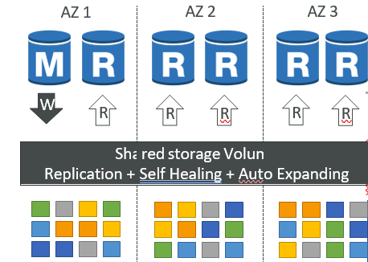

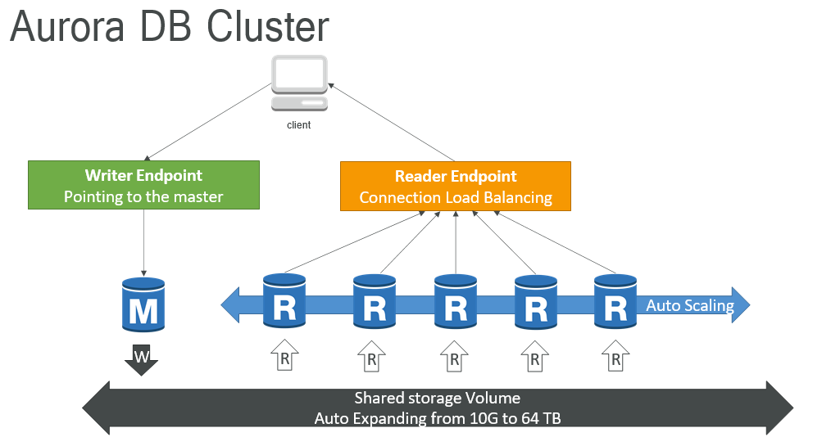

**Features of Aurora**

* Automatic fail-over
* Backup and Recovery
* Isolation and security
* Industry compliance
* Push-button scaling
* Automated Patching with Zero Downtime
* Advanced Monitoring
* Routine Maintenance
* Backtrack: restore data at any point of time without using backups

**Aurora Security**

* Similar to RDS because uses the same engines
* Encryption at rest using KMS
* Automated backups, snapshots and replicas are also encrypted
* Encryption in flight using SSL (same process as MySQL or Postgres)
* Possibility to authenticate using IAM token (same method as RDS)
* You are responsible for protecting the instance with security groups
* You can’t SSH