**Installing Jenkins:**

**Prerequisites**

Before continuing with this tutorial, make sure you have CentOS/amazonlinux/redhat machine created and logged in as a user with sudo privileges.

To install Jenkins on your amazonlinux system, follow these steps:

**1. Install Java.**

Since Jenkins is a Java application, the first step is to install Java. Update the package index and install the Java 11 OpenJDK package with the following commands:

sudo amazon-linux-extras install java-openjdk11 -y

**2. Add the Jenkins repository.**

sudo wget -O /etc/yum.repos.d/jenkins.repo \

https://pkg.jenkins.io/redhat-stable/jenkins.repo

sudo rpm --import https://pkg.jenkins.io/redhat-stable/jenkins.io.key

sudo yum upgrade

**3. Install Jenkins.**

sudo yum install jenkins -y

sudo systemctl daemon-reload

You can enable the Jenkins service to start at boot with the command:

sudo systemctl enable jenkins

You can start the Jenkins service with the command:

sudo systemctl start jenkins

You can check the status of the Jenkins service using the command:

sudo systemctl status jenkins

**Setting Up Jenkins:**

To set up your new Jenkins installation, open your browser, type your domain or IP address

followed by port 8080 make sure you opened port 8080 in AWS security groups

,http://your_ip_or_domain:8080 and screen similar to the following will be displayed:

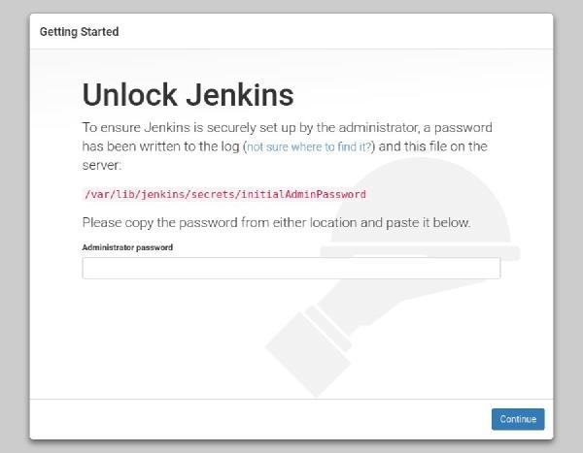

During the installation, the Jenkins installer creates an initial 32-character long alphanumeric password. Use the following command to print the password on your terminal:

sudo cat /var/lib/jenkins/secrets/initialAdminPassword

2115173b548f4e99a203ee99a8732a32

Copy the password from your terminal, paste it into the Administrator password field and click Continue and install Selected Plugins.

**Setting Up Docker in Jenkins Server:**

1. Install Docker

sudo yum install docker -y

sudo systemctl enable docker

sudo systemctl start docker

sudo systemctl status docker

1. Add Jenkins User to docker group

sudo usermod -a -G docker Jenkins

3. Restart Jenkins

sudo systemctl restart jenkins