AbleSpace Full Stack Developer Assignment
Part 2 — Product Understanding
Caseload Tab → "Take Data" Workflow Walkthrough

Overview
This document walks through the data-collection workflow available in AbleSpace, starting from the Caseload tab and following the "Take Data" action for a student through to recording a trial and adding a session note. I signed up for the free trial to explore this flow first-hand. Screenshots below are from my own trial account (student names shown are AbleSpace's built-in demo students).

Step 1 — Signing up and choosing a role
After signing up for the free trial, AbleSpace runs a short onboarding flow. One step asks "What's your role?" with options such as Administrator, Director of Student Services, Special Education Coordinator, School Principal, Case Manager, Special Education Teacher, and Resource Teacher. I selected "Special Education Teacher" since that role has the most direct, day-to-day relationship with the Caseload and data-collection features this walkthrough focuses on.
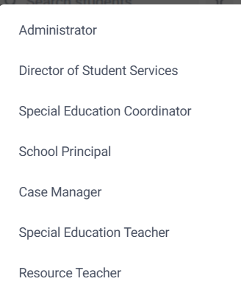
Fig 1 — Role selection step during onboarding.
The onboarding also includes a "With my team / On my own" setup step and an "Invite your teammates" step, both of which can be skipped without affecting access to the Caseload.

Step 2 — The Caseload screen
[ PASTE SCREENSHOT HERE: Caseload list showing Students (2), Full Name / Last Name / IEP Due / Eval Due / Actions columns, with a 'Take Data' button in each row ]
The Caseload tab is the home base for a teacher's assigned students. It lists every student with key details (IEP due date, evaluation due date, collaborators) in a table. Each row has a "Take Data" action on the right — this is the entry point into a live data-collection session for that student. The layout is a fairly standard data table, which makes it easy to scan a full caseload at a glance rather than opening each student individually.

Step 3 — Starting a session with Take Data
[ PASTE SCREENSHOT HERE: The session screen right after clicking 'Take Data' — shows the time window (e.g. 04:34 PM - 05:04 PM), 'Select Goal' and 'Customize' buttons, a 'Capture' section, 'Trial 1', and the goal description with a large counter and '+' button ]
Clicking "Take Data" opens a dedicated session screen with its own URL (app.ablespace.io/session/...). The top bar automatically shows a 30-minute session window (start and end time), which suggests AbleSpace timestamps each data-collection session rather than treating it as a single instantaneous action. Below that, the currently active goal is shown along with its full description (e.g., "Demo Student1 will take 5 bites, from a handheld snack, such as a cheese stick in 4 out of 5 opportunities"), and a large counter with a "+" button is the primary way to log a data point for the current trial.

Step 4 — Selecting a goal
[ PASTE SCREENSHOT HERE: The Goals (7/7) list panel showing Social Studies, Writing, Math (with two sub-objectives 3.1 and 3.2), Reading, Toileting, etc. ]
Clicking "Select Goal" opens a panel listing every goal on the student's IEP — in this demo account there were 7 goals across subjects like Social Studies, Writing, Math, Reading, and Toileting. Math goals are broken into sub-objectives (3.1, 3.2), which shows AbleSpace supports hierarchical goal structures, not just a flat list. This matters for real caseloads where a single annual goal is often broken into smaller measurable objectives.

Step 5 — Recording a trial
With a goal selected, pressing the large "+" button logs one data point and the counter increases (0 → 1 in my test). An "Undo" link sits above the counter in case of a misclick. The session also supports multiple "Trials" (Trial 1, Trial 2, ...) navigated with left/right arrows next to the trial label, and a "+ Phase" option, which lets a clinician structure data collection into phases/trials rather than one flat count for the whole session.

Step 6 — Customize (List / Board / Group view)
The "Customize" button opens a small view-switcher with three layout options for the capture area: List, Board, and Group. This is useful when a teacher is collecting data on several goals at once during a session and wants a different visual layout depending on how many goals or students they're tracking simultaneously.

Step 7 — Auto-save behavior
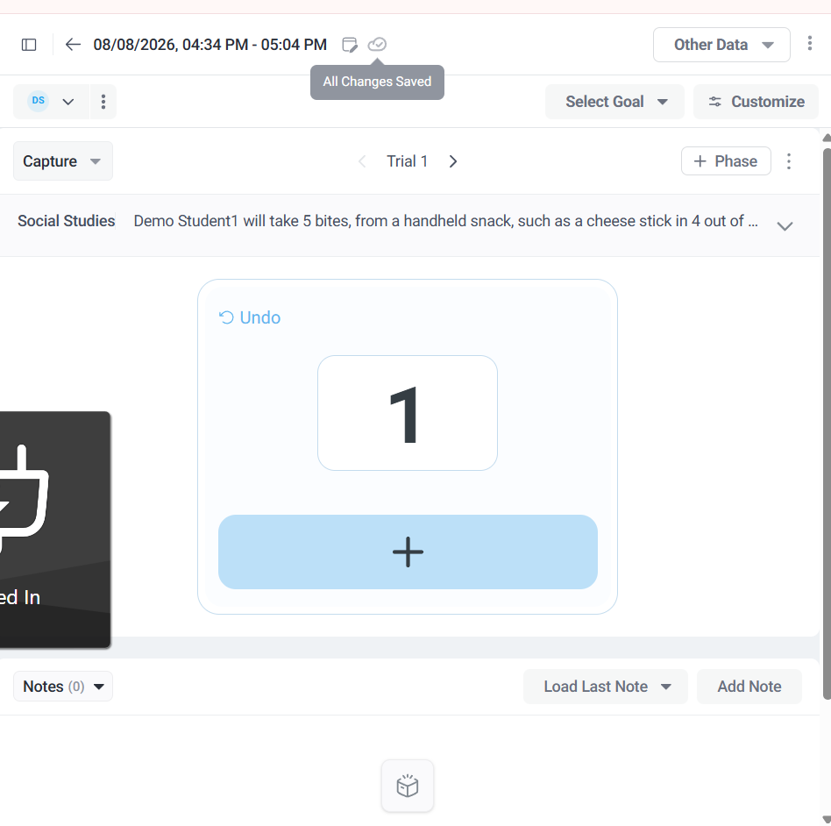
Fig 2 — Hovering the cloud icon next to the timestamp shows "All Changes Saved".
There is no explicit "Save" or "Submit" button on this screen. Instead, a small cloud/checkmark icon next to the date-time header shows a tooltip reading "All Changes Saved" — confirming that every trial logged via the "+" button is saved automatically in real time. This is a sensible design choice for a data-collection tool used in the middle of a live session, where stopping to manually save would be disruptive.

Step 8 — Adding a note
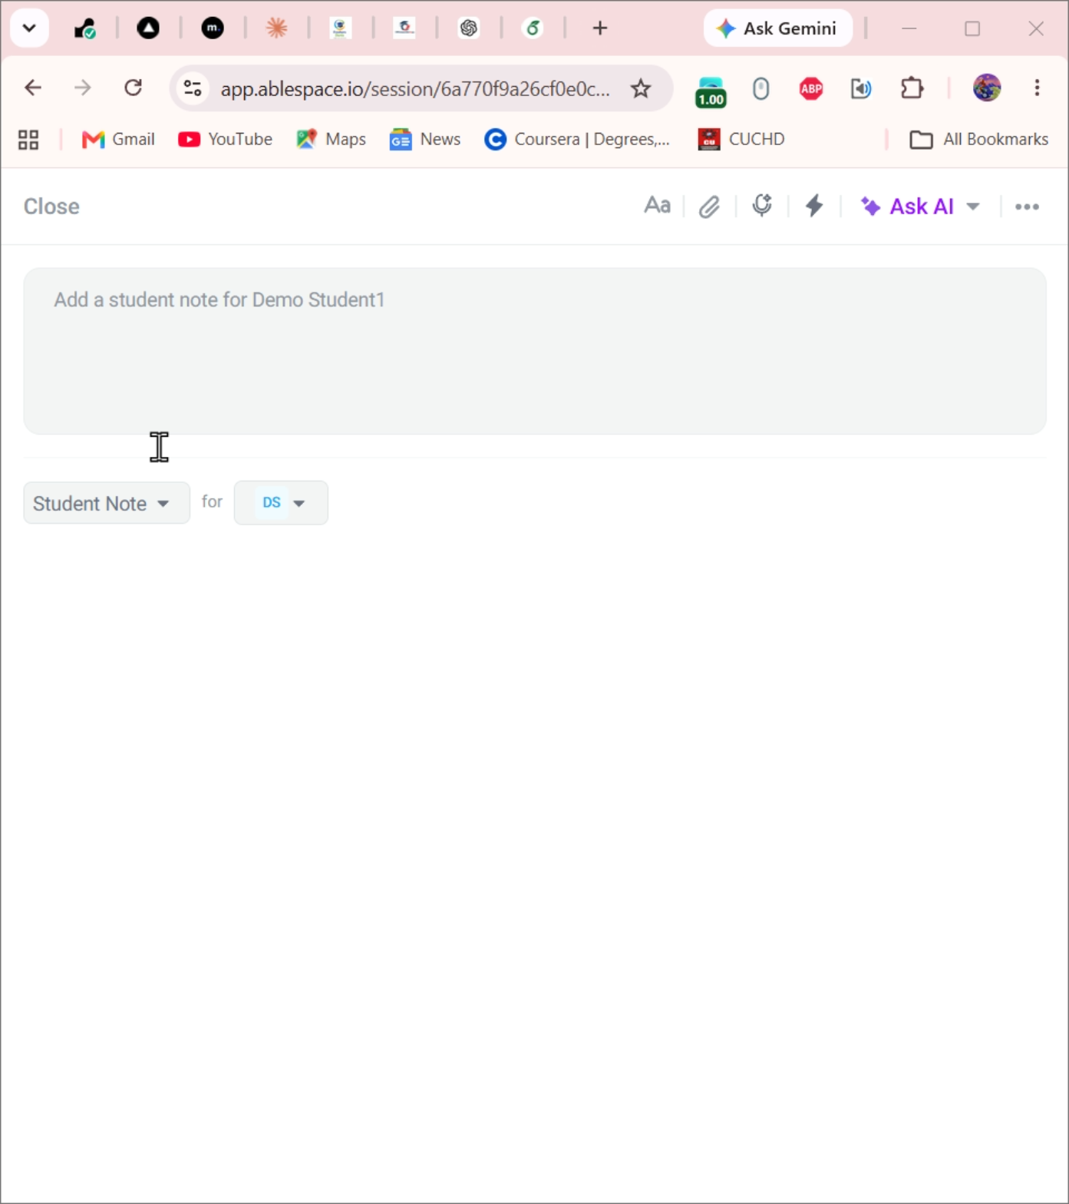
Fig 3 — The "Add Note" panel, pre-filled with the student's initials and a "Student Note" type.
The "Add Note" button at the bottom of the session screen opens a simple rich-text editor pre-tagged as a "Student Note" for the current student. It includes basic formatting (Aa), attachment, voice input, and an "Ask AI" option — suggesting AbleSpace offers AI-assisted note drafting, likely to help turn raw session observations into a more polished progress note.

Step 9 — Other session options
The three-dot menu at the top-right of the session screen exposes two more actions: "Remove Service Time & Attendance" and "View Activity Log." The per-student three-dot menu (next to the student's initials) offers "Mark Absent" and "Remove Student" — both important real-world scenarios (a student who isn't present that day, or was added to a session by mistake) that the workflow accounts for directly, without forcing the teacher to leave the session screen.

UX / UI and Functionality Observations
Based on exploring this flow, a few observations that could improve the experience:
- The auto-save confirmation ("All Changes Saved") only appears as a hover tooltip on a small icon, so it's easy to miss. A brief, more visible inline confirmation (e.g., text that appears near the counter for a second after each trial) would give clinicians more confidence that fast-paced data entry during a live session is actually being captured.
- There's no clearly-labeled "Finish Session" or "Complete" action on the main capture screen — the only way out is the back arrow. A dedicated "End Session" step (even if it just confirms and navigates back) would make the session lifecycle feel more explicit, especially for less tech-savvy users.
- Long goal descriptions are truncated with "..." directly in the capture header. A quick "expand" affordance right there (instead of only through the separate Goals panel) would save a click when a teacher just wants to re-read the exact goal criteria mid-session.
- Trial navigation uses small left/right arrows next to the "Trial 1" label with no visible count of total trials taken so far in the session — a compact running summary (e.g., a strip showing all trial results) would help a teacher see the full session pattern at a glance, rather than paging through trials one at a time.
- "Mark Absent" and "Remove Student" are grouped in the same three-dot menu with similar visual weight, even though one is a routine daily action and the other is a destructive, harder-to-reverse one. Visually separating them (e.g., a divider or warning color only on "Remove Student") would reduce the risk of an accidental click during a busy session.

Links
- GitHub repository: https://github.com/Abhishek180-Kumar/ablespace-task-manager
- Live project (frontend): [ Vercel link ]
- Live project (backend): https://ablespace-task-manager.onrender.com

