# Project: Analyzing a Market Test

## Step 1: Plan Your Analysis

1. **What is the performance metric you’ll use to evaluate the results of your test?**

Gross margin would be the performance metrics use to evaluate the results of the test. The Profitability should be enough to justify the increased marketing budget – at least 18% increase in profit growth compared to the comparative period while compared to the control stores, otherwise known as incremental lift.

1. **What is the test period?**

The test period is between 2016-April-29 to 2016-July-21 for treatment and 2015-Feb-06 to 2016-July-21 for control.

1. **At what level (day, week, month, etc.) should the data be aggregated?**

The Data should be aggerated on a weekly basis.

## Step 2: Clean Up Your Data

*In this step, you should prepare the data for steps 3 and 4. You should aggregate the transaction data to the appropriate level and filter on the appropriate data ranges. You can assume that there is no missing, incomplete, duplicate, or dirty data. You’re ready to move on to the next step when you have weekly transaction data for all stores.*

## Step 3: Match Treatment and Control Units

*In this step, you should create the trend and seasonality variables, and use them along with you other control variable(s) to match two control units to each treatment unit. Note: Calculate the number of transactions per store per week to calculate trend and seasonality.*

*Apart from trend and seasonality...*

1. **What control variables should be considered? Note: Only consider variables in the RoundRoastersStore file.**

The variables that should be considered are: StoreID, Invoice Number, Invoice Data, Category, Product, Gross Margin, Sales, Sq_Ft, AvgMonthSales, Region.

1. **What is the correlation between your each potential control variable and your performance metric?**

From the below chart we can see that AvgMonthSales has a high correlation of 0.99 with the Sum_Gross_Margin, but Sq_Ft has a poor correlation of -0.046.

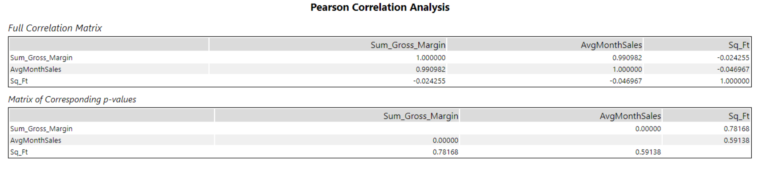

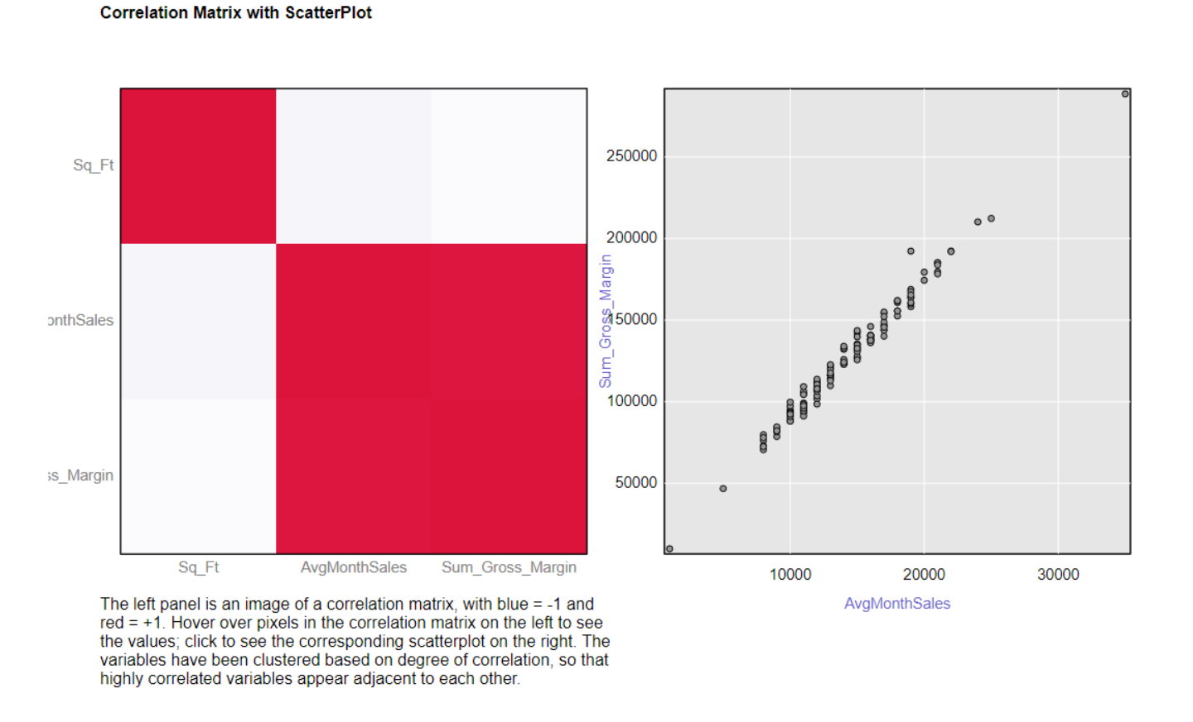

1. **What control variables will you use to match treatment and control stores?**

AvgMonthSales will be used together with Trends and Seasonality when matching treatment and control stores.

1. **Please fill out the table below with your treatment and control stores pairs:**

|  |  |  |
| --- | --- | --- |
| Treatment Store | Control Store 1 | Control Store 2 |
| 1664 | 7162 | 8112 |
| 1675 | 1580 | 1807 |
| 1696 | 1964 | 1863 |
| 1700 | 2014 | 1630 |
| 1712 | 8162 | 7434 |
| 2288 | 9081 | 2568 |
| 2293 | 12219 | 9524 |
| 2301 | 3102 | 9238 |
| 2322 | 2409 | 3235 |
| 2341 | 12536 | 2383 |

## Step 4: Analysis and Writeup

*Conduct your A/B analysis and create a short report outlining your results and recommendations. (250 words limit)*

*Answer these questions. Be sure to include visualizations from your analysis:*

1. **What is your recommendation - Should the company roll out the updated menu to all stores?**

The company should roll out the update menu to all the stores as based on the A/B test analysis result, the profit growth is more than 18%. The Predict impact to profitability would be enough to justify the increased marketing budget – at least 18% increase in profit growth compared to the comparative period while compared to the control stores.

1. **What is the lift from the new menu for West and Central regions (include statistical significance)?**

**West Region**

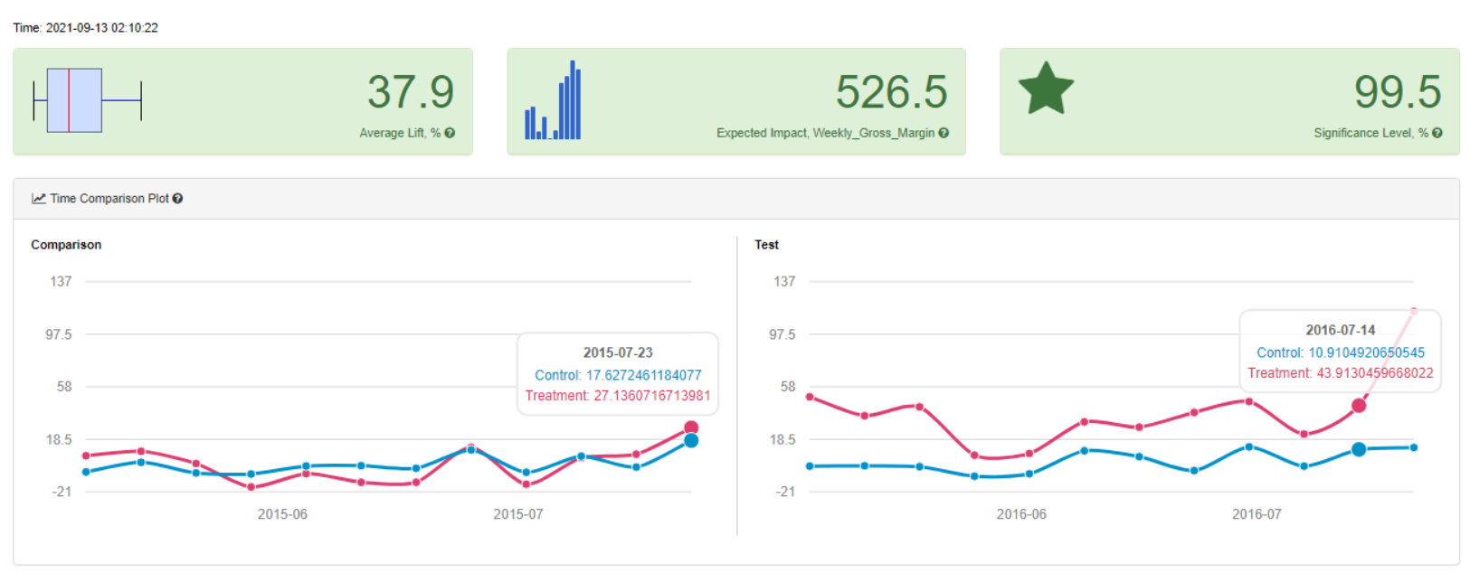

The above report shows that after rolling out the new menu for west region, showed 37.9% improvement at a significance of 99.5% over the existing menu. The average lift as a result from changing the menu would be 37.9% per store per week or approximately $526.5 per store per week.

**Central Region**

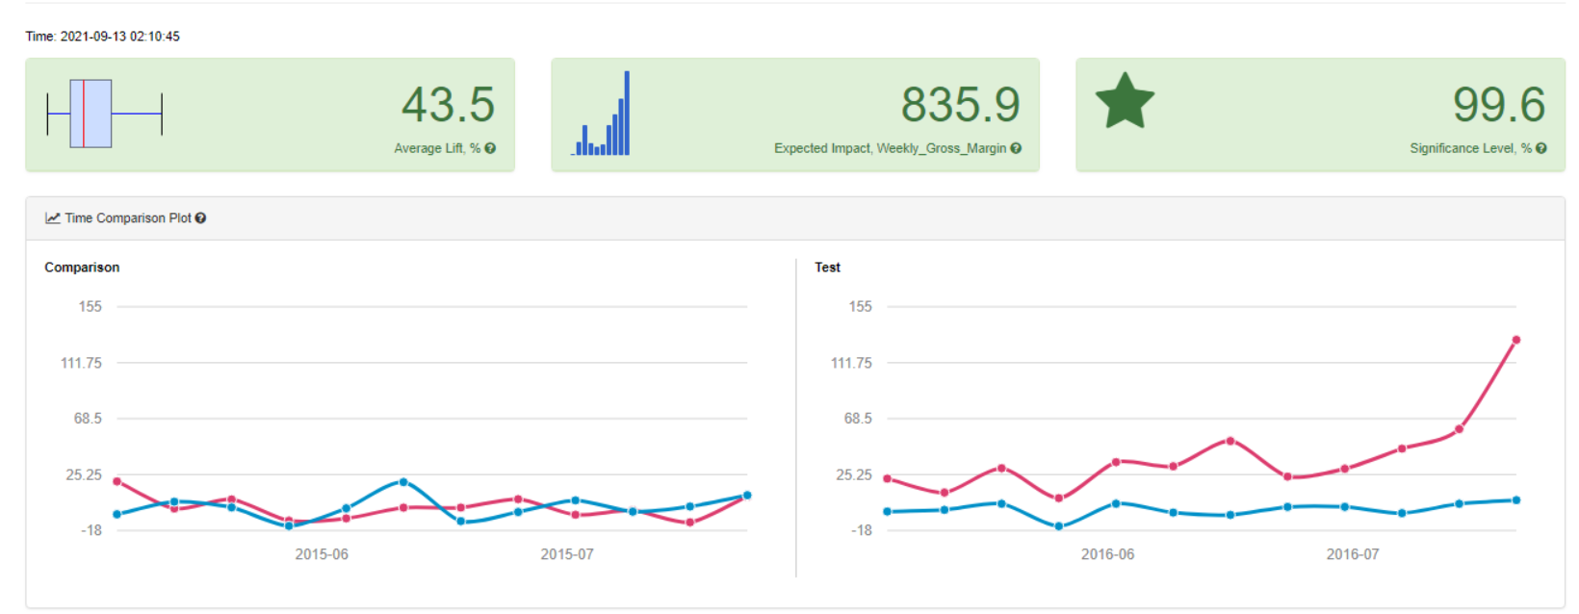

The above report shows that after rolling out the new menu for central region, showed 43.5% improvement at a significance of 99.6% over the existing menu. The average lift as a result from changing the menu would be 43.5% per store per week or approximately $835.9 per store per week.

1. **What is the lift from the new menu overall?**

**Overall**

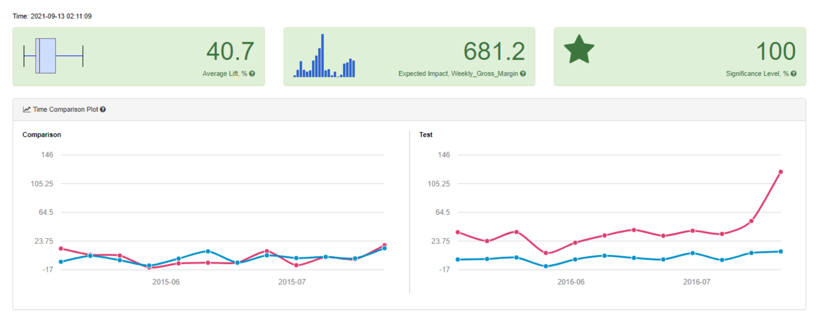

The above report shows that after rolling out the new menu, showed 40.7% improvement at a significance of 100% over the existing menu. The average lift as a result from changing the menu would be 40.7% per store per week or approximately $681.2 per store per week.

Rolling out the new would be improves Gross Margin therefore the change should be rolled out across all stores.

**My Alteryx Workflow:**

* **Data Cleaning:**

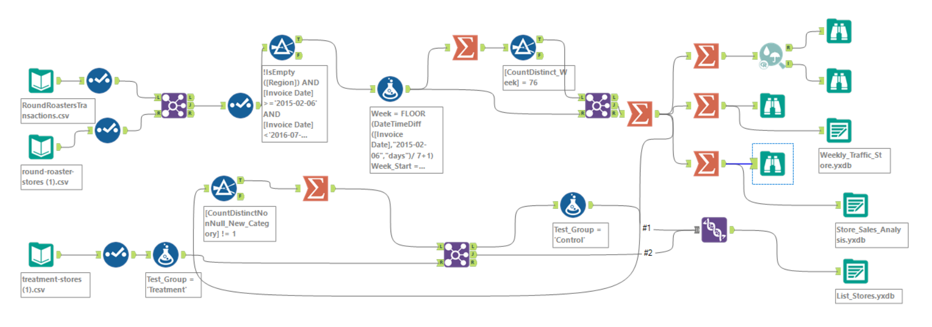

* **Match Treatment Control Unit:**

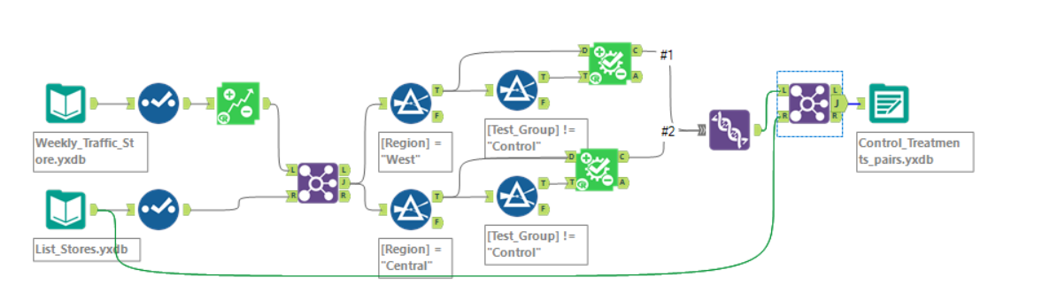

* **A/B Test Analysis:**

