Project: Diamond Prices

# Step 1: Understanding the Model

*Answer the following questions:*

1. According to the model, if a diamond is 1 carat heavier than another with the same cut, how much more should I expect to pay? Why?

* The one additional carat would result in an additional $8,413 in price. The formula created by the regression determined that the coefficient for a Carat is 8413, so for every increase in the number of carats the price will increase by the amount of the coefficient.

1. If you were interested in a 1.5 carat diamond with a **Very Good** cut (represented by a 3 in the model) and a **VS2** clarity rating (represented by a 5 in the model), how much would the model predict you should pay for it?

* The formula for price is:

Price = -5,269 + 8,413 x **Carat** + 158.1 x **Cut** + 454 x **Clarity**

* **= -5269 + 8413* 1.5 + 158.1*3 + 454*5**
* **= -5269 + 12619.5 + 474.3 + 2270**
* **= 10094.8**

So, the price to pay will be $10,094.8

# Step 2: Visualize the Data

Make sure to plot and include the visualizations in this report. For example, you can create graphs in Excel and copy and paste the graphs into this Word document.

1. Plot 1 - Plot the data for the diamonds in the database, with carat on the x-axis and price on the y-axis.
2. Plot 2 - Plot the data for the diamonds for which you are predicting prices with carat on the x-axis and predicted price on the y-axis.
   * **Note**: You can also plot both sets of data on the same chart in different colors.
3. What strikes you about this comparison? After seeing this plot, do you feel confident in the model’s ability to predict prices?

OR

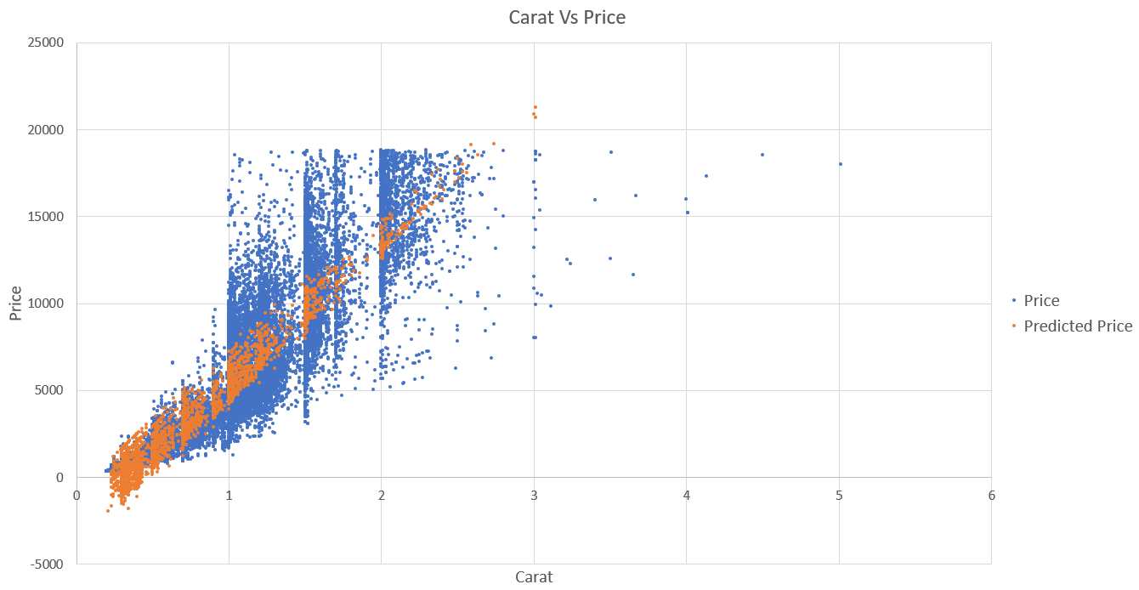

Both of them are same graph one is copy paste from excel sheet and another one is screenshot of graph from excel sheet.

After looking into graph or plot it appears on average to predict the price is not ok, because for small carats the price become negative. The outliers in diamond were sold for more than $20,000 for carat of 3. This is happening because of we are not accounting everything that effects the price. There are many more things than cartas that effects it. We had Cut and Clarity into our formula but not even that will account for all the variation. The model is not doing a decent job for predicting the price.

# Step 3: Make a Recommendation

*Answer the following questions:*

1. What price do you recommend the jewelry company to bid? Please explain how you arrived at that number.

* I recommend a bid of $8,213,465.932. I arrived at this number by using a formula from the regression model provided that was based on previous diamond sales and applied it to the diamond that were up for bid. I then factored in the margin the investors were looking for which was 30% so I multiply the predicted amount 11733522.76 by .70 to get the final predicted bid of $8,213,465.932.