6.1 Uniform Quantization and Quantization Error Analysis of a Discrete-Time
Sinusoidal Signal Using MATLAB
Code:
clc;
clear;
close all;

%% Signal
fs = 1000;
f = 50;
t = 0:1/fs:0.1;
x = sin(2*pi*f*t);

%% Quantization Levels
L = [8 16 32];
colors = {'r','g','m'};

figure;

for i = 1:length(L)

% Quantization
xq{i} = round((x + 1) .* (L(i) - 1) ./ 2) ...
.* (2 ./ (L(i) - 1)) - 1;

% Quantization Error
e{i} = x - xq{i};

% Mean Square Error
mse(i) = mean(e{i}.^2);

% Plot Quantized Signal
subplot(4,1,i+1);
stairs(t, xq{i}, colors{i}, 'LineWidth', 1.2);
title(['Quantized Signal (' num2str(L(i)) ' Levels)']);
xlabel('Time (s)');
ylabel('Amplitude');
grid on;
end

%% Original Signal
subplot(4,1,1);
plot(t, x, 'LineWidth', 1.5);
title('Original Signal');
xlabel('Time (s)');
ylabel('Amplitude');
grid on;

%% Display MSE
fprintf('MSE for 8 Levels = %f\n', mse(1));
fprintf('MSE for 16 Levels = %f\n', mse(2));
fprintf('MSE for 32 Levels = %f\n', mse(3));

%% Error Plots
figure;

for i = 1:3
subplot(3,1,i);
plot(t, e{i}, 'LineWidth', 1.2);
title(['Quantization Error (' num2str(L(i)) ' Levels)']);
xlabel('Time (s)');
ylabel('Error');
grid on;
end

Output:
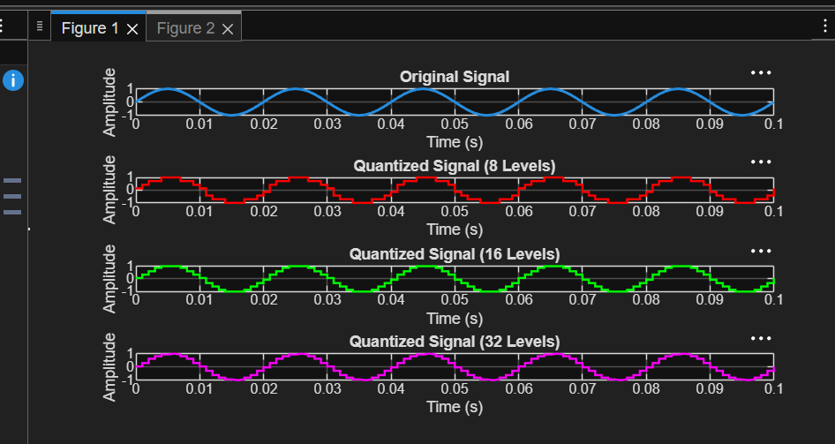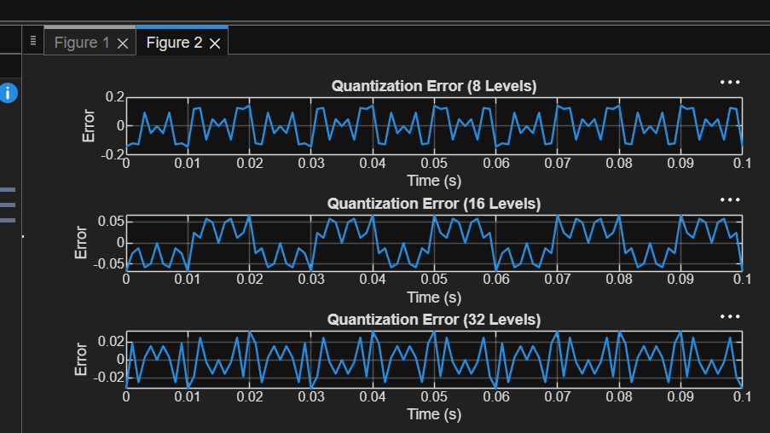

6.2 Analysis of Finite Word Length Effects in Digital Signal Representation Using
Truncation and Rounding Techniques in MATLAB

Code:
clc; clear; close all
n=0:79;
x=sin(2*pi*n/40);
q=8;
xt=floor(x*q)/q;
xr=round(x*q)/q;

et=x-xt;
er=x-xr;
% Fig 1
figure
plot(n,x,'b',n,xr,'r','LineWidth',1.5)
grid on
title('Original vs Quantized')
legend('Original','Quantized')
% Fig 2
figure
plot(n,x,'b',n,xt,'r',n,xr,'g','LineWidth',1.5)
grid on
title('Truncation vs Rounding')
legend('Original','Truncated','Rounded')
% Fig 3
figure
stem(n,et,'r')
hold on
stem(n,er,'g')
grid on
title('Quantization Error')
legend('Truncation','Rounding')
% Fig 4
figure
bar([mean(et.^2) mean(er.^2)])
set(gca,'XTickLabel',{'Truncation','Rounding'})
grid on
title('MSE Comparison')
ylabel('MSE')

Output:
