5.1 Generate the coefficients of an FIR High-Pass filter using Rectangular
windowing techniques.
Code:
clc; clear; close all;
%% --- Input Parameters ---
fp = 1000; % High-pass cutoff frequency (Hz)
fs = 8000; % Sampling frequency (Hz)
N = 50; % Filter order

wc = fp/(fs/2); % Normalized cutoff (0–1)

%% --- 1. FIR High Pass using Rectangular Window ---
b_rect = fir1(N, wc, 'high', rectwin(N+1));
disp('--- High-Pass Coefficients (Rectangular Window) ---');
disp(b_rect');

%% --- 2. FIR High Pass using Hamming Window ---
b_hamm = fir1(N, wc, 'high', hamming(N+1));
disp('--- High-Pass Coefficients (Hamming Window) ---');
disp(b_hamm');
%% --- 3. FIR High Pass using Hanning Window ---
b_hann = fir1(N, wc, 'high', hanning(N+1));
disp('--- High-Pass Coefficients (Hanning Window) ---');
disp(b_hann');
%% --- Frequency Response Plots ---
figure;
freqz(b_rect,1);
title('High-pass FIR using Rectangular Window');
figure;
freqz(b_hamm,1);
title('High-pass FIR using Hamming Window');
figure;
freqz(b_hann,1);
title('High-pass FIR using Hanning Window');

Output:
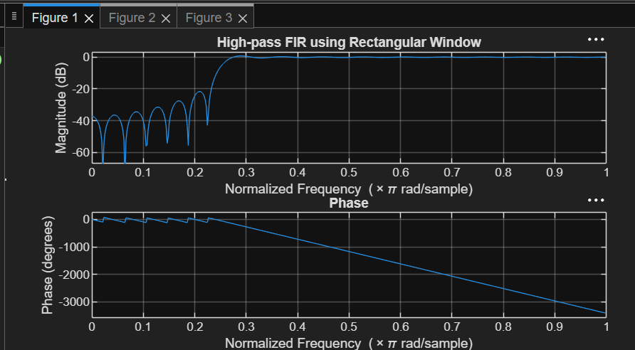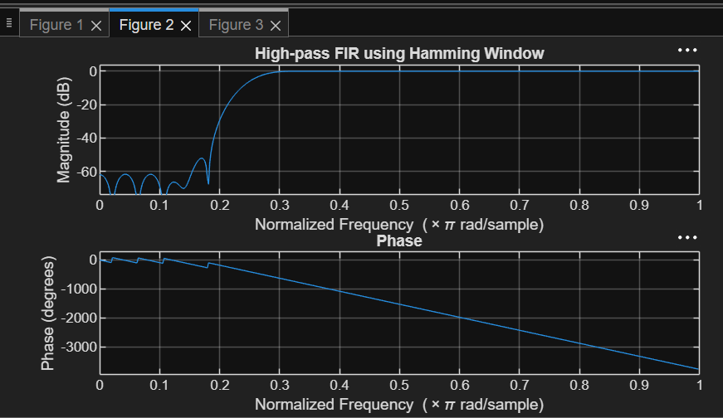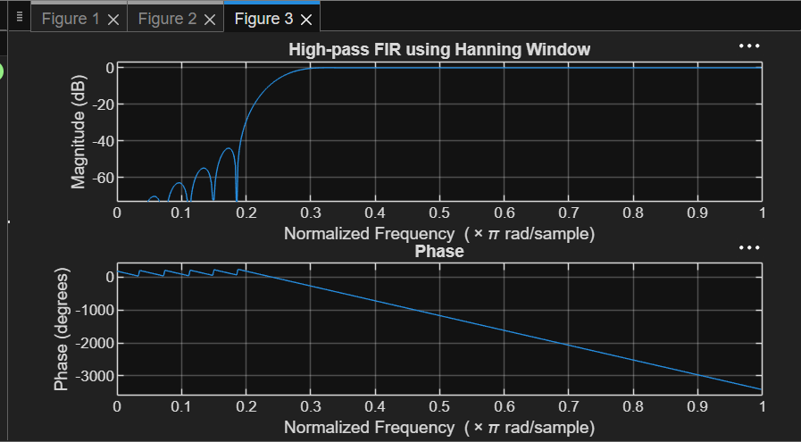

5.2. Generate the coefficients of an FIR High-Pass filter using Hamming windowing
Techniques

Code:
clc; clear; close all;
%% --- Input Parameters ---
fp = 1000; % High-pass cutoff frequency (Hz)
fs = 8000; % Sampling frequency (Hz)
N = 50; % Filter order
wc = fp/(fs/2); % Normalized cutoff (0–1)
%% --- FIR High Pass using Hamming Window ---
b_hamm = fir1(N, wc, 'high', hamming(N+1));

disp('--- High-Pass Coefficients (Hamming Window) ---');
disp(b_hamm');
%% --- Frequency Response Plots ---
figure;
freqz(b_hamm,1);
title('High-pass FIR using Hamming Window');
title('High-pass FIR using Hanning Window');

Output:
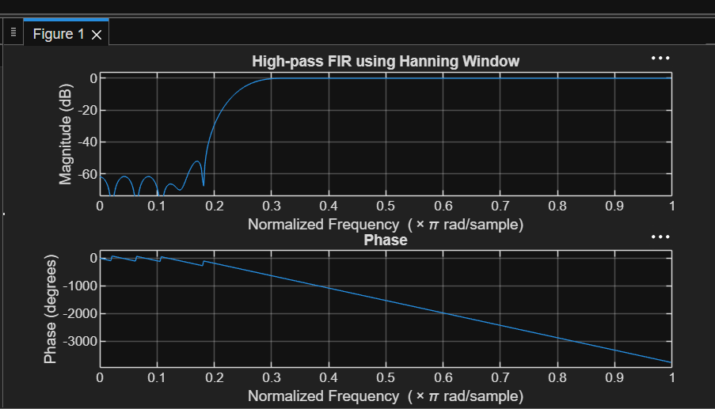

5.3. Generate the coefficients of an FIR High-Pass filter using Hanning windowing
Techniques
Code:
clc; clear; close all;

%% --- Input Parameters ---
fp = 1000; % High-pass cutoff frequency (Hz)
fs = 8000; % Sampling frequency (Hz)
N = 50; % Filter order

wc = fp/(fs/2); % Normalized cutoff (0–1)
%% --- FIR High Pass using Hanning Window ---

b_hann = fir1(N, wc, 'high', hanning(N+1));
disp('--- High-Pass Coefficients (Hanning Window) ---');
disp(b_hann');
%% --- Frequency Response Plots ---
figure;
freqz(b_hann,1);
title('High-pass FIR using Hanning Window');

Output:
