**PIZZA SALES SQL QUERIES**

**1.Calculate total revenue:-**

select sum(total_price) as total_revenue from pizza_sales;

**output:-**

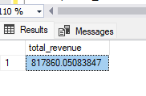

**2.Average order value:-**

SELECT CAST(SUM(total_price) / COUNT(DISTINCT order_id) as decimal(10,2)) AS Avg_order_value FROM pizza_sales;

**output:-**

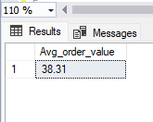

**3.Total pizza sold:-**

SELECT sum(quantity) total_pizza_sales FROM pizza_sales;

**output:-**

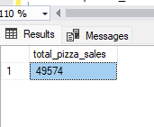

**4.Total orders:-**

SELECT COUNT(distinct order_id) as total_orders FROM pizza_sales;

**output:-**

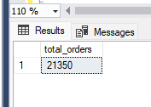

**5.Average pizza per order:-**

SELECT sum(quantity)/COUNT(distinct order_id) as avg_pizza_per_order FROM pizza_sales;

**output:-**

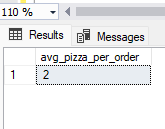

**6.Daily trend for total orders:-**

SELECT DATENAME(WEEKDAY, order_date) AS Day,COUNT(distinct order_id) as total_orders

FROM pizza_sales

group by DATENAME(WEEKDAY, order_date)

order by COUNT(distinct order_id) desc ;

**output:-**

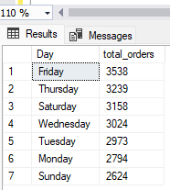

**7.Monthly trend for total orders:-**

SELECT DATENAME(MONTH, order_date) AS MonthName,

COUNT(distinct order_id) AS total_orders

FROM pizza_sales

GROUP BY DATENAME(MONTH, order_date)

ORDER BY COUNT(distinct order_id) DESC;

**output:-**

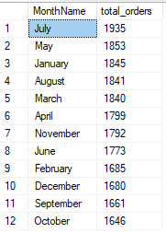

**8.% of sales by pizza category:-**

select pizza_category,cast(sum(total_price) *100 /(select sum(total_price) as total_revenue from pizza_sales ) as decimal(10,2)) as pct from pizza_sales

group by pizza_category

order by pct desc;

**output:-**

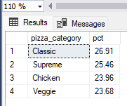

**9.% of sales by pizza size:-**

select pizza_size,cast(sum(total_price) *100 /(select sum(total_price) as total_revenue from pizza_sales ) as decimal(10,2)) as pct from pizza_sales

group by pizza_size

order by pct desc;

**output:-**

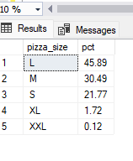

**10.Top 5 best seller pizza by Revenue, Total quantity, Total order:-**

SELECT TOP 5 pizza_name,sum(total_price) as total_rev, sum(quantity) total_pizza_sales, Count(distinct order_id) as total_order

FROM pizza_sales

group by pizza_name

ORDER BY sum(total_price) desc , sum(quantity),Count(distinct order_id) ;

**output:-**

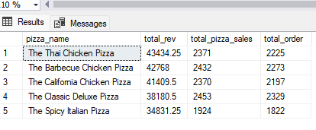

**10.Bottom 5 best seller pizza by Revenue, Total quantity, Total order:-**

SELECT TOP 5 pizza_name,sum(total_price) as total_rev, sum(quantity) total_pizza_sales, Count(distinct order_id) as total_order

FROM pizza_sales

group by pizza_name

ORDER BY sum(total_price) desc , sum(quantity),Count(distinct order_id) ;

**output:-**

