BEE UNIT 3B

Electrostatic fields

Electrostatic fields are electric fields which do not change with time, which happens when charges and currents are stationary.

Electric Flux Density

Electric Flux density is the electric flux(flux lines) passing through a unit area and perpendicular to the direction of the flux.
It is measured in C/m² (Coulomb/meter²).
E=q/(4πε r²)
D= ε E
D=q/(4πr²)

Electric field strength

The force acting on a unit positive charge when placed in an electric field is known as electric field strength.
It is measured in V/m (Volt/meter).

E=V/D

Absolute permittivity
It is the ability of dielectric material to polarize.
It is denoted by ε0.
The permittivity of free space is 8.85x10^-¹² Farads/meter(F/m).

Relative permittivity

The permittivity of a given material relative to the permittivity of free space is called relative permittivity.
It is denoted by εr.

Capacitance

The ability of a material to store electric charges.
It is measured in Farads(F).

q=CV

where, q= charge
C= capacitance
V = voltage

Capacitor

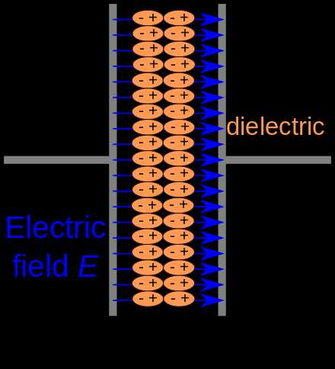
It is a device that stores electrical energy in an electric field. It is a passive electronic component with two terminals.
It consists of two conductor seperated by a dielectric.

C=AK/d
where, C= capacitance
K= dielectric constant
A= area of plates
d= distance between plates

