

Practical File

Delhi Global Institute Technology Maharshi Dayanand University Session(2023-2026)

BCA(6THsem)

Subject- Programming with java

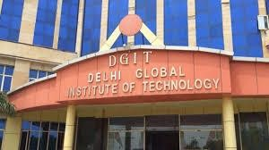

**Submitted to: Submitted by:**

**Vivek Pundir Abhishek Jaiswal**

**(Assistant Professor) 2113081440**