**The Customized Convolutionary Neural Network using Flower Recognition Data Set**

Name- Abhishek Patel (11711954)

Roll no. : 24 Section: KM038 Mob: +91 8630416819

Email: ashu.abhishekpatel@gmail.com

School of Computer Science and Engineering, Lovely Professional University, Punjab 144411, India.

**ABSTRACT:**

The investigation of flower arrangement framework is a significant subject in the field of Botany. A classifier of flowers with high precision will likewise carry a ton of amusing to individuals' lives. Be that as it may, due to the unpredictable foundation of flowers, the comparability between the various types of flowers, and the distinctions among similar types of flowers, there are still a few difficulties in the acknowledgment of flower pictures. The conventional flower grouping is mostly founded on the three highlights: shading, shape and surface, this order expects individuals to choose highlights for characterization, and the exactness/accuracy isn't high. We utilize the exchange learning innovation to hold the flower class datasets, which can incredibly improve the accuracy of flower grouping. It is a hard and a moving crucial recognize various kinds of flowers as they are fundamentally the same as. Indeed, even master botanists and nursery workers can't recognize some of them precisely. Automating flower acknowledgment is puzzling as the flowers are not inflexible articles and their pictures can be influenced by numerous outside impacts. The proposed framework use AI calculations to completely mechanize and build the accuracy of flower classification. AI model will be utilized to remove flower's highlights naturally, measure through various layers of the neural system lastly order the flower class.

INTRODUCTION

Plant species recognition based on flower

identification remain a challenge in Image processing and

Computer Vision community mainly because of their vast

existence, complex structure and unpredictable variety of

classes in nature. Because of these natural complexities, it is

highly undesirable to perform normal segmentation or feature

extraction or combining shape, texture and color features

which results in moderate accuracy on benchmark datasets.

Although some feature extraction techniques combining

global and local feature descriptors reaches state of the art

accuracy in classifying flowers, still there is a need for a

robust and efficient system to automatically identify and

recognize flower species at a larger scale in complex

INTRODUCTION

Plant species recognition based on flower

identification remain a challenge in Image processing and

Computer Vision community mainly because of their vast

existence, complex structure and unpredictable variety of

classes in nature. Because of these natural complexities, it is

highly undesirable to perform normal segmentation or feature

extraction or combining shape, texture and color features

which results in moderate accuracy on benchmark datasets.

Although some feature extraction techniques combining

global and local feature descriptors reaches state of the art

accuracy in classifying flowers, still there is a need for a

robust and efficient system to automatically identify and

recognize flower species at a larger scale in complex

Plant species recognition based on flower

identification remain a challenge in Image processing and

Computer Vision community mainly because of their vast

existence, complex structure and unpredictable variety of

classes in nature. Because of these natural complexities, it is

highly undesirable to perform normal segmentation or feature

extraction or combining shape, texture and color features

which results in moderate accuracy on benchmark datasets.

Although some feature extraction techniques combining

global and local feature descriptors reaches state of the art

accuracy in classifying flowers, still there is a need for a

robust and efficient system to automatically identify and

recognize flower species at a larger scale in comple

**INTRODUCTION:**

Plant species acknowledgment dependent on flower recognizable proof stay a test in Image processing and Computer Vision people group essentially as a result of their immense presence, complex structure and unpredictable variety of classes in nature. In light of these common complexities, it is exceptionally bothersome to perform ordinary segmentation or feature extraction or joining shape, surface and shading features which brings about moderate accuracy on benchmark datasets. Although some component extraction procedures consolidating worldwide and neighborhood highlight descriptors arrives at cutting edge accuracy in grouping flowers, still there is a requirement for a robust and productive framework to consequently distinguish and perceive flower species at a bigger scope in complex condition. Scarcely any analysts proposed a technique to perceive flowers, where two pictures are required, one of the flower and other of the leaf. This technique requires the client to put a dark cloth behind the flower to remember it. This isn't doable and is awkward for the client to utilize this technique in real time scenarios. A technique that joins morphological features, for example, angle proportion, unconventionality, rectangularity and Moving Median Center (MMC) hypersphere classifier. A tale way to deal with perceive and distinguish plants utilizing shape, shading and surface highlights joined with Zernike minutes with Radial Basis Probabilistic Neural Networks (RBPNN). A flower characterization approach dependent on vocabulary of surface, shading and shape highlights was additionally proposed. To precisely perceive flowers in pictures, an analyst proposed a division approach that utilizations shading grouping and space information on flowers. Although various calculations and procedures have been proposed and actualized to perceive flowers and plants, they despite everything appear to be very hard to investigate because of their intricate 3D structure and high intra-class variety.

*Deep Learning using CNN:*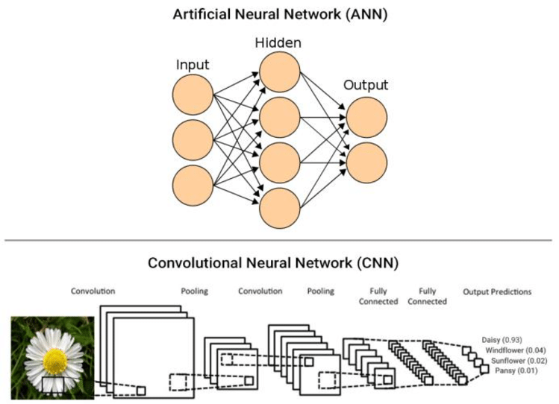

In Deep Learning research, CNNs are specifically applied for Computer Vision applications that involves Image Classification and Object Recognition. Flower Species Recognition is a combination of both Object Recognition and Image Classification, as the system must detect a flower in the image as well as recognize which species it belongs to. To recognize the flower species, an intelligent system must be trained with larger set of images, so that it could predict the flower species from its learned patterns. This approach is termed as “Supervised Learning” which requires an external dataset of images with labels to predict the label of an unseen image. This research work uses Convolutional Neural Networks (CNN) along with Transfer Learning as the intelligent algorithm to efficiently recognize flower species in real-time. The major difference between a traditional Artificial Neural Network (ANN) and CNN is that only the last layer of a CNN is fully connected whereas in ANN, each neuron is connected to every other neurons as shown in the above figure.

CNNs consists of a stack of layers that takes in an input image, perform a mathematical operation (non-linear activation function such as ReLU, tanh) and predicts the class or label probabilities at the output. Instead of using standard handcrafted feature extraction methods, CNNs takes in the raw pixel intensity of the input image as a flattened vector. For example, a [30x30] color image will be passed as a 3-dimensional matrix to the input layer of CNN. CNN automatically learns complex features present in the image using the different layers which has “learnable” filters and combines the results of these filters to predict the class or label probabilities of the input image. Unlike an ANN, the neurons in a CNN layer are not connected to all other neurons, but connected only to a small region of neurons in the previous layer. The first layer might detect the lowest level features such as corners and edges in the image. The next subsequent layers might detect middle level features such as shapes and textures, and finally higher level features such as structure of the plant or flower will be detected by higher layers in the network. This unique technique of building up from lower level features to higher level features in an image is what makes CNNs most useful in many applications. A Convolutional Neural Network (CNN) has three types of layers as follows –

1. Convolutional Layer (CONV)

2. Pooling Layer (POOL)

3. Fully-Connected Layer (FC)

**PROPOSED WORK:**

1-Building the model and import the dataset

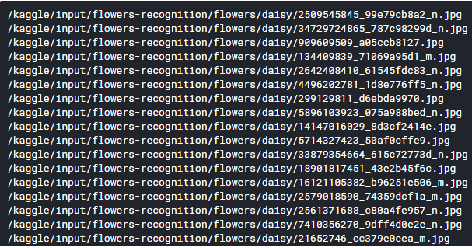

C:\Users\Dillip\Downloads\pro\Capture1.PNG

C:\Users\Dillip\Downloads\pro\Capture2.PNG

C:\Users\Dillip\Downloads\pro\Capture3.PNG

2-Analyzing results:

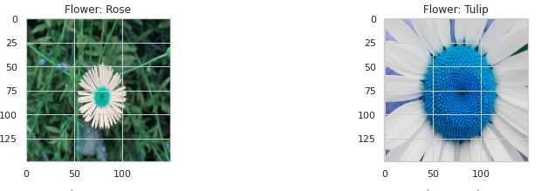

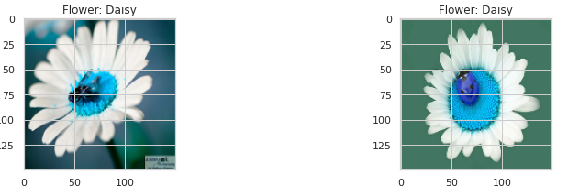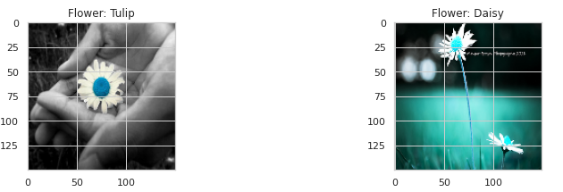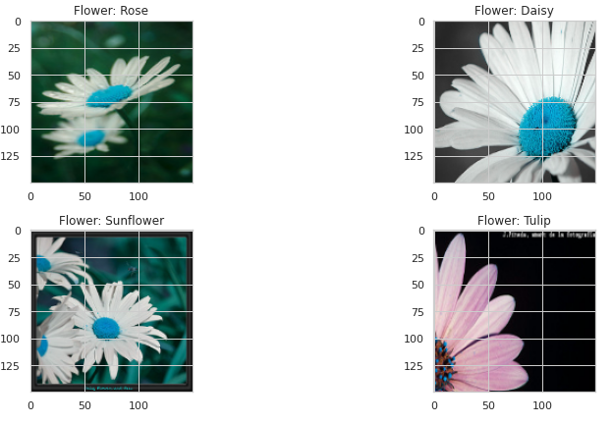

There are few correct and incorrect labels at random. That depends upon the probability whether the labels are correct or incorrect.

3- Improving the model by choosing an appropriate learning rate.

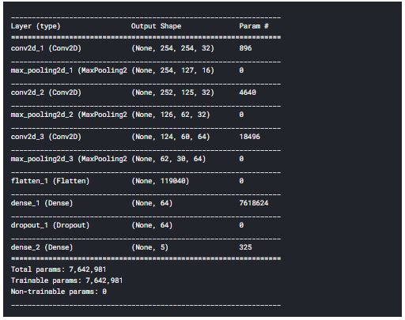

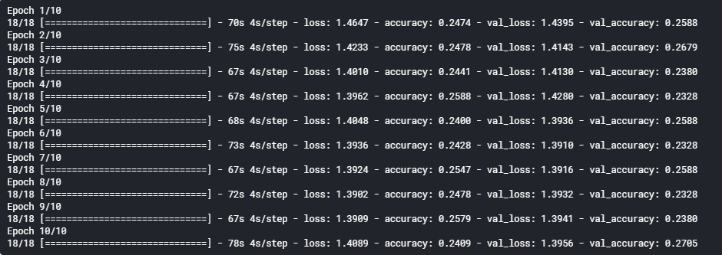

4-Data analysis after fine tuning and learning rate annealing

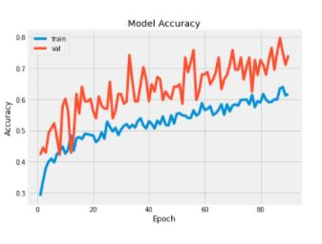

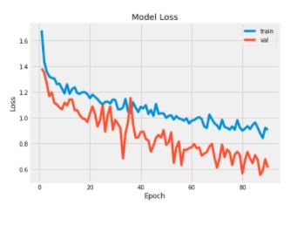

5-The final correctly classified images-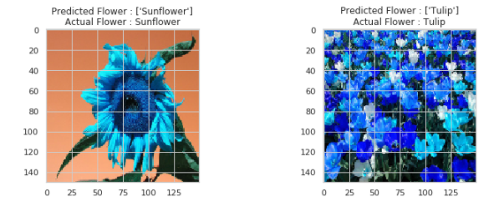

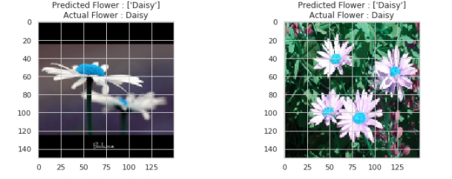

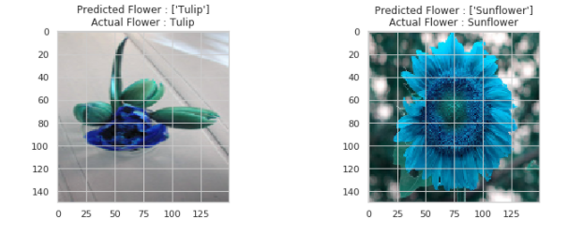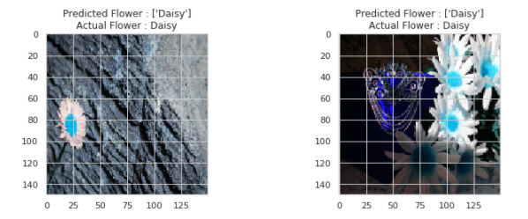

6- Confusion matrices

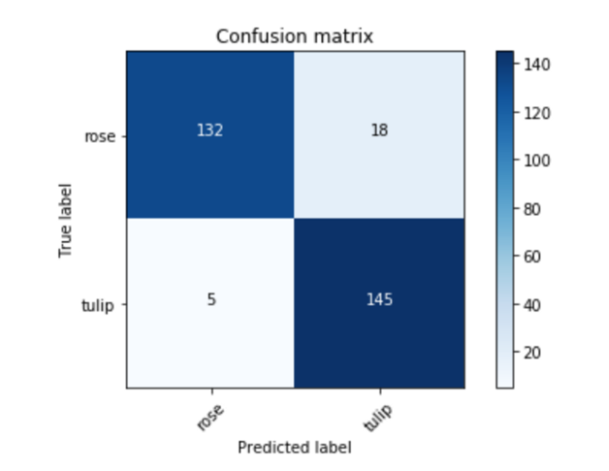

**RESULTS AND DISCUSSION**

Flower Species Recognition: The overall flower species recognition problem is divided into three parts. Firstly, the network is trained using various machine learning classifiers such as Bagging trees, Linear Discriminant Analysis, Gaussian Naïve Bayes, K-Nearest Neighbor, Logistic Regression, Decision Trees, Random Forests and Stochastic Gradient Boosting. Finally, random test images are given to the network for label prediction to evaluate the accuracy of the system. It is observed that the system correctly identifies flower species with a Rank-1 accuracy of 82.32% and Rank-5 accuracy of 97.5% using Logistic Regression as the machine learning classifier on flowers-recognition dataset. The flowers-recognition dataset is split into 1680 training images and 560 testing images. Few demonstrations show the accuracy obtained by training different machine learning classifiers on the CNN extracted features from the training images. It could be noted that bagging trees, logistic regression and random forests achieves a Rank-5 accuracy of 92.14%, 97.5% and 94.82%, respectively.

**CONCLUSION:**

The proposed work is a quicker method to prepare a Convolutional Neural Network (CNN) with a dataset of small size and restricted computational assets, for example, CPU. As there is a great diversity of flower groups far and wide, this framework could without much of a stretch be adjusted via preparing more number of flower species pictures to perceive various species around the globe. In this way, the future work is build a bigger information base with flower pictures, yet additionally with leaves, natural products, bark and so forth., gathered from various sources around various pieces of the world. This framework would likewise be valuable to distinguish plants for therapeutic purposes, for example, in the event of emergency treatment. The client can rapidly take a picture of the plant species and get data about it to choose whether or not it very well may be utilized for emergency treatment. The critical part in building such a framework is the preparation dataset which should be arranged either by physically taking photos of the plants around the city or by utilizing open datasets.

**REFERENCES:**

[1] Saitoh, T.; Kaneko, T., “Automatic recognition of wild Flowers”, Pattern Recognition, Proceedings. 15th International Conference on, vol.2, no., pp.507-510 vol.2, 2000.

[2] Kumar, N., Belhumeur, P.N., Biswas, A., Jacobs, D.W., Kress, W.J., Lopez, I.C., Soares, J.V.B. “Leafsnap: A computer vision system for automatic plant species identification”, European Conference on Computer Vision. pp. 502-516, 2012.

[3] G. Cerutti, V. Antoine, L. Tougne, J. Mille, L. Valet, D. Coquin, and A. Vacavant, “Reves participation-tree species classification using random forests and botanical features”, in Conference and Labs of the Evaluation Forum, 2012.

**Github Link: https://github.com/Abhishek2798/ML-PROJECT-FLOWER-RECG.**

***THANK YOU***