DEPARTMENT OF COMPUTER SCIENCE & ENGINEERING
ABES ENGINEERING COLLEGE, GHAZIABAD
SOFTWARE REQUIREMENTS
SPECIFICATION (SRS)
Project Title: CardioSense AI – Heart Disease Prediction System
Standard Academic Compliance: IEEE Std 830-1998
————————————————————————————
SUBMITTED BY:  1. Abhishek Kumar Yadav (Roll No: 2400321530014)  Degree: Bachelor of Technology (B.Tech)  Academic Year: 2026 - 2027 | UNDER THE GUIDANCE OF:  Aditya Kumar (mentor)  Status: 3rd Year Project Specification  Date of Submission: 01-10-2026

Guidance Note: This Software Requirements Specification document conforms to the IEEE 830-1998 recommended-practice structure. The requirements are tailored to the CardioSense AI heart disease prediction application and are intended for 3rd-year university project evaluation, review, and implementation planning.

1. Introduction
1.1 Purpose
The purpose of this Software Requirements Specification (SRS) document is to provide a complete and unambiguous description of CardioSense AI – Heart Disease Prediction System. The document defines the system scope, data inputs, machine-learning prediction workflow, user interface behavior, external interfaces, performance expectations, security considerations, and academic constraints. The SRS acts as a baseline between the student developer, project guide, evaluators, and intended users. The supplied implementation shows a Python and Streamlit application that loads a trained KNN classifier, a StandardScaler, and the expected feature-column list before accepting patient health parameters and generating a binary risk prediction. The project is therefore specified as a decision-support and educational prediction system rather than a replacement for professional medical diagnosis.
1.2 Scope of the System
The proposed application addresses the problem of providing a simple, interactive machine-learning interface for estimating heart disease risk from routinely available cardiovascular parameters. The supplied project uses a 918-record dataset with 12 original columns and transforms the categorical variables into an encoded feature space before scaling and classification. The Streamlit interface accepts age, biological sex, resting blood pressure, cholesterol, fasting blood sugar, maximum heart rate, ST depression (Oldpeak), chest-pain type, resting ECG, exercise-induced angina, and ST-slope information. The application then returns the predicted class and probability-based confidence values. The system is intended for academic demonstration, preliminary risk stratification, and machine-learning learning purposes.
- In-Scope Capabilities: Patient parameter entry, input validation through bounded widgets and selections, categorical encoding, StandardScaler transformation, KNN model inference, probability display, risk-result presentation, quick preset test cases, and Streamlit-based interactive visualization.
- Out-of-Scope Boundaries: Clinical diagnosis, prescription or treatment decisions, persistent electronic health-record management, hospital information-system integration, direct medical-device control, and storage of identifiable patient records in a production database.
- Expected Benefits: Fast model-based risk estimation, consistent preprocessing of entered parameters, an accessible browser interface, transparent display of the evaluated input categories, and a practical demonstration of an end-to-end machine-learning deployment workflow.
1.3 Definitions, Acronyms, and Abbreviations
Category | Term / Acronym | Definition / Standard Context
Standard | SRS | Software Requirements Specification based on the IEEE Std 830-1998 structure.
Application | CardioSense AI | Streamlit-based heart disease risk prediction application using a trained KNN classifier.
ML | KNN | K-Nearest Neighbors classification algorithm used for the final prediction model.
Preprocessing | StandardScaler | Scikit-learn scaler used to standardize model input features before inference.
Encoding | One-Hot Encoding | Transformation of categorical variables into numerical indicator features.
UI | Streamlit | Python framework used to provide the interactive web application interface.
Target | HeartDisease | Binary target variable where 0 represents no disease and 1 represents disease.
1.4 References
- IEEE Std 830-1998: IEEE Recommended Practice for Software Requirements Specifications.
- Ian Sommerville, Software Engineering, 10th Edition, Pearson Education.
- Project source artifacts: Heart(1).ipynb, Heart_report(1).csv, app(2).py, requirements(1).txt, and serialized model/scaler/feature-column files supplied with the project.
1.5 Document Overview
Section 2 describes the product perspective, user classes, operating environment, implementation constraints, and assumptions. Section 3 specifies the functional requirements for patient input, preprocessing, KNN prediction, results presentation, and application support features. Section 4 defines user, hardware, software, and communication interfaces. Section 5 states measurable non-functional requirements for performance, security, reliability, usability, and portability. Section 6 identifies the academic system-design models applicable to the project, including use-case, data-flow, activity/sequence, and data-preparation representations.
2. Overall Description
2.1 Product Perspective
CardioSense AI is a self-contained machine-learning web application implemented with Python and Streamlit. Its processing flow consists of a presentation layer for patient input, an application layer that converts the entered values into the trained feature schema, a preprocessing stage using StandardScaler, and a prediction stage using the serialized KNN classifier. The application loads the trained assets from local project files and performs inference in the active Streamlit session. The supplied code explicitly states that inferences are processed locally in session memory, and no relational database or external clinical system is required for the current implementation.
[System Context Diagram Placeholder]
Insert here your high-level Context Level Diagram (DFD Level 0) or System Block Architecture showing external entities interacting directly with the central application boundary.

2.2 User Classes and Characteristics
The target software is designed around a small number of user personas appropriate for an academic prediction application:
User Role / Persona | Technical Proficiency | Core Responsibilities & Rights
End User / Student Tester | Basic to Intermediate | Enter health parameters, use presets, execute prediction, and interpret the displayed model result within the project's stated limitations.
Health-Aware Reviewer / Faculty Evaluator | Intermediate | Review input flow, model output presentation, system behavior, and academic compliance during demonstrations.
Project Maintainer | High (Python/ML) | Maintain the Streamlit application, model/scaler/column artifacts, dependency versions, and test cases.
2.3 Operating Environment
The application operates in the following software and hardware environment:
- Client Requirements: A modern web browser such as Google Chrome, Mozilla Firefox, Microsoft Edge, or Safari with a display capable of presenting the responsive Streamlit interface.
- Application Runtime: Python with Streamlit, Pandas, NumPy, and Scikit-learn dependencies. The supplied requirements file lists Streamlit, Pandas, NumPy, and Scikit-learn.
- Model Assets: Serialized KNN model, StandardScaler, and expected feature-column list loaded using joblib/pickle from the application project directory.
2.4 Design and Implementation Constraints
- Academic and Resource Constraint: The solution is designed as a lightweight student project and uses local serialized model assets rather than a separate database or enterprise infrastructure.
- Data and Privacy Constraint: The current application does not persist patient entries to a database; the source code states that inference is processed locally in session memory. Users should therefore avoid entering personally identifiable information.
- Model Constraint: Prediction behavior depends on the trained KNN model, the feature order saved in the expected column list, and the preprocessing pipeline used during training. Changes to these artifacts must be versioned and tested together.
2.5 Assumptions and Dependencies
- Assumptions: Users enter health parameters within the ranges and categories offered by the application and understand that the output is a machine-learning prediction rather than a medical diagnosis.
- Dependencies: Correct availability and compatibility of knn_heart_model.pkl, heart_scaler.pkl, heart_columns.pkl, the Python dependencies listed in requirements.txt, and a Streamlit-compatible runtime.
3. System Features and Functional Requirements
Requirements are categorized by functional subsystem modules with unique requirement identifiers (FR-x.x):
3.1 Module 1: Patient Data Input & Validation
Req ID | Feature Description | Input / Validation Rule | Priority
FR-1.1 | Patient Demographic Capture | Age restricted to 18–100; biological sex selected from Male/Female. | High
FR-1.2 | Hemodynamic & Metabolic Inputs | RestingBP, cholesterol, fasting blood sugar and MaxHR use bounded numeric/select controls. | High
FR-1.3 | Symptoms & ECG Inputs | Chest pain, resting ECG, exercise angina, Oldpeak and ST slope selected/entered from defined project categories. | High
3.2 Module 2: ML Preprocessing & Risk Prediction
Req ID | Feature Description | Input / Validation Rule | Priority
FR-2.1 | Categorical Encoding | Convert sex, chest pain, ECG, angina and ST-slope values to the encoded feature representation expected by the trained model. | High
FR-2.2 | Feature Scaling | Transform the constructed patient feature vector using the serialized StandardScaler before inference. | High
FR-2.3 | KNN Risk Inference | Use the serialized KNN classifier to predict HeartDisease class and obtain class probabilities. | High
3.3 Module 3: Results, Presets & Application Support
Req ID | Feature Description | Input / Validation Rule | Priority
FR-3.1 | Risk Result Display | Display Class 0 or Class 1 with a clear risk message and probability/confidence values. | High
FR-3.2 | Patient Test Presets | Provide Low Risk, Borderline, High Risk and Reset presets for repeatable demonstrations. | Medium
FR-3.3 | Application Health & Asset Handling | Load model assets at startup; show an error and stop safely if required model files cannot be loaded. | High
4. External Interface Requirements
4.1 User Interfaces (UI)
The interface is implemented in Streamlit with a high-contrast healthcare-oriented visual design. The main screen organizes patient information into Demographics & Vitals, Metabolic & Symptoms, and Electrocardiogram (ECG) sections. Input labels, bounded numeric fields, select boxes, contextual badges, preset buttons, and a central prediction action are provided. The result area distinguishes the two model classes and displays a probability/confidence breakdown. The supplied application also uses high-contrast colors and WCAG-oriented styling to improve readability.
[Project UI / Workflow Representation]
Main interface: CardioSense AI header → Demographics & Vitals → Metabolic & Symptoms → ECG → Execute Clinical Risk Evaluation → Class 0 / Class 1 result banner → Diagnostic Confidence Breakdown. The supplied application also provides quick patient presets and reset controls.

4.2 Hardware Interfaces
The system does not require specialized medical hardware. It interacts with standard computer peripherals used to operate a web browser:
- Standard Deployment: Keyboard, mouse, display, and network-capable computer/mobile device are sufficient for entering patient parameters and viewing results.
- Optional External Devices: No direct sensor, ECG machine, wearable, or microcontroller interface is implemented in the supplied version.
4.3 Software Interfaces
- Machine-Learning Interface: Scikit-learn provides KNeighborsClassifier, StandardScaler, model prediction, and probability prediction functionality; joblib/pickle are used to load serialized project assets.
- Application Interface: Streamlit provides the browser-rendered widgets, layout, session state, buttons, status messages, and result display used by the application.
4.4 Communication Interfaces
- Web Communication: When hosted through Streamlit, the application is accessed through a web browser over the hosting platform's network connection. The current inference pipeline itself operates on the application runtime using locally loaded model assets.
- Data Representation: Patient input is converted into a Pandas DataFrame whose columns are aligned to the saved expected feature list before scaling and prediction.
5. Non-Functional Requirements (NFRs)
Attribute | Target Metric / Standard | Verification & Testing Method
5.1 Performance | Prediction request should complete interactively after input submission; model and scaler are loaded once using Streamlit resource caching. | Functional timing test across representative inputs; verify cached resource loading behavior.
5.2 Security & Privacy | No plain-text credentials are used because the current application has no account system; patient inputs are not written to a persistent database in the supplied implementation. | Code review of data flow and session behavior; verify no patient-data file/database write is performed.
5.3 Reliability | Application should fail clearly when model/scaler/column assets are missing or incompatible rather than returning an unverified prediction. | Startup test with missing/corrupt assets and representative prediction test cases.
5.4 Usability & Accessibility | Readable labels, bounded input controls, contextual value indicators, high-contrast styling, and clear result states. | Browser inspection and manual usability review on desktop and responsive viewport.
6. System Design and Analysis Models
The project should be represented using standard academic analysis models that explain both the static structure and dynamic behavior of the prediction workflow:
Diagram Type | Objective & Scope | Deliverable Format
Use Case Diagram | Maps End User, Reviewer, and Project Maintainer interactions with the prediction application. | UML use-case diagram covering input, prediction, result viewing, presets, and maintenance.
Data Flow Diagram (DFD) | Shows flow from patient parameters through encoding and scaling to KNN inference and result display. | Context Level and Level 1 flow diagrams.
Data / Feature Flow | Shows original 12 dataset fields, one-hot encoding, 16-feature model matrix, scaling, and prediction output. | Feature-processing block diagram with labeled transformations.
Activity / Sequence Diagram | Describes the chronological flow from opening the app through input, preprocessing, prediction, probability calculation, and result rendering. | UML activity or sequence diagram including asset-load and error paths.
6.1 Use Case Diagram
The use case model identifies the external roles that interact with CardioSense AI. The End User / Student Tester enters cardiovascular parameters, executes the prediction, views the risk result and can use demonstration presets. The Health-Aware Reviewer / Faculty Evaluator reviews the workflow and displayed results during academic evaluation. The Project Maintainer manages the serialized KNN model, scaler, feature artifacts, dependencies, and test cases. The diagram therefore captures the principal functional interactions without extending the system into clinical diagnosis or persistent patient-record management.
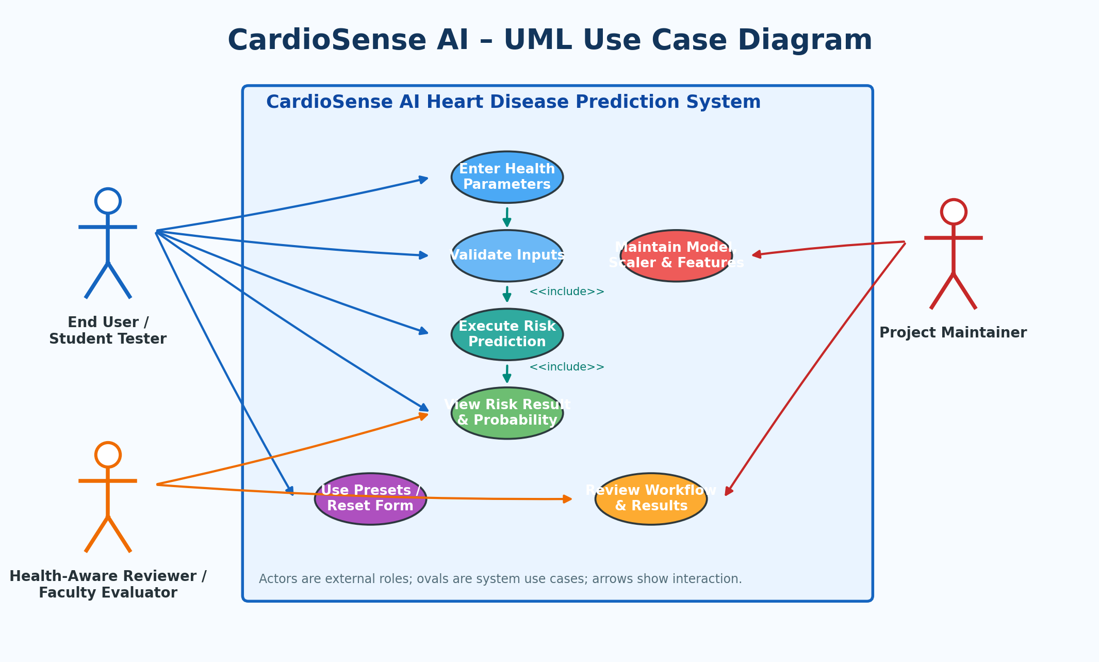
Figure 6.1: Fully Colored UML Use Case Diagram for CardioSense AI
6.2 Sequence Diagram
The sequence model shows the chronological execution of a prediction request. After the application is opened and the model assets are loaded, the user submits health parameters through the Streamlit interface. The validation/encoding stage converts categorical inputs into the feature representation expected by the model, the StandardScaler transforms the feature vector, and the KNN classifier produces the predicted class and probability. The result engine prepares the risk message and the Streamlit interface renders it to the user. The diagram also records the startup asset-error path and the session-local inference behavior described in the SRS.
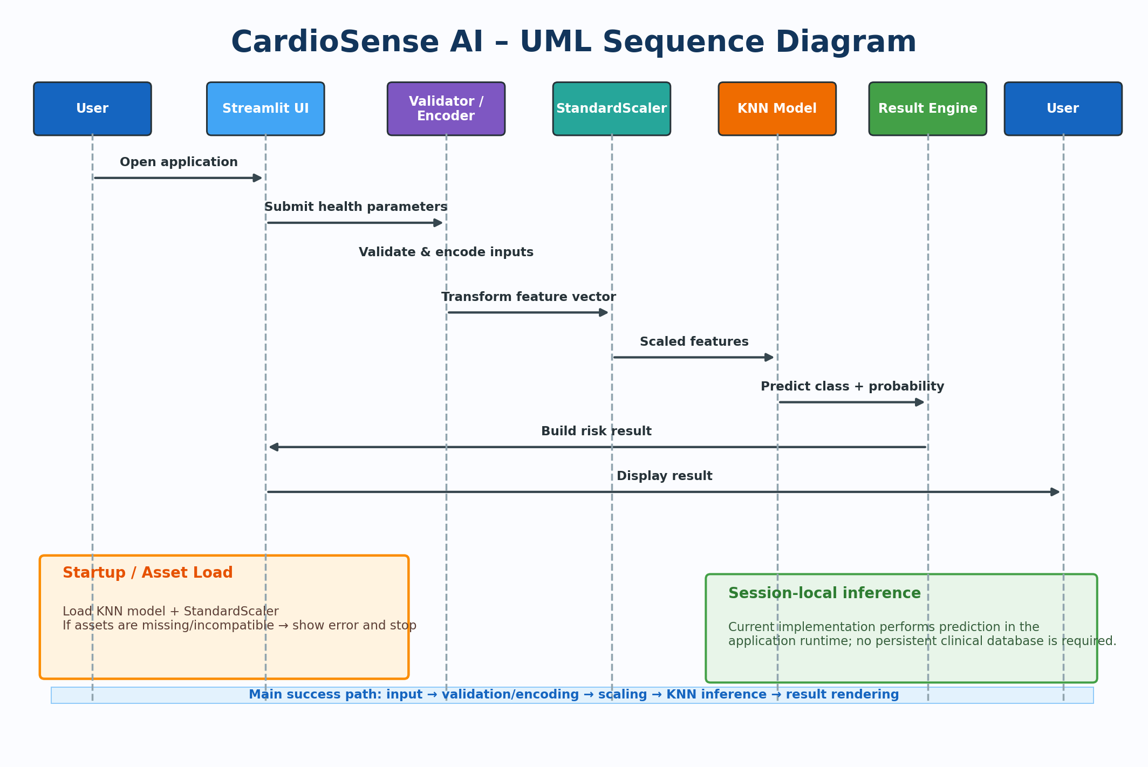
Figure 6.2: Fully Colored UML Sequence Diagram for CardioSense AI
6.3 Interpretation of the Models
Together, the two diagrams provide complementary views of the system. The use case diagram focuses on who interacts with CardioSense AI and what functions are available to each role, while the sequence diagram focuses on when each processing step occurs during a prediction request. Both models are aligned with the documented architecture: Streamlit presentation, input validation and categorical encoding, StandardScaler preprocessing, KNN inference, and result presentation. They also preserve the current project boundaries stated in the SRS, including the absence of persistent clinical-record storage and the restriction of the output to an educational decision-support prediction.
7. Academic Review & Sign-Off
This Software Requirements Specification document has been prepared for academic review and sign-off for the CardioSense AI – Heart Disease Prediction System.
Project Coordinator / Guide | Internal Examiner | Head of Department (HOD)
Signature: __________________  Date: __________________ | Signature: __________________  Date: __________________ | Signature: __________________  Date: __________________

