IoT Data Analytics
EXPERIMENT 1
NAME: ABHISHEK PANDEY SAP: 60019220110
Year: T.Y. BTech - Sem VI Roll No.: B073

Aim: Install and configure a small Hadoop cluster using virtual machines or cloud services
Objective: In this lab, you will set up a small Hadoop cluster using Vagrant + VirtualBox and manage everything inside VS Code.

Create:
1] Master node → `master`
2] Worker nodes → `worker1`, `worker2`
All commands will be executed using VS Code terminals.

Prerequisites (Install Once):
Before starting the lab, install the following software on your system.
1] Install VirtualBox
2] Install Vagrant

Step 1 – Open Project in VS Code
• Extract the ZIP file
• Open the extracted folder in Visual Studio Code
• Verify that the project folder appears in the Explorer panel
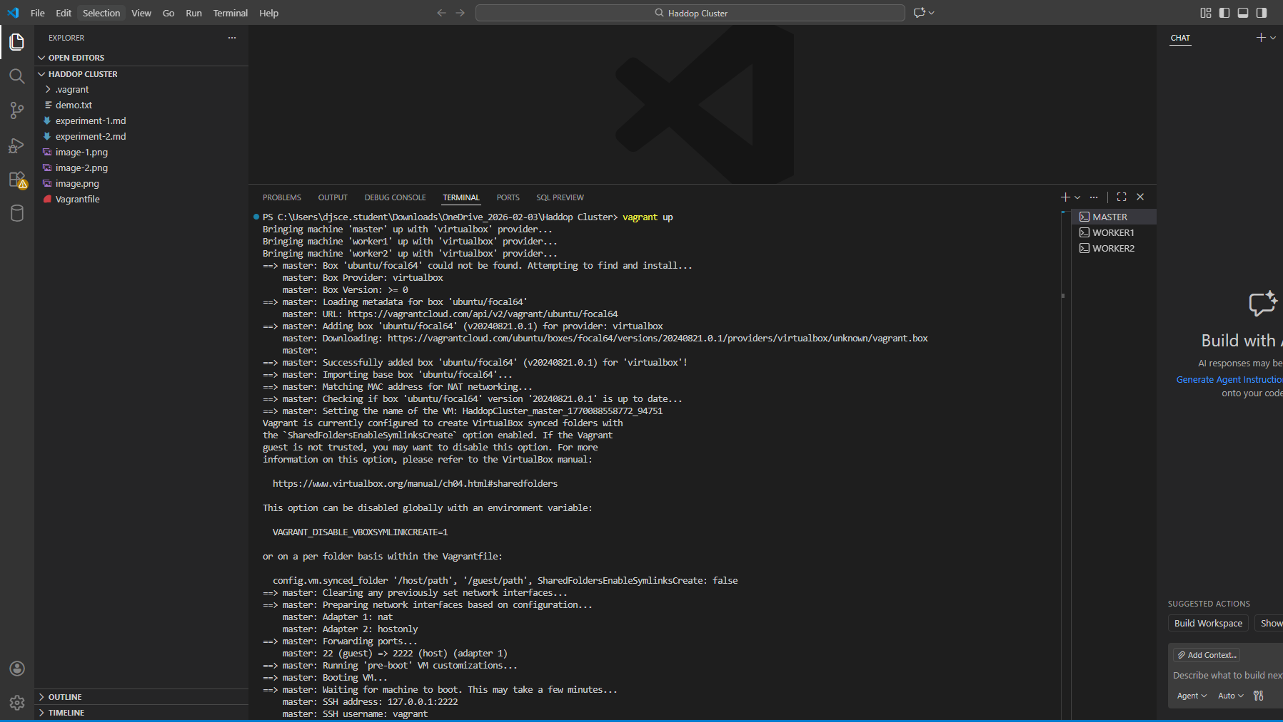
Step 2 – Open Three Terminals in VS Code
• Open three integrated terminals
• Rename the terminals as MASTER, WORKER1, and WORKER2
• Use each terminal to represent one node in the cluster

Step 3 – Start Virtual Machines
• Start all virtual machines from the MASTER terminal
• Wait until the master and worker nodes boot successfully
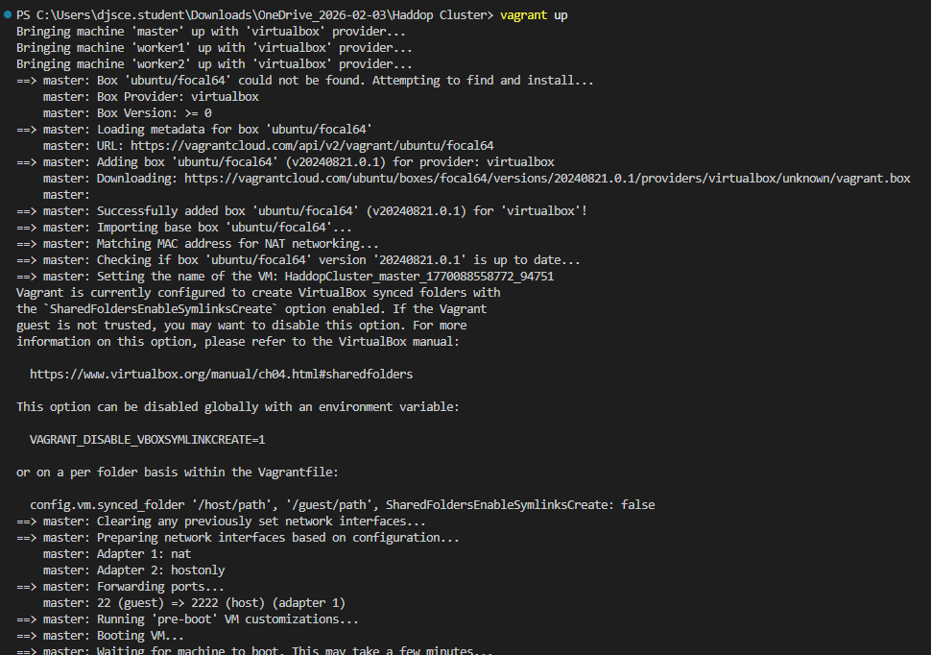

Step 4 – Connect to Each Node
• Connect the MASTER terminal to the master node
• Connect the WORKER1 terminal to the first worker node
• Connect the WORKER2 terminal to the second worker node
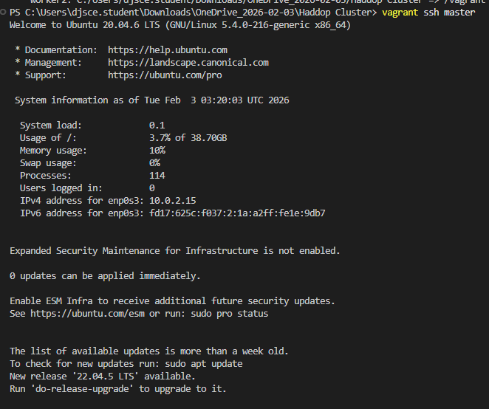
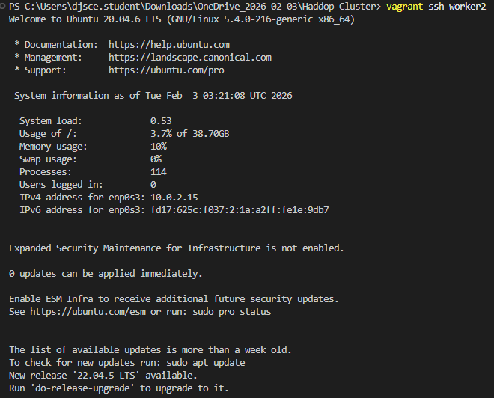

Step 5 – Install Java on All Nodes
• Update the package list on each node
• Install Java Development Kit
• Verify Java installation on master and worker nodes
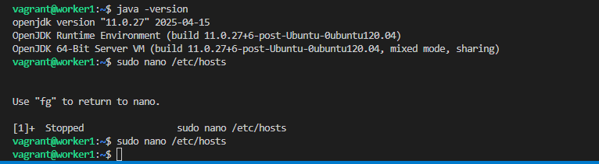
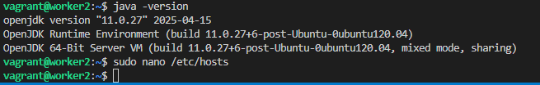
Step 6 – Configure Hostname Resolution
• Edit the hosts file on all nodes
• Map IP addresses to master and worker hostnames
• Ensure all nodes can communicate using hostnames

Step 7 – Install Hadoop on Master Node
• Download Hadoop on the master node
• Extract Hadoop binaries
• Move Hadoop to system directory
• Assign proper ownership permissions
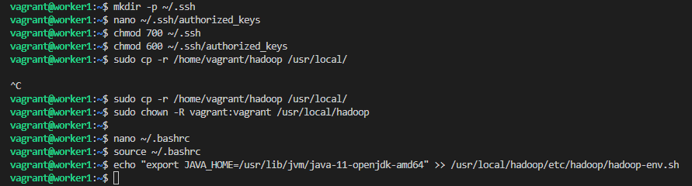

Step 8 – Set Hadoop Environment Variables
• Configure Hadoop and Java environment variables
• Apply environment changes on all nodes
• Ensure Hadoop commands are accessible system-wide

Step 9 – Setup Passwordless SSH
• Generate SSH key on the master node
• Share the public key with worker nodes
• Enable passwordless communication between nodes
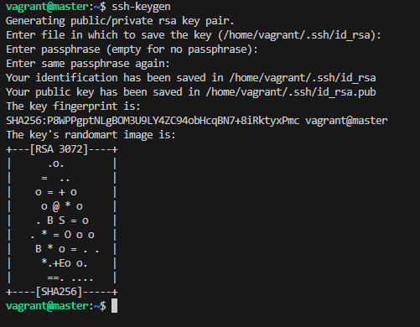

Step 10 – Copy Hadoop to Worker Nodes
• Transfer Hadoop directory from master to workers
• Place Hadoop in the correct system location on workers
• Set appropriate ownership permissions

Step 11 – Configure Hadoop Files
• Configure core site settings for HDFS
• Configure HDFS replication and storage paths
• Define worker nodes in the workers file

Step 12 – Create HDFS Data Directories
• Create required HDFS data directories on worker nodes
• Assign correct permissions to avoid DataNode failures

Step 13 – Synchronize Configuration Files
• Copy updated Hadoop configuration files from master to workers
• Ensure all nodes use identical configuration
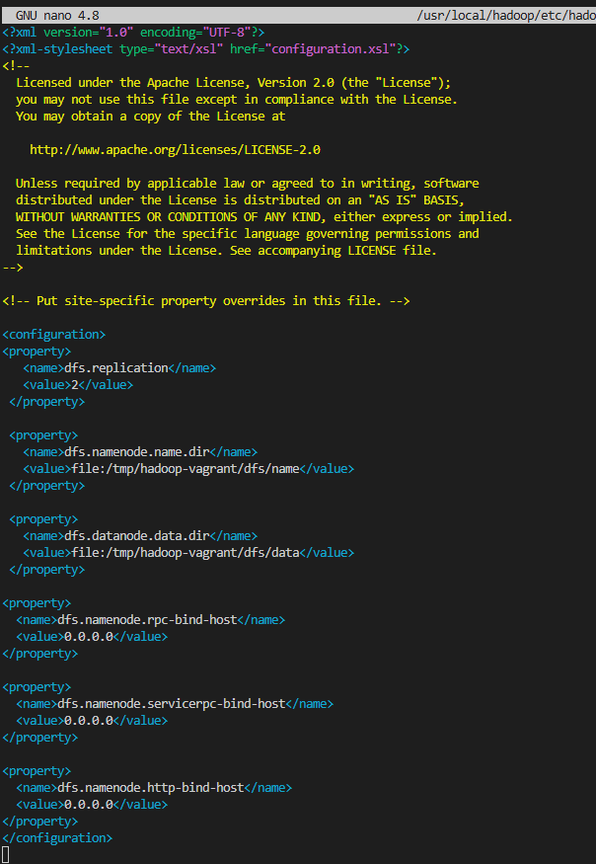

Step 14 – Format and Start Hadoop Cluster
• Format the NameNode
• Start HDFS services
• Start YARN services
• Verify running processes
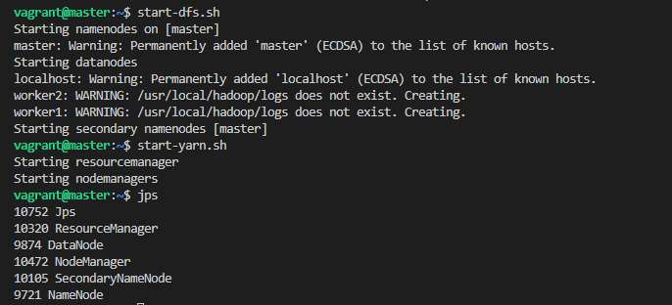

Step 15 – Access Hadoop Web Interfaces
• Open NameNode web interface in the browser
• Open YARN resource manager interface
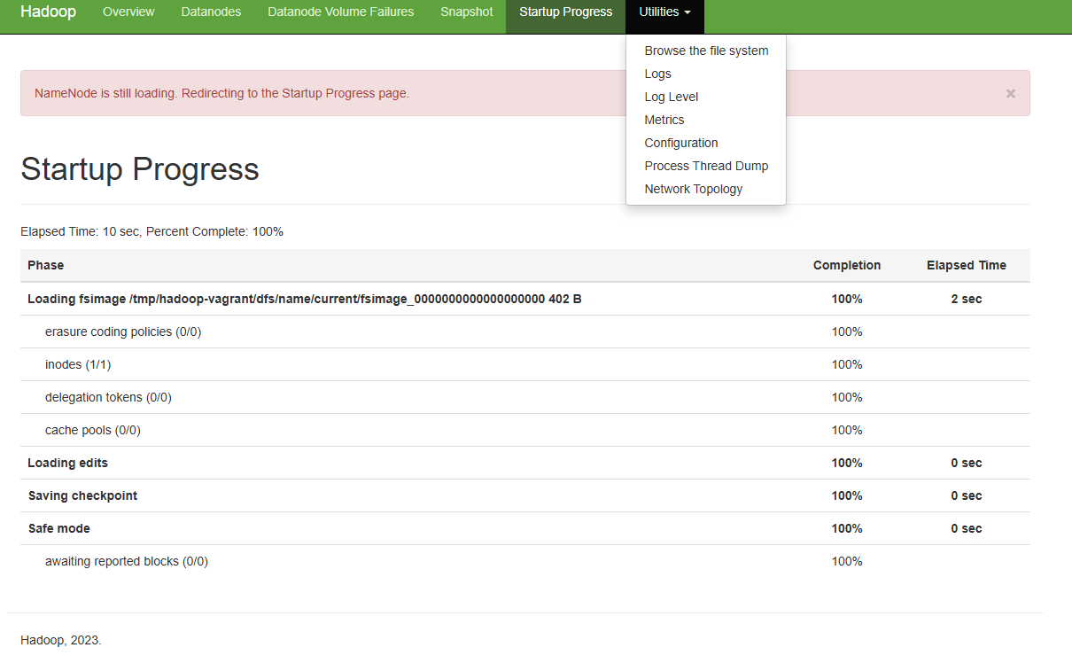
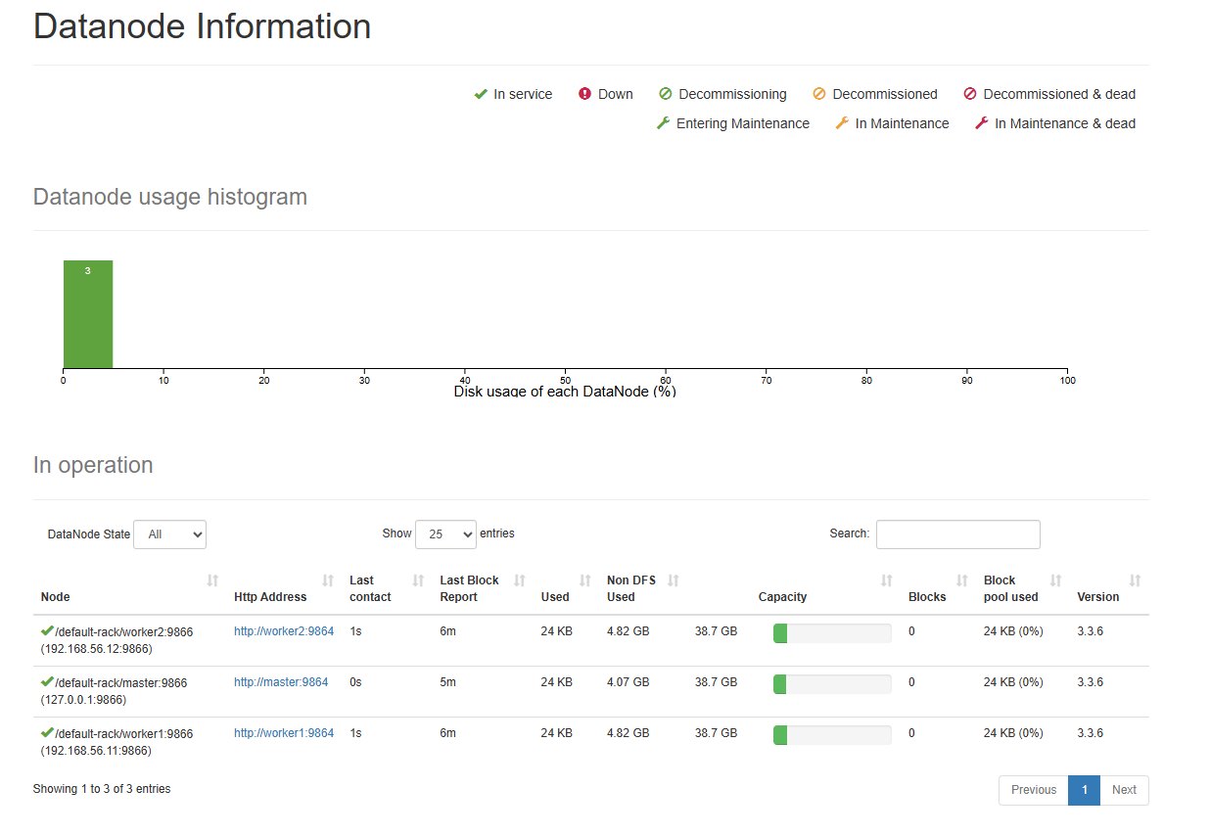
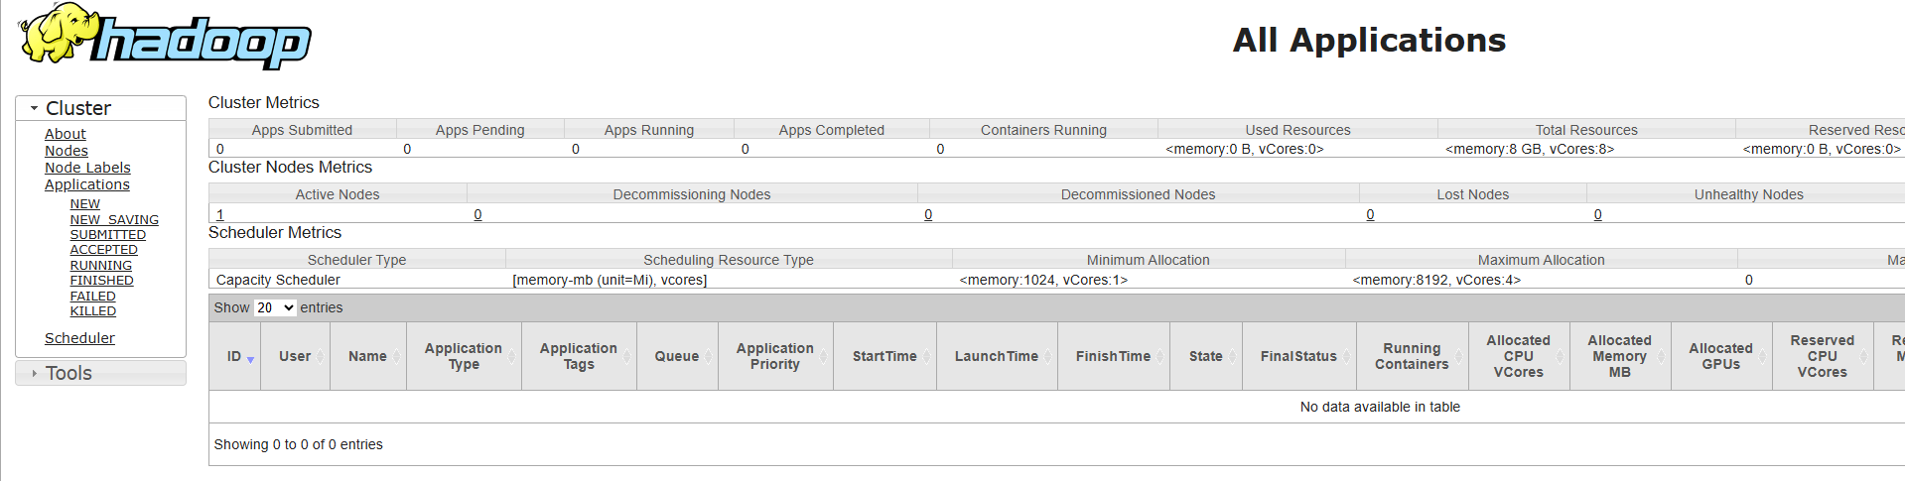
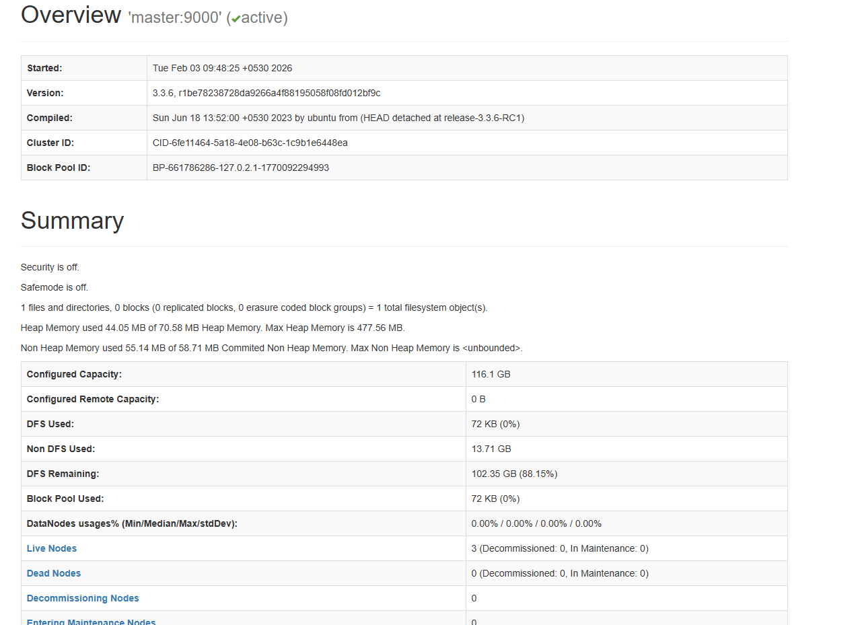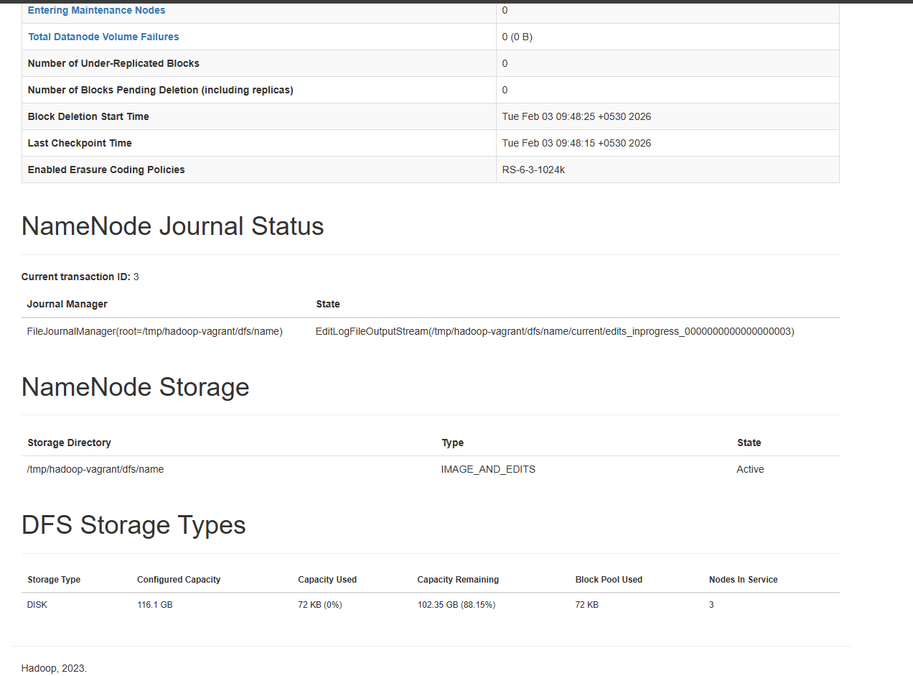

Step 16 – Test Hadoop Cluster
• Upload a test file to HDFS
• List files in HDFS to confirm operation
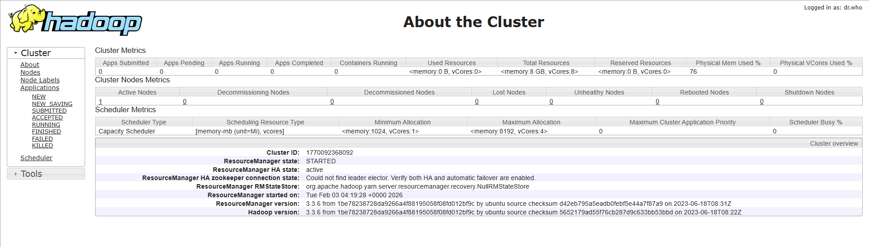
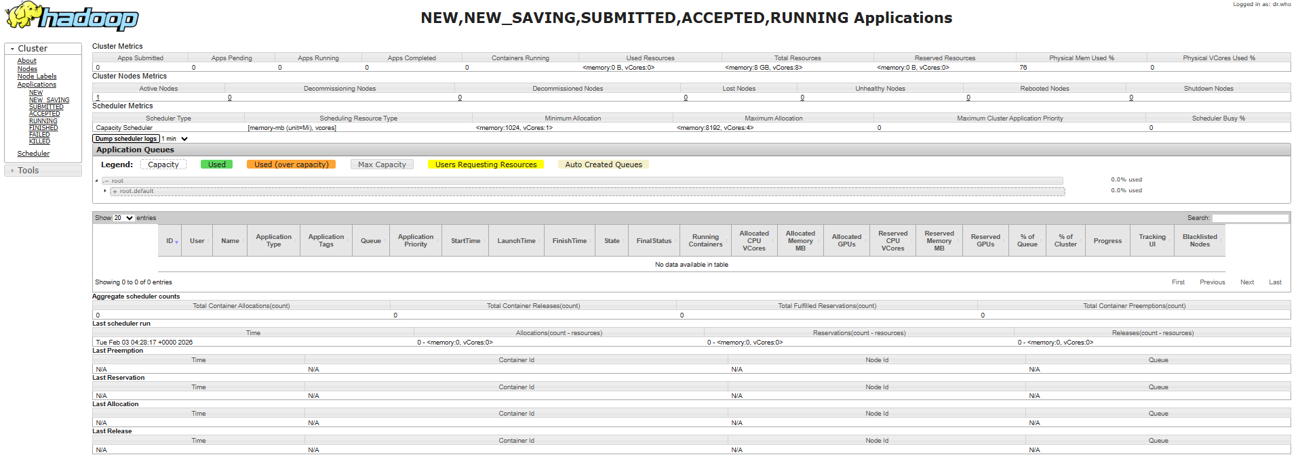
Step 17 – Stop Hadoop Cluster
• Stop YARN services
• Stop HDFS services
• Shut down all virtual machines
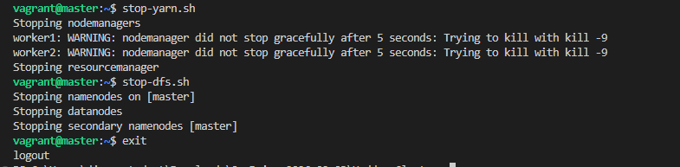
Conclusion: In this experiment, a multi-node Hadoop cluster was successfully configured using virtual machines. The master and worker nodes were integrated to enable distributed storage and processing. The cluster was validated using HDFS and YARN operations, demonstrating the basic working of Hadoop.

