IoT Data Analytics
EXPERIMENT 2
NAME: ABHISHEK PANDEY SAP: 60019220110
Year: T.Y. BTech - Sem VI Roll No.: B073

Aim: To understand and perform basic file management operations in Hadoop Distributed File System (HDFS) including creating directories, uploading files, retrieving files, viewing file contents, and deleting files and directories using Hadoop cluster commands.
Objective: In this experiment, we will learn how to manage files and directories in Hadoop HDFS.
To perform the following operations:
a. Adding files and directories
b. Retrieving files
c. Deleting files and directories
All commands will be executed from the MASTER terminal.

Prerequisites(Master): Make sure you completed experiment 1 and Hadoop cluster is running.
Step 1: Verify Hadoop Cluster Status
- Open the MASTER terminal.
- Check whether Hadoop services are running.
- Ensure NameNode, DataNode, ResourceManager, and NodeManager are active.
- If not running, format the NameNode (only if required) and start DFS and YARN services.
- Confirm that the Hadoop cluster is successfully initialized before proceeding.

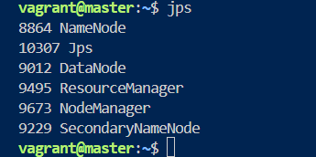
Step 2: Create Directory in HDFS
- Create a new directory inside HDFS.
- Verify that the directory is successfully created by listing the root directory contents.
- Observe that the new directory appears in the HDFS file structure.
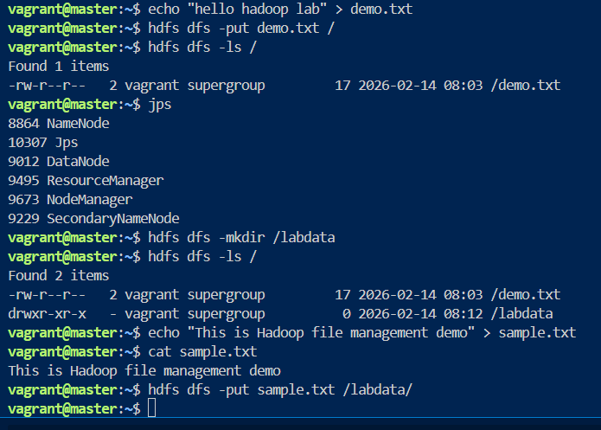
Step 3: Create a File in Local Linux System
- Create a sample text file in the local system.
- Add sample content to the file.
- Verify the file content using display command.
- Ensure the file is properly created before uploading.

Step 4: Upload File to HDFS
- Transfer the locally created file to the newly created HDFS directory.
- Verify upload by listing the contents of that directory in HDFS.
- Confirm that the file now exists inside HDFS storage.

Step 5: Retrieve File from HDFS
- Copy the file from HDFS back to the local system using retrieval operation.
- Verify that the downloaded file exists locally.
- Display its contents to ensure data integrity.

Step 6: View File Directly from HDFS
- Display the content of the file directly from HDFS without downloading it.
- Observe that HDFS allows viewing file contents stored in distributed storage.
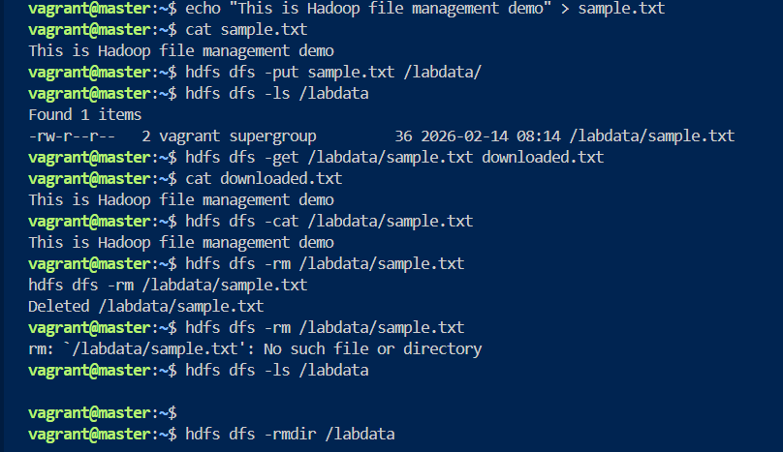
Step 7: Delete File from HDFS
- Remove the uploaded file from the HDFS directory.
- Verify deletion by listing directory contents.
- Confirm that the file no longer exists.

Step 8: Delete Directories in HDFS
- Attempt to delete an empty directory and verify successful removal.
- Create another directory and upload a file into it.
- Try deleting the non-empty directory and observe that it fails.
- Use recursive delete operation to remove the non-empty directory.
- Verify that the directory is completely removed from HDFS.

Step 9: Stop Hadoop Cluster
- Stop YARN and DFS services from MASTER.
- Exit the virtual machine.
- Shutdown the VM properly.

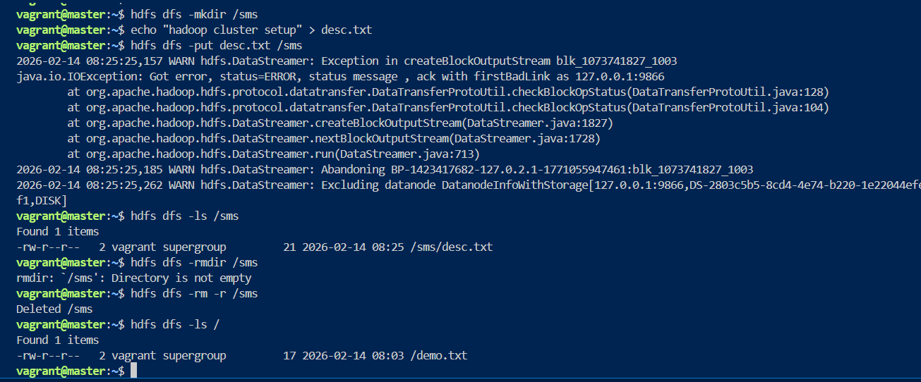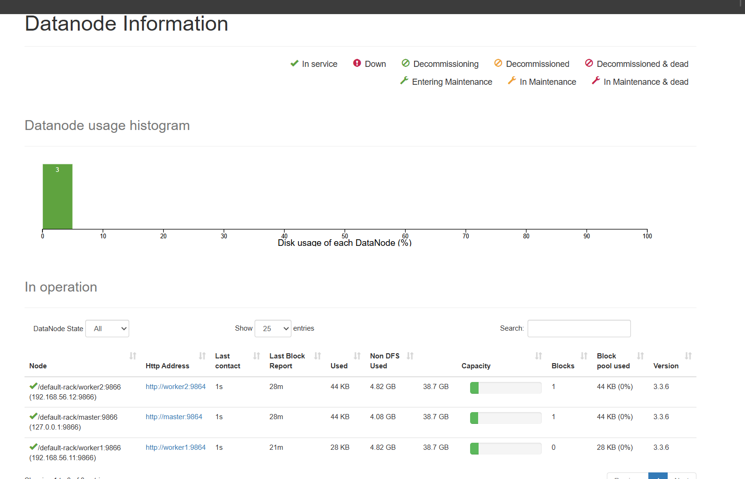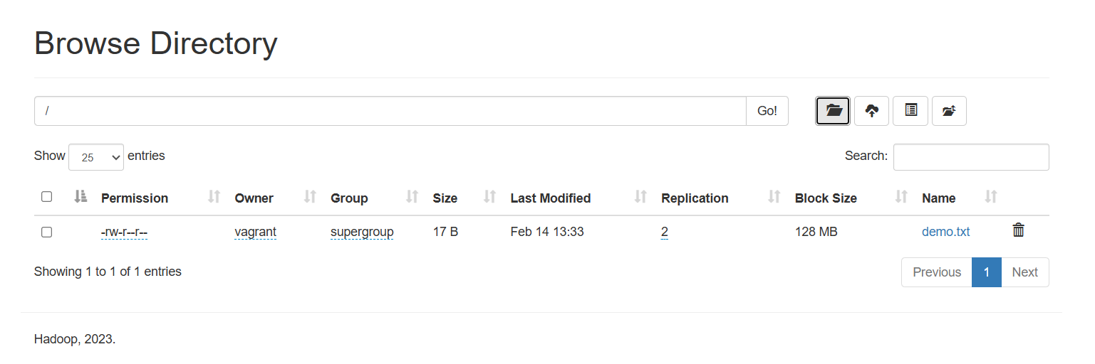

Conclusion: In this experiment, we successfully performed file management operations in the Hadoop Distributed File System. We learned how to create directories, upload and retrieve files, display file contents, and delete both files and directories in HDFS. The experiment helped in understanding how Hadoop manages distributed storage and how users can interact with HDFS using command-line operations. This practical implementation strengthened our knowledge of basic Hadoop file handling commands and cluster management.

