Name: ABHISHEK PANDEY Subject: IoT Data Analytics
Sap Id: 60019220110 Roll no: B073

Experiment 3

Matrix-Vector Multiplication with Hadoop MapReduce
AIM: In this experiment, you will implement Matrix-Vector Multiplication using the Hadoop MapReduce framework.

You will:
1. Write a Java MapReduce program.
2. Prepare input data for a matrix and a vector.
3. Run the program on your Hadoop cluster.
4. Verify the results.

Prerequisites
Start the Hadoop cluster (Master and Workers).

1. Start the Nodes VMs (Master)
vagrant up

2. SSH into the master node (Master)
vagrant ssh master

4. Start the hadoop cluster (Master)
hdfs namenode -format
start-dfs.sh
start-yarn.sh
jps
Expected Output: NameNode, ResourceManager, etc.

Step 1 – Prepare Input Data (MASTER)
Create the matrix and vector files on the Master node local filesystem.

1. Create Matrix File (matrix.txt)
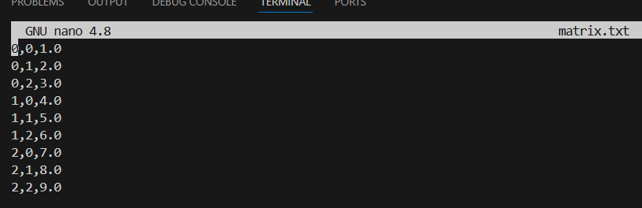

2. Create Vector File (vector.txt)
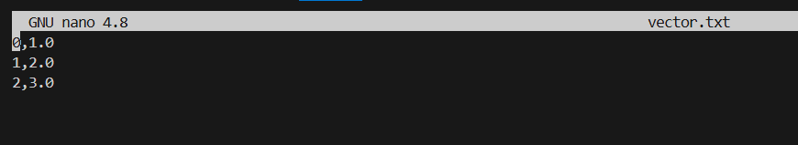

Step 2 – Upload Data to HDFS
Execute the following commands to create a directory and upload your files:
hdfs dfs -mkdir /experiment3
hdfs dfs -put matrix.txt /experiment3/
hdfs dfs -put vector.txt /experiment3/

Step 3 – Create and Compile Java Code (MASTER)

1. Create Java file
nano MatrixVectorMultiplication.java

2. Java Code
Paste the following code into the file:

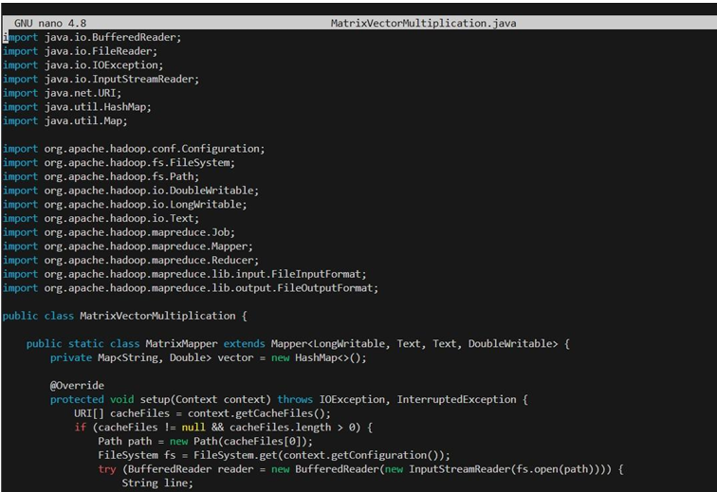

3. Compile the code
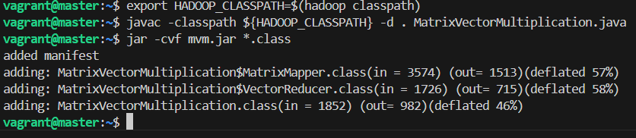

Step 4 – Run MapReduce Job
Execute the job using the jar file created in the previous step:
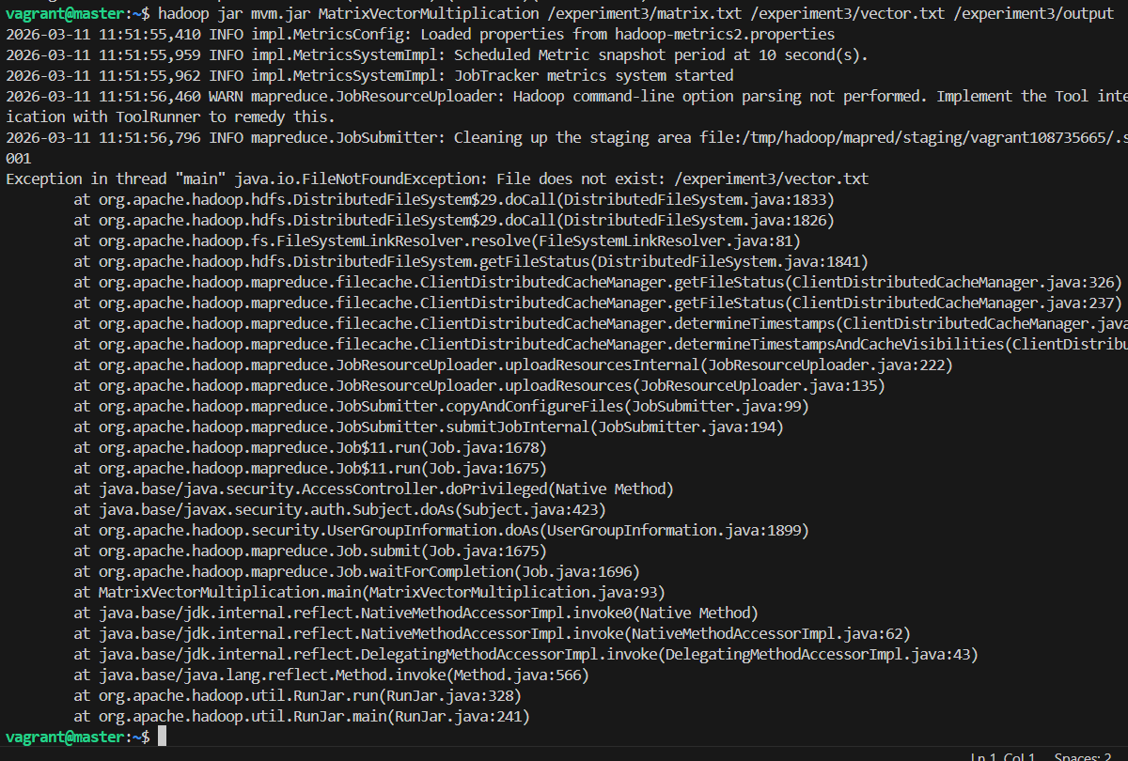

Step 5 – Verify Results
Check the output generated in HDFS:
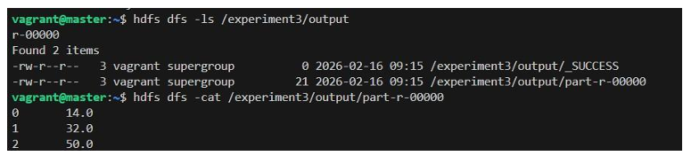

Stop the Cluster
stop-yarn.sh
stop-dfs.sh
exit

Shutdown the VMs
vagrant halt

CONCLUSION:
MapReduce efficiently processed the computation in parallel, demonstrating Hadoop’s capability for large-scale matrix operations.

