Name: ABHISHEK PANDEY Sap Id: 60019220110
Course: IoT Data Analytics Sem: VI

EXP 4

NoSQL Database Operations Using MongoDB
_Create, Insert, Update, Delete using Vagrant Virtual Machine_

1. Aim
To create a virtual machine using Vagrant, install MongoDB, and perform NoSQL database operations such as create, insert, update, and delete data.

2. Objectives
After completing this experiment, the student will be able to:

- Understand NoSQL databases
- Create a virtual machine using Vagrant
- Install MongoDB on Ubuntu
- Create databases and collections
- Perform CRUD operations in MongoDB

3. Software & Hardware Requirements

Software
Component | Details
Virtualization | Oracle VirtualBox
VM Manager | Vagrant
OS | Ubuntu 22.04
Database | MongoDB
Interface | Terminal / Command Prompt

Hardware
- Minimum 8 GB RAM (4 GB also works)
- Active internet connection

4. Theory
MongoDB is a NoSQL document-based database. It stores data in JSON-like documents instead of tables and rows. It is flexible, scalable, and suitable for modern applications. Unlike traditional relational databases, MongoDB does not require a fixed schema, making it ideal for dynamic and rapidly evolving data structures.

Vagrant is a tool for building and managing virtual machine environments in a single workflow. It creates a Vagrantfile that describes the type of machine required and how to configure and provision it. This ensures every student works in an identical, reproducible environment regardless of their host machine.

CRUD stands for Create, Read, Update, and Delete — the four basic operations performed on any database.

5. Experiment Procedure

Step 1: Create Virtual Machine Using Vagrant
What we are doing: We set up an isolated Ubuntu virtual machine using Vagrant so that MongoDB can be installed in a clean, controlled environment without affecting the host system.

1. Open the Project Directory in VS Code
Open VS Code and navigate to or create a folder for this experiment (e.g., IDA-EXP-10).

2. Open an Integrated Terminal
In VS Code, go to Terminal → New Terminal to open a terminal inside the project folder.

3. Create the Vagrantfile
Create a file named Vagrantfile in the project folder with the following content. This file tells Vagrant to use Ubuntu 22.04 and allocate 2 GB RAM and 2 CPU cores to the VM.

4. Start the Virtual Machine
This command downloads the Ubuntu box (first time only) and boots the virtual machine.

vagrant up
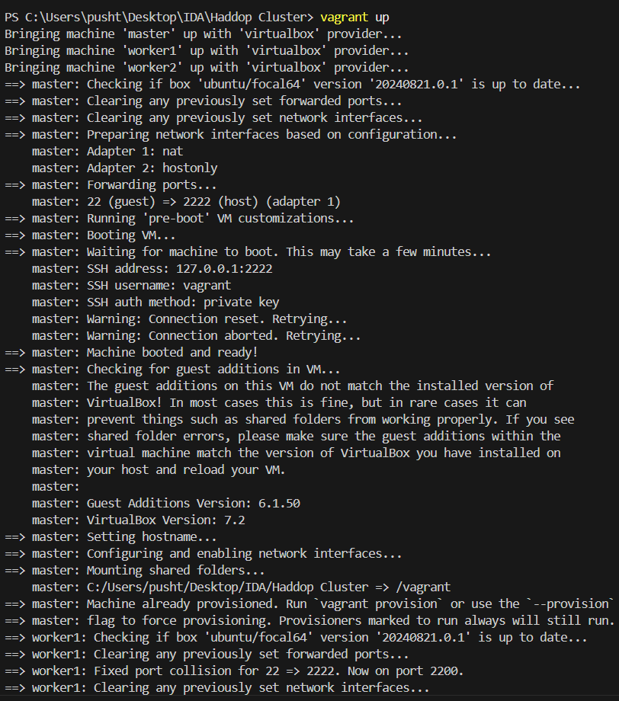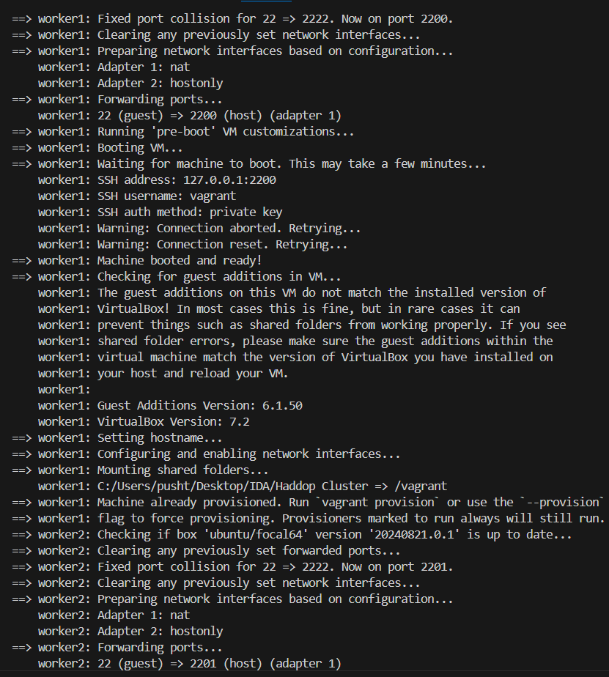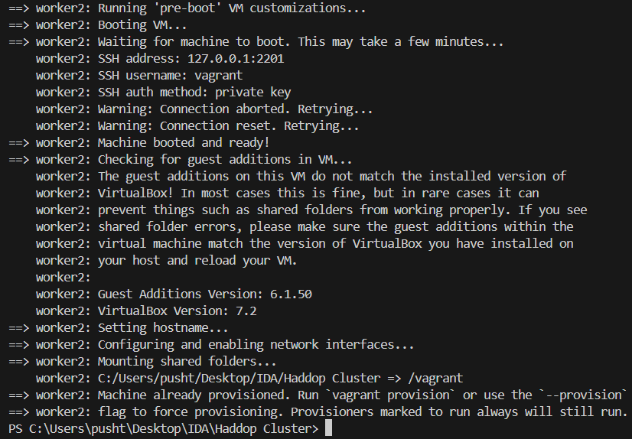
Vagrant will print boot progress messages. Once done, the VM is running in the background inside VirtualBox.

5. Login to the VM
SSH into the running virtual machine. This gives you a terminal session inside Ubuntu.

vagrant ssh
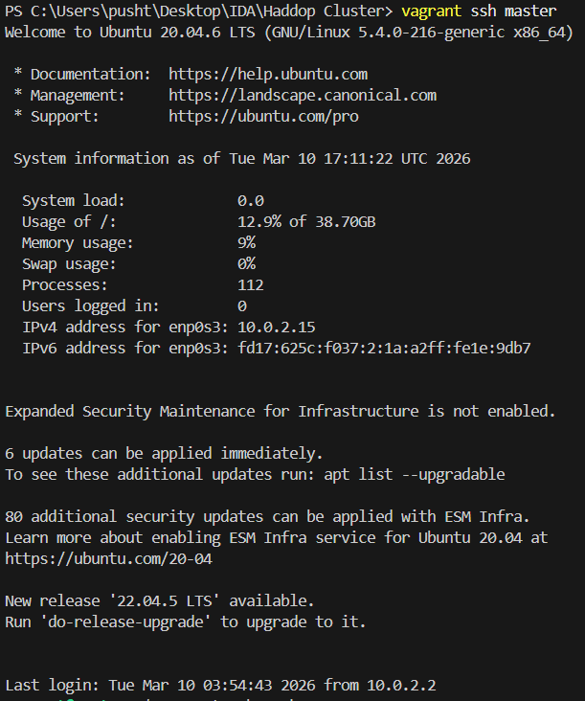
output: Welcome to Ubuntu 22.04 LTS ...
vagrant@ubuntu-focal:~$You are now inside the Ubuntu virtual machine. All further commands run inside this VM.

Step 2: Install MongoDB on Ubuntu VM
**What we are doing:** We add MongoDB's official package repository to Ubuntu and install it. Using the official repository ensures we get a stable, supported version of MongoDB.

1. Import MongoDB GPG Key
This downloads and stores MongoDB's cryptographic key, which Ubuntu uses to verify that packages come from a trusted source.
**Expected:** No output means success. The key file is saved silently.

2. Add MongoDB Repository
This registers the official MongoDB repository so apt knows where to download MongoDB from.
**Expected:** The command echoes the repository line back to the terminal, confirming it was written.

3. Update Package List
Refresh Ubuntu's package index so it includes the newly added MongoDB repository.
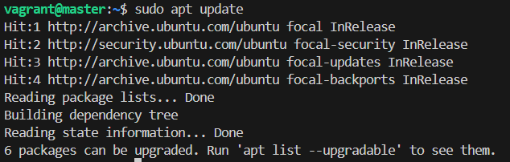
**Expected:** A list of package sources being fetched, ending with `Reading package lists... Done`.

4. Install MongoDB
Download and install the MongoDB server and shell packages. 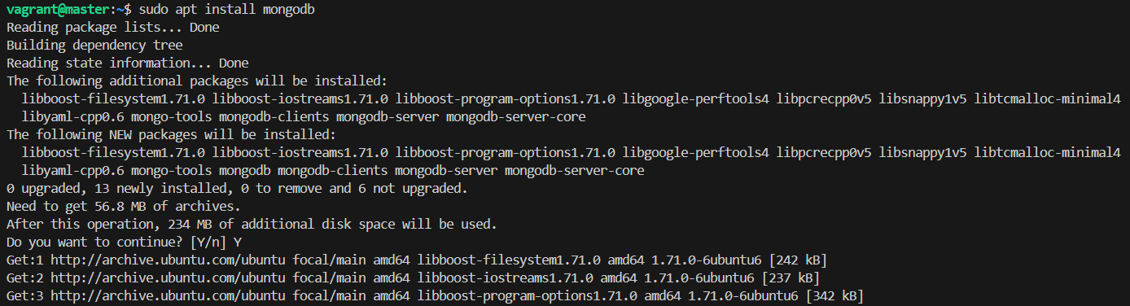
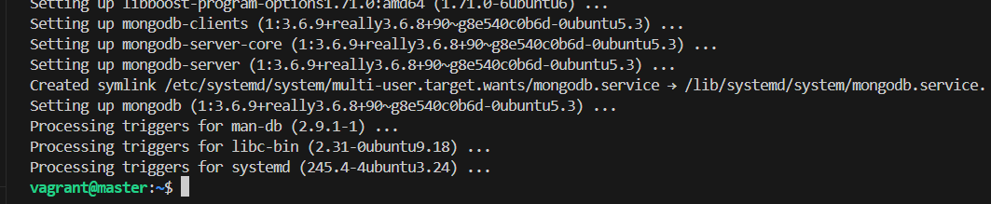

**Expected:** Ubuntu will list what will be installed and ask for confirmation. Type `Y` and press Enter. Installation completes with `Processing triggers...`.

5. Start MongoDB Service
Start the MongoDB background service (called mongod — the MongoDB daemon).
**Expected:** No output means the service started successfully.

6. Enable MongoDB on Boot
Configure MongoDB to start automatically every time the VM boots up.
**Expected:**Created symlink /etc/systemd/system/... → .../mongodb.service

7. Check MongoDB Status
Verify that the MongoDB service is running correctly.
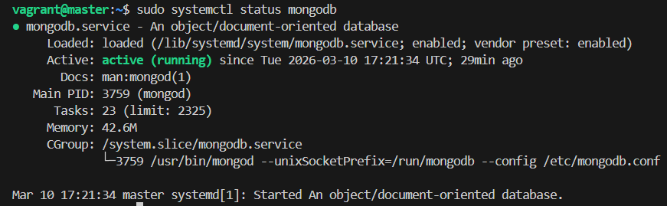
**Expected:** The output should show `Active: active (running)` in green, confirming MongoDB is live.

8. Verify Installation
Run a quick connection test to confirm MongoDB is accepting connections and responding correctly.
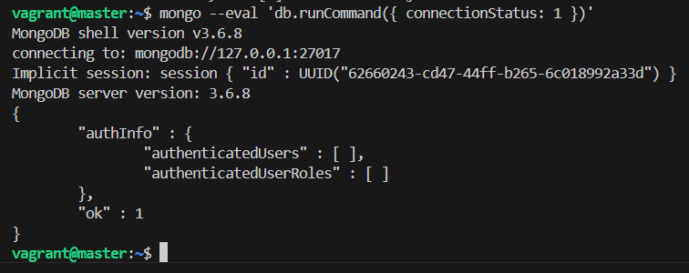

Step 3: Start MongoDB Shell
**What we are doing:** We open the interactive MongoDB shell where we can type database commands directly.
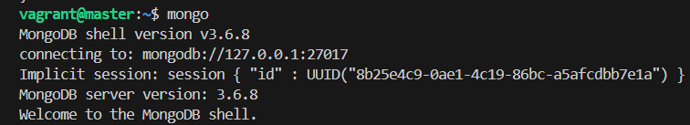

Step 4: Create Database and Collection
**What we are doing:** We create a new database called `companyDB` and inside it, a collection called `employees`. In MongoDB, a **collection** is like a table in SQL, and a **document** is like a row.

1. Create / Switch Database
Switch to (or create) the companyDB database. MongoDB will create this database automatically when the first document is inserted.

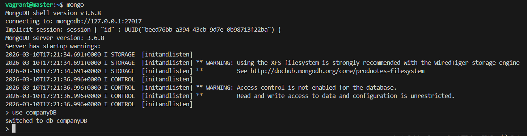

2. Create a Collection
Explicitly create a collection named employees inside companyDB.
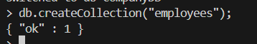

3. Verify Collection
Query the collection to confirm it exists. Since no data has been inserted yet, this returns an empty result.

Step 5: CRUD Operations

A. Create — Insert Data
**What we are doing:** We add employee records into the `employees` collection. `insertOne()` adds a single document; `insertMany()` adds multiple documents at once.

Insert one document:
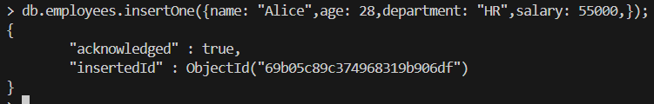

Insert multiple documents:
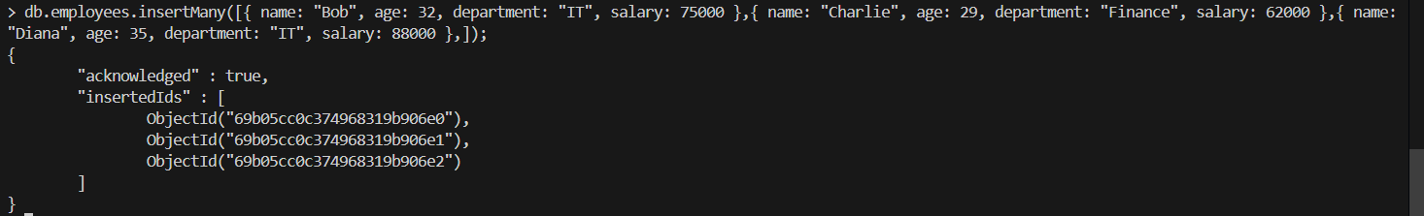

B. Read — Retrieve Data
**What we are doing:** We query the collection to retrieve documents. MongoDB's `find()` method works like `SELECT` in SQL and supports filtering and field projection.

Display all records:
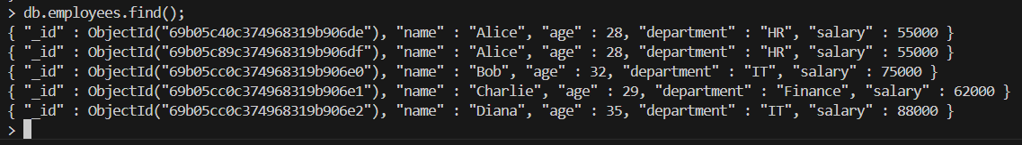

Filter records — IT department only:

Display selected fields only (Projection):
The second argument { name: 1, salary: 1, _id: 0 } tells MongoDB to return only name and salary, and suppress the _id field.

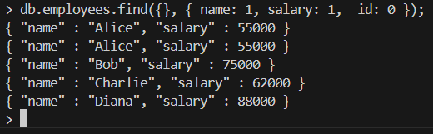

C. Update Data
**What we are doing:** We modify existing documents. `updateOne()` changes the first matching document; `updateMany()` changes all matching documents. `$set\text{‘}replacesafieldvalue;\text{‘}$inc` increments a numeric field by a given amount.

Update single document — change Alice's salary:
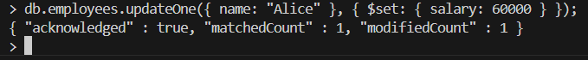

Update multiple documents — give all IT employees a ₹5000 raise:

D. Delete Data
**What we are doing:** We remove documents from the collection. `deleteOne()` removes the first matching document; `deleteMany()` removes all matching documents.

Delete one document — remove Charlie:
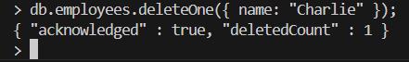

Delete multiple documents — remove all Finance employees:
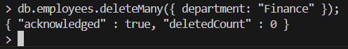
Charlie was the only Finance employee and was already deleted in the previous step, so no documents remain to delete.

Step 6: Exit MongoDB and VM
**What we are doing:** We cleanly close the MongoDB shell, log out of the VM, and shut it down to free up system resources.

Exit MongoDB shell:
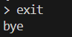
Exit VM:
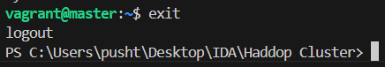

Stop the VM:
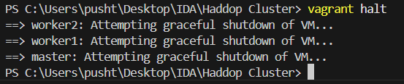

6. Result
The MongoDB NoSQL database was successfully installed on a Vagrant-based Ubuntu virtual machine. All four CRUD operations were performed and verified on the employees collection in the companyDB database:

Operation | Command Used | Outcome
Create | insertOne/Many() | 4 employee documents inserted
Read | find() | Records retrieved with filters
Update | updateOne/Many() | Salaries updated using $set/$inc
Delete | deleteOne/Many() | Documents removed by filter

7. Conclusion
MongoDB provides a flexible schema and fast data access compared to traditional relational databases. Using Vagrant ensures a consistent and repeatable lab environment for all students, eliminating configuration differences across machines. This experiment demonstrated the complete lifecycle of NoSQL database operations — from setting up the virtual environment and installing MongoDB, to performing all four CRUD operations on a real dataset and verifying each result through expected outputs.

