Name: ABHISHEK PANDEY Subject: IoT Data Analytics
Sap Id: 60019220110 Roll no: B073

Experiment 5

Install and Run Apache Pig to Write Pig Latin Scripts

1. Aim
To install Apache Pig on a Hadoop cluster, run Pig in MapReduce mode, and write Pig Latin scripts to perform data operations such as filtering, sorting, grouping, joining, and projection.

2. Objectives
After completing this experiment, the student will be able to:

- Install Apache Pig on a Vagrant-based Hadoop cluster
- Understand Pig Latin syntax and structure
- Run Pig in Local Mode and MapReduce Mode
- Write Pig Latin scripts to sort, group, join, project, and filter data
- Execute Pig script files on a Hadoop cluster

3. Software & Hardware Requirements

Software
Component | Details
OS | Ubuntu (Vagrant VM)
Framework | Hadoop (from Experiment 1)
Tool | Apache Pig 0.17.0
VM Manager | Vagrant + VirtualBox
Shell | Bash / Pig Grunt Shell

Hardware
- Minimum 8 GB RAM
- Active internet connection

4. Theory

What is Apache Pig?
Apache Pig is a high-level data processing platform built on top of Hadoop. It allows developers to write complex data transformations using a simple scripting language called Pig Latin, instead of writing verbose Java MapReduce programs.

Pig automatically compiles Pig Latin scripts into MapReduce jobs and executes them on the Hadoop cluster. This makes big data processing significantly easier and faster to develop.

Pig Latin vs MapReduce
Feature | MapReduce (Java) | Apache Pig (Pig Latin)
Language | Java | Pig Latin (scripting)
Lines of Code | 100s of lines | 10–20 lines
Ease of Use | Complex | Simple and readable
Execution | Compiled Java | Auto-converted to MR jobs
Best For | Custom low-level logic | Data transformation tasks

Pig Execution Modes
Mode | Description
Local Mode | Runs on local filesystem, no Hadoop needed
MapReduce | Runs on Hadoop cluster using HDFS and YARN

5. Prerequisites
Before starting this experiment, ensure:

- Your Vagrant Hadoop cluster is running (from Experiment 1)
- Hadoop services (HDFS + YARN) are started

Start the Cluster (Master)
SSH into the master node:

vagrant up
vagrant ssh master

Start Hadoop services:

hdfs namenode -format

start-dfs.sh
start-yarn.sh
jps

Verify all services are running:
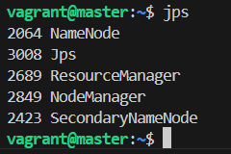

All four services must be present before proceeding.

6. Experiment Procedure

Step 1: Install Apache Pig on Master Node
**What we are doing:** We download Apache Pig, extract it, and move it to a standard system directory so it can be used from anywhere on the machine.
1. Download Apache Pig

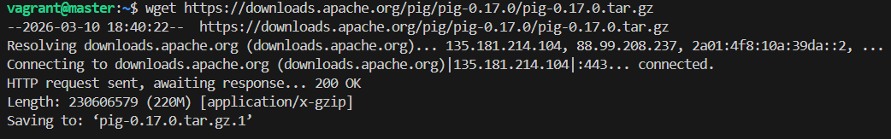

2. Extract the Archive
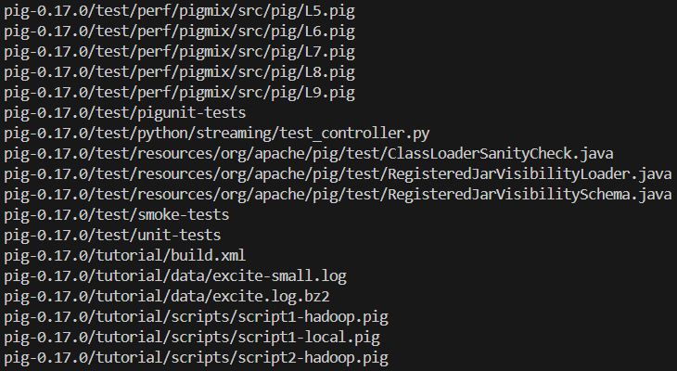

3. Move to System Directory

Step 2: Set Environment Variables
**What we are doing:** We tell the system where Pig is installed (`PIG_HOME`) and add it to the `PATH` so the `pig` command works from any directory.

Edit .bashrc
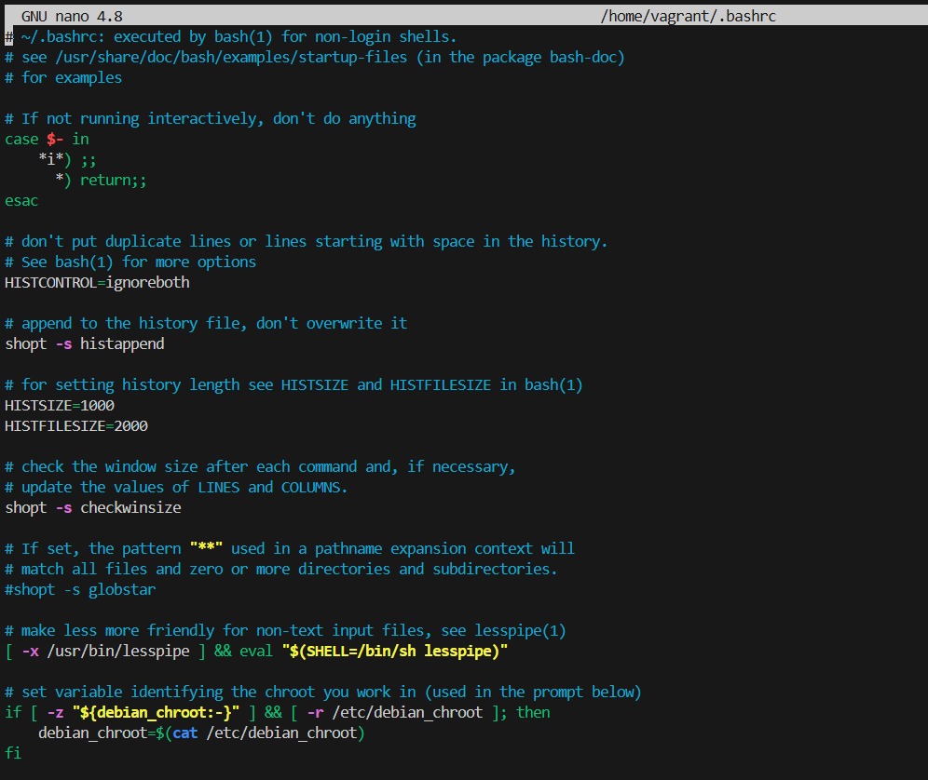

2. Add the Following Lines at the End
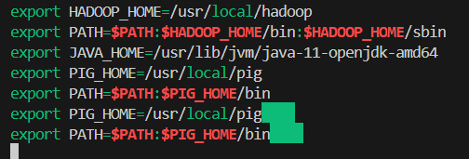

3. Apply the Changes

4. Verify Installation
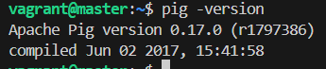

Step 3: Create Sample Dataset
**What we are doing:** We create a CSV text file containing student records and upload it to HDFS so Pig can read it during MapReduce execution.

1. Create the Dataset File
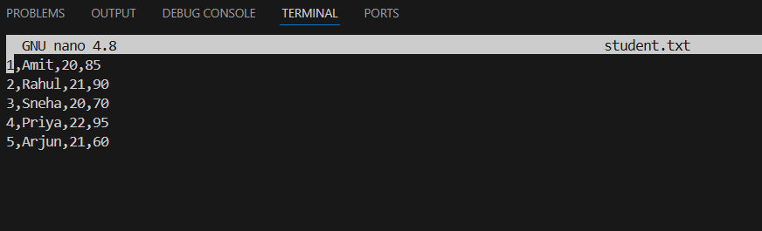

2. Upload to HDFS
Create a directory in HDFS and upload the file:
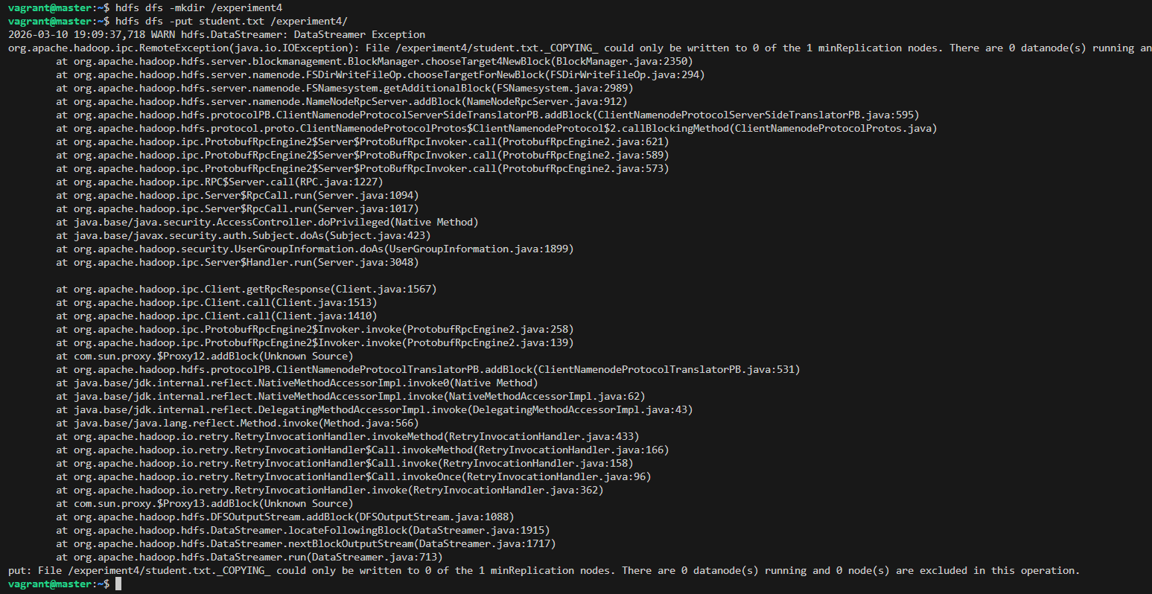

3. Verify Upload

Step 4: Start Pig in MapReduce Mode
What we are doing: We launch the interactive Pig shell (Grunt) in MapReduce mode so that our scripts run on the Hadoop cluster.
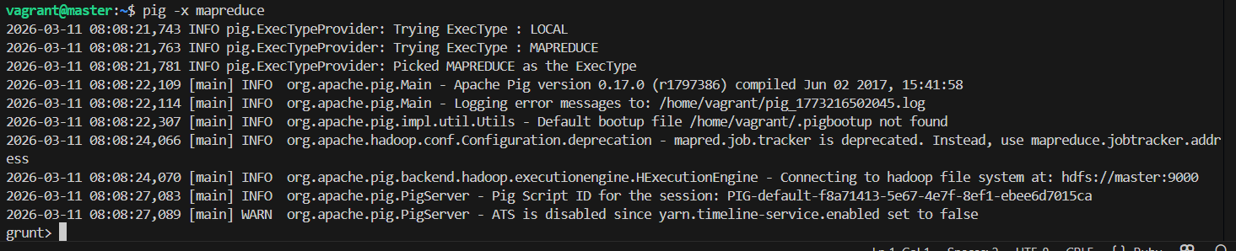

Step 5: Pig Latin Operations

Operation 1: LOAD Data
What we are doing: We load the student dataset from HDFS into a Pig relation (like a table). We define the schema — field names and their data types — so Pig knows how to interpret each column.
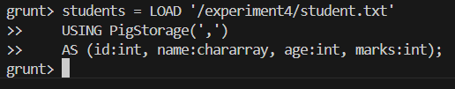
Note: `PigStorage(',')` tells Pig the file is comma-separated. `char array` is Pig's string type. No output is shown — Pig uses lazy evaluation and only processes data when `DUMP` or `STORE` is called.

Operation 2: FILTER Data
What we are doing: We retrieve only the records that satisfy a condition — similar to `WHERE` in SQL. Here we filter students who scored more than 80 marks.

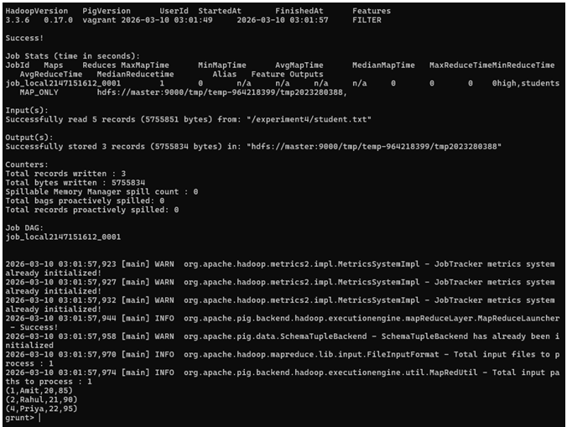

Operation 3: PROJECT Columns
What we are doing: We select only specific fields from each record — similar to `SELECT name, marks FROM ...` in SQL. This is called projection.
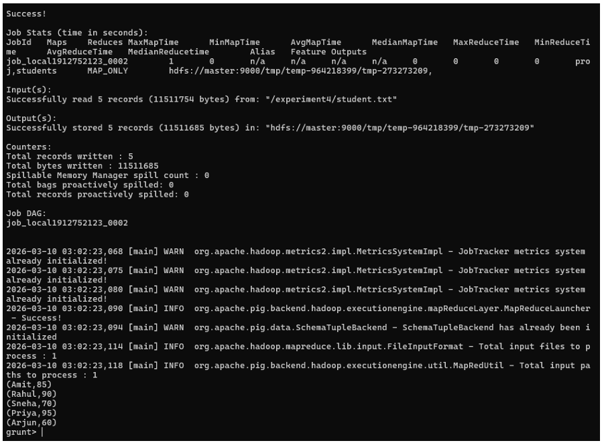

Operation 4: SORT Data
What we are doing: We sort the student records by marks in descending order — similar to `ORDER BY marks DESC` in SQL.
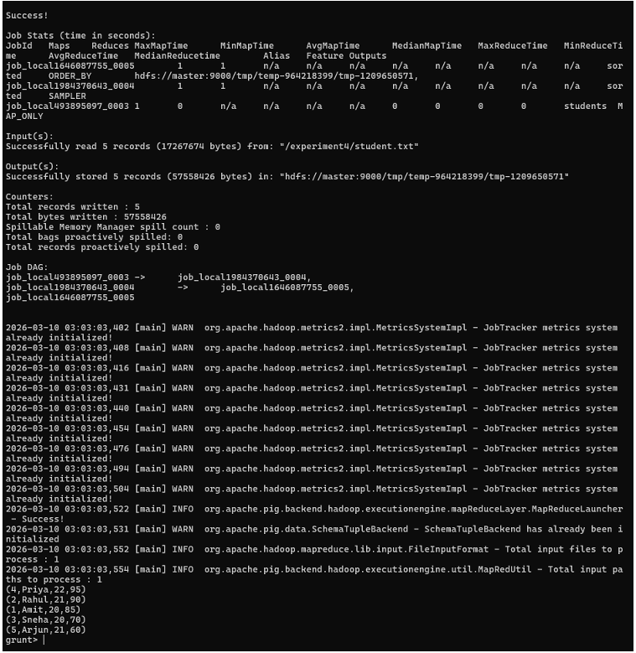

Operation 5: GROUP Data
**What we are doing:** We group records that share the same value in a field — similar to `GROUP BY` in SQL. Then we use `AVG()` to compute the average marks for each age group.

Group by age:
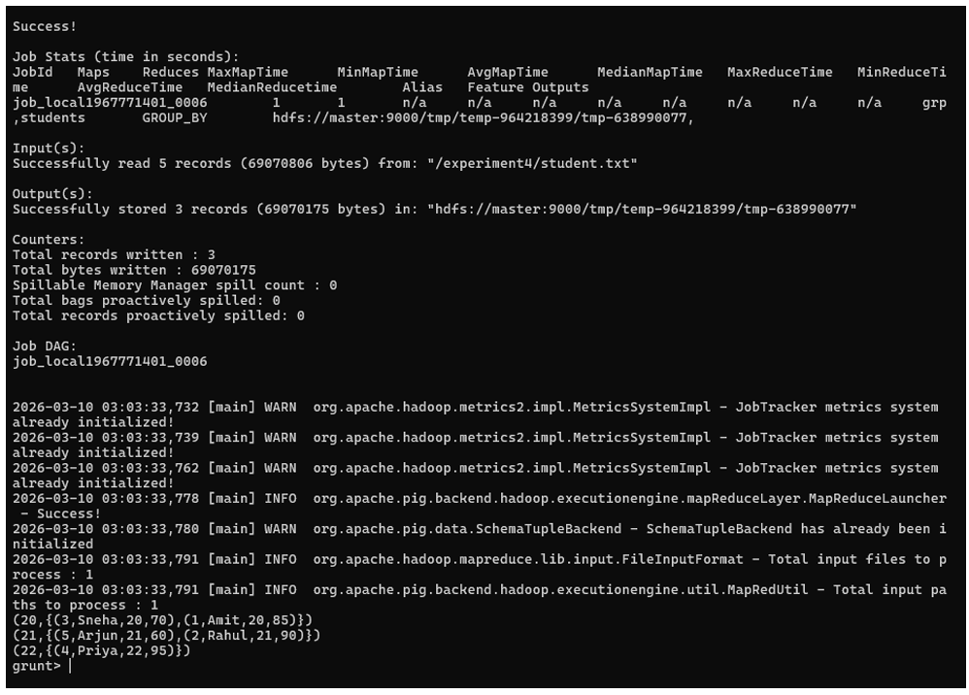

Calculate average marks per age group:
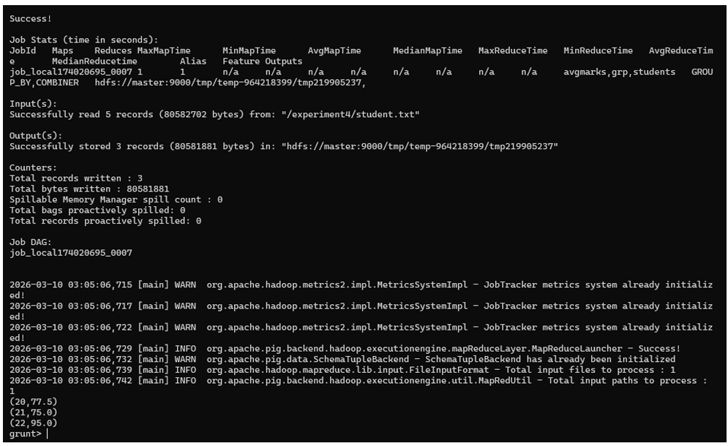

Operation 6: JOIN Datasets
**What we are doing:** We combine two datasets based on a common field (`id`) — similar to `INNER JOIN` in SQL. First, we create a department dataset and join it with the student dataset.

Exit Pig shell temporarily:
quit

Create the department file:
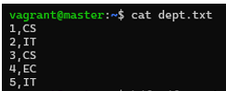

Upload to HDFS:
Restart Pig and perform the JOIN:
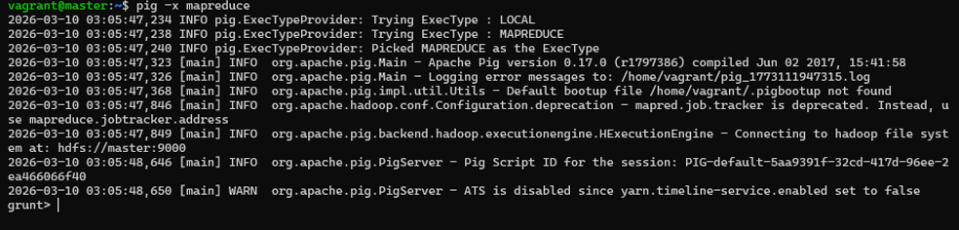
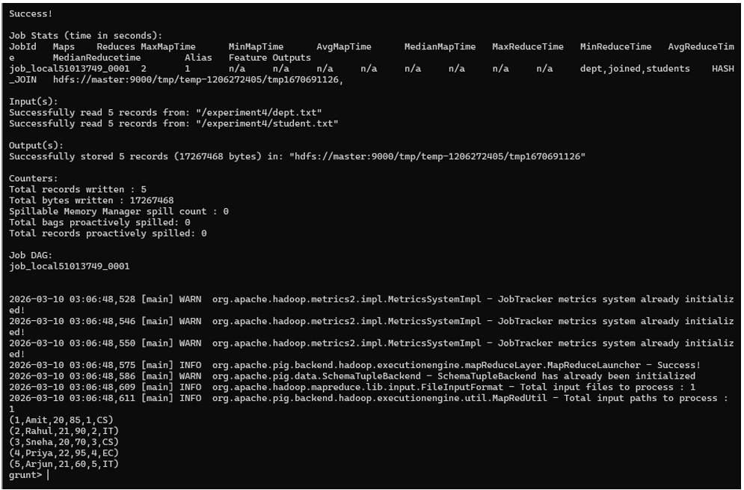

Step 6: Write and Run a Pig Script File
**What we are doing:** Instead of typing commands one by one in the shell, we write all the Pig Latin statements into a `.pig` script file and run it in one go. This is the standard approach for real-world Pig jobs.

1. Exit the Pig Shell
quit

2. Create the Script File
nano exp4.pig

Add the following script:

-- Load the student dataset from HDFS
students = LOAD '/experiment4/student.txt'
USING PigStorage(',')
AS (id:int, name:chararray, age:int, marks:int);
-- Filter students with marks greater than 75
high = FILTER students BY marks > 75;
-- Sort the filtered results by marks in descending order
sorted = ORDER high BY marks DESC;
-- Store the final output back to HDFS
STORE sorted INTO '/experiment4/output';
What this script does: Loads all students → keeps only those with marks > 75 → sorts them highest to lowest → saves the result to HDFS.

3. Run the Script
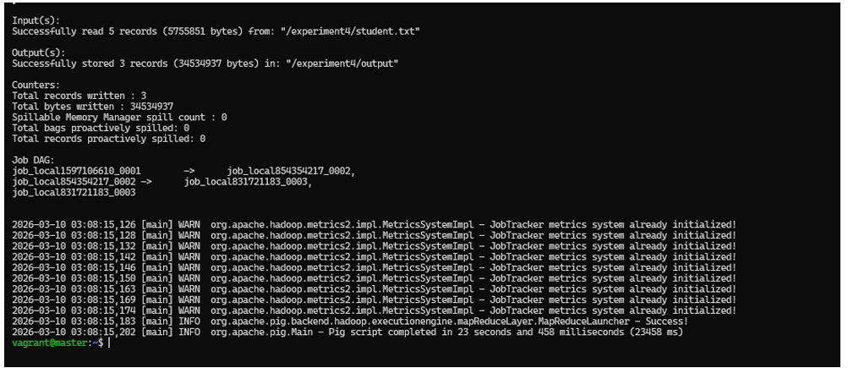

> 2026-02-26 19:26:06,140 [main] INFO org.apache.pig.backend.hadoop.executionengine.mapReduceLayer.MapReduceLauncher - Success!
> 2026-02-26 19:26:06,162 [main] INFO org.apache.pig.Main - Pig script completed in 21 seconds and 409 milliseconds (21409 ms)

4. Verify the Output
List the output files:
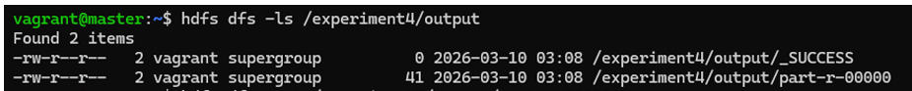
View the result:
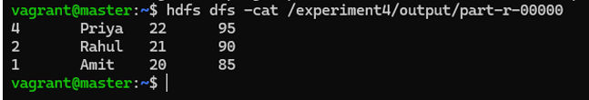

Step 7: Stop the Cluster
**What we are doing:** We cleanly shut down Hadoop services and the Vagrant VM to free up system resources.
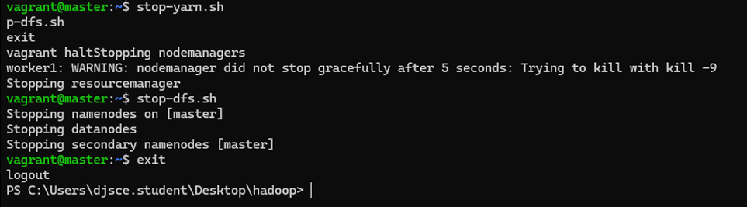

7. Result
Apache Pig was successfully installed on the Hadoop cluster and all Pig Latin operations were performed in MapReduce mode. The following operations were executed and verified:

Operation | Pig Latin Command | Purpose
Load | LOAD ... USING PigStorage | Read data from HDFS
Filter | FILTER ... BY | Select records matching a condition
Project | FOREACH ... GENERATE | Select specific columns
Sort | ORDER ... BY ... DESC | Sort records by a field
Group | GROUP ... BY | Group records by a common field
Aggregate | AVG() | Compute average within groups
Join | JOIN ... BY | Combine two datasets on a common key
Store | STORE ... INTO | Write output back to HDFS

9. Conclusion
Apache Pig significantly simplifies big data processing by allowing developers to write concise Pig Latin scripts instead of complex Java MapReduce programs. In this experiment, all major data transformation operations — filtering, projection, sorting, grouping, aggregation, and joining — were successfully performed on a student dataset using a Vagrant-based Hadoop cluster. The Pig script file approach demonstrated how real-world batch data pipelines are built and executed on Hadoop.

