Project problem statement:
“Linters and coverage reports describe a codebase today. No one connects "this PR merged" to "and here's how it shifted the complexity, architecture, and risk of the codebase." Engineering teams ship blind”.
Solution:
Build a system that ingests a Git repository, builds a code knowledge graph per commit, and visualizes how repo health changes over time.
Here is how you can implement each step of the revised, efficient architecture using Python:
- Git Ingestion
This step involves reading the history of a repository to understand what changed and when.
Walk every commit in the repo's history, extract the diff (which files changed, what lines were added/removed), and store the metadata (SHA, author, timestamp, message). This is the raw data feed for everything downstream.
- Python Tool: pygit2 (Python bindings for the libgit2 library).
- Implementation:
  - Use pygit2.clone_repository with the bare=True flag to pull code without a working directory (saving space).
  - Use a "Commit Walker" to iterate through every commit SHA chronologically.
  - For each commit, extract the diff to identify exactly which files were modified.
For large repos, process commits in a queue so you're not loading everything into memory at once.

2. Code Parsing (AST Extraction)
To understand code structurally, you convert raw text into an Abstract Syntax Tree (AST).
For every changed file in a commit, parse the source code into an Abstract Syntax Tree and extract named entities: functions, classes, methods, imports, and the call relationships between them. This turns raw code into structured data.
- Python Tool: tree-sitter.
- Implementation:
  - Instead of parsing the whole repo, only parse the files identified in the Git diff.
  - The tree-sitter library will "read" the code and identify "entities" like functions, classes, and import statements.

3. Knowledge Graph Construction
A "Knowledge Graph" in this context represents the relationships between code components.
Store each commit's entities and their relationships as a graph snapshot. Nodes are files, functions, and classes. Edges are imports, function calls, and inheritance. Then compute the diff between two consecutive commit graphs — this is what lets you answer "what did this PR structurally change?"
- Python Tool: networkx.
- Implementation:
  - For every commit, use networkx to build an in-memory graph of these relationships.
  - The "No Index" approach: Instead of saving the whole graph to a heavy database like Neo4j, you simply calculate the "delta" (the change in connections) and then discard the graph to save memory.

4. Deterministic Metric Engine
This calculates the "health" scores of the code without using expensive AI.
- Python Tool: radon.
- Implementation:
  - Complexity: Use radon to calculate Cyclomatic Complexity (how many paths a program can take).
  - Coupling: Use your networkx graph to calculate Fan-in (how many things call this code) and Fan-out (how many things this code calls).
  - Churn Risk: Identify "hotspots" by multiplying how often a file changes (Git history) by its coupling score.
  - Architectural drift: track how the module dependency graph changes in shape over time. A flat graph getting spiky = centralisation risk.All metrics are stored as time-series data keyed by commit SHA.

5. Justified LLM Integration
AI is used sparingly to explain why metrics changed, rather than calculating the metrics themselves.
- Python Tool: OpenAI or Anthropic SDKs.
- Implementation:
  - The Gate: Set a threshold (e.g., a 25% spike in complexity).
  - Only when this threshold is hit, send the specific code diff and the graph delta to the LLM to generate a "Spike Explainer".

6. Visualization
Three views that answer the original problem:
- Health timeline — a line chart of complexity, coupling, and risk scores over commits (or PRs). You can immediately see which PR caused a spike.
- Graph diff view — a before/after network graph for a specific PR. New edges highlighted in green, removed in red, changed nodes in amber.
- Hotspot risk map — a file-tree heatmap combining churn frequency × coupling score. The redder the file, the more dangerous it is.
Tools: React + D3.js or Recharts for the timeline and heatmap. Cytoscape.js or react-force-graph for the interactive knowledge graph visualization.

6. Storage and API
- Storage: Use SQLite to store the final scalar metrics (e.g., {commit_sha: "abc", complexity: 12}). This is much lighter than a graph database.
- API: Use FastAPI to create endpoints that the React frontend can call to get the timeline data or graph diffs.

The whole architecture:
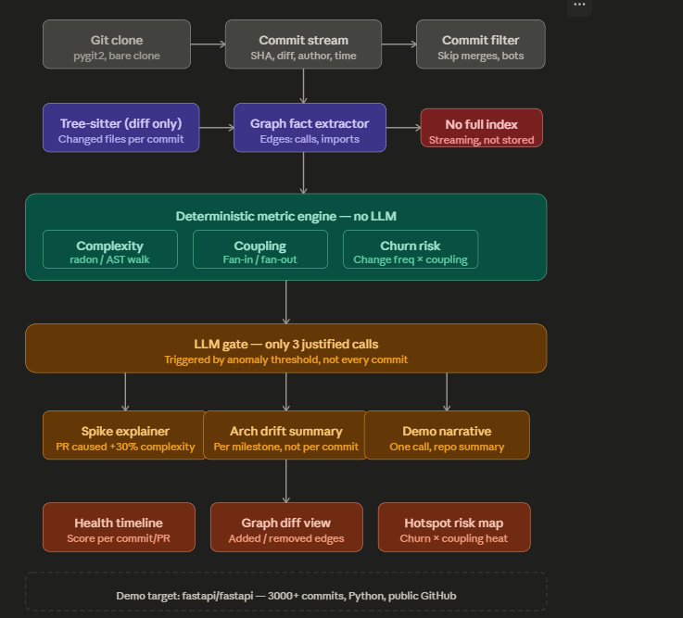

Constraints:
Constraint 1 — LLM calls must be cost-justified
The original plan had no LLM at all, which is actually too conservative — an LLM earns its cost in exactly three places, and nowhere else.
Call 1 — Spike explainer. When a commit causes complexity to jump by more than a configurable threshold (say 25%), the deterministic engine flags it but cannot explain why. You send the diff of that specific commit to the LLM and ask: "what structural decision caused this spike, and is it intentional?" You get one call per anomaly, not one per commit. On a 500-commit repo that might fire 8–12 times total.
Call 2 — Architectural drift summary.
Every 50 commits (or at tagged releases), the system computes which modules gained/lost connections in the graph. The LLM gets a compact serialised delta — not the raw code — and generates a 3-sentence human-readable summary of what changed architecturally. This is the "and here's what the PR shift meant" insight the problem statement asks for. The input is small (JSON graph delta), the output is high-value prose.

Call 3 — Demo narrative (one-time).
A single call at the end to generate a written walkthrough of the repo's health story: "Between commits 100 and 300, coupling tripled in the auth module, which correlates with the spike in bug-fix commits in that period." This is a demo asset, not a production recurring cost.
Constraint 2 — Demo on a real public repo with 500+ commits
Constraint 3 — Minimise indexing
This is the most surgical change to the original design. The previous plan stored a full graph snapshot per commit in Neo4j. That is an index — a pre-computed, queryable store of every entity in every commit. Under this constraint, you drop Neo4j entirely.
Overall: This makes the system vastly simpler to run — no Neo4j instance, no Celery queue, no Redis. A single Python process, a SQLite file, and a React frontend reading that file via a tiny FastAPI endpoint.
Use the following UI interface design
Mimic the font style, Same color scheme, Structure as shown below. Tailor to our project needs.
