**Table of Contents**

### Page No.

### Chapter 1. Introduction

1. Introduction to the System 4
2. Problem Definition 4
3. Aim 4
4. Objective 4
5. Goal 5
6. Need of System 5

### Chapter 2. Hardware and Software requirement

1. FrontEnd 7
2. Backend 7
3. Software requirement 8
4. Hardware requirements 8

### Chapter 3. Modules

1. Admin Module 9
2. User Module 9

### [Chapter 4.Implementation issues](#chap 8)

1. PYTHON 11
2. HTML 13
3. Cascading style sheet(CSS) 16
4. SQLITE 17

**Chapter 5. System Design**

1. Introduction 18
2. Conceptual Design 22
3. ER-Diagram 23
4. Logical Design 23
5. Physical Design 24
6. Data Flow Diagram of **“**Job Portal**” 25**

### [Chapter 6.User Screens](#chap 8) 25-32

### [Chapter 7.Coding](#chap 8) 33-57

[**Chapter 8. Conclusion**](#chap 9)

1. Features of “Job Portal” 58
2. Benefits Accrued from “Job Portal” 59
3. Limitations of “Job Portal” 60

Bibliography

**CHAPTER # 1**

**Introduction**

*Contents:*

* Introduction
* Problem Definition
* Aim
* Objective
* Goal
* Need of System

**Introduction to the System:**

* Job portal is an application which connects employer and job seekers where employers are the source of the resources and the job seeker can find and apply for their targeted job.
* This website can be also providing information about online job.
* The customer can get the online registration.

The Job Portal web application can be used by any employee to apply job and any employer are post to job.

**Aim:**

# “Resolve all the job searching problems and help the job seeker to find the desired job.”

**Objective:**

This objective of this website is to provide a platform to employee to apply for a job and employer can post a job.

**CHAPTER** # **2**

**Hardware and Software Requirements**

*Contents:*

##### Introduction

* System environment
* Software requirement
* Hardware requirements

**Software Requirements:**

* Framework : Django
* IDE : Pycharm/Atom
* Client Side Technologies: HTML, CSS, JavaScript , Bootstrap
* Server Side Technologies: Python
* Data Base Server: Sqlite
* Operating System: Microsoft Windows/Linux

**Hardware Requirements:**

* Processor: Pentium-III (or) Higher
* Ram: 64MB (or) Higher
* Hard disk: 80GB (or) Higher

**CHAPTER # 3**

**Modules**

**Employer Modules :**

* Post Job
* View/Edit/Delete Jobs
* View Candidates

**Job Seeker Modules**

* View/Search Job
* Apply For Job

**Admin Modules :**

* Manage Recruiters
* Manage Users
* Manage Jobs

**CHAPTER # 4**

**Implementation issues**

**Python**

Python is a widely used general-purpose, high level programming language. It was initially designed by Guido van Rossum in 1991 and developed by Python Software Foundation. It was mainly developed for emphasis on code readability, and its syntax allows programmers to express concepts in fewer lines of code.

Python is a programming language that lets you work quickly and integrate systems more efficiently.

Python is dynamically typed and garbage-collected. It supports multiple programming paradigms, including procedural, object-oriented, and functional programming. Python is often described as a "batteries included" language due to its comprehensive standard library.

**HTML**

HTML (Hypertext Markup Language) is the set of markup symbols or codes inserted in a file intended for display on a World Wide Web browser page. The markup tells the Web browser how to display a Web page's words and images for the user. Each individual markup code is referred to as an element (but many people also refer to it as a tag). Some elements come in pairs that indicate when some display effect is to begin and when it is to end.

**CASCADING STYLE SHEET (CSS)**

Cascading Style Sheets (CSS) are a collection of rules we use to define and modify web pages. CSS are similar to styles in Word. CSS allow Web designers to have much more control over their pages look and layout. For instance, you could create a style that defines the body text to be Verdana, 10 point. Later on, you may easily change the body text to Times New Roman, 12 point by just changing the rule in the CSS. Instead of having to change the font on each page of your website, all you need to do is redefine the style on the style sheet, and it will instantly change on all of the pages that the style sheet has been applied to. With HTML styles, the font change would be applied to each instance of that font and have to be changed in each spot.

CSS can control the placement of text and objects on your pages as well as the look of those objects.

HTML information creates the objects (or gives objects meaning), but styles describe how the objects should appear. The HTML gives your page structure, while the CSS creates the “presentation”. An external CSS is really just a text file with a .css extension. These files can be created with Dreamweaver, a CSS editor, or even Notepad.

The best practice is to design your web page on paper first so you know where you will want to use styles on your page. Then you can create the styles and apply them to your page.

**Javascript**

JavaScript is a programming language commonly used in web development. It was originally developed by Netscape as a means to add dynamic and interactive elements to websites. While JavaScript is influenced byJava, the syntax is more similar to C and is based on ECMAScript, a scripting language developed by Sun Microsystems.

JavaScript is a client-side scripting language, which means the source code is processed by the client's web browser rather than on the web server. This means JavaScript functions can run after a webpage has loaded without COMMUNICATING with the server. For example, a JavaScript function may check a web form before it is submitted to make sure all the required fields have been filled out. The JavaScript code can produce an error message before any information is actually transmitted to the server.

Like server-side scripting languages, such as PHP and ASP, JavaScript code can be inserted anywhere within the HTML of a webpage. However, only the output of server-side code is displayed in the HTML, while JavaScript code remains fully visible in the source of the webpage. It can also be referenced in a separate .JS file, which may also be viewed in a browser.

**Django**

Django is a web application framework written in Python programming language. It is based on MVT (Model View Template) design pattern. The Django is very demanding due to its rapid development feature. It takes less time to build application after collecting client requirement.

This framework uses a famous tag line: **The web framework for perfectionists with deadlines.**

**CHAPTER # 5**

**System Design**

*Contents:*

* Use case diagram
* Sequence Diagram
* Data flow diagram

**Use Case Diagram:**

* Use case diagram consists of use cases and actors and shows the interaction between them. The key points are:
* The main purpose is to show the interaction between the use cases and the actor.
* To represent the system requirement from user’s perspective.
* The use cases are the functions that are to be performed in the module.

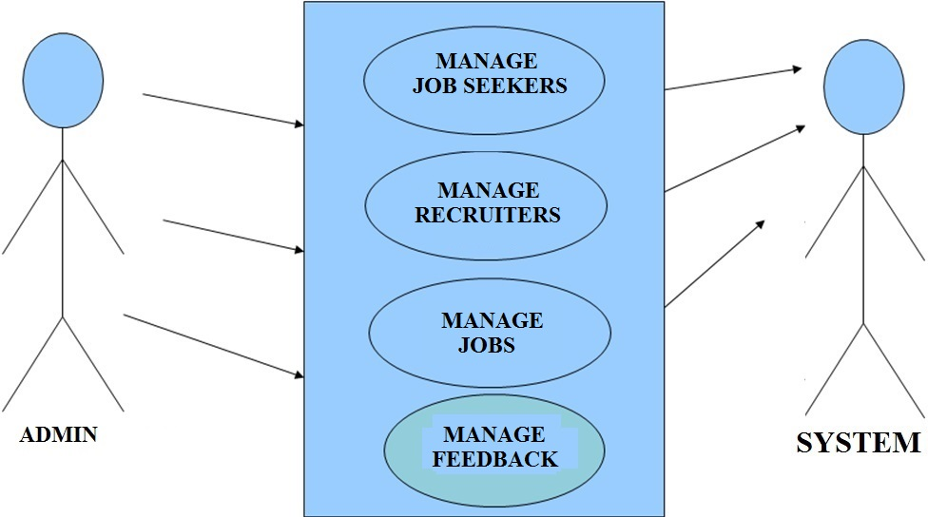

**Use Case Diagram between ADMIN and SYSTEM:**

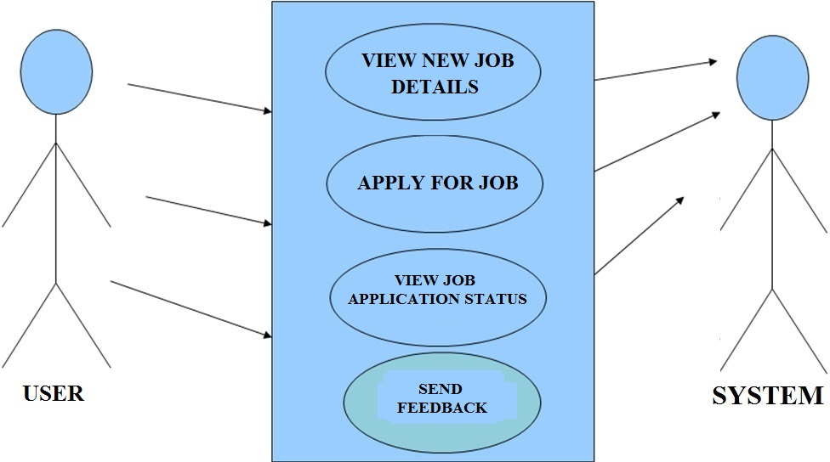

Fig.5.2

**Use Case Diagram between USER and SYSTEM:**

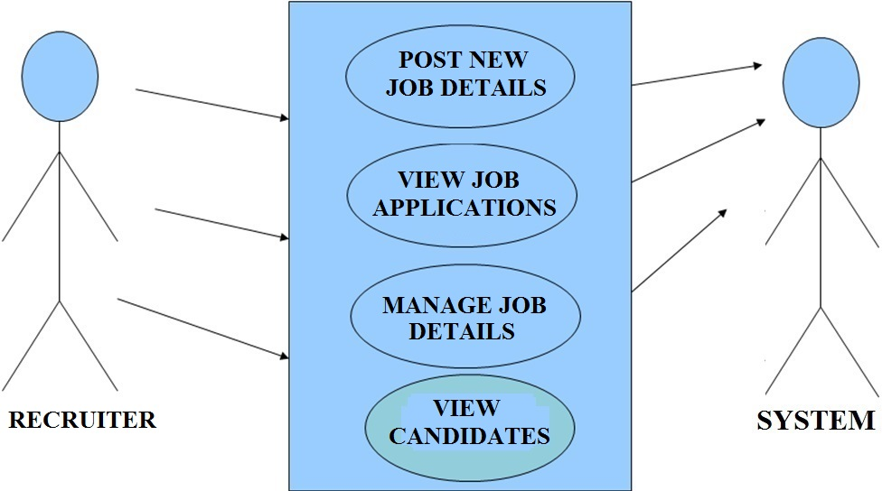

Fig.5.3

**Use Case Diagram between RECRUITER and SYSTEM:**

**Sequence Diagram For Administrator:-**

**Administrator**

**Success:hide()**

**Login**

**Application**

**Database**

**Login**

**:Request**

**:Validate()**

**:executeQuery()**

**Response**

**Show Result**

**Failed:show()**

Fig.5.4

**Data Flow Diagram**

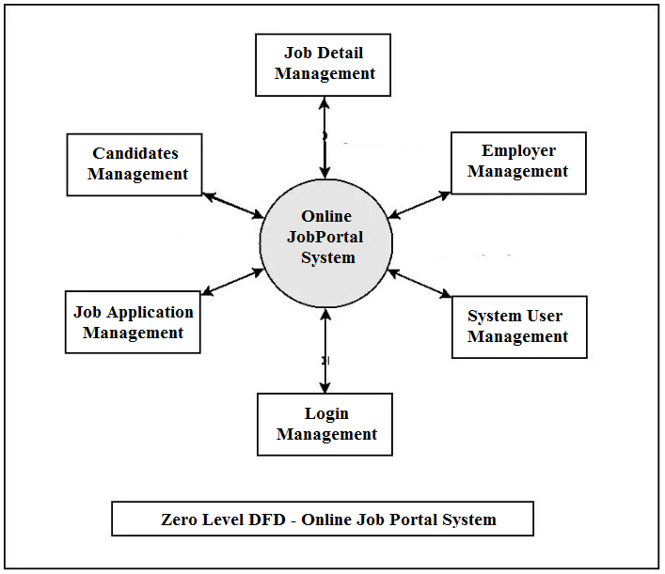

**First Level DFD**

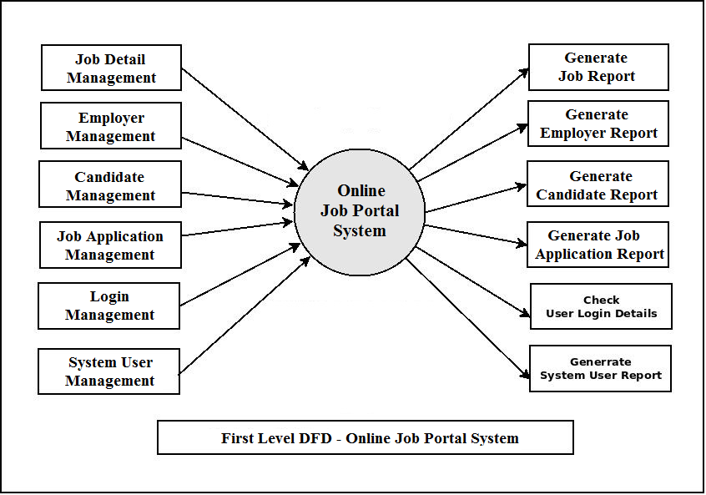

**Class Diagram:**

A description of set of objects that share the same attributes operations, relationships, and semantics

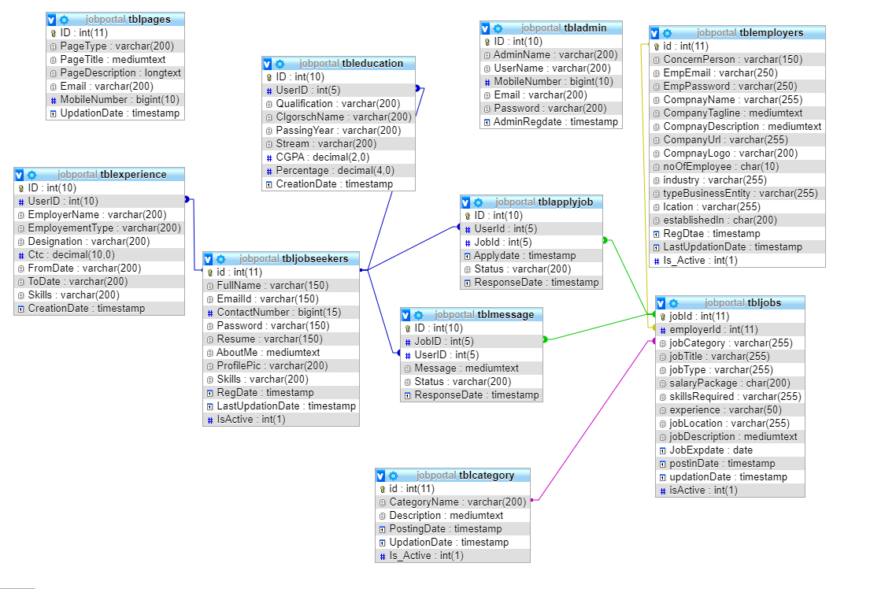

**ER Diagram:**

The Entity-Relationship (ER) model was originally proposed by Peter in 1976 [Chen76] as a way to unify the network and relational database views. Simply stated the ER model is a conceptual data model that views the real world as entities and relationships. A basic component of the model is the Entity-Relationship diagram which is used to visually represent data objects. Since Chen wrote his paper the model has been extended and today it is commonly used for database design for the database designer, the utility of the ER model is:

* It maps well to the relational model. The constructs used in the ER model can easily be transformed into relational tables.
* It is simple and easy to understand with a minimum of training. Therefore, the model can be used by the database designer to communicate the design to the end user.
* In addition, the model can be used as a design plan by the database developer to implement a data model in specific database management software.

**ER Notation**

There is no standard for representing data objects in ER diagrams. Each modeling methodology uses its own notation. The original notation used by Chen is widely used in academics texts and journals but rarely seen in either CASE tools or publications by non-academics. Today, there are a number of notations used; among the more common are Bachman, crow's foot, and IDEFIX.

All notational styles represent entities as rectangular boxes and relationships as lines connecting boxes. Each style uses a special set of symbols to represent the cardinality of a connection. The notation used in this document is from Martin. The symbols used for the basic ER constructs are:

* **Entities** are represented by labeled rectangles. The label is the name of the entity. Entity names should be singular nouns.
* **Relationships** are represented by a solid line connecting two entities. The name of the relationship is written above the line. Relationship names should be verbs
* **Attributes**, when included, are listed inside the entity rectangle. Attributes which are identifiers are underlined. Attribute names should be singular nouns.
* **Cardinality** of many is represented by a line ending in a crow's foot. If the crow's foot is omitted, the cardinality is one.

**Existence** is represented by placing a circle or a perpendicular bar on the line. Mandatory existence is shown by the bar (looks like a 1) next to the entity for an instance is required. Optional existence is shown by placing a circle next to the entity that is optional.

**ER Diagram**

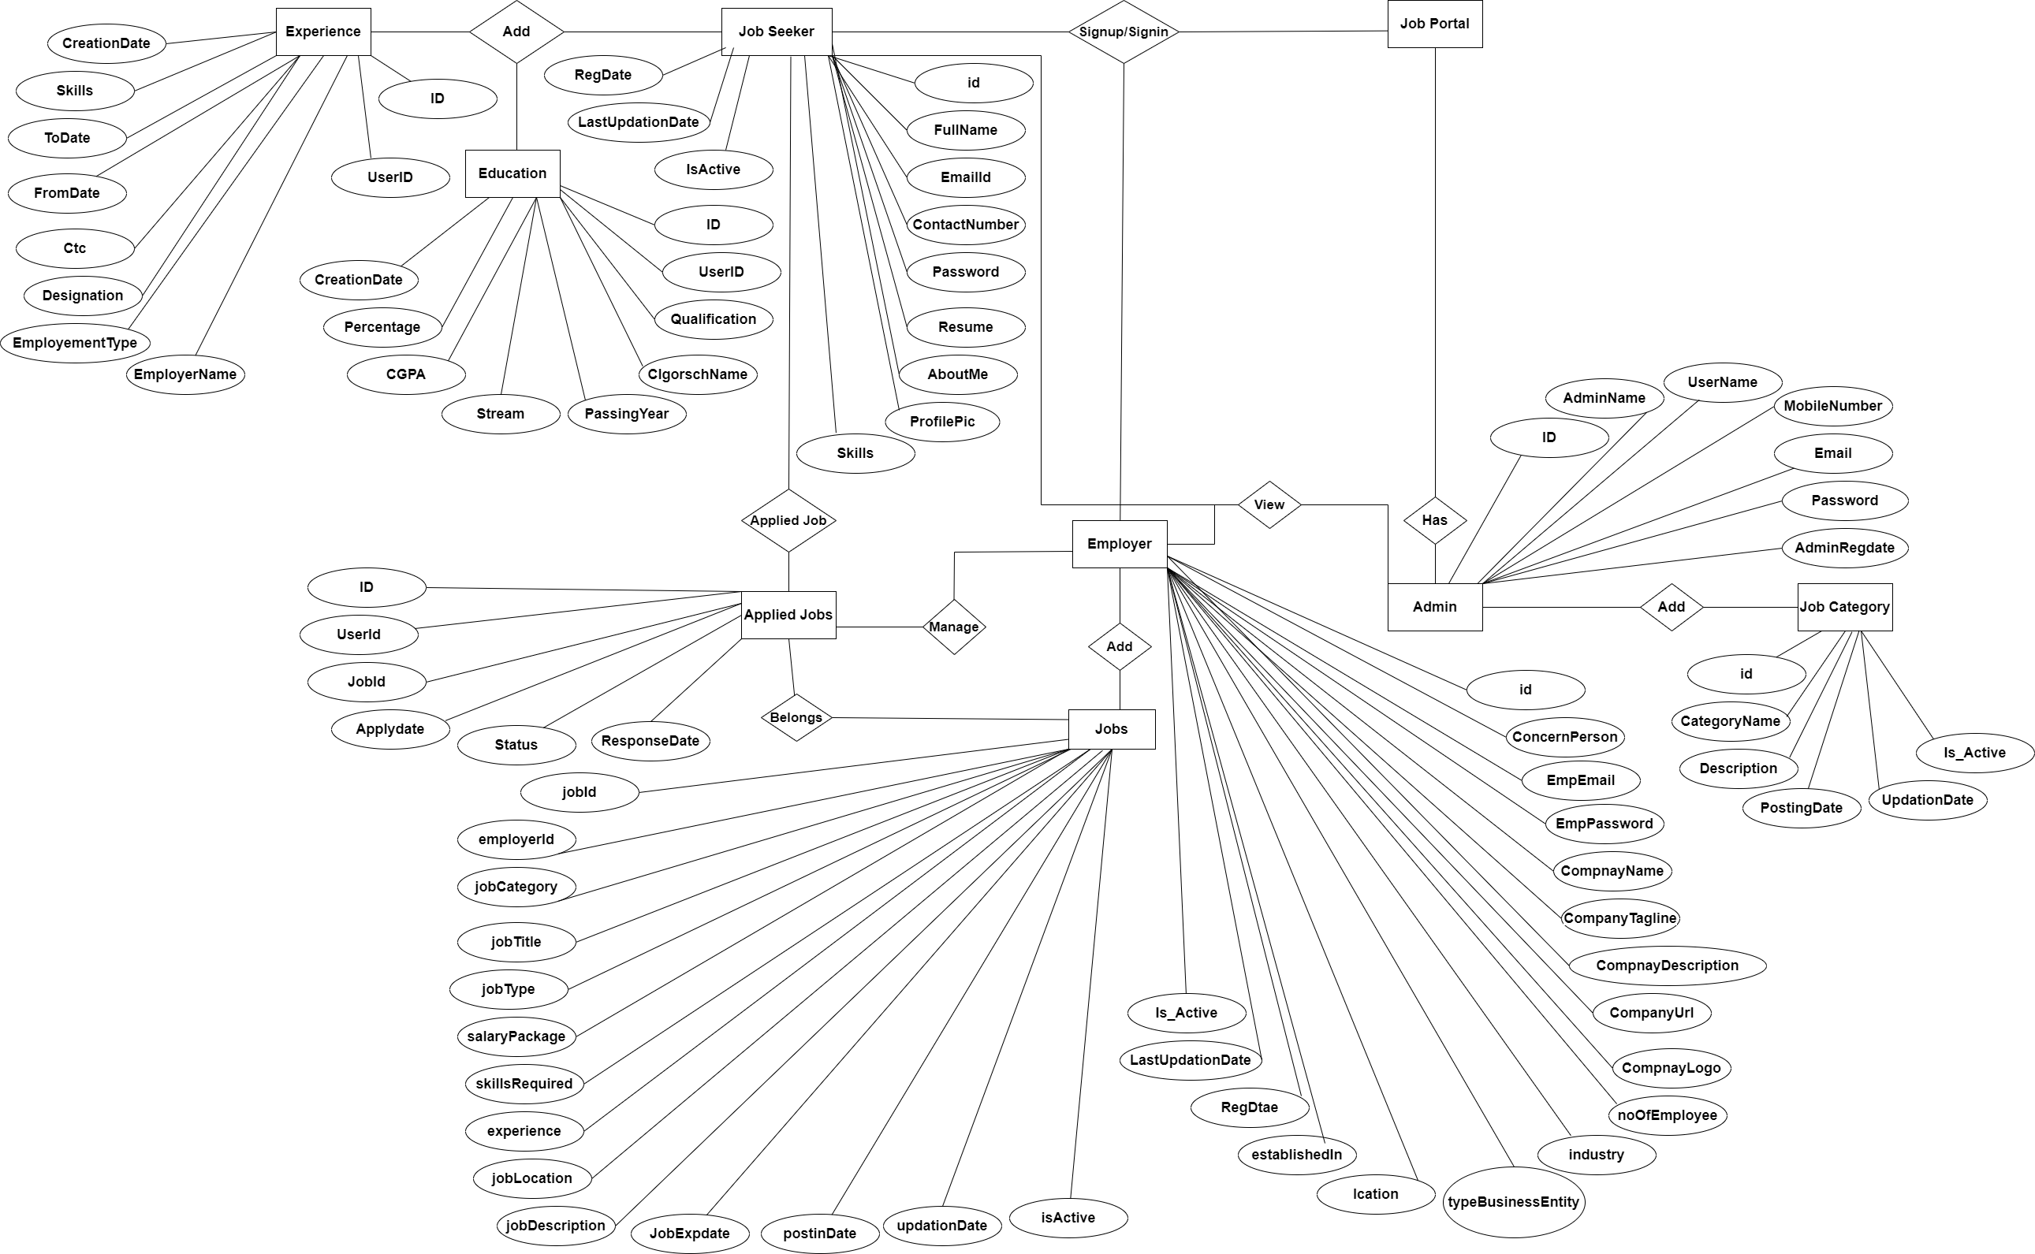

**DataBase Tables:**

**Admin Table:**(Table name is admin)

This store admin personal and login details.

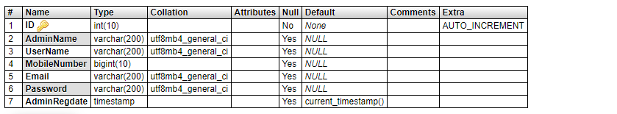

**Category Table(**Table name is tblcategory)

This table store category of jobs.

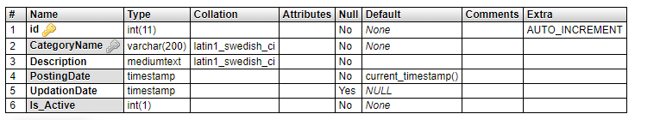

**Apply Job Table:** (Table name is tblapplyjob)

This table store the details of apply jobs.

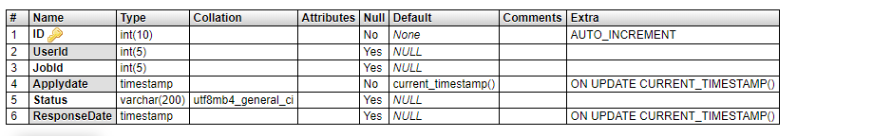

**Education Table:** (Table name is tbleducation)

This table stores the education details of candidates.

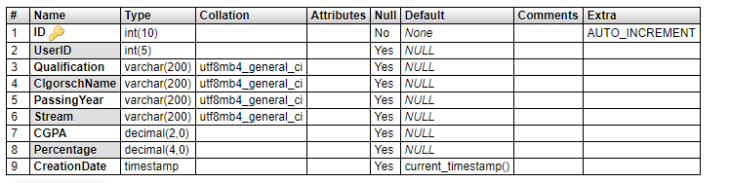

**Experience Table:** (Table name is tblexperience)

This table stores the experience details of candidates.

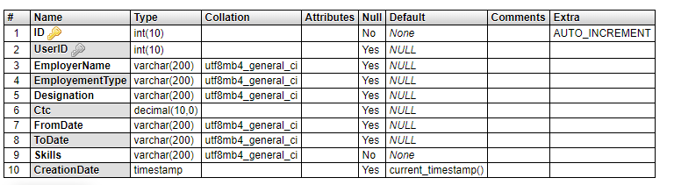

**Employers** **Table:** (Table name is tblemployers)

This table stores details of employers.

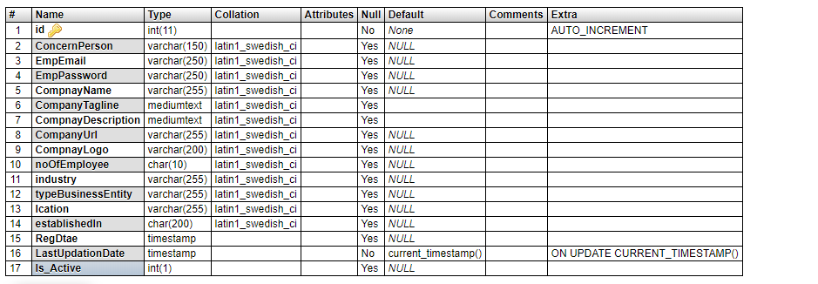

**Jobs** **Table:** (Table name is tbljobs)

This table stores details of jobs which are posted by employers.

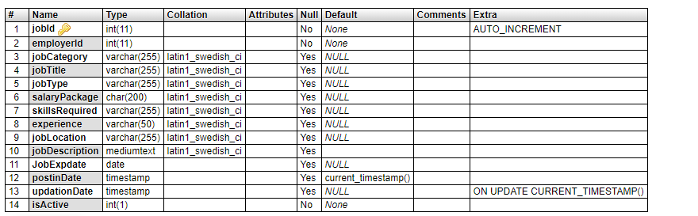

**Jobseekers** **Table:** (Table name is tbljobseekers)

This table stores details of jobseeker.

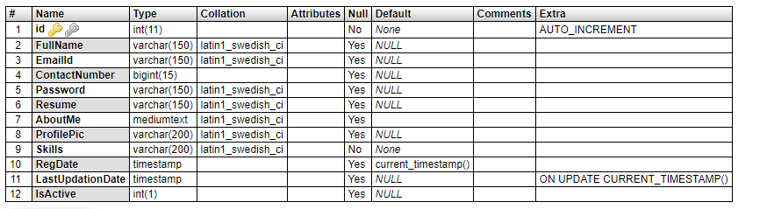

**Message** **Table:** (Table name is tblmessage)

This table stores message detail which is send by employer to jobseeker.

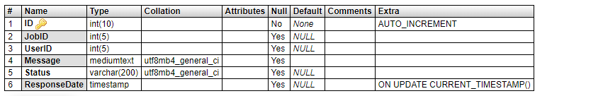

**Pages** **Table:** (Table name is tblpages)

This table stores about us and contact us details.

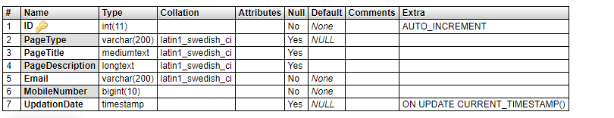

**Implementation and System Testing**

After all phase have been perfectly done, the system will be implemented to the server and the system can be used.

**System Testing**

The goal of the system testing process was to determine all faults in our project .The program was subjected to a set of test inputs and many explanations were made and based on these explanations it will be decided whether the program behaves as expected or not. Our Project went through two levels of testing

1. Unit testing

2. Integration testing

**UNIT TESTING**

Unit testing is commenced when a unit has been created and effectively reviewed .In order to test a single module we need to provide a complete environment i.e. besides the section we would require

* The procedures belonging to other units that the unit under test calls
* Non local data structures that module accesses
* A procedure to call the functions of the unit under test with appropriate parameters

**1. Test for the admin module**

* **Testing admin login form-**This form is used for log in of administrator of the system. In this form we enter the username and password if both are correct administration page will open otherwise if any of data is wrong it will get redirected back to the login page and again ask the details.
* **Report Generation:** admin can generate report from the main database.

**INTEGRATION TESTING**

In the Integration testing we test various combination of the project module by providing the input.

The primary objective is to test the module interfaces in order to confirm that no errors are occurring when one module invokes the other module.

**CHAPTER # 6**

**Output screens**

**HOME PAGE**

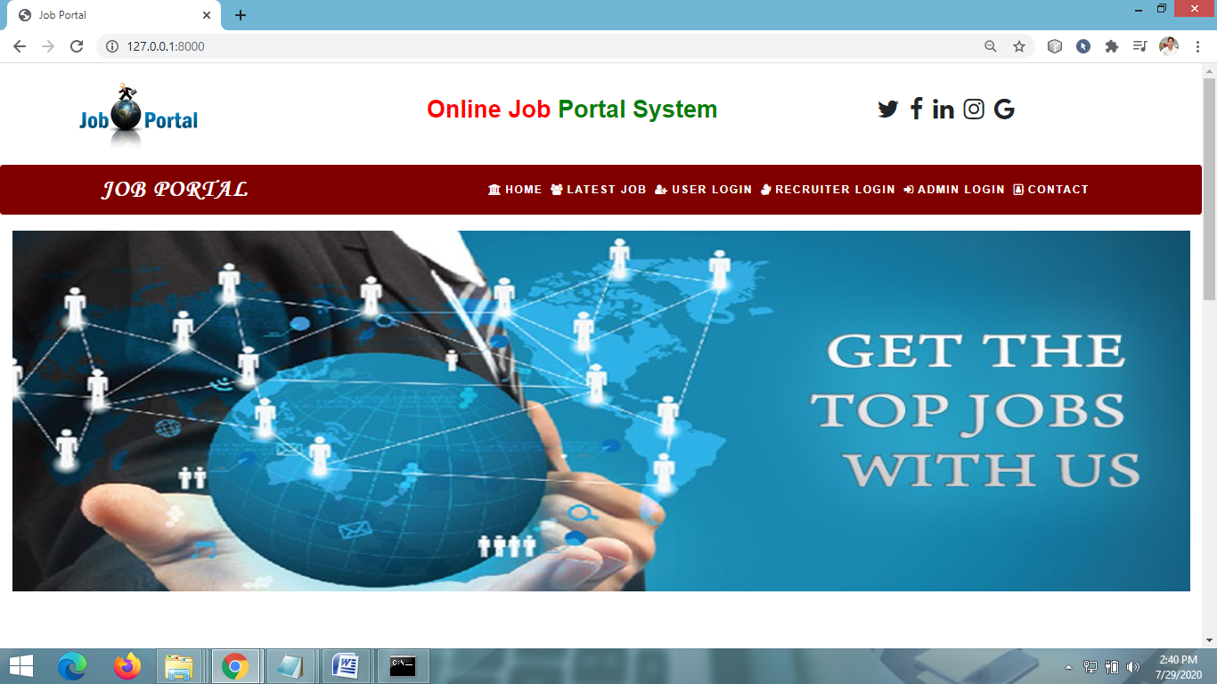

**LATEST JOB PAGE**

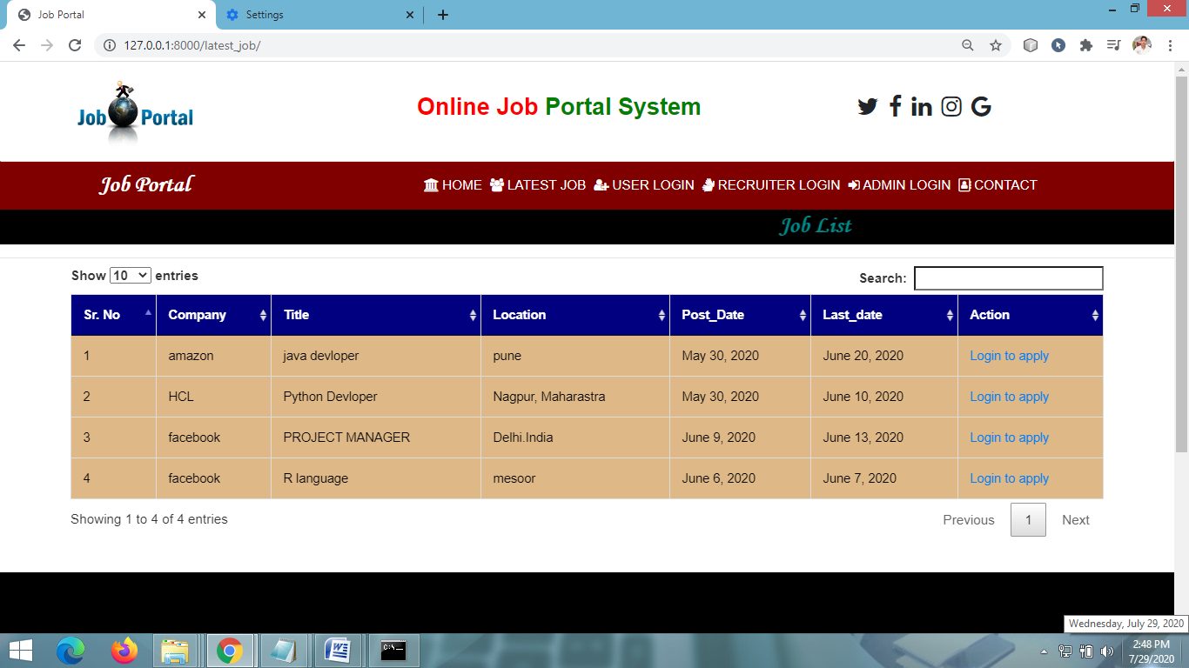

**USER LOGIN PAGE**

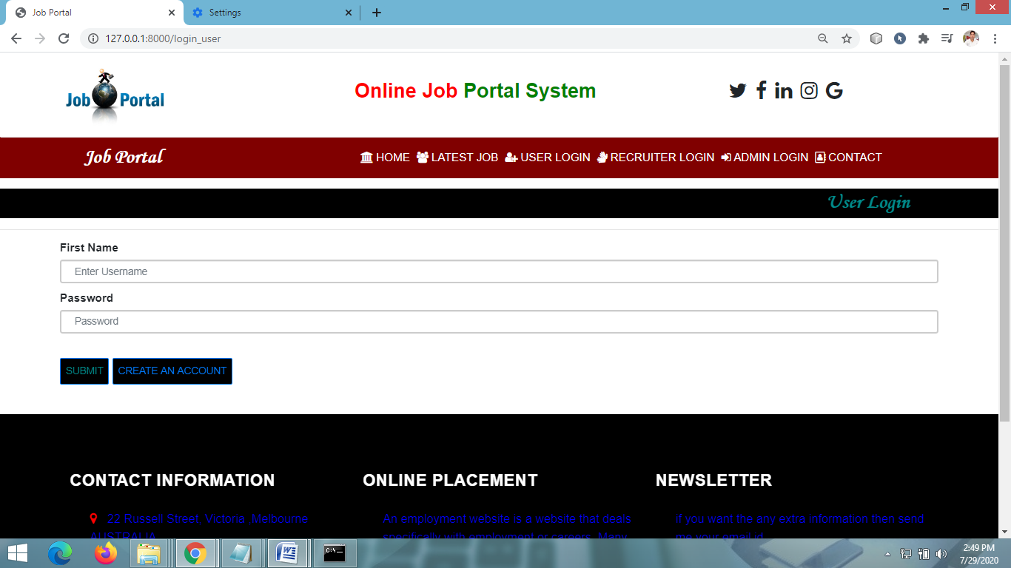

**USER SIGNUP PAGE**

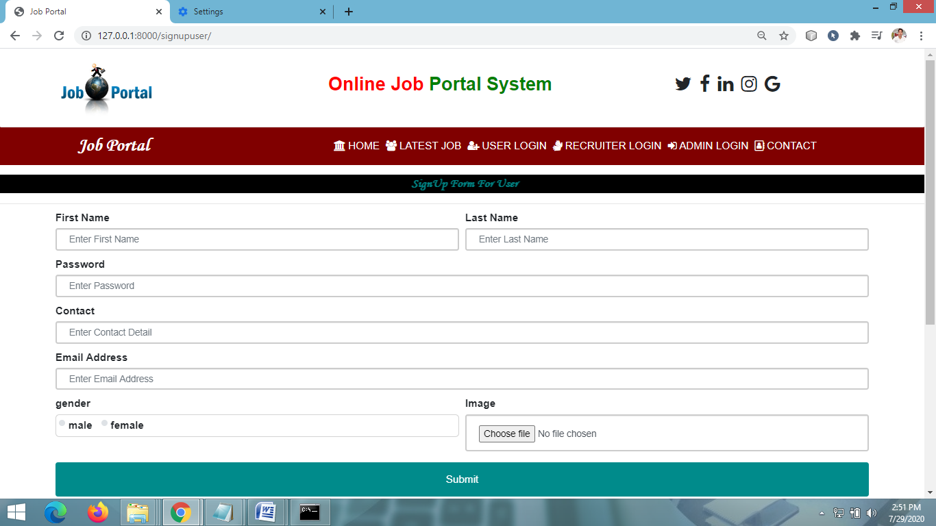

**USER HOME PAGE**

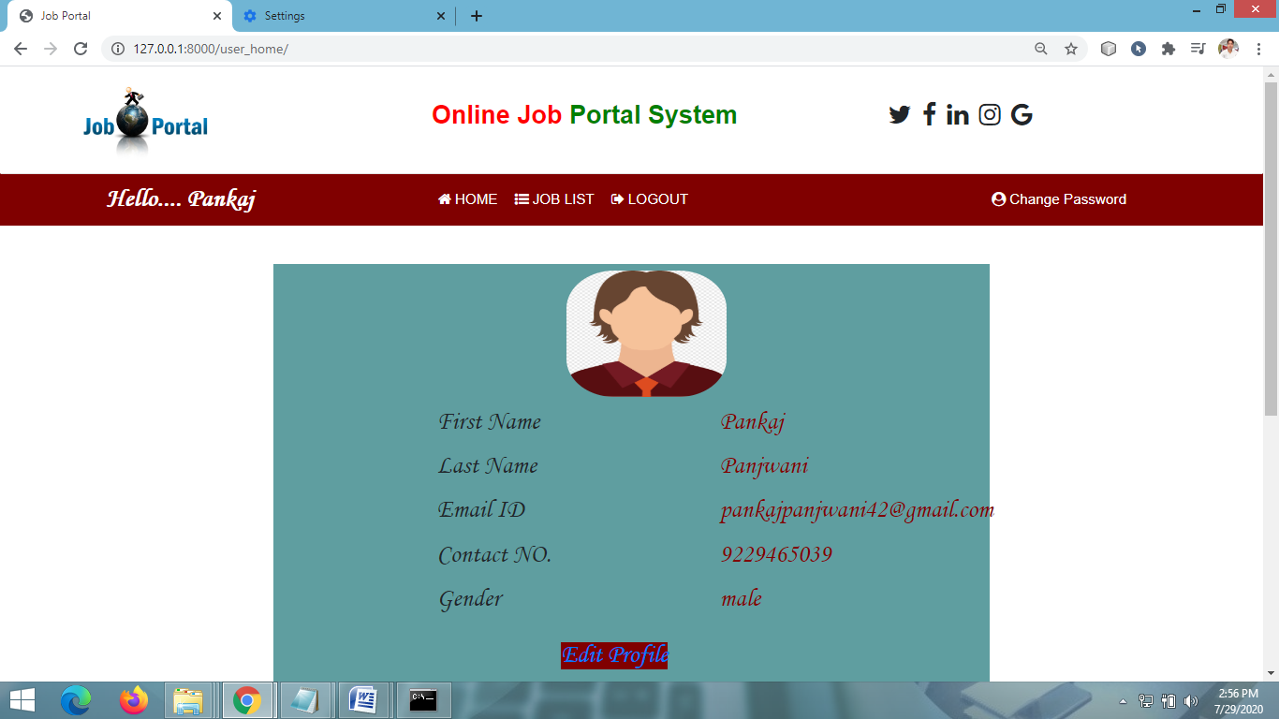

**VIEW JOB LIST PAGE**

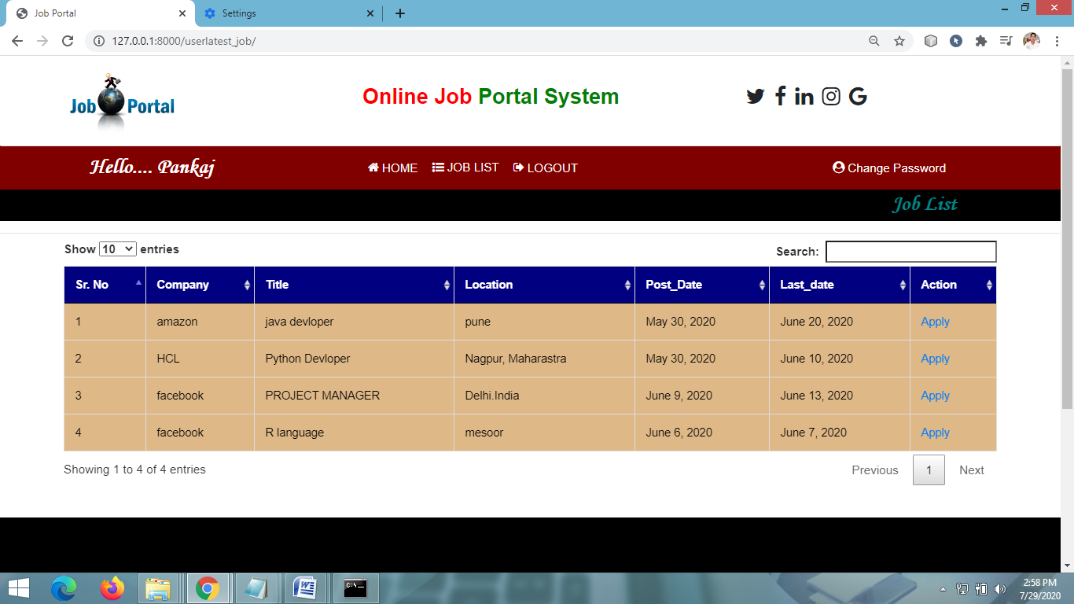

**APPLY FOR JOB PAGE**

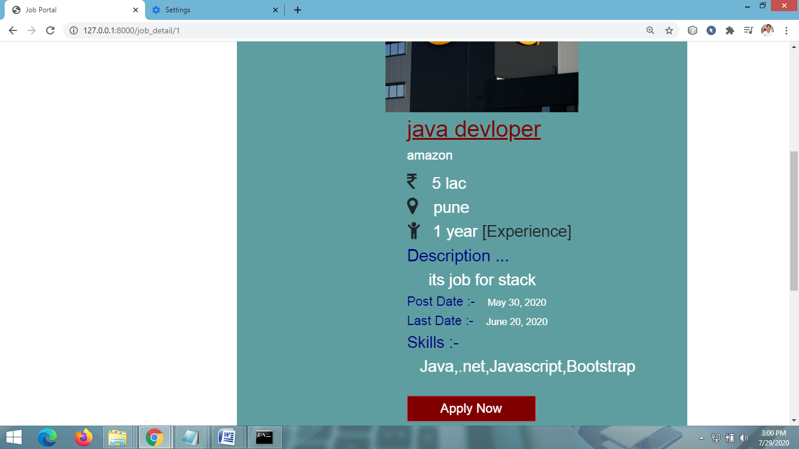

**RECRUITER HOME PAGE**

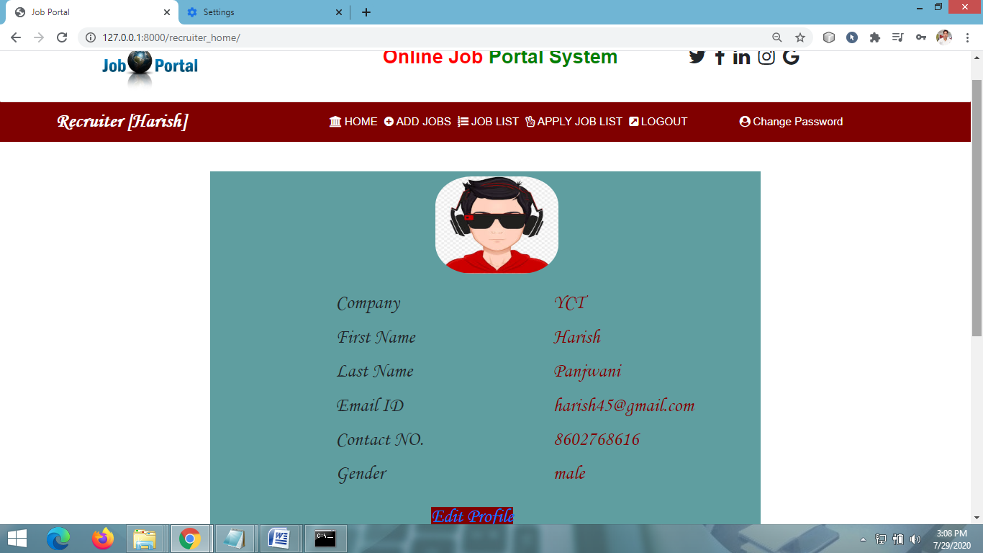

**ADD JOB PAGE**

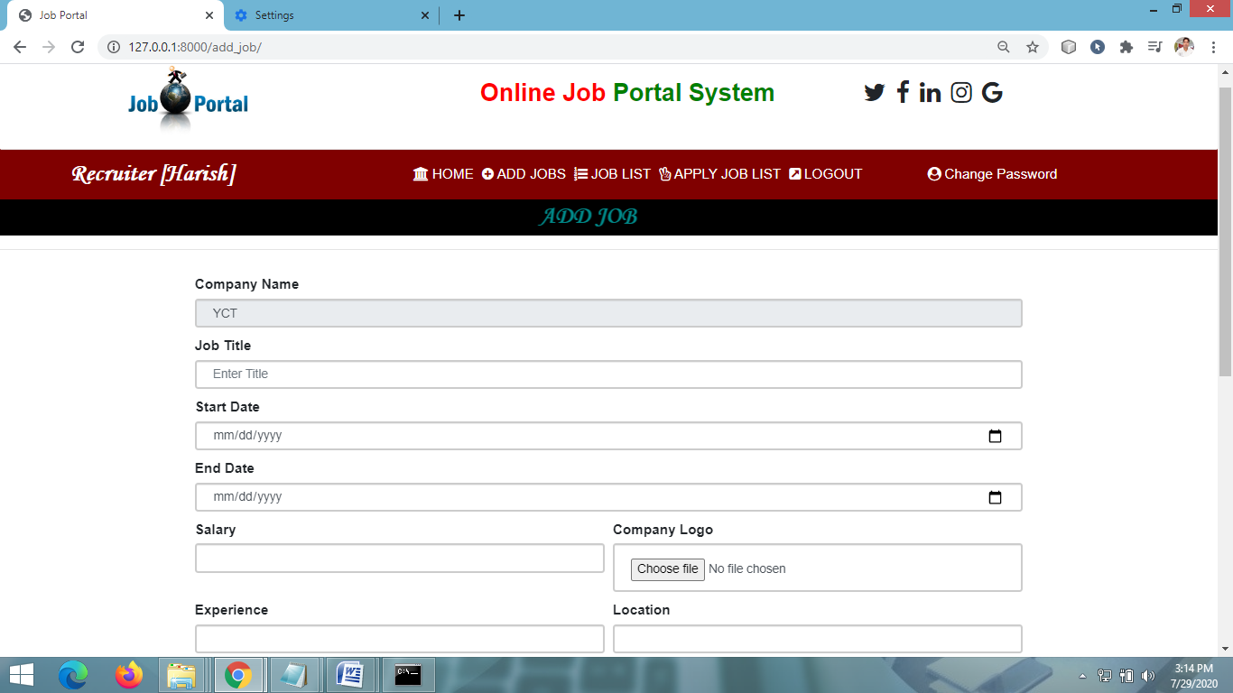

**ADMIN HOME PAGE**

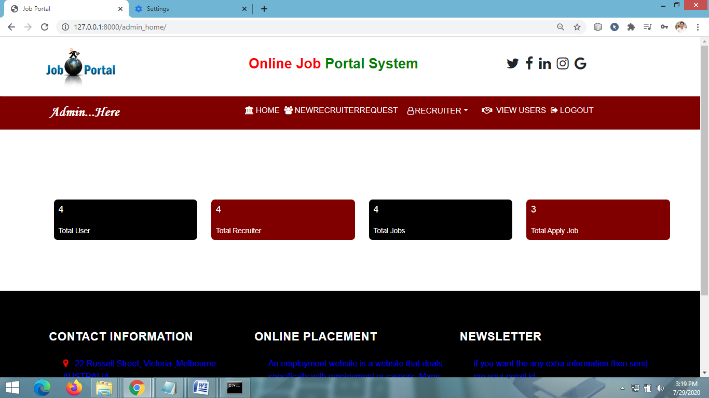

**VIEW RECRUITERS**

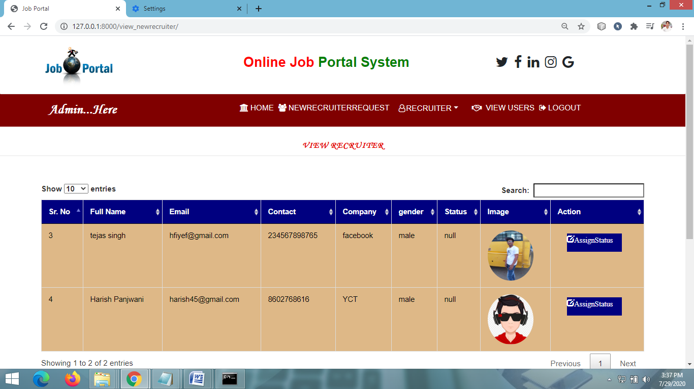

**VIEW ALL USERS PAGE**

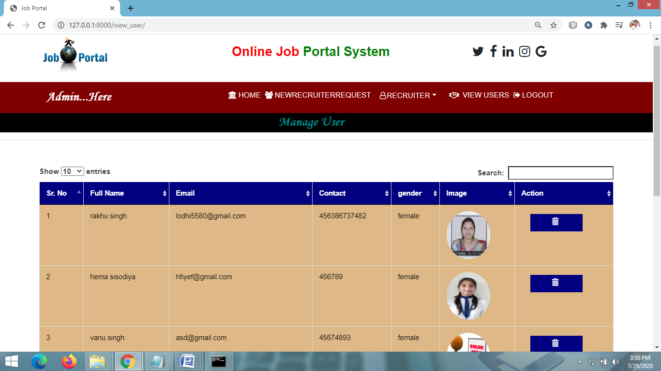

**CHAPTER # 7**

***Coding***

**HOME PAGE CODING**

**{% extends 'navigation.html' %}**

**{% block body %}**

**{% load static %}**

**<link rel="stylesheet" href="https://cdnjs.cloudflare.com/ajax/libs/font-awesome/4.7.0/css/font-awesome.min.css">**

**<style>**

**.container {**

**position: relative;**

**text-align: center;**

**color: white;**

**}**

**.bottom-left {**

**position: absolute;**

**bottom: 8px;**

**left: 16px;**

**}**

**.top-left {**

**position: absolute;**

**top: 8px;**

**left: 16px;**

**}**

**.top-right {**

**position: absolute;**

**top: 8px;**

**right: 16px;**

**}**

**.bottom-right button {**

**position: absolute;**

**bottom: 8px;**

**right: 16px;**

**margin-right:9%;**

**margin-bottom:10%;**

**}**

**.centered {**

**position: absolute;**

**top: 50%;**

**left: 50%;**

**transform: translate(-50%, -50%);**

**}**

**</style>**

**<div class="container-fluid" style="width:100%;margin-top:1%">**

**<img src="{% static 'images/portal5.jpg' %}" alt="Snow" style=" height:450px;width:100%;">**

**</div>**

**{% block body1 %}**

**{% endblock %}**

**{% endblock %}**

**USER LOGIN PAGE CODING**

**{% extends 'navigation.html' %}**

**{% block body %}**

**{% load static %}**

**{% ifequal error "yes" %}**

**<script>**

**alert('logged in successfully');**

**window.location=('{% url 'user_home' %}');**

**</script>**

**{% endifequal %}**

**{% ifequal error "not" %}**

**<script>**

**alert('Username & Password are not Matching');**

**</script>**

**{% endifequal %}**

**{% ifequal error "no" %}**

**<script>**

**alert('user is not exist');**

**</script>**

**{% endifequal %}**

**<style>**

**\* {**

**box-sizing: border-box;**

**}**

**body {**

**font-family: Arial;**

**font-size: 17px;**

**}**

**.container {**

**position: relative;**

**max-width: 90%;**

**margin: 0 auto;**

**margin-bottom:3%**

**}**

**.container img {vertical-align: middle;}**

**.container .content {**

**position: absolute;**

**bottom: 0;**

**background: rgb(0, 0, 0); /* Fallback color */**

**background: rgba(0, 0, 0, 0.5);**

**color: #f1f1f1;**

**width: 100%;**

**}**

**</style>**

**<center><marquee style = "font-family : 'Monotype Corsiva' ; font-size:30px;color :darkcyan**

**; background-color:black;font-weight : bold;margin-top:1%">User Login</marquee></center><hr>**

**<div class="container" style="margin-top:1%">**

**<form method="post" action="">**

**{% csrf_token %}**

**<div class="form-group">**

**<label for="exampleInputEmail1">First Name</label>**

**<input type="text" class="form-control" id="exampleInputEmail1" aria-describedby="emailHelp" name="uname" placeholder="Enter Username">**

**</div>**

**<div class="form-group">**

**<label for="exampleInputPassword1">Password</label>**

**<input type="password" class="form-control" id="exampleInputPassword1" placeholder="Password" name="pwd">**

**</div>**

**<button type="submit" class="btn btn-primary" style="margin-top:2%;color:darkcyan;background-color:black;height:40px; font-size: 15px;">SUBMIT</button>**

**<button class="btn btn-primary"style="color:white;background-color:black;margin-top:2%;height:40px; font-size: 15px;"><a href="{% url 'signupuser' %}" >CREATE AN ACCOUNT</a></button>**

**</form>**

**</div>**

**{% endblock %}**

**USER HOME PAGE CODING**

**{% extends 'user_nav.html' %}**

**{% load static %}**

**{% block body %}**

**<style>**

**glow {**

**font-size: 80px;**

**color: #fff;**

**text-align: center;**

**-webkit-animation: glow 1s ease-in-out infinite alternate;**

**-moz-animation: glow 1s ease-in-out infinite alternate;**

**animation: glow 1s ease-in-out infinite alternate;**

**}**

**@-webkit-keyframes glow {**

**from {**

**text-shadow: 0 0 10px #fff, 0 0 20px #fff, 0 0 30px #e60073, 0 0 40px #e60073, 0 0 50px #e60073, 0 0 60px #e60073, 0 0 70px #e60073;**

**}**

**to {**

**text-shadow: 0 0 20px #fff, 0 0 30px #ff4da6, 0 0 40px #ff4da6, 0 0 50px #ff4da6, 0 0 60px #ff4da6, 0 0 70px #ff4da6, 0 0 80px #ff4da6;**

**}**

**}**

**/* Rounded border */**

**hr.rounded {**

**border-top: 8px solid lightblue;**

**border-radius: 5px;**

**}**

**.prjdiv:hover{**

**transform:translateY(-10px)**

**}**

**div .container1{**

**width:100%;**

**background-color:lightgrey;**

**border-radius:8px;**

**}**

**h2, h4{**

**padding:10Px;**

**}**

**</style>**

**<div class="container" style="background-color:Cadetblue;height:600px;width:850px;margin-top:3%">**

**<div class="row" style="margin-top:1%;margin-left:20%">**

**<div class="col-md-6" style="font-family : 'Monotype Corsiva' ; font-size:30px;margin-left:23%">**

**<img src="{{data.image.url}}" style="width:190px;height:150px;border-radius:30%">**

**</div>**

**</div>**

**<div class="row" style="margin-top:1%;margin-left:20%">**

**<div class="col-md-6" style="font-family : 'Monotype Corsiva' ; font-size:30px">**

**First Name**

**</div>**

**<div class="col-md-6" style="font-family : 'Monotype Corsiva' ; font-size:30px;color:maroon">**

**{{data.user.username}}**

**</div>**

**</div>**

**<div class="row" style="margin-top:1%;margin-left:20%">**

**<div class="col-md-6" style="font-family : 'Monotype Corsiva' ; font-size:30px">**

**Last Name**

**</div>**

**<div class="col-md-6" style="font-family : 'Monotype Corsiva' ; font-size:30px;color:maroon">**

**{{data.user.last_name}}**

**</div>**

**</div>**

**<div class="row" style="margin-top:1%;margin-left:20%">**

**<div class="col-md-6" style="font-family : 'Monotype Corsiva' ; font-size:30px;">**

**Email ID**

**</div>**

**<div class="col-md-6" style="font-family : 'Monotype Corsiva' ; font-size:30px;color:maroon">**

**{{data.user.email}}**

**</div>**

**</div>**

**<div class="row" style="margin-top:1%;margin-left:20%">**

**<div class="col-md-6" style="font-family : 'Monotype Corsiva' ; font-size:30px;">**

**Contact NO.**

**</div>**

**<div class="col-md-6" style="font-family : 'Monotype Corsiva' ; font-size:30px;color:maroon">**

**{{data.mobile}}**

**</div>**

**</div>**

**<div class="row" style="margin-top:1%;margin-left:20%">**

**<div class="col-md-6" style="font-family : 'Monotype Corsiva' ; font-size:30px;">**

**Gender**

**</div>**

**<div class="col-md-6" style="font-family : 'Monotype Corsiva' ; font-size:30px;color:maroon">**

**{{data.gender}}**

**</div>**

**</div>**

**<div class="row" style="margin-top:1%;margin-left:20%">**

**<div class="col-md-6" style="font-family : 'Monotype Corsiva' ; font-size:30px;color:white;margin-left:22%;margin-top:2%">**

**<a href="{% url 'useredit_profile' %}" style="background-color:maroon;">Edit Profile</a>**

**</div>**

**</div>**

**</div>**

**{% endblock %}**

**EDIT PROFILE PAGE CODING**

**{% extends 'instruct_nav.html' %}**

**{% block body %}**

**{% load static %}**

**<div class="container">**

**<h2 style="font-weight:bold;font-family : 'Monotype Corsiva' ; color : #E6120E ;margin-top:2%" align="center">Edit Profile</h2><hr>**

**<div class="container-fluid" style="">**

**<div class="row">**

**<div class="col-md-8">**

**<form method="post" action="" enctype="multipart/form-data">**

**{% csrf_token %}**

**<div class="form-row">**

**<div class="form-group col-md-6">**

**<label for="inputEmail4">First Name</label>**

**<input type="text" class="form-control" value="{{pro.user.first_name}}" name="fname" id="inputEmail4">**

**</div>**

**<div class="form-group col-md-6">**

**<label for="inputPassword4">Last Name</label>**

**<input type="text" class="form-control" name="lname" value="{{pro.user.last_name}}" id="inputPassword4">**

**</div>**

**</div>**

**<div class="form-row">**

**<div class="form-group col-md-12">**

**<label for="inputEmail4">Email Address</label>**

**<input type="text" class="form-control" name="uname" value="{{pro.user.username}}" id="inputEmail4" readonly>**

**</div>**

**</div>**

**<div class="form-row">**

**<div class="form-group col-md-12">**

**<label for="exampleInputPassword1">Contact</label>**

**<input type="text" class="form-control" id="exampleInputPassword1" value="{{pro.contact}}" name="contact">**

**</div>**

**</div>**

**<div class="form-row">**

**<div class="form-group col-md-6">**

**<label for="exampleInputPassword1">Institute Type</label>**

**<input type="text" class="form-control" id="exampleInputPassword1" value="{{student.institute_type}}" name="institute_type">**

**</div>**

**<div class="form-group col-md-6">**

**<label for="exampleInputPassword1">Purpose</label>**

**<input type="text" class="form-control" id="exampleInputPassword1" name="purpose" value="{{student.purpose}}">**

**</div>**

**</div>**

**<div class="form-row">**

**<div class="form-group col-md-6">**

**<label for="exampleInputPassword1">Institute Name</label>**

**<input type="text" class="form-control" id="exampleInputPassword1" value="{{student.institute_name}}" name="institute">**

**</div>**

**<div class="form-group col-md-6">**

**<label for="exampleInputPassword1">Image</label>**

**<input type="file" class="form-control" id="exampleInputPassword1" name="file">**

**</div>**

**</div>**

**<button type="submit" class="btn btn-primary" style="margin-bottom:5%">update</button>**

**</form>**

**</div>**

**<div class="col-md-4">**

**<img src="{{pro.image.url}}" style="width:60%">**

**</div>**

**</div>**

**</div>**

**</div>**

**{% if error %}**

**<script>**

**alert('Update Successfully');**

**window.location = "{% url 'instruct_profile' %}";**

**</script>**

**{% endif %}**

**{% endblock %}**

**VIEW JOB DETAILS PAGE CODING**

**{% extends 'user_nav.html' %}**

**{% block body %}**

**<center><marquee style = "font-family : 'Monotype Corsiva' ; font-size:30px;color :darkcyan**

**; background-color:black;font-weight : bold;">Job List</marquee></center><hr>**

**<div class="container">**

**<table class="table table-bordered" id="myTable">**

**<thead>**

**<tr >**

**<th>Sr. No</th>**

**<th>Company</th>**

**<th>Title</th>**

**<th>Location</th>**

**<th>Post_Date</th>**

**<th>Last_date</th>**

**<th>Action</th>**

**</tr>**

**</thead>**

**<tbody>**

**{% for i in data %}**

**<tr style="color:black">**

**<td>{{forloop.counter}}</td>**

**<td>{{i.recruiter.company}} </td>**

**<td>{{i.title}}</td>**

**<td>{{i.location}}</td>**

**<td>{{i.start_date}}</td>**

**<td>{{i.end_date}}</td>**

**{% if i.id in li %}**

**<td> Applied</td>**

**{% else %}**

**<td><a href="{% url 'job_detail' i.id %}">Apply</a>**

**{% endif %}**

**</tr>**

**{% endfor %}**

**</tbody>**

**</table>**

**</div>**

**<script>**

**var el_up = document.getElementById("GFG_UP");**

**el_up.innerHTML =**

**"Click on the LINK for further confirmation.";**

**</script>**

**{% endblock %}**

**ADD NEW JOB PAGE CODING**

**{% extends 'recruiter_nav.html' %}**

**{% block body %}**

**{% load static %}**

**<center><marquee style = "font-family : 'Monotype Corsiva' ; font-size:30px;color :darkcyan**

**; background-color:black;font-weight : bold;">ADD JOB</marquee></center><hr>**

**<div class="container-fluid" style="width:70%;margin-top:2%">**

**<form method="post" action="" enctype="multipart/form-data">**

**{% csrf_token %}**

**<div class="form-row">**

**<div class="form-group col-md-12">**

**<label for="inputEmail4">Company Name</label>**

**<input type="text" class="form-control" value="{{data.company}}" name="company" readonly>**

**</div>**

**</div>**

**<div class="form-row">**

**<div class="form-group col-md-12">**

**<label for="inputEmail4">Job Title</label>**

**<input type="text" class="form-control" placeholder="Enter Title " name="title" id="inputEmail4">**

**</div>**

**</div>**

**<div class="form-row">**

**<div class="form-group col-md-12">**

**<label for="exampleInputPassword1">Start Date</label>**

**<input type="date" class="form-control" id="exampleInputPassword1" name="start_date">**

**</div></div>**

**<div class="form-row">**

**<div class="form-group col-md-12">**

**<label for="inputEmail4">End Date</label>**

**<input type="date" class="form-control" name="end_date" id="inputEmail4">**

**</div></div>**

**<div class="form-row">**

**<div class="form-group col-md-6">**

**<label for="inputPassword4">Salary </label>**

**<input type="text" class="form-control" name="position" id="inputPassword4">**

**</div>**

**<div class="form-group col-md-6">**

**<label for="inputPassword4">Company Logo</label>**

**<input type="file" class="form-control" name="image" id="inputPassword4">**

**</div>**

**</div>**

**<div class="form-row">**

**<div class="form-group col-md-6">**

**<label for="inputPassword4">Experience </label>**

**<input type="text" class="form-control" name="experience" id="inputPassword4">**

**</div>**

**<div class="form-group col-md-6">**

**<label for="inputPassword4">Location</label>**

**<input type="text" class="form-control" name="location" id="inputPassword4">**

**</div>**

**</div>**

**<div class="form-row">**

**<div class="form-group col-md-6">**

**<label for="inputPassword4">Skills </label>**

**<input type="text" class="form-control" name="skills" id="inputPassword4">**

**</div>**

**</div>**

**<div class="form-row">**

**<div class="form-group col-md-12">**

**<label for="inputPassword4">Description </label>**

**<textarea name="description"></textarea>**

**</div>**

**</div>**

**<button type="submit" class="btn btn-danger" style="width:300px;height:30px;margin-bottom:3%;background-color:navy">Submit</button>**

**</form>**

**</div></div>**

**{% if error %}**

**<script>**

**alert('Add Job Successfully');**

**window.location = "";**

**</script>**

**{% endif %}**

**{% endblock %}**

**APPLY FOR JOB PAGE**

**{% extends 'recruiter_nav.html' %}**

**{% block body %}**

**{% load static %}**

**{% ifequal error "notable" %}**

**<script>**

**alert(' Application are close last date is over');**

**window.location = "{% url 'userlatest_job' %}";**

**</script>**

**{% endifequal %}**

**{% ifequal error "close" %}**

**<script>**

**alert(' Application line is not opend');**

**window.location = "{% url 'userlatest_job' %}";**

**</script>**

**{% endifequal %}**

**{% ifequal error "able" %}**

**<script>**

**alert(' Apply Successfully');**

**window.location = "{% url 'userlatest_job' %}";**

**</script>**

**{% endifequal %}**

**<center><marquee style = "font-family : 'Monotype Corsiva' ; font-size:30px;color :darkcyan**

**; background-color:black;font-weight : bold;">Apply Job</marquee></center><hr>**

**<div class="container-fluid" style="width:70%;margin-top:5%">**

**<form method="post" action="" enctype="multipart/form-data">**

**{% csrf_token %}**

**<div class="form-row">**

**<div class="form-group col-md-12">**

**<center> <label for="inputPassword4" style="font-size:30px">Upload Resume</label></center>**

**<input type="file" class="form-control" name="image" id="inputPassword4">**

**</div>**

**</div>**

**<button type="submit" class="btn btn-danger" style="width:900px;height:40px;margin-bottom:6%;background-color:navy;font-size:20px">Submit</button>**

**</form>**

**</div></div>**

**{% endblock %}**

**Manage Recruiter Page Coding**

**{% extends 'admin_nav.html' %}**

**{% block body %}**

**<center><marquee style = "font-family : 'Monotype Corsiva' ; font-size:30px;color :darkcyan**

**; background-color:black;font-weight : bold"> Manage Recruiter </marquee></center><hr>**

**<div class="container" style="margin-top:1%">**

**</div>**

**<div class="container">**

**<table class="table table-bordered" id="myTable">**

**<thead>**

**<tr >**

**<th>Sr. No</th>**

**<th>Full Name</th>**

**<th>Email</th>**

**<th>Contact</th>**

**<th>Company </th>**

**<th>gender</th>**

**<th>Status</th>**

**<th>Image</th>**

**<th>Action</th>**

**</tr>**

**</thead>**

**<tbody>**

**{% for i in data %}**

**{% ifnotequal i.status "null" %}**

**<tr style="color:black">**

**<td>{{forloop.counter}}</td>**

**<td>{{i.user.username}} {{i.user.last_name}}</td>**

**<td>{{i.user.email}}</td>**

**<td>{{i.mobile}}</td>**

**<td>{{i.company}}</td>**

**<td>{{i.gender}}</td>**

**<td>{{i.status}}</td>**

**<td><img src="{{i.image.url}}" style="width:100px;height:110px;border-radius:50%"></td>**

**<td><a href="{% url 'delete_recruiter' i.id %}"><i class="glyphicon glyphicon-trash" onclick="return confirm('Are you sure?')" style="color:white;margin-left:20px;margin-top:3%;background-color:navy;height:40px;width:120px;padding-top:5%;padding-left:25%"></i></a>**

**</tr>**

**{% endifnotequal %}**

**{% endfor %}**

**</tbody>**

**</table>**

**</div>**

**<script>**

**var el_up = document.getElementById("GFG_UP");**

**el_up.innerHTML =**

**"Click on the LINK for further confirmation.";**

**</script>**

**{% endblock %}**

**VIEW APPLYING CANDIDATES PAGE**

**{% extends 'recruiter_nav.html' %}**

**{% block body %}**

**<center><marquee style = "font-family : 'Monotype Corsiva' ; font-size:30px;color :darkcyan**

**; background-color:black;font-weight : bold;"> Applied Job List</marquee></center><hr>**

**<div class="container">**

**<table class="table table-bordered" id="myTable">**

**<thead>**

**<tr >**

**<th>Sr. No</th>**

**<th>FullName</th>**

**<th>Email Id</th>**

**<th>Title</th>**

**<th>contact</th>**

**<th>Company</th>**

**<th>Resume</th>**

**</tr>**

**</thead>**

**<tbody>**

**{% for i in data %}**

**{% ifequal request.user.username i.job.recruiter.user.username %}**

**<tr style="color:black">**

**<td>{{forloop.counter}}</td>**

**<td>{{i.sign.user.username}} {{i.sign.user.last_name}} </td>**

**<td>{{i.sign.user.email}}</td>**

**<td>{{i.job.title}}</td>**

**<td>{{i.sign.mobile}}</td>**

**<td>{{i.job.recruiter.company}}</td>**

**<td><a href="{{i.image.url}}" download>Download Resume</a></td>**

**</tr>**

**{% endifequal %}**

**{% endfor %}**

**</tbody>**

**</table>**

**</div>**

**<script>**

**var el_up = document.getElementById("GFG_UP");**

**el_up.innerHTML =**

**"Click on the LINK for further confirmation.";**

**</script>**

**{% endblock %}**

**CHAPTER # 8**

**Advantages & Limitations**

**Advantages of “Job Portal System”:**

“Job Portal System” provides various features, which complement the information system and increase the productivity of the system. These features make the system easily usable and convenient. Some of the important features included are listed as follows:

* Intelligent User Forms Design
  + - Data access and manipulation through same forms
    - Access to most required information
* Data Security
* Restrictive data access, as per login assigned only.
* Organized and structured storage of facts.
* Strategic Planning made easy.
* No decay of old Records.
* Exact financial position of the Business.

**Limitations of “Job Portal”:**

Besides the above achievements and the successful completion of the project, we still feel the project has some limitations, listed as below:

* 1. It is not a large scale system.
  2. Only limited information provided by this system.
  3. Since it is an online project, customers need internet connection to use it.
  4. People who are not familiar with computers can’t use this software.

**CHAPTER # 8**

**Future Scope**

**FUTURE SCOPE**

Thisweb application involves almost all the basic features of the online service. The future implementation will be online help for the users and chatting with website administrator.

**CONCLUSION**

The project entitled “Job Portal” is developed using HTML, CSS and Bootstrap as front end and Python, Sqlite database in back end to computerize the process. This project covers only the basic features required.

**Bibliography**

**BIBLIOGRAPHY**

* Wikipedia
* <https://www.geeksforgeeks.org/python-django/>
* <https://www.javatpoint.com>
* <https://www.python.org/>
* <https://www.tutorialspoint/>
* **REFERENCE BOOKS**

### Two scoops of Django for 1.11 by Daniel Greenfeld’s and Audrey Greenfield

### Lightweight Django by Elman and Mark Lavin