Stock Performance Report: AAPL vs MSFT in 2023

Methodology
This report analyzes the daily stock price performance of Apple Inc. (AAPL) and Microsoft Corporation (MSFT) for the calendar year 2023. The data was fetched using the yfinance library, obtaining daily adjusted closing prices. Daily volatility was calculated by observing the standard deviation of daily returns, and a 30-day moving average was computed to smooth out short-term fluctuations in stock prices.

30-Day Moving Average Comparison
Figure 1 below shows the 30-day moving averages of AAPL and MSFT throughout 2023.
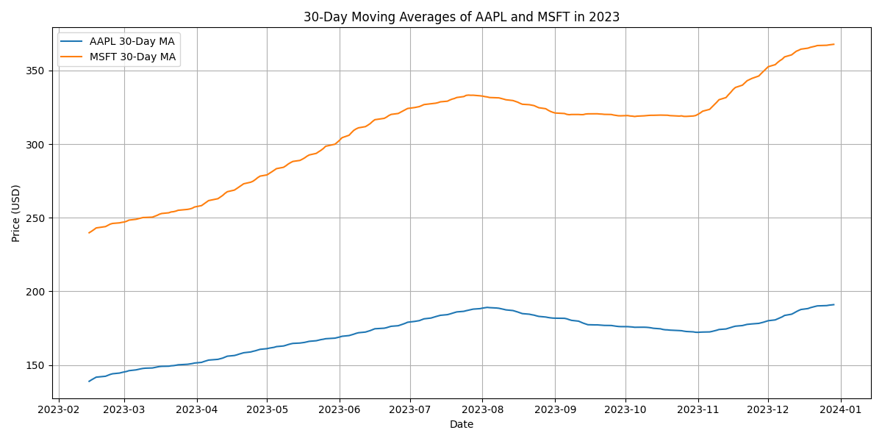

Conclusion
Based on the calculated daily return volatilities, Apple (AAPL) demonstrated slightly more stable stock performance than Microsoft (MSFT) in 2023.

