Campuslearn
campus Learn project:-
1.fronted setup
1.npm create vite@latest
2.npm install
npm run dev
3.clean unnecessary files
4.for tailwind setup --- https://v3.tailwindcss.com/docs/guides/create-react-app
5.EP 7: Create Login Page (First Real Feature)
-->
2:-Backend Setup (Node + Express)
-cd backend
-Initialize Node Project
npm init -y
-npm install express mongoose cors dotenv [package]
-express → helps create the server
mongoose → connects to MongoDB
cors → allows frontend to talk to backend
dotenv → keeps secret keys safe
--"type": "module" tells Node.js: “I will use import and export”
---Run Backend Server
node server.js
---Check Browser
Open:
http://localhost:5000
3.Connect Frontend to Backend
1️⃣ Install Axios in Frontend -- npm install axios //Axios helps the frontend talk to the backend.
2️⃣ Create API Service File -- api.js
3️⃣ Test Backend from Frontend --
// Import useEffect hook to run code when the page loads
4.API.get('/') sends a message from frontend to backend and waits for the reply.
// UseState to store message coming from backend
4.Create Login API
1️⃣ Install Authentication Packages--- backend -- npm install bcryptjs jsonwebtoken
- User enters password
- bcryptjs checks it
- If correct → jsonwebtoken creates token
- Token is sent to frontend
In one line
bcryptjs → protects passwords
jsonwebtoken → keeps user logged in
2️⃣ Create User Model --- backend > modals > user.js
--create schema of db
3️⃣ Connect MongoDB
async --allows waiting
await --pauses until work finishes
------------------
console.log("Start")
mongoose.connect(url)
console.log("Connected")
❌ “Connected” prints before connection is ready.
-----------------------------------
4️⃣ Update server.js --
import connectDB from './config/db.js'
connectDB()
5️⃣ Add .env File
mongo_uri ---
5.Create Login API Route
1️⃣ Create Routes Folder -- backend > routes > authRoutes.js
2️⃣ Add Login Route Code
3️⃣ Connect Route to Server
--> app.use()---used to attach routes or middleware|
Frontend
↓
/api/auth/login
↓
app.use('/api/auth', authRoutes)
↓
router.post('/login')
---------------------------------
Why /api/auth is used
Organizes code
Separates features
Keeps URLs clean
------------------------------
6.Create Register API
1️⃣ Update authRoutes.js
2️⃣ Restart Backend Server
3️⃣ Test Register API -- postman/Thunder Client
7.Connect Loginfronted Page to Backend
1️⃣ Open Login Page -- login.jsx
2️⃣ Replace Full Code with This
8.Create Register Page (Frontend)
--register.jsx

9.Save the token after login
- What localStorage does (simple)
Stores data in browser
Data stays even after refresh
Used for login session
localStorage.setItem('token', res.data.token)
localStorage.setItem('user', JSON.stringify(res.data.user))

- Why this is important
Backend knows who is logged in
nauthorized users are blocked
Required for notes upload, profile, admin access
10. Add Page Routing (Login ↔ Register)
- npm install react-router-dom -----for route
- import { BrowserRouter } from 'react-router-dom' -- main.jsx
- import { Routes, Route } from 'react-router-dom' --- app.jsx
<Routes>
<Route path="/" element={<Home />} />
<Route path="/login" element={<Login />} />
<Route path="/register" element={<Register />} />
</Routes>
11.navigate from login to home
- import { useNavigate } from 'react-router-dom'
- Inside Register():
- const navigate = useNavigate()
- navigate('/')

12. Protect Home Page
Only logged-in users should see the Home page.
fronted > components >ProtectedRoute.jsx
- What this does (very simple)
- Checks if user is logged in
- Stops unauthenticated users
- Redirects them to login page
- Allows logged-in users to continue
- <Route path="/"element={
- <ProtectedRoute>
- <Home />
- </ProtectedRoute>
- }
- />

13.Notes Upload – Backend (Multer Setup)
- Cd backend > npm install multer
- 1️⃣ Create folder – backend > modals >note.js
- 2️⃣ Paste this code
- Create folder – backend > middleware > upload.js
- Paste code
- Create Notes Route – routes – noteroutes.js
- Connect Notes Route to Server
- Serve Uploaded Files
import path from 'path'

app.use('/uploads', express.static('uploads'))

14. JWT Authentication Middleware
- This step makes sure:
- Only logged-in users can upload notes
- Backend knows who uploaded the note
- Create Auth Middleware – backend – middleware- authmiddle.js
15. Test Notes Upload (End-to-End) -frontend -backend
- Create UploadNotes.jsx
- Add Route for Upload Notes Page

16. Protect Upload Route(only for teacher)
- Create teacherRoute.jsx --restriction only teacher access
- Then
<Route
path="/upload"
element={
<TeacherRoute>
<UploadNotes />
</TeacherRoute>
}
/>
✔ TeacherRoute already checks login + role
17. Backend Role Validation (Teacher Only Upload)—double check
18. Redirect After Upload to Manage Notes
import { useNavigate } from 'react-router-dom'
const navigate = useNavigate()
navigate('/manage-notes')
19. Show Uploaded Notes in Manage Notes Page
- Backend API – Get Notes (Teacher Only)
- backend/routes/noteRoutes.js -- open
- 2️⃣ Add This Route BELOW upload route
- Fetch Notes in ManageNotes Page
Notes:-
Lucide react – use for svg, icons
npm install lucide-react
import { BookOpen, Bot, Upload, FileText, Users, BarChart3, TrendingUp, Award, Clock } from 'lucide-react'
20. Student View Notes Page
- Backend API – Get All Notes (For Students)
- Open - backend/routes/noteRoutes.js
- Get ‘/’

21.add filters and search
22. AI Chatbot – Overall Idea
- Student Question
- ↓
- Node.js Backend
- ↓
- Python AI Service
- ↓
- Search Notes (Vector DB)
- ↓
- If not found → Internet
- ↓
- Final Answer

Python handles AI. Node handles users.
- Create AI Service Folder
- Backend > aiservice
22.1 Setup python environment
- Create a virtual environment -- python -m venv venv
- Virtual environment activated--- venv\Scripts\activate
    - What this does:
- Creates a folder named venv
- Inside it, Python keeps all project libraries
- Uses your system Python
    - Why it is important:
- Avoids library conflicts
- Each project has its own packages
- How to know it work
- You will see:
- (venv)
- before your terminal path.
- This means the environment is active.
- How to stop the environment
- deactivate

22.2 pip install openai
All packages install only inside this project.
22.3 Install AI Dependencies
pip install flask langchain-openai langchain-community langchain-core faiss-cpu python-dotenv pypdf
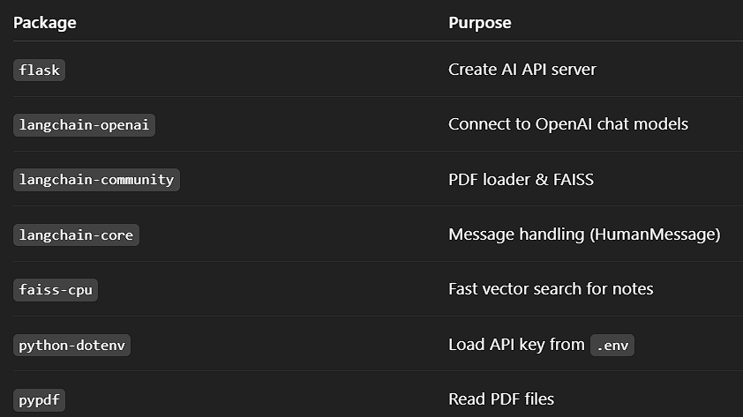
22.4 Create Required Files
ai-service/
├── app.py
├── chatbot.py
├── loader.py
├── vector_store.py
├── .env
22.5 OPENAI_API_KEY=your_api_key_here
22.6 Load Notes (PDF Reader)
Open loader.py: paste code
from langchain.document_loaders import PyPDFLoader
def load_pdf(file_path):
loader = PyPDFLoader(file_path)
pages = loader.load()
return pages
22.7 Create Vector Store (FAISS) –vector-store.py
from langchain.embeddings.openai import OpenAIEmbeddings # Import OpenAI embeddings to convert text into vectors
from langchain.vectorstores import FAISS # Import FAISS for fast vector searc
def create_vector_store(documents): # Function to create a vector database
embeddings = OpenAIEmbeddings() # Initialize OpenAI embedding model
db = FAISS.from_documents(documents, embeddings) # Convert documents into vectors and store in FAISS
return db # Return the FAISS vector store
Enables fast semantic search.
PDF Notes
↓
Text Extraction
↓
Embeddings
↓
FAISS Vector Store
↓
AI Answers Student Questions

22.8 Chatbot Logic – chatbot.py
from langchain.chains import RetrievalQA # Import RetrievalQA to combine search + AI answering
from langchain.llms import OpenAI # Import OpenAI language model
def get_answer(db, question): # Function to get answer from notes
qa = RetrievalQA.from_chain_type( # Create a Retrieval Question-Answer chain
llm=OpenAI(), # Use OpenAI model to generate answers
retriever=db.as_retriever() # Use FAISS database to retrieve relevant text
)
return qa.run(question) # Ask question and return AI-generated answer

Student Question
↓
FAISS (search notes)
↓
OpenAI (understand + answer)
↓
Answer to Student

22.9 Flask API (AI Server)
app.py – paste code
Run AI Server pyhon app.py
23. Connect Node.js Backend → AI Service
1.1: Install Axios in Backend – npm install axios -- Axios is a tool that sends messages between the frontend and the backend.
• Send data to the server
• Get data from the server
1.2: Create AI Controller
- backend/controllers aiController.js file
- paste code
1.3: Create AI Route – routes > aiRoutes.js
- Paste code
1.4: Register Route in Server
- backend/server.js
- import aiRoutes from './routes/aiRoutes.js'
- app.use('/api/ai', aiRoutes) // add middleware
run again backend
1.6: Test Backend → AI Connection
POST http://localhost:5000/api/ai/ask -- postman
24. Load Uploaded Notes into AI
1.1: Add Load Notes API (Backend)
- backend/controllers/aiController.js

1.2: Add Route for Load Notes
backend/routes/aiRoutes.js
router.post('/load', authMiddleware, loadNotesToAI)
// What this line does (simple words)
// This line creates a POST API route that:
// Checks if the user is logged in
// Then loads notes into the AI system
// Only authorized users can access it.

Request
↓
authMiddleware (token check)
↓
loadNotesToAI (AI logic)
↓
Response
Why load notes first?
Answer:
The AI uses vector embeddings, so notes must be indexed before answering questions.

free embedding
---pip install sentence-transformers langchain-huggingface

pip install langchain-text-splitters

=>for image to text – loader.py
import os
from langchain_community.document_loaders import PyPDFLoader
from langchain_text_splitters import RecursiveCharacterTextSplitter

def load_pdf(file_path):
if not os.path.exists(file_path):
raise FileNotFoundError(f"File not found: {file_path}")

loader = PyPDFLoader(file_path)
pages = loader.load()

splitter = RecursiveCharacterTextSplitter(
chunk_size=500,
chunk_overlap=50
)

chunks = splitter.split_documents(pages)

# ❗ Remove empty chunks
chunks = [c for c in chunks if c.page_content.strip()]

return chunks

What This Confirms
- ✔ AI pipeline is fully working
- ✔ Notes are loaded, chunked, embedded
- ✔ /ask API returns real answers
- ✔ Backend ↔ AI ↔ Database flow is stable
- ✔ You understood the root cause, not just the fix
- Vector-based AI systems require textual data.
- Image-only PDFs must use OCR before embedding.

25.UI of chatbot.jsx
frontend/src/pages/Chatbot.jsx
paste code
26.give answer from internet
Chatbot behavior should be:
1️⃣ First try to answer from notes
2️⃣ If notes do not contain enough info
3️⃣ Then give answer from internet (Wikipedia-style)
4️⃣ Clearly mention: “This answer is from general knowledge”
🧠 HOW WE DO THIS (Without Paid APIs)
We will:
- Check retrieved text length
- If too small → treat as “not found”
- Use DuckDuckGo search (free, no API key)
aiservice > pip install duckduckgo-search
2: Update chatbot.py
New Logic:
- Retrieve top chunks
- Measure similarity score
- If similarity is below threshold → treat as no match
- Then use DuckDuckGo internet fallback

Your AI service works like this:
1️⃣ AI service starts → db = None
2️⃣ You ask a question → ❌ db is empty
3️⃣ AI correctly says: “Notes are not loaded yet
--update aicontrollers.js – load before ask
RAG
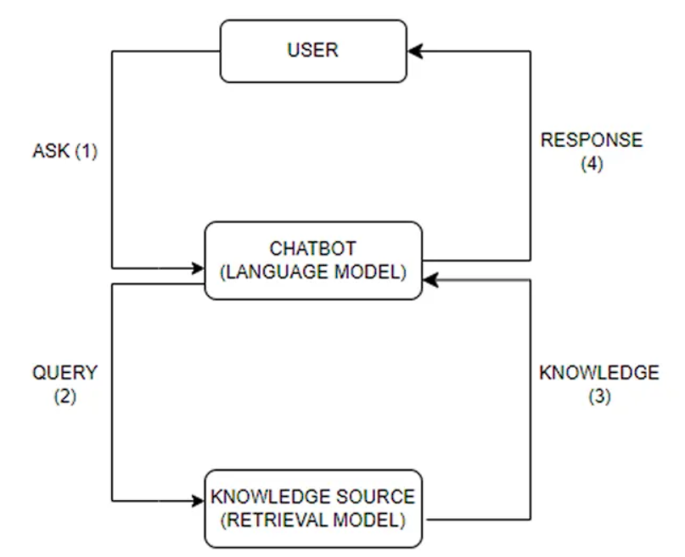

Simple rag
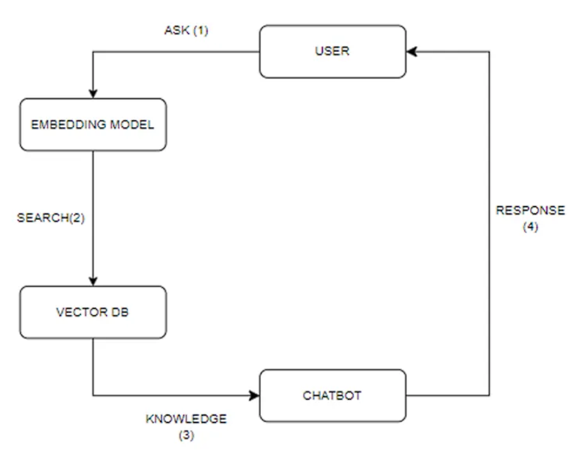
=>run models from Hugging Face. With ollama, you don’t need to have access to a server or cloud service to run the models. You can run the models directly on your computer.
25.🎥 YOUTUBE RECOMMENDATION MODE (NEXT STEP)
YT Mode Page (React)
↓
Node.js Backend
↓
Python AI Service
↓
YouTube Search
↓
Best Video Links

1.pip install yt-dlp
2.import yt-dlp – in app.py
3. @app.route('/youtube', methods=['POST'])
def youtube_mode():
topic = request.json.get('topic')
if not topic:
return jsonify({ "videos": [] })
ydl_opts = {
'quiet': True,
'extract_flat': True,
'skip_download': True,
'default_search': 'ytsearch5',
}
videos = []
with yt_dlp.YoutubeDL(ydl_opts) as ydl:
result = ydl.extract_info(
f"{topic} full lecture explanation",
download=False
)
for entry in result.get('entries', []):
videos.append({
"title": entry.get('title'),
"link": entry.get('url'),
"channel": entry.get('uploader')
})

return jsonify({ "videos": videos })

📌 Teacher Features
✔ Create subject
✔ Add topics under subject
✔ Upload notes for topic
✔ Write article for topic
✔ Add YouTube links for topic
Step 26: Subject & Topic CRUD (Teacher side).
Teacher
└── Subject
└── Topic
✅ STEP 1.1: Create Subject Model
- backend/models/Subject.js – paste schema
- backend/models/Topic.js – PASTE SCHME
1.3: Subject Controller
- backend/controllers/subjectController.js ----
1.4 topic controller
- backend/controllers/topicController.js
1.5 Route
backend/routes/subjectRoutes.js
backend/routes/topicRoutes.js
1.6 Register Routes
backend/server.js

STEP 2: TEACHER UI – CREATE SUBJECT & TOPIC
Create file:
frontend/src/pages/TeacherSubjects.jsx
frontend/src/pages/TeacherTopics.jsx
2.3: Add Routes
Into app.jsx –
ERROR
TeacherSubject.jsx:20 POST http://localhost:5000/api/subjects 500 (Internal Server Error)
 | Promise.then
 | createSubject | @ | TeacherSubject.jsx:20
TeacherSubject.jsx:31 Uncaught (in promise)
- AxiosError {message: 'Request failed with status code 500', name: 'AxiosError', code: 'ERR_BAD_RESPONSE', config: {…}, request: XMLHttpRequest, …}
  - code: "ERR_BAD_RESPONSE"
  - config: {transitional: {…}, adapter: Array(3), transformRequest: Array(1), transformResponse: Array(1), timeout: 0, …}
  - message: "Request failed with status code 500"
  - name: "AxiosError"
  - request: XMLHttpRequest {onreadystatechange: null, readyState: 4, timeout: 0, withCredentials: false, upload: XMLHttpRequestUpload, …}
  - response: {data: {…}, status: 500, statusText: 'Internal Server Error', headers: AxiosHeaders, config: {…}, …}
  - status: 500
  - stack: "AxiosError: Request failed with status code 500\n at settle (http://localhost:5173/node_modules/.vite/deps/axios.js?v=bb094cc3:1257:12)\n at XMLHttpRequest.onloadend (http://localhost:5173/node_modules/.vite/deps/axios.js?v=bb094cc3:1606:7)\n at Axios.request (http://localhost:5173/node_modules/.vite/deps/axios.js?v=bb094cc3:2223:41)\n at async createSubject (http://localhost:5173/src/pages/TeacherSubject.jsx:19:5)"
  - [[Prototype]]: Error

500 Internal Server Error ka matlab hai frontend sahi request bhej raha hai, lekin backend (server) ke andar kuch galat ho raha hai. Problem React/Axios mein nahi, balki API ya backend code mein hai.
Error due to :-
1️⃣ req.user is undefined
2️⃣ Auth middleware is not attaching user correctly
3️⃣ MongoDB error (schema mismatch)
4️⃣ Role not checked properly
createdBy: req.userId // ✅ FIX HERE in createSubject of subjectController.js
STEP 3: TOPIC CONTENT (Teacher Side)
🎯 What Teacher Can Do
Inside each topic, teacher can:
- 📄 Upload Notes (PDF)
- ✍️ Article link
- 🎥 Add YouTube links
Backend
Step1 – topicContect.js > inside models
Step2- topiccontroller > inside controller
Step3- middleware – upload.js
Step4 – routes – topicroutes.js
Step5- server.js – add routes
Frontend :
Step1- teachertopic.jsx
Step2- add route to app.jsx

Error:-
Navbar.jsx:27 Uncaught ReferenceError: t is not defined at Navbar (Navbar.jsx:27:31)
🧩 STEP 4: STUDENT VIEW + MARK COMPLETE
🎯 What Student Can Do
✔ View Subjects
✔ Open Topics
STEP 4.1: Create Progress Model
models/progress.js
conrollers/progressController.js
routes/progressroutes.js
add route to server.js
app.use('/api/progress', progressRoutes)

Frotend:
Pages/studenttopic.jsx
add route to app.jsx

Step 1:- studentSubject.jsx

30 :- ANALYTICS API
Step 1 :- analyticControllers.js
Step 2 :-analyticRoutes.js
Step 3:- add to server.js
frontend
step 1:- teacherAnalytics.jsx
step 2:- add to app.jsx
• 400 series error → frontend mistake
• 500 series error → backend mistake ✅

30. Certificates generate :-
Backend
Step 1:- npm install pdfkit
Step2:-certificateController.js
Step 3:- certificateRoutes.js
Step 4 :- server.js update—add routes
app.use('/api/certificate', certificateRoutes)

Frontend
Step 1:- add download in – studentSubject.jsx
  - When progress === 100 – show download cerficate

ERROR:- after click on download
{"message":"No token provided"}
• our certificate API is protected
• Browser window.open() does NOT send Authorization headers
DO NOT use window.open()
Instead:
✔ Fetch the PDF using Axios
✔ Send Authorization header
✔ Convert response to Blob
✔ Download file manually
const downloadCertificate = async (subjectId, subjectTitle) => {
try {
const res = await API.get(`/api/certificate/${subjectId}`, {
responseType: 'blob' // VERY IMPORTANT
})

const url = window.URL.createObjectURL(new Blob([res.data]))
const link = document.createElement('a')
link.href = url
link.setAttribute('download', `${subjectTitle}-certificate.pdf`)
document.body.appendChild(link)
link.click()
link.remove()
} catch (error) {
alert(error.response?.data?.message || 'Unable to download certificate')
}
}

NOTES:-
This creates a package.json file, which keeps track of your project dependencies.
31.MESSAGE TO TEACHER :-
We need Express (for handling HTTP requests) and Socket.IO (for WebSockets communication):
A group chat per section & subject, automatically created.
Students of that section + Subject teacher are inside that group.
Step1- backend – npm install socket.io
models
- Update user model - add non existing detail
- GroupChat Model (NEW) -- // Backend/models/groupChat.js
- 3. Message Model (NEW)- // Backend/models/message.js
Backend Routes
- Group Chat Routes (NEW FILE) -// Backend/routes/groupChatRoutes.js
- Message Routes (NEW FILE) -- // Backend/routes/messageRoutes.js
Socket.io Setup
- Update server.js -- // Backend/server.js
Frontend Components
frontend – npm installl socket.io-client
- Create Group (teacher)- Frontend/src/pages/CreateGroupChat.jsx
- Group Chat Interface -- / Frontend/src/pages/GroupChat.jsx
- Group List (Student) -- Frontend/src/pages/StudentGroups.jsx
- Teacher all groups - -- Teachergroups.jsx
- Add routes In - Frontend/src/App.jsx
ERROR:-
- const server = http.createServer(app);
SyntaxError: Identifier 'server' has already been declared
- Module "util" has been externalized for browser compatibility. Cannot access "util.promisify" in client code
- GroupChat validation failed: createdBy: Path createdBy is required.
Group Validation Error: createdBy Required
The key error:
GroupChat validation failed: createdBy: Path `createdBy` is required.
This means your Mongoose schema has:
createdBy: {
type: mongoose.Schema.Types.ObjectId,
ref: 'User',
required: true
}
But when saving the group, you did not send createdBy.
4.uploadBY is not undefine and path not found
reaond “req.userid” not define may time.
- Check authmiddleware , login,register route(authroute)
- Change this line in middleware:
- req.userId = decoded.id
- to:
- req.userId = decoded.userId

32. group message ui and backend
- Already created –
- Group Chat Interface -- / Frontend/src/pages/GroupChat.jsx
- message.js = model
- messageRoutes.js – route

Error in console:-
1.GET http://localhost:5000/api/messages/696cd422cf496c1ffa0df2e8 404 (Not Found)
This means the route exists in backend, but something inside the route caused a 404.
Reson :- server.js me api.use(/api/message) – miss ‘s’ in message – its ‘messages’
2.This error indicates that duplicate messages are being added to your messages state.
multiple socket connection -> multiple listener fire for sameevent no duplicate prevention
#FIX
--> Solution 1: Single Socket Instance
javascript
// ✅ CORRECT - Create socket outside component
let socket = null

function GroupChat() {
// Initialize once
useEffect(() => {
if (!socket) {
socket = io('http://localhost:5000', {
transports: ['websocket', 'polling']
})
}
}, [])
}
Why this works: Socket is created once and reused across component re-renders
Solution 2: Proper Event Cleanup
javascript
// ✅ CORRECT - Named handlers for proper cleanup
useEffect(() => {
const handleNewMessage = (msg) => {
// Handle message
}

socket.on('new-message', handleNewMessage)

return () => {
socket.off('new-message', handleNewMessage) // Remove THIS specific listener
}
}, [groupId])
Why this works: When component unmounts or groupId changes, the old listener is removed before adding a new one
Solution 3: Duplicate Prevention
javascript
// ✅ CORRECT - Check if message already exists
const handleNewMessage = (msg) => {
setMessages(prev => {
// Check if message with this ID already exists
const exists = prev.some(m => m._id === msg._id)
if (exists) {
console.log('⚠️ Duplicate message ignored:', msg._id)
return prev // Don't add duplicate
}
return [...prev, msg] // Add new message
})
}
Why this works: Even if a duplicate arrives, it's ignored
Solution 4: Remove Duplicates on Load
javascript
// ✅ CORRECT - Filter duplicates when loading
const loadMessages = async () => {
const res = await API.get(`/api/messages/${groupId}`)

// Remove any duplicates
const uniqueMessages = res.data.filter((msg, index, self) =>
index === self.findIndex(m => m._id === msg._id)
)

setMessages(uniqueMessages)
}

33.make like whatsppp
- groupChat.jsx – ui update
- messageRoutes.js (Enhanced with Delete & Clear)
- message.js (Enhanced Model) - upload any document
Error:-
You upload a file, you download it, but when opened the file is corrupted and shows “We can't open this file”.
This always means one of these two problems:

Error:
1.throw castError --
34.

DEPLOYMENT
1.BACKEND
USE RENDER
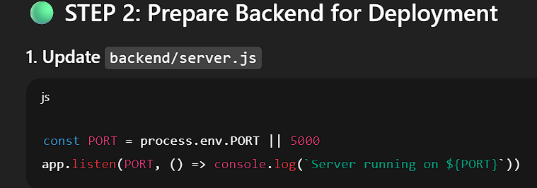
3. Add package.json start script
"scripts": {
"start": "node server.js"
}
4.on Render – ai services
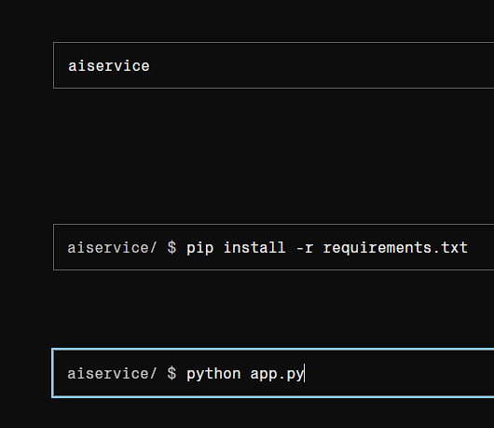

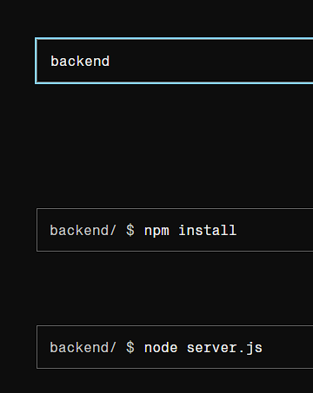
Then backend-

Backend link :- https://campus-learn-lms.onrender.com
Frontend link :- https://campus-learn-lms-zqft.vercel.app/

Ai services link :-

Error:- deployment
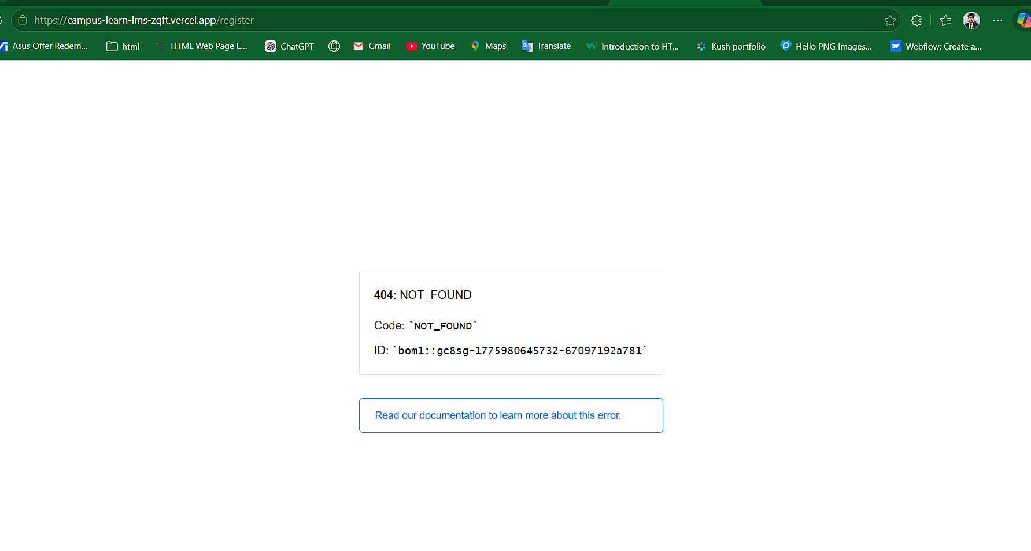
- 404: NOT_FOUND
→ The URL exists in browser, but Vercel cannot find that page.
Your URL:
https://campus-learn-lms-zqft.vercel.app/register
Vercel is saying:
“There is no /register page available in your deployed app.”
Solution:-
In vercel.json - frontend
{
"rewrites": [
{ "source": "/(.*)", "destination": "/" }
]
}
Basically – you have to add link of deploy backend on api.js of frontend .
- => No open ports detected, continuing to scan... ==> Docs on specifying a port: https://render.com/docs/web-services#port-binding ==> No open ports detected, continuing to scan... ==> Docs on specifying a port: https://render.com/docs/web-services#port-binding ==> No open ports detected, continuing to scan...
Solution:-

New feature :- track uploaded asignment link:
1.createassignment
2.assignmentSubmission
3.studentAssignment
4.TeacherAssingment
Improve registration :-
Otp verify :- registrationOtp.js
Update user.js
Update authRoute.js
- Register.jsx
:5000/api/auth/send-registration-otp:1 Failed to load resource: the server responded with a status of 503 (Service Unavailable)

