VISVESVARAYA TECHNOLOGICAL UNIVERSITY
Jnana Sangama, Belagavi – 590018
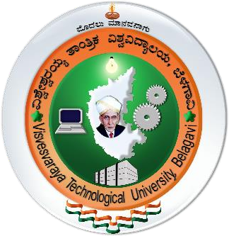

NSS ACTIVITY REPORT
on

ACTIVITY_TITLE
Submitted in partial fulfilment for the award of degree of

Bachelor of Engineering
in

DEPARTMENT

Submitted by
STUDENT_NAME
USN
Under the Guidance of

GUIDE_NAME DESIGNATION
DEPT
SaIT, Bengaluru


DEPARTMENT_NAME

SAMBHRAM INSTITUTE OF TECHNOLOGY

M. S. Palya, Bengaluru – 560097

ACADEMIC_YEAR

SAMBHRAM INSTITUTE OF TECHNOLOGY
M. S. Palya, Bengaluru – 560097

DEPARTMENT_NAME

CERTIFICATE
Certified that the NSS Activity entitled ACTIVITY_TITLE carried out by Mr. STUDENT_NAME, bearing the USN, a bonafide student of SAMBHRAM INSTITUTE OF TECHNOLOGY in partial fulfilment for the award of BACHELOR OF ENGINEERING IN DEPARTMENT_NAME of VISVESVARAYA TECHNOLOGICAL UNIVERSITY, Belgaum during the year ACADEMIC_YEAR. It is certified that all corrections/suggestions indicated for Internal Assessment have been incorporated in the report deposited in the departmental library. The report has been approved as it satisfies the academic requirements in respect of NSS activity prescribed for the said Degree.

GUIDE_NAME
Guide
DESIGNATION
Dept. of CSE
SaIT, Bengaluru
PROGRAM_OFFICER_NAME
Program Officer
National Service Scheme SaIT, Bengaluru

XYZHOD123

HOD
DEPT
SaIT, Bengaluru

PRINCIPLE_NAME
Principal SaIT, Bengaluru

