Kinematics of the myCobot 280 — A Worked Book
Forward & inverse kinematics, the velocity-propagation Jacobian, manipulability, and the code — in reference notation
For: Abhishek Roy
2026

Preface — how to read this book
This book explains the mathematics and the code of the myCobot 280 projects, in the notation of your reference notes (modified Denavit–Hartenberg, the velocity-propagation method). Read a chapter, then open the file it names and match each equation to the lines of code.
Two kinds of callouts appear throughout:
Key point. The one idea you must not miss.
Meaning. A plain-language reading of the symbols right after each equation.
Notation used throughout (from your reference notes):
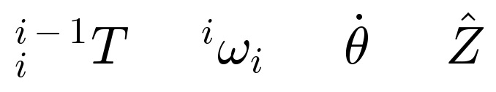
A leading super/subscript denotes the frame: the first symbol above is the transform from frame $i​−​1$ to frame $i$; the second is an angular velocity of link $i$, written in frame $i$. A dot is a time derivative (joint speed), a hat is a unit vector (the $z$-axis).

Chapter 1 — The robot and its frames
The myCobot 280 is a 6-joint (6-DOF) arm; every joint is revolute and turns about its own $z$-axis. To do kinematics we attach a coordinate frame to each link and describe how consecutive frames relate. We use the modified (Craig) Denavit–Hartenberg convention, which needs only two axes per frame ($x$ and $z$) and four numbers per joint:
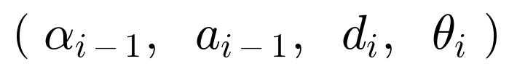
symbol | name | meaning
$α_{i−1}$ | link twist | angle from $Z_{i−1}$ to $Z_{i}$ about $X_{i−1}$
$a_{i−1}$ | link length | distance between the two $z$-axes along $X_{i−1}$
$d_{i}$ | link offset | distance from $X_{i−1}$ to $X_{i}$ along $Z_{i}$
$θ_{i}$ | joint angle | angle from $X_{i−1}$ to $X_{i}$ about $Z_{i}$ (the variable for a revolute joint)
Key point. For a revolute joint only $θ_{i}$ changes as the motor turns; $α_{i−1},a_{i−1},d_{i}$ are fixed by the robot’s geometry.
Meaning. Twist and length describe how one joint axis sits relative to the next; offset and angle describe how far and how much you travel along/around the joint axis to reach the next link.

Chapter 2 — Forward kinematics
Question. Given the six joint angles, where is the tool?
Each pair of frames is related by one modified-DH link transform — exactly the matrix in your notes:
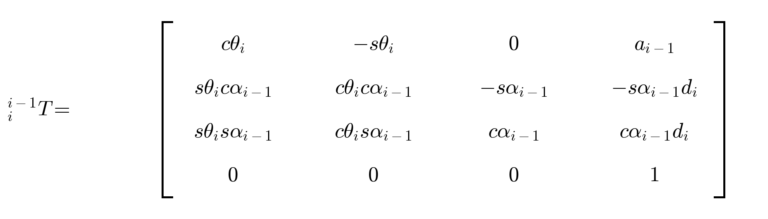
with $cθ=cosθ$, $sθ=sinθ$. Chaining the six link transforms from the base to the tool gives the full forward kinematics:
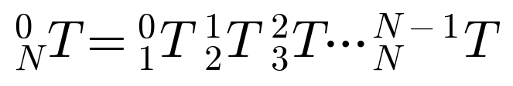
Key point. Forward kinematics is just a product of these link matrices. One set of joint angles gives exactly one tool pose.
Meaning. The top-left $3×3$ block of the tool transform $T$ is the tool’s orientation; the top-right $3×1$ block is its position.
In code (mycobot_thesis/robot.py): _dh_link(alpha, a, d, theta) builds one matrix above; fk_frames(q) multiplies them and returns every frame; and forward_kinematics(q) returns the last one, $​_{N}^{0}T$. The DH table (identified from the URDF, verified to ${10}^{−15} \text{m}$) is the array DH_TABLE.

Chapter 3 — The Jacobian (velocity-propagation method)
Question. How does the tool move when the joints move? The Jacobian $J\left(q\right)$ answers this, mapping joint speeds $\dot{q}$ to the tool’s linear and angular velocity (its twist).
Your notes build $J$ by propagating velocity outward, frame by frame. Angular velocity carries out and gains the new joint’s spin:
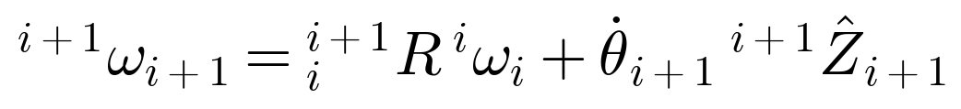
Linear velocity carries out, picking up the lever-arm cross-product, and gains a prismatic slide (zero for our revolute joints):
Meaning. The rotation $R$ carries a vector from frame $i$ into frame $i+1$; the cross-product $ω×P$ is the velocity a rotating link imparts at its far end; ${\dot{θ}}_{i+1}$ and ${\dot{d}}_{i+1}$ add the new joint’s own motion.
For an all-revolute arm this closes into the compact geometric Jacobian, whose $i$-th column is
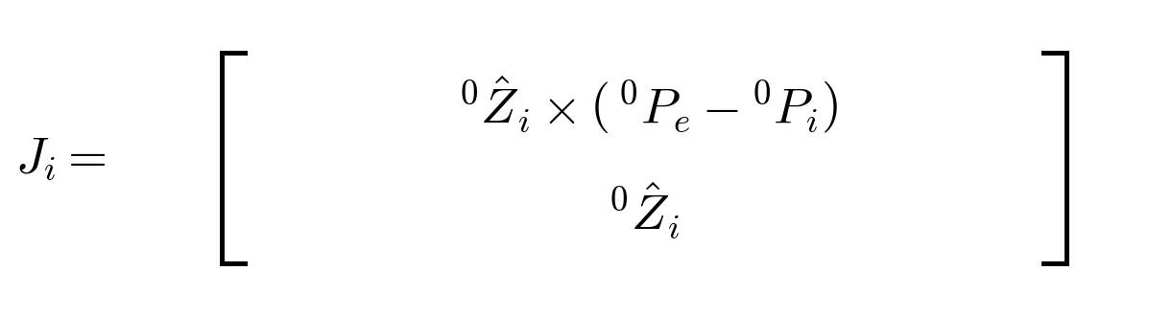
Key point. Column $i$ says: if only joint $i$ spins, the tool’s linear velocity is ${\hat{Z}}_{i}×\left(P_{e}−P_{i}\right)$ and its angular velocity is ${\hat{Z}}_{i}$.
In code (robot.py): jacobian(q) builds exactly these columns from the frame axes $z_{i}$ and origins $p_{i}$ returned by fk_frames. It is verified against a finite-difference Jacobian to $≈2.5×{10}^{−7}$.

Chapter 4 — Inverse kinematics
Question. We want the tool at a desired pose — which joint angles get there? There is no simple formula, so we iterate with damped least squares:
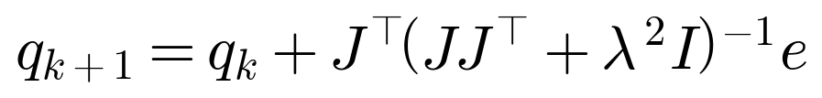
where $e$ is the 6-vector pose error (position + orientation) and $λ$ is a small damping constant.
Key point. The damping $λ^{2}I$ is what keeps the step finite near a singularity (where $J$ loses rank and a plain inverse blows up). It trades a tiny steady-state error for stability.
Meaning. Each step multiplies the pose error by a damped inverse of the Jacobian to get a joint correction, then repeats until the tool reaches the target.
In code (mycobot_thesis/ik.py): damped_least_squares(...) is the equation above; pseudoinverse, jacobian_transpose, and levenberg_marquardt are the alternatives compared in the thesis. Damped least squares was the most robust (98.7% success); see the figure below.
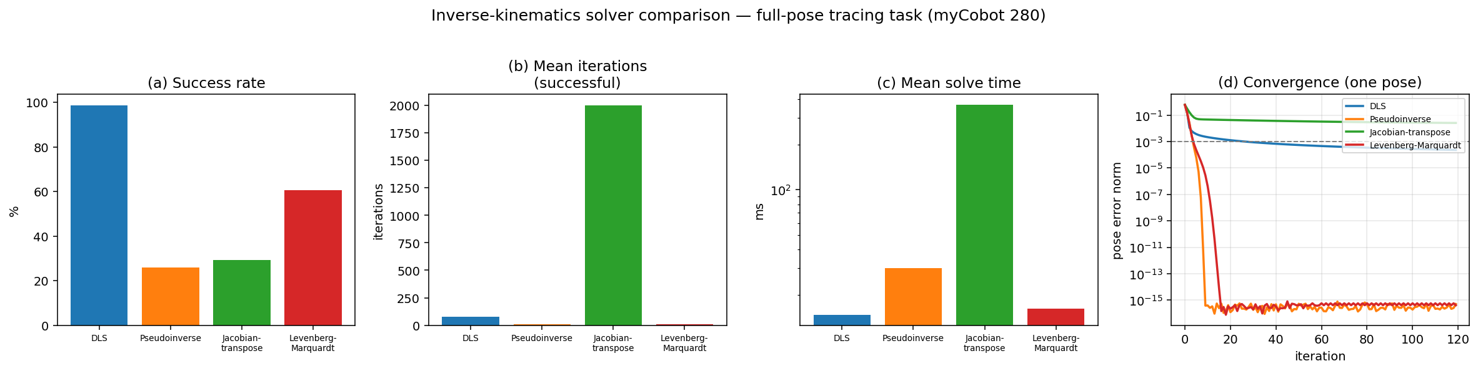

Chapter 5 — Manipulability and the task-constrained workspace
Not every reachable point is equally good, and — for drawing — not every reachable point can be reached with the pen perpendicular to the surface.
Dexterity. Yoshikawa manipulability and the condition number measure how far a configuration is from a singularity:
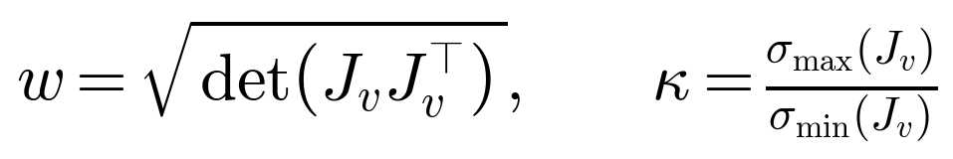
Meaning. $w→0$ (and $κ→∞$) at a singularity: the arm loses a direction of motion and IK becomes twitchy. Large $w$, small $κ$ = dexterous.
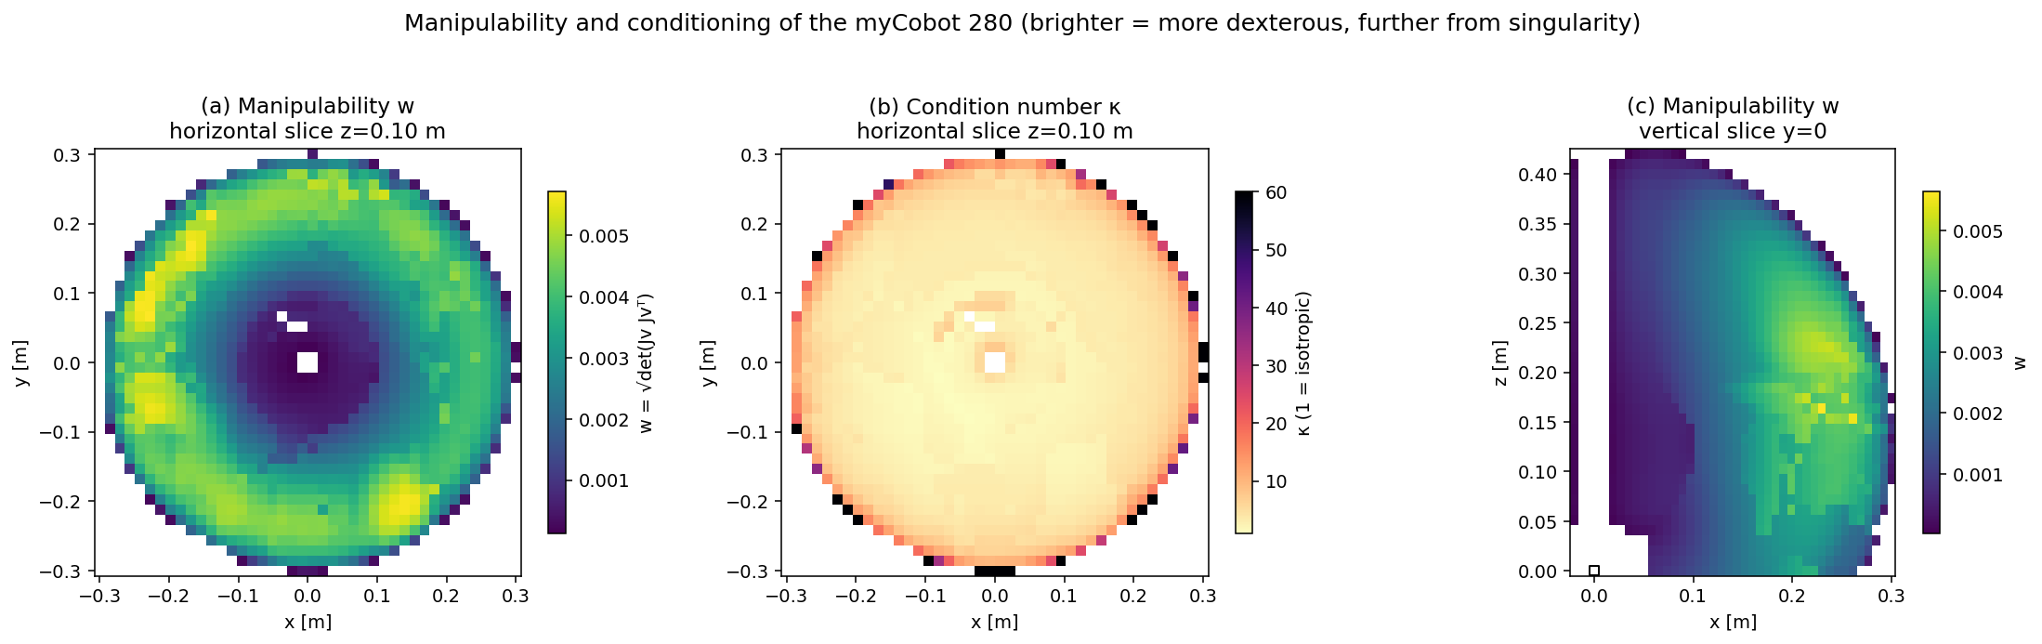
Drawable workspace. Given a surface with normal $n$, the positions the pen can reach while staying perpendicular form the task-constrained set
Key point. The reachable set $R$ and the drawable set $D\left(n\right)$ are different: $D\left(n\right)⊂R$, and the gap depends on the surface orientation.
For the myCobot: only $57.9\%$ of $R$ allows a perpendicular pen on a vertical surface ($35.2\%$ front-facing), and $63.5\%$ allows pen-down drawing on a horizontal table — an annulus around a dead zone above the base.
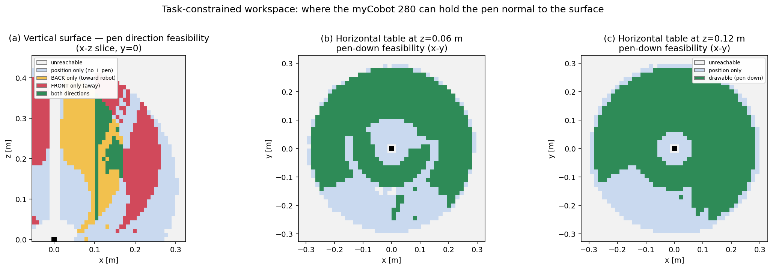

Chapter 6 — Reading the code
Every module mirrors a chapter. The library is pure math (no ROS); the nodes wrap it for live RViz.
mycobot_thesis/robot.py — the model (Chapters 2–3, 5).
- DH_TABLE — the identified modified-DH parameters $\left(α_{i−1},a_{i−1},d_{i},θ_{i}^{\text{off}}\right)$.
- _dh_link, fk_frames, forward_kinematics — the link matrix and the product.
- jacobian — the velocity-propagation columns.
- manipulability, condition_number — the dexterity metrics.
- target_orientation(normal, advance) — builds the pen-perpendicular target frame.
mycobot_thesis/ik.py — the solvers (Chapter 4). damped_least_squares and the three alternatives, each returning convergence info.
mycobot_thesis/draw_node.py — the ROS driver. It picks a surface preset, generates the sine targets, solves IK for each (warm-started), and streams /joint_states. The 'paper' preset uses a raised IK branch so the arm is opened toward $z$ while the pen traces the identical sine.
Key point. A ROS node is a thin wrapper: it calls the same robot/ik library the offline analysis uses, then publish()es. Same math, live robot.
Redundancy in action. A 6-DOF arm can reach the same tool pose with different postures (IK branches). Seeding the IK toward a raised branch keeps the drawn sine identical while lifting the elbow:
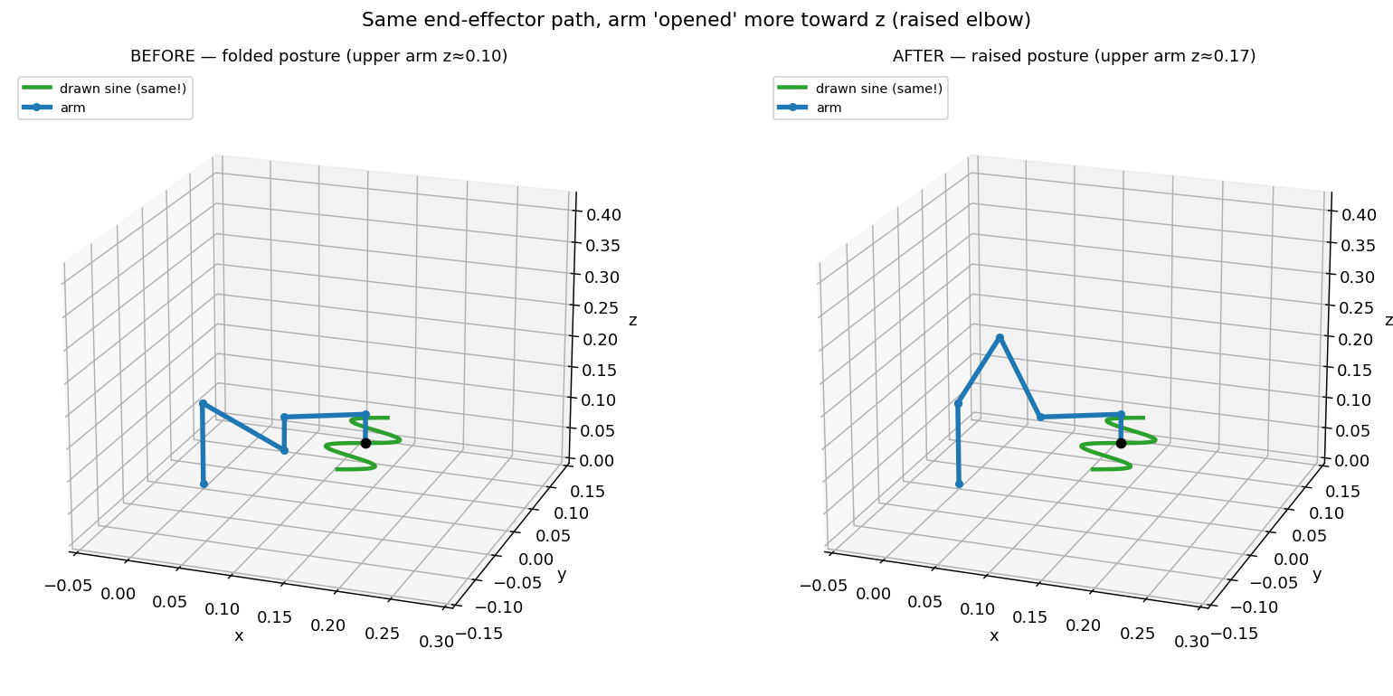
The live demo (ros2 launch mycobot_thesis thesis_draw.launch.py surface:=paper) writes the sine left-to-right on a table in front of the robot, raised posture:
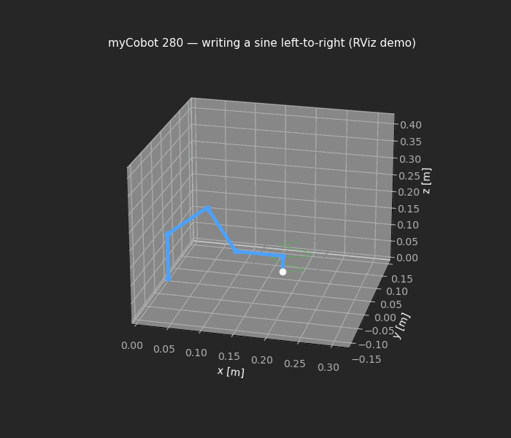

Appendix — Identified DH table and commands
$i$ | $α_{i−1}$ (°) | $a_{i−1}$ (m) | $d_{i}$ (m) | $θ_{i}^{\text{off}}$ (°)
1 | 0 | 0 | 0.13056 | +90
2 | +90 | 0 | 0 | −90
3 | 0 | −0.1104 | 0 | 0
4 | 0 | −0.096 | 0.06062 | −90
5 | +90 | 0 | 0.07318 | +90
6 | −90 | 0 | 0.0456 | 0
# analysis (pure Python)
cd ~/ros2_ws/src/mycobot_thesis
python3 analysis/exp1_feasibility.py # task-constrained workspace
python3 analysis/exp2_ik_comparison.py # IK solver comparison
# live drawing in RViz
cd ~/ros2_ws && colcon build --packages-select mycobot_thesis && source install/setup.bash
bash src/mycobot_thesis/scripts/run_thesis_demo.sh surface:=paper

