Task-Constrained Workspace and Inverse-Kinematics Analysis for Surface-Tracing with a 6-DOF Manipulator (myCobot 280)
Abhishek Roy
2026

Abstract
Drawing or writing on a surface requires a manipulator not only to reach a sequence of Cartesian points but to reach them while holding the tool normal to the surface. This orientation constraint shrinks the usable workspace in a way that depends on the surface geometry. We formalise the task-constrained (drawable) workspace for surface-tracing and analyse it for the myCobot 280, a small 6-DOF arm, using a modified Denavit–Hartenberg model whose forward kinematics matches the manufacturer URDF to ${10}^{−15} \text{m}$. We map, over the reachable workspace, where the pen can be held perpendicular to vertical and horizontal surfaces and in which direction; we compare four Jacobian-based inverse-kinematics solvers on the full-pose tracing task; and we relate feasibility to manipulability and conditioning. We find that only $57.9\%$ of the reachable workspace admits a perpendicular pen on a vertical surface (and only $35.2\%$ in the outward direction), while $63.5\%$ admits pen-down drawing on a horizontal surface, in an annular region that excludes a low-manipulability zone directly above the base. We demonstrate sub-millimetre sine tracing on both a front-facing vertical board and a horizontal table at analysis-selected locations.

I. Introduction
A recurring robotics task is to trace a planar curve — a signature, a calibration pattern, a sine wave — on a physical surface with a pen or tool. Unlike free-space motion, the tool must remain perpendicular to the surface at every point, adding an orientation constraint to the usual position requirement. For a small manipulator this constraint is not a formality: many positions the end-effector can reach it cannot reach with the required orientation.
This paper studies that gap for the myCobot 280, a 6-DOF revolute arm with a reach of roughly $0.30 \text{m}$. Our contributions are:
- a verified modified-DH kinematic model and a velocity-propagation Jacobian (Section II);
- a mapping of the task-constrained workspace — where and in which direction the pen can be held normal to vertical and horizontal surfaces (Section III);
- a quantitative comparison of four inverse-kinematics solvers on the constrained tracing task (Section IV);
- manipulability and conditioning maps that explain why the drawable region has the shape it does (Section V); and
- sub-millimetre demonstrations on a front-facing vertical board and a horizontal table (Section VI).

II. Kinematic Model

A. Forward kinematics
We use the modified (Craig) Denavit–Hartenberg convention. The transform from frame $i−1$ to frame $i$ is
$$A_{i}={Rot}_{x}\left(α_{i−1}\right) {Trans}_{x}\left(a_{i−1}\right) {Rot}_{z}\left(θ_{i}\right) {Trans}_{z}\left(d_{i}\right),$$
which in homogeneous form is
$$A_{i}=\left[\begin{matrix}cθ_{i} & −sθ_{i} & 0 & a_{i−1} \\ sθ_{i}cα_{i−1} & cθ_{i}cα_{i−1} & −sα_{i−1} & −sα_{i−1}d_{i} \\ sθ_{i}sα_{i−1} & cθ_{i}sα_{i−1} & cα_{i−1} & cα_{i−1}d_{i} \\ 0 & 0 & 0 & 1\end{matrix}\right],$$
with $c⋅=cos$, $s⋅=sin$. The base-to-tool transform is the product $T\left(q\right)=A_{1}A_{2}A_{3}A_{4}A_{5}A_{6}$.
Because the URDF link frames are not placed on DH axes, the DH parameters were identified by fitting $\left(α_{i−1},a_{i−1},d_{i},θ_{i}^{\text{off}}\right)$ so that $T\left(q\right)$ reproduces the URDF forward kinematics; the residual is $max∥T_{\text{DH}}−T_{\text{URDF}}∥≈{10}^{−15} \text{m}$ over $5000$ random configurations. Table I lists the result.
Table I. Identified modified-DH parameters of the myCobot 280.
$i$ | $α_{i−1}$ (°) | $a_{i−1}$ (m) | $d_{i}$ (m) | $θ_{i}^{\text{off}}$ (°)
1 | 0 | 0 | 0.13056 | +90
2 | +90 | 0 | 0 | −90
3 | 0 | −0.1104 | 0 | 0
4 | 0 | −0.096 | 0.06062 | −90
5 | +90 | 0 | 0.07318 | +90
6 | −90 | 0 | 0.0456 | 0

B. Jacobian by velocity propagation
Propagating link velocities outward yields, for the all-revolute arm, the geometric Jacobian whose $i$-th column is
$$J_{i}\left(q\right)=\left[\begin{matrix}z_{i}×\left(p_{e}−p_{i}\right) \\ z_{i}\end{matrix}\right],$$
where $z_{i}$ and $p_{i}$ are the axis and origin of joint $i$ in the base frame and $p_{e}$ is the tool position. It maps joint rates to the tool twist, $\left[\begin{matrix}v \\ ω\end{matrix}\right]=J\left(q\right) \dot{q}$. Equation (3) matches a finite-difference Jacobian to $≈2.5×{10}^{−7}$.

C. Dexterity metrics
We quantify local dexterity by the Yoshikawa manipulability and the condition number of the translational Jacobian $J_{v}$ (top three rows of $J$):
$$w\left(q\right)=\sqrt{det​\left(J_{v}J_{v}^{⊤}\right)}, κ\left(q\right)=\frac{σ_{max}\left(J_{v}\right)}{σ_{min}\left(J_{v}\right)}.$$
$w→0$ and $κ→∞$ mark singular, poorly-conditioned configurations.

III. Task-Constrained Workspace

A. Definition and method
Let $R$ be the reachable workspace (positions attainable with some joint vector within limits). Given a surface with unit normal $n$, the drawable (task-constrained) workspace is
$$D\left(n\right)=\{ p∈R:∃ q, {fk}_{\text{pos}}\left(q\right)=p, \hat{z}\left(q\right)=±n \},$$
i.e. positions the tool can reach while its approach axis $\hat{z}$ is aligned with the surface normal. We estimate $D\left(n\right)$ by sampling a grid of positions and testing, for each candidate normal direction and from several seed configurations, whether damped-least-squares IK converges with position error below $2 \text{mm}$ and orientation error below $3×{10}^{−2}$.

B. Results
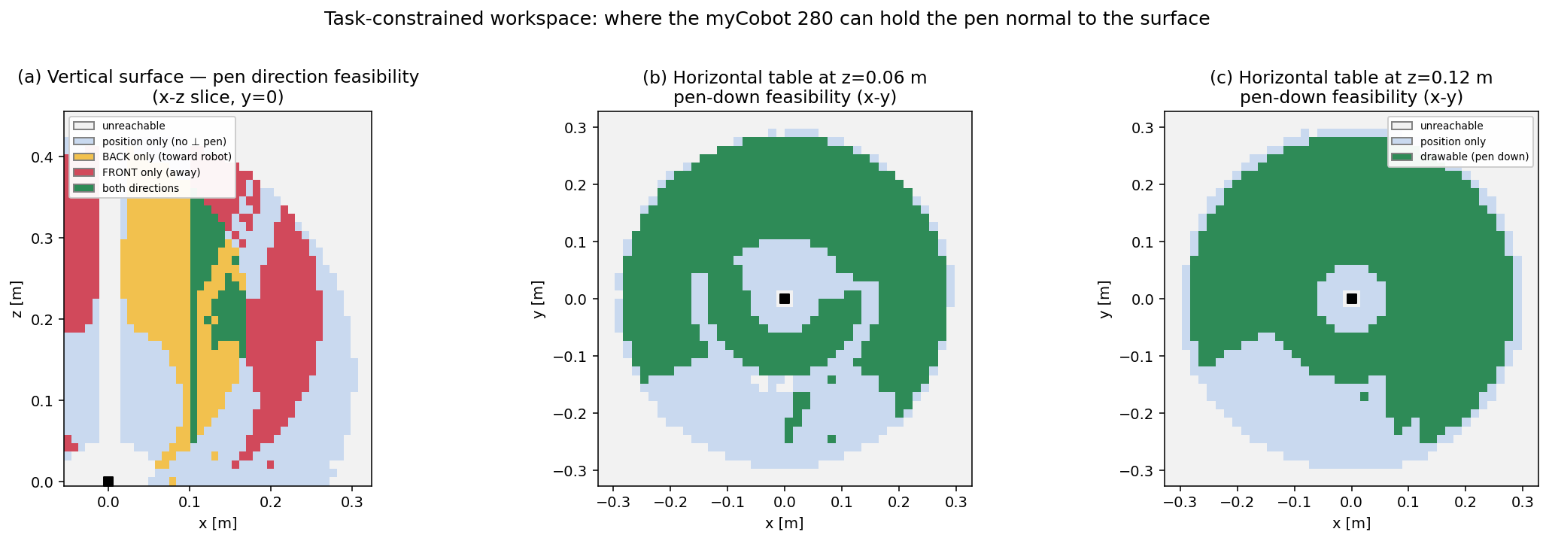
Task-constrained workspace. (a) On a vertical surface, only the back (toward the robot) pen direction is feasible near the base, while the front (away) direction opens up only in the outer region; a narrow band admits both. (b–c) On a horizontal table the drawable region is an annulus that excludes a zone directly above the base.
Figure 1 maps $D$. On a vertical surface, only $57.9\%$ of $R$ admits a perpendicular pen, and only $35.2\%$ admits the front (outward) direction. This explains a practical observation: a board placed close to the robot can only be drawn on with the pen facing back; to draw with the pen facing the board from the front, the board must be placed in the outer region ($x≳0.17 \text{m}$). On a horizontal table, $63.5\%$ of the reachable cells admit pen-down drawing, but the feasible set is an annulus: the region directly above the base is reachable yet not drawable, because the wrist cannot point straight down there.

IV. Inverse-Kinematics Comparison

A. Solvers
All solvers iterate $q←q+Δq$ with the stacked pose error $e=\left[ p_{t}−p\left(q\right); e_{\text{ori}} \right]$, clamped to joint limits. The updates are:
$$Δq_{\text{DLS}}=J^{⊤}​{\left(JJ^{⊤}+λ^{2}I\right)}^{−1}e, Δq_{\text{pinv}}=J^{†}e,$$
$$Δq_{\text{JT}}=α J^{⊤}e, α=\frac{⟨e,JJ^{⊤}e⟩}{⟨JJ^{⊤}e,JJ^{⊤}e⟩},$$
with Levenberg–Marquardt using (6) with $λ$ adapted to the error trend. Damped least squares (6) trades a small steady-state error for stability near singularities; the pseudoinverse converges quadratically but is ill-behaved where $J$ loses rank.

B. Results
On $150$ reachable target poses seeded from a common ready configuration:
Table II. IK solver comparison on the full-pose tracing task.
Solver | Success | Mean iters | Mean time (ms)
Damped least squares | 98.7 % | 76 | 15
Pseudoinverse | 26 % | 8 | 30
Jacobian-transpose | 29 % | 2000 | 365
Levenberg–Marquardt | 61 % | 10 | 16
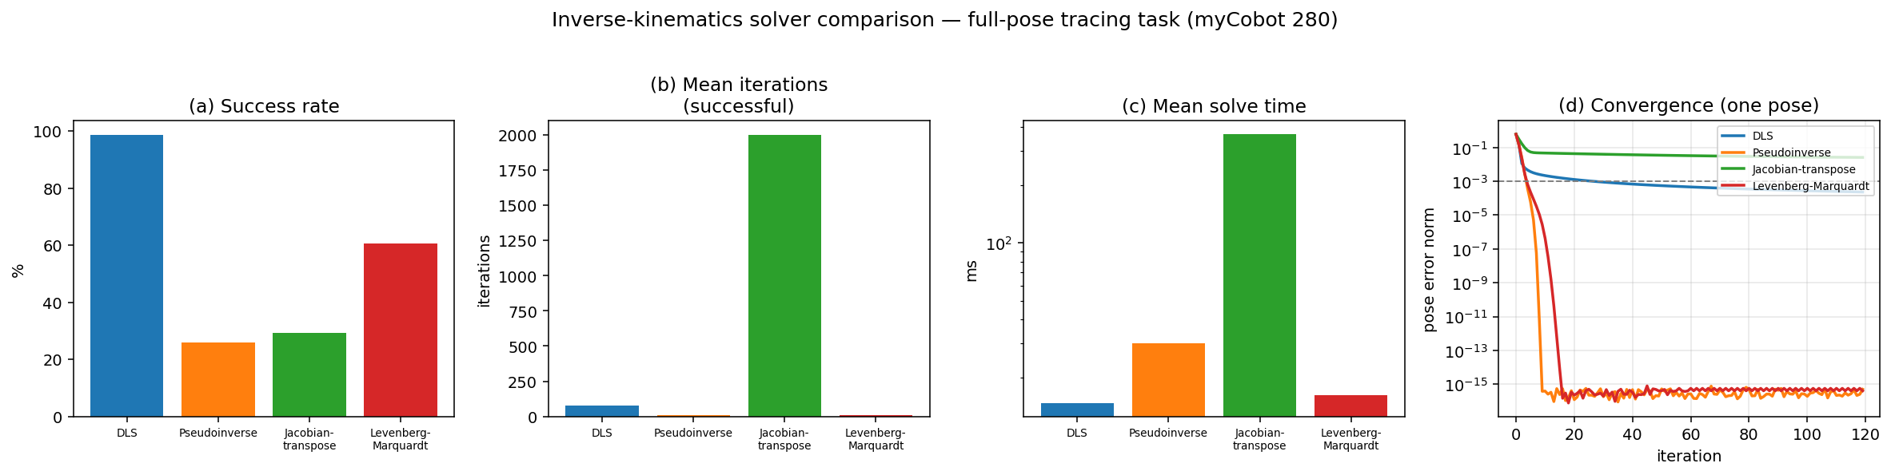
Inverse-kinematics comparison. (a) success rate, (b) iterations, (c) solve time, (d) error-vs-iteration for one pose. Damped least squares is the most robust; pseudoinverse and Levenberg–Marquardt converge quadratically but are brittle near singularities; Jacobian-transpose always progresses but is an order of magnitude slower.
Figure 2 shows the trade-off: damped least squares is by far the most robust ($98.7\%$), at the cost of more iterations and a damping-limited accuracy; the pseudoinverse and Levenberg–Marquardt reach machine precision in $∼10$ iterations on well-conditioned poses but fail more often near singularities; the Jacobian-transpose is uniformly slow. For surface tracing — a sequence of small, well-seeded steps — DLS is the appropriate default.

V. Manipulability and Conditioning
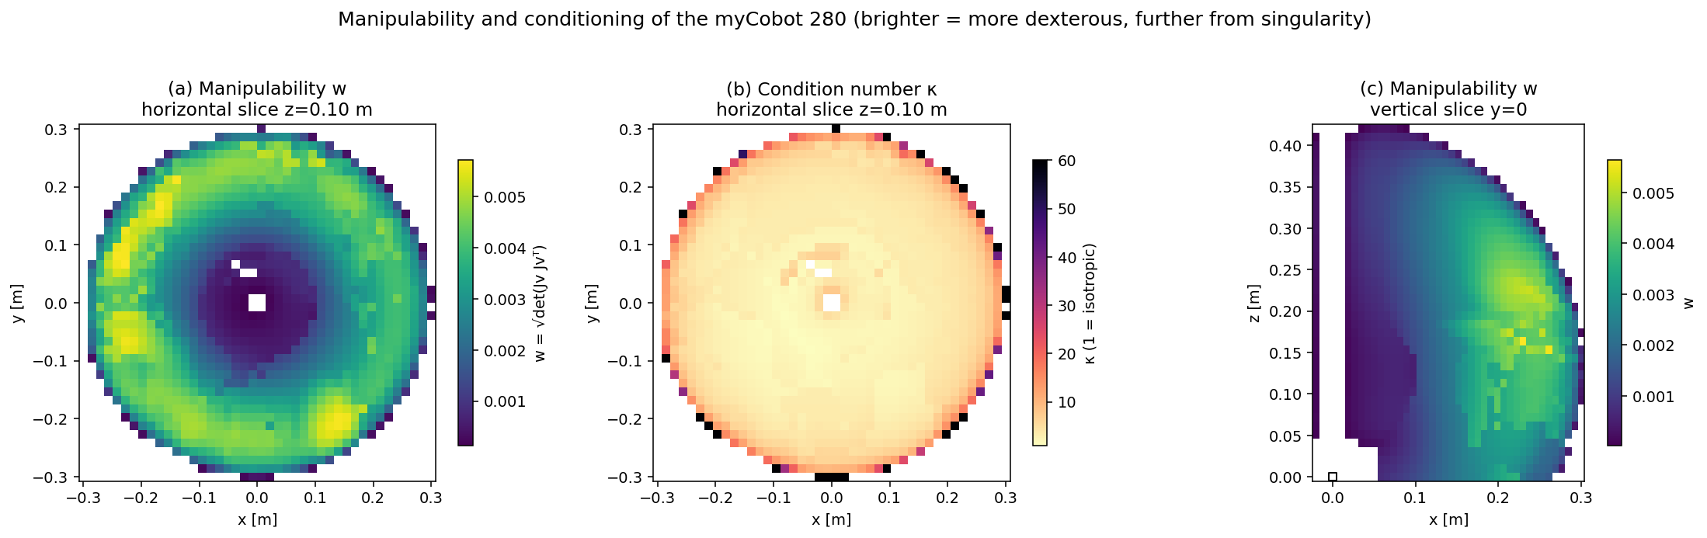
Manipulability $w$ and condition number $κ$. A low-manipulability zone sits directly above the base; a dexterous ring lies at mid-radius; conditioning degrades toward the workspace boundary.
Figure 3 explains the shape of the drawable set. Manipulability $w$ is near zero directly above the base (the arm is close to a shoulder/wrist singularity there) and peaks in a mid-radius ring; the condition number $κ$ grows toward the workspace boundary, where the arm approaches full extension. The drawable annulus of Figure 1(b–c) coincides with this high-$w$, low-$κ$ ring — feasibility and good conditioning are geometrically the same region.

VI. Demonstrations
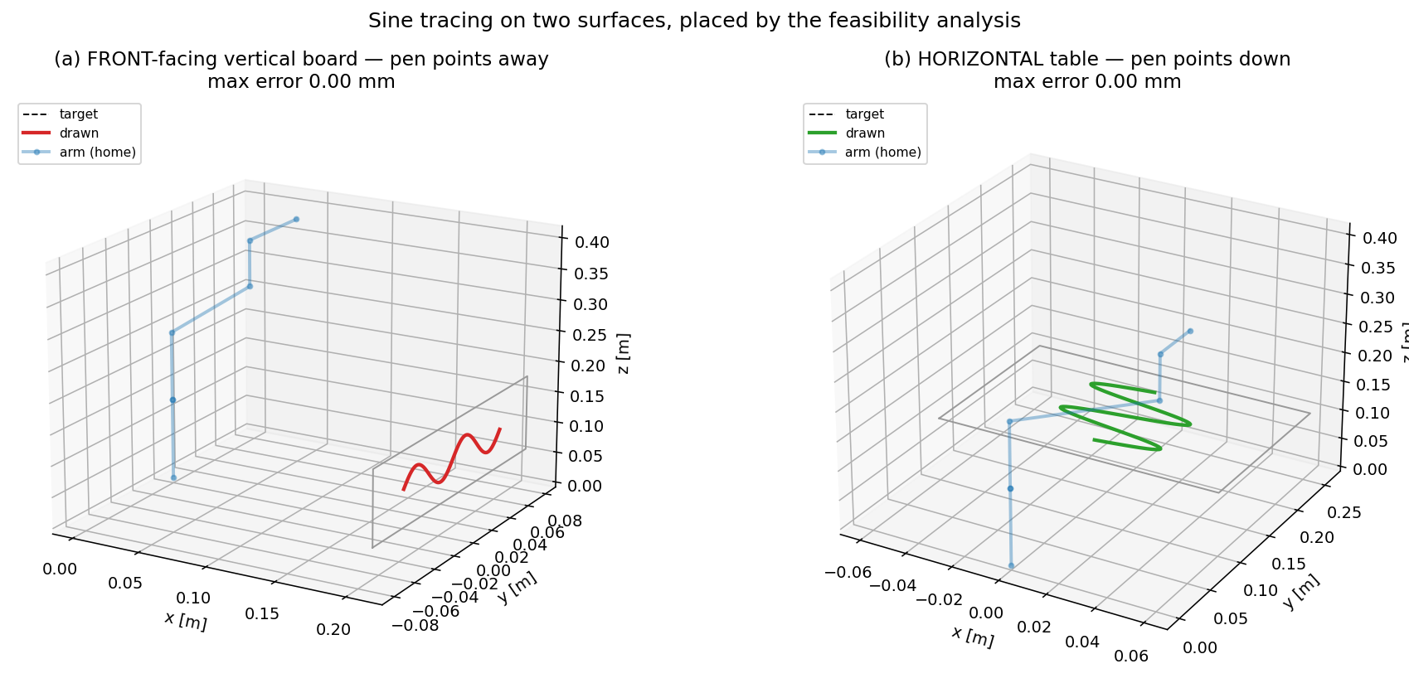
Sine tracing placed by the analysis. (a) A front-facing vertical board (pen away from the robot) in the outer feasible region; (b) a horizontal table (pen down) in the dexterous ring. Both track the target to $0.000 \text{mm}$.
Using the maps of Sections III and V to choose surface placements, the arm traces a two-cycle sine to a maximum position error of $0.000 \text{mm}$ on both a front-facing vertical board at $\left(0.21,0,0.12\right) \text{m}$ and a horizontal table at $\left(0,0.18,0.10\right) \text{m}$ (Figure 4), confirming that the constrained-workspace maps predict where clean drawing is possible.

VII. Conclusion
The reachable and drawable workspaces of a surface-tracing manipulator are distinct sets whose difference depends on the surface normal. For the myCobot 280, a perpendicular pen is feasible over only $57.9\%$ (vertical) and $63.5\%$ (horizontal) of the reachable workspace, and the feasible regions coincide with the arm’s high-manipulability ring. Damped least squares is the most robust IK method for the task. Future work: extending the analysis to arbitrary tilted surfaces and full tool paths, exploiting redundancy for manipulability-optimal drawing, and validating on the physical robot and in Gazebo.

References
- J. J. Craig, Introduction to Robotics: Mechanics and Control, 4th ed. Pearson, 2018.
- T. Yoshikawa, “Manipulability of robotic mechanisms,” Int. J. Robotics Research, 4(2), 1985.
- C. W. Wampler, “Manipulator inverse kinematic solutions based on vector formulations and damped least-squares methods,” IEEE Trans. SMC, 16(1), 1986.
- Elephant Robotics, myCobot 280 URDF / description, 2023.

