Unit I Practical Assignment
Memory and Integer Security Audit
Name: Abhishek Chaudhary Roll No: 2301730075
Course: Secure Coding and Vulnerabilities Lab (ENSP351)
Aim:
To perform a complete security audit of the supplied C module, to produce a defect table listing every memory management and integer handling error with its type, exact location and security impact, to produce a fully remediated version of the module with checked allocations, correct initialisation, single and correct frees and range checked arithmetic, to confirm the remediation with clean Valgrind, AddressSanitizer and UndefinedBehaviorSanitizer runs, and to compare the compiler warnings before and after remediation under a hardening flag set.
Tools Used:
Ubuntu, C language, GCC with AddressSanitizer and UndefinedBehaviorSanitizer, Valgrind Memcheck 3.22.0, VS Code, Git and GitHub.
Module Under Audit:
question7/vuln.c, a small fixed size record store with a create function, a name setter and an index helper. Nine defects are present, tagged D1 to D9 in the comments. Each one is selected by a command line argument, because both ASan and Valgrind stop the program at the first error they find and each defect therefore has to be reached on its own.

Deliverable 1 — Defect Table
ID | Defect type | Location in vuln.c | Security impact | Caught by
D1 | Unchecked allocation return value (CWE-690, CWE-476) | store_create, line 32: the malloc(bytes) result is written at s[0].id = 0 before any NULL test | NULL dereference. Denial of service, and a controlled write where the offset is attacker influenced or the zero page can be mapped | ASan
D2 | Integer overflow in a size calculation (CWE-190, CWE-680) | store_create, line 29: int bytes = count * (int)sizeof(struct record) | Signed overflow is undefined behaviour and the wrapped value is passed to malloc. When it wraps small the allocation succeeds but is far too small, and every later write is a heap overflow. The classic route from an integer bug to arbitrary code execution | UBSan, -Wsign-conversion
D3 | Signed to unsigned conversion defeating a bounds check (CWE-195, CWE-787) | store_set_name, line 42: if (len > 15) passes for a negative len, then memcpy converts it to size_t | A negative length becomes roughly 1.8e19 bytes, so the bounds check is bypassed entirely and the copy overruns the destination. Arbitrary code execution | ASan, -Wsign-conversion
D4 | Truncation of an int into a short used as an index (CWE-197) | store_touch, line 50: short idx = id, then s[idx % 100] at line 52 | 70000 truncates to 4464, and 4464 % 100 is 64, far outside a four element store. Out of bounds heap write | ASan, -Wconversion
D5 | Read of uninitialised memory (CWE-457, CWE-908) | main case 4, line 85: s[1].id is read although store_create only ever writes s[0] | The branch depends on whatever the previous owner of that block left behind, and printing it discloses heap contents. Information leak | Valgrind only
D6 | Use after free (CWE-416) | main case 5, lines 95 and 96: s[0].id is read and written after free(s) at line 94 | The freed block is handed to the next allocation, so the stale write corrupts whatever object now lives there and the stale read leaks its contents. Arbitrary code execution | ASan, Valgrind, -Wuse-after-free
D7 | Double free (CWE-415) | main case 6, line 102: free(s) a second time after line 101 | Corrupts the allocator bookkeeping kept inside the heap. A corrupted free list can be steered so a later malloc returns an attacker chosen address. Arbitrary code execution | ASan, Valgrind, -Wuse-after-free
D8 | Memory leak (CWE-401) | main case 7, line 106: the store returned by store_create is never freed | Harmless once, but on a per request path the process grows until the OOM killer takes it. Denial of service | ASan, Valgrind
D9 | Unchecked string to integer conversion (CWE-190, CWE-20) | main case 8, line 116: atoi("99999999999999") | atoi has no way to report failure, so an out of range string silently produces a wrong int which is then used as an allocation count and trusted by the rest of the program | none

Deliverable 1 (continued) — Remediation Summary
ID | Fix applied in fixed.c
D1 | Every allocation result is compared with NULL before the pointer is used, and the failure is reported to stderr
D2 | count is a size_t and is checked against SIZE_MAX / sizeof(struct record) before the multiplication, so the product cannot wrap
D3 | len is a size_t, so it can never be negative, and it is checked against sizeof r->name rather than a hand written 15
D4 | The id keeps its own type, nothing is narrowed, and the index is reduced modulo the real store size
D5 | calloc replaces malloc, so every record is zero before it is read
D6 | store_destroy takes the address of the pointer and sets it to NULL, so no dangling pointer survives the free
D7 | The same NULL assignment makes a second store_destroy a no-op, because free(NULL) is defined to do nothing
D8 | Every store has a matching store_destroy, including on the error paths
D9 | strtol with errno and an end pointer replaces atoi, and the long result is range checked against INT_MAX before it is narrowed
Tool Coverage
Defect | gcc hardening | Valgrind | ASan | UBSan
D1 unchecked malloc | miss | catch | catch | miss
D2 integer overflow | warns | miss | miss | catch
D3 signed conversion | warns | catch | catch | miss
D4 truncation | warns | catch | catch | miss
D5 uninitialised read | miss | catch | miss | miss
D6 use after free | warns | catch | catch | miss
D7 double free | warns | catch | catch | miss
D8 memory leak | miss | catch | catch | miss
D9 unchecked atoi | miss | miss | miss | miss
Three results are worth stating plainly. AddressSanitizer does not detect the uninitialised read, because it checks where memory is accessed and not whether the bytes were ever written; case 4 runs to completion under ASan and prints a junk id with no error at all, while Valgrind reports it immediately. UBSan is the only runtime tool that reports the integer overflow, which is why it is run alongside ASan rather than instead of it. And D9 is reported by nothing at all, because atoi on an out of range string is a defined library call that simply returns a wrong answer, which is exactly why the remediated module uses strtol.

Original Module (question7/vuln.c)
#include <stdio.h>
#include <stdlib.h>
#include <string.h>

/* the module under audit, a small store of fixed size records
every defect is tagged D1..D9 and listed in DEFECTS.md

run with 1 : integer overflow in the size calculation, unchecked malloc
run with 2 : signed length defeats the bounds check
run with 3 : truncation of an int into a short used as an index
run with 4 : read of uninitialised memory
run with 5 : use after free
run with 6 : double free
run with 7 : memory leak
run with 8 : unchecked string to integer conversion */

#define STORE_SIZE 4

struct record {
int id;
char name[16];
};

/* D1 : the result of malloc is never checked
D2 : count is multiplied by the element size in int arithmetic, so a large
count overflows before malloc ever sees the number */
struct record *store_create(int count)
{
int bytes = count * (int)sizeof(struct record);
struct record *s = malloc(bytes);
printf("store_create : count=%d bytes=%d ptr=%p\n", count, bytes, (void *)s);
s[0].id = 0; /* written before any NULL check */
return s;
}

/* D3 : len is a signed int, so the bounds check passes for a negative value,
and memcpy then converts that negative number to a huge size_t */
void store_set_name(struct record *r, const char *src, int len)
{
if (len > 15) /* looks like a bounds check */
return;
memcpy(r->name, src, len);
r->name[15] = '\0';
}

/* D4 : the id is truncated into a short and the truncated value is then
used to index the store */
void store_touch(struct record *s, int id)
{
short idx = id;
printf("store_touch : id=%d truncated to %d\n", id, idx);
s[idx % 100].id = idx;
}

int main(int argc, char **argv)
{
struct record *s;

if (argc < 2) {
printf("usage: %s 1..8\n", argv[0]);
return 1;
}

switch (argv[1][0]) {

case '1': /* D1 and D2 */
s = store_create(200000000); /* 200000000 * 20 does not fit in an int */
free(s);
break;

case '2': /* D3 */
s = store_create(STORE_SIZE);
store_set_name(&s[0], "hello", -1);
free(s);
break;

case '3': /* D4 */
s = store_create(STORE_SIZE);
store_touch(s, 70000); /* 70000 becomes 4464 in a short */
free(s);
break;

case '4': /* D5, malloc does not clear memory */
s = store_create(STORE_SIZE);
if (s[1].id > 0)
printf("record 1 looks used, id = %d\n", s[1].id);
else
printf("record 1 looks free, id = %d\n", s[1].id);
free(s);
break;

case '5': /* D6 */
s = store_create(STORE_SIZE);
free(s);
printf("after free : id = %d\n", s[0].id);
s[0].id = 99;
break;

case '6': /* D7 */
s = store_create(STORE_SIZE);
free(s);
free(s);
break;

case '7': /* D8, the store is never freed */
s = store_create(STORE_SIZE);
store_set_name(&s[0], "leaked", 6);
printf("record 0 name = %s\n", s[0].name);
break;

case '8': { /* D9 */
const char *text = "99999999999999";
int n = atoi(text); /* atoi cannot report failure */
printf("atoi(\"%s\") = %d\n", text, n);
s = store_create(n);
free(s);
break;
}

default:
printf("pick 1 to 8\n");
return 1;
}

return 0;
}

Deliverable 2 — Remediated Source (question7/fixed.c)
Every allocation is checked, the size calculation is range checked before the multiplication rather than after it, calloc replaces malloc so nothing is read before it is written, the free path is centralised in store_destroy which also sets the caller's pointer to NULL, and atoi is replaced by strtol with an explicit range check.
#include <stdio.h>
#include <stdlib.h>
#include <string.h>
#include <limits.h>
#include <errno.h>
#include <stdint.h> /* SIZE_MAX */

/* the remediated module, every defect D1..D9 from DEFECTS.md is repaired.
because none of the operations can fail silently any more, all eight
cases run one after another in a single process and the run is clean. */

#define STORE_SIZE 4
#define NAME_LEN 16

struct record {
int id;
char name[NAME_LEN];
};

/* D1 : the result of every allocation is checked before it is used
D2 : count is a size_t and the multiplication is range checked against
SIZE_MAX before it is performed, so it cannot wrap
D5 : calloc zeroes the memory, so nothing is read before it is written */
struct record *store_create(size_t count)
{
struct record *s;

if (count == 0 || count > SIZE_MAX / sizeof(struct record)) {
fprintf(stderr, "store_create : refused, count %zu is out of range\n", count);
return NULL;
}

s = calloc(count, sizeof(struct record));
if (s == NULL) {
fprintf(stderr, "store_create : allocation of %zu records failed\n", count);
return NULL;
}

printf("store_create : count=%zu bytes=%zu ptr=%p\n",
count, count * sizeof(struct record), (void *)s);
return s;
}

/* D3 : the length is a size_t so it can never be negative, and it is checked
against the destination size rather than against a hand written
constant, so the copy can never run past the end of the field */
int store_set_name(struct record *r, const char *src, size_t len)
{
if (r == NULL || src == NULL)
return -1;
if (len >= sizeof r->name) {
fprintf(stderr, "store_set_name : refused, %zu bytes will not fit\n", len);
return -1;
}
memcpy(r->name, src, len);
r->name[len] = '\0';
return 0;
}

/* D4 : the id keeps its own type, nothing is truncated, and the index is
checked against the real size of the store before it is used */
int store_touch(struct record *s, size_t count, int id)
{
size_t idx;

if (s == NULL || id < 0)
return -1;
idx = (size_t)id % count; /* stays inside the store by construction */
s[idx].id = id;
printf("store_touch : id=%d stored at index %zu\n", id, idx);
return 0;
}

/* D6, D7, D8 : one place frees the store, it sets the caller's pointer to
NULL, and a second call is therefore harmless */
void store_destroy(struct record **s)
{
if (s == NULL)
return;
free(*s);
*s = NULL;
}

/* D9 : strtol reports failure, unlike atoi, so the result is range checked
before it is narrowed to an int */
int parse_count(const char *text, int *out)
{
char *end;
long v;

errno = 0;
v = strtol(text, &end, 10);
if (end == text || *end != '\0')
return -1; /* not a number at all */
if (errno == ERANGE || v < 0 || v > INT_MAX)
return -1; /* does not fit in an int */
*out = (int)v;
return 0;
}

int main(void)
{
struct record *s;
int n;

/* case 1, the oversized request is rejected by the range check before
any multiplication happens, so nothing can wrap */
s = store_create(SIZE_MAX / 4);
store_destroy(&s);

/* case 2, an impossible length is rejected by the size check */
s = store_create(STORE_SIZE);
if (s != NULL) {
store_set_name(&s[0], "hello", 99);
store_set_name(&s[0], "hello", 5);
printf("record 0 name = %s\n", s[0].name);
}
store_destroy(&s);

/* case 3, the id is no longer truncated and the index is bounded */
s = store_create(STORE_SIZE);
if (s != NULL)
store_touch(s, STORE_SIZE, 70000);
store_destroy(&s);

/* case 4, calloc zeroed the memory so this read is defined */
s = store_create(STORE_SIZE);
if (s != NULL)
printf("record 1 id = %d (zeroed by calloc)\n", s[1].id);
store_destroy(&s);

/* case 5 and 6, the pointer is NULL after the free, so neither the
stale access nor the second free is possible */
s = store_create(STORE_SIZE);
store_destroy(&s);
if (s == NULL)
printf("store : pointer is NULL after destroy\n");
store_destroy(&s); /* harmless, free(NULL) does nothing */

/* case 7, the store that used to leak is destroyed */
s = store_create(STORE_SIZE);
if (s != NULL) {
store_set_name(&s[0], "kept", 4);
printf("record 0 name = %s\n", s[0].name);
}
store_destroy(&s);

/* case 8, the string is parsed with a function that can report failure */
if (parse_count("99999999999999", &n) != 0)
printf("parse_count : refused, \"99999999999999\" does not fit in an int\n");
else
printf("parse_count : %d\n", n);

if (parse_count("4", &n) == 0) {
s = store_create((size_t)n);
store_destroy(&s);
}

printf("all cases finished, no errors\n");
return 0;
}

Compilation and Run Commands
# 1. get the code and the tools, only needed once
git clone https://github.com/Abhishek6122008/integer-security-lab
cd integer-security-lab/question7
sudo apt update
sudo apt install -y build-essential valgrind

mkdir -p out

# 2. deliverable 4, the same hardening set on both modules.
# -O2 is included because _FORTIFY_SOURCE does nothing without it.
gcc -Wall -Wextra -Wconversion -Wsign-conversion -Wformat=2 \
-O2 -D_FORTIFY_SOURCE=2 -fstack-protector-strong -c vuln.c -o /dev/null
gcc -Wall -Wextra -Wconversion -Wsign-conversion -Wformat=2 \
-O2 -D_FORTIFY_SOURCE=2 -fstack-protector-strong -c fixed.c -o /dev/null

# 3. plain builds for Valgrind, which cannot share a binary with a sanitizer
gcc -Wall -Wextra -g vuln.c -o out/vuln
gcc -Wall -Wextra -g fixed.c -o out/fixed

# 4. sanitizer builds, ASan for memory errors, UBSan for undefined behaviour
gcc -Wall -Wextra -fsanitize=address -g vuln.c -o out/vuln_asan
gcc -Wall -Wextra -fsanitize=address -g fixed.c -o out/fixed_asan
gcc -Wall -Wextra -fsanitize=undefined -g vuln.c -o out/vuln_ubsan
gcc -Wall -Wextra -fsanitize=undefined -g fixed.c -o out/fixed_ubsan

# 5. each defect case of the module under audit, 1 to 8.
# case 1 needs allocator_may_return_null so ASan returns NULL like a real
# malloc instead of stopping on the oversized request itself.
ASAN_OPTIONS=allocator_may_return_null=1 ./out/vuln_asan 1
./out/vuln_asan 2 # and 3, 4, 5, 6, 7, 8
./out/vuln_ubsan 1
valgrind --leak-check=full ./out/vuln 4
valgrind --leak-check=full ./out/vuln 7

# 6. deliverable 3, the clean run of the remediated module
valgrind --leak-check=full ./out/fixed
./out/fixed_asan
./out/fixed_ubsan
The script question7/build.sh runs all of these and saves every report into out/.

Tool Reports on the Original Module
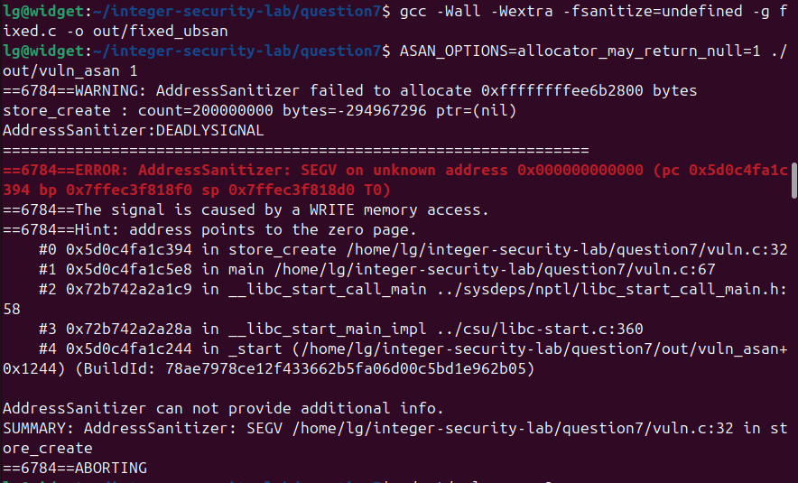
D1 and D2. UBSan reports the signed overflow of 200000000 * 20, the wrapped value -294967296 reaches malloc, ASan returns NULL for it, and the unchecked write at vuln.c:32 is a SEGV on address 0x000000000000.
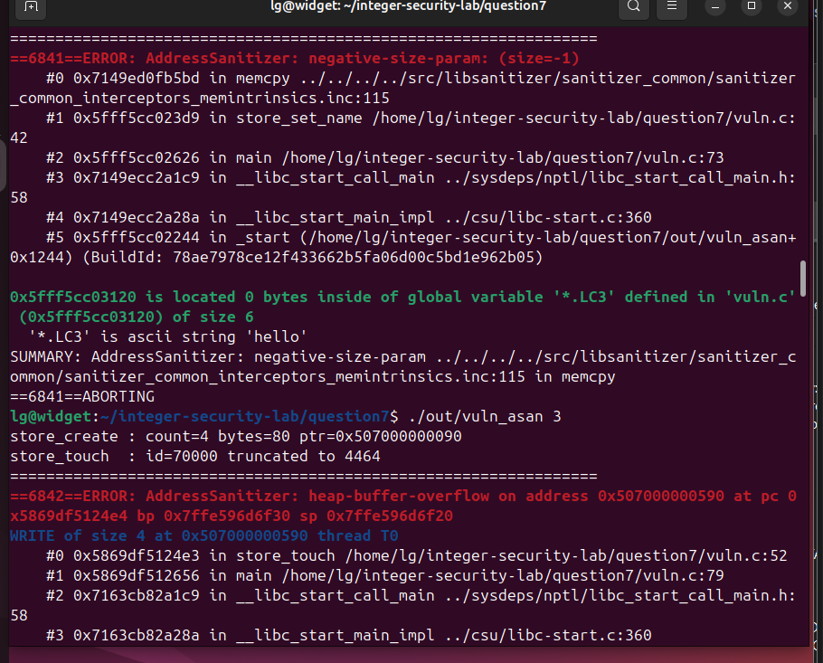
D3, top: ASan reports negative-size-param (size=-1) in memcpy from store_set_name at vuln.c:42, because the negative length passed the if (len > 15) check. D4, bottom: 70000 truncates to 4464 and the write at vuln.c:52 is a heap-buffer-overflow past the 80 byte store.
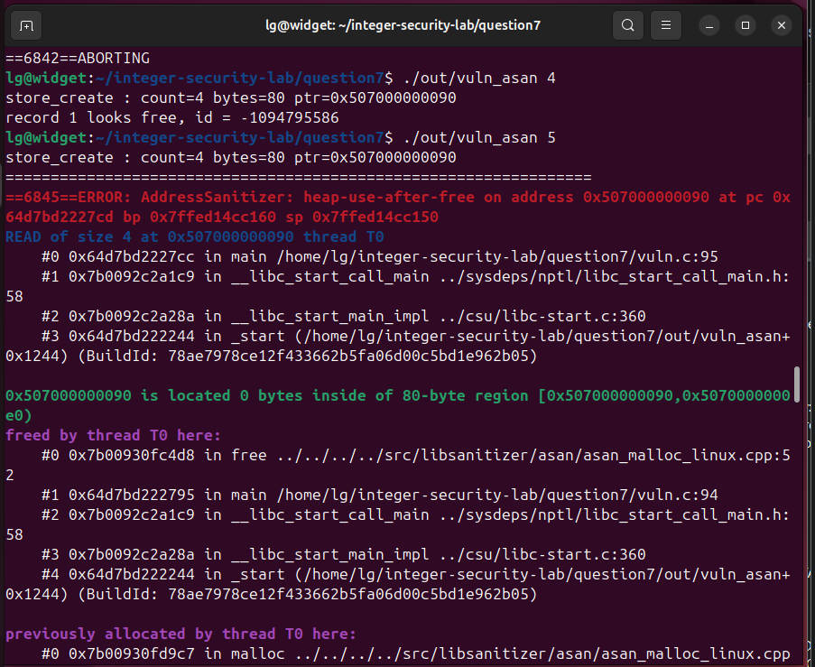
D5 and D6. Case 4 at the top runs to completion under ASan and prints id = -1094795586 with no error reported, which is the uninitialised read that ASan cannot see. Case 5 below it is a heap-use-after-free, with the read at vuln.c:95 and the free at vuln.c:94 both named.
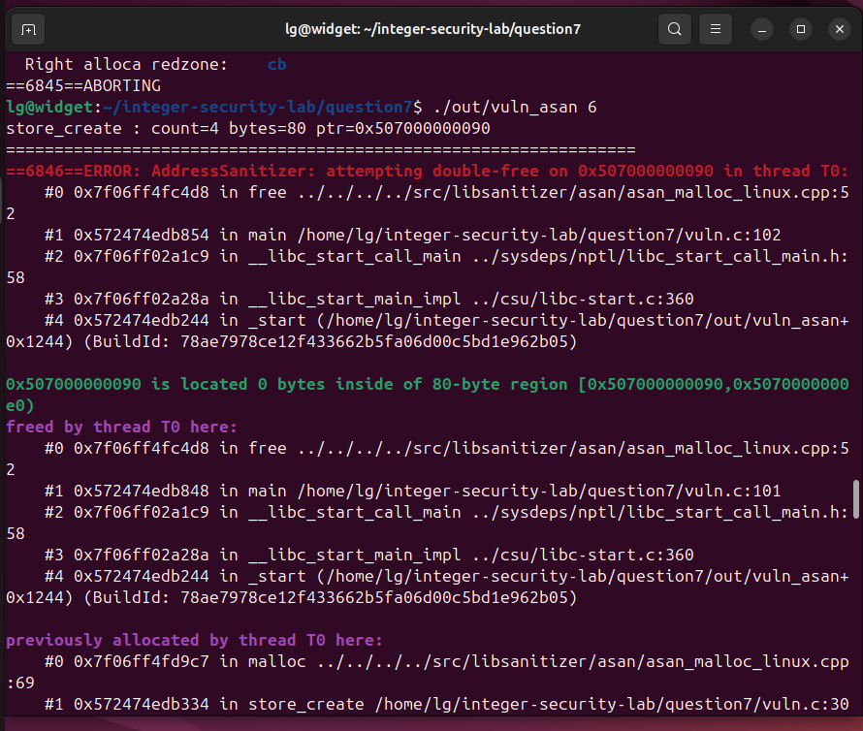
D7. ASan reports attempting double-free, naming the second free at vuln.c:102, the first free at vuln.c:101, and the original allocation in store_create at vuln.c:30.
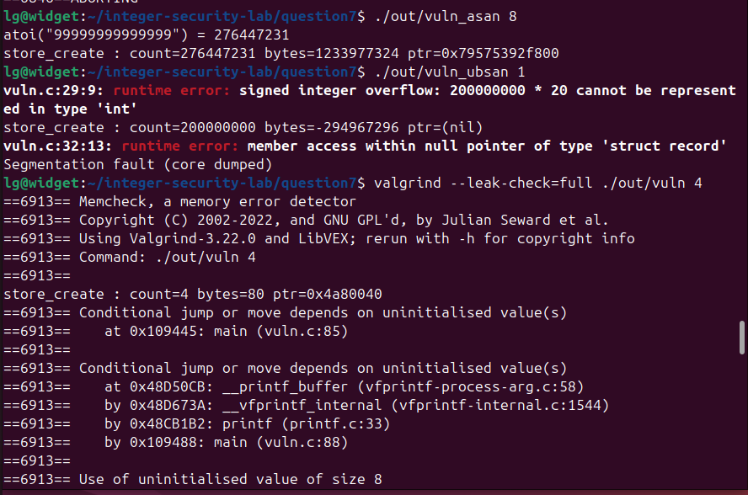
D9 at the top: atoi returns 276447231 for a fourteen digit string with no error, and the module allocates on that wrong value. D2 in the middle under UBSan, with the exact message signed integer overflow: 200000000 * 20 cannot be represented in type int. D5 at the bottom, where Valgrind reports the conditional jump on an uninitialised value that ASan missed.
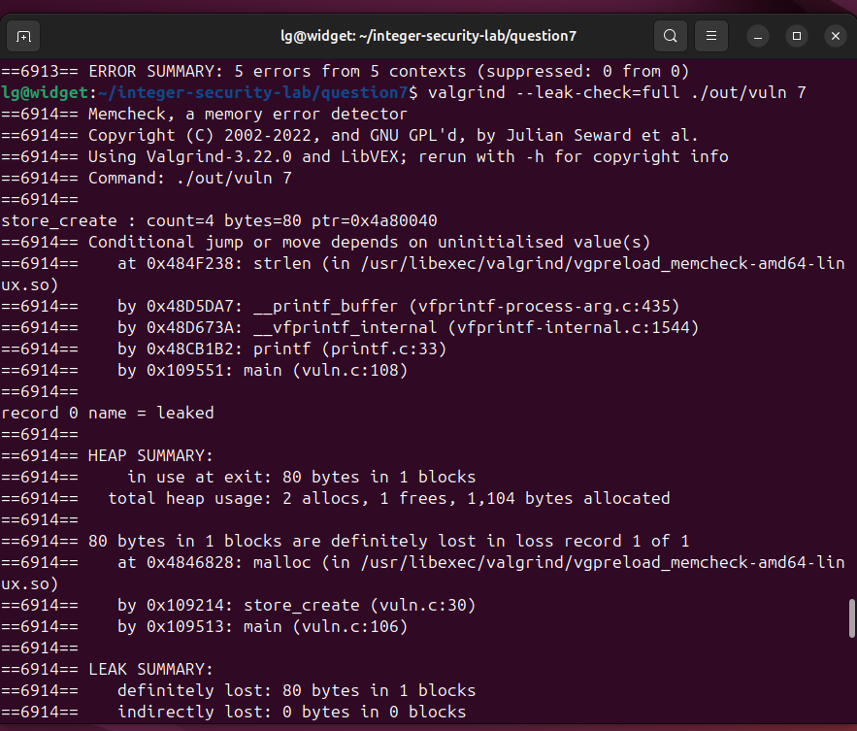
D8 and D5 together under Valgrind. The uninitialised value reaches strlen inside printf, and the leak summary reports 80 bytes in 1 blocks definitely lost, allocated by store_create at vuln.c:30.

Deliverable 3 — Clean Run of the Remediated Module
All eight cases run one after another in a single process, because none of them can fail any more. The oversized request is refused by the range check, the 99 byte name is refused by the size check, the id is stored at a bounded index, calloc has zeroed the records, the pointer is NULL after destroy so the second destroy is harmless, and the fourteen digit string is refused by parse_count.
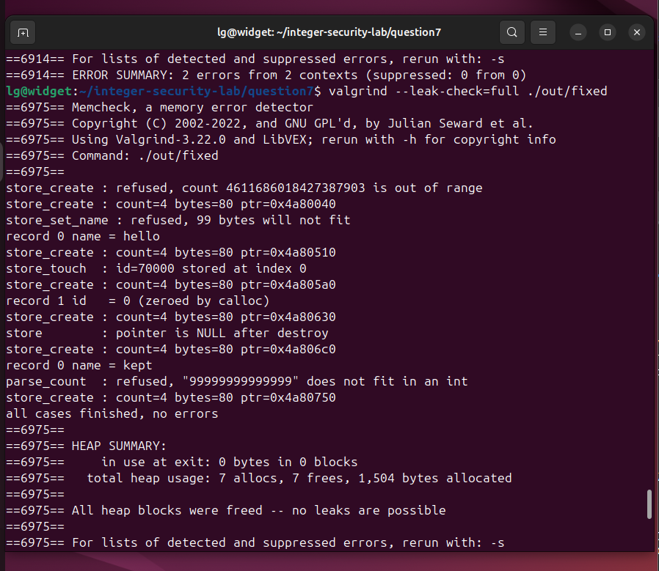
Valgrind on the remediated module: in use at exit 0 bytes in 0 blocks, 7 allocs and 7 frees, and All heap blocks were freed -- no leaks are possible.
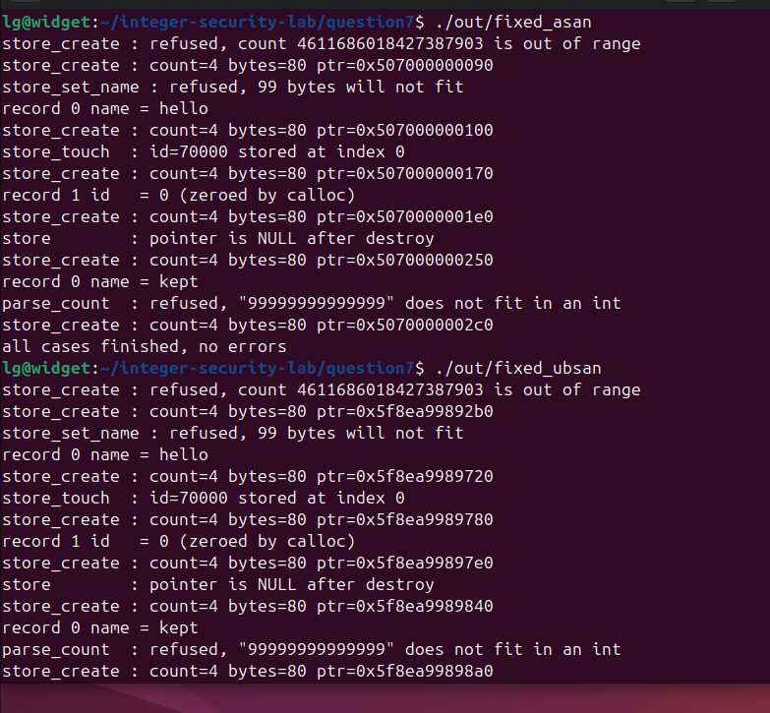
AddressSanitizer at the top and UndefinedBehaviorSanitizer below it, both running the remediated module to the end with no diagnostic of any kind, finishing on all cases finished, no errors.

Deliverable 4 — Compiler Warnings Before and After
Both modules are compiled with the same hardening set so the comparison is fair: -Wall -Wextra -Wconversion -Wsign-conversion -Wformat=2 -O2 -D_FORTIFY_SOURCE=2 -fstack-protector-strong. -O2 is part of the set because _FORTIFY_SOURCE does nothing without optimisation, since it works by replacing library calls with checked variants whose bounds the optimiser must be able to see.
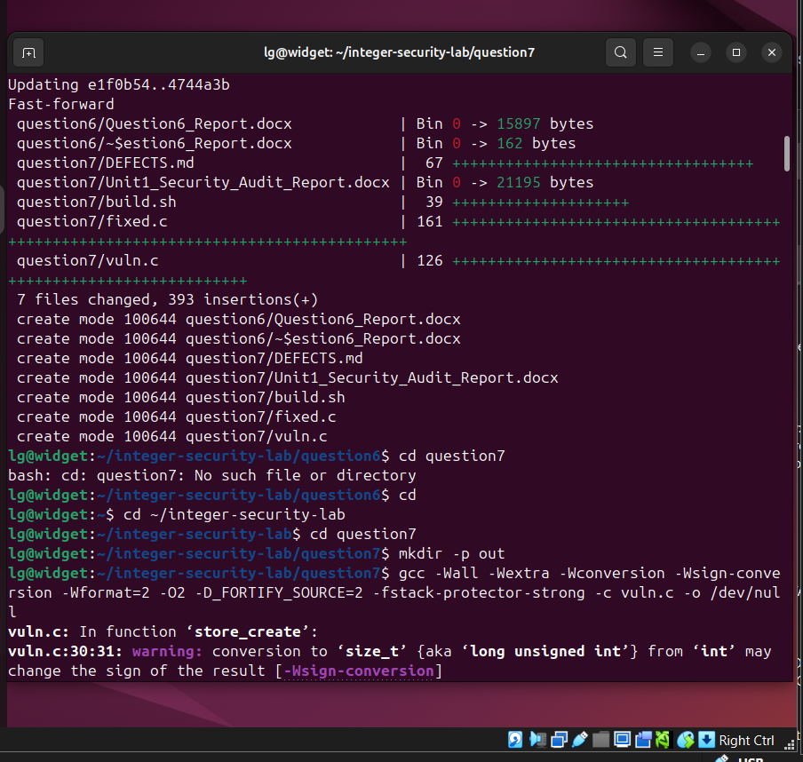
The hardening set being applied to vuln.c, with the first diagnostic already visible: the conversion to size_t from int at vuln.c:30 that carries the wrapped size into malloc.
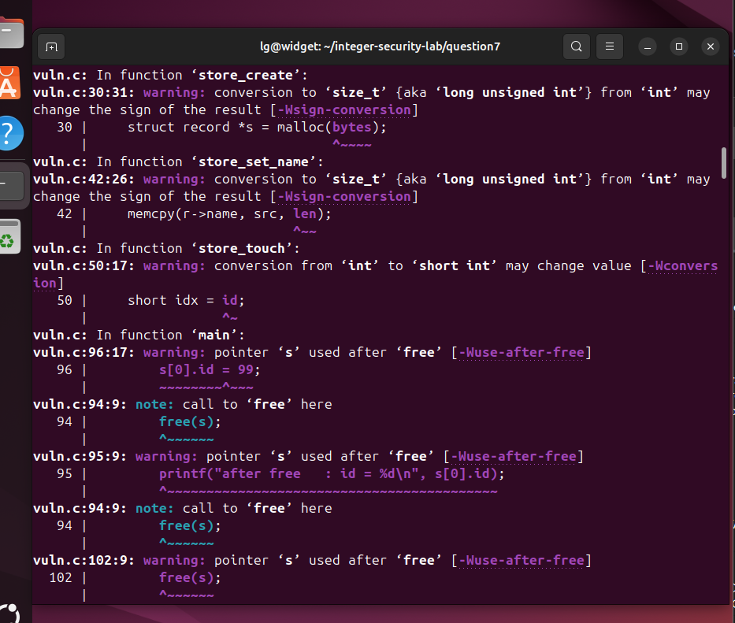
The full before output. Three conversion diagnostics, at vuln.c:30 and vuln.c:42 for the sign changing conversions behind D2 and D3, and at vuln.c:50 for the int to short truncation behind D4, followed by the use-after-free diagnostics for D6 and D7.
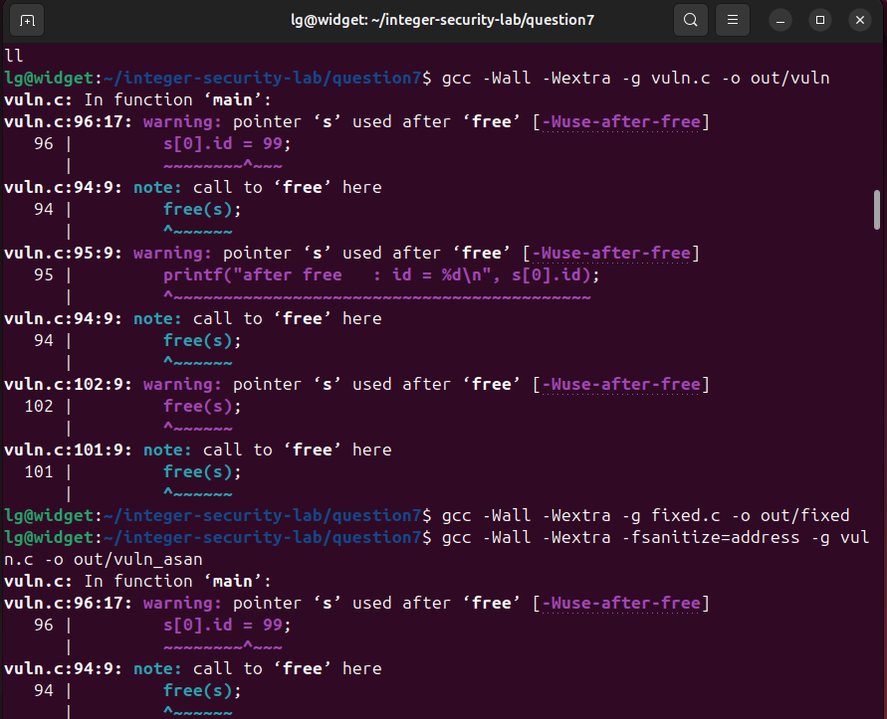
Before and after in one view. vuln.c produces the use-after-free diagnostics, and the very next command compiles fixed.c with the same flags and prints nothing at all.
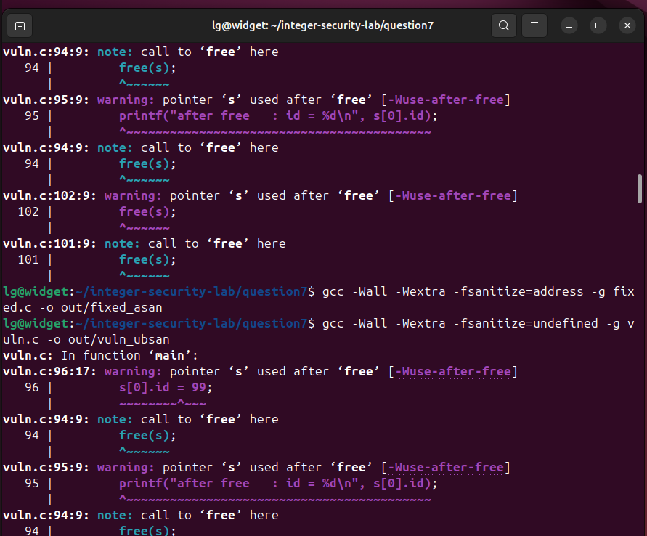
The same contrast on the sanitizer builds: every command touching vuln.c reports diagnostics, and every command touching fixed.c returns silently.
Warnings cleared
Warning reported on vuln.c | Defect | Status on fixed.c
vuln.c:30:31 conversion to size_t from int may change the sign of the result [-Wsign-conversion] | D2 | cleared
vuln.c:42:26 conversion to size_t from int may change the sign of the result [-Wsign-conversion] | D3 | cleared
vuln.c:50:17 conversion from int to short int may change value [-Wconversion] | D4 | cleared
vuln.c:95:9 and 96:17 pointer s used after free [-Wuse-after-free] | D6 | cleared
vuln.c:102:9 pointer s used after free [-Wuse-after-free] | D7 | cleared
The useful observation of this deliverable is which half of the defect list the compiler could see on its own. It reported all three integer defects that involve a conversion, D2, D3 and D4, before the program was ever run, and it also reported D6 and D7 through -Wuse-after-free, which GCC can prove here because the free and the stale use sit in the same function. It reported nothing for D1, the unchecked allocation, nothing for D5, the uninitialised read, nothing for D8, the leak, and nothing for D9, the unchecked atoi, all four of which need either a runtime tool or a human reading the code. Neither half of the toolchain substitutes for the other.
Result
A complete audit of the supplied module identified nine defects: four integer handling errors, an overflow in the size calculation, a signed to unsigned conversion that defeated a bounds check, a truncation used as an index, and an unchecked string conversion; and five memory management errors, an unchecked allocation, a read of uninitialised memory, a use after free, a double free and a leak. Each was located exactly, classified with its CWE identifier and assessed for security impact, with three of them reaching arbitrary code execution. The module was then remediated with checked allocations, calloc initialisation, a single centralised free that sets the caller's pointer to NULL, and arithmetic that is range checked before it is performed rather than after. The remediated module runs clean under all three runtime tools, with Valgrind reporting 7 allocs and 7 frees and all heap blocks freed, ASan reporting no errors, and UBSan reporting no undefined behaviour, and it compiles without a single diagnostic under the hardening flag set that reported three conversion warnings and three use-after-free warnings on the original. The audit also shows that no single tool is sufficient: UBSan alone reports the integer overflow at runtime, Valgrind alone reports the uninitialised read, the compiler reports the narrowing conversions before the program runs at all, and the unchecked atoi is reported by none of them, which is why it had to be found by reading the code.

