Name:-Abhishek kadadevarmath
Rollno:-c46
Class:-TY CSE

Experiment no:-13
Title:- Create Data frame ,load data from csv ,and perform basics data analysis such as filtering grouping and aggregation
- Create a CSV file named employees.csv with columns Name, Age, Department, Salary. Load the data, filter employees older than 30, group by Department, and calculate the average, minimum, and maximum salary for each
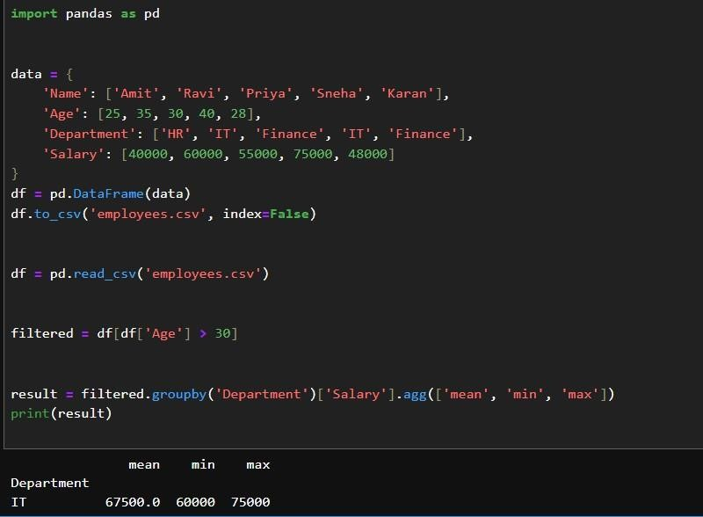
- Create a CSV file named sales.csv with columns SaleID, Product, Amount, Customer. Load the data, filter sales with amount greater than 50,000, group
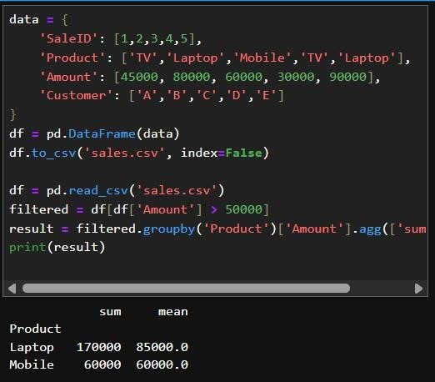
- Create a CSV file named student_marks.csv with columns StudentID, Name, Maths, Science, English. Load the data, filter students with Maths marks
Code:-
data = {
'StudentID': [1,2,3,4],
'Name': ['Anu','Ravi','Neha','Raj'],
'Maths': [90,75,85,60],
'Science': [80,70,95,55],
'English': [85,65,88,70]
}
df = pd.DataFrame(data)
df.to_csv('student_marks.csv', index=False)

df = pd.read_csv('student_marks.csv') filtered =
df[df['Maths'] > 80] df['Total'] =
df[['Maths','Science','English']].sum(axis=1) df['Average'] = df[['Maths','Science','English']].mean(axis=1) result = df.groupby('Name')[['Total','Average']].mean() print(result)
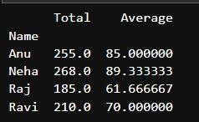
- Create a CSV file named products.csv with columns ProductID, ProductName, Category, Stock. Load the data, filter products with stock less than 50, group Code:- data = {
'ProductID':[1,2,3,4,5],
'ProductName':['Pen','Book','Bag','Pencil','Notebook'],
'Category':['Stationery','Stationery','Bags','Stationery','Stationery'], 'Stock':[20,100,40,15,10]
}
df = pd.DataFrame(data)
df.to_csv('products.csv', index=False)

df = pd.read_csv('products.csv') filtered
= df[df['Stock'] < 50] result = filtered.groupby('Category')['Stock'].agg(['sum','mean']) print(result)
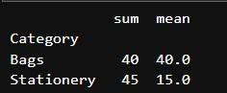
- Create a CSV file named transactions.csv with columns TransactionID, Customer, Amount, Date. Load the data, filter transactions with amount greater than 1000, group by Customer, and calculate total and average spending per customer

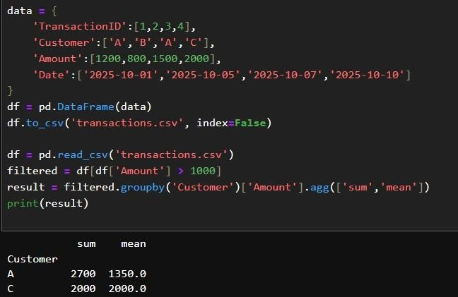

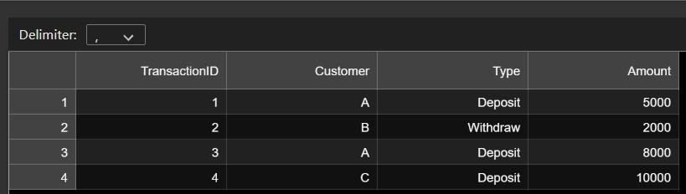

- Create a CSV file named employee_salary.csv with columns EmpID, Name, Department, Salary. Load the data, filter employees with salary above 60,000, group by Department, and calculate mean, max, and min salary per
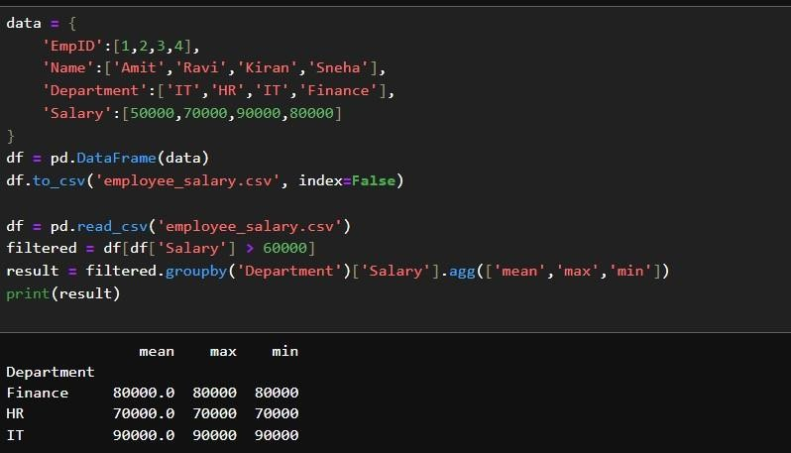
- Create a CSV file named orders.csv with columns OrderID, Customer, Product, Quantity, OrderDate. Load the data, filter orders with quantity greater than 5, group by Product, and calculate total quantity sold per product
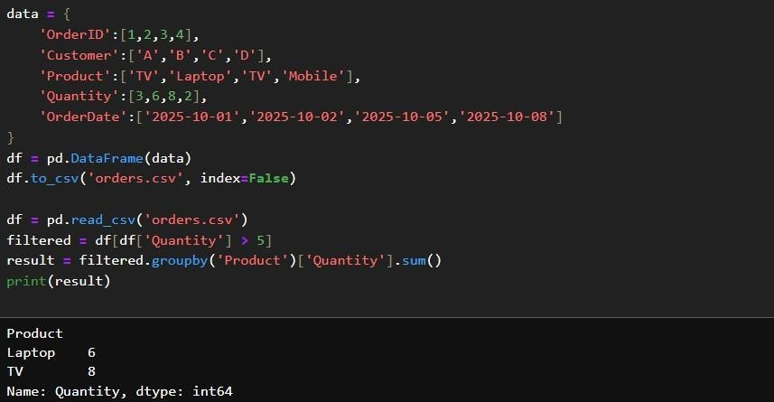
- Create a CSV file named movies.csv with columns MovieID, Title, Genre, Rating. Load the data, filter movies with rating above 8, group by Genre, and calculate average, maximum, and minimum rating per genre.
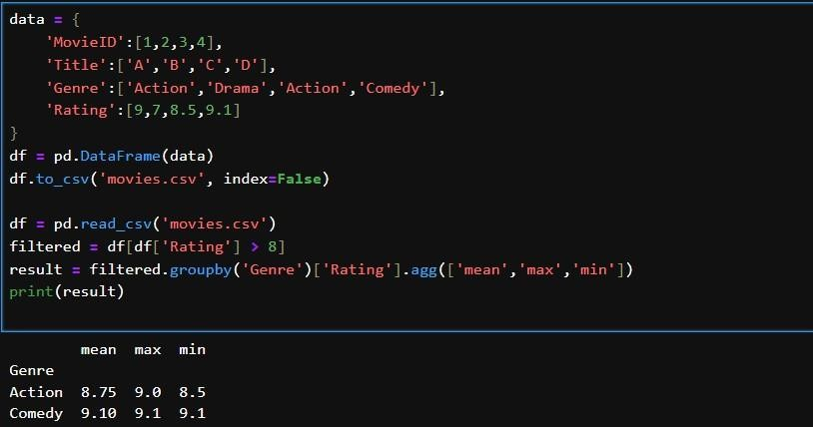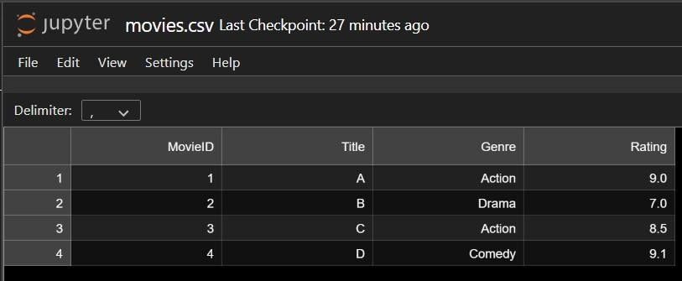
- Create a CSV file named weather.csv with columns Date, City, Temperature, Humidity. Load the data, filter days with temperature above 35°C, group by City, and calculate maximum, minimum, and average temperature for each City,
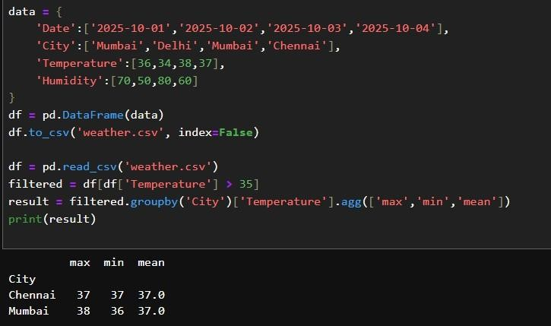
- Create a CSV file named bank_transactions.csv with columns TransactionID, Customer, Type, Amount. Load the data, filter deposits, group by Customer, and calculate total, maximum, and average deposit amount per customer. data = {
'TransactionID':[1,2,3,4],
'Customer':['A','B','A','C'],
'Type':['Deposit','Withdraw','Deposit','Deposit'],
'Amount':[5000,2000,8000,10000]
}
df = pd.DataFrame(data)
df.to_csv('bank_transactions.csv', index=False)

df = pd.read_csv('bank_transactions.csv') filtered
= df[df['Type'] == 'Deposit'] result = filtered.groupby('Customer')['Amount'].agg(['sum','max','mean']) print(result)
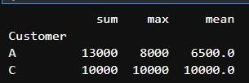

- Create a CSV file named hospital.csv with columns PatientID, Name, Department, AdmissionDate. Load the data, filter patients admitted in the last month, group by Department, and calculate the total number of patients per department.
data = {
'PatientID':[1,2,3,4],
'Name':['A','B','C','D'],
'Department':['Cardio','Neuro','Ortho','Cardio'],
'AdmissionDate':['2025-10-05','2025-09-20','2025-10-10','2025-10-15']
}
df = pd.DataFrame(data)
df.to_csv('hospital.csv', index=False)

df = pd.read_csv('hospital.csv')
df['AdmissionDate'] = pd.to_datetime(df['AdmissionDate'])
filtered = df[df['AdmissionDate'] > '2025-09-30'] result = filtered.groupby('Department')['PatientID'].count() print(result)
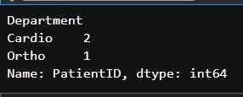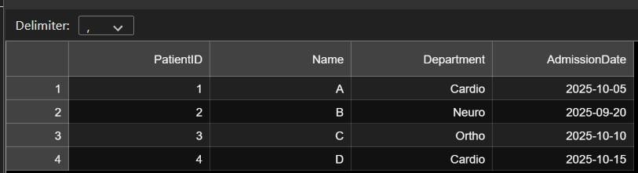

- Create a CSV file named online_store.csv with columns OrderID, Customer, Product, Amount. Load the data, filter orders with amount greater than 200 group by Customer, and calculate average, total, and maximum order amount per customer.
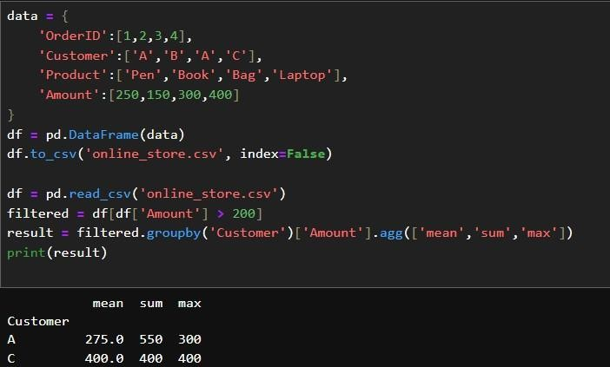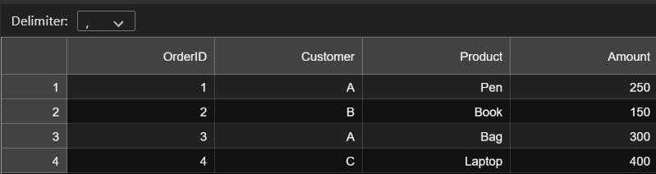
- Create a CSV file named flights.csv with columns FlightID, Airline, Source, Destination, Delay. Load the data, filter flights with delay above 30 minutes, group by Airline, and calculate total flights, average, and maximum delay per airline.
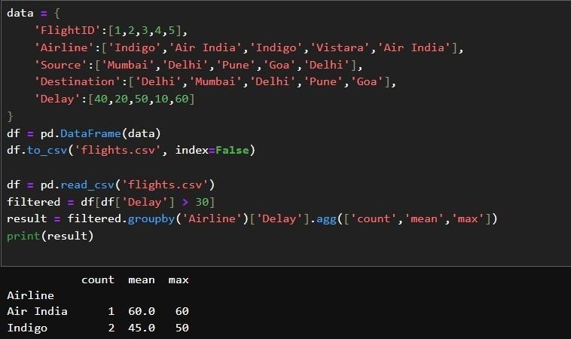
- Create a CSV file named inventory.csv with columns ProductID, ProductName, Supplier, Stock. Load the data, filter out-of-stock products, group by Supplier, and calculate total out-of-stock products per supplier.
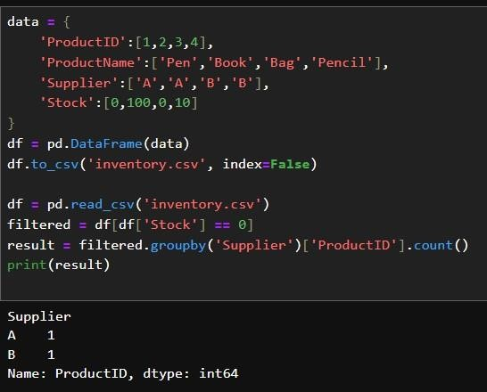
- Create a CSV file named ecommerce.csv with columns OrderID, Category, SubCategory, Sales. Load the data, filter sales above 500, group by Category and SubCategory, and calculate total, average, and maximum sales per combination
