TABLES

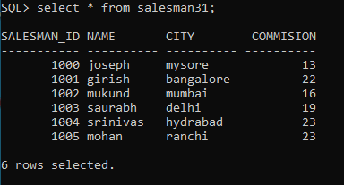

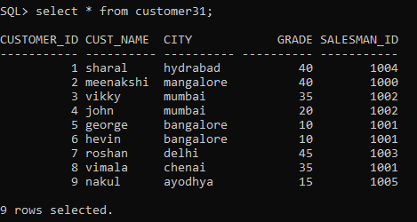

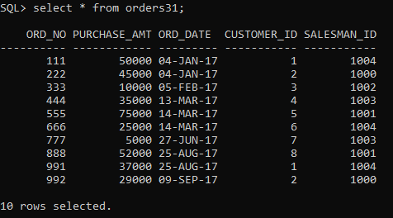

QUERIES

1. Count the customers with grades above bangalore’s avg.

SQL> select grade,count(distinct customer_id)

2 from customer31

3 group by grade

4 having grade>(select avg(grade)

5 from customer31

6 where city='bangalore');

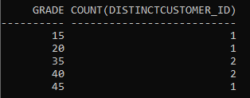

1. Find the name and numbers of all salesman who had more than one customer.

SQL> select salesman_id,Name

2 from salesman31

3 where salesman_id in (select salesman_id

4 from customer31

5 group by salesman_id

6 having count(customer_id)>1);



1. List all salesman names and customer names for whom order amount is more than 4000.

SQL> select Name,cust_name

2 from salesman31 S,customer31 C,orders31 O

3 where S.salesman_id=O.salesman_id and O.customer_id=C.customer_id and purchase_amt>4000;

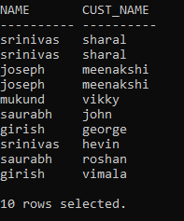

1. Demonstrate the DELETE operation by removing salesman with ID 1000. All his orders must also be deleted.

SQL> delete from salesman31 where salesman_id=1000;

C:\Users\Admin\Desktop\q4.PNG

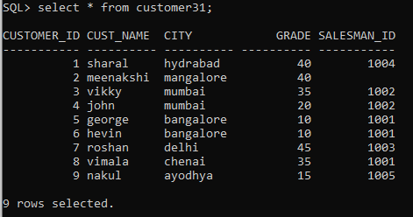

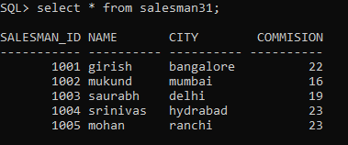

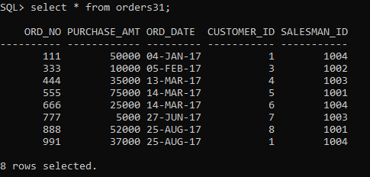

NAME: Apurva Upadhyae

USN: 2GI21CS027