Pin Out Diagram for

**MCL**

Programmer Master Clear (MCLR) Pin

**VDD**

Power Pin for Programmer

**GND**

Ground Pin for Programmer

**PGD**

Programmer Data Pin

**PGC**

Programmer Clock Pin

**ID1**

Logic Analyzer Pin 1

**ID2**

Logic Analyzer Pin 2

**ID3**

Logic Analyzer Pin 3

**ID4**

Logic Analyzer Pin 4

**AN8**

Breakout pin of RC2

**SEN**

Sensor Pin for Resistance Measurements

**CAP**

Sensor Pin for Capacitance Measurement

**ID1**

Logic Analyzer Pin 1

**GND**

Ground Pin

**ESP**

ESP Programmer Pin

**RXP**

UART Rx Pin for ESP and Microprocessor

**TXP**

UART Tx Pin for ESP and Microprocessor

**ID4**

Logic Analyzer Pin 4

**ID3**

Logic Analyzer Pin 3

3

**ID2**

Logic Analyzer Pin 2

**GND**

Ground Pin

**GND**

Ground Pin

**GND**

Ground Pin

**SQ2**

32 MHz PWM Generator Pin 2

2

**SQ3**

32 MHz PWM Generator Pin 3

**SQ4**

32 MHz PWM Generator Pin 4

**SQ1**

32 MHz PWM Generator Pin 1

**GND**

Ground Pin

**SI2**

5 Hz – 5 kHz Wave Generator Pin 2

**GND**

Ground Pin

**SI1**

5 Hz – 5 kHz Wave Generator Pin 1

**GND**

Ground Pin

**PCS**

Programmable Current Source (max 3.3 mA)

**PV1**

Programmable Voltage Source (± 3.3 V)

**PV2**

Programmable Voltage Source (± 5.0 V)

**PV3**

Programmable Voltage Source (max 3.0 V)

**GND**

Ground Pin

**GND**

Ground Pin

**GND**

Ground Pin

**GND**

Ground Pin

**SCL**

I2C Serial Clock Pin

**SDA**

I2C Serial Data Pin

**VDD**

+3.3 V (Supply Pin)

**GND**

Ground Pin

**VR+**

+6.8 V (Test Pin)

**V+**

+10 V (Test Pin)

**VR-**

-6.8 V (Test Pin)

**V-**

-10 V (Test Pin)

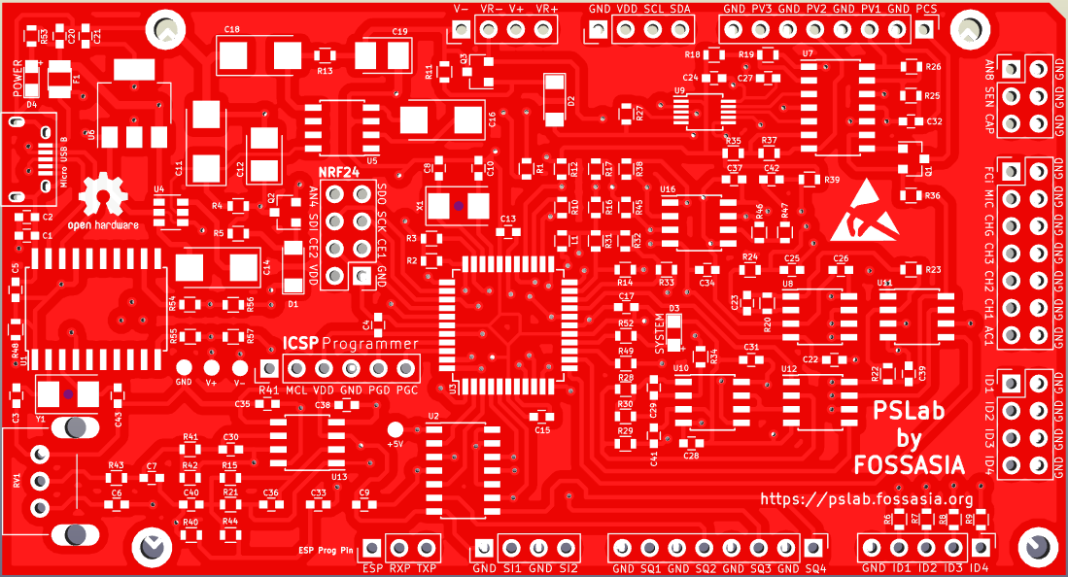 **PSLab V4**

**FCi**

Frequency Counter Pin

**MIC**

Microphone + Pin

**CHG**

Channel 3 Gain Control Pin

**CH3**

Channel 3 (Oscilloscope)

**CH2**

Channel 2 (Oscilloscope)

**CH1**

Channel 1 (Oscilloscope)

**AC1**

Channel for AC Waves (Oscilloscope)

Double check connections when using pins

**PIN**

!

**PIN**

Breakouts

**PIN**

Special Function Pins

**R41**

Breakout pin of RB15

**PIN**

Function Pins

**PIN**

Power Pins

**PIN**

Signal Pins

**PIN**

Programmable Power Pins

**PIN**

Description of Pin

**NRF**

Breakout for NRF24 Connector