EPIC 06 — JIRA TASK 03
Transactions & Distributed Transaction Fundamentals
Final Implementation & Technical Documentation
Task | EPIC 06 — JIRA TASK 03
Topic | Transactions & Distributed Transaction Fundamentals
Assigned Date | 30-09-2026
Completed Date | 29-09-2026
Status | Completed — one day before the scheduled assigned date

1. Executive Summary
This task implemented and verified local transaction handling in the Order Service and established the distinction between local database transactions and distributed transactions in the microservices architecture. Spring @Transactional was added to the order creation workflow so Order and OrderItem database writes are handled as one local transaction. A successful commit was verified, a controlled failure was used to demonstrate rollback, and the temporary test code was removed afterward.

2. Objectives and Deliverables
- Implement a local transaction in Order Service.
- Demonstrate rollback when a failure occurs after multiple database writes.
- Explain and document ACID properties.
- Analyze distributed transaction fundamentals.
- Document distributed transaction failure scenarios.
- Create transaction architecture diagrams.
- Verify the implementation and restore clean production-presentable code.
- Produce final technical documentation containing workflow, changes, concepts learned, verification, and architecture.

3. Architecture Relevant to Task 03
Order Service owns order_service_db and persists orders and order_items. It communicates with User Service over REST and publishes OrderCreated events through Kafka. These are separate service/data boundaries.
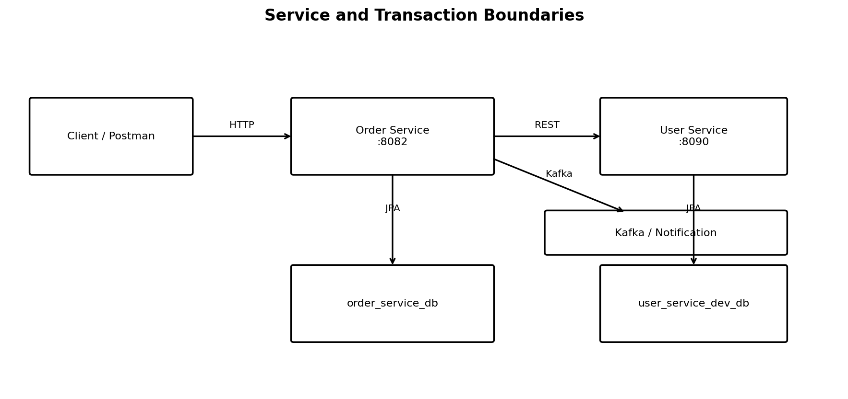
Figure 1 — Service and transaction boundaries.

4. Code Changes Made

4.1 OrderService.java
The primary implementation change was adding Spring transaction management:
import org.springframework.transaction.annotation.Transactional;
@Transactional
public OrderResponse createOrder(CreateOrderRequest request) {
The existing workflow was preserved: user lookup, Order creation, Order save, OrderItem creation and save, existing Kafka event publication, and response mapping.
Order savedOrder = orderRepository.save(order);
OrderItem orderItem = new OrderItem();
orderItem.setOrder(savedOrder);
orderItem.setProductName(savedOrder.getProductName());
orderItem.setQuantity(savedOrder.getQuantity());
orderItem.setAmount(savedOrder.getAmount());
orderItemRepository.save(orderItem);

4.2 OrderItem.java
No change was required. The existing JPA relationship was retained:
@ManyToOne
@JoinColumn(name = "order_id", nullable = false)
private Order order;
This mapping correctly connects each order item to its parent order.

4.3 OrderItemRepository.java
No change was required. The existing JpaRepository was reused.

4.4 Temporary Rollback Test Code
For the rollback demonstration only, a temporary RuntimeException was added after both save operations. It was triggered with productName = FAIL_TRANSACTION and removed immediately after verification.
if ("FAIL_TRANSACTION".equals(request.getProductName())) {
throw new RuntimeException("Intentional failure for transaction rollback test");
}

5. Clean Workflow of the Task
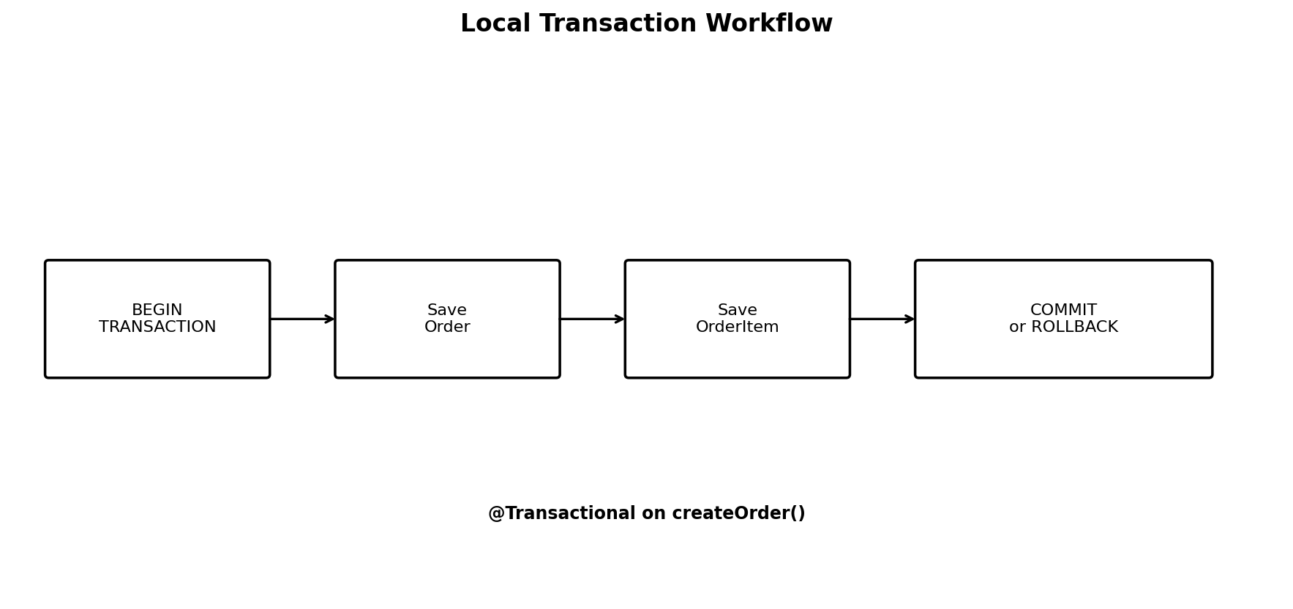
Figure 2 — Local transaction workflow.
- Client sends POST /api/v1/orders to Order Service.
- Order Service retrieves the user from User Service.
- Spring manages the local database transaction.
- Order is saved to orders.
- OrderItem is linked to the Order and saved to order_items.
- If the method completes successfully, the local transaction commits.
- If a runtime failure occurs, the local transaction rolls back.
- The existing Kafka event flow remains separate from the local database transaction boundary.
Normal flow: BEGIN → Save Order → Save OrderItem → COMMIT. Failure flow: BEGIN → Save Order → Save OrderItem → Exception → ROLLBACK.

6. ACID Concepts Learned and Applied
Property | Meaning | Task 03 Example
Atomicity | All operations succeed together or roll back together. | Order and OrderItem were both absent after the controlled rollback.
Consistency | Data remains valid and respects relationships/constraints. | OrderItem references its Order through order_id.
Isolation | Concurrent transaction work is isolated according to database transaction rules. | The Order and OrderItem writes execute within the Spring-managed transaction.
Durability | Committed changes remain stored. | The successful transaction remained persisted in MySQL after the request completed.

7. Successful Transaction Verification
A normal order request returned HTTP 201 Created. MySQL was then used to verify both the Order and its OrderItem.
POST http://localhost:8082/api/v1/orders
{
"userId": 1,
"productName": "Transaction Test Product",
"quantity": 1,
"amount": 500
}
Verified result: Order ID 16397 was created and a corresponding order_items record with order_id = 16397 was present. This confirmed the successful commit path.

8. Rollback Demonstration
A controlled failure was triggered after both database save operations by sending productName = FAIL_TRANSACTION. Postman returned HTTP 500 Internal Server Error.
SELECT * FROM orders
WHERE product_name = 'FAIL_TRANSACTION';
SELECT * FROM order_items
WHERE product_name = 'FAIL_TRANSACTION';
- orders query returned 0 rows.
- order_items query returned 0 rows.
- The result demonstrated atomic rollback of both local database changes.
After verification, the temporary failure block was removed and Order Service was restarted successfully.

9. Distributed Transaction Analysis
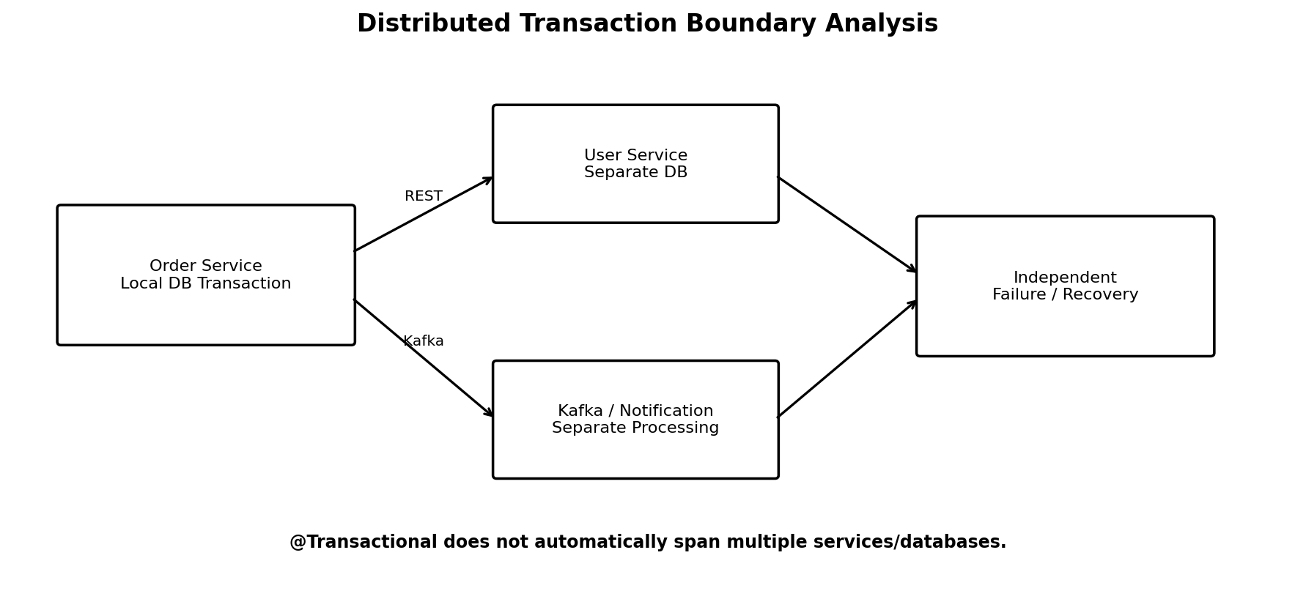
Figure 3 — Distributed transaction boundaries.
The Order Service local transaction covers its own database work. User Service owns a separate database and is reached through REST. Kafka and Notification processing form another separate boundary. Therefore, @Transactional on Order Service does not automatically create one atomic transaction spanning multiple services, databases, and Kafka processing.

10. Distributed Transaction Failure Scenarios
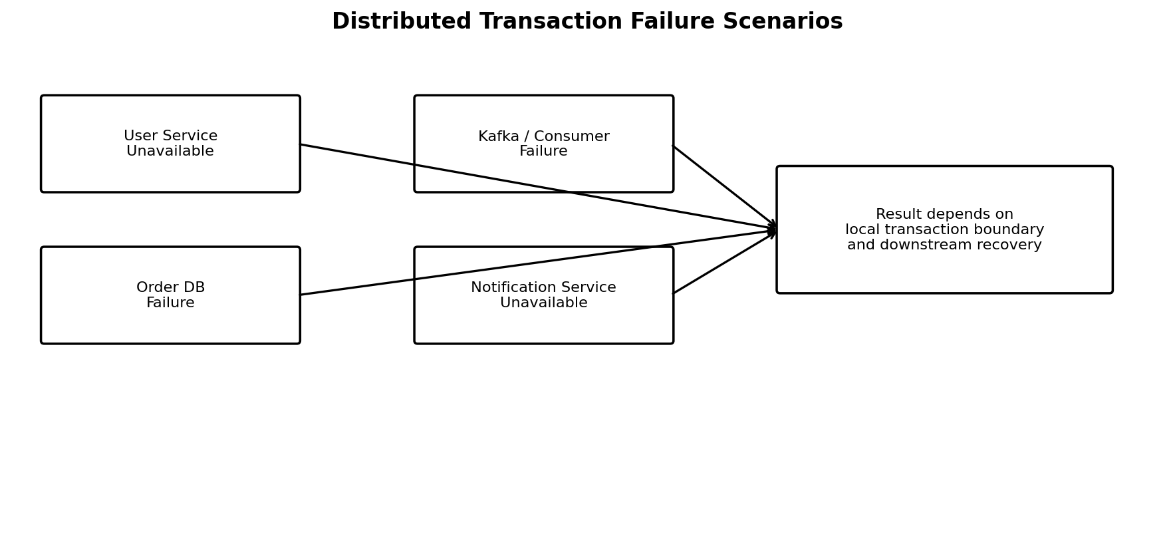
Figure 4 — Failure scenarios analyzed.
Scenario | Effect
User Service unavailable | User lookup cannot complete, so order creation cannot proceed normally.
Order database failure | The local transaction cannot complete and local database changes are rolled back.
Kafka / downstream processing failure | The Order database transaction and downstream event processing have separate boundaries; the order can remain committed while downstream recovery is needed.
Notification Service unavailable | Notification processing can fail independently from the already-created order.
Partial distributed operation | Different services can reach different states because one local rollback does not automatically reverse all remote operations.

11. Transaction Architecture Summary
- Local ACID boundary: Order + OrderItem in order_service_db.
- REST boundary: Order Service → User Service.
- Event boundary: Order Service → Kafka → Notification Service.
- Local rollback protects the local database transaction only.
- Distributed failures require recovery/coordination mechanisms beyond a single @Transactional annotation.

12. Concepts Learned
- Spring @Transactional and local transaction boundaries.
- Commit versus rollback.
- Practical Atomicity demonstration.
- JPA repository operations participating in one database transaction.
- ACID properties in a microservices context.
- Difference between local and distributed transactions.
- Independent service/database ownership.
- REST and Kafka as distributed communication boundaries.
- Failure handling and recovery considerations in distributed systems.

13. Verification Checklist
Item | Evidence / Result | Status
Local transaction | @Transactional added to OrderService.createOrder() | Completed
Successful transaction | Order 16397 and corresponding OrderItem verified in MySQL | Completed
Rollback | HTTP 500; both FAIL_TRANSACTION queries returned 0 rows | Completed
Temporary code cleanup | Intentional failure code removed; service restarted successfully | Completed
OrderItem mapping | Existing @ManyToOne mapping retained; no changes required | Completed
Distributed analysis | REST, Kafka, separate databases and boundaries analyzed | Completed
Failure scenarios | User, DB, Kafka/consumer, notification and partial-state cases documented | Completed
Architecture | Service, local transaction, distributed boundary and failure diagrams included | Completed

14. Final Deliverables
- Local transaction implementation using @Transactional.
- Successful transaction verification.
- Rollback demonstration and database verification.
- ACID explanation with practical examples.
- Distributed transaction analysis.
- Distributed failure scenario analysis.
- Transaction architecture diagrams.
- Clean final code with temporary rollback test removed.
- Final task documentation and verification checklist.

15. Final Status
COMPLETED
Task Assigned Date: 30-09-2026
Task Completed Date: 29-09-2026
Completion: Completed one day before the scheduled assigned date.
All implementation and documentation deliverables for EPIC 06 — JIRA TASK 03 have been completed and verified.

16. One-Line Work Status
Implemented and verified local transactions and rollback in Order Service using @Transactional, and documented ACID properties, distributed transaction boundaries, failure scenarios, and transaction architecture.

