BLACKROTH PROJECT
JIRA TASK 01 — Database Design & Database-per-Service Architecture
EPIC 06 — Database & Distributed Data Design

Document field | Value
Project | BlackRoth Project
Epic | EPIC 06 — Database & Distributed Data Design
Completion date | 28-Sep-2026
Status | Completed • On Time • Not Overdue
Prepared for | JIRA task completion record

Evidence-based final documentation

1. Task Status and Scope
Item | Record
JIRA task | Task 01 — Database Design & Database-per-Service Architecture
Completion date | 28-Sep-2026
Completion status | Completed
On time | Yes
Overdue | No
Primary objective | Apply database-per-service, service ownership, and clear database boundaries across the microservices system.

Completion statement
The task was completed by aligning the User, Product, Order, and Payment services with separate service-owned MySQL databases, completing the required Order/OrderItem and Payment schema alignment, and validating the application/database flow with Postman, MySQL Workbench, Docker, and runtime logs.

2. Database-per-Service Design
The implemented ownership model is:
User Service -> user_service_dev_db -> users
Product Service -> productdb -> products
Order Service -> order_service_db -> orders, order_items
Payment Service -> paymentdb -> payments
Service | Database | Owned tables / data | Evidence
User Service | user_service_dev_db | users | Development configuration reviewed; User Service runs on port 8090.
Product Service | productdb | products | Configuration and MySQL data verified.
Order Service | order_service_db | orders, order_items | Configuration, schema, order creation, and OrderItem persistence verified.
Payment Service | paymentdb | payments | Configuration, schema, and payment creation verified.

3. User Service Database
The User Service development profile points to the dedicated user database on MySQL. The current users table contains the user identity and account fields already used by the application, including name, email, phone, password, status, created_at, and updated_at.
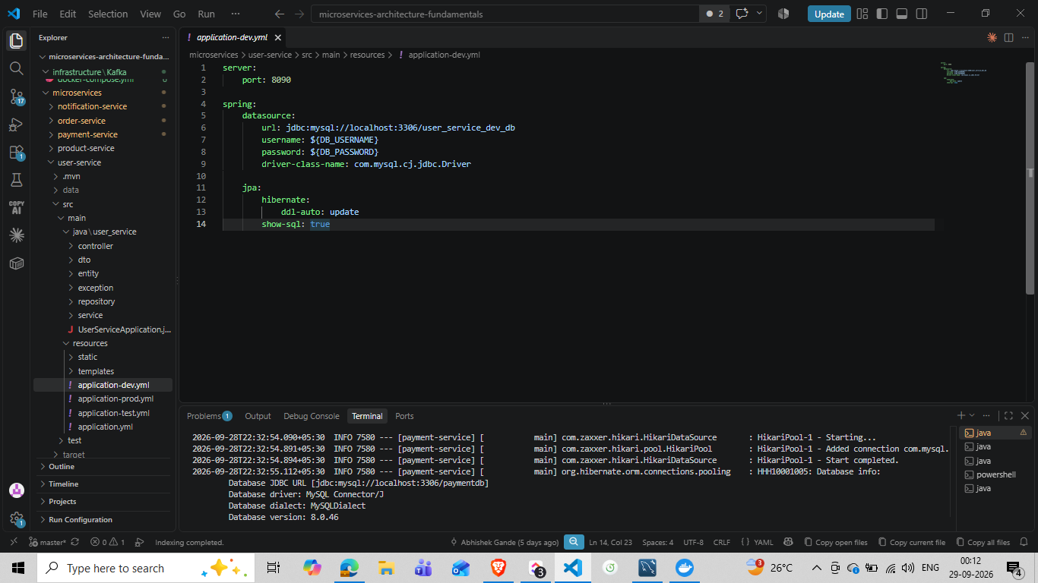
Figure 1 — User Service development configuration showing port 8090 and user_service_dev_db.

4. Product Service Database
The Product Service uses its own product database. The existing products table was checked directly in MySQL Workbench and contains application data, confirming that product persistence is separated from the other service databases.
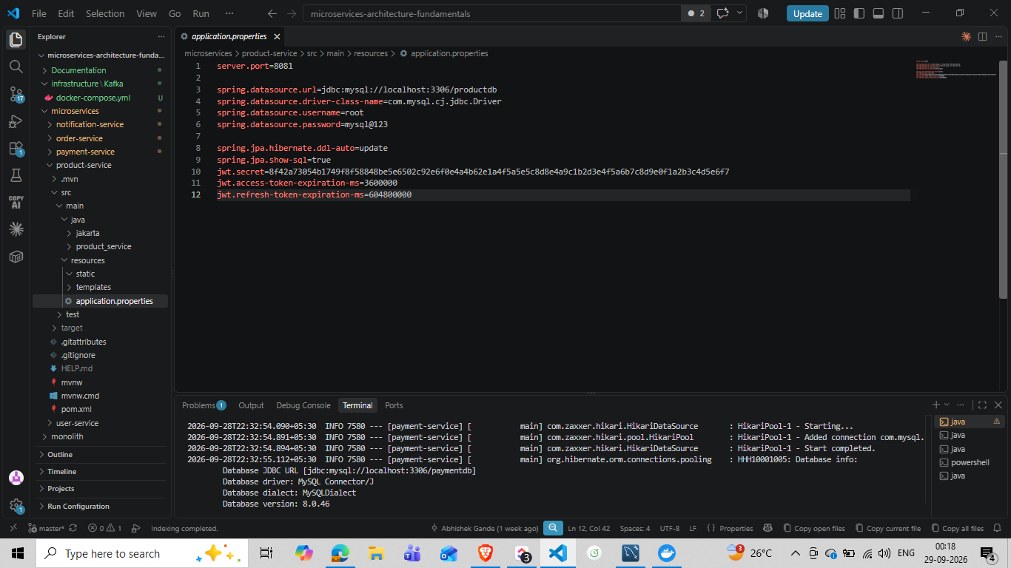
Figure 2 — Product Service configuration showing port 8081 and productdb.

5. Order Service Database and Order Items
The Order Service was aligned so that both orders and order_items belong to order_service_db. The order_items table was created with a foreign-key relationship from order_items.order_id to orders.id. An OrderItem JPA entity and repository were then added so the application could persist order-item records.
OrderItem columns
id BIGINT (PK, auto-increment)
order_id BIGINT (FK -> orders.id)
product_id BIGINT
product_name VARCHAR(255)
quantity INT
amount DOUBLE
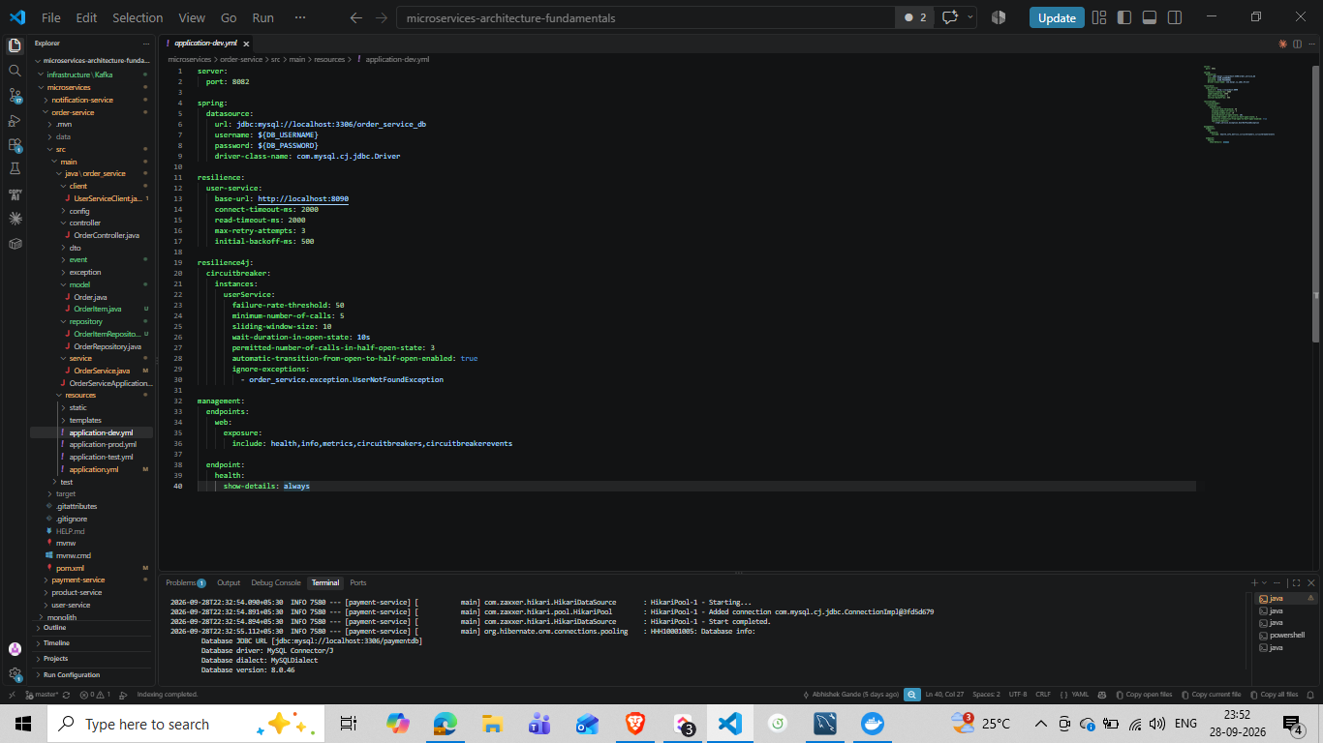
Figure 3 — Order Service application configuration showing order_service_db, REST dependency configuration, timeouts/retries, circuit breaker settings, and Kafka bootstrap configuration.
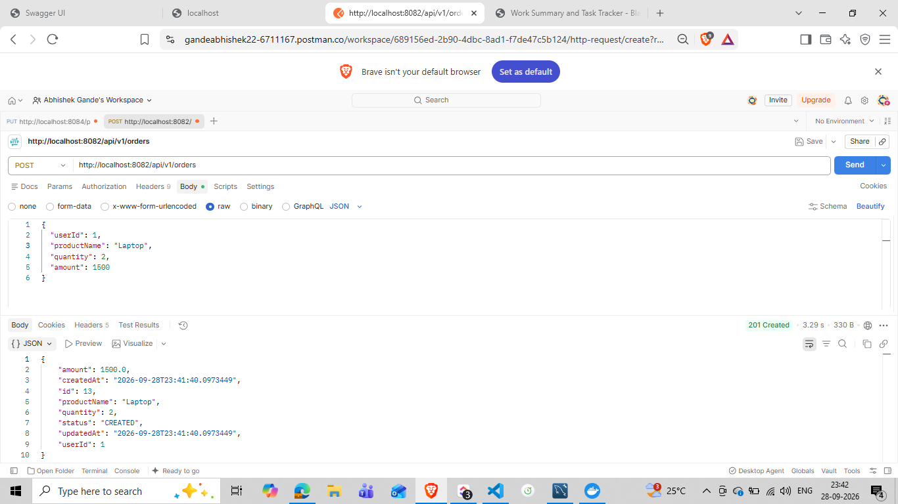
Figure 4 — Successful POST /api/v1/orders request on port 8082 returning 201 Created for order id 13.
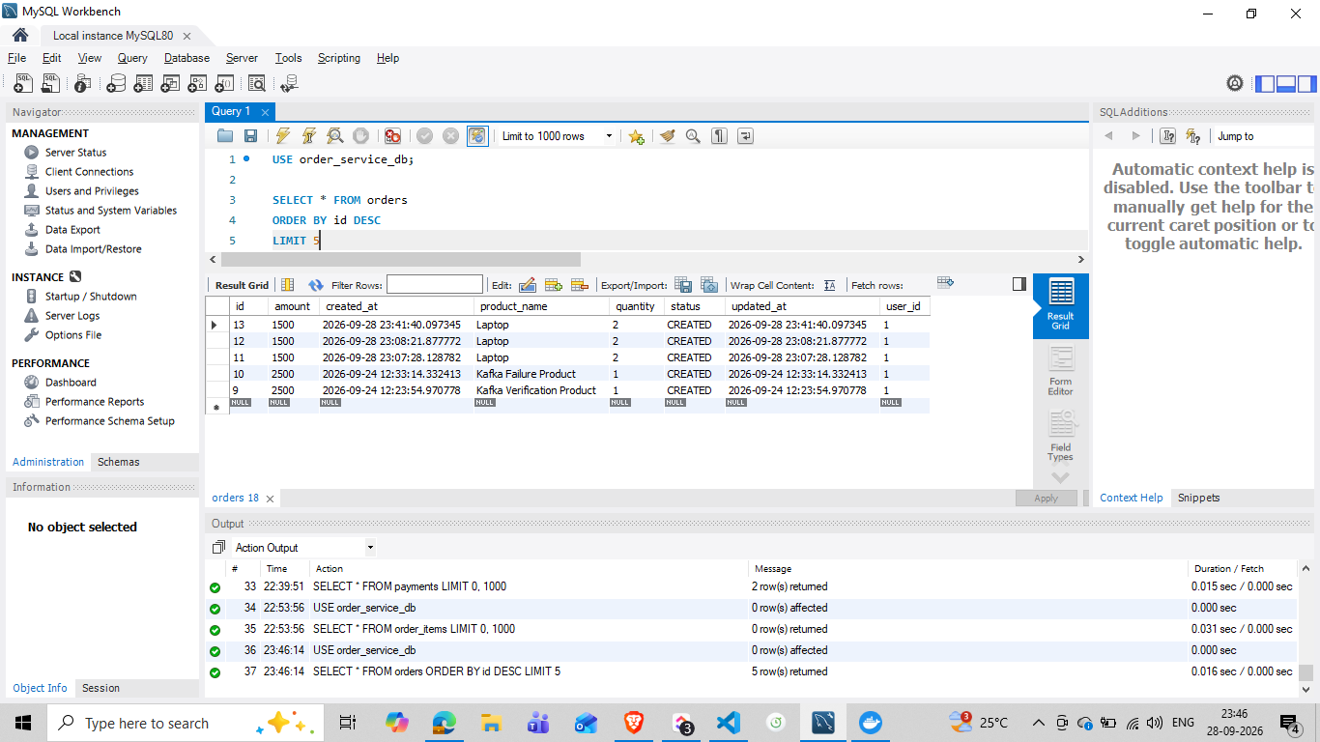
Figure 5 — MySQL verification of orders table; latest order id 13 is persisted in order_service_db.
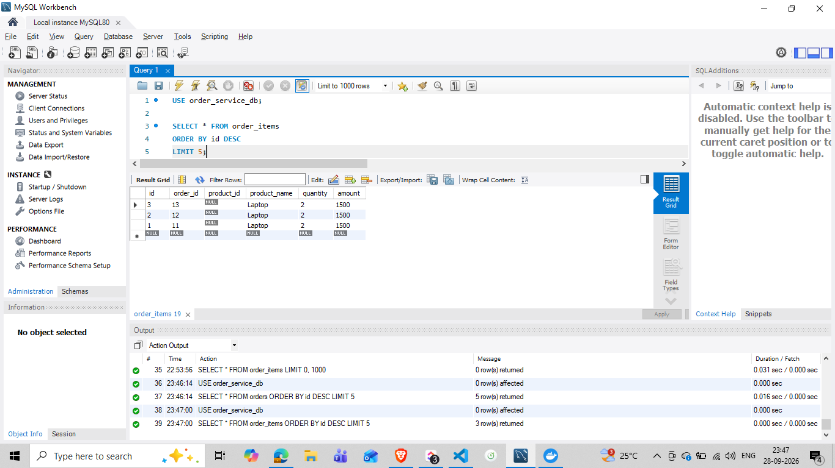
Figure 6 — MySQL verification of order_items; order_item id 3 references order_id 13.
Observed application result
The order creation test produced both the order record and its corresponding order-item record. The latest order shown in evidence is id 13, with product Laptop, quantity 2, and amount 1500.

6. Payment Service Database
Payment Service uses its own paymentdb database. The payments table was updated to match the required payment fields and the Java model was aligned so that the application populates the renamed payment_status column, transaction_reference, and created_at.
payments columns
id BIGINT (PK, auto-increment)
order_id BIGINT
amount DOUBLE
payment_status VARCHAR(255)
transaction_reference VARCHAR(255)
created_at DATETIME
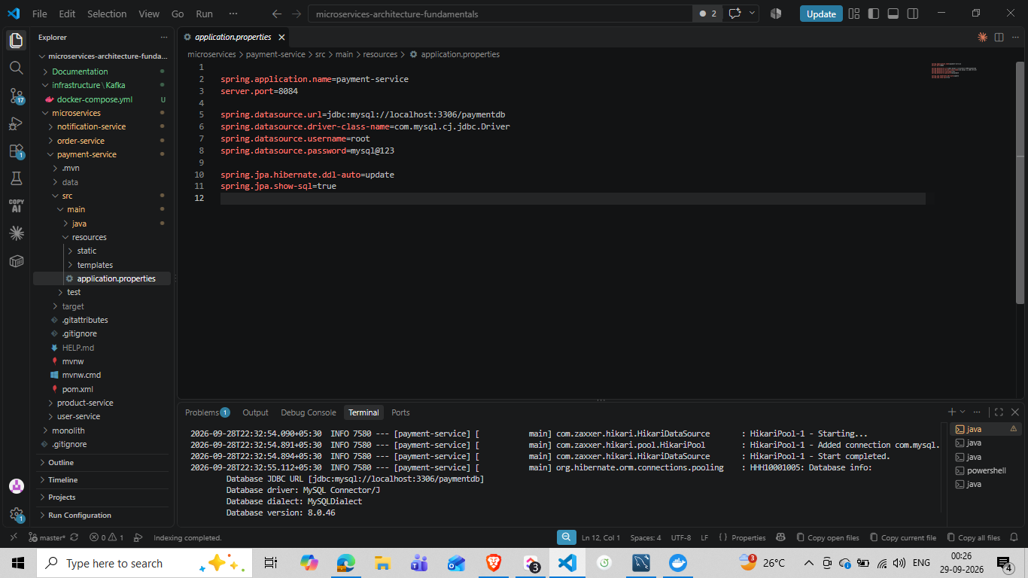
Figure 7 — Payment Service configuration showing port 8084 and paymentdb.
A payment creation request was verified through Postman using POST http://localhost:8084/payments. The successful row observed in MySQL used order_id 1, amount 750, payment_status SUCCESS, transaction_reference TXN-1001, and a populated created_at value.

7. Service-to-Service Communication and Data Ownership
The Order Service does not directly access the User Service database. Instead, the Order Service uses UserServiceClient to request user information from User Service over HTTP. This preserves database ownership and keeps the owning service as the source of truth for user data.
Order Service (8082)
|
| GET user data through User Service API
v
User Service (8090)
|
v
user_service_dev_db
The Order Service development profile also contains connection and retry settings for the User Service, including 2-second connect/read timeouts, up to 3 retry attempts, and a 500 ms initial backoff, together with a Resilience4j circuit breaker for the userService instance.

8. Kafka Event Flow
Kafka is used for asynchronous order-event communication. After order creation, the Order Service publishes an OrderCreatedEvent. With Kafka running on localhost:9092, Notification Service consumed the event and logged the notification requirement for order 13.
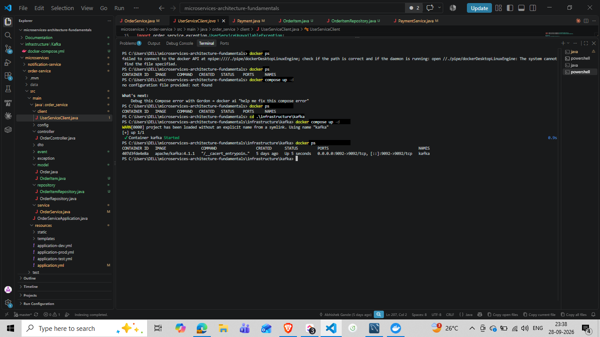
Figure 8 — Kafka container running with port 9092 exposed.
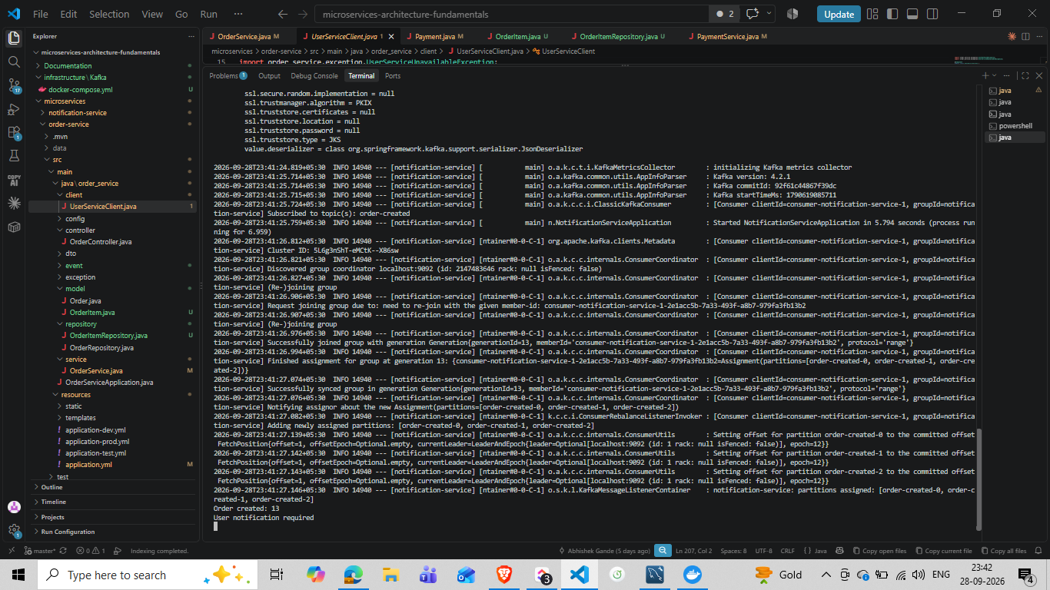
Figure 9 — Notification Service Kafka consumer log showing receipt of order-created information for order 13.

9. Architecture and Ownership Rules
Rule | Implementation evidence
One service owns its database | User, Product, Order, and Payment services each point to their own database.
No direct cross-service DB access | Order Service obtains user information through UserServiceClient instead of querying user_service_dev_db.
Order data owned by Order Service | Both orders and order_items are persisted in order_service_db.
Payment data owned by Payment Service | payments is persisted in paymentdb.
Service communication uses APIs/events | REST is used for Order -> User lookup; Kafka is used for OrderCreatedEvent delivery to Notification Service.

10. Validation and Evidence Summary
Validation | Observed result
User Service configuration | Port 8090 mapped to user_service_dev_db.
Product database | productdb contained the products table and existing product records.
Order database | order_service_db contained orders and order_items.
Order creation | POST /api/v1/orders returned 201 Created and created order id 13.
OrderItem persistence | order_items row id 3 persisted with order_id 13.
Payment database | paymentdb contained payments with required payment columns.
Payment creation | POST /payments returned 200 OK and populated transaction_reference and created_at.
Kafka flow | Order-created event reached Notification Service after Kafka was started.
Resilience configuration | Order Service contains timeout, retry, and circuit-breaker settings for User Service.

11. Deliverables Checklist
Deliverable | Status | Evidence in this document
Service-owned database design | Completed | Sections 2 and 9
User database alignment | Completed | Section 3
Product database alignment | Completed | Section 4
Order + order_items design | Completed | Section 5
Payment database alignment | Completed | Section 6
Ownership and API-based access | Completed | Section 7
Event-driven communication evidence | Completed | Section 8
Validation evidence | Completed | Section 10

12. Final Outcome
JIRA Task 01 was completed on 28-Sep-2026 and recorded as on time with no overdue status. The implementation now demonstrates clear data ownership across the four core persistent services, with Order Service owning orders and order_items, Payment Service owning payments, and inter-service information exchange occurring through API/event boundaries rather than direct database access.

