EPIC 04 — API Security & Authentication with Spring Security
Jira Task 02 — User Registration, Password Hashing & Login API
Field | Details
Project | product-service (microservices-architecture-fundamentals)
Sprint | Sprint 11 (7/9 – 20/9)
Task date | 16-Sep-2026
Effort | 8 hours
Priority | Critical
Prepared by | Gande Abhishek

1. Objective
This task built a secure user registration and login mechanism on top of the Spring Security foundation from Task 01. The goals were to model a User entity, validate registration input, hash passwords before storing them, prevent duplicate accounts, and implement a login flow that verifies credentials without ever exposing or comparing plain-text passwords.

2. Concepts learned

2.1 Password hashing vs. encryption
Passwords are hashed, not encrypted — hashing is one-way, so the original password can never be recovered from the stored value, even by the application itself. BCryptPasswordEncoder was used specifically because it automatically incorporates a random salt into every hash and is intentionally slow, which makes brute-force and rainbow-table attacks impractical even if the database were ever exposed.

2.2 Why DTOs are used instead of the entity directly
RegisterRequest and LoginRequest carry only the fields a client should be allowed to submit (name, email, password), while RegisterResponse deliberately excludes the password entirely — even the hashed form — from anything sent back to the client. Separating request/response shapes from the User entity prevents internal fields (like role or status) from being set directly by a client and stops sensitive data from ever leaving the server by accident.

2.3 Bean-validation annotations
Validation rules (@NotBlank, @Email, @Size) are declared directly on the DTO fields and enforced automatically by Spring when the controller method is annotated with @Valid — invalid input is rejected with a 400 response before it ever reaches the service layer, without writing manual if-checks.

2.4 Correct HTTP status codes for auth failures
A duplicate registration returns 409 Conflict (the resource — an account with that email — already exists), while a failed login returns 401 Unauthorized. Login failures deliberately return the same message and status whether the email doesn't exist or the password is wrong, to avoid letting an attacker discover which emails are registered.

3. Technologies and dependencies used
Component | Version / Detail
Password hashing | Spring Security Crypto — BCryptPasswordEncoder
Persistence | Spring Data JPA — UserRepository extends JpaRepository
Validation | Jakarta Bean Validation (@NotBlank, @Email, @Size)
Database | MySQL — users table, auto-generated via Hibernate ddl-auto=update

4. Changes made

4.1 New file — User.java (entity)
Defines the users table: id, name, email (unique), password (stores the BCrypt hash, never plain text), role (defaults to "USER"), status (defaults to "ACTIVE"), and createdAt (set automatically via @PrePersist, with no public setter so it can never be overwritten after creation).

4.2 New files — RegisterRequest.java, RegisterResponse.java
RegisterRequest validates incoming registration data (name required, valid email, password minimum 8 characters). RegisterResponse returns id, name, email, role, status, and createdAt — explicitly omitting the password in any form.

4.3 New files — LoginRequest.java, LoginResponse.java
LoginRequest carries email and password for the login attempt. LoginResponse (the shape used at the time this task was completed) returned id, name, email, role, and a success message. This response shape was later replaced by token-based responses once JWT authentication was introduced in Task 03.

4.4 New file — UserRepository.java
A Spring Data JPA repository with a single custom method, findByEmail(String email), used both to check for duplicate registrations and to look up a user during login.

4.5 New file — AuthService.java
register() checks for an existing account with the same email (returning 409 Conflict if found), hashes the incoming password with passwordEncoder.encode(...), and saves the new user. login() looks up the user by email and uses passwordEncoder.matches(...) to compare the submitted password against the stored hash, returning 401 Unauthorized on any mismatch.

4.6 New file — AuthController.java
Exposes POST /api/v1/auth/register (returns 201 Created) and POST /api/v1/auth/login (returns 200 OK), both under a single @RequestMapping("/api/v1/auth") base path.

4.7 Updated — SecurityConfig.java
Added a PasswordEncoder bean (BCryptPasswordEncoder) and permitted /api/v1/auth/** without authentication, since a user registering or logging in does not yet hold any credentials to authenticate with.

5. What we did with Postman
Every scenario in the registration and login flow was tested directly against the running service:
Request | Expected result | Result
POST /auth/register (new email) | 201 Created, password excluded from response | Pass
POST /auth/register (same email again) | 409 Conflict — “Email already registered” | Pass
POST /auth/login (correct credentials) | 200 OK with user details | Pass
POST /auth/login (wrong password) | 401 Unauthorized — “Invalid email or password” | Pass
POST /auth/login (non-existent email) | 401 Unauthorized — same message as wrong password | Pass
SELECT password FROM users (MySQL) | Stored value is a BCrypt hash, not the original password | Pass
All requests are retained in the Postman workspace history for traceability during review.

6. Registration and login flow
The diagram below shows both flows side by side: registration branches on whether the email is already taken, and login branches on whether the submitted credentials match a stored, hashed password.
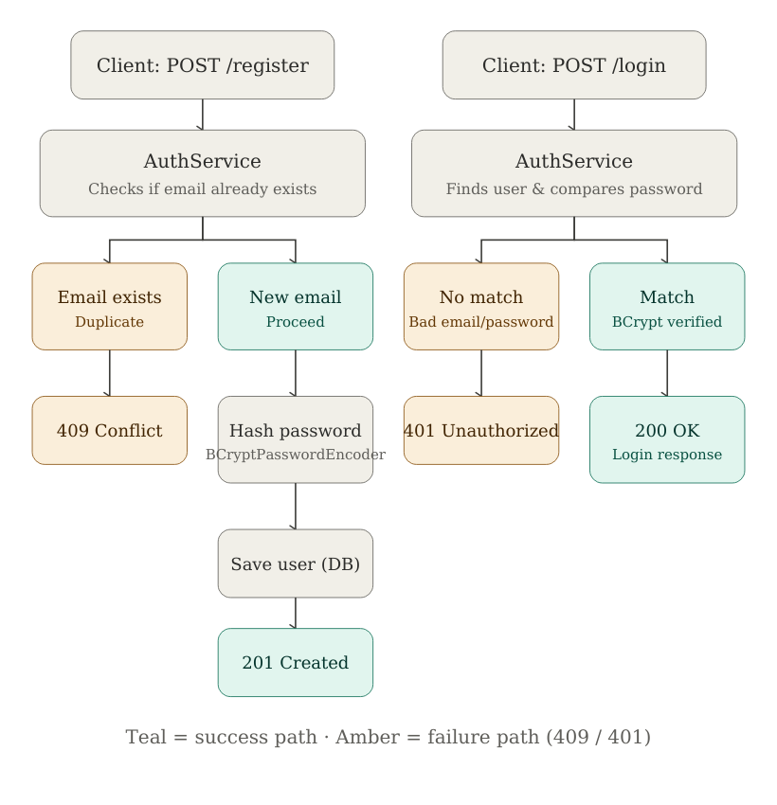

7. Lifecycle of the task
- Step 1 — Created the User entity with id, name, email, password, role, status, and createdAt, and verified the users table was generated correctly in MySQL.
- Step 2 — Created the RegisterRequest DTO to capture registration input.
- Step 3 — Added validation rules to RegisterRequest: name required, valid email format, password required with a minimum length.
- Step 4 — Configured a BCryptPasswordEncoder bean and used it to hash passwords before saving, ensuring plain-text passwords are never stored.
- Step 5 — Built the registration API (POST /api/v1/auth/register), returning 201 Created with the new user's details, password excluded.
- Step 6 — Added a duplicate-email check that returns 409 Conflict if the email is already registered.
- Step 7 — Built the login API (POST /api/v1/auth/login).
- Step 8 — Implemented credential verification: look up the user by email, then compare the submitted password against the stored hash.
- Step 9 — Tested incorrect credentials (wrong password and non-existent email), confirming both return a consistent 401 Unauthorized.
- Step 10 — Verified directly in MySQL Workbench that stored passwords are BCrypt hashes, not the original plain-text values.

8. Issues found and fixed along the way
- GlobalExceptionHandler had a catch-all handler for RuntimeException that hard-coded every match to a 404 Not Found response. Since ResponseStatusException (used for the 409 Conflict on duplicate registration) is itself a RuntimeException, it was being caught by this generic handler, which overwrote the correct 409 status with 404 while still showing the correct error message. Fixed by adding a dedicated handler specifically for ResponseStatusException that respects its own status code, which Spring dispatches to in preference to the more generic handler.
- Adding the BCryptPasswordEncoder bean in this task had a side effect that only became visible while testing product endpoints afterward: it replaced Spring Security's default password-matching strategy application-wide, which broke authentication for Spring Boot's auto-generated development user (whose placeholder-encoded password format the new encoder could no longer interpret). This was resolved by introducing a CustomUserDetailsService that authenticates against real users in the users table instead of relying on the auto-generated development account.

9. What we learned
- Hashing is one-way and salted by design in BCrypt — the same password hashed twice produces two different-looking hashes, and verification is done by re-hashing and comparing, never by decrypting.
- DTOs are a security boundary, not just convenience classes — they control exactly what a client can send in and what the server allows back out.
- Returning identical error messages and status codes for “user not found” and “wrong password” is a deliberate security choice to prevent account enumeration, not an oversight.
- A generic, catch-all exception handler can silently override more specific error handling elsewhere in the application — Spring dispatches to the most specific matching exception type, so a dedicated handler is often needed alongside a broad fallback.
- Introducing a new security-related bean (like a PasswordEncoder) can have application-wide side effects that only surface when testing unrelated parts of the system, which is why re-testing previously working endpoints after a security change is important.

10. Deliverables completed
- Registration API (POST /api/v1/auth/register)
- Login API (POST /api/v1/auth/login)
- BCrypt password hashing, verified directly in the database
- Duplicate-user validation (409 Conflict)
- Authentication service (AuthService) encapsulating registration and login logic
- DTOs for request and response shapes (RegisterRequest/Response, LoginRequest/Response)
- Postman collection covering success and failure cases
- Test evidence (Postman history and MySQL verification)

