EPIC 04 — API Security & Authentication with Spring Security
Jira Task 03 — JWT Access Token & Refresh Token Implementation
Field | Details
Project | product-service (microservices-architecture-fundamentals)
Sprint | Sprint 11 (7/9 – 20/9)
Task date | 17-Sep-2026
Effort | 8 hours
Priority | Critical
Prepared by | Gande Abhishek

1. Objective
This task replaced the interim HTTP Basic authentication (from Task 01) with token-based, stateless authentication using JSON Web Tokens (JWT). The goal was to implement access and refresh token generation on login, validate those tokens on every protected request via a custom security filter, and support renewing an access token without requiring the user to log in again.

2. Concepts learned

2.1 What a JWT is
A JWT is a self-contained, digitally signed string made of three parts: a Header (declares the signing algorithm), a Payload (the claims — data about the user, such as email, role, issue time, and expiry), and a Signature (a cryptographic seal computed from the header and payload using a secret key). Anyone can read the header and payload, but only a party holding the secret key can produce a valid signature — so any tampering with the payload is immediately detectable, because the signature will no longer match.

2.2 Stateless authentication
Unlike session-based authentication, where the server stores login state in memory or a database, JWT authentication is stateless: the server verifies the token's signature on every request instead of looking anything up. This removes the need for server-side session storage and is why SecurityConfig now explicitly disables session creation (SessionCreationPolicy.STATELESS).

2.3 Access tokens vs. refresh tokens
Two tokens are issued at login. The access token is short-lived (1 hour) and is sent with every request to prove identity. The refresh token is longer-lived (7 days) and is used only to obtain a new access token via a dedicated endpoint, without re-entering credentials. Keeping the access token short-lived limits the damage if it is ever leaked, since it expires quickly; the refresh token is used far less often and only against one endpoint, reducing its exposure.

2.4 The Bearer scheme
Tokens are sent using the HTTP Authorization header in the form Authorization: Bearer <token>. “Bearer” indicates that whoever holds the token is treated as authorized — the server does not separately verify identity beyond validating the token itself, which is what makes the scheme lightweight but also why short expiry and careful handling of tokens matters.

3. Technologies and dependencies used
Component | Version / Detail
JWT library | io.jsonwebtoken (JJWT) 0.13.0 — jjwt-api, jjwt-impl, jjwt-jackson
Signing algorithm | HMAC-SHA (HS256), via Keys.hmacShaKeyFor
Security framework | Spring Security 7 (Spring Boot 4.1.1)
Session policy | STATELESS (no server-side session)

4. Changes made

4.1 Configuration — application.properties
Added externalized JWT configuration so the signing secret and token lifetimes are never hard-coded in source files:
- jwt.secret — the HMAC signing key
- jwt.access-token-expiration-ms — 3,600,000 ms (1 hour)
- jwt.refresh-token-expiration-ms — 604,800,000 ms (7 days)

4.2 New file — JwtService.java
Central service for all token operations: generateAccessToken and generateRefreshToken (build and sign a token with claims such as userId, email, role, issuedAt, and expiration), extractClaims (parses and verifies a token's signature), isTokenValid (safely checks a token, catching malformed, tampered, or expired tokens), and extractEmail / extractRole / extractUserId (read specific claims back out of a validated token).

4.3 New file — JwtAuthenticationFilter.java
A Spring Security filter (extending OncePerRequestFilter) that runs on every incoming request before it reaches any controller. It reads the Authorization header, and if a well-formed Bearer token is present and valid, it populates Spring Security's SecurityContext with the user's identity and role — which is what allows anyRequest().authenticated() to accept the request further down the chain. If no token or an invalid one is present, the filter does not reject the request itself; it simply passes through without authenticating, leaving rejection to the security configuration.

4.4 New file — JwtAuthenticationEntryPoint.java
A custom entry point that returns a clean 401 Unauthorized JSON response whenever a request reaches a protected endpoint with no valid authentication. This was added after discovering that, without it, Spring Security's default behaviour returned 403 Forbidden instead — the wrong status code for “not authenticated,” and one that would have been indistinguishable from the role-based 403s planned for Task 04.

4.5 New files — AuthResponse.java and RefreshRequest.java
AuthResponse standardises the token payload returned by both login and refresh: accessToken, refreshToken, tokenType (“Bearer”), and expiresIn (seconds). RefreshRequest is a minimal DTO carrying the refresh token submitted to the refresh endpoint.

4.6 Updated — AuthService.java
login() now generates and returns a full token pair after verifying credentials, instead of a plain success message. A new refresh() method validates an incoming refresh token, re-derives the user from its email claim, and issues a brand-new access and refresh token pair (refresh token rotation), rather than only renewing the access token.

4.7 Updated — AuthController.java
The /login endpoint now returns AuthResponse instead of the earlier LoginResponse. A new endpoint, POST /api/v1/auth/refresh, was added to expose the refresh flow.

4.8 New file — CustomUserDetailsService.java
Implements Spring Security's UserDetailsService so that authentication is backed by real registered users in the users table rather than Spring Boot's auto-generated development account. This was required once a custom PasswordEncoder bean was introduced, since Spring Security could no longer match the auto-generated account's placeholder-encoded password.

4.9 Updated — SecurityConfig.java
HTTP Basic authentication was removed entirely and replaced by the JWT filter for both /api/v1/products/** and /api/v2/products/**. Session creation was set to STATELESS, the custom authentication entry point was registered, and the JWT filter was inserted ahead of Spring's default UsernamePasswordAuthenticationFilter so tokens are checked before any other authentication mechanism runs.

5. What we did with Postman
Postman was used to validate every stage of the JWT lifecycle:
Request | Expected result | Result
POST /auth/login (valid credentials) | 200 OK with accessToken, refreshToken, tokenType, expiresIn | Pass
GET /api/v1/products (no token) | 401 Unauthorized | Pass
GET /api/v1/products (old Basic Auth) | 401 Unauthorized — confirms Basic Auth fully replaced | Pass
GET /api/v1/products (valid Bearer token) | 200 OK with product list | Pass
GET /api/v1/products (malformed token) | 401 Unauthorized | Pass
GET /api/v1/products (tampered token) | 401 Unauthorized | Pass
POST /auth/refresh (valid refresh token) | 200 OK with a new token pair | Pass
All requests are retained in the Postman workspace history for traceability during review.

6. JWT authentication flow
The diagram below shows the full lifecycle: login issues a token pair, the client attaches the access token to subsequent requests, and the JWT filter either authenticates the request or routes it to the custom entry point for rejection.
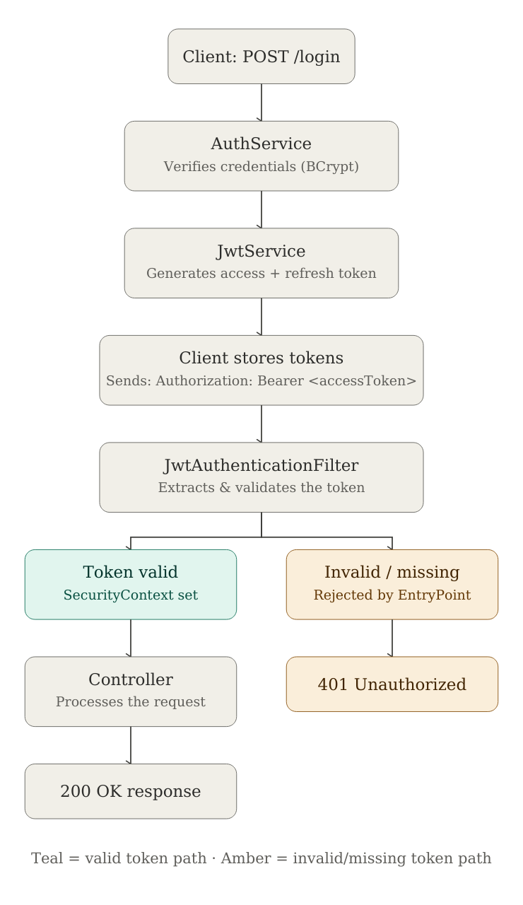

7. Lifecycle of the task
- Step 1 — Studied JWT structure (header, payload, signature), access vs. refresh tokens, token expiration, and stateless authentication.
- Step 2 — Added the JJWT dependency and configured the secret key and token expirations in application.properties.
- Step 3 — Implemented access token generation in JwtService, issued immediately after successful login.
- Step 4 — Added claims to the token payload: userId, email, role, issuedAt, and expiration.
- Step 5 — Standardised the authentication response shape (AuthResponse) with accessToken, refreshToken, tokenType, and expiresIn.
- Step 6 — Built JwtAuthenticationFilter to read, validate, and authenticate incoming Bearer tokens on every request.
- Step 7 — Replaced HTTP Basic authentication with the JWT filter in SecurityConfig for both v1 and v2 product endpoints, and verified protected APIs work correctly with a valid Bearer token.
- Step 8 — Tested invalid-token handling: missing, malformed, and tampered tokens, all correctly returning 401 after the entry-point fix.
- Step 9 — Implemented the refresh token endpoint (POST /api/v1/auth/refresh) with token rotation, returning a fresh access and refresh token pair.

8. Issues found and fixed along the way
- AuthController still referenced the old LoginResponse return type after AuthService was updated to return AuthResponse, causing a compilation failure; fixed by updating the controller's login method signature to match.
- Removing HTTP Basic authentication also removed Spring Security's default authentication entry point, causing unauthenticated requests to incorrectly return 403 Forbidden instead of 401 Unauthorized; fixed by adding a custom JwtAuthenticationEntryPoint and registering it via exceptionHandling(...) in SecurityConfig.
- A Windows/Git case-sensitivity issue caused the security package folder to exist as both Security and security in the Git repository, because Windows treats the two names as identical while Git (once core.ignorecase was corrected) did not; resolved by explicitly removing the stale capitalised folder from Git's tracking with git rm -r --cached and re-committing the corrected lowercase path.

9. What we learned
- A JWT's signature makes it tamper-evident without needing a database lookup on every request — this is the core performance and design benefit of stateless authentication.
- Access and refresh tokens serve different purposes and should have different lifetimes and exposure: the access token is used often and expires quickly, the refresh token is used rarely and lives longer.
- Introducing a custom PasswordEncoder bean silently disables Spring Boot's auto-generated development login, since the two use incompatible password-encoding formats — a UserDetailsService backed by real data is the correct long-term fix.
- Spring Security's default behaviour for an unauthenticated request is 403 Forbidden unless an authentication entry point is explicitly configured; without one, genuine “not logged in” and “not allowed” cases become indistinguishable.
- Filters in Spring Security run before controllers and should only establish identity, not reject requests themselves — rejection is handled separately by the authorization rules and the entry point.
- Git on Windows can silently hide case-only folder renames unless core.ignorecase is explicitly set to false, which can lead to duplicate, differently-cased folders being tracked in the repository.

10. Deliverables completed
- JWT generation (access and refresh tokens with claims)
- JWT validation (signature, structure, and expiry checks)
- Authentication filter (JwtAuthenticationFilter, applied to all endpoints)
- Access token issuance on login
- Refresh token endpoint with token rotation
- Protected APIs verified working with Bearer authentication (v1 and v2)
- Invalid-token handling (missing, malformed, tampered) with correct 401 responses
- Postman test evidence (request history)
- This documentation

