Spring Boot Microservices Project
Daily Task Report with Embedded Evidence
DAY 2 — TUESDAY, 20 OCTOBER 2026 (verification screenshots dated 21 October)

1. Objective
Verify Gateway request-size protection, rate limiting and safe error handling, plus Product Service role-based authorization.

2. Implementation reviewed
Area | Implementation / behavior
Request-size limit | RequestSizeLimitFilter uses gateway.request.max-body-size (default 1 MiB) and rejects oversized bodies with HTTP 413.
Rate limiting | Redis-backed per-IP limit: 100 requests per 60 seconds; response headers include X-RateLimit-Limit and X-RateLimit-Remaining.
Redis outage | When Redis was stopped, Gateway logged connection-refused/timeout errors; the rate-limiter path returned a generic HTTP 503 response.
Safe downstream error | GatewayExceptionHandler maps ResourceAccessException to HTTP 503 with a generic message, without returning exception details.
Authorization | Product Service requires authentication for GET, ADMIN or MANAGER for POST/PUT/PATCH, and ADMIN for DELETE.

3. Test results
Test | Observed result | Outcome
GET without token | 401 Unauthorized | Pass
GET with valid User token | 200 OK; product list returned | Pass
POST with fresh User token | JWT valid; ROLE_USER; final status 403 | Pass — authenticated but forbidden
POST with Admin token | Earlier Postman evidence showed 201 Created | Pass — observed
Oversized body | 413 Payload Too Large with generic JSON response | Pass
Normal GET | 200 OK with rate-limit headers and remaining count decrementing | Pass
Rate-limit runner | 101 iterations configured; screenshot showed 429 on final iteration. Existing assertion checked headers rather than explicitly asserting 429. | 429 observed; assertion caveat recorded
Redis unavailable | Generic 503 response while Redis unavailable | Pass — fail-closed behavior observed
Downstream unavailable | 503 Service Unavailable with generic message | Pass

4. Embedded evidence screenshots
The following are actual screenshots attached in this conversation and are embedded below. They are not placeholder filenames.
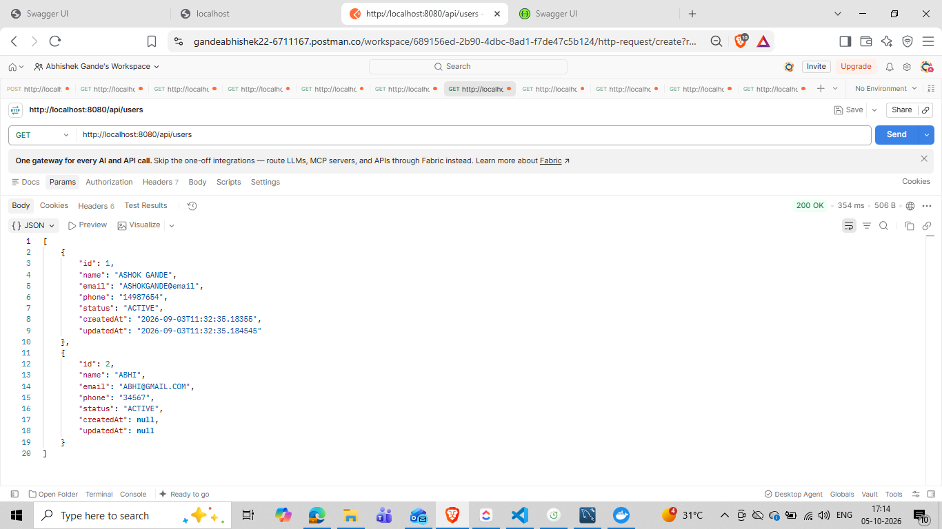
Evidence 1 — Postman request-size protection: oversized body returned HTTP 413 Payload Too Large.
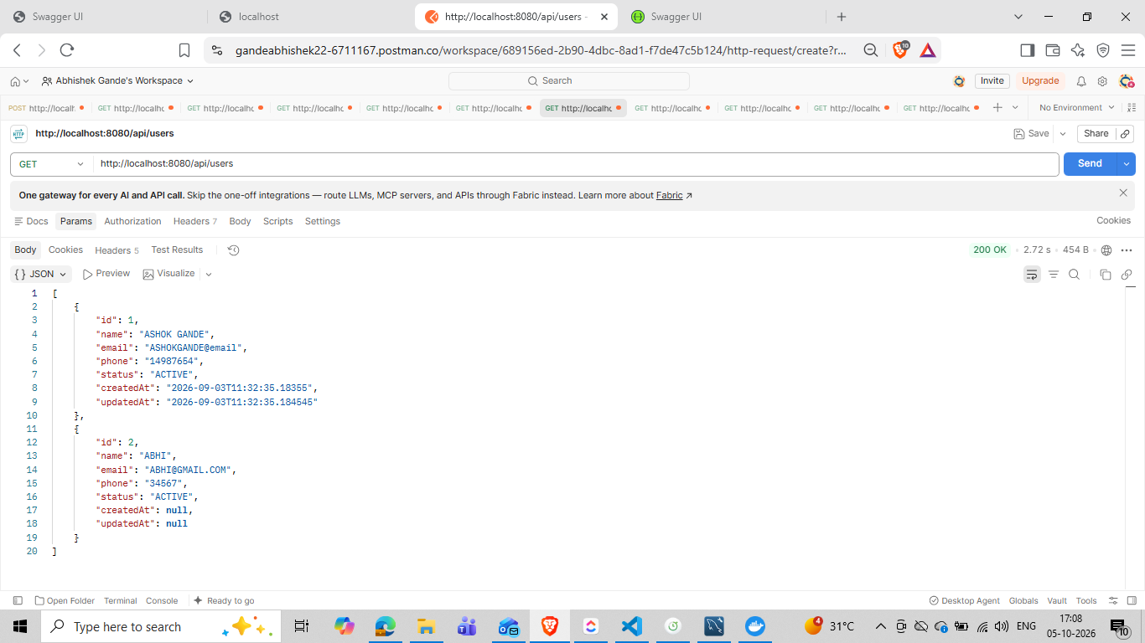
Evidence 2 — Postman rate-limit Runner results: 101 iterations, with HTTP 429 visible on the final iteration.
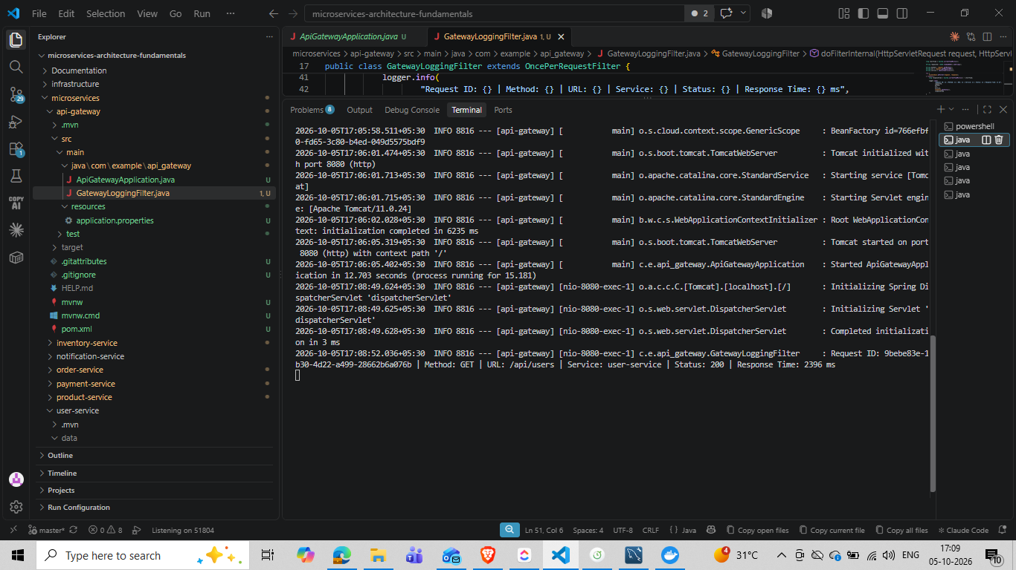
Evidence 3 — Gateway terminal logs during Redis connectivity failure / rate-limiter error handling.
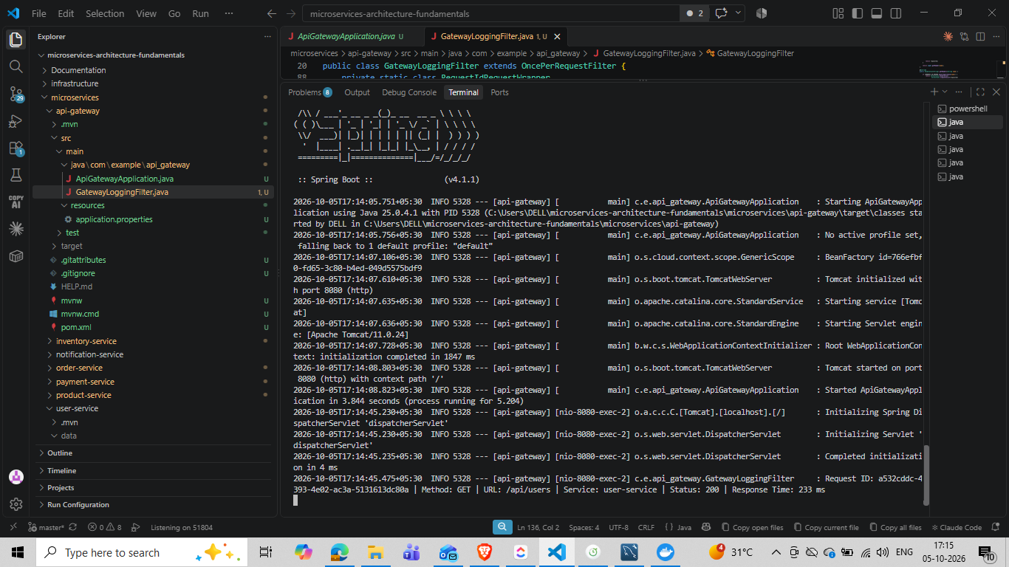
Evidence 4 — Product Service terminal logs showing valid User JWT, ROLE_USER, and POST ending with HTTP 403.
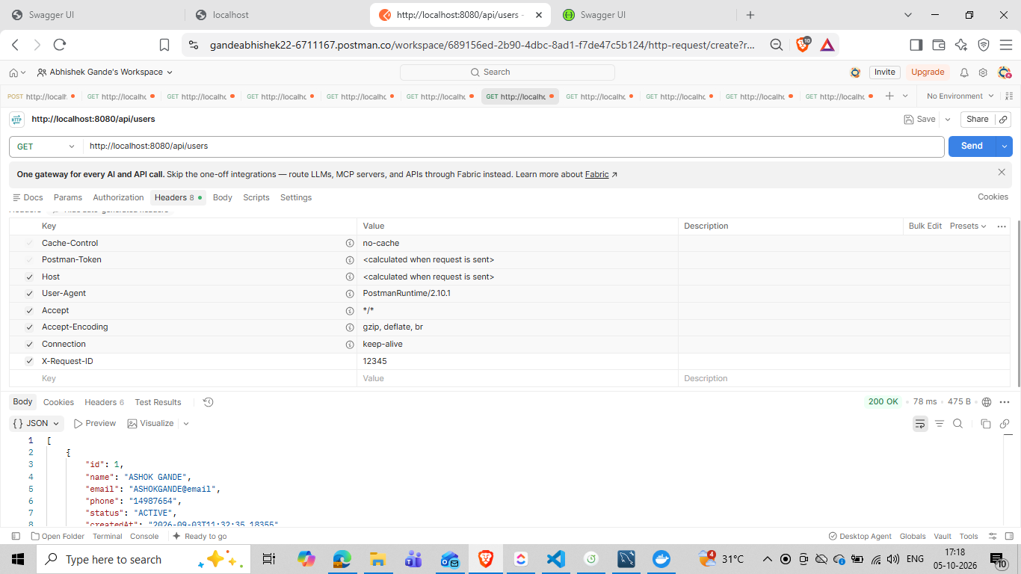
Evidence 5 — Postman response headers showing HTTP 200 and X-RateLimit-Limit / X-RateLimit-Remaining.
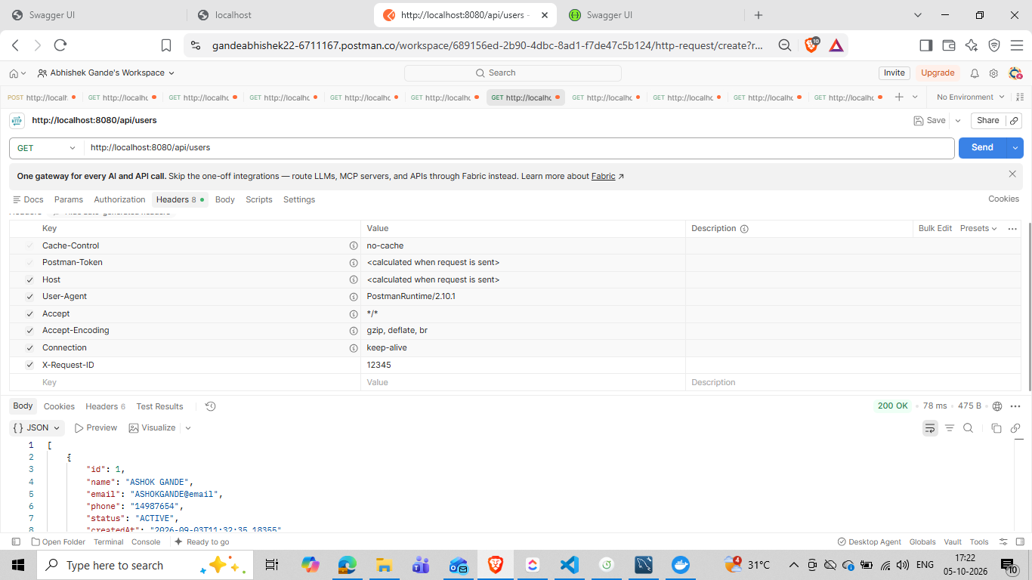
Evidence 6 — Postman response header view for a normal product request.
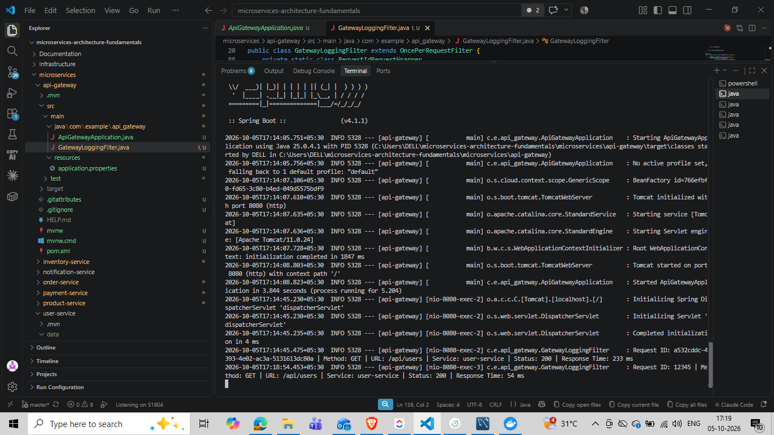
Evidence 7 — Gateway logs for observed request outcomes, including downstream status responses.

5. Notes and completion
The User authorization test initially returned 401 because the token had expired. After using a fresh token, Product Service validated the token and denied POST with 403, the correct result for a User without write permission.
Day 2 is recorded as complete based on the work and evidence already shared. No repeat tests are requested. Screenshots carry 21 October timestamps although this task is labeled Tuesday, 20 October 2026.

