EPIC 04 — API Security & Authentication with Spring Security
Jira Task 01 — Spring Security Fundamentals & Authentication Setup
Field | Details
Project | product-service (microservices-architecture-fundamentals)
Sprint | Sprint 11 (7/9 – 20/9)
Task date | 15-Sep-2026
Effort | 8 hours
Priority | High
Prepared by | Gande Abhishek

1. Objective
This task focused on introducing Spring Security into the existing product-service microservice and configuring a baseline authentication layer. The goal was to understand Spring Security's default behaviour, then explicitly define which API endpoints should remain publicly accessible and which should require authenticated access, before moving on to more advanced authentication mechanisms (JWT, role-based access) in subsequent tasks of this epic.

2. Technologies and dependencies used
The product-service module runs on the following stack:
Component | Version / Detail
Java | 25
Spring Boot | 4.1.1
Build tool | Maven
Web starter | spring-boot-starter-webmvc
Persistence | spring-boot-starter-data-jpa, MySQL (mysql-connector-j)
Validation | spring-boot-starter-validation
API documentation | springdoc-openapi-starter-webmvc-ui 2.7.0 (Swagger UI)
Security (added this task) | spring-boot-starter-security
Security testing support (added) | spring-boot-starter-security-test
Spring Boot 4 restructures starters by capability, and spring-boot-starter-security remains the correct dependency for securing a Spring MVC application under this version, working with the lambda-based SecurityFilterChain configuration style used below.

3. Changes made

3.1 Dependency changes — pom.xml
Added the Spring Security starter and its test-scoped counterpart to enable authentication support and future security-focused test cases:
- spring-boot-starter-security
- spring-boot-starter-security-test (test scope)

3.2 New file — SecurityConfig.java
Created a new security package (product_service.security) containing SecurityConfig.java, which defines a SecurityFilterChain bean. This configuration:
- Disables CSRF protection, appropriate for a stateless REST API
- Permits unauthenticated access to /api/v1/products/public
- Permits Swagger/OpenAPI documentation routes (/v3/api-docs/**, /swagger-ui/**, /swagger-ui.html) so the API remains explorable without login
- Requires authentication for every other request via anyRequest().authenticated()
- Enables HTTP Basic authentication as the interim authentication mechanism for this task

3.3 New endpoint — ProductController.java
Added a getPublicProducts() method mapped to GET /api/v1/products/public, reusing the existing productService.getProducts(...) call with default pagination. This gives the security configuration a real, working public route to demonstrate the public/private split, rather than a placeholder.

4. What we did with Swagger
Once Spring Security was added, Spring's default behaviour locked down every endpoint in the application — including Springdoc's own /v3/api-docs definition, which powers Swagger UI. This initially broke Swagger UI with an “Unable to render this definition” error, because the browser received a 401 response instead of a valid OpenAPI JSON document.
This was resolved by explicitly whitelisting Swagger's own routes in SecurityConfig (/v3/api-docs/**, /swagger-ui/**, /swagger-ui.html), so that documentation remains browsable while the actual product APIs stay protected. Swagger UI was used throughout the task to visually confirm endpoint definitions, and the native browser Basic Auth prompt (triggered when calling a protected endpoint from Swagger) was used as a secondary confirmation that authentication was being enforced.

5. What we did with Postman
Postman was used as the primary tool for verifying security behaviour, as it allows explicit control over authentication headers that Swagger's browser-based flow does not provide as cleanly. The following verifications were performed:
Request | Expected result | Result
GET /api/v1/products (no auth) | 401 Unauthorized | Pass
GET /api/v1/products (Basic Auth) | 200 OK with product list | Pass
GET /api/v1/products/public (no auth) | 200 OK with product list | Pass
POST /api/v1/products (no auth) | 401 Unauthorized | Pass
PUT /api/v1/products/{id} (no auth) | 401 Unauthorized | Pass
PATCH /api/v1/products/{id} (no auth) | 401 Unauthorized | Pass
DELETE /api/v1/products/{id} (no auth) | 401 Unauthorized | Pass

All Postman requests are retained in the workspace request history for traceability during review.

6. Security architecture diagram
The diagram below illustrates the request lifecycle for this task: an incoming client request is intercepted by Spring Security's SecurityFilterChain before it ever reaches the controller. Based on the requested path, the filter chain either allows the request through immediately (public endpoint) or requires valid credentials (protected endpoint) before forwarding it to ProductController, which then returns the appropriate response.
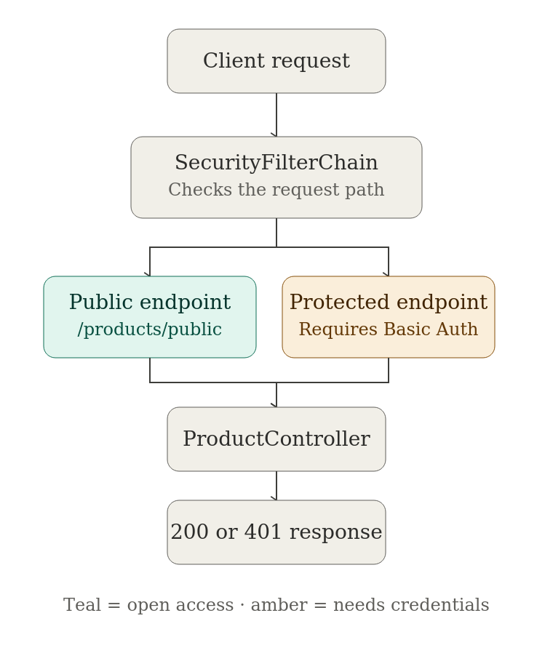
Teal = open access (no authentication required). Amber = protected access (requires HTTP Basic credentials).

7. Lifecycle of the task
The task was executed in the following order, matching the step-by-step structure defined in the Epic 04 sprint plan:
- Step 1 — Studied core security concepts: authentication, authorization, identity, roles, permissions, access control, and the distinction between public and protected APIs.
- Step 2 — Studied the Spring Security request architecture: Client → Security Filter → Authentication → Authorization → Controller.
- Step 3 — Added the spring-boot-starter-security dependency to pom.xml.
- Step 4 — Ran the application and verified that Spring Security protected all endpoints by default, confirmed via the auto-generated console password and a 401 response on an unauthenticated request.
- Step 5 — Created SecurityConfig.java and defined the SecurityFilterChain bean.
- Step 6 — Added the GET /api/v1/products/public endpoint and permitted it in the security configuration.
- Step 7 — Confirmed that all other product endpoints (GET, POST, PUT, PATCH, DELETE) remained protected.
- Step 8 — Tested every endpoint without authentication in Postman and verified consistent 401 responses on protected routes.
- Step 9 — Documented the resulting security flow, including the architecture diagram above.
A secondary issue was encountered and resolved along the way: enabling security broke Swagger UI's ability to load its own API definition, since /v3/api-docs was no longer publicly reachable. This was fixed by explicitly whitelisting Swagger's routes, allowing both Swagger UI and Postman to be used side by side for the remainder of the task.

8. What we learned
- Spring Security secures every endpoint by default the moment the starter is added — nothing needs to be manually “turned on.”
- The SecurityFilterChain bean, configured with the lambda-based DSL, is the central place to declare which routes are public versus protected.
- Static path rules (like /public) are matched ahead of path-variable rules (like /{id}), so there was no routing ambiguity to worry about.
- A 401 response happens at the filter level, before the request body or path variables are even processed by the controller — meaning malformed request bodies on protected endpoints still correctly return 401, not 400.
- Enabling security has side effects on adjacent tooling (Swagger/OpenAPI) that also needs to be explicitly accounted for.
- Postman is a more reliable tool than a browser for testing authentication headers directly, since it avoids the native browser Basic Auth popup that Swagger UI triggers.

9. Deliverables completed
- Spring Security configuration (SecurityConfig.java)
- Public/private API configuration (/public permitted, remaining routes authenticated)
- SecurityFilterChain bean
- 401 handling, verified via Postman across all HTTP methods
- Security architecture diagram (Section 6)
- Postman test evidence (request history)
- This documentation

