BRACT’s
Vishwakarma Institute of Technology, Pune
Practical Implementation Sheet
Department: CSE-AI Semester: 5 Academic Year: 2026-27
Division: C Batch: 1 Practical No: 1
Roll no: 16 PRN No: 12412535 Name of Student: Abhishek Dasharath Kadam
Subject Name: Deep Learning
Problem Statement:
Install and configure TensorFlow/Keras in Google Colab. Perform data preprocessing, normalization, train-test split, and visualization on a sample dataset.
Algorithm:
Data Preprocessing, Normalization, Train-Test Splitting, and Visualization using MNIST Dataset
- Start the program.
- Import the required libraries (TensorFlow/Keras, NumPy, Matplotlib, Scikit-learn, KaggleHub, etc.).
- Download the Fashion_MNIST dataset using kagglehub.dataset_download().
- Load the Fashion_MNIST images and labels into memory.
- Verify the dataset dimensions and inspect the data.
- Separate the image data (features) and digit labels (targets).
- Normalize the pixel values by dividing each pixel by 255 so that all values lie in the range 0 to 1.
- Split the dataset into training and testing sets using train_test_split().
- Visualize sample handwritten digit images using Matplotlib.
- Plot the distribution of digit classes to understand the dataset.
- Display the shapes of the training and testing datasets.
- End the program.
Code:
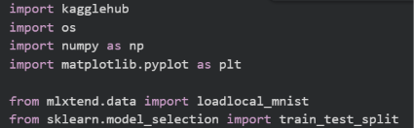
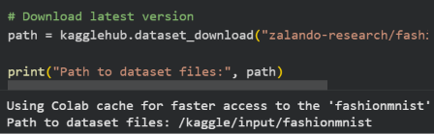
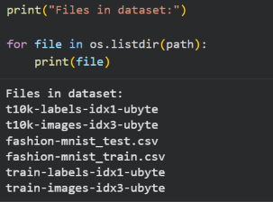
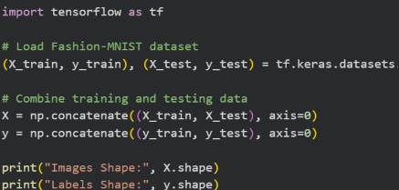
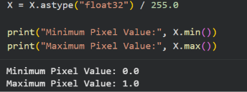
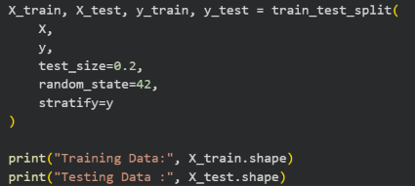
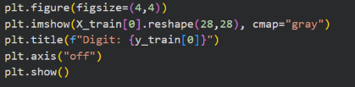
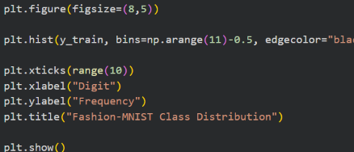
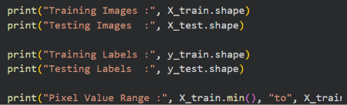

Output :

