# Coursera Capstone Project The Battle of Neighborhoods

Abhishek Shekade

July 16, 2020

# Introduction

In a city of Helsinki, if someone is looking to open a café restaurant, the question is, where would you recommend that they open it? The background of the problem is that in order for a café to be profitable, there must be enough customers, and in order to have enough customers, it is not worth setting up a café in the immediate promixity of existing ones.

Let’s also make sure that audience is explicitly defined to be the local restaurant entrepreuners in Helsinki and they should care about this problem because the location of the new café has a significant impact on the expected returns.

# Data

A description of the data: the data used to solve this problem is geolocation data collected from FourSquare. Adequate

explanation and discussion, with examples, of the data is the following. Data is a single dataframe, containing at least a

location of the café. Explanation of the location data is a

standard tuple (lat, lng), where lat stands for latitude and lng for longitude. Some other metadata like name, postal code and so on is also collected, but let us discuss that they are not absolutely necessary for the analysis. Example of the data used in analysis is shown in table 1.

Data will be used in the following way: by knowing the locations of already existing cafes, it’s possible to apply

unsupervised learning technique like kernel density estimation (KDE) to determine the area of influence of the existing cafes, and start up new café which is not in the area of influence.

|  |  |  |  |  |  |
| --- | --- | --- | --- | --- | --- |
| Identifier | Name | Address | Postalcode | Latitude | Longitude |
|  |  |  |  |  |  |
| 1 | Patisserie Teemu & Markus | Yrjönkatu 25 | 00100 | 60.167899 | 24.938190 |
| 2 | Kaffecentralen | Fredrikinkatu 59 | 00100 | 60.167580 | 24.932526 |
| 3 | La Torrefazione | Mannerheimintie 22 | 00100 | 60.170721 | 24.936158 |
| 4 | The Ounce | Fredrikinkatu 55 | 00100 | 60.167182 | 24.932993 |
| 5 | La Torrefazione | Aleksanterinkatu 50 | 00100 | 60.168877 | 24.943845 |

Table: Five first rows of data used in the machine learning algorithm.

# Methodology

Heatmap-based kernel density estimation was used. Heatmat was already implemented as plugin for Folium, which was used to visualize data to map. Visualization is shown in figure 1.

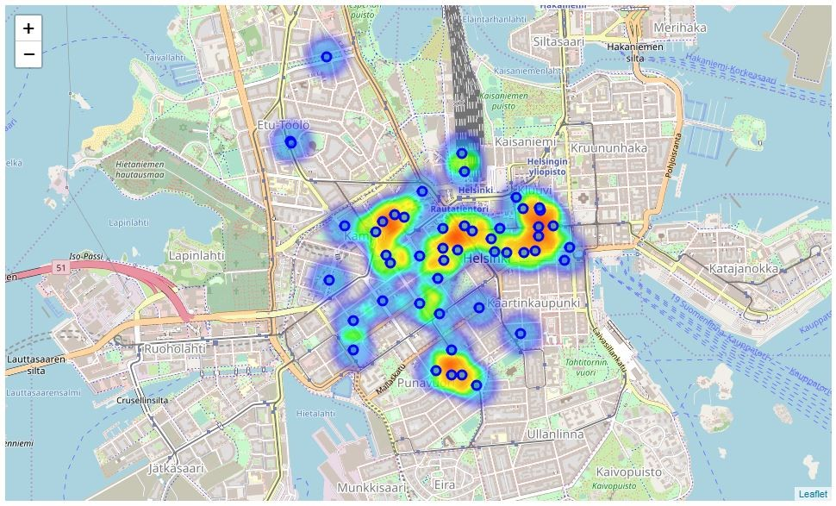

Figure: Data visualized to the map of Helsinki, including heatmap-based kernel density estimation.

# Results

Based on the preliminary results, one possibly good location for new Cafe would be in crossroad of Aleksanterinkatu and Mikonkatu, shown in figure 2.

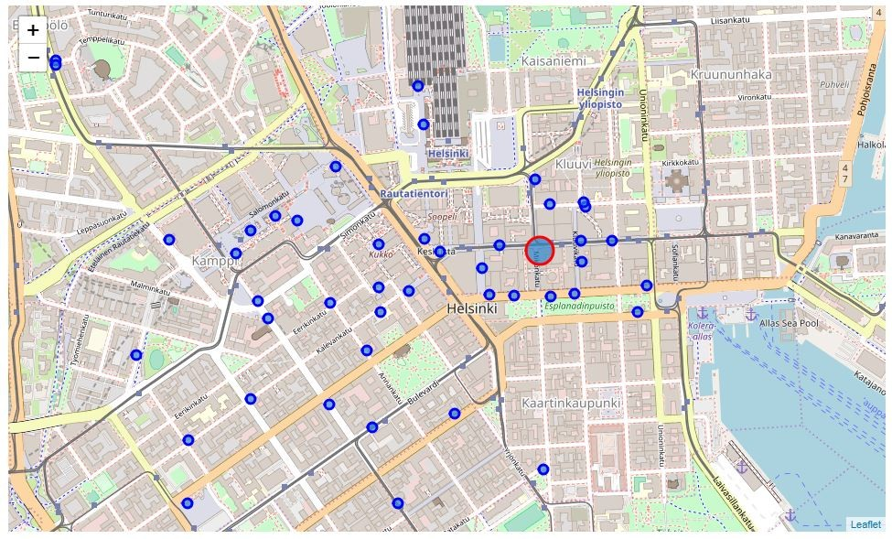

Figure: Proposed location for a new café restaurant.

# Discussion

Before starting a business, some further data analysis of the optimal location of shop may be required.

# Conclusions

Optimal location for a new coffee shop in center of Helsinki was estimated based on data from FourSquare.