Abhishek Veerappa Magalada
abhimagalad003@gmail.com

1️⃣ Number Classification (if + function)
Write a shell script that uses a function to check whether a number is positive, negative, or zero using if.
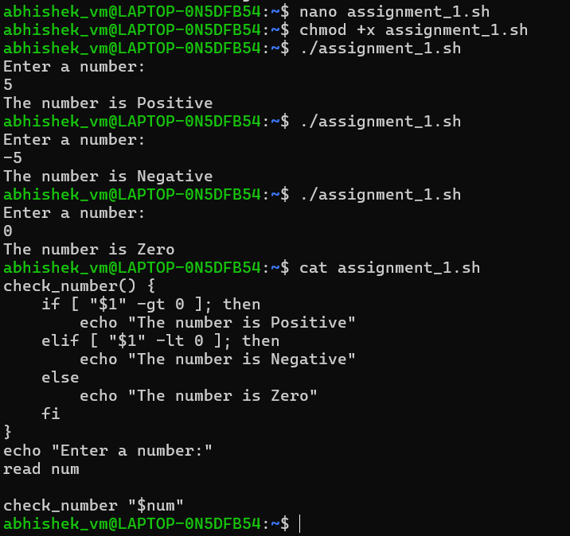

2️⃣ Factorial of a Number (while + function)

Write a shell script to calculate the factorial of a number using a while loop inside a function.
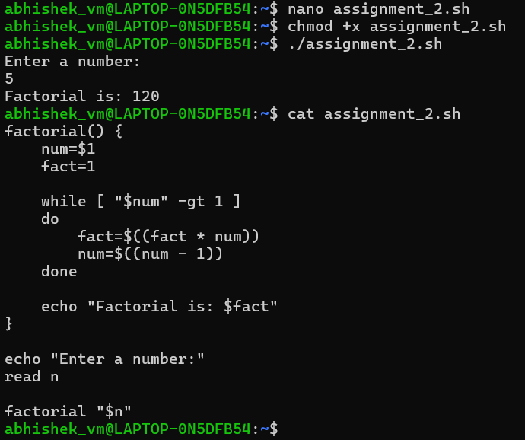

3️⃣ Sum of N Numbers (for + function)

Write a shell script to calculate the sum of numbers from 1 to N using a for loop inside a function.
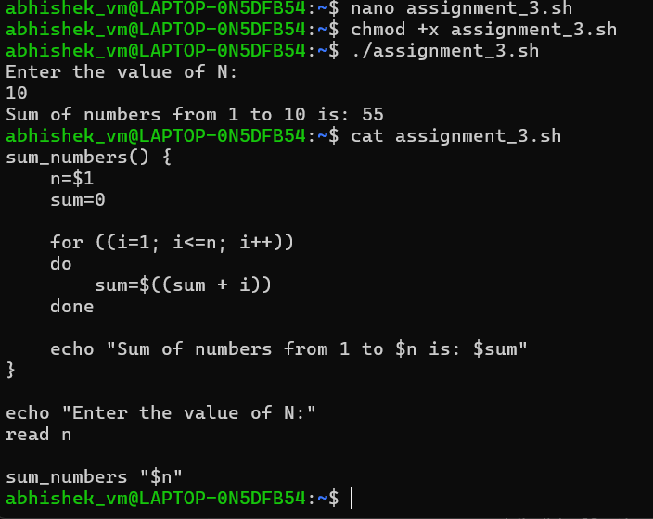

4️⃣ Prime Number Check (if + for + function)

Write a shell script that uses a function to check whether a given number is prime using if and for.
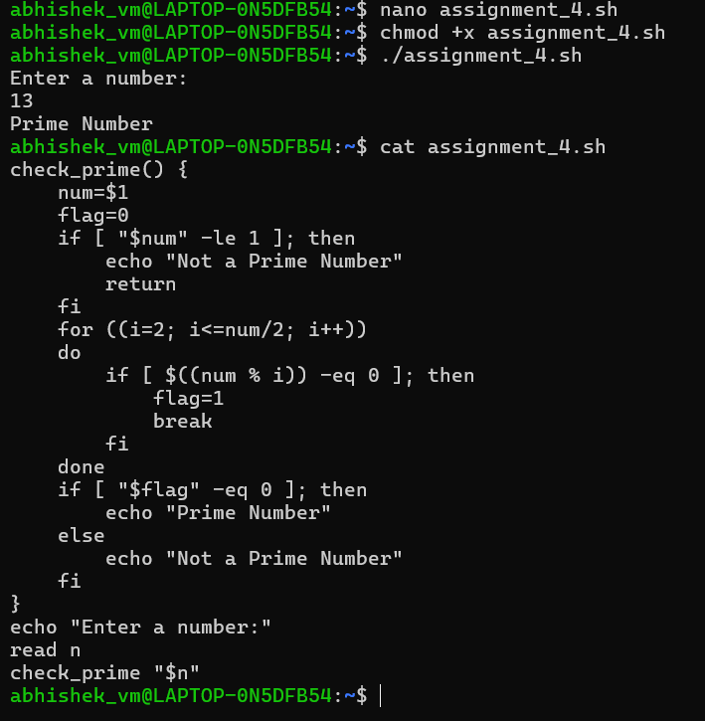

5️⃣ Reverse a Number (while + if)

Write a shell script to reverse a number using a while loop and if conditions where required.
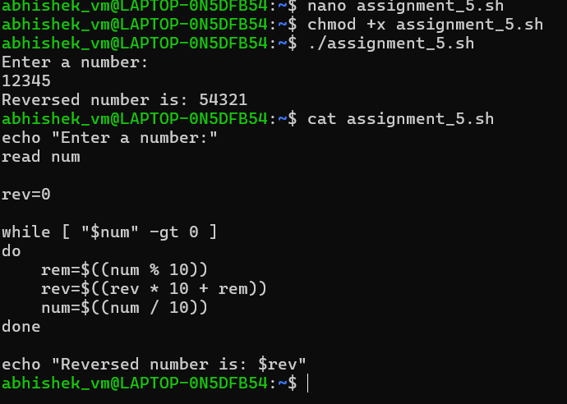

6️⃣ File Existence & Permission Check (if + function)

Write a shell script that uses a function to check if a file exists and whether it has read, write, and execute permissions.
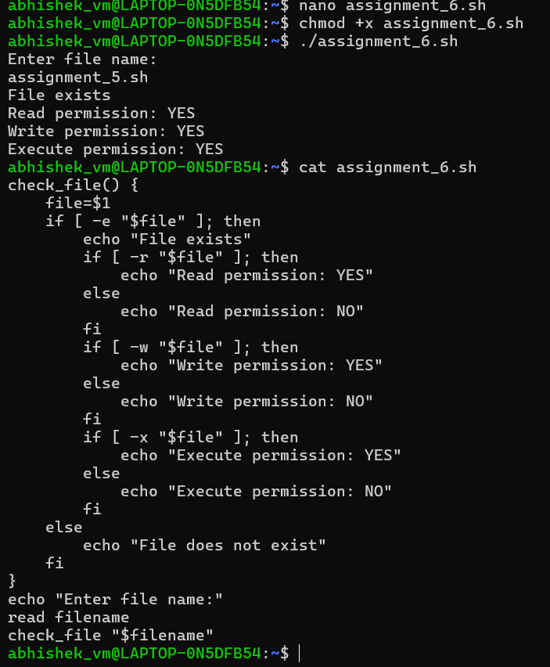

7️⃣ Menu-Driven Calculator (while + case + function)
Write a shell script that shows a menu in a while loop and performs add, subtract, multiply, divide using functions.
