**ON LIN E MOVIE TICKET BOOKING SYSTEM**

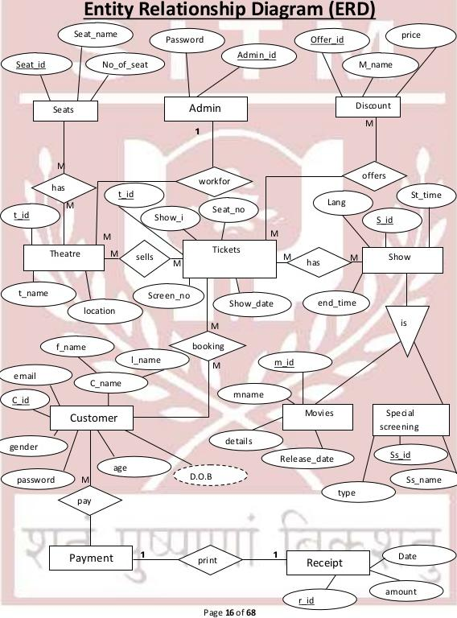

**Entity Relationship Diagram (ERD)**

Se atname

CPassy'rd

(1.'se;)

Seats I Mmin

gender