GREENBASKET
Product Requirements Document (PRD) + System Design Specification
Version 2.0 · 13 October 2026 · Draft for owner review
Field | Value
Document | Greenbasket — Product Requirements Document (PRD) and System Design Specification
Version | 2.0 — supersedes version 1.0
Date | 13 October 2026
Status | Draft for owner review. Requirements baseline for Phase 0 and Phase 1.
Business | Greenbasket, fresh-produce e-commerce
Platform baseline | WordPress + WooCommerce + Blocksy + Elementor Free + Hostinger
Primary service area | Chandigarh, Mohali, Panchkula, India
Execution model | Phased, evidence-based, approval-gated
Audience | Business owner; Claude (Claude Pro, Claude in Chrome, Claude Code); developer; QA; operations
Owner approval of v2.0 | Pending. Every v2.0 addition is a RECOMMENDATION or OPEN DECISION until the owner confirms it. Nothing CONFIRMED in v1.0 was removed or changed in meaning.

Contents
PART A — USING THIS DOCUMENT
0. Instructions for the AI Agent Reading This Document
1. What Changed in Version 2.0
PART B — PRODUCT AND BUSINESS
2. Executive Summary
3. The 15 Pillars and Build Order
4. Confirmed Requirements
5. Business and Legal Groundwork (Track A)
6. Open Decisions Register
PART C — SYSTEM DESIGN
7. Architecture Overview
8. Functional Modules
9. Data Model
10. Pricing Engine Specification
11. State Machines
12. Core Workflows
13. Inventory Ledger and Reservations
14. Subscription Scheduling and Billing
15. Delivery Slots and Fulfilment
16. Payments
17. Notifications and Integrations
PART D — EXPERIENCE
18. Brand and Design System
19. Frontend and Shopper Experience
20. Content and Catalogue
PART E — PLATFORM AND OPERATIONS
21. Hosting, Domain and Environments
22. Security and Access
23. Performance, Observability and Recovery
24. Operations and Customer Support
25. Marketing, SEO and Analytics
PART F — QUALITY AND DELIVERY
26. Acceptance Criteria
27. Phased Implementation Plan
28. Launch and Ongoing Maintenance
29. Required AI Agent Workflow
30. First Claude Session Prompt
31. Final Architecture Decision Summary
APPENDICES
Appendix A. Change Log from Version 1.0
Appendix B. Risk Register
Appendix C. Phase 0 Audit Evidence Checklist

PART A — USING THIS DOCUMENT

0. Instructions for the AI Agent Reading This Document
This document is the source of truth for Greenbasket requirements. Follow it as a specification, not as permission to invent missing business rules.

0.1 Operating rules
- Do not implement the whole system in one pass. Work only on the current phase approved by the owner.
- Do not install, activate, deactivate, update, or purchase plugins without explicit approval.
- Do not edit the live production website during discovery, audit, or development. Use the verified staging site.
- Do not assume the current hosting plan supports the target load. Inspect available resources and run tests before making performance claims.
- Do not guess settings, plugin names, gateway capabilities, APIs, tax rules, prices, delivery cutoffs, tier boundaries, or policies. Mark them as unresolved and ask concise questions only when the answer blocks the current phase.
- Do not make broad changes to WordPress, WooCommerce, theme settings, database records, or checkout until the impact is understood and a backup is verified.
- Do not expose, copy, or request passwords, API secrets, payment credentials, customer personal data, or production payment tokens.
- Do not use the browser UI to perform irreversible actions without the owner's explicit confirmation. This includes deleting data, changing DNS, updating production, publishing pages, charging payments, and changing live orders.
- Inspect before acting. Report what was observed, what was inferred, and what remains unknown.
- Use one phase at a time. Produce the phase deliverables, run the acceptance checklist, summarize changed files and settings, list unresolved issues, and wait for approval before proceeding.
- Do not claim an action succeeded unless it was verified.
- Do not create duplicate functionality when WooCommerce already provides a suitable supported capability. Verify compatibility and limitations before recommending implementation.
- Prefer a small, modular Greenbasket-specific extension for custom domain logic over scattering custom code across theme files, snippets, and page builders. This is an architectural direction, not authorization to begin coding before the design is approved.
- Do not change the architecture silently. If a requirement conflicts with WooCommerce, hosting constraints, gateway limitations, or another requirement, explain the conflict and offer options before implementation.
- Keep an implementation log. For each phase, record decisions, files changed, settings changed, tests run, results, and rollback instructions (template in §29.4).
- Treat every v2.0 addition as a RECOMMENDATION or OPEN DECISION unless this document labels it CONFIRMED.
- Use this document's identifiers (requirement, decision, transition, acceptance and risk IDs — §0.4) when reporting work, so every claim and test can be traced.

0.2 Required response format at the end of every phase
Return:
- Phase status: PASS, PASS WITH OPEN ITEMS, or BLOCKED.
- What was inspected.
- What was changed, if anything.
- Evidence for each important claim.
- Tests run and exact results, by acceptance ID (§26).
- Known risks (Appendix B IDs) and unresolved decisions (§6 IDs).
- Backup and rollback method.
- Proposed next phase.
- A request for approval before starting the next phase.

0.3 Uncertainty labels
Use these labels consistently:
- CONFIRMED: explicitly chosen by the business owner.
- OBSERVED: verified directly in the website, settings, files, or a test result.
- RECOMMENDATION: suggested design decision that still requires approval.
- OPEN DECISION: business choice not yet made.
- CONFIGURABLE: value must be stored as a setting, not hard-coded.
- BLOCKER: cannot safely proceed without resolution.
- NOT IN SCOPE: explicitly deferred or excluded.

Never convert a recommendation, assumption, or open decision into a confirmed requirement.

0.4 Identifiers and conventions
Prefix | Used for | Example
BP, RT, FB, WS, SB, CP, IN, DL, OR, NA, RL | Confirmed requirements, by area (§4) | SB-04
LG | Business and legal groundwork items (§5) | LG-03
OD | Open decisions (§6) | OD-25
O, P, R, L, S, V, F | State transitions: order, payment, stock reservation, slot reservation, subscription, subscription delivery, refund (§11) | O13
J | Shopper journeys (§19.4) | J6
AC | Acceptance criteria (§26) | AC-INV-01
RK | Risks (Appendix B) | RK-05
C | Phase 0 audit evidence items (Appendix C) | C2

Conventions (RECOMMENDATION unless stated):
- Money is stored as whole paise (₹1 = 100 paise) in Greenbasket tables, so no rounding errors build up. It is displayed in rupees with two decimals. The rounding rule is OD-50.
- Time is stored in UTC. Business rules — slots, cutoffs, operating hours, renewal dates — are evaluated in India Standard Time (Asia/Kolkata, UTC+05:30).
- Stock quantities are whole numbers of a base unit: grams, millilitres or pieces (RK-05).
- Atomic means the check and the change happen as one indivisible database operation (a conditional update or a row lock), so two simultaneous shoppers can never both get the last unit or the last slot.
- Idempotent means repeating an operation — a retried job, a duplicate gateway callback, a double-clicked button — has the same effect as doing it once.
- Must marks a mandatory requirement; should marks a recommendation.

0.5 Current status and next instruction
- Phase 0 brief delivered (13 October 2026): business understanding, high-level architecture, confirmed requirements, open decisions, risks, and the audit evidence list (Appendix C).
- Phase 0 audit: BLOCKER — waiting for staging evidence from the owner. Items C1–C3 (staging relationship, backups, isolation) come first.
- Track A — business and legal groundwork (§5): may start now. It needs no website access.
- Next instruction to Claude: continue Phase 0 only. Collect the Appendix C evidence and produce the environment report, plugin and theme inventory (no recommendations), current-state architecture, updated risk register, open decisions, and backup and rollback verification. Do not install plugins or modify site settings.

0.6 Glossary
Term | Meaning
Base unit | The single unit a product's stock is counted in — for example grams for tomatoes, pieces for coconuts.
Selling unit | What the customer buys: a pack, piece or bunch, with a fixed conversion to the base unit (a "500 g pack" = 500 g).
Nominal quantity | The quantity a selling unit states it contains — the "500 g" in a 500 g pack.
Channel | The shopping experience a cart line came from: Retail, Farm Box, Wholesale or Subscription.
Shared stock pool | One stock count per product, used by every channel.
Reservation (hold) | A temporary claim on stock or slot capacity so it cannot be sold to someone else while checkout completes.
Price lock | A 15-minute guarantee of the prices calculated at checkout start.
Allowance | The money value of products a subscription plan includes per period.
Tier | A wholesale quantity band with its own unit rate.
Slot | A delivery time window on a date, with limited capacity.
Cutoff | The latest time an order or basket change is accepted for a slot or delivery.
Protected capacity | Slot capacity set aside for subscription deliveries before regular orders can use what remains.
COD | Cash on delivery — cash or UPI collected at the door.
Gateway | The payment provider that processes online payments.
Callback (webhook) | A message the gateway's server sends to the website's server to report a payment result.
Reconciliation | Comparing the website's records with the gateway's or bank's records and resolving any difference.
Idempotency key | A unique key attached to an operation so that repeating it never creates a duplicate.
Audit log | An append-only history of who changed what, when, and why.
Exception case | A tracked problem that needs a person to resolve it (for example a shortage or an unclear payment).
Staging / production | Staging is a private copy of the website for testing; production is the live site.
HPOS | WooCommerce High-Performance Order Storage: orders kept in dedicated tables instead of WordPress posts.
RTO / RPO | Recovery Time Objective (how quickly the site must be back) / Recovery Point Objective (how much recent data may be lost).
Mandate / token | A permission held by the gateway that allows automatic recurring charges without the customer re-entering payment details.
DLT | TRAI's registration system that Indian businesses must use for commercial SMS (entity, sender IDs, templates).
FSSAI | Food Safety and Standards Authority of India.
Wireframe | A simple sketch of a page's layout and content before visual design.
Design token | A named design value — a colour, font size or spacing step — reused everywhere so the brand stays consistent.

1. What Changed in Version 2.0
- Seven missing pillars added: business and legal groundwork (§5), hosting, domain and environments (§21), brand and design system (§18), frontend and shopper experience (§19), content and catalogue (§20), marketing, SEO and analytics (§25), and ongoing maintenance (§28). Payments (§16), security (§22), operations and support (§24) and testing (§26) were extended.
- Formal state machines with transition tables for orders, payments, stock reservations, slot reservations, subscriptions, subscription deliveries, refunds and exception cases (§11). They are built from the owner-supplied diagrams and corrected where those diagrams conflicted with the requirements (Appendix A.2).
- Fifteen core workflows with diagrams and step lists (§12).
- Identifiers for every confirmed requirement, open decision, transition, acceptance criterion and risk.
- Open decisions register grew from 18 to 60 items, each with the phase it blocks (§6).
- Data model: missing entities added (saved Farm Box, price lock, cutoff rule, service area, quote, refund transaction, COD collection, bank-transfer verification, delivery attempt, dispute, consent) and the reservation reference fixed (§9).
- Phase plan: sequencing fixed — slot holds moved into Phase 3 because checkout depends on them; a duplicated protected-capacity task removed; gateway sandbox testing placed in Phase 3. Parallel Tracks A and B added (§27).
- v1.0 formatting defects fixed: tables that appeared as raw | pipe | text, literal **asterisks**, and list numbering that ran on across sections (the phase-end checklist was numbered 16–24).

PART B — PRODUCT AND BUSINESS

2. Executive Summary
Greenbasket is a fresh-produce e-commerce business serving Chandigarh, Mohali, and Panchkula. The website is being built on WordPress and WooCommerce, with Blocksy as the theme, Elementor Free for page design, and Hostinger as the hosting provider. The domain and hosting have been purchased (CONFIRMED).
Greenbasket intends to launch four shopping experiences together:
- Retail store
- Farm Box builder
- Wholesale store
- Subscription service

All experiences must use one consistent commerce foundation: a shared product catalogue, shared inventory pool, customer identity, pricing engine, cart and checkout where compatible, order management, payment reconciliation, and delivery operations.
The system must support:
- retail products sold in predefined packs or pieces;
- fixed pack prices independent of actual packed weight;
- Farm Box baskets made from eligible products;
- public wholesale pricing with product-specific quantity tiers;
- fixed-price subscription plans with an eligible-product monetary allowance;
- weekly and monthly billing and delivery combinations;
- separate delivery orders for each delivery in a monthly-billed, weekly-delivered subscription;
- online payments, eligible COD, and bank transfer;
- a shared stock pool with reservation handling;
- customer-selected delivery slots with limited capacity;
- own delivery operations;
- support-reviewed refund requests;
- configurable business rules and auditable operational records.

Primary architectural objective: operate four shopping experiences through one reliable system without duplicating product identities, stock, customers, orders, or charges.
Important constraint: no plugin may be selected or installed until requirements, the current website, compatibility, and implementation alternatives have been reviewed.

3. The 15 Pillars and Build Order
An e-commerce platform rests on fifteen pillars. On WordPress and WooCommerce many of them are already provided by the platform; Greenbasket builds only what is specific to its business.
Frontend, backend and database on WordPress. WooCommerce already provides a working backend (products, cart, checkout, orders, customers) and stores everything in the MySQL database that comes with the hosting plan. Blocksy and Elementor provide the frontend. Greenbasket builds only what WooCommerce does not have: the shared stock ledger and reservations, wholesale tiers, the Farm Box builder, subscriptions with allowances, delivery slots, payment reconciliation and the operations screens.

# | Pillar | What it covers | Where | When
1 | Business and legal groundwork | Registrations, policies, gateway KYC, messaging registrations | §5 | Track A — start now
2 | Requirements and features | What every experience must do | §4, §6, §8 | This document
3 | System design and architecture | How the parts work together; states and workflows | §7, §10–§17 | Frozen in Phase 1
4 | Hosting, domain and environments | Server, SSL, staging, email, scheduled jobs, access | §21 | Phase 0 verifies; Phase 1 decides
5 | Database | What is stored, how, and with which guarantees | §9 | Phase 1 designs; Phase 2 builds
6 | Backend | WooCommerce plus the Greenbasket extension logic | §8, §10–§15 | Phases 2–5
7 | Payments | Methods, gateway, callbacks, reconciliation, refunds | §16 | Phase 1 selects; Phase 3 builds in sandbox; Phase 6 goes live
8 | Security | Access control, data protection, WordPress hardening | §22 | Every phase
9 | Brand and design system | How Greenbasket looks: tokens, components, imagery | §18 | Track B
10 | Frontend and shopper experience | Pages, journeys, mobile, accessibility, speed | §19 | Track B wireframes; built in Phases 3–5
11 | Content and catalogue | Product data, photos, descriptions, page and policy text | §20 | Track B
12 | Operations and customer support | Packing, delivery, queues, COD cash, support channels | §15, §24 | Phase 5
13 | Marketing, SEO and analytics | Being found, consent, measurement | §17, §25 | Phase 6
14 | Testing | Acceptance, concurrency, load, recovery, real-shopper tests | §26 | Every phase; full run in Phase 6
15 | Launch and ongoing maintenance | Go-live, hypercare, updates, renewals | §28 | Phase 7 onwards

Build-order rules:
- Track A starts immediately. Registrations and gateway onboarding have the longest lead times, and the payment gateway will not activate without the policy pages and business documents.
- Requirements and system design come before the database, because the database is designed from them.
- The engine (pillars 5–8) comes before the shop window (pillars 9–11), because pages display what the engine does. Track B needs no code and can run in parallel once requirements are approved.
- Security is not a step. It starts at setup and never stops.

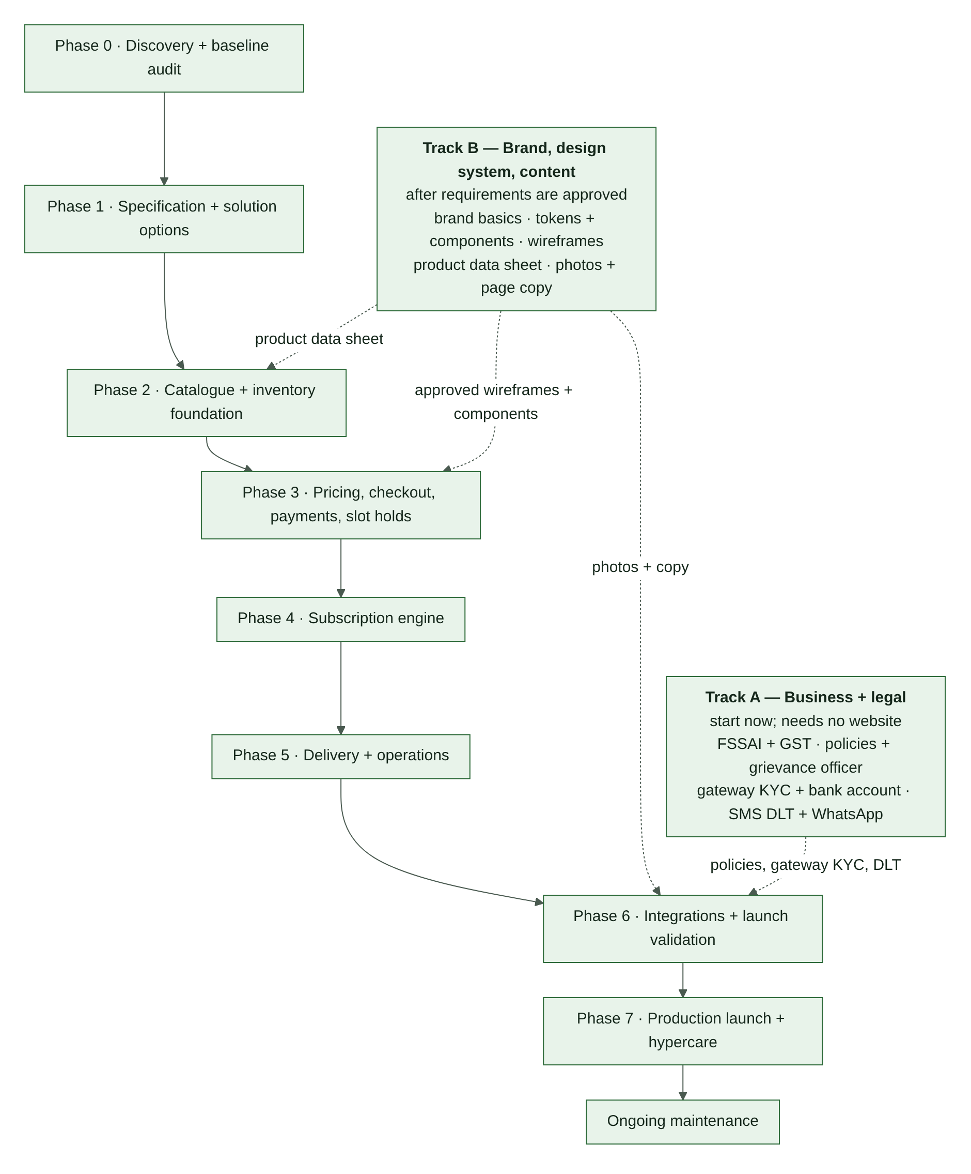
Figure 1. Delivery plan: main build track with parallel Tracks A and B

4. Confirmed Requirements
Everything in this section is CONFIRMED by the owner unless a row says otherwise.

4.1 Business and platform (BP)
ID | Requirement
BP-01 | Business: Greenbasket, fresh-produce e-commerce.
BP-02 | Service area: Chandigarh, Mohali, Panchkula.
BP-03 | Platform: WordPress + WooCommerce. Theme: Blocksy. Page builder: Elementor Free. Hosting: Hostinger. Domain and hosting already purchased.
BP-04 | Website first.
BP-05 | All four shopping experiences launch together.
BP-06 | Customer types: households and businesses.
BP-07 | Sourcing and procurement workflow: NOT IN SCOPE for now.
BP-08 | Delivery: Greenbasket's own delivery operation.
BP-09 | Custom development budget: not decided (OD-12).
BP-10 | Plugin budget: initially free-only; must be reconciled against reliability, gateway, subscription and operations requirements before implementation (OD-18).
BP-11 | Prefer configuration over custom code when the capability is reliable and compatible.
BP-12 | WooCommerce with a modular custom extension is permitted if required.

4.2 Retail (RT)
ID | Requirement
RT-01 | Products are sold in predefined pack sizes or pieces, depending on the product.
RT-02 | The selected pack price is fixed.
RT-03 | Actual packed weight does not recalculate the customer price.
RT-04 | Stock deduction uses the nominal quantity of the selected selling unit.
RT-05 | Product-specific units are allowed.

4.3 Farm Box (FB)
ID | Requirement
FB-01 | Customer selects eligible products and quantities.
FB-02 | Customer pays for the selected items.
FB-03 | No Farm Box minimum is required initially.
FB-04 | A basket can be saved and reused.
FB-05 | A saved basket is a template, not a stock reservation or price guarantee.
FB-06 | Products consume the same shared stock pool as other channels.
FB-07 | Farm Box items may be combined with compatible products in a shared cart and order.

4.4 Wholesale (WS)
ID | Requirement
WS-01 | Public access is allowed; wholesale pricing is not restricted to approved business accounts by default.
WS-02 | Each product has its own quantity tiers.
WS-03 | The tier rate applies to every unit at the qualifying tier.
WS-04 | Quantities for the same product and same selling unit are combined across cart lines before tier calculation (scope: OD-26).
WS-05 | Minimum, maximum, and quantity increment rules are configurable per product.
WS-06 | Manual quotation for exceptions is supported as an operational process; its workflow is not yet specified (OD-14).
WS-07 | Retail and wholesale lines may appear in one cart.
WS-08 | Tier boundaries and rates are not decided and must remain CONFIGURABLE (OD-01).

4.5 Subscriptions (SB)
ID | Requirement
SB-01 | Billing cadence: weekly or monthly.
SB-02 | Delivery cadence: weekly or monthly.
SB-03 | Supported combinations: weekly billing + weekly delivery; monthly billing + monthly delivery; monthly billing + weekly deliveries.
SB-04 | Monthly billing with weekly delivery creates a separate order for each delivery, linked to the same billing period.
SB-05 | Plan price is fixed per subscription period.
SB-06 | Plan allowance is a monetary allowance for eligible products.
SB-07 | The product basket cannot exceed the allowance.
SB-08 | Delivery charges and applicable taxes are separate from the plan product allowance and price, as confirmed by the owner.
SB-09 | Customer can edit, skip, pause, and cancel a subscription.
SB-10 | If the basket-edit cutoff is missed, the last saved basket is used.
SB-11 | Customer chooses from eligible products.
SB-12 | A payment method is saved for automatic renewal only if the chosen gateway and applicable requirements support the intended flow.
SB-13 | Renewal failure: up to three retries over three days, then future deliveries pause.
SB-14 | Skipping a weekly delivery within a monthly subscription does not automatically reduce the monthly charge.
SB-15 | Basket and delivery snapshots are preserved for audit.

4.6 Checkout and payments (CP)
ID | Requirement
CP-01 | Shared cart and checkout for compatible one-time purchases.
CP-02 | Guest checkout and account checkout are both desired.
CP-03 | One delivery address per order.
CP-04 | One customer account across shopping experiences.
CP-05 | Payment methods: online, COD for eligible orders, bank transfer.
CP-06 | COD eligibility criteria are not yet decided (OD-06).
CP-07 | An ambiguous gateway transaction remains pending or review-required until reconciled.
CP-08 | A payment callback must not create duplicate payment processing or duplicate orders.
CP-09 | Bank-transfer orders are not packed until payment is verified, except through an explicitly authorized exception.
CP-10 | Unpaid stock reservation timeout: 15 minutes.
CP-11 | A successful payment after reservation expiry enters review; the order is not dispatched until payment and stock are reconciled.
CP-12 | Checkout price lock: 15 minutes.
CP-13 | Price changes after lock expiry require recalculation and customer confirmation before payment.
CP-14 | Refund requests are reviewed by support under a published policy; there is no self-service refund approval.
CP-15 | Cancellation is allowed before packing, subject to published policy and applicable requirements.
CP-16 | If a customer reports a debit after a failed-looking payment, the gateway or bank status is reconciled before the customer is asked to pay again.

4.7 Inventory (IN)
ID | Requirement
IN-01 | One shared stock pool across channels.
IN-02 | Initially, staff update stock manually.
IN-03 | Use a canonical base unit per product where practical.
IN-04 | Products sold by piece use whole-unit stock.
IN-05 | Selling units have explicit conversions to the product's base unit.
IN-06 | Retail stock deduction is based on nominal pack quantity, not actual packed weight.
IN-07 | Actual packed weight may be recorded for operational variance if available.
IN-08 | Stock reservations must be safe under concurrent checkout.
IN-09 | Stock movements and manual adjustments must be auditable.
IN-10 | A saved Farm Box or subscription basket is not itself a stock reservation.

4.8 Delivery (DL)
ID | Requirement
DL-01 | Own delivery.
DL-02 | Service area: Chandigarh, Mohali, Panchkula (exact boundary: OD-27).
DL-03 | Operating hours: 6 AM to 10 PM (meaning: OD-31).
DL-04 | Delivery days: Monday through Sunday.
DL-05 | Customers select from available slots.
DL-06 | Slot capacity is limited.
DL-07 | A slot is temporarily reserved at checkout and confirmed with the order; abandoned or expired checkout releases capacity.
DL-08 | Delivery cutoff is configurable; exact times are not decided (OD-04).
DL-09 | Subscription capacity is protected before regular orders use remaining capacity.
DL-10 | Shortage policy: pause the affected item and contact the customer.
DL-11 | One order may contain multiple channel-labelled lines.
DL-12 | Packing lists, delivery records, and proof-of-delivery and failed-delivery workflows are required.

4.9 Operational records (OR)
ID | Requirement (required at launch)
OR-01 | Packing lists and item-level fulfilment status.
OR-02 | Delivery assignment and delivery outcome records.
OR-03 | GST-compliant invoice and credit-note capability where applicable, after CA validation.
OR-04 | Staff audit log for price, stock, payment, and order changes.

4.10 Notifications and analytics (NA)
ID | Requirement
NA-01 | Desired channels: email, WhatsApp, SMS, and push notifications if technically appropriate (OD-15).
NA-02 | Desired events: order updates, delivery reminders, abandoned cart, back in stock, reorder reminders, subscription renewal reminders, promotional offers, failed payment alerts.
NA-03 | Analytics: GA4 and Google Search Console.
NA-04 | All promotional messages respect applicable consent and opt-out requirements.
NA-05 | Notification failure must not roll back an otherwise successful payment or order.

4.11 Reliability targets (RL)
ID | Requirement
RL-01 | Planning load: up to 500 orders per day.
RL-02 | Initial peak concurrency target: 50 shoppers.
RL-03 | Recovery Time Objective (RTO): 2 hours.
RL-04 | Recovery Point Objective (RPO): 15 minutes.
RL-05 | These are target requirements, not verified capabilities of the current Hostinger plan. Hosting and database design must be tested to determine whether they are achievable. Daily backups alone do not guarantee a 15-minute RPO.

5. Business and Legal Groundwork (Track A)
None of these items are website tasks, and several have long lead times. The payment gateway will not activate without many of them, and the law requires others before launch. This section is a checklist, not legal advice: confirm each item with a chartered accountant (CA), lawyer or licensing consultant.
ID | Item | Why it matters | Owner | Needed by
LG-01 | Business entity, PAN, and a bank account in the business's name | Gateway KYC and settlement; invoices | Owner | Before gateway application
LG-02 | GST registration decision and GSTIN (if registering) | Tax configuration and invoices (OD-09) | Owner + CA | Phase 1
LG-03 | FSSAI registration or licence. The tier depends on turnover and business model; confirm whether the number must be shown on the website. | Greenbasket sells food | Owner + consultant | Before launch
LG-04 | Legal Metrology: weighing scales used in trade verified and stamped; rules for produce packed and sold by stated weight; rule for packs that weigh less than stated (OD-57) | Packs are sold at a stated weight (RT-03, IN-06) | Owner + consultant | Phase 2
LG-05 | Consumer Protection (E-Commerce) Rules, 2020: seller details, customer-care contact, named grievance officer, clear refund, return, cancellation and delivery terms, total price shown before purchase | Legal requirement for selling online | Owner + lawyer | Phase 6 (pages live)
LG-06 | Digital Personal Data Protection Act, 2023 and rules in force: privacy notice, consent for marketing, retention and deletion (OD-17) | Customer personal data | Owner + lawyer | Consent design in Phase 3; live by Phase 6
LG-07 | Policies: privacy; terms of sale and use; refund and cancellation; delivery (area, slots, cutoffs, failed delivery); subscription terms (renewal, retries, skip, pause, cancel); wholesale terms (tiers, quotes); COD terms | Law, gateway onboarding, customer trust | Owner + lawyer | Drafts by Phase 3; final by Phase 6
LG-08 | Payment gateway onboarding: KYC documents; website readiness (policy pages, contact details, visible prices); recurring-payment or mandate approval if required | Online payments cannot start without it | Owner | Shortlist in Phase 1; apply before Phase 6
LG-09 | Messaging registrations: SMS DLT (entity, sender IDs, message templates); WhatsApp Business Platform (business verification, template approval, opt-in rules) | SMS and WhatsApp cannot be sent without them | Owner | Before Phase 6
LG-10 | Business email on the domain, with sender authentication (§21.4) | Order emails must reach inboxes | Owner + developer | Phase 1
LG-11 | Brand name and trademark check (RECOMMENDATION, optional) | Avoid a forced rename later | Owner | Track B

Website pages these items require: privacy policy; terms; refund and cancellation policy; delivery policy; subscription terms; wholesale terms; contact page with seller details and grievance officer; FSSAI number if required (LG-03).
Track A gate: LG-01, LG-03, LG-05, LG-07 and LG-08 must be complete before Phase 6 connects the live gateway. LG-09 must be complete before SMS or WhatsApp messages are enabled.

6. Open Decisions Register
The system design must support these values without hard-coding them. The owner sets each value before the relevant feature is enabled. Do not block the architecture on these decisions: keep the values CONFIGURABLE and block only the specific feature whose safe operation depends on the missing value. "Needed by" names the first phase that cannot finish without the answer.
OD-01 to OD-18 come from v1.0. OD-19 onwards were added in v2.0.

6.1 Pricing and catalogue
ID | Decision | Needed by | Design response / recommendation
OD-01 | Wholesale tier boundaries and rates | Phase 3 (to enable) | Per-product, per-selling-unit tier table; CONFIGURABLE.
OD-02 | Minimum order value, and which channels it applies to | Phase 3 | CONFIGURABLE with channel eligibility.
OD-03 | Free-delivery threshold and its basis: before or after discounts and tax; which channels and areas | Phase 3 | CONFIGURABLE by order, channel and area.
OD-08 | Treatment of a mixed Farm Box cart under any general minimum | Phase 3 | RECOMMENDATION: Farm Box lines have a zero minimum initially (FB-03).
OD-26 | Wholesale aggregation scope: do retail or Farm Box lines of the same product and unit count toward a tier? | Phase 3 | RECOMMENDATION: only wholesale-channel lines aggregate.
OD-33 | Farm Box price source: the retail selling-unit price or a Farm Box-specific price | Phase 3 | Price rules are per channel, so both are possible. RECOMMENDATION: use the retail price unless the owner sets a Farm Box price.
OD-44 | Which coupons and promotions apply to which channels, and whether they stack | Phase 3 | RECOMMENDATION: no coupons on wholesale tier prices or subscription plan charges unless explicitly allowed per coupon.
OD-50 | Money rounding rule: per line or per order, and to the paisa or the rupee | Phase 1 (with CA) | Single rounding function used everywhere; amounts stored in paise.
OD-55 | Customer reviews and ratings on the site | Phase 3 | If enabled: genuine purchasers only, published moderation policy.
OD-57 | Packs that weigh less than stated: minimum acceptable packed weight | Phase 2 | Confirm under Legal Metrology (LG-04); packing screen enforces the rule.

6.2 Checkout and payments
ID | Decision | Needed by | Design response / recommendation
OD-06 | COD eligibility criteria | Phase 3 | Server-side rules, for example order value, area, customer history; CONFIGURABLE.
OD-10 | Payment gateway | Phase 1 | Evaluate against §16.6 after the architecture and compatibility audit.
OD-11 | Recurring payment support (mandate or token) for the selected gateway under applicable Indian rules | Phase 1 (verify); Phase 4 (build) | Never enable automatic renewal until verified (SB-12).
OD-23 | Fallback if automatic renewal is not available at launch: a payment link each period, or subscriptions delayed | Phase 1 | Owner chooses; BP-05 means this decision can affect the launch date.
OD-25 | Bank-transfer hold window for stock and slot | Phase 3 | Stock reservation enters Extended for this window (R2); the slot hold uses the same window (§11.4).
OD-30 | Do saved Farm Boxes and subscriptions require a customer account? | Phase 3 | RECOMMENDATION: yes; guest checkout remains for one-time purchases.
OD-34 | Automatic reservation extension when an online payment starts close to expiry: duration and maximum count | Phase 3 | RECOMMENDATION: one automatic extension per order.
OD-35 | Review hold limit: how long stock and slot stay held while a payment is ambiguous | Phase 3 | CONFIGURABLE; after the limit the reservation expires (R10) and any later success follows the late-payment workflow (§12.5).
OD-36 | Authorize at checkout and capture at packing, so shortages reduce the capture instead of needing a refund | Phase 1 | Only if the gateway supports it for the chosen payment methods.
OD-37 | Refund request window and eligible reasons for fresh produce | Phase 5 | Published in the refund policy (LG-07).
OD-38 | Auto-approval of system-calculated refunds (cancellations, shortages, duplicates) versus manual review | Phase 3 | RECOMMENDATION: auto-approve exact system-calculated amounts; customer complaints always need human review (CP-14).
OD-39 | How COD orders are refunded: UPI, bank transfer, or store credit | Phase 5 | Payout details are sensitive data, deleted after use (§22.4).
OD-49 | COD confirmation method: automatic on eligibility, phone OTP, or a confirmation call | Phase 3 | CONFIGURABLE per COD rule.

6.3 Subscriptions
ID | Decision | Needed by | Design response / recommendation
OD-07 | Plan prices, allowances and eligible products | Phase 4 | Data-driven plan configuration.
OD-19 | Monthly billing + weekly delivery: is the allowance per delivery or per month? | Phase 4 | Allowance check runs at the chosen scope.
OD-20 | Monthly billing + weekly delivery: when delivery charges are billed (inside the monthly charge or per delivery); whether a period is a calendar month or a fixed 4 weeks; how many deliveries a period contains | Phase 4 | A calendar month holds 4 or 5 weekly deliveries; charging per delivery conflicts with §14.1 "no additional recurring charge per delivery". Owner must choose.
OD-21 | Do deliveries continue while a renewal is being retried (subscription PastDue)? | Phase 4 | Options: hold, continue, or continue only already-paid deliveries.
OD-22 | Does the first failed attempt count as one of the three retries, and how are retries spaced? | Phase 4 | CONFIGURABLE retry schedule.
OD-24 | Missed cutoff when the last saved basket is no longer valid (price rise pushes it over allowance; item ineligible or unavailable) | Phase 4 | RECOMMENDATION: exception case and customer contact; never a silent substitution (§14.6).
OD-29 | Does a subscriber choose a recurring delivery slot? | Phase 4 | Protected capacity is planned per chosen or assigned slot.
OD-32 | The amount shown on each generated delivery order, and when the GST invoice is issued (at billing or per delivery) | Phase 4 (with CA) | Order value is either allocated or zero with a period reference; CA decides.
OD-41 | How long a subscription may stay in PendingSetup before it is cancelled | Phase 4 | CONFIGURABLE.
OD-46 | Pause: when it takes effect, and whether billing stops during the pause | Phase 4 | Published in subscription terms (LG-07).
OD-47 | Cancellation: do remaining deliveries in an already-paid period still happen? | Phase 4 | Published in subscription terms (LG-07).
OD-48 | Do plans have a fixed term that ends (subscription Completed)? | Phase 4 | Status exists but is only used if plans have terms.

6.4 Delivery and operations
ID | Decision | Needed by | Design response / recommendation
OD-04 | Delivery cutoff times | Phase 3 (slot holds) | CONFIGURABLE by date and slot.
OD-05 | Slot durations and capacities | Phase 3 | Date-specific CONFIGURABLE capacity.
OD-14 | Wholesale quotation workflow: request, approval, expiry, conversion to order | Phase 3 | Skeleton in §12.14; quote overrides need actor, reason, amount, approval and expiry.
OD-16 | Failed delivery and return policy: maximum re-attempts, re-delivery charge, refund for a failed delivery, what happens to perishables | Phase 5 | Published in the delivery policy (LG-07).
OD-27 | Service-area boundary: exact PIN codes and zones (for example, whether Zirakpur, Kharar or New Chandigarh are included) | Phase 3 | PIN-code list with zones; CONFIGURABLE.
OD-28 | Default action for a shortage when the customer cannot be reached before dispatch | Phase 5 | Options: remove the item and refund it, or hold the order. Published in policy.
OD-31 | Is 6 AM–10 PM the delivery window, the ordering window, or both? | Phase 3 | Slots are generated only inside the delivery window.
OD-40 | Proof-of-delivery method: OTP, photo, signature | Phase 5 | Proof reference stored on the delivery attempt.
OD-42 | Slot capacity unit: orders, crates, or weight | Phase 3 | Capacity check uses this unit.
OD-43 | Substitution policy: allowed or not; how price differences are handled | Phase 5 | Never without the customer's explicit approval (§14.6).
OD-54 | Customer support channels, hours and response targets for each queue | Phase 5 | §24.2 and §24.3.
OD-58 | Booking window: how many days ahead slots are offered | Phase 3 | CONFIGURABLE.

6.5 Platform, budget and compliance
ID | Decision | Needed by | Design response / recommendation
OD-09 | Tax calculation and invoice numbering | Phase 1 (with CA) | Configure in WooCommerce tax settings; never invent tax treatment.
OD-12 | Custom development budget | Phase 1 | Do not assume a budget.
OD-13 | Hosting capacity, and whether the current plan can meet RTO and RPO | Phase 0 (verify); Phase 1 (decide) | NOT VERIFIED. Inspect the plan and load-test.
OD-15 | Push notifications: website, PWA or app scope, and the consent model | Phase 6 | Optional channel.
OD-17 | Customer data retention and privacy details | Phase 3 (consent capture); Phase 6 | Based on applicable law (LG-06) and business needs.
OD-18 | Plugin budget: free-only, or paid where reliability requires it | Phase 1 | Compared in the Phase 1 cost and risk matrix.
OD-45 | WooCommerce order-status mapping: custom statuses, or one WooCommerce status plus a separate fulfilment field | Phase 1 | RECOMMENDATION in §11.1.
OD-56 | Business registrations: FSSAI tier and GST registration | Track A | LG-02, LG-03.
OD-59 | Performance budget: p95 server response time, error rate, Core Web Vitals | Phase 1 (after Phase 0 measurements) | RECOMMENDATION in §19.7.

6.6 Experience and brand
ID | Decision | Needed by | Design response / recommendation
OD-51 | Site languages: English only, or Hindi and Punjabi too | Phase 1 | Adding languages later is harder; decide before templates are built.
OD-52 | Brand assets: do a logo, colours and fonts already exist? | Track B | §18.1.
OD-53 | Accessibility target level | Phase 1 | RECOMMENDATION: WCAG 2.2 level AA.
OD-60 | Product photography approach: own photography, supplier images, or stock images | Track B | §20.3 photo specification applies to all sources.

PART C — SYSTEM DESIGN

7. Architecture Overview

7.1 Architecture style
Use a modular monolith for the initial WordPress and WooCommerce implementation:
- one website and application;
- one authoritative commerce database;
- clear domain modules;
- custom tables for transactional data that needs reliable history, constraints, or concurrency handling;
- supported WooCommerce APIs for standard product, order and customer operations;
- asynchronous jobs for notifications, subscription schedules, reservation expiry, and reconciliation tasks.

Do not introduce separate microservices unless measured load, operational needs, or platform constraints justify them.
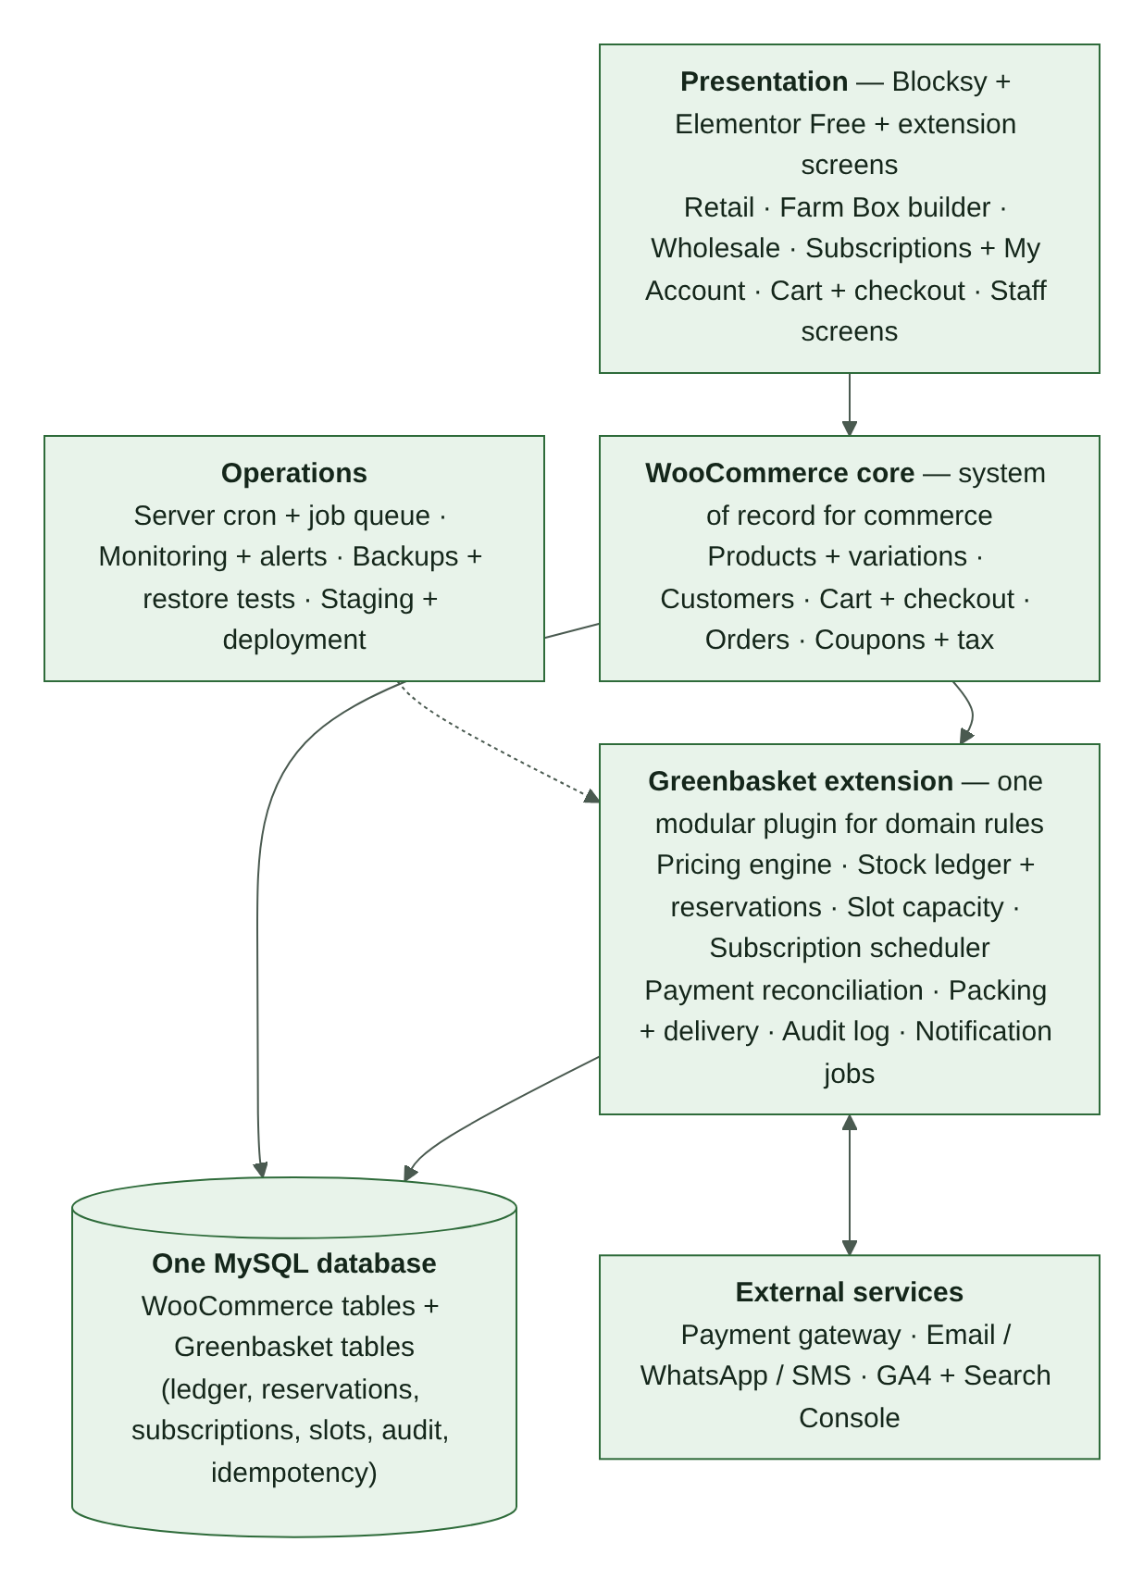
Figure 2. Logical architecture

7.2 Logical layers
- Presentation layer: retail pages; Farm Box builder; wholesale pages; subscription pages and account controls; cart and checkout; customer account; staff and admin screens.
- WooCommerce commerce layer: products and variations; customers; cart; checkout; coupons; standard orders; tax and total calculation integration; supported order storage.
- Greenbasket domain layer: selling-unit and channel eligibility rules; pricing engine; inventory ledger and reservation service; subscription scheduler; delivery-slot capacity service; payment reconciliation; packing and fulfilment workflows; notification event handling; audit logging.
- Persistence layer: WordPress and WooCommerce data; custom transactional tables; audit and event records; scheduled-job records; idempotency records.
- External services: payment gateway; email, WhatsApp and SMS providers; analytics; optional accounting or export services.
- Operations: scheduled and background jobs; monitoring and alerting; backup and recovery; staging and deployment process; load and regression testing.

7.3 System boundary rule
WooCommerce remains the system of record for standard commerce orders. Greenbasket-specific tables extend the system for inventory reservations, stock movements, subscription periods and deliveries, delivery-slot reservations, payment reconciliation, and audit history.
Do not assume all WooCommerce orders are stored in legacy WordPress post tables. The implementation must support the site's configured WooCommerce order-storage mode (HPOS or posts storage — Appendix C, item C6) and use supported APIs.

7.4 Where each responsibility lives
RECOMMENDATION — confirm in Phase 1 after the Phase 0 audit.
Responsibility | WooCommerce | Greenbasket extension
Product identity, SKU, category | Authoritative | Reads
Selling units and base-unit conversions | Variations or product data | Conversion rules and validation
Channel eligibility, min/max/increment | — | Authoritative
Price calculation | Receives the calculated price per cart line | Pricing engine is authoritative (§10)
Stock availability | Display only, or switched off (§13.8) | Ledger and reservations are authoritative (§13)
Cart and checkout | Native flow | Adds channel context, price lock, slot and stock holds
Order record | Authoritative | Line context, fulfilment state, references
Payment processing | Gateway integration | Attempts, reconciliation, idempotency (§16)
Delivery slots | — | Authoritative (§15)
Subscriptions | Order foundation for delivery orders | Plans, periods, baskets, deliveries — or an approved subscription plugin, decided in Phase 1
Notifications | Native emails where suitable | Event queue, WhatsApp, SMS, retries (§17)
Audit | — | Append-only audit events for every critical change

7.5 Background jobs
Background work must run on time even when nobody is visiting the site.
- Trigger scheduled jobs from a real server cron at a fixed interval. WordPress's built-in scheduler only runs when pages are visited, so it is not reliable enough on its own (RK-04).
- Every job is idempotent and recoverable. A job that runs twice, or restarts halfway, never duplicates a stock movement, charge, order or message.
- Availability checks treat a reservation whose expiry time has passed as inactive even if the expiry job has not yet run. A late job can therefore never lock up stock or slot capacity.
- The maximum acceptable delay for each job is set in Phase 1. Job lag is monitored (§23.3).

Job | Purpose
Reservation expiry | Expire stock reservations (R4, R10) and slot holds (L3); release capacity
Payment reconciliation sweep | Look up pending and review-required attempts with the gateway; apply verified results
Subscription cutoff | Freeze baskets at cutoff and generate delivery orders (§12.7)
Renewal and retries | Charge due periods; run the retry schedule (§12.8)
Notification queue | Send queued messages with retries (§17.3)
Exception-case watchdog | Alert when a case passes its response target (OD-54)
Health checks | Confirm backups completed, cron running, queues not stuck

8. Functional Modules
Each module lists its responsibilities and rules. Rules added in v2.0 are marked (v2).

8.1 Catalogue module
Responsibilities: canonical product identity and SKU; category and product status; selling units and pack sizes; base-unit conversion; channel eligibility; tax classification; product-specific minimum, maximum and increment rules; availability presentation; product content fields (§20.1).
Rules:
- one canonical product is reused across channels where it is the same physical product;
- do not duplicate product records solely to show different channel prices;
- separate product identities only where units, conversion or inventory genuinely require them;
- validate every selling unit server-side;
- (v2) base units are whole-number units — grams, millilitres or pieces — so stock is never fractional;
- (v2) the rule for packs that weigh less than stated comes from OD-57 and is enforced on the packing screen.

8.2 Retail module
Responsibilities: display retail-eligible products; show pack and piece options; fixed selected-unit prices; quantity selection; shared cart integration; availability display.
Rules:
- pack price is fixed;
- actual packed weight does not change the customer price;
- stock deduction uses nominal pack quantity;
- unavailable or invalid variations cannot be purchased.

8.3 Farm Box module
Responsibilities: eligible product catalogue; product and quantity selection; live estimate of basket value; saved basket templates; restore and edit a basket; shared cart integration.
Rules:
- no Farm Box-specific minimum at initial launch unless the owner approves otherwise;
- the basket uses eligible selling units only;
- a saved basket does not reserve stock or guarantee price;
- prices, eligibility and stock are revalidated when the customer checks out, and any change is shown before payment;
- the origin label is preserved on each line;
- compatible mixed carts are allowed;
- (v2) the Farm Box price source is OD-33;
- (v2) saving a basket requires an account if OD-30 is confirmed; saved baskets are stored as versioned templates (§9.1).

8.4 Wholesale module
Responsibilities: public wholesale access; product-specific tier display; quantity minimum, maximum and increment enforcement; aggregation of the same product and selling unit across cart lines; applying the qualifying tier rate to all qualifying units; mixed carts; an auditable manual quote and override workflow.
Rules:
- different products are never combined;
- different selling units are not combined unless an explicit approved conversion or aggregation rule exists;
- tier rates and boundaries remain configurable;
- the server recalculates the tier after any relevant cart change;
- quote overrides require actor, reason, amount, approval, and validity or expiry where applicable;
- (v2) which lines aggregate is OD-26;
- (v2) the tier table shown to the customer comes from the same price rules the server uses, so displayed and charged prices cannot differ.

8.5 Subscription module
Responsibilities: plan catalogue; billing and delivery cadence; product allowance; eligible product list; saved basket and versions; cutoff handling; delivery schedule; recurring payment attempt records; retry policy; pause, skip, cancel and edit controls; generated delivery orders.
Rules:
- fixed plan price per billing period;
- the product basket cannot exceed the monetary allowance;
- delivery and applicable taxes are separate according to confirmed plan rules;
- the basket is frozen at cutoff; if the cutoff is missed, the last saved basket is used;
- monthly billing with weekly delivery creates one delivery order per delivery, linked to one subscription period;
- skipping a weekly delivery in a monthly plan does not automatically reduce the monthly charge;
- failed renewal: up to three retries over three days, then future deliveries pause;
- gateway support and applicable recurring-payment requirements must be verified before automatic renewals are enabled;
- no duplicate charge or delivery order on retried jobs or callbacks;
- (v2) subscription enrolment is a separate checkout; it is never mixed into a one-time cart;
- (v2) open rules: allowance scope (OD-19), delivery charge and period definition (OD-20), deliveries during retries (OD-21), retry counting (OD-22), invalid basket at cutoff (OD-24), recurring slot (OD-29), pause and cancel semantics (OD-46, OD-47).

8.6 Shared cart and checkout
Responsibilities: combine compatible retail, Farm Box and wholesale lines; preserve line-level channel and pricing context; calculate authoritative totals on the server; validate stock, price, coupon, delivery address, slot, tax, and payment method; snapshot price and rule versions; manage the 15-minute checkout price lock; reserve stock and slot; prevent duplicate submission.
Rules:
- subscription enrolment and renewal are distinct transactions. A subscription delivery order may use the shared WooCommerce order and fulfilment foundation but must reference the subscription and billing period;
- (v2) the channel is part of each cart line's identity, so the same product added from two channels stays on two lines with their own context;
- (v2) the Place Order action is idempotent: double-clicks and browser retries cannot create two orders or two payment attempts.

8.7 Inventory module
Responsibilities: on-hand balances; active reservations; stock movements; manual adjustments; expiry and release; packing variance; reconciliation; audit trail.
Rules:
- one shared pool per canonical product and base unit;
- available = on-hand minus active reservations;
- atomic stock check and reservation;
- 15-minute unpaid reservation by default; the timeout is configurable;
- a late payment after expiry enters review;
- actual pack weight does not alter the customer price; nominal stock deduction is used for the selected pack; actual weight, if measured, is recorded separately for variance;
- no duplicate stock movement on retries;
- reservation expiry is processed by recoverable background jobs;
- (v2) expiry is also enforced at read time (§7.5);
- (v2) a shortage found at packing releases the unfilled quantity and records a stock correction (§13.4).

8.8 Payment module
Responsibilities: online gateway integration; COD eligibility and confirmation; bank-transfer pending state and verification; payment attempts; callback verification; reconciliation; refunds and refund review; idempotency.
Rules:
- a gateway redirect is not proof of payment;
- an ambiguous payment stays pending or review-required;
- do not prompt a second payment while the first attempt is ambiguous;
- a bank-transfer order cannot be packed before verified payment, except through an explicitly authorized exception;
- payment callback replay must not duplicate processing;
- refund requests are support-reviewed; the published policy and applicable legal and provider requirements govern outcomes;
- (v2) an order has at most one active payment attempt at a time; a retry creates a new attempt only after the previous one is final (§11.2);
- (v2) duplicate payments, disputes, COD collection and bank-transfer verification are handled as specified in §16.

8.9 Delivery module
Responsibilities: service-area validation; configurable cutoff by date and slot; slot creation and capacity; temporary slot reservation at checkout; subscription capacity protection; packing batches; delivery assignment; proof of delivery; failed-delivery records.
Rules:
- service area is Chandigarh, Mohali, Panchkula;
- operating hours are 6 AM to 10 PM, every day;
- slot reservation is independent of stock reservation;
- capacity checks are concurrency-safe;
- subscriptions receive protected capacity before regular orders use the remaining capacity;
- slot reservations are released when checkout expires or the order cannot be confirmed;
- an order is not marked fully fulfilled while a shortage exception remains unresolved;
- (v2) the service area is validated by PIN code (OD-27) before slots are shown;
- (v2) rescheduling holds the new slot before releasing the old one, so a customer is never left without a slot.

8.10 Operations and audit module
Responsibilities: packing lists; item-level packing status; delivery assignment and outcome; payment reconciliation queue; shortage exception cases; refund and cancellation review; staff roles; audit events; operational exports; (v2) COD cash reconciliation; (v2) support tooling.
Required records: packing lists; delivery records; applicable GST invoice and credit-note records after CA validation; audit trail for price, stock, payment and order changes.

8.11 Customer account module (v2)
Responsibilities: one account across all experiences (CP-04); addresses; order history and tracking; saved Farm Boxes; subscriptions (basket, skip, pause, resume, cancel, payment method); refund requests and their status; communication preferences and consent (§17.4).
Rules: guest checkout stays available for one-time purchases (CP-02); customers can create an account after a guest order; account deletion and data export follow OD-17 and LG-06.

9. Data Model
This is a logical schema. Do not implement SQL until Phase 1 approves the exact schema, WooCommerce storage mode, constraints, indexes, and migration and rollback strategy. Entities and fields added in v2.0 are marked (v2). Money fields are in paise and timestamps in UTC (§0.4).

9.1 Catalogue, pricing and saved baskets
Entity | Purpose | Fields
Product | Canonical product | product_id, sku, name, category_id, base_unit, tax_class, tax_status, active_status, created_at, updated_at
SellingUnit | What the customer buys | selling_unit_id, product_id, unit_type (pack, piece, bunch, kg, g…), nominal_quantity, base_unit_conversion, retail_price, active_status, valid_from, valid_until
ChannelEligibility | Which channels may sell a product | product_id, channel, eligible, min_quantity (v2), max_quantity (v2), quantity_increment (v2), valid_from, valid_until
PriceRule | Versioned price per product, unit and channel | price_rule_id, product_id, selling_unit_id, channel, price, currency, valid_from, valid_until, version, created_by
WholesaleTier | Quantity band | tier_id, product_id, selling_unit_id, min_quantity, max_quantity (null = open-ended top tier), unit_price, valid_from, valid_until, version
SubscriptionPlan | Plan definition | plan_id, name, billing_interval, delivery_interval, fixed_period_price, product_allowance, allowance_scope (v2, OD-19), active_status, valid_from, valid_until
SubscriptionEligibility | Products a plan allows | plan_id, product_id, selling_unit_id (if unit-specific), min_quantity, max_quantity, quantity_increment
SavedBasket (v2) | Farm Box template (FB-04, FB-05) | saved_basket_id, customer_id, name, version, created_at, updated_at
SavedBasketItem (v2) | Line in a saved basket | saved_basket_id, product_id, selling_unit_id, quantity
Promotion (v2) | Coupon or promotion with channel rules | promotion_id, code, eligible_channels, stackable, rule_definition, valid_from, valid_until, version (OD-44)

9.2 Inventory
Entity | Purpose | Fields
InventoryBalance | Current on-hand per product | product_id, base_unit, on_hand_quantity, reserved_quantity (derived or cached only if consistency rules are defined), updated_at, version (optimistic concurrency if appropriate)
InventoryMovement | Append-only stock history | movement_id, product_id, quantity_delta, base_unit, movement_type (initial_stock, restock, fulfilment_deduction, shortage_correction, waste, stocktake_correction, return_restock, cancellation_reversal, authorized_correction), reason, source_type, source_id, actor_id, created_at, idempotency_key
StockReservation | Hold on stock for one order line | reservation_id, checkout_reference (v2), order_id (null until the order exists (v2)), order_item_id, product_id, quantity_base_unit, status (§11.3), created_at, expires_at, extension_count (v2), extension_reason (v2), confirmed_at, consumed_quantity (v2), released_quantity (v2), release_reason (v2), released_at, idempotency_key
PackingRecord | What was packed | packing_record_id, order_id, order_item_id, product_id, nominal_quantity, actual_quantity (nullable), packed_quantity, shortage_quantity, packed_by, packed_at
InventoryAdjustment | Manual change request | adjustment_id, product_id, quantity_delta, reason, created_by, approved_by, created_at

(v2) Why the reservation reference changed: in v1.0 a reservation pointed at an order, but stock is reserved during checkout (§12.1 step 5), before the order exists. A reservation now points at the checkout first and is linked to the order when the order is created.

9.3 Orders, payments and refunds
Use WooCommerce order and order-item records for the canonical commerce transaction. Add structured metadata or custom tables for:
Entity | Purpose | Fields
OrderLineContext (v2) | Greenbasket context per order line | order_item_id, order_id, channel, price_rule_id, price_rule_version, price_lock_id, reservation_id, subscription_delivery_id (if any), fulfilment_status, packed_quantity, shortage_quantity
OrderFulfilment (v2) | Fulfilment state kept apart from payment state | order_id, fulfilment_status (§11.1), slot_reservation_id, review_reason, updated_at
PriceLock (v2) | 15-minute checkout price lock (CP-12) | price_lock_id, checkout_reference, customer_reference, snapshot (lines, unit prices, tiers, promotions, delivery fee, tax, totals), rule_versions, created_at, expires_at, status (active, expired, consumed), order_id
PaymentAttempt | One try to pay | payment_attempt_id, order_id, method (online, cod, bank_transfer) (v2), attempt_no (v2), gateway, gateway_transaction_id, amount, currency, status (§11.2), failure_reason (v2), idempotency_key, created_at, updated_at, last_reconciled_at
PaymentReconciliation | Result of checking with gateway or bank | reconciliation_id, payment_attempt_id, gateway_reference, result, review_status, reviewed_by, reviewed_at, notes
CodCollection (v2) | Cash or UPI collected at the door | cod_collection_id, order_id, amount_due, amount_collected, method (cash, upi), collected_by, collected_at, handed_over_at, reconciled_by, variance, status
BankTransferVerification (v2) | Checking a bank credit | verification_id, order_id, payment_reference, amount_expected, amount_received, bank_reference, verified_by, verified_at, status, exception_approved_by, exception_reason
RefundRequest | Request for money back | refund_request_id, order_id, payment_attempt_id, source (customer, system) (v2), reason, requested_amount, approved_amount (v2), status (§11.7), reviewed_by, resolution_reference, created_at, resolved_at
RefundTransaction (v2) | One refund payout | refund_transaction_id, refund_request_id, payment_attempt_id, amount, method (gateway, upi, bank_transfer, store_credit), gateway_refund_id, status (pending, succeeded, failed), idempotency_key, created_at, completed_at
Dispute (v2) | Chargeback or bank dispute | dispute_id, payment_attempt_id, gateway_dispute_id, amount, reason, status, response_deadline, outcome, handled_by
QuoteRequest (v2) | Wholesale quote (OD-14) | quote_id, customer_id, lines, quoted_prices, requested_at, approved_by, valid_until, status, converted_order_id

9.4 Subscriptions
Entity | Purpose | Fields
Subscription | The customer's plan | subscription_id, customer_id, plan_id, status (§11.5), billing_interval, delivery_interval, next_billing_at, next_delivery_at, cutoff_rule_id, preferred_slot (v2, OD-29), payment_method_reference, paused_from (v2), cancel_effective_at (v2), created_at, updated_at
SubscriptionPeriod | One billing period | period_id, subscription_id, period_start, period_end, fixed_charge, payment_status, payment_attempt_reference, retry_count (v2)
SubscriptionBasket | Versioned basket | basket_id, subscription_id, version, created_at, updated_at
SubscriptionBasketItem | Line in a basket version | basket_id, product_id, selling_unit_id, quantity, snapshot_price, snapshot_rule_version
SubscriptionDelivery | One delivery instance | subscription_delivery_id, subscription_id, period_id, delivery_date, basket_version (v2), basket_snapshot, allowance_snapshot (v2), generated_order_id, status (§11.6), slot_reservation_id, created_at
CutoffRule (v2) | Defines a cutoff (v1.0 referenced it without defining it) | cutoff_rule_id, applies_to (slot, subscription_delivery), rule (fixed time or offset before slot start), valid_from, valid_until

9.5 Delivery
Entity | Purpose | Fields
ServiceArea (v2) | PIN codes served (OD-27) | pincode, zone, active, valid_from, valid_until
DeliverySlot | A delivery window | slot_id, delivery_date, start_time, end_time, service_zone, total_capacity, subscription_protected_capacity, status, cutoff_at
SlotReservation | Hold on slot capacity | slot_reservation_id, slot_id, checkout_reference (v2), order_id or subscription_delivery_id, reservation_type (regular, subscription) (v2), capacity_units, status (§11.4), created_at, expires_at, confirmed_at, released_at
DeliveryAssignment | Driver allocation | delivery_assignment_id, order_id, assigned_to, route_reference, status, out_for_delivery_at, delivered_at, proof_reference, failure_reason
DeliveryAttempt (v2) | Each attempt, including failures | attempt_id, order_id, delivery_assignment_id, slot_id, attempt_no, outcome (delivered, failed), failure_reason, proof_reference, attempted_at

(v2) Regular capacity is derived, not stored: regular capacity = total_capacity − subscription_protected_capacity. Storing all three numbers (as v1.0 did) lets them disagree.

9.6 Audit, consent and asynchronous processing
Entity | Purpose | Fields
AuditEvent | Who changed what | event_id, actor_type, actor_id, action, entity_type, entity_id, before_value, after_value, reason, created_at
NotificationJob | One message to send | notification_job_id, event_id, channel, recipient_reference, message_type (transactional, marketing) (v2), status, attempt_count, next_attempt_at, provider_reference, last_error
ConsentRecord (v2) | Marketing and messaging consent (LG-06) | consent_id, customer_id, channel (email, whatsapp, sms, push), purpose (marketing), status (granted, withdrawn), source, policy_version, captured_at, withdrawn_at
IdempotencyRecord | Prevents duplicates | idempotency_key, operation_type, source_reference, result_reference, status, created_at, completed_at
ExceptionCase | A problem needing a person | case_id, case_type (§11.8), order_id, subscription_id, status, assigned_to, resolution, due_at (v2), created_at, resolved_at

9.7 Data integrity requirements
- Define foreign keys or equivalent application-level integrity controls where supported.
- Add indexes for order IDs, product IDs, reservation status and expiry, subscription due dates, delivery slots, and gateway transaction references.
- Use unique constraints for idempotency keys and external transaction references (gateway transaction ID, gateway refund ID, bank reference).
- Do not store card PAN or CVV.
- Keep audit records append-only; do not silently overwrite history.
- Preserve order and subscription snapshots even if product prices later change.
- Design migrations with rollback and recovery instructions.
- Do not assume all data belongs in WordPress post metadata; choose structured storage for transactional workloads.
- (v2) Status values may only change through the transitions in §11; any other change is rejected and logged.
- (v2) Availability queries ignore reservations whose expires_at has passed, whatever their stored status (§7.5).

10. Pricing Engine Specification
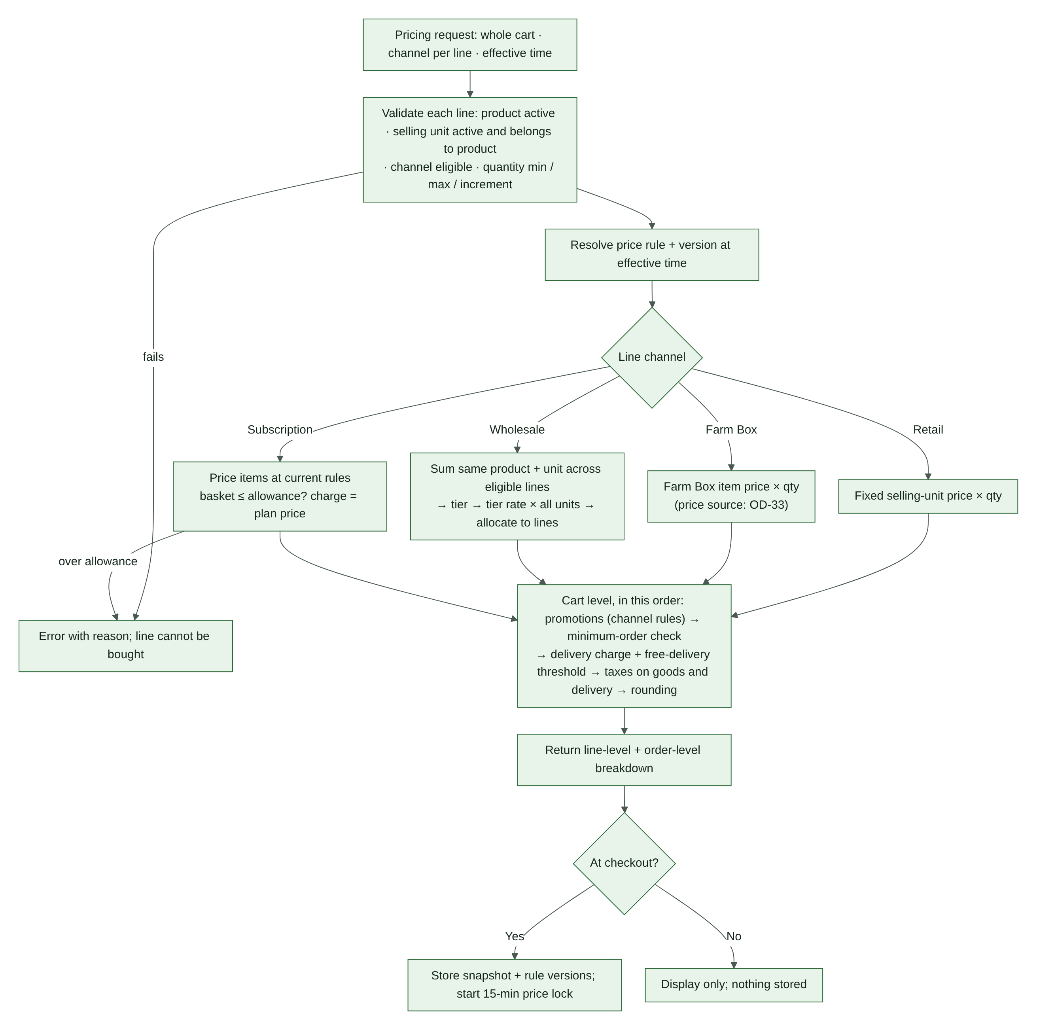
Figure 3. Pricing engine flow (reviewed version of the owner-supplied diagram)

10.1 Inputs
A pricing request covers the whole cart, because wholesale tiers depend on other lines. It includes: product ID, selling-unit ID, quantity and channel for every line; customer or account context where relevant; subscription plan and period context if relevant; coupon and promotion context; effective time; delivery and tax context (address, slot).

10.2 Validation and calculation order
- Confirm the product is active.
- Confirm the selling unit is active and belongs to the product.
- Confirm the product is eligible for the line's channel.
- Validate quantity minimum, maximum and increment for that channel.
- Resolve the applicable price rule and version at the effective time.
- Calculate each line by channel: retail fixed price (§10.3); Farm Box price (§10.4); wholesale — aggregate the same product and selling unit across the relevant lines (OD-26), resolve the tier, apply the tier rate to all aggregated units, then allocate back to lines (§10.5); subscription — price the basket at current rules and verify eligibility and the monetary allowance (§10.6).
- Apply permitted coupon and promotion rules (§10.7).
- Check the minimum order (§10.8).
- Calculate the delivery fee and free-delivery logic (§10.8).
- Calculate applicable taxes on goods and delivery according to configured tax rules (§10.9).
- Apply the rounding rule (OD-50).
- Return a line-level and order-level breakdown.
- At checkout, store the price snapshot and rule versions, and start the price lock (§10.10).

If any of steps 1–4, or the subscription allowance check, fails, return an error with a reason code (§10.11); the line cannot be bought. The exact tax and discount sequence must be verified against the configured WooCommerce tax setup and applicable requirements. Do not invent tax treatment.
(v2) Changes from the owner-supplied pricing diagram. (a) Wholesale aggregation is a cart-level step; the diagram priced each line on its own, which cannot add up quantities across lines (WS-04). (b) The delivery charge is now calculated before tax, because delivery may itself be taxable; the diagram taxed first. (c) Missing steps added: price-rule version, minimum order, rounding, snapshot and price lock, and the error path.

10.3 Retail formula
line_subtotal = selected_selling_unit_price × quantity
The selected pack price remains fixed even when actual packed weight differs.

10.4 Farm Box formula (v2)
line_subtotal = farm_box_unit_price × quantity, where farm_box_unit_price is the retail selling-unit price unless a Farm Box price rule exists (OD-33). A saved basket stores products, units and quantities only — never prices (FB-05).

10.5 Wholesale formula
For each eligible product and selling unit:
- Aggregate eligible quantities across cart lines.
- Resolve the tier for the aggregate quantity.
- Apply that tier's unit rate to all aggregated units.
- Allocate the result back to line snapshots for order and reporting, while preserving the correct aggregate basis.

Because one rate applies to every unit, allocation is exact: each line's amount = tier rate × that line's quantity, and the line amounts always add up to the aggregate total.
Example only: 5 kg + 7 kg of the same product and selling unit = 12 kg. If the 10–24 kg tier is ₹45/kg, the total is ₹540 (lines of ₹225 and ₹315). Actual tier rates and boundaries remain undecided (OD-01). Do not aggregate different products or different units without explicit rules.

10.6 Subscription allowance
- eligible_basket_value must not exceed plan_product_allowance (scope per OD-19).
- A basket above the allowance is blocked until edited.
- The allowance is not an extra charge; the charge is the fixed plan price.
- Delivery and applicable taxes are handled separately under plan rules.
- Preserve price and allowance snapshots for each subscription period and delivery.
- Define how a period's prices are locked and how updated prices apply to the next period before enabling subscriptions.

10.7 Promotions (v2)
- Coupons are validated on the server against their channel rules and validity window (OD-44).
- The promotion version used is stored in the snapshot.
- A promotion never lowers a line below zero or changes a wholesale tier boundary.

10.8 Minimum order and delivery charge (v2)
- The minimum order (OD-02) is checked on the eligible subtotal after promotions; Farm Box treatment follows OD-08.
- The delivery fee and free-delivery threshold follow OD-03, including whether the threshold uses the subtotal before or after discounts and tax.

10.9 Tax and rounding (v2)
- Taxes follow the configured WooCommerce tax settings, validated by the CA (OD-09). Fresh produce, processed items and delivery charges may not share the same treatment.
- One rounding function is used everywhere (OD-50). Displayed totals always equal charged totals.

10.10 Price-lock rule
- Checkout price lock duration: 15 minutes.
- Recalculate and validate on the server at checkout start.
- Store the snapshot, rule versions and expiry.
- If the lock expires before payment initiation, recalculate and require customer confirmation of changes.
- If a gateway response is delayed after payment initiation, reconcile the attempt against the original attempt and snapshot. Do not silently charge a different amount.
- Never trust browser-submitted totals.
- (v2) The lock covers line prices, tiers, promotions, delivery fee, tax and the total.
- (v2) If the cart changes during the lock, the server reprices it (wholesale tiers included), shows the customer what changed, and starts a new lock.

10.11 Error reason codes (v2)
product_inactive, unit_invalid, not_eligible_for_channel, quantity_below_minimum, quantity_above_maximum, quantity_not_increment, price_rule_missing, over_allowance, promotion_invalid, below_minimum_order, outside_service_area. Each code has a plain-language customer message (§18.5).

11. State Machines
Greenbasket tracks several things that each have their own lifecycle. They must stay separate. One combined status would hide important facts: an order can be delivered and partly refunded, or paid and waiting for stock review.
State machine | Tracks
Order (§11.1) | Where the goods are: confirmation, packing, delivery
Payment attempt (§11.2) | Where the money is for one try to pay
Stock reservation (§11.3) | The hold on stock for one order line
Slot reservation (§11.4) | The hold on delivery capacity for one order
Subscription (§11.5) | The customer's plan
Subscription delivery (§11.6) | One scheduled delivery of a subscription
Refund request (§11.7) | One request for money back
Exception case (§11.8) | One problem that needs a person

Rules that apply to every state machine:
- A status changes only through a transition listed here. Any other change is rejected and logged.
- Every transition is idempotent and writes an audit event: actor, before, after, reason, time.
- A "guard" must be true for the transition to happen. "Effects" are what the system does as part of the same change.
- Section §11.9 lists how the machines affect each other.

11.1 Order (fulfilment)
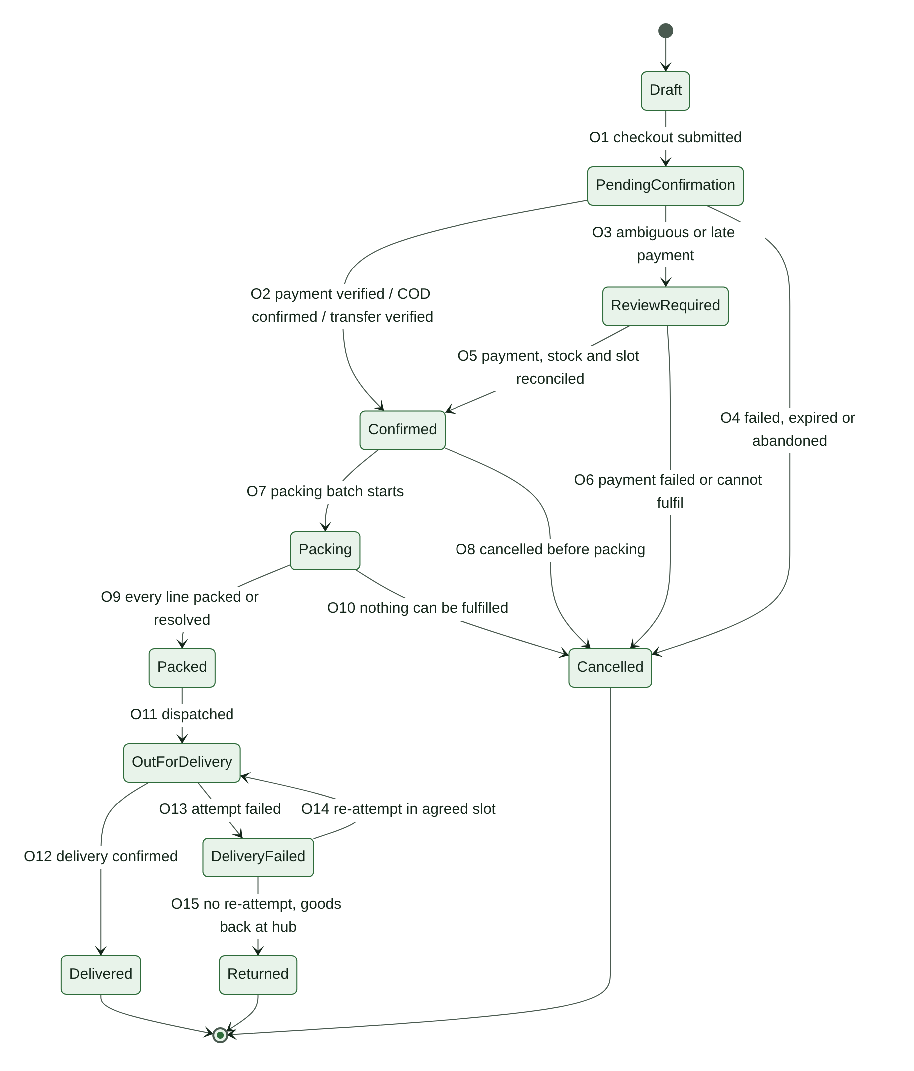
Figure 4. Order state machine
State | Meaning | WooCommerce status (RECOMMENDATION, OD-45)
Draft | Cart or checkout in progress; not visible to staff as an order | Cart session or checkout draft
PendingConfirmation | Submitted; waiting for payment verification, COD confirmation or transfer verification | Pending payment (online); On hold (bank transfer)
ReviewRequired | Needs staff reconciliation: ambiguous, late or mismatched payment, or stock or slot could not be re-secured | On hold, with a review reason
Confirmed | Payment verified, COD confirmed, or transfer verified; stock and slot confirmed | Processing
Packing | Being picked and packed | Custom status "Packing"
Packed | Every line packed or resolved | Custom status "Packed"
OutForDelivery | With a driver | Custom status "Out for delivery"
DeliveryFailed | A delivery attempt failed | Custom status "Delivery failed"
Delivered | Handed over with proof | Completed
Returned | Goods came back to the hub; final | Custom status "Returned"
Cancelled | Final; nothing will be delivered | Cancelled

WooCommerce may set its own "Refunded" status when an order is fully refunded. Greenbasket keeps the fulfilment state in its own field (OrderFulfilment, §9.3) so delivery history is never lost. Custom statuses must be verified against the site's order storage mode in Phase 1.
ID | From → To | Trigger | Guard | Effects
O1 | Draft → PendingConfirmation | Customer places the order | Server repricing passed; price lock valid or changes confirmed by the customer; stock and slot reservations active; payment method eligible | Create the WooCommerce order; link reservations and price lock to it; create a payment attempt or start the COD or bank-transfer flow
O2 | PendingConfirmation → Confirmed | Online payment verified, COD confirmed (OD-49), bank transfer verified, or authorized bank-transfer exception | Amount matches the snapshot; stock and slot reservations still Active or Extended | Reservations → Confirmed (R3, L2); confirmation notification queued
O3 | PendingConfirmation → ReviewRequired | Payment ambiguous, amount mismatch, or payment succeeded after the reservation expired | — | Reservations held for review (R6, L5) or flagged (R7); exception case opened; customer told payment is being verified and is not asked to pay again
O4 | PendingConfirmation → Cancelled | Payment confirmed failed and not retried, reservations expired with no payment, customer abandoned, or bank-transfer window ended | No payment is Paid or ReviewRequired | Release reservations (R5, L4); payment attempt final
O5 | ReviewRequired → Confirmed | Review resolved | Payment Paid; stock re-secured (R8); slot held before its cutoff, or the customer agreed a new slot | Reservations → Confirmed; exception case resolved
O6 | ReviewRequired → Cancelled | Payment reconciled as failed, or paid but cannot be fulfilled and the customer declines alternatives | — | Release reservations; if paid, open a system refund request (F1)
O7 | Confirmed → Packing | Packing starts for the order's slot | Bank transfer verified or exception recorded (CP-09) | Lines enter picking
O8 | Confirmed → Cancelled | Customer cancels before packing (CP-15), or staff cancel with a reason | Cancellation policy allows it | Release reservations (R12, L9); if paid, open a system refund request
O9 | Packing → Packed | Every line packed or its shortage resolved | No open shortage exception on the order | Packed quantity consumed (R11); shortage quantity released with stock correction (R12); amount changes go to a refund request or reduce the COD amount due
O10 | Packing → Cancelled | Nothing can be fulfilled, or the customer cancels after shortage contact | Recorded customer decision or approved default action (OD-28) | Release reservations; refund if paid
O11 | Packed → OutForDelivery | Dispatched to an assigned driver | Delivery assignment exists | Out-for-delivery notification
O12 | OutForDelivery → Delivered | Handover confirmed | Proof of delivery captured (OD-40); COD collection recorded if due | Slot hold Used (L10); delivered notification; refund window opens (OD-37)
O13 | OutForDelivery → DeliveryFailed | Attempt failed (not available, wrong address, refused, no access) | Reason and proof recorded | Delivery attempt saved; customer notified; exception case opened
O14 | DeliveryFailed → OutForDelivery | Re-attempt dispatched | Policy allows it (OD-16); customer agreed a new slot, held atomically | New slot reservation; attempt number increases
O15 | DeliveryFailed → Returned | No re-attempt | Goods received back at the hub | Stock disposition: restock or waste movement; refund or charges per OD-16

Differences from the owner-supplied order diagram: (1) a failed-delivery path (DeliveryFailed, Returned) was added, because DL-12 requires failed-delivery workflows and the diagram had none. (2) Refund states were moved out of the order into the refund lifecycle (§11.7). In the diagram, a partially refunded order lost the fact that it had been delivered, and could not receive a second refund. (3) Cancellation from Packing (O10) was added for shortages. (4) v1.0's ready_for_packing state was dropped: it duplicated Confirmed, since packing is driven by the slot date.

11.2 Payment attempt
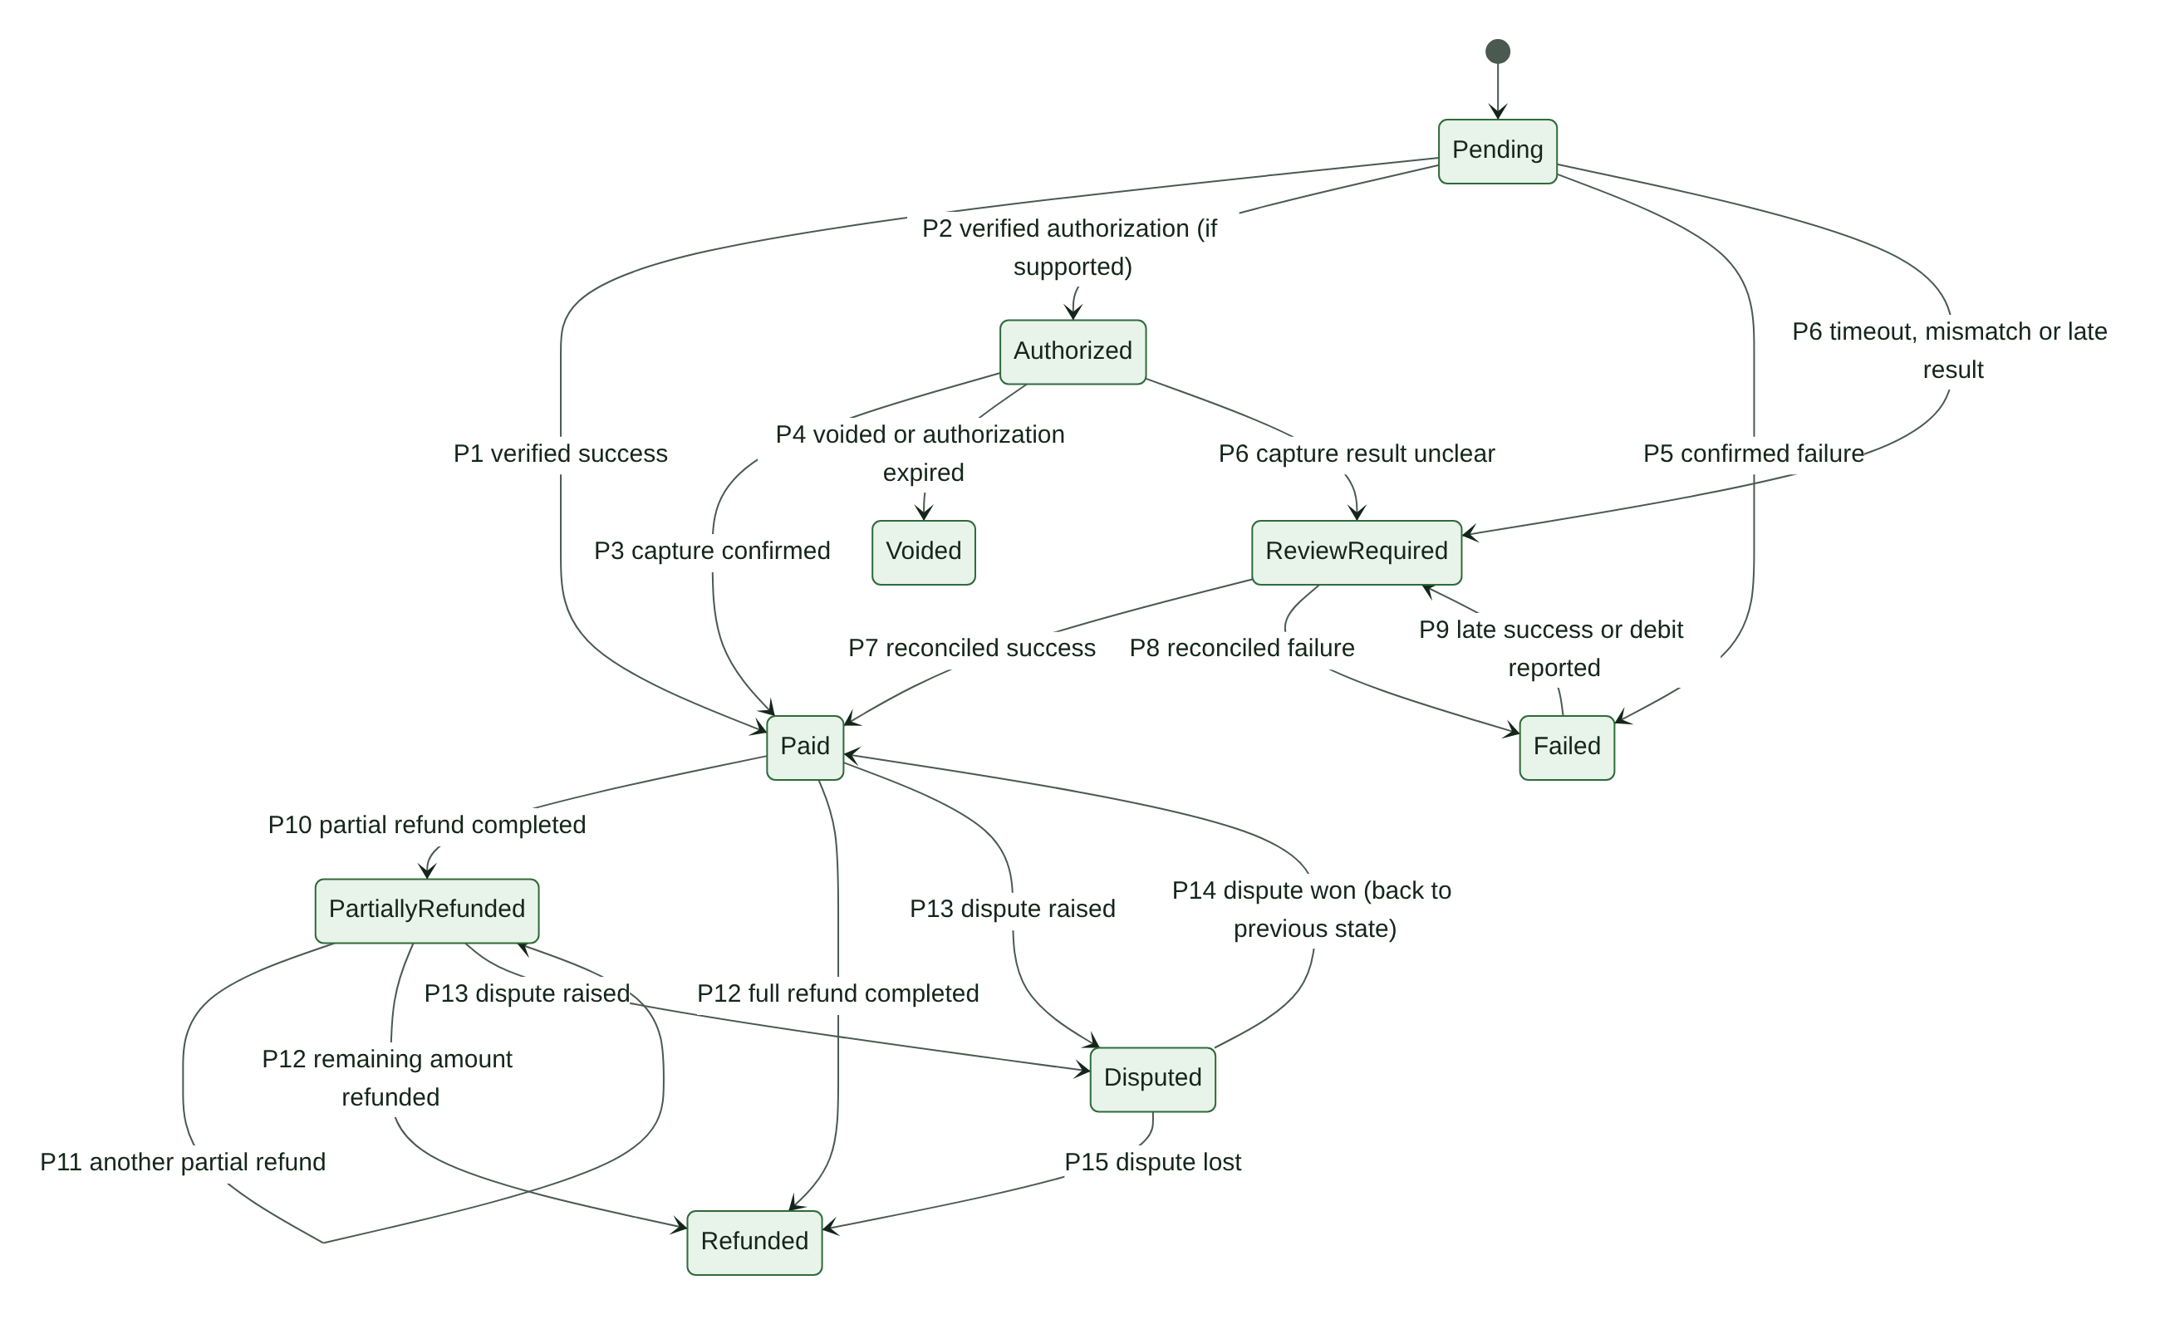
Figure 5. Payment attempt state machine

State | Meaning | Applies to
Pending | Attempt created; result not yet known. For COD: awaiting collection. For bank transfer: awaiting the credit. | All methods
Authorized | Funds authorized but not captured | Online, only if the gateway and method support it (OD-36)
Paid | Money received and verified | All methods
Failed | Final failure for this attempt (declined, abandoned and confirmed unpaid, not collected, transfer not received) | All methods
Voided | Authorization released before capture | Online with authorization
ReviewRequired | Result unclear or inconsistent; a person must reconcile | All methods
PartiallyRefunded | Some money returned; derived from completed refund transactions | Paid attempts
Refunded | All money returned | Paid attempts
Disputed | Customer's bank raised a dispute or chargeback | Online

ID | From → To | Trigger | Guard | Effects
P1 | Pending → Paid | Verified success: signed callback or server status lookup; COD collection recorded; bank credit verified | Amount, currency and order match the snapshot; event not processed before | Order O2 (or O5); idempotency record saved
P2 | Pending → Authorized | Verified authorization | Gateway supports authorization for this method | Capture scheduled per OD-36
P3 | Authorized → Paid | Capture confirmed | Captured amount ≤ authorized amount | As P1
P4 | Authorized → Voided | Authorization voided, or expired at the gateway | — | Order cancelled or a new attempt required
P5 | Pending → Failed | Gateway confirms failure; attempt window ended and lookup confirms nothing was charged; COD not collected; transfer window ended | No conflicting success signal | Release holds if the order cancels (O4); a retry creates a new attempt
P6 | Pending or Authorized → ReviewRequired | Timeout without a definitive status; amount or currency mismatch; success for an order already cancelled or expired | — | Order O3; exception case; no second payment prompt
P7 | ReviewRequired → Paid | Reconciled as success | Verified with the gateway or bank | Order O5 if stock and slot can be re-secured; otherwise O6 with refund
P8 | ReviewRequired → Failed | Reconciled as failure | Verified with the gateway or bank | Order O4 or O6
P9 | Failed → ReviewRequired | Late success notice from the gateway, or customer reports a debit (CP-16) | — | Never marked Paid without verification; exception case
P10 | Paid → PartiallyRefunded | A refund transaction succeeds for less than the paid amount | — | Order fulfilment state unchanged
P11 | PartiallyRefunded → PartiallyRefunded | Another partial refund succeeds | Total refunded < paid amount | —
P12 | Paid or PartiallyRefunded → Refunded | Refund transactions total the paid amount | — | —
P13 | Paid or PartiallyRefunded → Disputed | Dispute notice from the gateway | — | Dispute record; response deadline tracked
P14 | Disputed → previous state | Dispute won | — | Dispute closed
P15 | Disputed → Refunded | Dispute lost (chargeback) | — | Recorded as chargeback; finance notified

Rules:
- An order has at most one attempt in Pending, Authorized or ReviewRequired at a time. A customer retry creates a new attempt only after the previous one is final.
- If two attempts for the same order both become Paid, the second goes to ReviewRequired and its amount is refunded (§16.8).
- Refund states are derived only from succeeded refund transactions (§11.7), never set by hand.

Differences from the owner-supplied payment diagram: (1) a voided authorization now goes to Voided, not Failed — it is a cancellation, not a payment failure, and reporting must tell them apart. (2) Failed → ReviewRequired (P9) was added for late success and reported debits (CP-16). (3) Repeated partial refunds (P11), disputes (P13–P15) and capture-unclear (P6 from Authorized) were added. (4) COD and bank transfer were mapped onto the same states.

11.3 Stock reservation
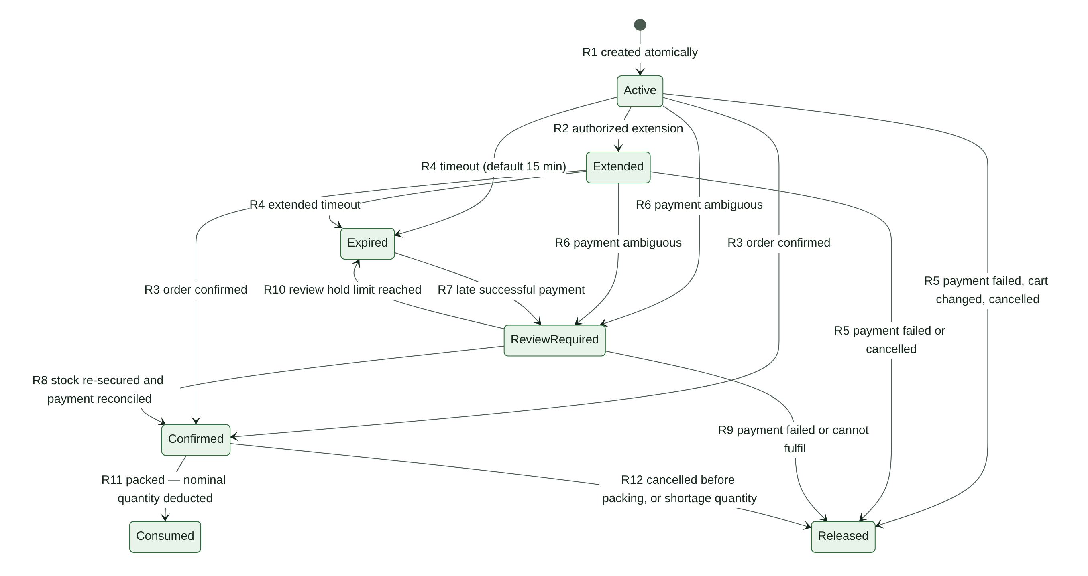
Figure 6. Stock reservation state machine

State | Meaning
Active | Quantity held for a checkout line; counts against availability until expires_at
Extended | Still held, with a later expiry under an authorized extension rule
Confirmed | Held for a confirmed order; waiting for packing
ReviewRequired | Held, or needs re-securing, while a payment is reconciled
Expired | Timed out; no longer counts against availability
Released | Given back to the pool; final
Consumed | Deducted from on-hand at packing; final

ID | From → To | Trigger | Guard | Effects
R1 | (new) → Active | Checkout reserves stock | Atomic: available ≥ requested quantity, for all lines together | expires_at = now + reservation timeout (default 15 min, CONFIGURABLE, CP-10)
R2 | Active → Extended | Authorized extension: online payment started near expiry (OD-34); bank transfer selected (OD-25); staff extension with reason | Extension count below the configured maximum | New expires_at; extension reason recorded
R3 | Active or Extended → Confirmed | Order confirmed (O2) | Not expired | confirmed_at set
R4 | Active or Extended → Expired | expires_at passed | Not confirmed | Quantity stops counting immediately (read-time rule, §7.5); the job records the state
R5 | Active or Extended → Released | Payment confirmed failed; customer changed or removed the line; checkout abandoned; order cancelled | — | release_reason recorded
R6 | Active or Extended → ReviewRequired | Payment ambiguous (O3) | — | Hold kept until resolved or until the review hold limit (OD-35)
R7 | Expired → ReviewRequired | Successful payment arrives after expiry (CP-11) | — | Late-payment exception case; dispatch blocked
R8 | ReviewRequired → Confirmed | Payment reconciled as Paid | Stock still held, or re-reserved atomically for the full quantity | Order O5
R9 | ReviewRequired → Released | Payment failed, or the line cannot be fulfilled and the customer declines alternatives | — | Refund if paid (O6)
R10 | ReviewRequired → Expired | Review hold limit reached (OD-35) | Payment still unresolved | A later success follows R7
R11 | Confirmed → Consumed | Line packed | — | fulfilment_deduction movement for the packed nominal quantity (idempotent)
R12 | Confirmed → Released | Cancelled before packing; or shortage at packing (unfilled quantity) | — | For a shortage: a shortage_correction movement reduces on-hand by the quantity that was not physically there (§13.4)

Differences from the owner-supplied reservation diagram: the Extended state is kept from the diagram. Added: payment failure and cancellation from Extended (R5); a hold while payment is ambiguous (R6), which the PRD requires ("do not blindly release or consume stock"); a review hold limit (R10); and partial outcomes at packing (R11 plus R12 for the shortage quantity). Also, an expired reservation stops counting at once, even if the expiry job is late.

11.4 Slot reservation
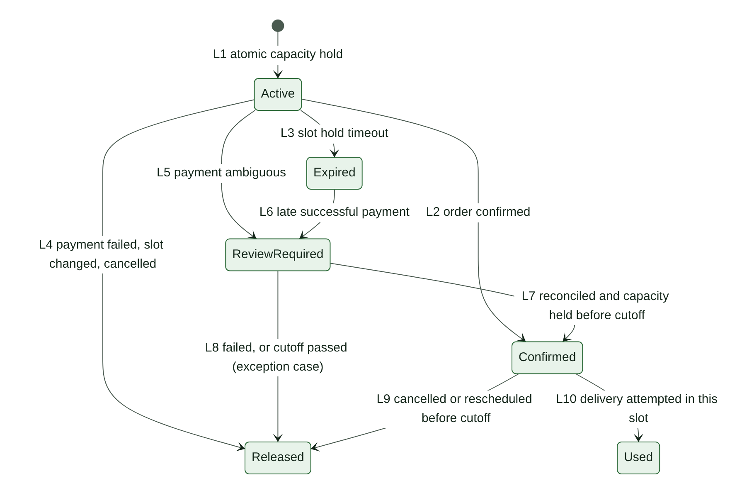
Figure 7. Slot reservation state machine
States: Active (held, with its own expiry, separate from stock — DL-07), Confirmed, ReviewRequired, Expired, Released, Used. A bank-transfer order or an authorized extension keeps the hold Active with a later expiry; the extension is recorded the same way as R2.
ID | From → To | Trigger | Guard | Effects
L1 | (new) → Active | Customer selects a slot | Atomic: slot open, before cutoff, regular capacity left (subscription holds use protected capacity) | expires_at = now + slot hold timeout (CONFIGURABLE)
L2 | Active → Confirmed | Order confirmed (O2) | Hold not expired | Slot allocation confirmed
L3 | Active → Expired | Hold timed out | Not confirmed | Capacity freed immediately (read-time rule)
L4 | Active → Released | Payment failed; customer chose another slot; checkout abandoned; cancelled | — | Capacity freed
L5 | Active → ReviewRequired | Payment ambiguous | — | Held until the slot's cutoff at most
L6 | Expired → ReviewRequired | Late successful payment | — | Try to re-hold the same slot atomically
L7 | ReviewRequired → Confirmed | Payment reconciled as Paid | Capacity held before the slot's cutoff | Order O5
L8 | ReviewRequired → Released | Payment failed, or the cutoff passed | — | Exception case: customer picks a new slot; never moved silently
L9 | Confirmed → Released | Cancelled or rescheduled before cutoff | For a reschedule, the new slot is held first | Capacity freed
L10 | Confirmed → Used | Delivery attempted in this slot | — | A re-attempt needs a new reservation (O14)

11.5 Subscription
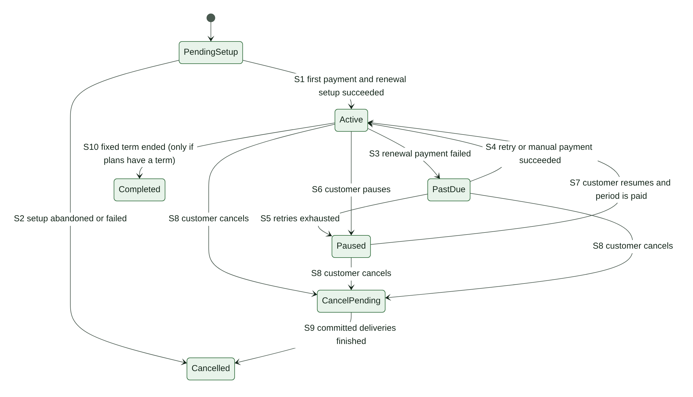
Figure 8. Subscription state machine

ID | From → To | Trigger | Guard | Effects
S1 | PendingSetup → Active | First period paid and renewal setup done | Required payment authorization or mandate succeeded (SB-12); never Active without it | First period's deliveries scheduled (V1)
S2 | PendingSetup → Cancelled | Setup abandoned or failed | Setup timeout reached (OD-41) | Holds released
S3 | Active → PastDue | Renewal payment failed | — | Retry schedule starts (§12.8)
S4 | PastDue → Active | Retry or manual payment succeeded | Previous attempt reconciled first; no duplicate charge | Period Paid
S5 | PastDue → Paused | Retries exhausted (3 over 3 days, SB-13; counting per OD-22) | — | Future deliveries paused (V3); customer notified
S6 | Active → Paused | Customer pauses | Effective date per OD-46 and cutoff rules | Future deliveries after the effective date cancelled; protected capacity released
S7 | Paused → Active | Customer resumes | Next period paid or payment set up | Deliveries scheduled from the next possible date
S8 | Active, Paused or PastDue → CancelPending | Customer cancels | Published terms (LG-07) | Remaining deliveries per OD-47
S9 | CancelPending → Cancelled | Committed deliveries finished | — | No further charges
S10 | Active → Completed | Fixed term ended | Only if plans have a term (OD-48) | —

11.6 Subscription delivery
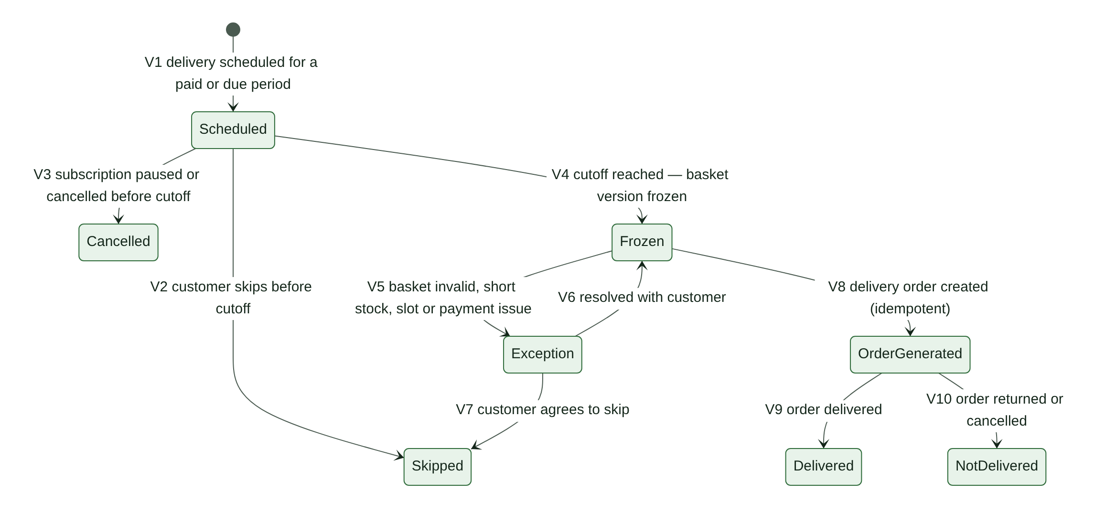
Figure 9. Subscription delivery state machine

ID | From → To | Trigger | Guard | Effects
V1 | (new) → Scheduled | Period scheduled | Subscription Active | Protected slot capacity counted (§15.3)
V2 | Scheduled → Skipped | Customer skips | Before cutoff | Protected capacity released; charge unchanged (SB-14)
V3 | Scheduled → Cancelled | Subscription paused or cancelled | Before cutoff | Protected capacity released
V4 | Scheduled → Frozen | Cutoff reached | — | Latest saved basket version frozen with price, allowance and rule snapshots (SB-10, SB-15)
V5 | Frozen → Exception | Basket invalid (OD-24), stock short, slot cannot be honoured, or period unpaid (OD-21) | — | Exception case; customer contacted; no silent substitution
V6 | Exception → Frozen | Resolved with the customer | Customer decision recorded | Snapshot updated as a new version
V7 | Exception → Skipped | Customer agrees to skip | — | Capacity released
V8 | Frozen → OrderGenerated | Delivery order created | Idempotency key = delivery ID; stock and slot confirmed | WooCommerce order linked to the subscription and period (SB-04)
V9 | OrderGenerated → Delivered | Order Delivered (O12) | — | —
V10 | OrderGenerated → NotDelivered | Order Returned or Cancelled | — | Credit or charge per published policy only

11.7 Refund request and refund transaction
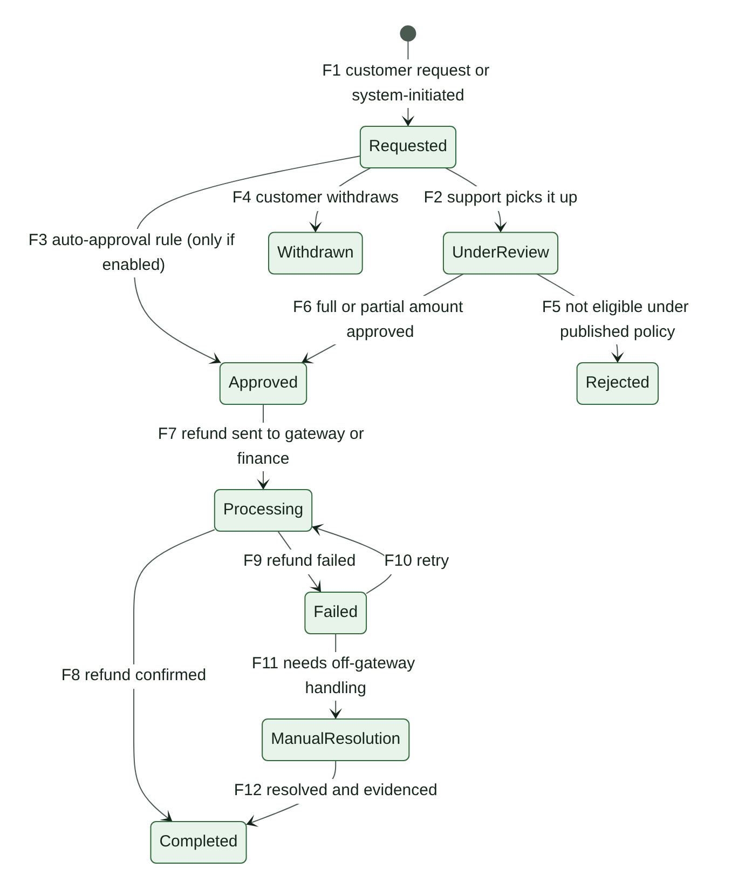
Figure 10. Refund request state machine
ID | From → To | Trigger | Guard | Effects
F1 | (new) → Requested | Customer request (within OD-37), or system-initiated: cancellation of a paid order, shortage, failed delivery, duplicate payment, late payment that cannot be fulfilled | Paid amount available to refund | Source and reason recorded
F2 | Requested → UnderReview | Support picks it up | — | Assigned reviewer
F3 | Requested → Approved | Auto-approval rule | Enabled by OD-38; system-calculated amount; not a customer complaint | Approval recorded as rule-based
F4 | Requested → Withdrawn | Customer withdraws | Not yet approved | —
F5 | UnderReview → Rejected | Not eligible under the published policy | Reason given to the customer | —
F6 | UnderReview → Approved | Full or partial amount approved | Approver has the refund permission (§22.1) | approved_amount set
F7 | Approved → Processing | Refund transaction created | Idempotency key per refund transaction | Sent to the gateway, or to finance for COD and bank-transfer payouts (OD-39)
F8 | Processing → Completed | Refund confirmed | — | Payment P10 or P12; credit note if applicable (OR-03)
F9 | Processing → Failed | Refund failed | — | Finance alerted
F10 | Failed → Processing | Retry | Retry is a new transaction with its own idempotency key | —
F11 | Failed → ManualResolution | Cannot complete through the gateway | — | Off-gateway payout with evidence
F12 | ManualResolution → Completed | Resolved and evidenced | Evidence attached | As F8

11.8 Exception case
Lifecycle: Open → Assigned → AwaitingCustomer (optional) → Resolved → Closed. A resolved case may be reopened with a reason. Each case type has an owner role and a response target (OD-54).
Case type | Raised when | Owner role
payment_review | Payment ambiguous or mismatched (P6) | Finance
late_payment | Payment succeeded after expiry or cancellation (R7, L6) | Finance + order manager
duplicate_payment | Two Paid attempts on one order | Finance
reported_debit | Customer reports a debit on a failed attempt (P9) | Customer support + finance
stock_shortage | Line cannot be fully packed | Packing lead + support
slot_capacity | Slot cannot be honoured, or capacity was reduced below allocations | Order manager
subscription_basket | Frozen basket invalid (V5) | Customer support
subscription_payment | Renewal past due or retries exhausted | Customer support
delivery_failed | Delivery attempt failed (O13) | Delivery lead + support
cod_variance | Cash handed over ≠ cash recorded | Finance
refund_failure | Refund transaction failed (F9) | Finance
dispute | Dispute or chargeback (P13) | Finance

11.9 How the state machines interact
When | Then
Order becomes Confirmed (O2, O5) | Online payment Paid, or COD confirmed, or bank transfer verified or under authorized exception; every line reservation Confirmed; slot reservation Confirmed
A shortage exception is open on an order | The order cannot become Packed (O9)
A bank transfer is unverified with no recorded exception | The order cannot enter Packing (O7)
Payment becomes ReviewRequired | Order → ReviewRequired (O3); stock and slot holds → ReviewRequired (R6, L5)
Order becomes Cancelled | Every reservation not yet Consumed is released; if any payment is Paid, a system refund request is opened (F1)
Reservation Expired, then payment Paid | Order → ReviewRequired; dispatch blocked until stock and payment are reconciled (CP-11)
A refund completes | Payment state changes (P10, P12); order fulfilment state does not
Subscription Paused or Cancelled | Scheduled deliveries after the effective date → Cancelled (V3); protected capacity released
Subscription PastDue | Upcoming deliveries follow OD-21
Any transition | Audit event written in the same database transaction

12. Core Workflows
Each workflow names the state transitions it uses (§11). Values marked with an OD are open decisions and must stay configurable.

12.1 Checkout with online payment
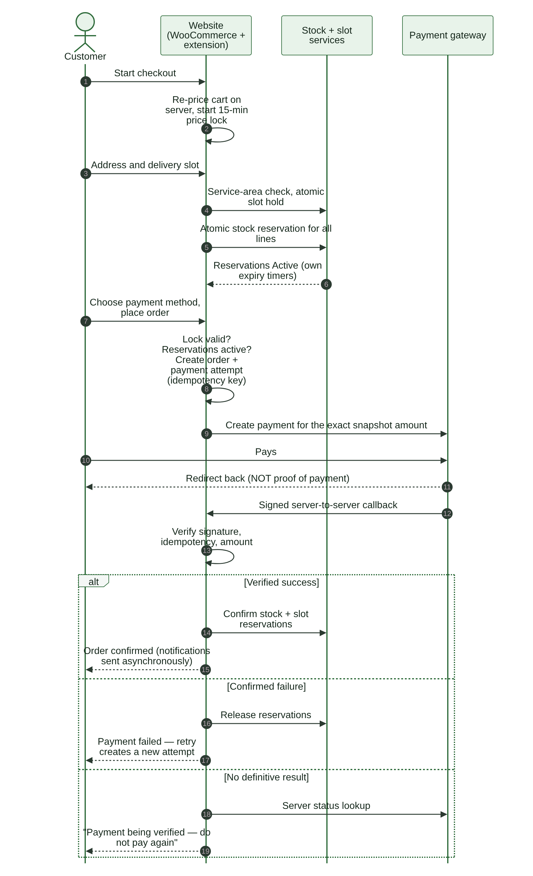
Figure 11. Checkout sequence with online payment
- Customer adds products. The server validates product, unit, quantity and channel, and prices the cart (§10).
- Customer starts checkout. The server reprices the cart and starts the 15-minute price lock (CP-12).
- Customer enters the delivery address. The server checks the PIN code against the service area (OD-27) and shows available slots (§12.6).
- Customer selects a slot. The server holds slot capacity atomically (L1).
- The server reserves stock for every line in one atomic step (R1). If any line cannot be reserved, nothing is reserved and the customer sees which line is short.
- Customer selects a payment method. The server checks eligibility: COD rules (OD-06); bank transfer availability.
- Customer places the order. The server checks that the price lock is valid (or that the customer has confirmed new prices — CP-13) and that the holds are active, then creates the order (O1) and one payment attempt with an idempotency key.
- The customer is sent to the gateway for exactly the snapshot amount.
- The gateway redirect only shows a status page; it is never proof of payment. The order is confirmed only by a verified server-to-server callback or a server status lookup (§12.2).
- Outcomes: verified success → order Confirmed (O2); confirmed failure → holds released, and a retry creates a new attempt; no definitive result → "payment being verified" page, status lookup, and no request to pay again (O3).
- If the online payment starts close to the reservation expiry, the reservation may be extended once (R2, OD-34).

12.2 Payment callback handling
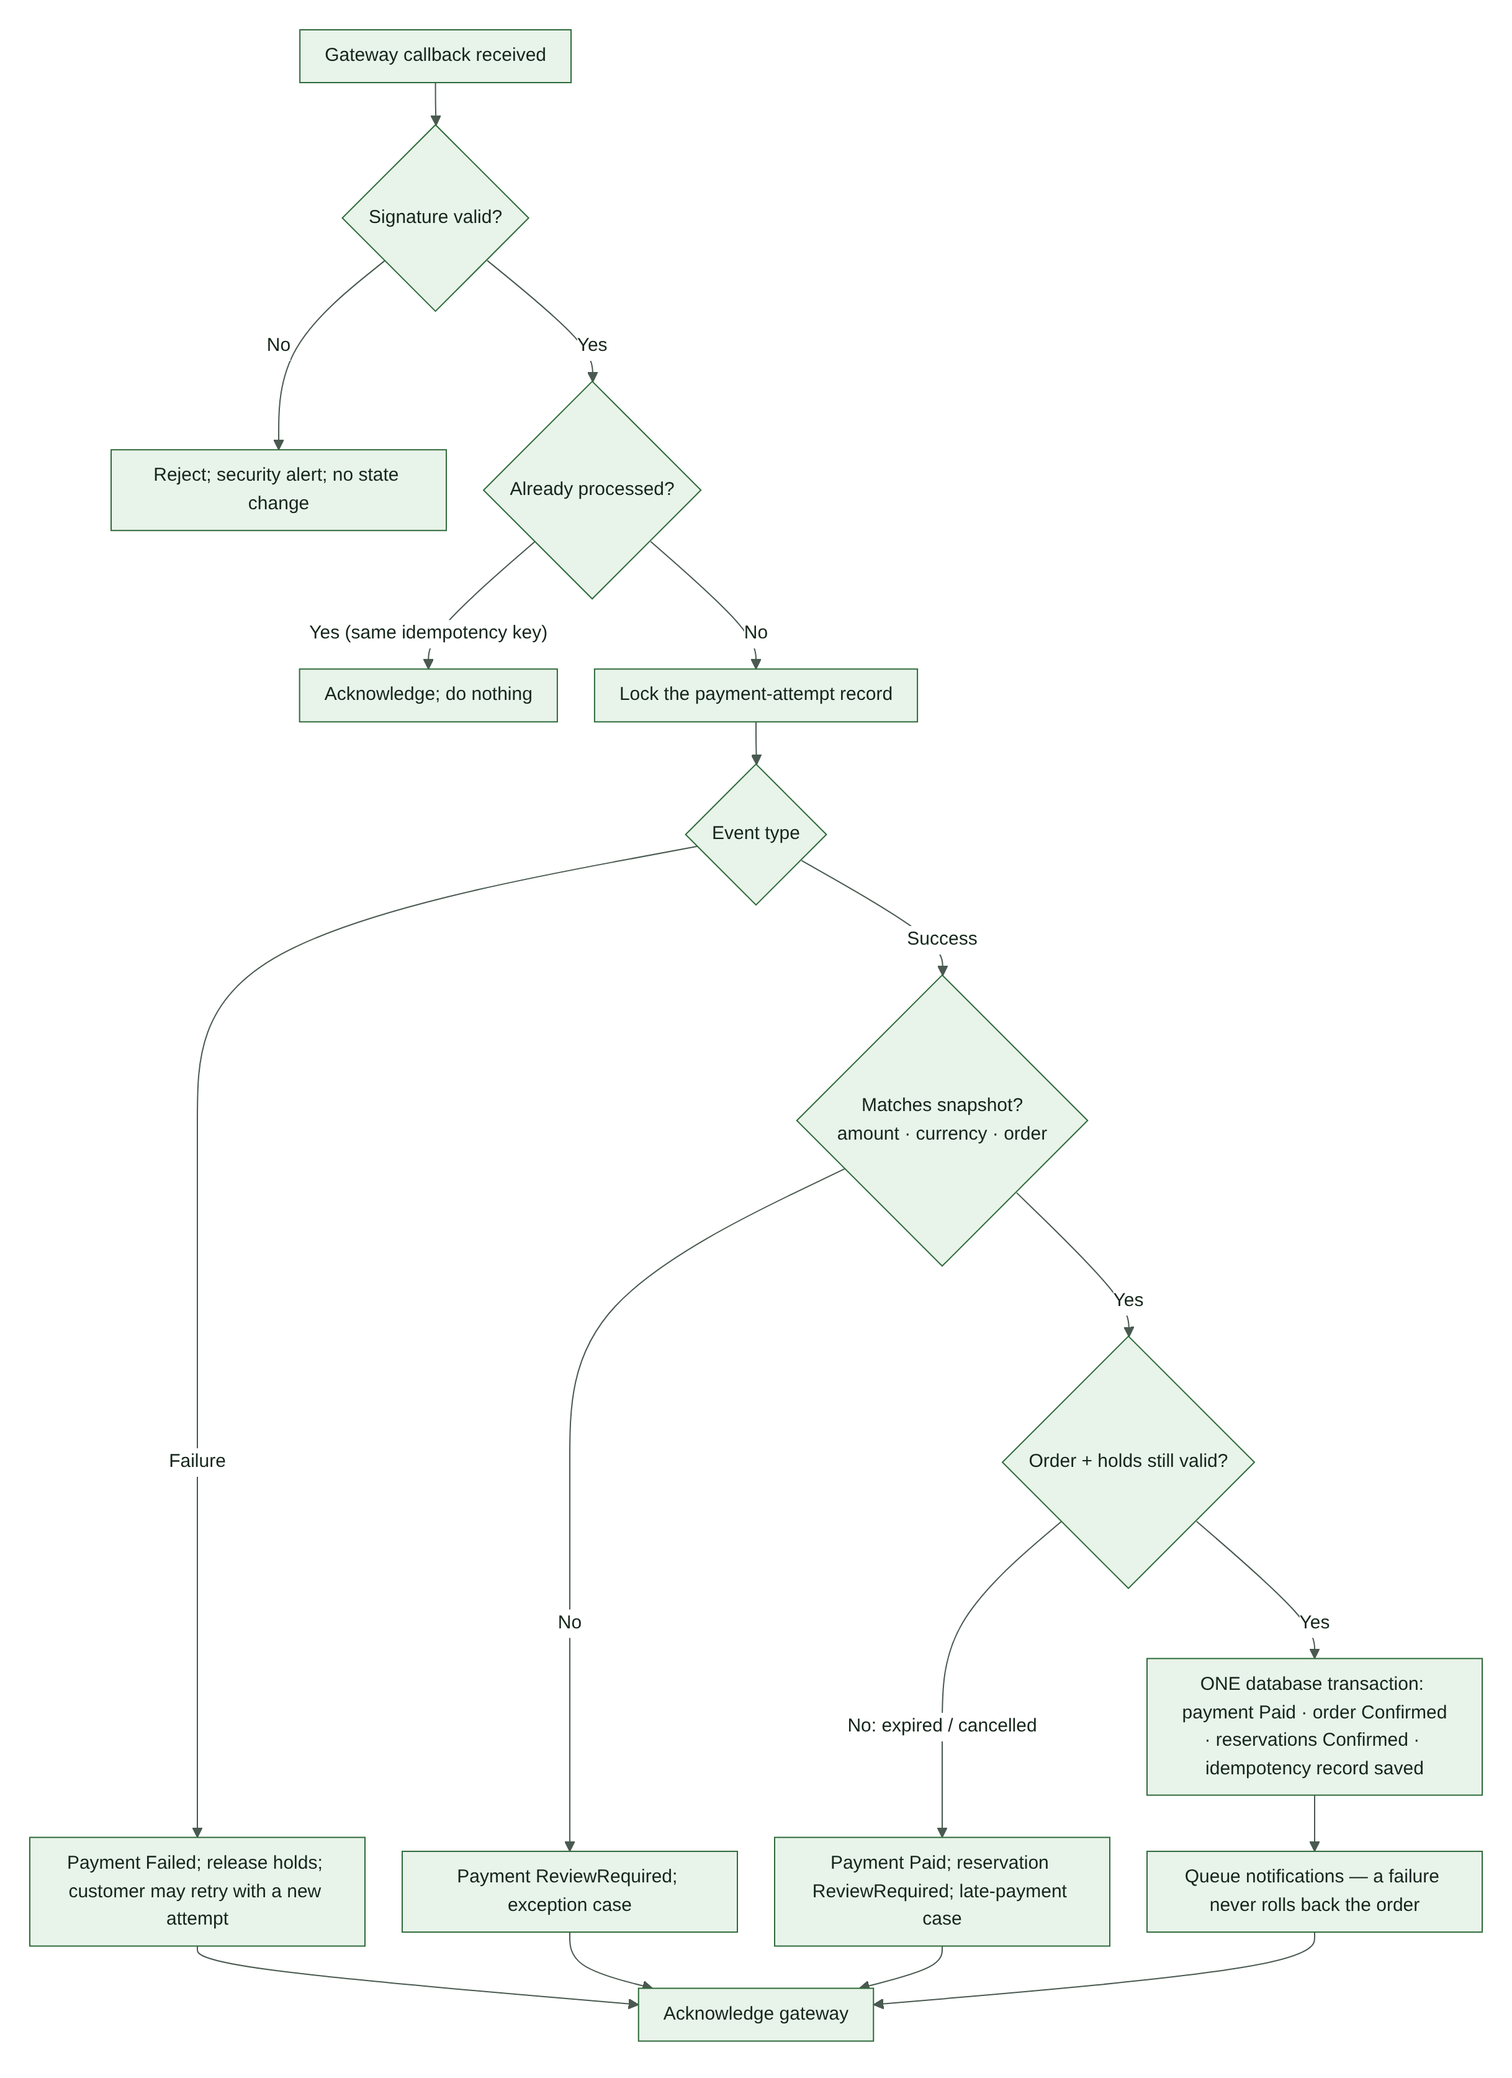
Figure 12. Payment callback handling
- Verify the callback signature. If it is invalid: reject it, raise a security alert, change nothing.
- Check the idempotency record for this gateway event. If already processed: acknowledge and do nothing.
- Lock the payment attempt record so two callbacks cannot process it at the same time.
- Failure event → payment Failed (P5); release holds or allow a new attempt.
- Success event → compare amount, currency and order with the snapshot. Mismatch → payment ReviewRequired (P6) and an exception case.
- If the order or its holds are no longer valid (expired or cancelled): payment Paid; reservation ReviewRequired (R7); late-payment case (§12.5).
- Otherwise, in one database transaction: payment Paid (P1), order Confirmed (O2), reservations Confirmed (R3, L2), idempotency record saved.
- Queue notifications. A failed notification never rolls back the order (NA-05).
- Acknowledge the gateway.

A reconciliation job (§7.5) also looks up every Pending or ReviewRequired attempt with the gateway, so a missed callback cannot leave an order stuck.

12.3 Cash on delivery (COD)
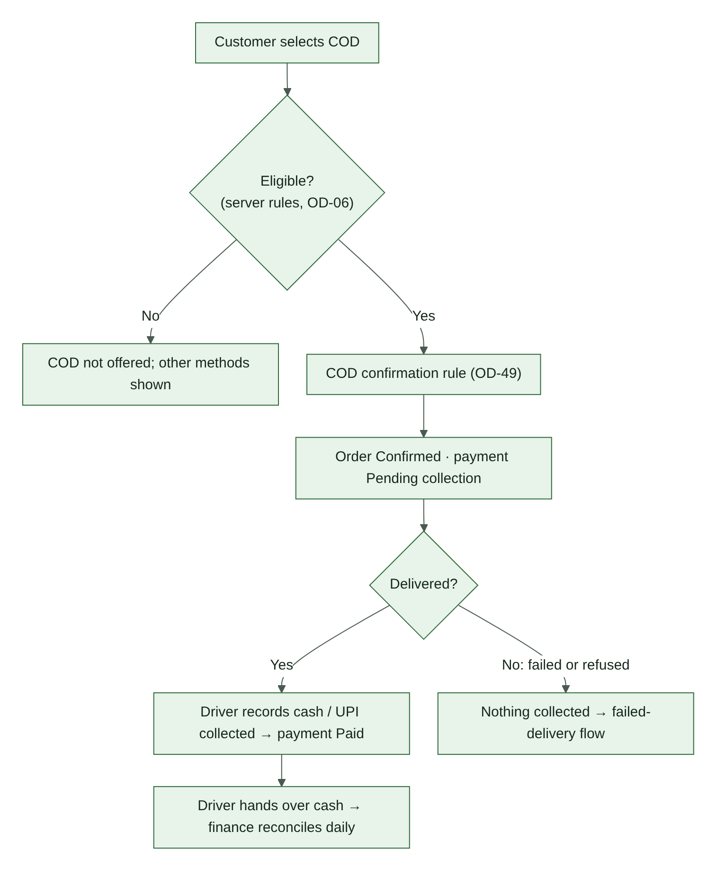
Figure 13. Cash on delivery flow
- COD is offered only if the server-side eligibility rules pass (OD-06).
- The COD confirmation rule runs (OD-49). On success the order is Confirmed (O2); the payment attempt stays Pending until collection.
- At the door, the driver records the amount and method collected (cash or UPI). The payment becomes Paid (P1).
- If a shortage reduced the order, the driver collects the reduced amount shown on the delivery screen.
- If delivery fails or the customer refuses, nothing is collected. The payment becomes Failed (P5) and the failed-delivery workflow runs (§12.10).
- At day end, drivers hand over cash. Finance reconciles collected against recorded amounts; any difference opens a cod_variance case.

12.4 Bank transfer
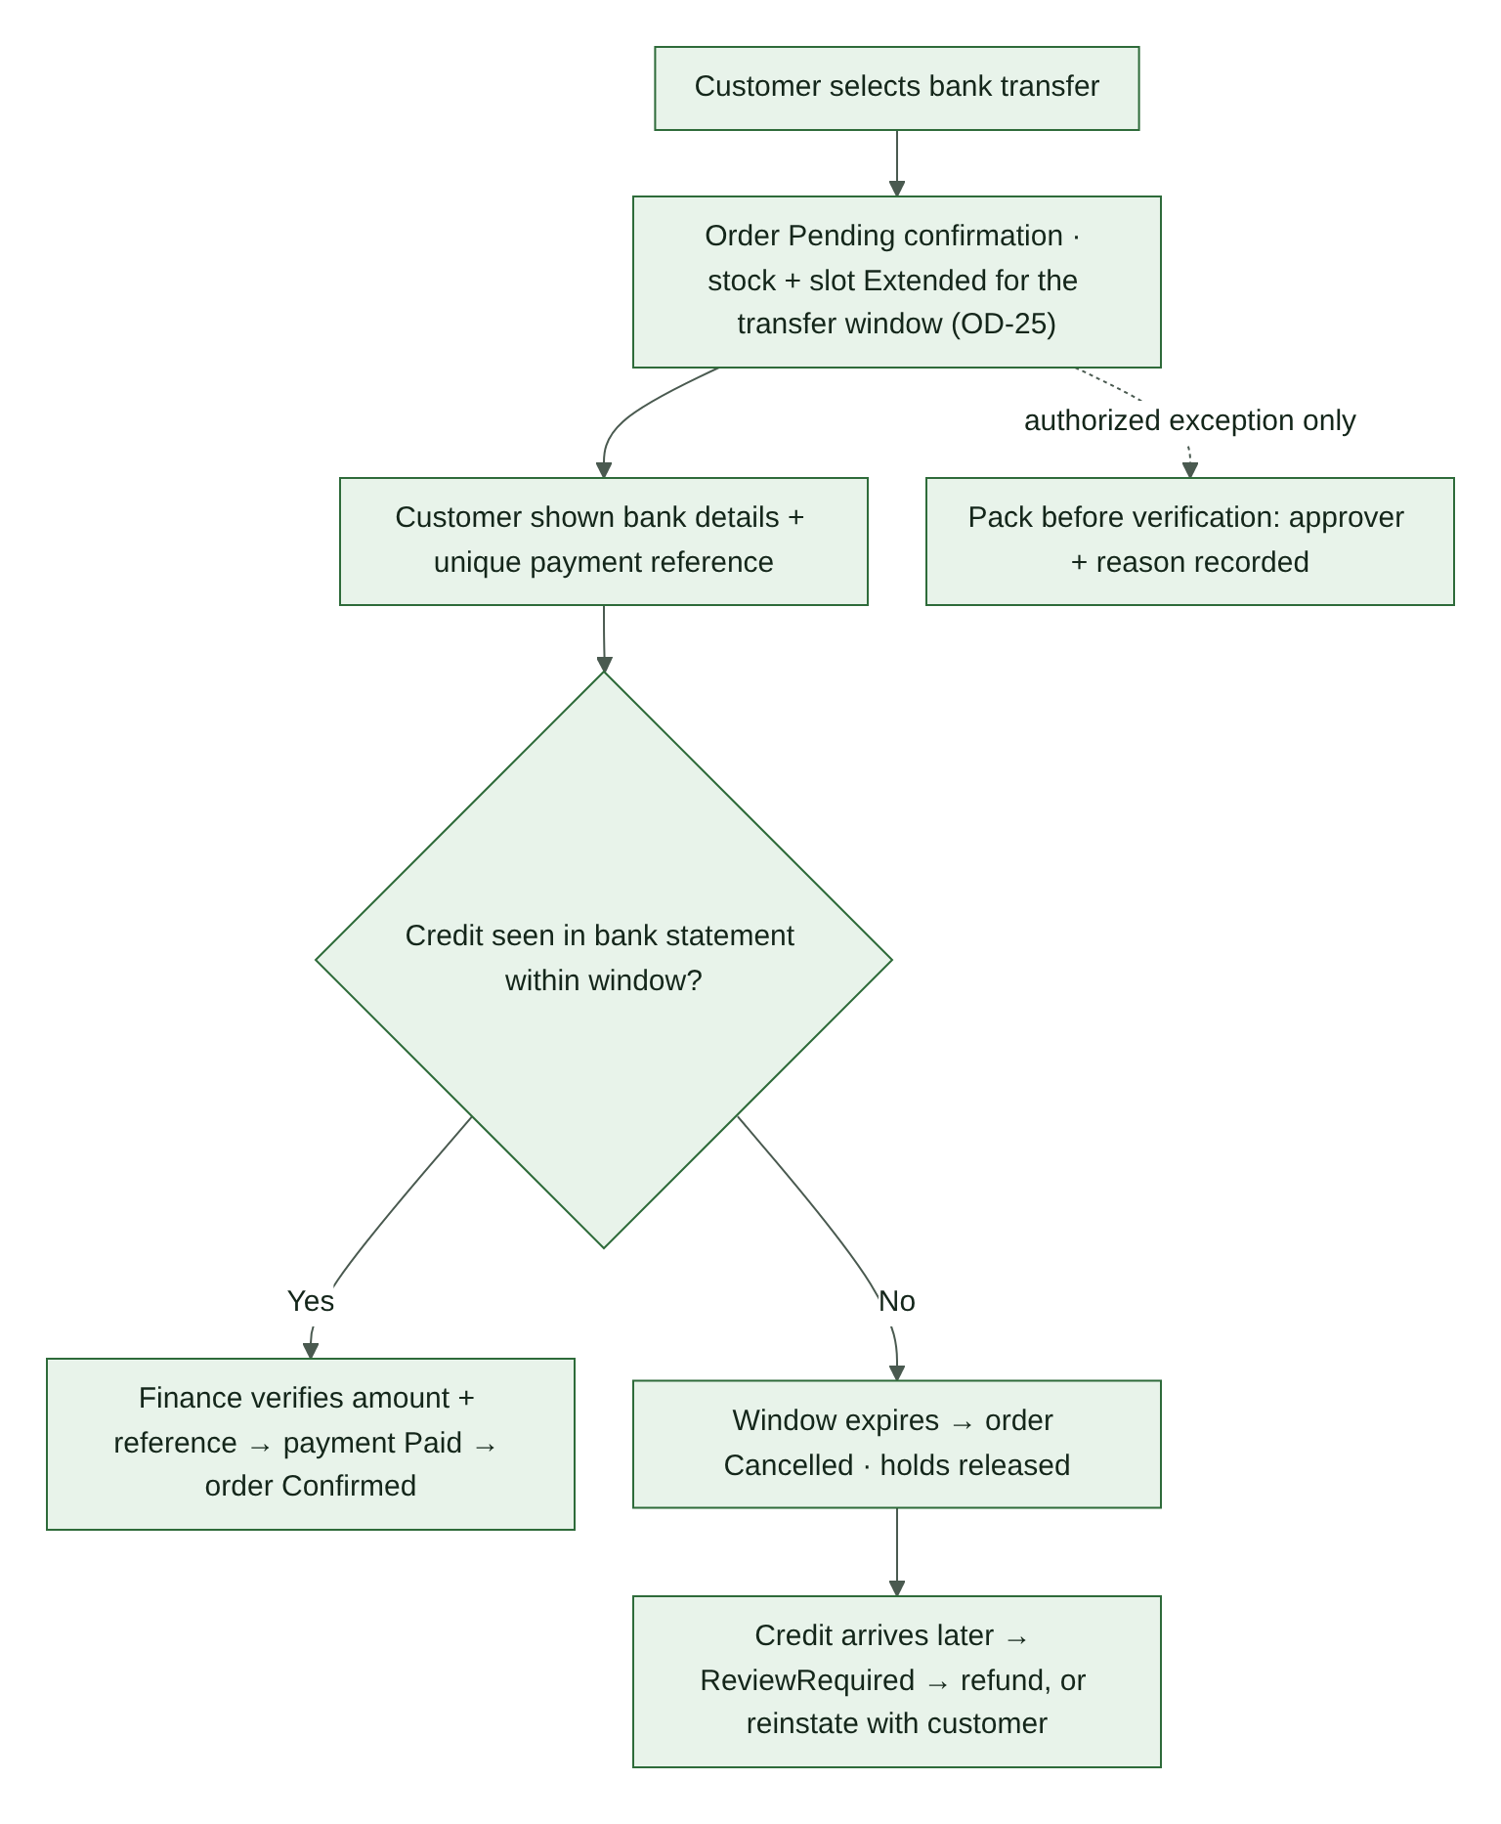
Figure 14. Bank transfer flow
- The order is created in PendingConfirmation (O1). Stock and slot holds are extended for the bank-transfer window (R2, OD-25).
- The customer sees bank details and a unique payment reference.
- Finance matches the credit in the bank statement by reference and amount, and records the verification. Payment Paid (P1); order Confirmed (O2).
- If no credit arrives within the window: order Cancelled (O4); holds released.
- If a credit arrives after cancellation: payment ReviewRequired; refund it, or reinstate the order with the customer's agreement if stock and a slot can be secured.
- Packing before verification is allowed only as an authorized exception, with the approver and reason recorded (CP-09).

12.5 Late payment after reservation expiry
- The payment is recorded as Paid; the reservation moves to ReviewRequired (R7) and a late_payment case opens. Dispatch is blocked (CP-11).
- The system tries to re-reserve every line atomically.
- All lines re-secured and a slot held before its cutoff → order Confirmed (O5).
- Some lines cannot be re-secured → contact the customer. The options are partial fulfilment with a refund of the difference, a new slot, or cancellation with a full refund (O6, F1).
- Nothing is moved, substituted or charged differently without the customer's recorded agreement.

12.6 Delivery slot booking
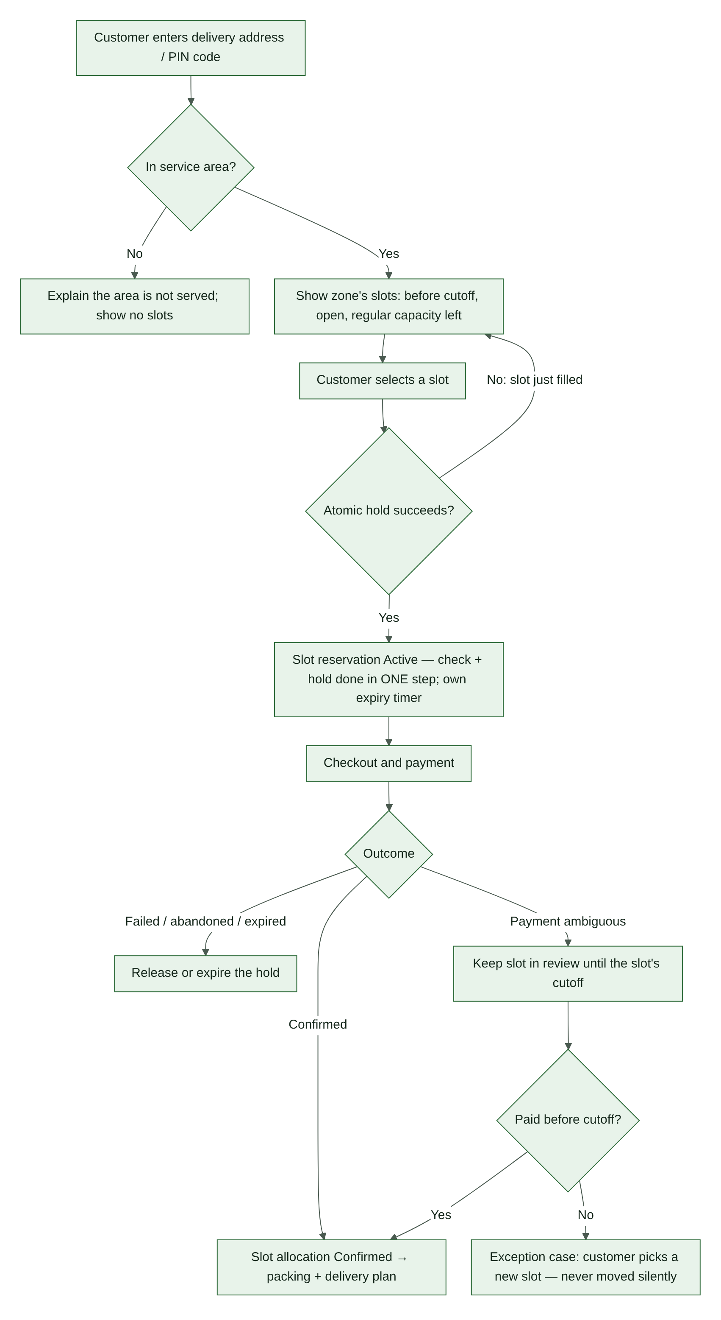
Figure 15. Delivery slot booking (reviewed version of the owner-supplied diagram)
- Check the PIN code first. Customers outside the service area see a clear message and no slots.
- Show only slots that are open, before their cutoff (OD-04), inside the booking window (OD-58), and with regular capacity left. Regular capacity = total − protected subscription capacity.
- When the customer selects a slot, check capacity and create the hold as one atomic step (L1). If the slot has just filled, refresh the list.
- The hold has its own expiry, separate from the stock hold (DL-07).
- Outcomes: confirmed → allocation Confirmed (L2) and included in the packing and delivery plan; failed, abandoned or expired → released (L3, L4); payment ambiguous → held until the slot's cutoff (L5). If unresolved by then, an exception case lets the customer pick a new slot. A customer is never moved silently.
- Rescheduling before cutoff holds the new slot first, then releases the old one (L9).
- If staff reduce a slot's capacity below what is already allocated, the overflow orders open slot_capacity cases.

Differences from the owner-supplied slot diagram: (1) the service-area check now comes before slots are shown, not after a slot is picked. (2) The capacity check and the hold are now one atomic step. As drawn, two customers could both see the last place free and both book it. (3) The ambiguous-payment path, rescheduling and capacity reductions were added.

12.7 Subscription delivery cycle
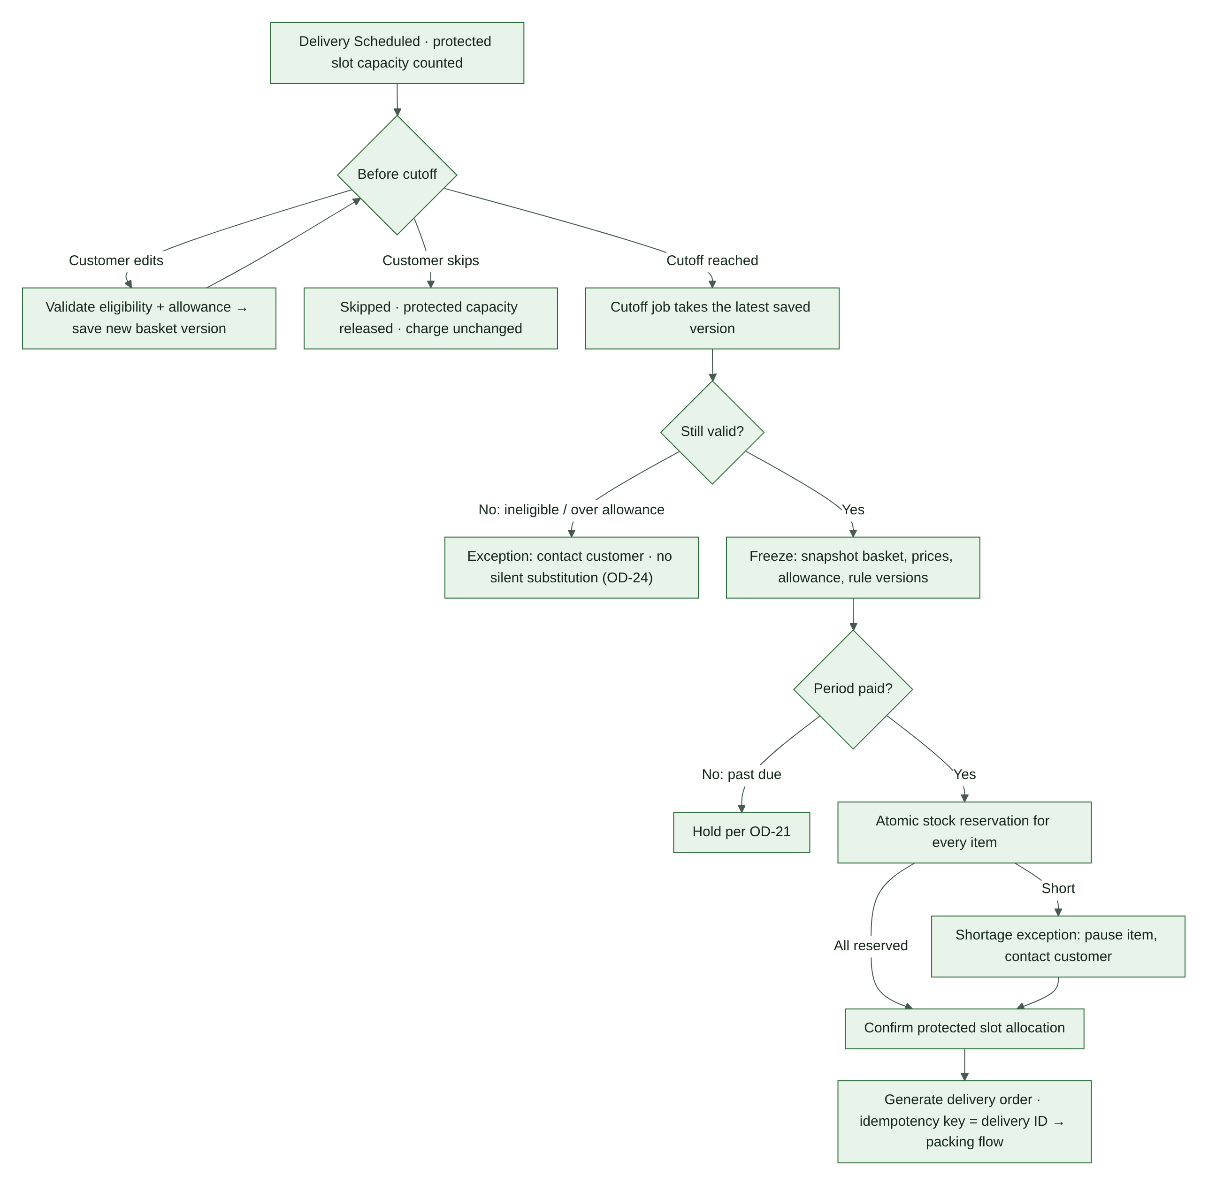
Figure 16. Subscription delivery cycle
- Each delivery of an Active subscription is Scheduled (V1), and its protected slot capacity is counted.
- Before the cutoff the customer may edit the basket. Each save is validated for eligibility and allowance and stored as a new version. The customer may also skip the delivery (V2) — the charge is unchanged (SB-14).
- At cutoff, a job takes the latest saved version, or the last saved basket if no edit was made (SB-10).
- If the basket is no longer valid — ineligible item, or over the allowance at current prices — open an exception and contact the customer (OD-24, V5). Never substitute silently.
- Freeze the basket: snapshot items, prices, allowance and rule versions (V4).
- If the billing period is not paid, follow OD-21.
- Reserve stock atomically for every item. A short item opens a shortage exception (pause the item, contact the customer — DL-10).
- Confirm the protected slot allocation.
- Generate the delivery order with idempotency key = delivery ID (V8), linked to the subscription and period. Its order value follows OD-32. The order then follows the normal packing and delivery flow.

12.8 Renewal and retries
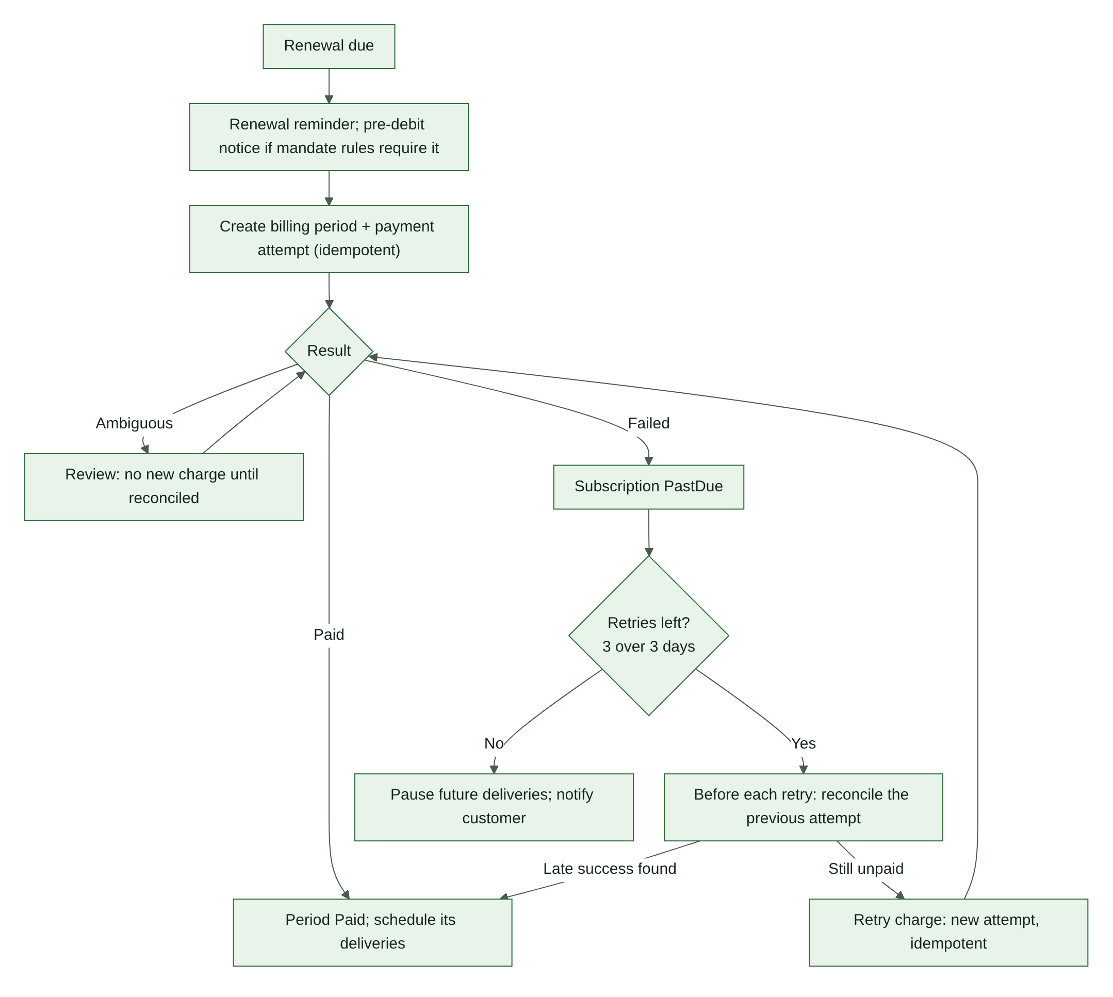
Figure 17. Renewal and retries
- Send the renewal reminder. If the mandate rules for the chosen gateway require a pre-debit notice, send it within the required time (verify in Phase 1, OD-11).
- Create the billing period and payment attempt idempotently (key = period ID + attempt number).
- Paid → schedule the period's deliveries.
- Ambiguous → review; no new charge until reconciled.
- Failed → subscription PastDue (S3). Retry up to three times over three days (SB-13); counting and spacing per OD-22.
- Before each retry, reconcile the previous attempt. If a late success is found, stop retrying.
- Retries exhausted → pause future deliveries and notify the customer (S5).

12.9 Packing and shortage
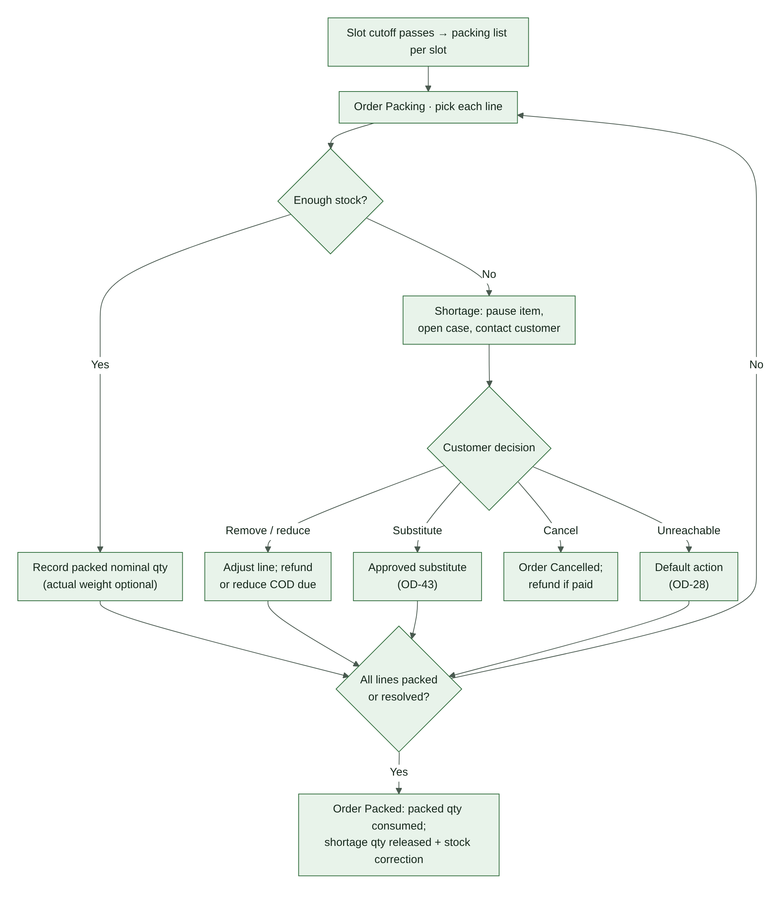
Figure 18. Packing and shortage handling
- When a slot's cutoff passes, generate its packing list. The list includes order reference, delivery date and slot, product and SKU, selling unit, quantity, channel label, customer instructions and an exception indicator.
- Order → Packing (O7). Pick each line and record the packed nominal quantity. Record actual weight if measured (IN-07). Apply the under-weight rule (OD-57).
- A line cannot be filled → record the shortage, pause that item, open a stock_shortage case and contact the customer (DL-10).
- Customer decision: remove or reduce the item (refund the difference, or reduce the COD amount due); an approved substitute (OD-43); or cancel the order (O10). If the customer cannot be reached before dispatch, apply the approved default action (OD-28).
- When every line is packed or resolved → order Packed (O9). The packed quantity is consumed (R11); the shortage quantity is released and a shortage_correction movement fixes on-hand (R12, §13.4).

12.10 Delivery and failed delivery
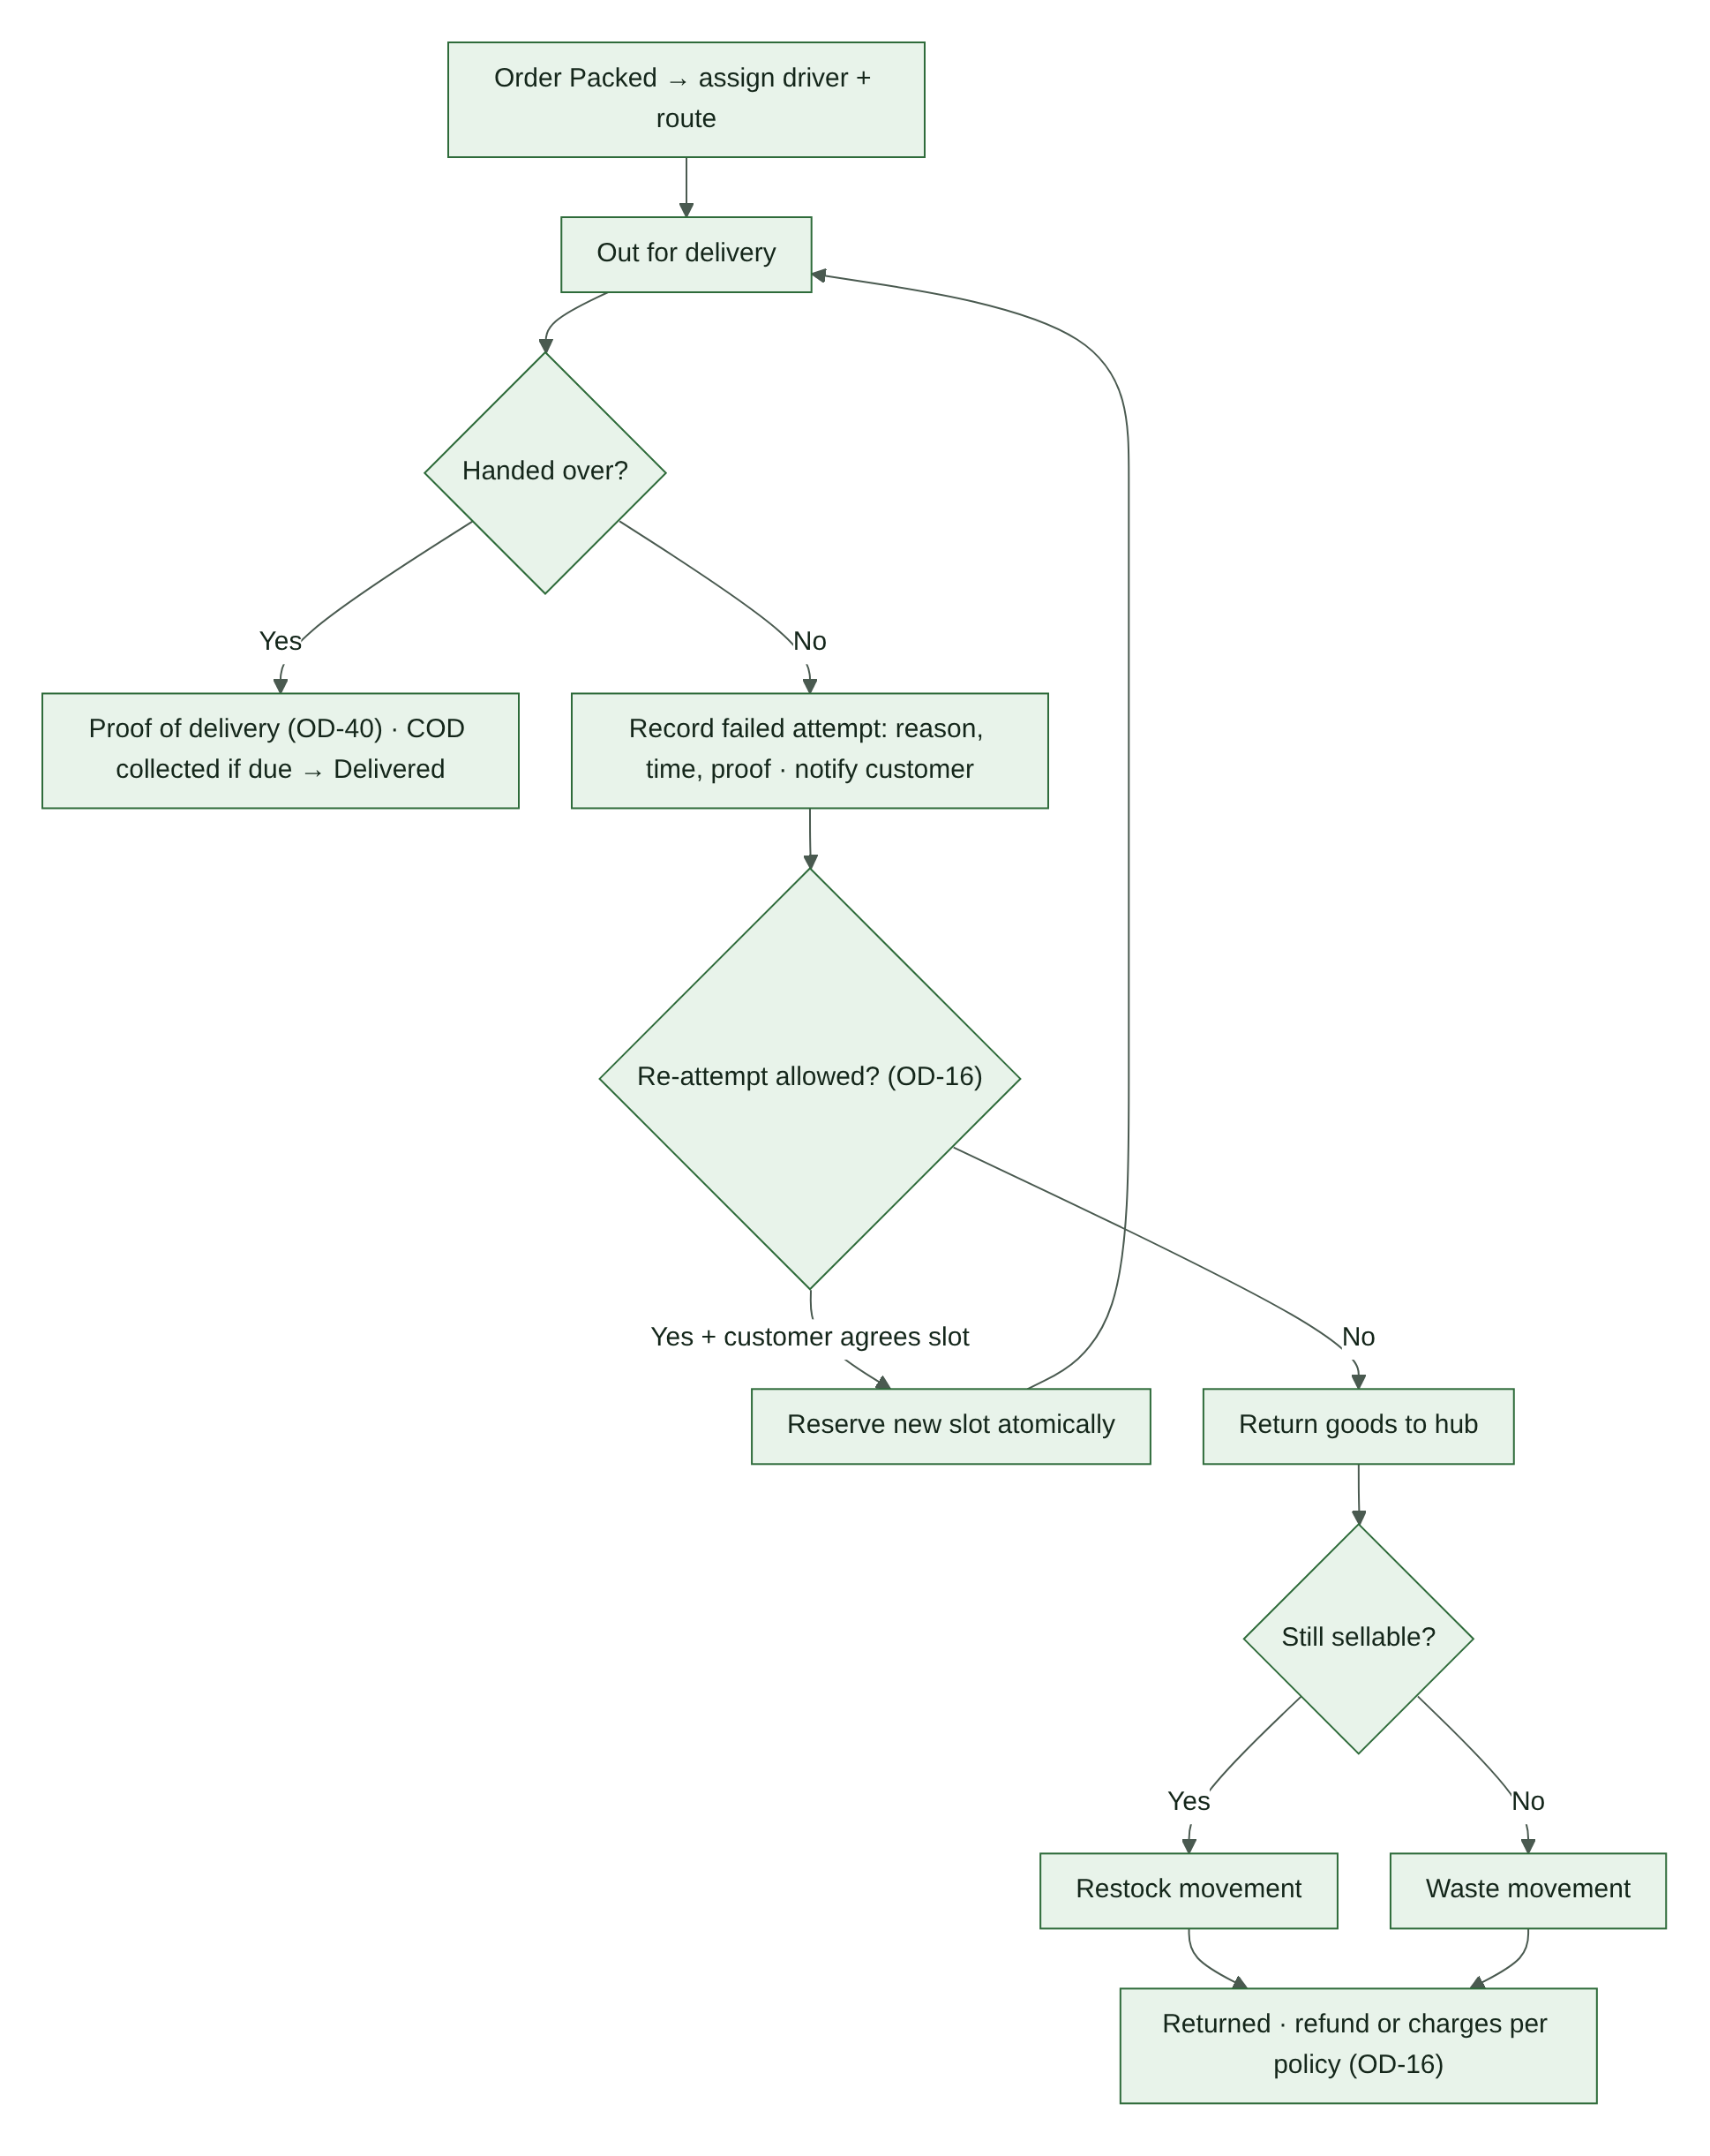
Figure 19. Delivery and failed delivery
- Assign a driver and route; dispatch (O11).
- Handover → capture proof of delivery (OD-40) and any COD collection → Delivered (O12).
- No handover → record the reason, time and proof; notify the customer; open a delivery_failed case (O13).
- If policy allows a re-attempt (OD-16) and the customer agrees a slot, hold the new slot atomically and dispatch again (O14).
- Otherwise return the goods to the hub (O15). If still sellable → return_restock movement; if not → waste movement. Refunds or charges follow OD-16.

12.11 Cancellation
- A customer may cancel before packing, subject to policy (CP-15). Staff may cancel with a recorded reason.
- Release every unconsumed stock and slot hold (R12, L9).
- If any payment is Paid, open a system refund request (F1). It is auto-approved only if OD-38 allows it.
- Cancellation after packing is not self-service. It goes through the shortage or failed-delivery paths, or a staff decision with a reason.

12.12 Refund request
- The customer requests a refund from the order page within the refund window (OD-37): items, reason and optional photo. System-initiated requests are created automatically (F1).
- Support reviews it under the published policy (CP-14), then approves a full or partial amount or rejects it with a reason (F5, F6).
- Approved refunds become refund transactions (F7): through the gateway for online payments; through the method chosen in OD-39 for COD and bank transfer.
- Completed refunds update the payment state (P10, P12) and produce a credit note where applicable (OR-03). Failed refunds are retried or resolved manually (F9–F12).

12.13 Manual stock adjustment and stocktake
- Staff enter product, quantity, unit, reason and actor (§13.6). Timestamp is automatic.
- The screen shows on-hand, reserved and available separately, and warns if available would go negative.
- Adjustments above a configured size need approval (approved_by).
- Each adjustment writes an InventoryMovement and an AuditEvent. Balances are never overwritten.
- A periodic stocktake compares counted with on-hand and posts stocktake_correction movements.

12.14 Wholesale quote (skeleton — OD-14)
- A customer requests a quote for quantities or terms outside the published tiers.
- Staff with quote permission set prices per line, a validity date and a reason; approval is recorded.
- The customer accepts within the validity period; the quote converts into an order at the quoted prices, recorded as an override with actor, reason, amount, approval and expiry (§8.4).
- Expired quotes cannot be converted.

12.15 Customer reports a debit after a failed-looking payment (CP-16)
- Support opens a reported_debit case. The customer is not asked to pay again yet.
- Finance looks up the attempt with the gateway and checks settlement records (P9).
- Money received → payment Paid. Then: order confirmed if stock and slot can be secured, or refunded if not.
- Money not received → share the result of the check with the customer, pass on the gateway's guidance on how and when an unsettled debit is reversed, then offer a new attempt.

13. Inventory Ledger and Reservations

13.1 Availability formula
available_quantity = on_hand_quantity − active_reserved_quantity
Quantities are expressed in the product's canonical base unit. "Active" means Active, Extended, Confirmed or ReviewRequired with an unexpired hold (§11.3). Expiry is enforced at read time (§7.5).

13.2 Atomic reservation
Stock availability check and reservation creation must be atomic or use an equivalent concurrency-safe mechanism. A read-then-write sequence without locking or a conditional update is not sufficient. A checkout reserves all its lines together or none of them.

13.3 Reservation timeout
- Default unpaid reservation timeout: 15 minutes (CP-10), CONFIGURABLE.
- The expiry worker must be recoverable and monitored.
- An expired reservation must not be reactivated blindly.
- A late successful payment after expiry enters reconciliation and must verify stock before fulfilment (§12.5).
- (v2) Extensions follow R2 only: online payment near expiry (OD-34), bank transfer (OD-25), or staff with a reason.

13.4 Stock movements
Record movements for: initial stock; manual restock; fulfilment deduction (reservation consumption); waste and shrinkage; stocktake correction; cancellation and return adjustment; authorized correction; (v2) shortage correction; (v2) return restock. Use idempotency keys so repeated job or callback execution never creates duplicate movements.
(v2) Shortage correction: if a confirmed line cannot be packed, the stock record said the goods existed but they did not. The unfilled quantity is released from the reservation (R12), and a shortage_correction movement reduces on-hand by the same amount, so the ledger matches the shelf.

13.5 Nominal pack deduction
If a 1 kg pack is selected, deduct 1 kg from the stock ledger even if the actual packed weight is 1.08 kg. Record actual packed weight separately if measured. Track variance and adjust stock through an explicit operational movement where appropriate. Do not alter the customer price because of actual packed weight. (v2) Packs below the stated weight follow OD-57 (LG-04).

13.6 Manual stock updates
- Require a quantity, unit, reason, actor, and timestamp.
- Show on-hand, reserved, and available quantities separately.
- Warn before an adjustment would make available stock negative.
- Keep history; do not silently overwrite inventory balances.
- Provide a stock reconciliation workflow (§12.13).

13.7 Returns and failed deliveries (v2)
Goods returned after a failed delivery are inspected. Sellable goods get a return_restock movement; unsellable goods get a waste movement (O15). Neither changes the customer's refund automatically; refunds follow OD-16.

13.8 WooCommerce's own stock settings (v2)
WooCommerce has its own stock counts and its own "hold stock" timer for unpaid orders. Two independent stock systems must never both decide availability (RK-05).
RECOMMENDATION: the Greenbasket ledger is the only authority. WooCommerce stock management is either switched off for these products, or updated one way from the ledger for display only. WooCommerce's unpaid-order hold must not cancel orders on a different timer from the reservation timeout. The final choice is made in Phase 1, after the Phase 0 audit records the current settings (Appendix C, C16).

14. Subscription Scheduling and Billing

14.1 Separate billing period from delivery order
A subscription period is a billing record. A delivery instance is a fulfilment record. They must be separate entities.
For monthly billing + weekly delivery:
- one subscription billing period;
- one monthly charge, subject to gateway and authorization rules;
- multiple separate weekly delivery records and orders;
- each delivery links to the same period;
- no additional recurring charge per delivery.

(v2) How delivery charges, the period length and the number of deliveries per period work with this rule is OD-20.

14.2 Basket edit workflow
- Load the current saved basket version.
- Allow the customer to edit eligible products, units and quantities.
- Validate the product allowance.
- Save a new version.
- At cutoff, freeze the appropriate version.
- If the cutoff is missed, use the last saved basket.
- Validate stock and protected slot capacity.
- Generate the delivery order.
- Preserve the snapshot and resolution history.

The full cycle is in §12.7.

14.3 Subscription status
Statuses: pending_setup, active, past_due, paused, cancel_pending, cancelled, completed. Transitions are S1–S10 (§11.5). Do not move a subscription to active unless the required payment authorization or setup has succeeded.

14.4 Renewal retries
- Retry up to three times over three days.
- After retries are exhausted, pause future deliveries and notify the customer.
- Decide before implementation whether the first failed attempt counts toward the three retries (OD-22).
- Retry scheduling is idempotent.
- Reconcile any late gateway success before starting another charge.
- Confirm the gateway's recurring payment capability and applicable Indian rules before launch (OD-11). (v2) These include e-mandate rules on pre-debit notification and on transaction amounts above which the customer must authenticate again, plus card tokenisation. Verify with the gateway in Phase 1 how they apply to weekly billing and to the retry schedule.

14.5 Skip, pause and cancel
- Skip applies to one scheduled delivery (V2).
- Pause affects future scheduling from its effective date (S6, OD-46).
- Cancellation stops future obligations according to published terms (S8, S9, OD-47).
- Skipping a weekly delivery within a monthly plan does not automatically reduce monthly billing.
- Preserve historical periods, orders, charges, and basket snapshots.

14.6 Subscription shortage
- Flag the affected line or item.
- Create an exception case.
- Contact the customer.
- Pause the affected item until it is resolved.
- Do not silently substitute or charge a different amount.
- Record customer approval and the final resolution.
- Apply any billing or credit decision only according to an approved published policy.

15. Delivery Slots and Fulfilment

15.1 Delivery configuration
Setting | Status | Value
Service area | CONFIRMED | Chandigarh, Mohali, Panchkula; exact PIN codes OD-27
Hours | CONFIRMED | 6 AM to 10 PM; meaning OD-31
Days | CONFIRMED | Monday through Sunday
Slot duration | OPEN DECISION | OD-05
Slot capacity and capacity unit | OPEN DECISION | Per date and slot (OD-05); unit OD-42
Cutoff | OPEN DECISION | OD-04
Booking window | OPEN DECISION | OD-58
Subscription capacity | CONFIRMED | Protected before regular orders use remaining capacity

15.2 Slot reservation
- Reserve slot capacity at checkout (L1).
- A temporary slot hold has its own expiry, separate from the stock reservation.
- Confirm the slot with order confirmation (L2).
- Release on checkout expiry, confirmed failure, or cancellation when appropriate.
- Use concurrency-safe capacity checks; never allow negative available capacity.
- (v2) The check and the hold are one atomic step (§12.6).

15.3 Protected subscription capacity
- The scheduler calculates future scheduled subscription deliveries.
- Protected capacity is allocated before remaining capacity is shown to regular orders.
- Paused, skipped, or cancelled deliveries release capacity according to cutoff rules.
- If slot capacity cannot be honoured, create an exception and do not silently move a customer to a different slot.

15.4 Packing and delivery
The packing list includes: order reference; delivery date and slot; product and SKU; selling unit; quantity; channel label; customer instructions; shortage and exception indicator.
Delivery workflow: packing assigned; items picked; shortages recorded; packed; delivery assigned; out for delivery; delivered, failed or returned; proof and timestamp stored where applicable. Details are in §12.9 and §12.10.
A mixed cart remains one customer order. Group lines for packing where useful, but do not create separate orders only because the channel label differs.

15.5 Driver view (v2)
Drivers see only their assigned deliveries (§22.1): address, slot, contact method, COD amount due, delivery instructions. They record proof of delivery, COD collection, and failed-attempt reasons. The view must work on a phone over mobile data.

16. Payments

16.1 Methods
Method | Summary
Online | Through the selected gateway (OD-10). Confirmed only by verified server-side result (§12.1, §12.2).
COD | For eligible orders only (OD-06). Confirmed by the COD rule (OD-49); paid at collection (§12.3).
Bank transfer | Order waits for verified credit within the transfer window (OD-25); not packed before verification except by authorized exception (§12.4).

16.2 Core rules
- A gateway redirect or browser success page is not proof of payment. Verify by server-to-server callback with signature, or by gateway status lookup.
- An ambiguous transaction remains pending or review-required until reconciled (CP-07).
- A payment callback must not create duplicate payment processing or duplicate orders (CP-08).
- Do not prompt a second payment while the first attempt is ambiguous.
- If a customer reports a debit after a failed-looking payment, reconcile before asking them to pay again (CP-16, §12.15).
- A successful payment after reservation expiry enters review; do not dispatch until payment and stock are reconciled (CP-11).
- Never charge an amount different from the snapshot the customer confirmed.

16.3 Payment states
Payment states and transitions are P1–P15 (§11.2): pending, authorized (if supported), paid, failed, voided, review_required, partially_refunded, refunded, disputed.

16.4 COD controls (v2)
COD eligibility is decided on the server and is never shown as available when the rules fail. The amount due at the door always comes from the server, after any shortage adjustment. Cash handover and variance follow §24.4.

16.5 Bank-transfer controls (v2)
Every bank-transfer order has a unique reference. Verification records the bank reference, amount received and verifier. Underpayments and overpayments open a payment_review case. Packing before verification needs an approver and a reason (CP-09).

16.6 Gateway selection criteria
Before selecting a provider, verify and cite current documentation for:
- WordPress and WooCommerce compatibility, including the order storage mode and checkout type in use;
- supported payment methods in India (UPI, cards, net banking, wallets);
- reliable signed, server-verified callbacks;
- transaction lookup and reconciliation, with settlement reports;
- refunds, including partial refunds, through the API;
- recurring-payment and token or mandate support for subscriptions, including weekly frequency, retries and pre-debit notification handling (OD-11);
- authorization and later capture, if OD-36 is wanted;
- handling of delayed or ambiguous payment results;
- documented retry and idempotency behaviour;
- dispute and chargeback process;
- a test or sandbox mode for Phase 3;
- fees, settlement timing, support, and compliance requirements;
- (v2) onboarding requirements: KYC documents and website readiness checks (LG-08).

Do not select a gateway solely because it supports one-time checkout.

16.7 Refunds and disputes
Refunds follow the refund lifecycle (§11.7, §12.12). Disputes follow P13–P15 with their response deadlines tracked. Refund requests are reviewed by support under the published policy; there is no self-service refund approval (CP-14).

16.8 Duplicate payments (v2)
If a customer pays twice for one order — for example in two browser tabs, or by retrying a UPI payment — the second Paid attempt goes to ReviewRequired and a duplicate_payment case opens. After verification, the duplicate amount is refunded through a system refund request (F1).

16.9 What is never stored
Card numbers (PAN), CVV, UPI PINs, net-banking credentials. Only gateway references and tokens the gateway issues are stored (§22).

17. Notifications and Integrations

17.1 Channels
Email; WhatsApp; SMS; push notifications if the chosen website or app capability supports them (OD-15).

17.2 Events
Event | Type (RECOMMENDATION) | Trigger
Order confirmation and status updates | Transactional | O2, O7–O15
Payment confirmation, failure, under review | Transactional | P1, P5, P6
Delivery reminder | Transactional | Before the slot (timing CONFIGURABLE)
Out for delivery, delivered, delivery failed | Transactional | O11, O12, O13
Shortage exception | Transactional | Stock_shortage case
Refund status | Transactional | F5, F6, F8
Subscription basket cutoff reminder | Transactional | Before the cutoff
Subscription renewal reminder and pre-debit notice | Transactional (pre-debit notice may be mandatory under mandate rules) | §12.8
Failed renewal and pause | Transactional | S3, S5
Back in stock | On customer request only | Customer asked to be told
Abandoned cart | Marketing — consent required | Checkout abandoned
Reorder reminder | Marketing — consent required | Configured interval
Promotional offers | Marketing — consent required | Campaign

Classify each message with LG-06 before launch.

17.3 Event processing
Each event or job includes: unique event ID; source order, subscription or product reference; event time; recipient and channel; processing status; attempt count; next retry time; provider reference; last error.
Rules:
- notifications are asynchronous where practical;
- notification failure must not roll back an order or payment (NA-05);
- retry safely without sending duplicates;
- use consent and opt-out controls for marketing (NA-04);
- do not log secrets or unnecessary personal data.

17.4 Consent and provider requirements (v2)
- Marketing messages are sent only to customers with a granted ConsentRecord for that channel. Every marketing message carries an opt-out.
- SMS uses DLT-registered sender IDs and templates; WhatsApp uses approved templates and opt-in rules (LG-09).
- Transactional email is sent through an authenticated sending service from the business domain (§21.4).

17.5 Analytics
- GA4 ecommerce events and Google Search Console (§25.3).
- Analytics must not be used as the financial source of truth.
- Do not send payment credentials or unnecessary sensitive customer data to analytics.

PART D — EXPERIENCE

18. Brand and Design System
A design system is the set of rules and parts that make every page look and behave like one brand. It is defined once and reused everywhere, so a change — a new brand colour, a larger button — is made in one place. Everything in this section is a RECOMMENDATION until the owner approves it. Actual colours, fonts and imagery are owner decisions (OD-52).

18.1 Brand foundations
- Logo set: primary logo, compact icon (for the browser tab and social media), and a single-colour version.
- Name usage: how "Greenbasket" is written and capitalised everywhere.
- Voice and tone: for example friendly, plain and trustworthy. Short sentences, no jargon, honest about delays and shortages.
- Brand colours: one primary and one secondary colour, chosen with contrast in mind (§18.2).

18.2 Design tokens
Define each token once in the theme's global settings and reuse it. Do not hard-code values in pages or templates.
Token group | Tokens to define | Rules
Colour | Brand primary and secondary; neutral scale; text; background; surface; border; success; warning; error; info; focus outline | Body text contrast ≥ 4.5:1; large text and interface parts ≥ 3:1 (WCAG AA)
Channel colours | Retail, Farm Box, Wholesale, Subscription badges | Never the only signal; always paired with a text label
Typography | At most two font families; sizes for display, H1–H4, body, small, price; line heights; weights | Body text at least 16 px on mobile; fonts load fast and support ₹
Spacing | One spacing scale used for all gaps and padding | Consistent rhythm across pages
Shape | Corner radius; border widths; shadows | Same values on all cards, buttons and inputs
Layout | Breakpoints for mobile, tablet, desktop; content width | Mobile-first (§19.5)
Motion | Durations and easing | Respect the "reduced motion" setting

18.3 Component inventory
Component | Used in | Variants and states
Button | Everywhere | Primary, secondary, text, destructive; hover, focus, disabled, loading
Product card | Listings, Farm Box | Image, name, unit selector, price, badges, add-to-cart; out of stock
Selling-unit selector | Product page, cards | Pack, piece, bunch; unavailable unit disabled
Quantity stepper | Cart, product, Farm Box, wholesale | Respects min, max and increment (§8.4); error message when invalid
Price display | Everywhere | Retail; wholesale tier table with the tier that applies highlighted; promotional price
Channel badge | Cart lines, orders, packing list | Retail, Farm Box, Wholesale, Subscription
Stock badge | Cards, product page | In stock, low, out of stock
Farm Box panel | Farm Box builder | Running total; save basket; add to cart
Allowance meter | Subscription basket | Used versus allowance; blocks saving when over (SB-07)
Delivery-area checker | Header, checkout | PIN-code input; in-area or not-served message
Slot picker | Checkout, subscription, reschedule | Date tabs; slot cards with availability; disabled after cutoff; "just filled" refresh
Price-lock notice | Checkout | Remaining time; "prices changed — please confirm" dialog (CP-13)
Payment method selector | Checkout | COD shown only when eligible; bank-transfer instructions
Payment status page | After payment | Confirmed; failed with retry; "being verified — do not pay again"
Order timeline | Account, tracking | Every order state in §11.1
Alerts and toasts | Everywhere | Success, warning, error, info
Forms | Checkout, account | Labels, help text, inline errors
Dialogs, empty states, loading skeletons | Everywhere | —
Staff components | Staff screens (§19.11) | Packing row, shortage dialog, review queue row, driver delivery card

18.4 Imagery and icons
- Product photos follow one style: same background, lighting, angle and aspect ratio (§20.3).
- One icon set with consistent stroke and corner style.
- Every meaningful image has alt text. Decorative images are marked decorative.

18.5 Microcopy
Standard messages for the situations customers meet most — written once and reused:
- price changed since checkout started;
- slot just filled;
- payment being verified (never ask to pay again);
- payment failed — try again;
- over subscription allowance;
- below wholesale minimum or not in the right increment;
- outside the delivery area;
- item short — we will contact you.

Each pricing error code (§10.11) maps to one of these messages.

18.6 Implementation on WordPress
Set colour and typography tokens once in Blocksy's global settings and Elementor's site-wide global colours and fonts. Extension screens read the same tokens through shared CSS variables. Verify each capability on the installed versions in Phase 1 before relying on it.

18.7 Deliverables and acceptance
Track B produces a brand sheet, token sheet and component sheet. The owner approves all three before the Phase 3 frontend build (AC-UX-01).

19. Frontend and Shopper Experience

19.1 Principles
- Mobile first. Most shoppers will use phones. Design the phone layout first.
- The server is the truth. The page never calculates the final price, stock or slot availability; it shows what the server returns.
- Clear over clever. One primary action per screen; plain language.
- Accessible. WCAG 2.2 AA target (OD-53).
- Fast on mobile data (§19.7).

19.2 Sitemap
Page | Purpose
Home | What Greenbasket is; entry to the four experiences; delivery-area checker
Shop (Retail) category and listing | Browse retail products
Product page | Units, price, availability, description, storage tips
Farm Box builder | Pick eligible items with a running total; save or add to cart
My saved Farm Boxes | Reuse, edit, delete saved baskets
Wholesale | Catalogue with tier tables; minimum and increment rules; quote request
Subscriptions | Plans, how allowance and cutoff work, sign-up
Cart | Lines with channel labels; edits; totals from the server
Checkout | Address, slot, payment method, price-lock notice
Payment status and order confirmation | Server-verified result
My Account | Orders, addresses, subscriptions, saved boxes, refund requests, communication preferences
Track order | Status timeline
Delivery areas and slots | PIN codes served, hours, cutoffs
FAQ, About | Trust and explanation
Contact and grievance officer | Seller details and complaint contact (LG-05)
Policies | Privacy, terms, refund and cancellation, delivery, subscription terms, wholesale terms
Search results, 404 | Find products; recover from bad links

19.3 Navigation
The four experiences are top-level menu items. The cart is always visible. The delivery-area checker is available before browsing, so customers outside the area learn early.

19.4 Key shopper journeys
ID | Journey | Steps | Must handle
J1 | Retail purchase | Browse → product → choose unit → add → cart → checkout → pay → confirmation | Unavailable unit; out of stock; price changed after lock
J2 | Build and save a Farm Box | Pick eligible items → running total → add to cart or save → reuse later | Saved items now ineligible, out of stock or repriced — changes shown before checkout
J3 | Wholesale purchase | View tiers → enter quantity → tier applied across lines → checkout | Below minimum; wrong increment; tier changes as quantity changes
J4 | Subscribe | Choose plan and cadence → build basket within allowance → set up payment → active | Over allowance; payment setup fails (stays PendingSetup)
J5 | Manage a subscription | Edit basket before cutoff; skip; pause; resume; cancel; see next charge, next delivery and cutoff countdown | Edit after cutoff blocked; skip does not reduce charge (explained)
J6 | Choose a delivery slot | PIN check → slots → hold → checkout | Outside area; slot just filled; hold expired
J7 | Pay and recover | Pay → result | Failure with retry; ambiguous result shows "being verified" and never asks to pay again
J8 | Track an order | Timeline → out-for-delivery → delivered or failed | Failed delivery with re-attempt options
J9 | Request a refund | Order → items → reason and photo → status | Outside the refund window; partial approval
J10 | Guest checkout | Checkout without an account → optional account afterwards | Saving a Farm Box or subscribing asks for an account (OD-30)

19.5 Mobile requirements
- Tap targets at least 24 × 24 CSS pixels (WCAG 2.2 AA minimum); 44 × 44 recommended for primary actions.
- Sticky "add to cart" and "checkout" buttons on long pages.
- Numeric keypad for quantities, PIN codes and phone numbers.
- No horizontal scrolling; images sized for the screen.

19.6 Accessibility
Target WCAG 2.2 level AA (OD-53): colour contrast; full keyboard use; visible focus; labelled inputs; errors described in text; alt text; no information by colour alone; reduced-motion support; screen-reader announcements when the cart total, price lock or slot availability changes.

19.7 Performance
RECOMMENDATION for OD-59: aim for Google's "good" Core Web Vitals on mobile at the 75th percentile — Largest Contentful Paint ≤ 2.5 s, Interaction to Next Paint ≤ 200 ms, Cumulative Layout Shift ≤ 0.1. Set server response targets (p95) after the Phase 0 measurements. Compress and lazy-load images. Never cache personalised pages (§23.2).

19.8 Trust signals
Delivery area and slot information early; policies linked in the footer and at checkout; seller details and grievance officer (LG-05); FSSAI number if required (LG-03); genuine reviews only (OD-55); security claims only if true.

19.9 Languages
Per OD-51. If more than one language is chosen, every template, message, policy and notification needs each language before launch.

19.10 Customer account
Implements §8.11: orders, addresses, subscriptions, saved Farm Boxes, refund requests, communication preferences, account deletion request.

19.11 Staff screens
Screen | Must show and do
Packing list | By date and slot; lines with unit, quantity, channel, instructions; record packed quantity and actual weight; raise a shortage
Shortage handling | Contact details; customer decision; default action after the deadline (OD-28)
Delivery assignment | Orders per slot; assign driver and route; dispatch
Driver view | Assigned deliveries only; proof of delivery; COD collection; failed-attempt reason (§15.5)
Review queues | Payment review, late payment, refunds, disputes, failed deliveries, COD variance — oldest first, with response targets
Stock screen | On-hand, reserved, available; adjustments with reason (§12.13)
Slot capacity | Create slots; set capacity and protected capacity; see allocations; warn before reducing below allocations
Price and tier management | Versioned price rules and tiers; audit trail

19.12 Deliverables and acceptance
Wireframes for J1–J10 and the staff screens are approved by the owner before the Phase 3 build (AC-UX-02). Before launch, at least five real customers place test orders on their own phones (AC-UX-05).

20. Content and Catalogue

20.1 Product data sheet
A spreadsheet, completed before Phase 2, with one row per selling unit:
SKU; product name; category and sub-category; base unit; selling unit name; nominal quantity; conversion to base unit; retail price; channel eligibility (Retail, Farm Box, Wholesale, Subscription); minimum, maximum and increment per channel; wholesale tiers if any; tax class (from the CA); origin; storage tips; shelf life; short description; long description; image file name; alt text; search keywords; active status.

20.2 Categories
The owner defines the category structure before Phase 2. Example only: vegetables; fruits; leafy greens and herbs; exotic produce.

20.3 Photography specification
- One main photo per product and, where useful, a pack-size photo.
- Same background, light, angle and aspect ratio for all products. RECOMMENDATION: square (1:1), at least 1200 × 1200 px source size.
- Files named by SKU; served in a modern compressed format with a fallback.
- The source of photos is OD-60.

20.4 Copy
Product descriptions; explainer pages for Farm Box, wholesale tiers and subscriptions (allowance, cutoff, skip, pause, cancel, retries); FAQ; About; delivery areas; contact and grievance details; all policy texts (LG-07).

20.5 Ownership and updates
The catalogue manager role maintains products, prices and content. Price changes are new price-rule versions, never overwrites. Stock is updated by staff through the stock screen.

20.6 Acceptance
The launch catalogue is complete in the data sheet; every product has a photo, alt text, description and verified unit conversion; every policy page is approved by the owner (AC-CNT-01 to AC-CNT-03).

PART E — PLATFORM AND OPERATIONS

21. Hosting, Domain and Environments

21.1 Current assets
The domain and Hostinger hosting are purchased (CONFIRMED). The plan's resources, backups, PHP and database versions, and staging arrangement are NOT VERIFIED until Phase 0 (Appendix C).

21.2 Environments
Environment | Requirements
Production | The live site. No testing, no experiments, no load tests. Changes arrive only through the deployment process below.
Staging | Separate files and separate database. Payment gateway in test mode only; outbound email, WhatsApp and SMS disabled or captured; no real customer data, or anonymised data only; hidden from search engines and password-protected; analytics off.
Local (optional) | A developer's own copy for building the extension.

Deployment process (mechanics fixed in Phase 1):
- Build and test on staging.
- Take and verify a production backup.
- Deploy the approved change.
- Run smoke tests.
- Keep the rollback ready; record everything in the implementation log.

21.3 Domain, DNS and HTTPS
- The registrar account is owned by the business, with two-factor login.
- DNS records are documented.
- HTTPS is active and forced on every page; one canonical host (with or without "www").
- Strict-Transport-Security is added only after HTTPS is verified everywhere.

21.4 Email
- Business mailboxes on the domain.
- Order and account emails are sent through an authenticated sending service, not the server's default mail function, which often lands in spam.
- SPF, DKIM and DMARC records are published and pass.
- From and reply-to addresses are set; deliverability is tested in Phase 6.

21.5 Scheduled jobs
A server cron triggers WordPress jobs at a fixed interval. Visit-triggered scheduling is switched off only after the server cron is verified. Job lag is monitored (§7.5, §23.3).

21.6 Backups and recovery
Backups cover files and the database, are stored off the server, and are restore-tested. A 15-minute RPO (RL-04) needs point-in-time database recovery or very frequent database backups; daily backups cannot meet it. Details are in §23.4.

21.7 Capacity
Phase 0 records the plan's limits and usage (Appendix C, C11–C13). Phase 1 decides whether the plan meets RL-01 to RL-04 — or whether a different plan or host is needed (OD-13). Load testing needs the host's permission and must never run against production.

21.8 Access and ownership
- The owner holds the master accounts: registrar, hosting, WordPress administrator, payment gateway, Google, messaging providers. Each has two-factor login.
- Staff get named accounts with the least access their role needs (§22.1).
- Credentials are never shared in chat, email or documents.
- Access is reviewed at each phase gate and when someone leaves.

22. Security and Access

22.1 Roles
Role | Access
Administrator | Everything; very few people
Catalogue manager | Products, selling units, price rules, tiers, content
Order manager | Orders, slots, review queues for orders, cancellations
Packing staff | Packing lists and shortage recording; cannot alter payment credentials or price rules
Delivery staff | Assigned deliveries only; proof of delivery; COD collection
Customer support | Cases, customer contact, refund requests; cannot silently erase payment or stock history
Finance and reconciliation | Payment review, bank-transfer verification, refunds, COD reconciliation, disputes

Least privilege applies everywhere:
- price overrides and stock adjustments require permission and a reason;
- refunds follow the configured approval workflow;
- every critical action is audited.

22.2 Application security requirements
- Server-side validation of price, quantity, stock, discount, and state transitions.
- Protected payment callbacks: signature verification and idempotency (§12.2).
- Secrets stored outside public code and outside the repository.
- No raw card PAN or CVV stored.
- Audit logs for critical actions.
- Staging isolation (§21.2).
- Backups and restoration tests.
- Access control for customer and financial data.
- (v2) Rate limits on public endpoints that check stock, slots or PIN codes, so they cannot be abused or scraped.

22.3 WordPress hardening (v2)
- Two-factor login for every administrator and every staff account with elevated access.
- Named accounts only; no shared logins; as few administrators as possible.
- WordPress core, theme and plugins kept updated — tested on staging first (§28.3).
- Unused plugins and themes removed; software installed only from reputable sources.
- File editing from the WordPress dashboard disabled.
- Login attempt limits.
- A web application firewall and malware scanning. The capability is required; the product choice waits for Phase 1 (rule 2).
- Least-privilege database user; secure cookies; HTTPS only.
- Backups encrypted and stored off the server.

22.4 Personal data (v2)
- Collect only what is needed. Mask personal data in logs.
- Customer payout details (for COD refunds — OD-39) are sensitive and deleted after the refund completes.
- Consent records and retention follow OD-17 and LG-06.
- Customer and financial data are visible only to roles that need them; access is logged.

22.5 Incident response (v2)
A one-page runbook, written in Phase 6:
- who to call;
- how to put the site into maintenance mode;
- how to rotate keys and passwords;
- how to restore from backup;
- what to record;
- whom to notify under applicable law.

23. Performance, Observability and Recovery

23.1 Load targets
- Up to 500 orders a day (RL-01); 50 concurrent shoppers initially (RL-02).
- Actual performance must be measured on staging.
- Define acceptable p95 response times and error rates after inspecting the hosting environment (OD-59); do not invent them.

23.2 Performance principles
- Cache public product pages and static assets.
- Never put personalised pricing, cart, checkout, stock authority, account pages, or payment state in a shared cache.
- Use database indexes for high-frequency lookups; avoid unbounded queries.
- Process slow integrations asynchronously.
- Monitor scheduled job delays.
- Test concurrent stock and slot reservation.
- Verify the configured WooCommerce order storage mode.
- Use supported APIs and hooks.

23.3 Monitoring
Monitor | Alert goes to (OD-54)
PHP and application errors | Developer
Database errors and slow queries | Developer
Payment callback failures; reconciliation backlog | Finance + developer
Order confirmation delays | Order manager
Reservation expiry and job lag | Developer
Subscription job failures | Developer + support
Notification queue failures | Developer
Slot capacity inconsistencies | Order manager
Backup completion and restore readiness | Owner + developer
Disk, memory, CPU and hosting resource usage | Developer
Site uptime | Owner + developer
Exception cases past their response target | Case owner role

Alert thresholds are set in Phase 1.

23.4 Recovery targets
- RTO: 2 hours (RL-03). RPO: 15 minutes (RL-04).
- Validate both against the hosting and database arrangement.
- Daily backups alone do not satisfy a 15-minute RPO.
- Recovery must include order, payment reference, inventory movement, reservation, subscription, and delivery records.

23.5 Recovery procedure
- Restore to a controlled environment.
- Verify database and custom table integrity.
- Reconcile payment attempts with the gateway.
- Reconcile stock balances, movements, and active reservations.
- Verify subscription periods and generated delivery orders.
- Run overdue jobs safely with idempotency.
- Resume checkout only after consistency checks pass.

24. Operations and Customer Support

24.1 Daily operating rhythm (RECOMMENDATION)
Exact times depend on OD-04 and OD-05.
- Before each slot's cutoff: clear the payment review and late-payment queues for that slot.
- At cutoff: generate the packing list; subscription cutoff jobs have already frozen baskets and generated orders.
- Packing: pick, record and handle shortages (§12.9).
- Dispatch and delivery (§12.10).
- End of day:
  - COD cash handover and reconciliation;
  - payment and settlement reconciliation;
  - review of stock variance and shortage corrections;
  - failed-delivery follow-up;
  - refund queue;
  - stock count updates.

24.2 Queues and response targets
Each exception case type (§11.8) has an owner role and a response target (OD-54). Queues are shown oldest first. Cases past their target raise an alert.

24.3 Customer support
- Channels, hours and response targets: OD-54.
- Grievance officer named and published (LG-05).
- Scripts for common situations:
  - debit but failed payment — reconcile before asking to pay again (§12.15);
  - shortage call;
  - failed delivery;
  - subscription skip, pause and cancel;
  - refund status.
- Support tools: support can look up orders and cases but cannot delete payment or stock history.

24.4 COD cash handling
- The driver records each collection (amount, cash or UPI, time).
- At day end, the driver hands over cash against a summary.
- Finance confirms. Any difference opens a cod_variance case.
- Deposits are recorded.

24.5 Records required at launch
Packing lists and item-level fulfilment status; delivery assignment and outcome records; GST-compliant invoice and credit-note records where applicable, after CA validation; staff audit log for price, stock, payment, and order changes (OR-01 to OR-04).

24.6 Exports
Packing lists; delivery manifests per slot; payment and settlement reconciliation; refund register; stock movement report; GST reports after CA validation.

25. Marketing, SEO and Analytics

25.1 SEO foundations
- Unique page titles and meta descriptions.
- Clean, readable URLs.
- Product structured data (schema.org Product and Offer), with prices that always match the page.
- XML sitemap; correct robots rules; canonical URLs; breadcrumbs.
- Image alt text; fast mobile pages (§19.7).
- Cart, checkout, account pages and the whole staging site are never indexed.

25.2 Local SEO
Greenbasket delivers locally, so local search matters most:
- a Google Business Profile set up as a service-area business;
- the same business name, address and phone everywhere;
- a delivery-areas page.

25.3 Analytics
- GA4 ecommerce events: view_item, add_to_cart, begin_checkout, add_payment_info, purchase, refund, with the channel as a parameter.
- Respect consent choices.
- Analytics is never the financial source of truth (§17.5).
- Verify Search Console and submit the sitemap.

25.4 Measures to define before launch
Decide what will be measured before launch, so tracking is in place from the first order. Targets are owner decisions; these are the measures:
- conversion rate and average order value;
- repeat-purchase rate;
- active subscriptions and subscription cancellations;
- Farm Box saved-to-reordered rate;
- wholesale share of revenue;
- slot utilisation and on-time delivery rate;
- shortage rate and refund rate;
- payment success rate.

25.5 Launch marketing (RECOMMENDATION)
The owner plans how the first customers will find Greenbasket. Examples: launch offers; opt-in WhatsApp communities; social media; local flyers; referrals. Every channel must respect consent (§17.4).

PART F — QUALITY AND DELIVERY

26. Acceptance Criteria
The system is not ready for launch until the relevant tests pass. Each criterion lists the requirements, decisions or transitions it verifies. Criteria added in v2.0 are marked (v2).

26.1 Catalogue and pricing
ID | Criterion | Verifies
AC-CAT-01 | Retail pack price does not change with actual packed weight. | RT-02, RT-03
AC-CAT-02 | Nominal stock deduction matches the configured selling-unit conversion. | RT-04, IN-05, IN-06
AC-CAT-03 | Product eligibility and min, max and increment are enforced server-side, including against tampered requests. | §10.2 steps 1–4
AC-CAT-04 | Wholesale quantities for the same product and unit aggregate across lines; the tier rate applies to all qualifying units; line allocations add up to the total. | WS-03, WS-04, §10.5
AC-CAT-05 | Different products or units are never combined without an explicit rule. | §10.5
AC-CAT-06 | A subscription basket above the allowance is blocked. | SB-07
AC-CAT-07 | The price lock expires after 15 minutes; any price change then requires customer confirmation before payment. | CP-12, CP-13
AC-CAT-08 (v2) | Displayed totals always equal charged totals, using the single rounding rule. | §10.9, OD-50
AC-CAT-09 (v2) | Each pricing error returns its reason code and customer message. | §10.11

26.2 Inventory
ID | Criterion | Verifies
AC-INV-01 | Concurrent attempts cannot reserve the same final stock (tested with simultaneous checkouts). | IN-08, R1
AC-INV-02 | An expired reservation releases stock — immediately at read time, even if the expiry job is delayed. | R4, §7.5
AC-INV-03 | A late payment after expiry enters reconciliation and blocks dispatch. | CP-11, R7
AC-INV-04 | A repeated callback or job never duplicates a stock movement. | §13.4
AC-INV-05 | Manual adjustments are auditable with quantity, unit, reason, actor and time. | IN-09, §13.6
AC-INV-06 | Stock and reservation balances reconcile after cancellation, expiry, shortage and return. | R5, R12, §13.7
AC-INV-07 (v2) | A shortage at packing releases the unfilled quantity and posts a shortage correction. | R12, §13.4

26.3 Payments
ID | Criterion | Verifies
AC-PAY-01 | A browser redirect alone never confirms payment. | §16.2
AC-PAY-02 | A duplicate callback does not duplicate processing. | CP-08, §12.2
AC-PAY-03 | An ambiguous transaction is held for review, and the customer is not asked to pay again. | CP-07, P6
AC-PAY-04 | A bank-transfer order cannot enter packing before verification, except with a recorded authorized exception. | CP-09, O7
AC-PAY-05 | A COD order is confirmed only after eligibility and confirmation checks. | OD-06, OD-49
AC-PAY-06 | Refund review and reconciliation are auditable. | CP-14, §11.7
AC-PAY-07 (v2) | An invalid callback signature changes nothing and raises an alert. | §12.2 step 1
AC-PAY-08 (v2) | An amount mismatch moves the payment to review. | P6
AC-PAY-09 (v2) | A reported debit on a failed attempt is reconciled before any new payment request. | CP-16, P9
AC-PAY-10 (v2) | A second Paid attempt on one order triggers duplicate handling and refund. | §16.8
AC-PAY-11 (v2) | Partial refunds can repeat until the paid amount, and refund states are derived only from succeeded refund transactions. | P10–P12
AC-PAY-12 (v2) | COD amount due at the door reflects shortage adjustments; cash variance opens a case. | §12.3, §24.4

26.4 Subscriptions
ID | Criterion | Verifies
AC-SUB-01 | Weekly and monthly combinations schedule correctly. | SB-01 to SB-03
AC-SUB-02 | Monthly billing with weekly delivery creates separate delivery orders linked to one period. | SB-04
AC-SUB-03 | A missed cutoff uses the last saved basket. | SB-10
AC-SUB-04 | A skipped weekly delivery in a monthly plan does not automatically reduce the monthly charge. | SB-14
AC-SUB-05 | The renewal retry policy runs without duplicate charges, reconciling before each retry. | SB-13, §12.8
AC-SUB-06 | Exhausted retries pause future deliveries and notify the customer. | S5
AC-SUB-07 | Basket versions and delivery snapshots are preserved. | SB-15
AC-SUB-08 (v2) | A subscription never becomes Active without the required payment setup. | S1
AC-SUB-09 (v2) | A re-run cutoff job never creates a second delivery order. | V8
AC-SUB-10 (v2) | An invalid frozen basket opens an exception; nothing is substituted silently. | V5, OD-24

26.5 Delivery
ID | Criterion | Verifies
AC-DEL-01 | Slot capacity cannot be exceeded by concurrent checkouts. | DL-06, L1
AC-DEL-02 | A slot hold expires independently from the stock reservation. | DL-07
AC-DEL-03 | Subscription capacity is protected. | DL-09, §15.3
AC-DEL-04 | The delivery cutoff is applied consistently. | DL-08
AC-DEL-05 | A shortage creates a case and pauses the affected item; the order cannot become Packed until resolved. | DL-10, O9
AC-DEL-06 | Packing, dispatch, delivered, failed and return outcomes are recorded. | DL-12
AC-DEL-07 (v2) | Addresses outside the service area see no slots. | §12.6, OD-27
AC-DEL-08 (v2) | Rescheduling holds the new slot before releasing the old one. | L9
AC-DEL-09 (v2) | A failed delivery can be re-attempted in a newly held slot, or returned with a stock disposition. | O13–O15

26.6 Operations and resilience
ID | Criterion | Verifies
AC-OPS-01 | Required packing and delivery records exist. | OR-01, OR-02
AC-OPS-02 | Applicable invoice and credit-note records can be produced after tax validation. | OR-03
AC-OPS-03 | Critical staff changes are audited. | OR-04
AC-OPS-04 | A 50-concurrent-shopper test is run. | RL-02
AC-OPS-05 | A load test reaches the agreed target without unacceptable errors. | RL-01, OD-59
AC-OPS-06 | An RTO and RPO recovery exercise is completed. | RL-03, RL-04
AC-OPS-07 | No unresolved critical or high-severity defects remain at launch. | §27 Phase 6

26.7 State machines (v2)
ID | Criterion | Verifies
AC-SM-01 | Every transition in §11 has at least one passing test. | §11
AC-SM-02 | An attempted transition not listed in §11 is rejected and logged. | §11, §9.7
AC-SM-03 | Every transition writes an audit event in the same database transaction. | §11.9
AC-SM-04 | The cross-machine rules in §11.9 hold under concurrent events. | §11.9

26.8 Business and legal (v2)
ID | Criterion | Verifies
AC-LG-01 | Policy pages, seller details and grievance officer are live and approved. | LG-05, LG-07
AC-LG-02 | FSSAI registration or licence is in place and displayed if required. | LG-03
AC-LG-03 | The gateway is activated in live mode for the business entity. | LG-01, LG-08
AC-LG-04 | SMS and WhatsApp send only registered or approved templates. | LG-09

26.9 Design system and frontend (v2)
ID | Criterion | Verifies
AC-UX-01 | Brand, token and component sheets are approved, and tokens are applied globally (no hard-coded colours). | §18
AC-UX-02 | Wireframes for J1–J10 and the staff screens are approved before the Phase 3 build. | §19.12
AC-UX-03 | Journeys J1–J10 pass on a mid-range Android phone, an iPhone and desktop. | §19.4
AC-UX-04 | Key journeys meet the accessibility target in automated and manual checks. | OD-53
AC-UX-05 | At least five real customers complete test orders on their own phones; issues found are triaged. | §19.12
AC-UX-06 | Performance targets are met on staging mobile tests. | OD-59, §19.7

26.10 Content (v2)
ID | Criterion | Verifies
AC-CNT-01 | The launch catalogue is complete in the product data sheet and imported. | §20.1
AC-CNT-02 | Every product has a photo, alt text, description and verified unit conversion. | §20.3, IN-05
AC-CNT-03 | Every policy and explainer page is approved by the owner. | §20.4

26.11 Platform and security (v2)
ID | Criterion | Verifies
AC-PLT-01 | HTTPS is forced site-wide. | §21.3
AC-PLT-02 | SPF, DKIM and DMARC pass; test order emails arrive in the inbox. | §21.4
AC-PLT-03 | The server cron runs jobs on schedule with nobody visiting the site. | §21.5
AC-PLT-04 | Two-factor login is enforced for administrators and elevated staff. | §22.3
AC-PLT-05 | Staging is isolated: test gateway keys, no live messages, not indexed. | §21.2
AC-PLT-06 | A restore from backup succeeds within the RTO. | RL-03

26.12 Marketing and analytics (v2)
ID | Criterion | Verifies
AC-MKT-01 | GA4 ecommerce events fire correctly and respect consent. | §25.3
AC-MKT-02 | Search Console is verified and the sitemap is submitted. | §25.1
AC-MKT-03 | Structured data validates and its prices match the page. | §25.1
AC-MKT-04 | Marketing messages go only to consenting customers and carry an opt-out. | NA-04, §17.4

27. Phased Implementation Plan
The phases define dependency order. All four shopping experiences are still intended to launch together after the acceptance tests pass (BP-05). Tracks A and B run alongside the main track (§3).
(v2) Sequencing fixes from v1.0:
- Temporary slot holds moved from Phase 5 to Phase 3, because checkout cannot be completed or tested without them.
- The duplicated "protected subscription capacity" task (it appeared in both Phase 4 and Phase 5) now sits only in Phase 4.
- Gateway integration is built and tested in sandbox mode in Phase 3; Phase 6 switches to live credentials.

Track A — Business and legal groundwork
Starts now. Items LG-01 to LG-11 (§5). Gate: LG-01, LG-03, LG-05, LG-07 and LG-08 complete before the live gateway in Phase 6; LG-09 before SMS or WhatsApp.

Track B — Brand, design system and content
Starts after the owner approves this requirements baseline.
- Deliverables: brand sheet; token sheet; component sheet (§18); wireframes for J1–J10 and staff screens (§19); product data sheet (§20.1); photography (§20.3); page and policy copy (§20.4).
- Dependencies: the product data sheet is needed by Phase 2; approved wireframes and components by Phase 3; photos and copy by Phase 6.

Phase 0: Discovery and baseline audit
Do not change site configuration.
Tasks:
- Inspect current WordPress and WooCommerce versions.
- Inspect PHP and database versions and the memory limit.
- Inspect Hostinger plan resources and backup capabilities.
- Inspect Site Health and WooCommerce system status.
- Inventory active and inactive plugins and theme versions.
- Verify the staging URL, separate files and database, and backup.
- Inspect the WooCommerce order-storage mode.
- Inspect products, categories, variations, pages, payment settings, shipping settings, and tax settings.
- Record existing errors and performance symptoms.
- Identify which requirements are already implemented.
- (v2) Verify staging isolation, HTTPS, email sending, the cron arrangement and the checkout type (blocks or shortcode) — Appendix C.

Deliverables: verified environment report; plugin and theme inventory only, not recommendations; current-state architecture; risk register (Appendix B updated); list of open decisions and blockers; backup and rollback verification.
Acceptance gate:
- no unknown production and staging relationship;
- a verified backup exists;
- current environment facts are recorded;
- no modifications were made without approval.

Phase 1: Technical specification and solution options
Tasks:
- Freeze the logical data model (§9).
- Define module boundaries and service contracts (§7.4, §8).
- Freeze the state machines (§11), including the WooCommerce status mapping (OD-45).
- Define pricing calculations (§10), with the rounding rule (OD-50).
- Define database indexes and idempotency rules.
- Define API and event contracts.
- Define acceptance tests (§26).
- Compare configuration, existing capability, and custom module options.
- Assess plugin compatibility and costs — only now.
- Confirm gateway requirements (§16.6) and hosting constraints, including whether RPO can be met (OD-13).
- (v2) Decide accessibility target, languages and performance budget (OD-53, OD-51, OD-59).
- (v2) Decide the job schedule and maximum acceptable delays (§7.5).

Deliverables: implementation-ready specification; decision log; compatibility matrix; cost and risk comparison; test plan; migration and rollback plan.
Acceptance gate: the owner approves the design and implementation options before any plugin is installed or code is deployed.

Phase 2: Catalogue and inventory foundation
Tasks:
- Normalise SKUs and product units (from the product data sheet).
- Define canonical whole-number base units and conversions.
- Implement the stock ledger and reservations (§13, R1–R12).
- Implement the manual stock adjustment workflow (§12.13).
- Implement reservation expiry, including read-time expiry.
- Implement the audit trail.
- Test concurrent reservations and late-payment cases.
- (v2) Configure WooCommerce's own stock settings per §13.8.

Acceptance gate: stock concurrency and ledger tests pass (AC-INV).

Phase 3: Pricing, shared checkout, payments and slot holds
Tasks:
- Implement retail pricing.
- Implement Farm Box selection and saved baskets.
- Implement the wholesale tier engine.
- Implement shared cart line context.
- Implement the price snapshot and 15-minute lock.
- Implement minimum-order and free-delivery configuration.
- Implement online, COD and bank-transfer states — gateway in sandbox mode.
- Implement reconciliation and duplicate protection.
- (v2) Implement service-area validation, slots and temporary slot holds (§12.6) — moved from Phase 5.
- (v2) Build the retail, Farm Box, wholesale, cart, checkout and account pages to the approved design system and wireframes.
- (v2) Implement consent capture (§17.4).

Acceptance gate: pricing, payment, slot-hold and checkout journey tests pass (AC-CAT, AC-PAY, AC-DEL-01, AC-DEL-02, AC-DEL-07, J1–J3, J6, J7).

Phase 4: Subscription engine
Tasks:
- Implement plans, allowance, and eligible products.
- Implement basket versioning and cutoff.
- Implement billing-period and delivery-instance records.
- Implement separate delivery order generation.
- Implement recurring payment setup after gateway verification.
- Implement retry, pause, skip, and cancellation.
- Implement protected subscription capacity.
- (v2) Build the subscription pages (J4, J5).

Acceptance gate: no duplicate charges or delivery orders under repeated job execution (AC-SUB).

Phase 5: Delivery and operations
Tasks:
- Configure delivery slots and cutoffs for operations.
- Implement packing lists and item-level status.
- Implement driver and delivery assignment, including the driver view.
- Implement shortage, cancellation, failed delivery, and refund review.
- Implement required exports and tax documents after validation.
- (v2) Implement COD collection and cash reconciliation.
- (v2) Implement review queues with response targets.

Acceptance gate: the full order lifecycle can be completed by staff (AC-DEL, AC-OPS-01 to AC-OPS-03).

Phase 6: Integrations and launch validation
Tasks:
- Connect the approved gateway in live mode and the notification providers.
- Configure GA4 and Search Console; SEO foundations (§25).
- Implement alerts and operational dashboards.
- Run regression and security tests.
- Run concurrency and load tests.
- Test backups and recovery.
- Train staff.
- Run a launch rehearsal using staging data.
- (v2) Publish policy and content pages; real-shopper testing (AC-UX-05); accessibility and performance checks.

Acceptance gate:
- all four shopping experiences pass end-to-end tests;
- no critical or high defects remain;
- operations and recovery are documented;
- Track A gate met;
- the owner explicitly approves production deployment.

Phase 7: Production launch and hypercare
See §28.

28. Launch and Ongoing Maintenance

28.1 Launch
- Confirm the production backup.
- Deploy the approved release through the documented process.
- Run smoke tests.
- Verify payment callbacks, stock reservations, subscription jobs, and notifications.
- Monitor errors, orders, payments, stock, and delivery capacity.
- Keep the rollback procedure ready.
- Review incidents daily during initial hypercare. The hypercare length is an owner decision.

Do not use production customers or real payment transactions for staging tests.

28.2 Go-live checklist (v2)
- All Phase 6 gates passed and approved.
- Live gateway verified with a small real transaction and refund, with the owner's approval.
- Policies, contact details, grievance officer and FSSAI details live.
- Server cron, backups, monitoring and alerts verified on production.
- Staff trained; support channels staffed.
- First week's slots and capacities configured.

28.3 Ongoing maintenance (v2)
Activity | Requirement
Updates | WordPress, theme and plugins updated on a regular schedule; tested on staging first; production backup before each update
Backup restore test | Monthly restore test into staging
Monitoring | Uptime and alerting reviewed weekly; alert owners kept current
Renewals calendar | Domain, hosting, paid plugins, gateway agreements, FSSAI and other registrations
Change log | Every production change recorded with date, reason and rollback
Access review | Quarterly, and whenever staff leave
Policy and decision review | Quarterly review of policies, open decisions and configurable values
Incident review | After every incident: cause, fix, prevention

29. Required AI Agent Workflow
Claude must follow this workflow across phases.

29.1 Phase execution template
For each phase:
- State the objective.
- List exact pages, settings and files to inspect.
- Explain any risk before changing anything.
- Ask for approval if the action is destructive, production-facing, financial, or irreversible.
- Make the smallest set of changes required.
- Verify the change directly.
- Run phase-specific tests, by acceptance ID.
- Record results and changed artifacts.
- Update the decision log and issue list.
- Stop and wait for approval before the next phase.

29.2 Evidence standard
For any claim about the existing website, use direct observation from the actual environment, not assumptions based on this document. If the browser does not expose a setting or the action cannot be verified, say so and ask the owner to provide the relevant screen or report.

29.3 Anti-hallucination rules
- Do not invent plugin features, current versions, API names, gateway support, or compatibility.
- Do not infer that a plugin is installed from a feature appearing on the site.
- Do not assume the current checkout or inventory behaviour is correct until tested.
- Do not claim the website supports 500 orders a day until a load test confirms it.
- Do not silently select prices, thresholds, policies, or cutoffs.
- Do not proceed past a failed acceptance gate.
- Do not modify production during Phase 0.
- Do not make broad code changes without explaining files, rationale, and rollback.
- If an external capability is unknown, inspect reliable current documentation during the implementation-options phase and cite it in the decision log.

29.4 Implementation log template (v2)
Date | Phase | Decision or change | Files or settings | Tests (AC IDs) | Result | Rollback
— | — | — | — | — | — | —

30. First Claude Session Prompt
Paste the following prompt after attaching this document to Claude:
You are the lead e-commerce solution architect and implementation lead for Greenbasket.
Treat the attached Greenbasket PRD and System Design Specification (version 2.0) as the authoritative requirements baseline.
We will work phase by phase. Do not attempt to implement the whole project at once.
Continue with Phase 0 only. Do not install, activate, deactivate, update, purchase, or recommend specific plugins yet. Do not modify the website or database.
Guide me through auditing my existing WordPress, WooCommerce, Blocksy, Elementor Free, and Hostinger staging environment, using the evidence checklist in Appendix C. Start with items C1–C3.
Inspect only what is necessary for Phase 0. Clearly distinguish confirmed requirements, directly observed facts, recommendations, open decisions, and blockers. Use the document's IDs.
Do not guess technical versions, plugin capabilities, payment-gateway support, hosting capacity, tax rules, or business values. If you cannot inspect a value in the browser, tell me exactly where I should find it or what safe report I should provide.
At the end of Phase 0, deliver the environment report, current-state architecture, risk register, open decisions, and rollback and backup verification. Stop and wait for my explicit approval before Phase 1.
Keep a concise decision log and implementation log throughout the project. Every phase must end with acceptance-test results and a request for approval before moving forward.

31. Final Architecture Decision Summary
The core architecture is:
- WordPress + WooCommerce as the initial commerce platform;
- one modular Greenbasket business-logic layer;
- one canonical product catalogue and shared stock ledger, which is the only stock authority;
- one pricing engine for all channels, working on the whole cart;
- one shared cart and checkout for compatible one-time purchases;
- separate subscription billing periods and delivery instances;
- separate state machines for order, payment, stock reservation, slot reservation, subscription, subscription delivery, refund and exception case;
- transaction-safe, atomic stock and slot holds, with expiry enforced even when jobs run late;
- asynchronous, retryable, idempotent event processing driven by a real server cron;
- auditable operations and recovery;
- phased implementation with explicit acceptance gates, with business, legal, brand and content work running in parallel tracks.

Do not begin with plugin installation. Begin with Phase 0 and verify the current staging environment. Then approve the implementation specification and compatibility assessment before selecting components.
The goal is not to make Claude generate the largest amount of code. The goal is to make Claude implement the correct system, in small verified steps, without inventing requirements or destabilising the existing website.

APPENDICES

Appendix A. Change Log from Version 1.0

A.1 Section mapping
v1.0 section | v2.0 section | Change
0. Instructions for the AI agent | §0 | Rules 16–17 added; identifiers, conventions, status and glossary added
1. Executive summary | §2 | Unchanged in substance
— | §3 | New: 15 pillars and build order
2. Business context and confirmed requirements | §4 | Same requirements, now with IDs
— | §5 | New: business and legal groundwork (Track A)
3. Open decisions | §6 | 18 → 60 decisions, with "needed by" phase
4. Architecture overview | §7 | Responsibility map and background-job rules added
5. Functional modules | §8 | Additions marked (v2); customer account module added
6. Data model | §9 | New entities; reservation reference fixed; derived regular capacity
7. Pricing engine | §10 | Cart-level wholesale; tax after delivery; promotions, rounding, error codes
8. Cart and checkout states | §11, §12 | Formal state machines and workflows
9. Inventory | §13 | Shortage correction, returns, WooCommerce stock settings
10. Subscriptions | §14 | Links to new decisions and mandate checks
11. Delivery | §15 | Configuration table; driver view
12. Notifications and integrations | §16, §17 | Payments consolidated into §16; event classification and consent
— | §18–§20 | New: design system, frontend and journeys, content
— | §21 | New: hosting, domain and environments
13. Security | §22 | WordPress hardening, personal data, incident response
14. Performance and recovery | §23 | Monitoring with alert owners
— | §24, §25 | New: operations and support; marketing, SEO and analytics
15. Acceptance criteria | §26 | IDs, "verifies" column, and 6 new groups
16. Phased plan | §27, §28 | Sequencing fixes; Tracks A and B; maintenance
17–19. Agent workflow, prompt, summary | §29–§31 | Log template; prompt updated for Phase 0 continuation

A.2 Review of the owner-supplied workflow diagrams
Five diagrams were supplied with the request for version 2.0. Each was checked against the confirmed requirements. All five were relevant and are incorporated; the corrections are listed here.
Diagram | Kept | Changed or added, and why
Payment states | Pending, Authorized, ReviewRequired, Paid, Failed, PartiallyRefunded, Refunded and their main transitions | A voided authorization goes to a new Voided state, not Failed (a cancellation is not a failure). Failed → ReviewRequired for late success or a reported debit (CP-16). Repeated partial refunds, disputes, capture-unclear, and COD and bank-transfer mappings added. Refund states derived from refund transactions. (§11.2)
Stock reservation states | Active, Extended, Expired, ReviewRequired, Confirmed, Released, Consumed | Added payment failure and cancellation from Extended; hold during ambiguous payment, which the requirements demand; review hold limit; release of shortage quantity at packing with a stock correction; read-time expiry so a late job never locks stock. (§11.3)
Order states | Draft through Delivered, ReviewRequired, Cancelled | Added DeliveryFailed and Returned (DL-12 requires a failed-delivery workflow). Refund states moved to their own lifecycle so delivery history and repeat refunds are not lost. Added cancellation from Packing for shortages. Dropped ready_for_packing as redundant. WooCommerce status mapping added. (§11.1)
Pricing flow | Validation steps, channel branches, promotions, taxes, delivery, server breakdown | Wholesale aggregation made cart-level (a per-line flow cannot add up quantities across lines). Delivery charge before tax, since delivery may be taxable. Added price-rule version, minimum order, rounding, snapshot and price lock, and the error path. (§10)
Slot booking flow | Select → check → hold → checkout → confirm or release | Service-area check moved before slots are shown. Check and hold merged into one atomic step — as drawn, two customers could both book the last place. Added the ambiguous-payment path, rescheduling and capacity reductions. (§12.6)

New diagrams added in v2.0: logical architecture; delivery plan; slot reservation states; subscription states; subscription delivery states; refund states; checkout sequence; payment callback handling; COD flow; bank-transfer flow; subscription delivery cycle; renewal and retries; packing and shortage; delivery and failed delivery.

A.3 Formatting defects fixed
Version 1.0 contained formatting errors that could cause a reader — or an AI agent — to misread it:
- every table appeared as raw | pipe | text instead of a table;
- bold markers appeared as literal **asterisks**;
- numbered lists continued their numbering across unrelated sections (for example, the phase-end checklist was numbered 16–24 and the Phase 0 tasks 79–88).

A.4 Diagram sources
All diagrams are kept as editable Mermaid source files with this document's build files, in the folder greenbasket/source/diagrams of the repository abhishek98980/test. Edit the source and rebuild rather than editing the images.

Appendix B. Risk Register
Severity reflects the impact if the risk is not handled. Owners and dates are assigned in Phase 0 and Phase 1.
ID | Risk | Severity | Mitigation
RK-01 | Scope versus budget: a free-only plugin preference and an undecided custom budget, against a custom ledger, reservations, tier engine, subscription scheduler and payment reconciliation | High | Decide OD-12 and OD-18 in Phase 1 with a cost and risk comparison
RK-02 | Recurring payments in India: automatic renewal depends on gateway mandate or token support and on mandate rules (pre-debit notice, authentication thresholds, tokenisation). Weekly billing and the retry schedule must fit them. Because all four experiences launch together (BP-05), this can delay the launch | High | Verify in Phase 1 (OD-11); choose a fallback (OD-23)
RK-03 | A 15-minute RPO may not be achievable on the current hosting plan | High | Verify in Phase 0; decide hosting in Phase 1 (OD-13)
RK-04 | Visit-triggered scheduling runs jobs late during quiet hours (expiry, retries, cutoffs) | High | Server cron (§21.5); read-time expiry (§7.5); job-lag monitoring
RK-05 | Two stock authorities: WooCommerce's own stock and hold timer versus the Greenbasket ledger; fractional stock | High | Ledger is the only authority; whole-number base units (§13.8, §0.4)
RK-06 | Subscription rules conflict or are undefined: allowance scope, delivery charge timing, 4 or 5 deliveries a month, invalid basket at cutoff | High (Phase 4) | OD-19 to OD-24 decided before Phase 4
RK-07 | Three separate timers (price lock, stock hold, slot hold) create late-payment reviews, especially with UPI app switching; bank transfers cannot complete in 15 minutes | Medium | Authorized extensions (R2, OD-34, OD-25); review hold limit (OD-35)
RK-08 | Staging not isolated: real customer data, live gateway keys or live messaging on staging; shared resources with production during load tests | High (Phase 0) | Appendix C, C3; §21.2
RK-09 | Checkout type (blocks or shortcode) and order storage mode change how every checkout customisation is built | Medium | Record in Phase 0 (C6, C7); design in Phase 1
RK-10 | Shortage handling at volume: a call per shortage at 500 orders a day with fixed slots | Medium | Default action (OD-28); staffing; shortage-rate monitoring
RK-11 | GST treatment of fixed-price plans over a mixed basket; invoice timing for monthly-billed weekly deliveries | Medium | CA decisions OD-09, OD-32
RK-12 | Messaging registrations (DLT, WhatsApp templates) take time | Low | Start in Track A (LG-09)
RK-13 | Launching all four experiences together: a defect in one blocks all (BP-05 is confirmed; flagged, not reopened) | Medium | Early end-to-end testing; launch rehearsal
RK-14 | Elementor Free is for page layout; the Farm Box builder, basket editor and tier tables are application screens | Low | Build them in the extension using the design tokens (§18.6)
RK-15 | WooCommerce order status and Greenbasket fulfilment status could disagree | Medium | One service writes both, in one transaction (OD-45)
RK-16 | Check-then-hold race in slot booking (as originally drawn) | High | Atomic hold (L1, §12.6)
RK-17 | Refunds modelled as order states would lose delivery history and block repeat refunds | Medium | Separate refund lifecycle (§11.7)
RK-18 | Duplicate payments from two tabs or UPI retries | Medium | One active attempt per order; duplicate handling (§16.8)
RK-19 | Customer payout details for COD refunds are sensitive | Medium | Minimal collection; deleted after use (§22.4)
RK-20 | Manual review load: late payments, shortages, refunds and failed deliveries at volume | Medium | Response targets, queues and alerts (§24.2); auto-approval rules where allowed (OD-38)
RK-21 | Packs below the stated weight could breach weights-and-measures rules | Medium | LG-04, OD-57; packing-screen check
RK-22 | v1.0 formatting defects could cause misreading | Low | Fixed in v2.0 (A.3)

Appendix C. Phase 0 Audit Evidence Checklist
Send text or screenshots. Never send: passwords; wp-config.php; API keys or secrets; payment gateway settings screens that show keys; customer names, emails, phone numbers or addresses; database dumps.

C.1 Gate items (Phase 0 cannot pass without them)
ID | Evidence | Where to find it
C1 | Production and staging URLs; how staging was created; confirmation that they use separate databases and folders | Hostinger hPanel (website list, database names); owner knowledge
C2 | Latest backup of each site: date, what it covers (files and database), where it is stored, retention, and whether a restore has ever been tested | hPanel backups; any backup tool in use
C3 | Staging isolation: payments in test mode? Email, WhatsApp and SMS off? Real customer or order data present? Hidden from search engines or password-protected? | Staging admin; owner knowledge

C.2 Platform
ID | Evidence | Where to find it
C4 | WooCommerce system report (versions, PHP, memory limit, database, plugins, theme, template overrides) | WooCommerce → Status → Get system report
C5 | Site Health status issues and site information | Tools → Site Health (Status; Info → Copy site info)
C6 | Order data storage setting and compatibility mode | WooCommerce → Settings → Advanced → Features
C7 | Whether Cart and Checkout pages use blocks, shortcodes or Elementor templates | Edit the Cart and Checkout pages
C8 | Site timezone | Settings → General
C9 | Scheduled actions: counts of pending, past-due and failed; any server cron jobs | WooCommerce → Status → Scheduled Actions; hPanel cron jobs
C10 | Child theme, must-use plugins, code-snippet plugins (names only) | Appearance → Themes; Plugins

C.3 Hosting
ID | Evidence | Where to find it
C11 | Plan name; resource limits; last 30 days of usage; any limit-reached notices | hPanel plan and usage pages
C12 | Backup frequency and retention included in the plan; whether production and staging share the plan's resources | hPanel; Hostinger support
C13 | Caching in use, and confirmation that cart, checkout and account pages are excluded | Caching settings
C14 | Whether load testing is allowed on the plan | Ask Hostinger support

C.4 Shop configuration
ID | Evidence | Where to find it
C15 | Product export (no customer data) | Products → Export (CSV)
C16 | Inventory settings: stock management, hold-stock minutes, out-of-stock behaviour | WooCommerce → Settings → Products → Inventory
C17 | General (selling locations, currency, decimals), Tax, and Shipping (zones, regions or PIN codes, methods) settings | WooCommerce → Settings
C18 | Payment methods list and their test or live mode — list page only | WooCommerce → Settings → Payments
C19 | Accounts and privacy settings; list of enabled emails | WooCommerce → Settings → Accounts & Privacy; Emails
C20 | Order counts by status (no customer details); coupons list | WooCommerce → Orders; Marketing → Coupons
C21 | Pages list, marking which use Elementor | Pages

C.5 Errors, symptoms and new checks
ID | Evidence | Where to find it
C22 | Fatal-error logs from the last 30 days, with customer details removed | WooCommerce → Status → Logs
C23 | Server error log, if the plan exposes one | hPanel
C24 | Problems the owner has noticed: slow pages, checkout errors, failed payments, stock mismatches | Owner
C25 (v2) | HTTPS forced on every page; certificate valid | Browser; hPanel
C26 (v2) | How the site sends email today; whether SPF, DKIM and DMARC records exist | hPanel DNS zone; email settings

