Container

Parameter of Container:

height & width:

height and width define the dimensions of a widget, specifying its size along the vertical

and horizontal axes, respectively,

The Container widget allows you to set properties such as height and width to control

the size of the container.

color:

Color defines the background color of the container.

Adjust values and color according to your layout and design preferences

color:

Color defines the background color of the container.

Adjust values and color according to your layout and design preferences

Center(

child: Container(

height: 200,

width: 200,

color: Colors.red,

),

),

**Output:**

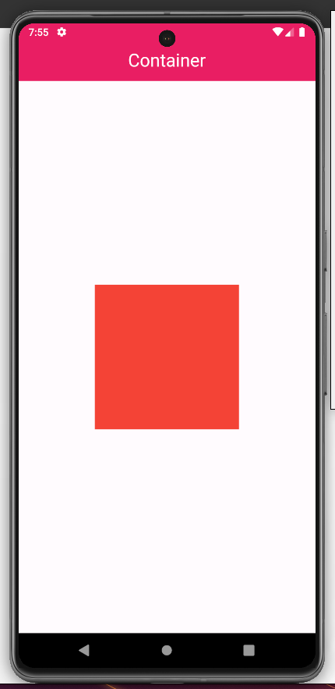

**padding:-**

The padding adds space around the child. It is used to create space or margins around

other widgets.

We can add padding in horizontal and vertical directions using EdgeInsets.symmetric().

Center(

child: Center(

child: Container(

color: Colors.green,

child: Container(

// padding: const EdgeInsets.symmetric(

// vertical: 20,

// horizontal: 20,

// ),

padding: const EdgeInsets.only(

left: 10,

right: 10,

bottom: 10,

top: 10,

),

height: 100,

width: 100,

child: const SizedBox(

height: 10,

width: 10,

child: Text('Hello'),

),

),

),

),

),

**Output:**

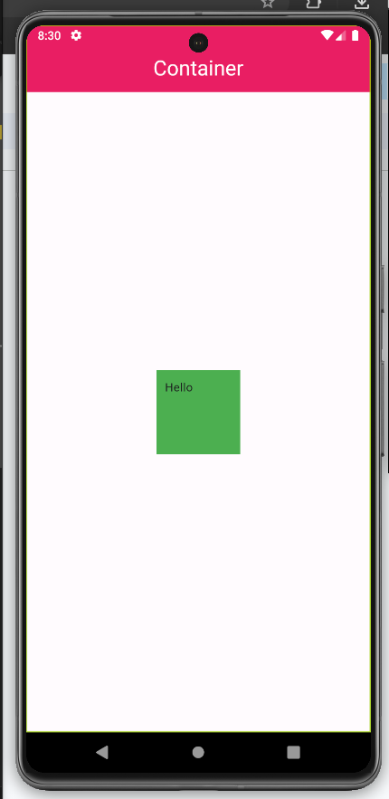

**margin:-**

margin is a property used to add space outside a widget's border. It represents the space

between the widget's border and the surrounding widgets or the edge of the screen.

Similar to padding we have multiple options to give margin to Container

Center(

child: Container(

margin:

const EdgeInsets.only(left: 120, right: 30, bottom: 40, top: 100),

color: Colors.red,

height: 200,

width: 200,

),

),

**Output:**

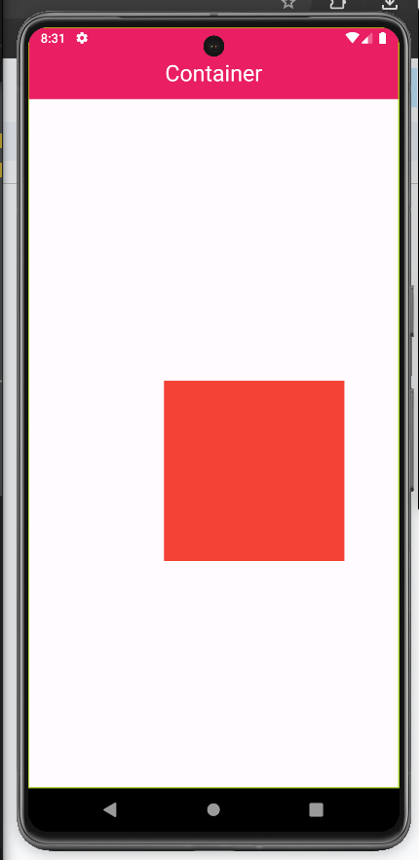

**decoration:-**

decoration property is used to apply visual styling to a widget, typically a Container. It

takes a BoxDecoration object that defines various visual elements such as color, border

**Border:**

**Container(**

**decoration: BoxDecoration(**

**// borderRadius: const BorderRadius.all(**

**// Radius.circular(**

**// 20,**

**// ),**

**// ),**

**border: Border.all(**

**width: 5,**

**color: Colors.yellow,**

**),**

**// color: Colors.red,**

**),**

**height: 200,**

**width: 200,**

**),**

**Output:**

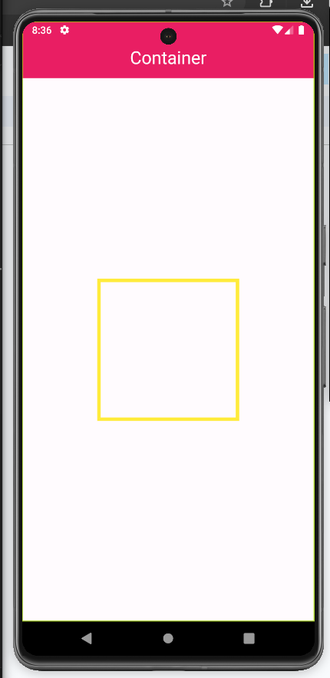

**BorderRadius:**

**Center(**

**child: Container(**

**decoration: BoxDecoration(**

**borderRadius: const BorderRadius.all(**

**Radius.circular(**

**20,**

**),**

**),**

**border: Border.all(**

**width: 5,**

**color: Colors.yellow,**

**),**

**// color: Colors.red,**

**),**

**height: 200,**

**width: 200,**

**),**

**),**

**Output:**

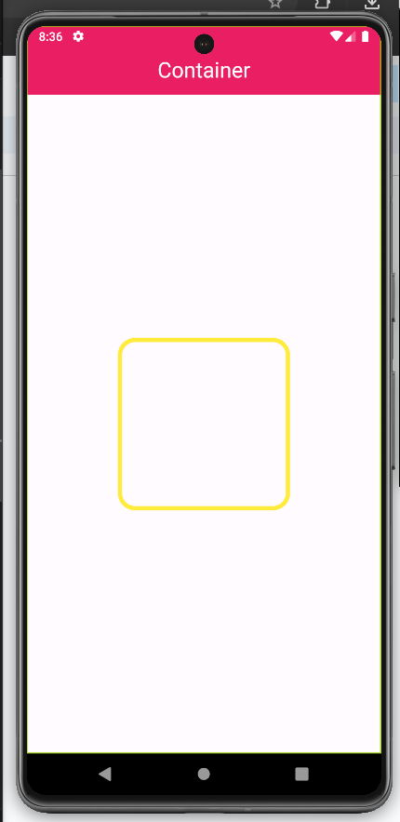

**boxShadow:**

**Container(**

**decoration: BoxDecoration(**

**borderRadius: const BorderRadius.all(**

**Radius.circular(**

**20,**

**),**

**),**

**border: Border.all(**

**width: 5,**

**color: Colors.yellow,**

**),**

**color: Colors.red,**

**boxShadow: const [**

**BoxShadow(**

**color: Colors.purple,**

**offset: Offset(30, 30),**

**blurRadius: 8,**

**),**

**BoxShadow(**

**color: Colors.red,**

**offset: Offset(20, 20),**

**blurRadius: 8,**

**),**

**BoxShadow(**

**color: Colors.red,**

**offset: Offset(10, 10),**

**blurRadius: 8,**

**)**

**]),**

**height: 200,**

**width: 200,**

**),**

**),**

**Output:**

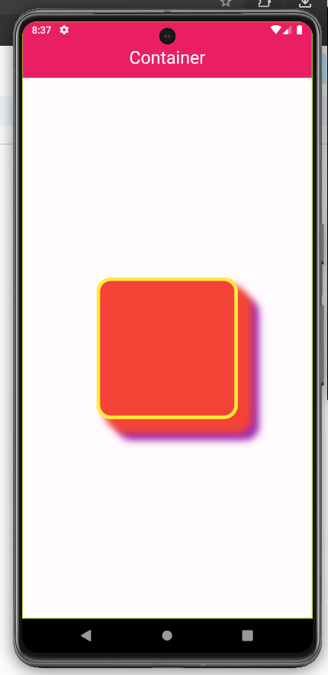

**Gradient:**

**Container(**

**decoration: BoxDecoration(**

**color: Colors.amber,**

**borderRadius: const BorderRadius.all(**

**Radius.circular(**

**20,**

**),**

**),**

**border: Border.all(**

**width: 5,**

**color: Colors.blue,**

**),**

**gradient: const LinearGradient(**

**stops: [0.3, 0.5],**

**colors: [Colors.red, Colors.green],**

**),**

**),**

**height: 200,**

**width: 200,**

**),**

**),**

