**ADS-1 FINAL SUBMISSION.docx**

--- Abhishek Aeera

Submission date: 10-Nov-2023

Submission ID: 22097107

File name: ADS-1FINAL-SUBMISSION

Word count:445 ,Character count:2506

**Name: Abhishek Aeera**

**Id: 22097107**

**Data set Link**: <https://github.com/AbhishekAeera/chikku/blob/main/airwaays2.csv>

**Github:** <https://github.com/AbhishekAeera/chikku/blob/main/ADS-1FINAL-SUBMISSION.docx>

**Visualisation of Air-Lines**

**Introduction**

The purpose of this report is to present an analysis of airline incidents through the use of various visualizations, including line, bar and scatter plots. These visualizations are intended to reveal trends in incidents and fatalities for various airlines.

Line Plot:

A line plot is a visual representation of airline incident and fatal accident data over time. Every line represents a total number of incident or fatal accident occurrences for a particular airline. You can customize the plot to include a range of time, add data filters, or use various types of visualizations such as bar graphs or scatter plots. In summary, a line plot is an effective and easy-to-use way to analyse and visualize airline incidents and fatal accident trends. The line plot is an interactive visualization tool that allows you to zoom in or out of the plot. By including the line plot description, you can gain a better understanding of trends and patterns in your data. You can also highlight the advantages of using line plots to analyse and visualize your data.

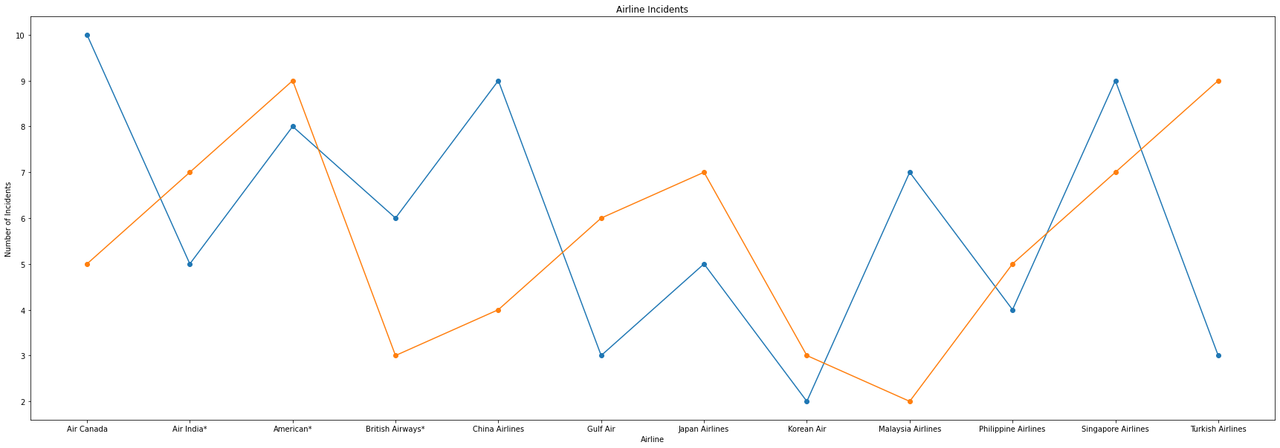

Bar plot:

The bar plot is an interactive data visualization tool that utilizes rectangular bars to represent quantitative values for various categories. It is particularly useful for airline incident and fatal accident data, as it allows users to easily compare the data between airlines. The bars in the plot are arranged at regular intervals, with the height or length indicating the quantity they represent, and the x-axis representing the categories and the y-axis the values. The bar plot can be customised to provide further insight into the data, such as by selecting a range of time or adding data filters. Ultimately, the bar plot is an invaluable tool for the visualization and analysis of airline incident and fatality data.

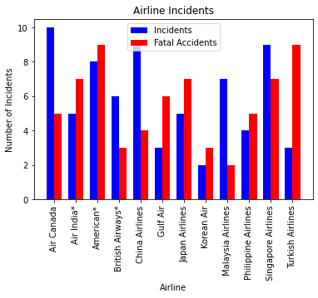

Scatter plot

A scatter plot is a visualization tool that provides a unique approach to understanding the trends and patterns of airline accidents. Each data point in a scatter plot represents an airline, and the x-coordinates of these points remain constant across all airlines, highlighting the differences in y-coordinates. The y-coordinates correspond to the total incidents or fatal accidents experienced by that airline. By using a scatter plot, it is possible to gain a better understanding of the relationship between different airlines and their respective incidents or fatal accidents. Additionally, the plot can be customized to include a range of time, data filters, or other visualizations, such as line plots or scatter plots or pie charts. Furthermore, the plot is interactive, allowing users to zoom in or out of the plot for more detailed analysis.

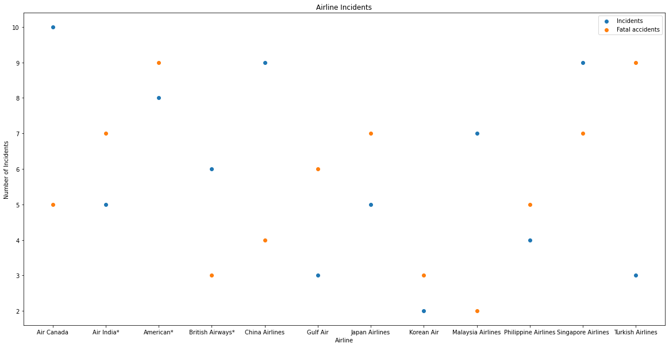

Conclusion

In this concluding statement, we have presented the results of our in-depth analysis of airline incident and fatal accident data. We have employed various visualizations, including line, bar and scatter plots, to provide a comprehensive view of the data and trends in the airline industry. The plots can be zoomed in and out to provide users with a more detailed view of the airline incident data and fatal accident data, allowing them to make more informed decisions or identify patterns in the data. In conclusion, our analysis of airline incident data provides a comprehensive overview of the trends in the industry, allowing users to make informed decisions and identify patterns.

**--------------------------------------------------------END-----------------------------------------------------------**