Software Architecture and Design Specification
Project: Smart Budget and Expense Tracker
Version: 1.0
Authors: Project Team
Date: 11 November 2026
Status: For Review

Revision History
Version | Date | Author | Change Summary
1.0 | 11 November 2026 | Project Team | Initial SAD aligned to the implementation, SRS and supplied use-case model.

Approvals
Approval status: Pending team review

1. Introduction
1.1 Purpose
This document describes the implemented architecture and design of the Smart Budget and Expense Tracker. It explains the system boundaries, components, data flow, security controls, APIs and design decisions so developers, reviewers and maintainers can understand how the product operates.
1.2 Scope
The system supports account registration and login, profile management, expense creation and editing, soft deletion with transaction-history visibility, search and filters, predefined and custom categories, weekly/monthly/yearly budgets, budget alerts and a private notification inbox, analytics, reports, and administrator account/activity functions. Google sign-in and email-change verification are optional integrations that require configuration.
1.3 Audience
The intended readers are the project team, software developers, QA reviewers, database maintainers, administrators and instructors reviewing the submitted design.
1.4 Definitions
API: application programming interface; CSRF: cross-site request forgery; HTTP: web protocol; OAuth: delegated sign-in; PostgreSQL: relational database; SAD: software architecture and design; SRS: software requirements specification; TLS: transport security.

2. Document Overview
2.1 How to use this document
Read the architecture and component sections for system boundaries and responsibilities, then use the sequence diagrams and API tables to follow request processing. The traceability matrix connects each SRS requirement to its implementing component.
2.2 Related Documents
The design is aligned with the project SRS, Security Requirements, Test Case Document, application README, and the supplied use-case diagram. The implementation uses the source in app/app.py, app/static, and app/db_migrations.

2.3 Use Case Diagram
The supplied use-case model identifies the User, Administrator and Notification System actors. The diagram below retains its functional scope and corrects the spelling of “Receive” in the budget-alert use case for readability.
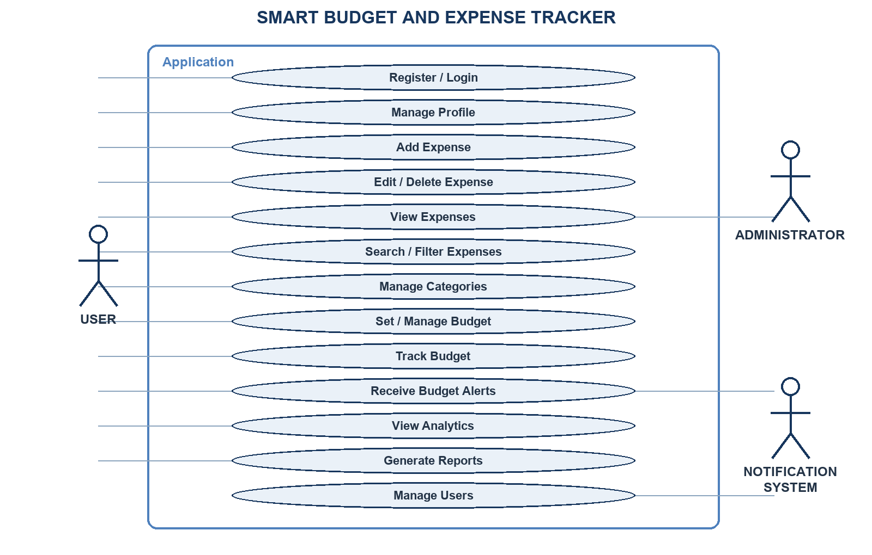
Figure 1. Use-case view based on the supplied project diagram.

3. Architecture
3.1 Goals & Constraints
The system protects account-owned financial data and separates browser presentation, HTTP handling, feature logic and PostgreSQL persistence. It is a single-process Python application with a vanilla JavaScript client. PostgreSQL is required; Google OAuth and SMTP are optional. The built-in server is for local demonstrations; public use requires production hosting and HTTPS.
3.2 Stakeholders & Concerns
End users need safe account access, accurate expense/budget totals and clear feedback. Administrators need limited user and activity views. The project operator needs dependable migrations, backups and configuration. Developers need testable modules and observable failures. External identity and email providers need correct callback/SMTP configuration. The database operator must restrict credentials and protect backups.

3.3 Component (UML) Diagram

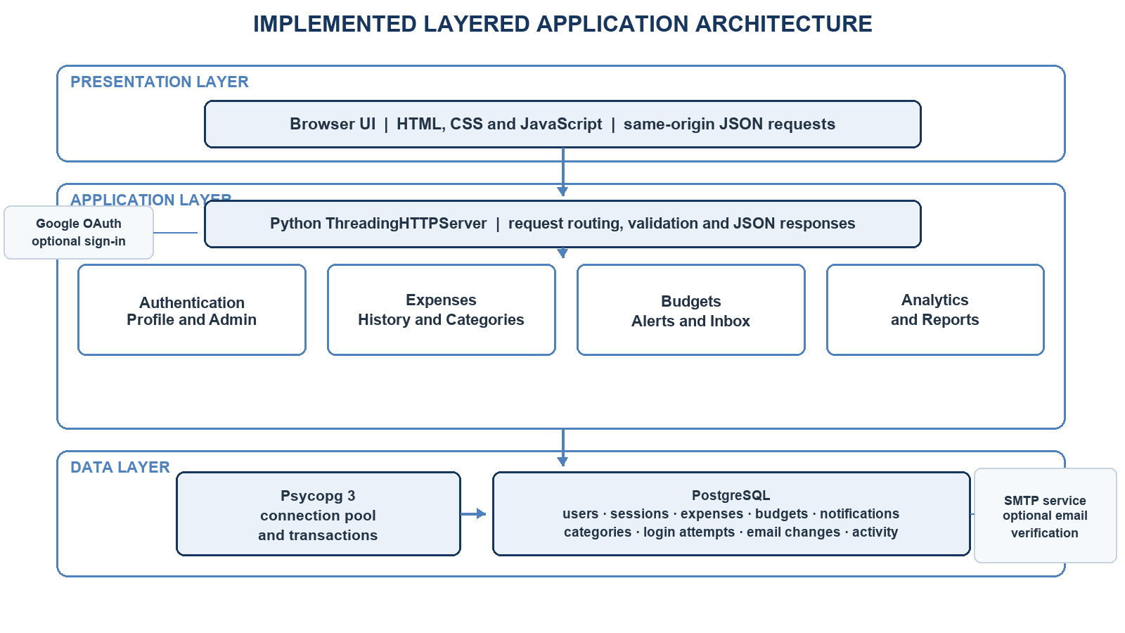
Figure 2. Implemented layered component view; external providers are optional integrations.

3.4 Component Descriptions
Browser presentation. Static HTML, CSS and JavaScript render account, dashboard, expense, budget and administrator views. The client sends same-origin JSON requests and refreshes results from the server.
HTTP application. Python’s ThreadingHTTPServer serves static files and routes GET, POST, PATCH and DELETE requests. Handler methods perform request parsing, session checks, validation, feature operations and JSON responses.
Authentication, profile and administrator functions. The server handles registration, login, optional OAuth and email verification, profile/password changes, and administrator user/activity routes. An operator provisions admin rights; registration never grants them.
Expense and category functions. Expense routes create, edit, soft-delete, list, search and filter records. Category logic supplies built-in categories and validates account-owned custom categories. History responses retain deleted_at so deleted records can remain visible while totals exclude them.
Budget, alert and notification functions. Budget routes manage weekly, monthly and yearly periods. Alert logic compares eligible expense totals with budget thresholds and persists warning/exceeded events. The notification endpoint returns recent events only for the authenticated account.
Analytics and report functions. Read-only routes aggregate active expenses, category totals, budget status and date-bounded monthly/yearly reports for the current account.
Persistence and migrations. A Psycopg 3 connection pool provides PostgreSQL connections; transaction contexts commit successful work and roll back failures. Ordered schema migrations create or upgrade tables and indexes.
External providers. Google OAuth supplies optional identity sign-in; SMTP sends one-time email-change verification links when configured. Neither provider is required for local email/password operation.

3.5 Chosen Architecture Pattern and Rationale
The application uses a layered monolith: a browser client calls a single Python HTTP application, which applies authentication and feature rules and accesses PostgreSQL through a connection pool. This keeps deployment and data transactions straightforward for the project’s scale while retaining clear feature boundaries. Microservices would add service discovery, deployment and consistency overhead without a demonstrated need.

3.6 Technology Stack & Data Stores
Client: HTML, CSS and vanilla JavaScript. Server: Python 3.12 standard-library HTTP server and JSON handlers. Persistence: PostgreSQL 17 through Psycopg 3 with connection pooling and ordered migrations. Passwords use salted scrypt hashes; sessions store token hashes. Optional providers: Google OAuth and SMTP. Tests use Python unittest and a dedicated PostgreSQL test database.

3.7 Risks & Mitigations
Database outage or pool exhaustion can block expense and budget operations; use bounded pool timeouts, clear service-unavailable responses, verified backups and recovery procedures. Incorrect account scoping could expose financial data; bind queries to the authenticated user and maintain cross-account tests. Misconfigured Google/SMTP secrets can disable optional flows; validate configuration and keep secrets out of source control. The built-in development server is not a public deployment boundary; deploy behind HTTPS with secure cookies and host-level controls.

3.8 Traceability to Requirements
Each SRS requirement maps to the components and data paths shown above. Weekly budgets, the notification inbox and account-specific isolation are included because they appear in the current SRS and application.
SRS ID | Requirement | Architecture mapping
FR01 | Register and log in securely. | Authentication; users, sessions and login_attempts
FR02 | Update profile and securely store credentials. | Profile/authentication; users and email_change_requests
FR03 | Add expense with amount, category, date, payment method and description. | Expense management; expenses
FR04 | Edit or delete existing expenses. | Expense management; expenses.deleted_at
FR05 | View transaction history. | History API; expenses
FR06 | Search and filter expenses. | History API; account-scoped expense query
FR07 | Provide predefined expense categories. | Category management; server category constants
FR08 | Create and edit custom categories. | Category management; user_categories
FR09 | Manage weekly, monthly and yearly budgets. | Budget management; budgets
FR10 | Generate alerts when a budget threshold is reached or exceeded. | Alert service; budgets, expenses and notifications
FR11 | Calculate expense and budget statistics. | Analytics; aggregate queries over active expenses
FR12 | Generate monthly and yearly reports. | Report API; period-filtered expense/budget data
FR13 | Let administrators manage users and monitor activity. | Administrator routes; users and system_activity
FR14 | Maintain system and database security. | Authentication, authorization, validation, SQL access and database operations
FR15 | View and manage account-specific budget notifications. | Notification inbox; notifications scoped by user_id
NFR01 | Performance: dashboards and analytics should load quickly. | Connection pool, indexed account/date queries and performance tests
NFR02 | Security: credentials and financial information are stored safely. | Scrypt hashes, hashed sessions, CSRF/origin checks and owner-scoped queries
NFR03 | Usability: system should be simple and user-friendly. | Single-page client, labeled forms, validation and feedback; desktop keyboard flow
NFR04 | Reliability: information should be stored and recoverable. | PostgreSQL transactions, migrations, backup and restore procedures
NFR05 | Maintenance: system should be regularly updated and maintained. | Versioned migrations, README setup and CI regression checks; update cadence is operational

3.9 Security Architecture
Authentication and sessions. Passwords use salted scrypt hashes. Login creates a random session token; PostgreSQL stores its keyed hash, user, CSRF token and expiry. The browser receives an HttpOnly, SameSite=Lax cookie (Secure when configured). Writes require same-origin and CSRF checks.
Authorization and data protection. Protected routes require a valid session. Expense, budget, notification, category and report queries are scoped to that session’s user ID. Administrator routes require the separately provisioned admin role. SQL uses parameterized values, validation constrains request data, and account deletion relationships use foreign keys.
Threat coverage. Spoofing is mitigated by password verification, OAuth state checks and session tokens; tampering by origin/CSRF checks, validation and parameterized SQL; information disclosure by account scoping and restricted administrator responses; denial of service by failed-login throttling and bounded database pool waits; privilege escalation by explicit admin authorization and self-service role changes being rejected.
Deployment boundary. Application-level password hashing and access controls do not by themselves guarantee encryption at rest. Storage encryption, TLS termination, database network restrictions, secret rotation, log retention and backup access controls depend on the deployment environment and must be configured there.

4. Design

4.1 Design Overview
The browser renders the user interface and sends JSON requests to a same-origin Python server. The server verifies session and request integrity, validates input, runs the requested feature operation through a PostgreSQL transaction, and returns a status code plus JSON data or a safe error. The two flows below show first account creation and the expense-to-alert path.

4.2 UML Sequence Diagrams
The diagrams describe the implemented account creation and expense/notification flows. Error branches are summarized in the security and error-handling sections.

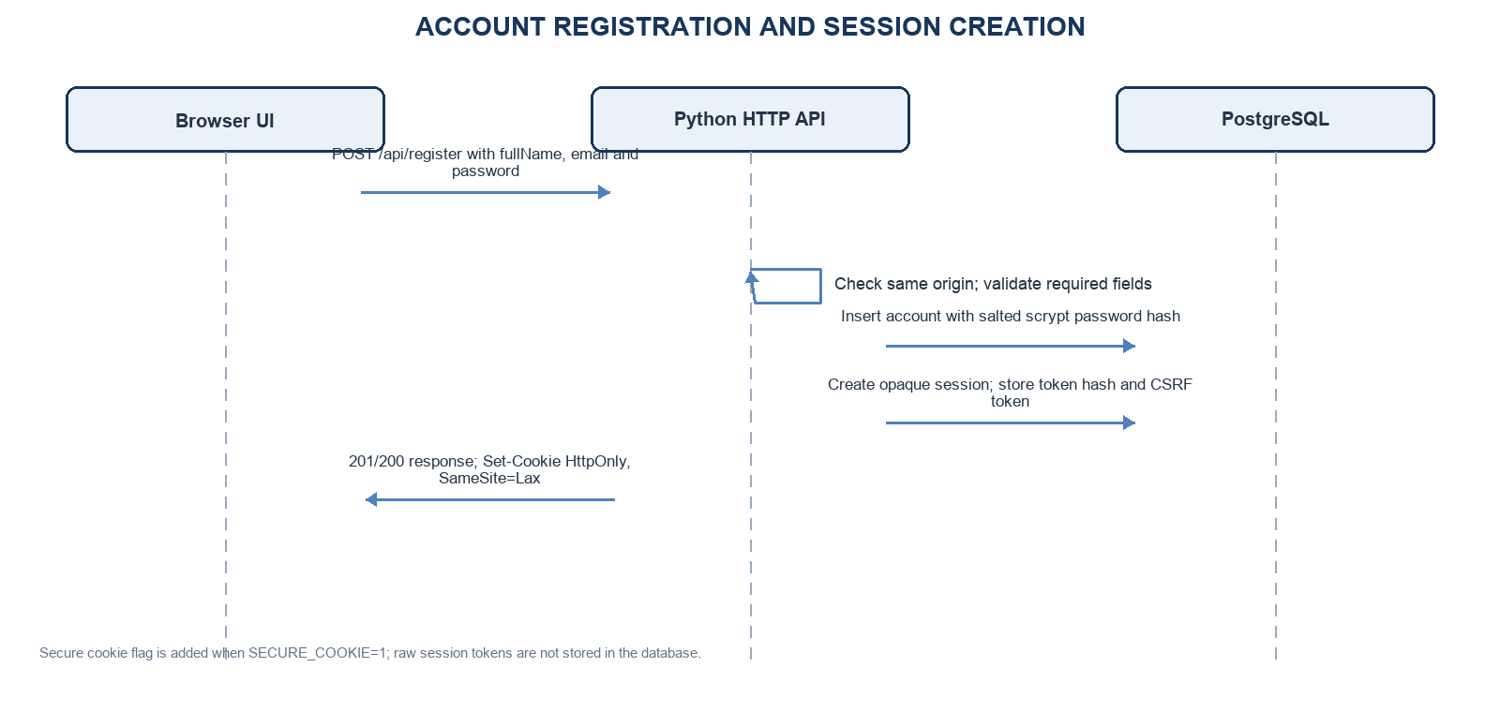
Figure 3. Account registration creates a password hash and authenticated session.
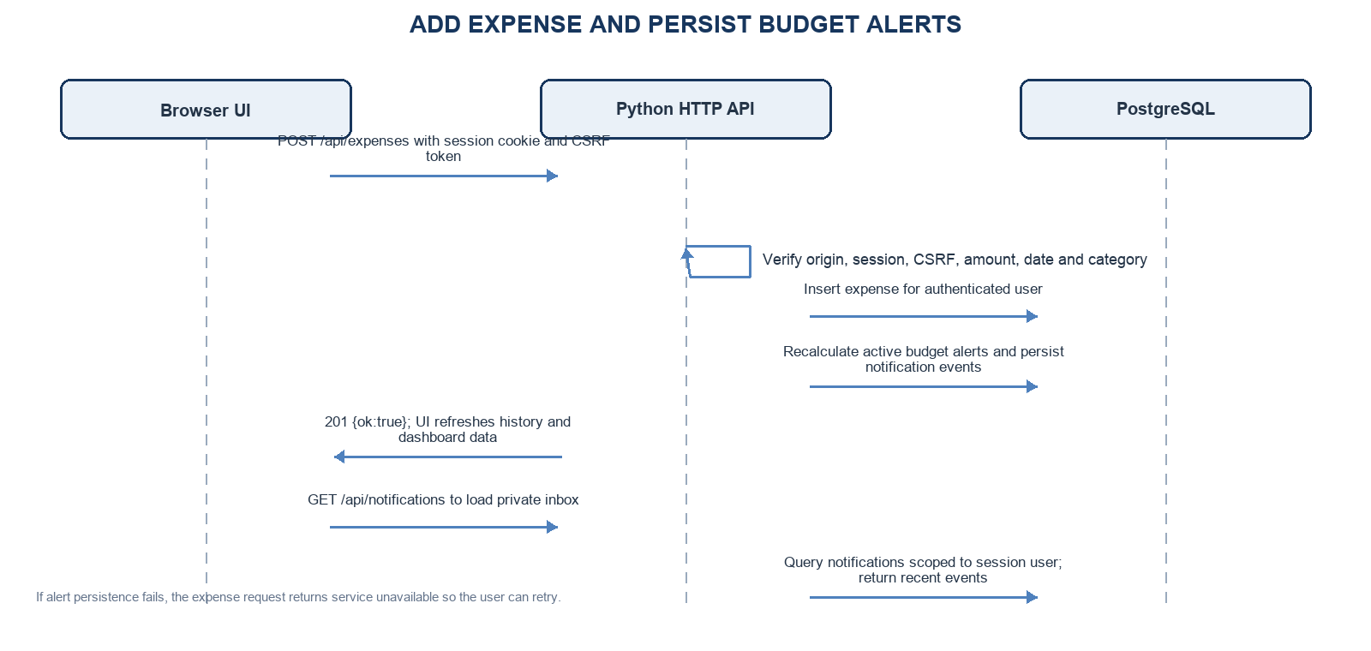
Figure 4. Expense creation recalculates persisted budget alerts for the same account.

4.3 API Design
The browser and server communicate over same-origin HTTP using JSON. Write requests use the session cookie and CSRF token; protected reads require an authenticated session.
The following interfaces summarize the core browser-to-application contract. Exact field validation and status codes are enforced by the route handlers.
Endpoint | Request | Behavior and response
POST /api/register | JSON: fullName, email, password | Create account, hash password, return session cookie and CSRF token.
POST /api/login | JSON: email, password | Verify credentials; returns 401 on mismatch, 429 after repeated failures; sets session cookie on success.
GET /api/expenses | Query: category, q, month | Return current user’s history including deleted_at marker; supports text/category/month filters.
POST /api/expenses | JSON: amount, category, date, paymentMethod, description | Create validated expense and persist alert changes; returns 201 or a validation/service error.
PATCH /api/expenses/{id} | JSON expense fields | Update an owned expense; reject invalid input and cross-account access.
DELETE /api/expenses/{id} | Path ID | Soft-delete an owned expense so history retains it and totals exclude it.
GET /api/notifications | Session cookie | Return the latest account-specific persisted budget notifications.
GET/PATCH /api/profile | Session / JSON profile fields | Read or update profile; email change requires configured verification delivery.

4.4 Error Handling, Logging & Monitoring
Invalid JSON, malformed fields, unsupported dates, missing categories, duplicate values and authorization failures return an appropriate 4xx response with a human-readable JSON error. Database unavailability, pool timeouts or failed alert persistence return service-unavailable responses rather than a false success. Database context managers commit successful work and roll back exceptions. Administrator activity records selected event types without storing expense amounts or descriptions. Operational monitoring should watch HTTP error rates, pool timeouts, migration outcomes, backup status and report latency; access logs and deployment logs must not expose credentials, cookies or verification tokens.

4.5 UX Design
The client presents registration/login and a dashboard with spending summary, quick expense entry, category management, history/search/filter, budgets, alerts/notifications, analytics and reports. Profile and administrator functions are separate views. Forms provide labels and inline validation; success and error messages explain the outcome. Keyboard access and visible focus are part of the desktop usability design. The project does not set a mobile-specific acceptance requirement.

4.6 Open Issues & Next Steps
Before public deployment, use a production-grade WSGI/ASGI server or managed application host, terminate TLS, set a unique session secret, enable secure cookies, restrict database network access, and configure managed secrets and SMTP/OAuth callbacks. Establish scheduled backups with restore drills, log review/retention, dependency updates and a release cadence. The built-in server remains intended for local development and demonstrations.

5. Appendices
5.1 Glossary
API is the interface used by the browser to request server operations. CSRF is a forged cross-site request; same-origin and token checks protect state-changing requests. HTTP carries the application requests and responses. OAuth delegates sign-in to an identity provider. PostgreSQL is the relational database; Psycopg is the Python database driver. SAD means Software Architecture and Design; SRS means Software Requirements Specification. TLS encrypts network traffic between supported deployment endpoints.
5.2 References
The design uses the project SRS as the functional and quality-requirement baseline; the Security Requirements and Test Case Document for security and verification context; the application README for setup and configuration; and the supplied use-case diagram for actor and feature scope. Implementation details are based on app/app.py, app/static, app/db_migrations and the current repository configuration.
5.3 Tools and Technologies
Python 3.12 and the standard-library HTTP server implement request handling; HTML, CSS and vanilla JavaScript implement the browser client; PostgreSQL 17 and Psycopg 3 provide persistence. Python unittest and Coverage.py support automated verification, GitHub Actions runs CI checks, and diagrams.net is used for architecture models.

