E-COMMERCE LABORATORY
Lab Assignment Report: Programs 1 to 6
A mini e-commerce store built in Python
Name | Abhishek Barali
Roll No. | 023bscit003
Section | A
Semester / Batch | 2023
Subject | E-Commerce Laboratory
Language used | Python 3 with the Flask micro framework
Data storage | In-memory lists and dictionaries (no database)

Source code: https://github.com/AbhishekBarali/ecommerce-lab

Contents
- Introduction
- Tools used and how to run the programs
- Lab 1: Product category list and items
- Lab 2: Product list and add to cart
- Lab 3: Add to cart and checkout
- Lab 4: Product list and wish list
- Lab 5: Payment gateway integration in sandbox mode
- Lab 6: Google Analytics setup and analytics parameters
- Conclusion
Introduction
This report covers the six programs of the E-Commerce Laboratory. All six are parts of one small online store, so the same product data is reused by every program instead of being written again for each lab. The store is written in Python using the Flask micro framework, and every record is held in ordinary Python lists and dictionaries, which the assignment allows in place of a database.
Each lab below is presented with its objective, the logic that was used, the source code of that program, and a screenshot of the output taken while the program was running.
Tools used and how to run the programs
Language | Python 3.12
Framework | Flask 3.1 (routing and HTML templates)
Data storage | Python lists and dictionaries in store/data.py
Analytics | Google Analytics 4 tracking snippet (gtag.js)
Payment gateway | eSewa test mode (sandbox), no live key used
Editor / OS | Visual Studio Code on Linux

The whole store runs from a single command:
python3 -m venv .venv
.venv/bin/pip install -r requirements.txt
.venv/bin/python app.py

Then open http://127.0.0.1:5000 in the browser.
Commands used to run the store
Project structure
ecommerce-lab/
app.py entry point, runs all six labs
store/data.py products, categories, cart, wishlist, orders
labs/lab1_categories.py Lab 1
labs/lab2_cart.py Lab 2
labs/lab3_checkout.py Lab 3
labs/lab4_wishlist.py Lab 4
labs/lab5_payment.py Lab 5
labs/lab6_analytics.py Lab 6
templates/ HTML pages, base.html holds the GA4 snippet
static/style.css styling
screenshots/ output screenshots used in this report
docs/ this report
Files in the project
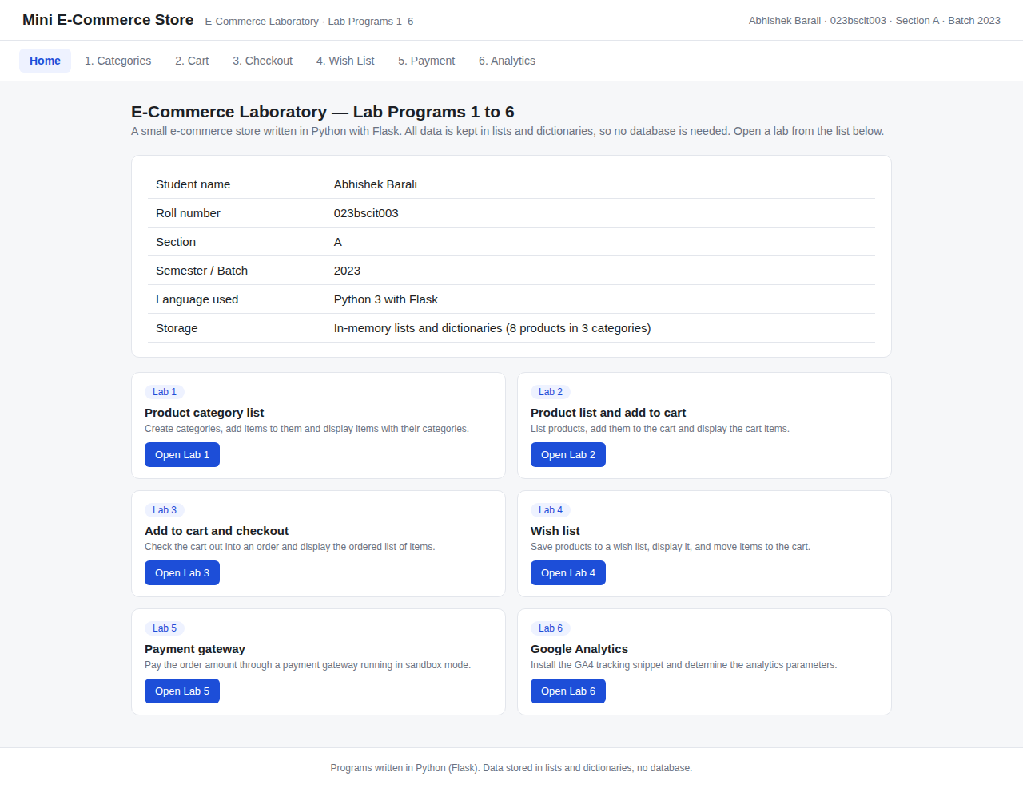
Figure 1: Home page of the store listing all six lab programs
Lab 1: Product Category List and Items
Objective
Create a product category list, add items into the created categories, and display all items together with their categories.
Logic used
- Categories are kept in a simple list of names, and items in a list of dictionaries where each item remembers the category it belongs to.
- The 'Add Category' form appends a new name to the category list, and duplicate names are ignored.
- The 'Add Item' form appends a dictionary with an id, name, price and the chosen category.
- For display, the items are grouped category by category, and every group is shown as a table with the item and its category.
Source code
"""Shared in-memory data for all lab programs.

No database is used. Everything is stored in plain Python lists and
dictionaries, which is allowed by the assignment.
"""

# ---------------------------------------------------------------- Lab 1 data
# Category list. Each category is just a name.
categories = ["Electronics", "Fashion", "Groceries"]

# Item list. Each item is a dictionary that remembers its category.
items = [
{"id": 1, "name": "Bluetooth Headphone", "price": 2500, "category":
"Electronics"},
{"id": 2, "name": "Power Bank 10000mAh", "price": 1800, "category":
"Electronics"},
{"id": 3, "name": "Smart Watch", "price": 4200, "category": "Electronics"},
{"id": 4, "name": "Cotton T-Shirt", "price": 900, "category": "Fashion"},
{"id": 5, "name": "Running Shoes", "price": 3500, "category": "Fashion"},
{"id": 6, "name": "Basmati Rice 5kg", "price": 1250, "category": "Groceries"},
{"id": 7, "name": "Sunflower Oil 2L", "price": 640, "category": "Groceries"},
{"id": 8, "name": "Green Tea 100g", "price": 320, "category": "Groceries"},
]

# ------------------------------------------------------- Labs 2, 3, 4 storage
cart = [] # list of {"id", "name", "price", "qty"}
wishlist = [] # list of items
orders = [] # list of {"order_id", "customer", "address", "items", "total"}
payments = [] # list of sandbox payment records (Lab 5)
events = [] # list of analytics events (Lab 6)

store/data.py - the category and item lists
"""Lab 1 - Product category list, add items to a category, display items
with their categories.
"""
from flask import Blueprint, render_template, request, redirect, url_for

from store import data

lab1 = Blueprint("lab1", __name__)

@lab1.route("/lab1")
def page():
# Group the items under each category for display.
grouped = {c: [i for i in data.items if i["category"] == c] for c in
data.categories}
return render_template("lab1.html", active="lab1", grouped=grouped,
categories=data.categories, msg=request.args.get("msg"))

@lab1.route("/lab1/add-category", methods=["POST"])
def add_category():
name = request.form.get("category", "").strip()
if name and name not in data.categories:
data.categories.append(name)
return redirect(url_for("lab1.page", msg=f"Category '{name}' created."))
return redirect(url_for("lab1.page"))

@lab1.route("/lab1/add-item", methods=["POST"])
def add_item():
name = request.form.get("name", "").strip()
price = request.form.get("price", "0").strip()
category = request.form.get("category", "")
if name and category:
data.items.append({
"id": data.next_item_id(),
"name": name,
"price": int(price or 0),
"category": category,
})
return redirect(url_for("lab1.page", msg=f"'{name}' added to {category}."))
return redirect(url_for("lab1.page"))
labs/lab1_categories.py - add category, add item, display grouped items
Output
A new category was created and an item was added into it, then all items were listed under their own category with the category name shown in each row.
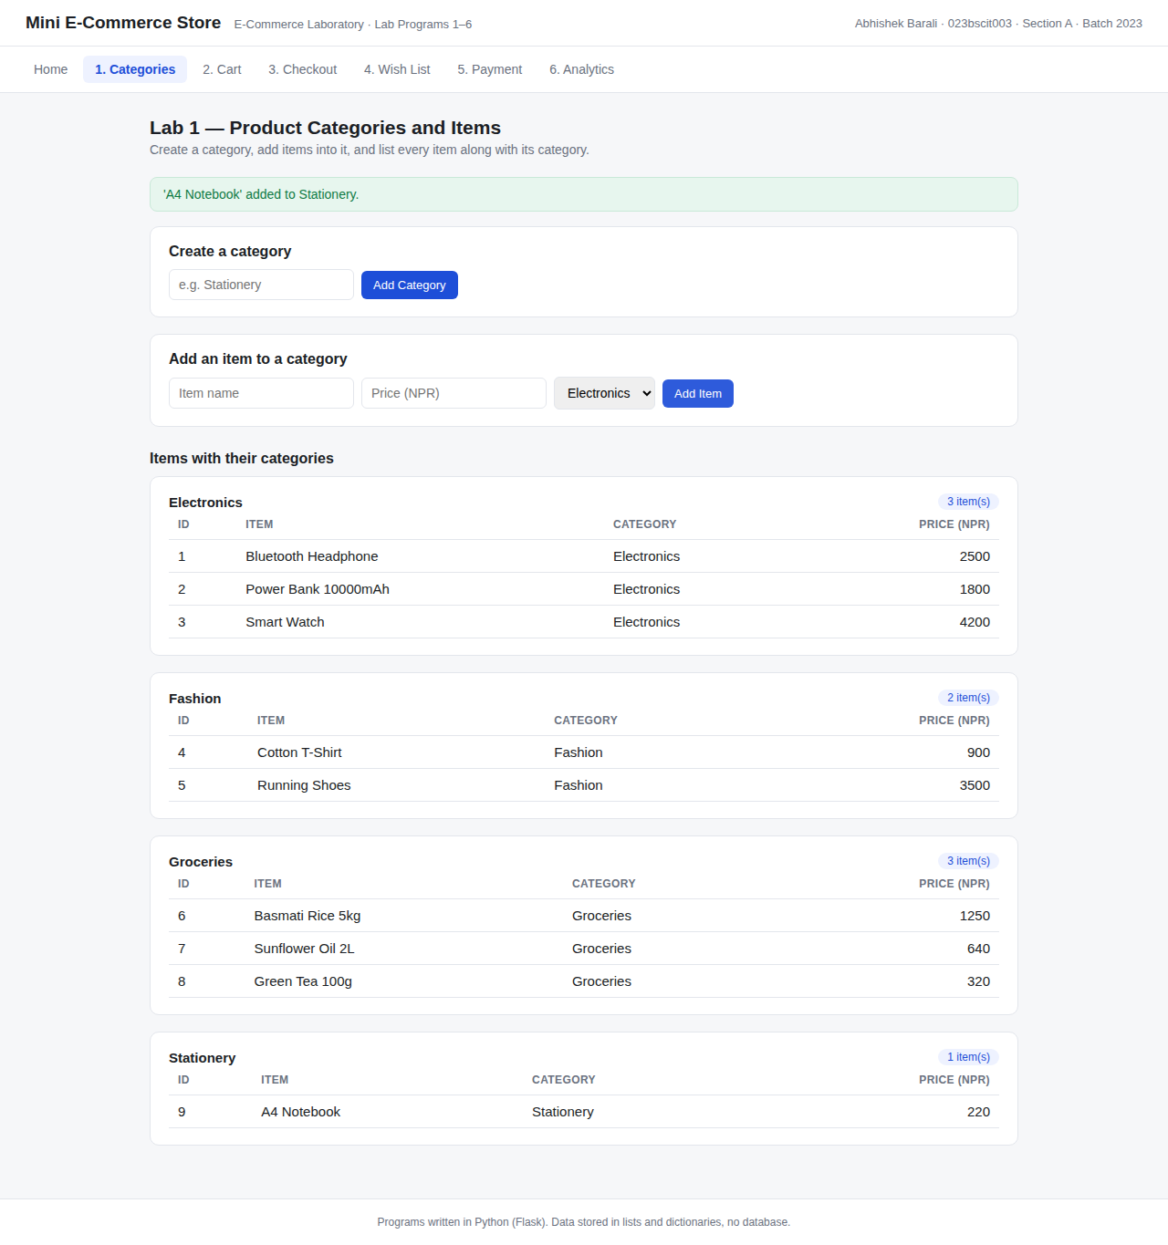
Figure 2: Lab 1 output. A new category 'Stationery' was created and the item 'A4 Notebook' was added to it. Items are listed under their categories.
Lab 2: Product List and Add to Cart
Objective
Create a product list, provide an add-to-cart feature for the products, and display the items present in the cart.
Logic used
- The product list from Lab 1 is displayed as cards, each with its own 'Add to Cart' button.
- The cart is a separate list of dictionaries holding the id, name, price and quantity of each line.
- If the product is already in the cart, only its quantity is increased; otherwise a new line is appended.
- The cart table shows every line with its subtotal, and the total is the sum of price multiplied by quantity for all lines.
Source code
"""Lab 2 - Product list with an add-to-cart feature, and display of cart
items.
"""
from flask import Blueprint, render_template, redirect, url_for, request

from store import data

lab2 = Blueprint("lab2", __name__)

def add_to_cart(item_id, qty=1):
"""Add an item to the cart list, or increase quantity if already there."""
item = data.find_item(item_id)
if not item:
return None
for line in data.cart:
if line["id"] == item_id:
line["qty"] += qty
return item
data.cart.append({"id": item["id"], "name": item["name"],
"price": item["price"], "qty": qty})
return item

@lab2.route("/lab2")
def page():
return render_template("lab2.html", active="lab2", products=data.items,
cart=data.cart, total=data.cart_total(),
msg=request.args.get("msg"))

@lab2.route("/lab2/add/<int:item_id>", methods=["POST"])
def add(item_id):
item = add_to_cart(item_id)
msg = f"'{item['name']}' added to cart." if item else None
return redirect(url_for("lab2.page", msg=msg))

@lab2.route("/lab2/remove/<int:item_id>", methods=["POST"])
def remove(item_id):
data.cart[:] = [line for line in data.cart if line["id"] != item_id]
return redirect(url_for("lab2.page", msg="Item removed from cart."))
labs/lab2_cart.py - add to cart, remove from cart, display cart
Output
Products were added to the cart, the quantity of a repeated product increased instead of creating a duplicate line, and the cart was displayed with the total amount.
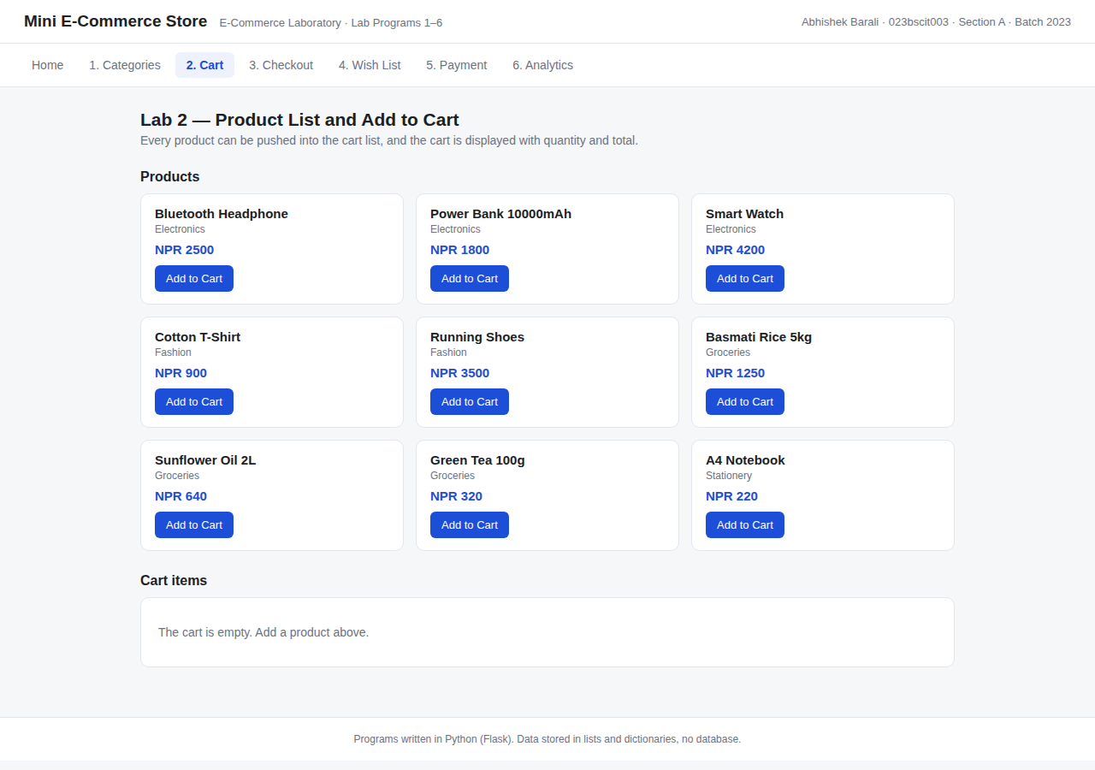
Figure 3: Lab 2. The product list with an Add to Cart button on every product.
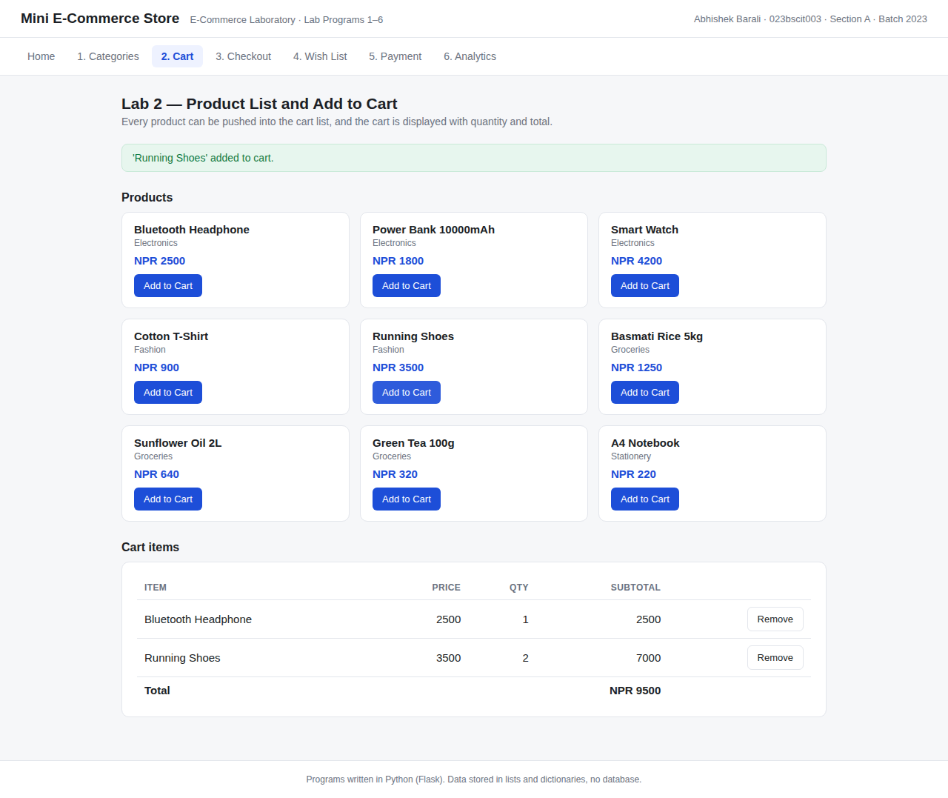
Figure 4: Lab 2 output. Bluetooth Headphone and two units of Running Shoes are in the cart, with subtotals and a total of NPR 9500.
Lab 3: Add to Cart and Checkout
Objective
Implement the add-to-cart and checkout features of the shopping store and display the ordered list of items.
Logic used
- Products are added to the same cart list used in Lab 2.
- The checkout form collects the customer name and the delivery address.
- On checkout, a new order dictionary is created with an order number, the customer details, a copy of the cart lines and the total amount.
- The order is appended to the orders list and the cart is emptied, which is how a real store behaves after an order is placed.
- Every placed order is then displayed as an ordered list of items.
Source code
"""Lab 3 - Add to cart plus checkout, and display of the ordered item list."""
from flask import Blueprint, render_template, request, redirect, url_for

from store import data
from labs.lab2_cart import add_to_cart

lab3 = Blueprint("lab3", __name__)

@lab3.route("/lab3")
def page():
return render_template("lab3.html", active="lab3", products=data.items,
cart=data.cart, total=data.cart_total(),
orders=data.orders, msg=request.args.get("msg"))

@lab3.route("/lab3/add/<int:item_id>", methods=["POST"])
def add(item_id):
item = add_to_cart(item_id)
msg = f"'{item['name']}' added to cart." if item else None
return redirect(url_for("lab3.page", msg=msg))

@lab3.route("/lab3/checkout", methods=["POST"])
def checkout():
if not data.cart:
return redirect(url_for("lab3.page", msg="Cart is empty, nothing to check
out."))

order = {
"order_id": 1001 + len(data.orders),
"customer": request.form.get("customer", "Guest").strip() or "Guest",
"address": request.form.get("address", "-").strip() or "-",
"items": [dict(line) for line in data.cart], # copy the cart lines
"total": data.cart_total(),
}
data.orders.append(order)
data.cart.clear() # cart is emptied after
checkout
return redirect(url_for("lab3.page", msg=f"Order #{order['order_id']} placed
successfully."))
labs/lab3_checkout.py - checkout turns the cart into an order
Output
The cart was checked out into order number 1001, the cart was emptied, and the ordered list of items was displayed with the customer name, address and total.
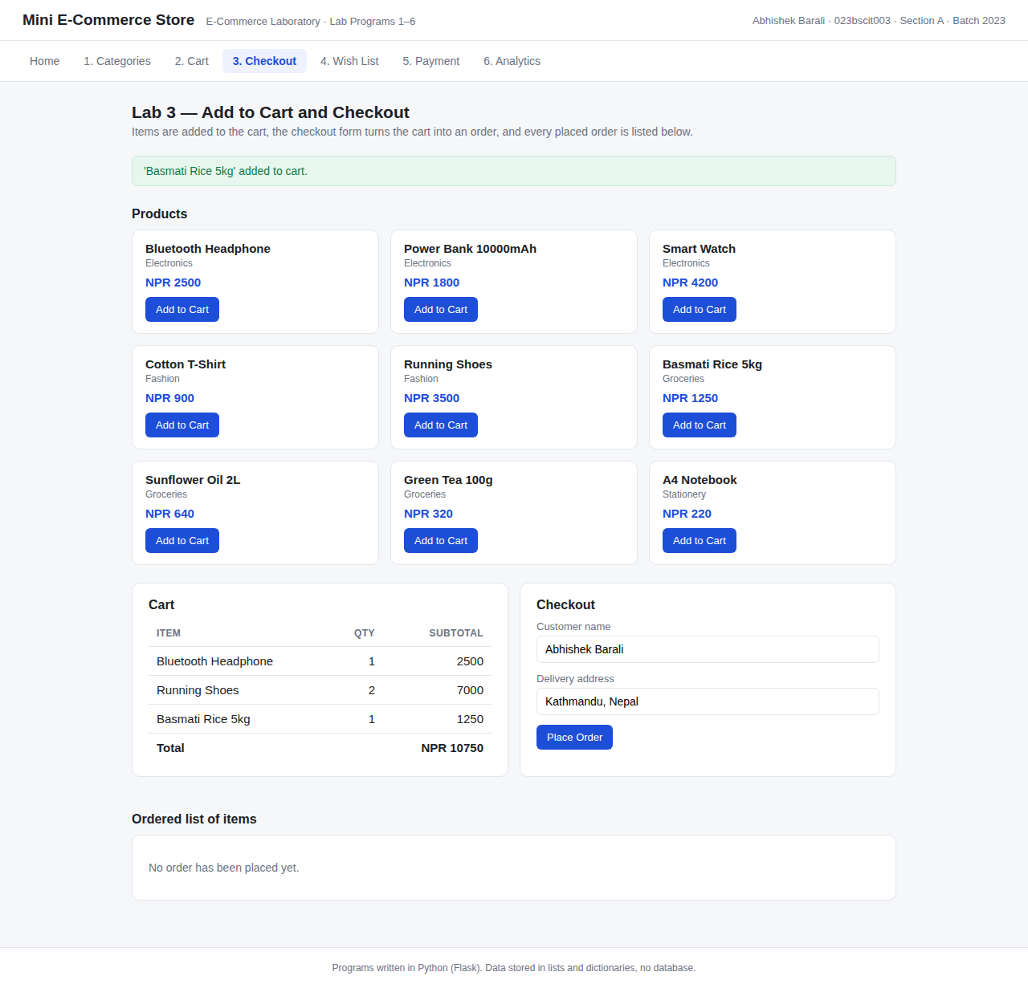
Figure 5: Lab 3. The cart on the left and the checkout form on the right.
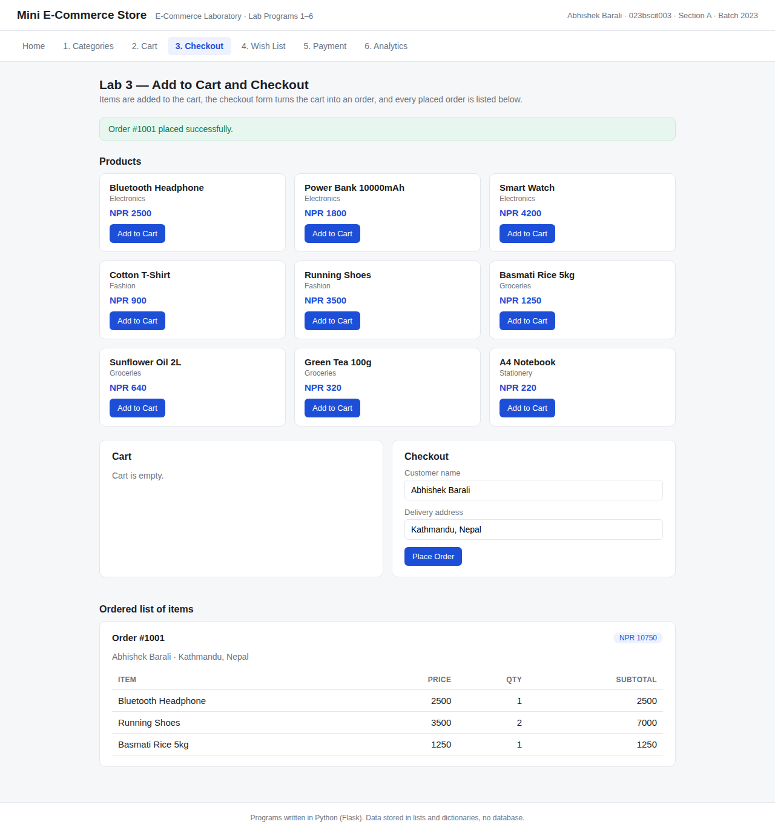
Figure 6: Lab 3 output. Order #1001 was placed, the cart became empty, and the ordered list of items is displayed with quantities and subtotals.
Lab 4: Product List and Wish List
Objective
Create a product list with an add-to-wish-list feature and display the wish list items.
Logic used
- The wish list is a separate list, so a product can be saved for later without being bought.
- A product is appended only once; if it is already saved, the button shows 'In Wish List' and the program reports that the item is already there.
- A saved item can be removed from the wish list, or moved into the cart, in which case it is added to the cart and dropped from the wish list.
- The wish list is displayed as a table with the item, its category and price.
Source code
"""Lab 4 - Product list with an add-to-wish-list feature, and display of the
wish list items.
"""
from flask import Blueprint, render_template, request, redirect, url_for

from store import data
from labs.lab2_cart import add_to_cart

lab4 = Blueprint("lab4", __name__)

@lab4.route("/lab4")
def page():
wished_ids = [i["id"] for i in data.wishlist]
return render_template("lab4.html", active="lab4", products=data.items,
wishlist=data.wishlist, wished_ids=wished_ids,
msg=request.args.get("msg"))

@lab4.route("/lab4/add/<int:item_id>", methods=["POST"])
def add(item_id):
item = data.find_item(item_id)
if item and item["id"] not in [w["id"] for w in data.wishlist]:
data.wishlist.append(item)
return redirect(url_for("lab4.page", msg=f"'{item['name']}' saved to wish
list."))
return redirect(url_for("lab4.page", msg="Item is already in the wish list."))

@lab4.route("/lab4/remove/<int:item_id>", methods=["POST"])
def remove(item_id):
data.wishlist[:] = [w for w in data.wishlist if w["id"] != item_id]
return redirect(url_for("lab4.page", msg="Item removed from wish list."))

@lab4.route("/lab4/move/<int:item_id>", methods=["POST"])
def move_to_cart(item_id):
"""Move a saved item from the wish list into the cart."""
item = add_to_cart(item_id)
data.wishlist[:] = [w for w in data.wishlist if w["id"] != item_id]
msg = f"'{item['name']}' moved to cart." if item else None
return redirect(url_for("lab4.page", msg=msg))
labs/lab4_wishlist.py - wish list add, remove and move to cart
Output
Two products were saved to the wish list and displayed with their category and price, and each saved item offers a move-to-cart and a remove action.
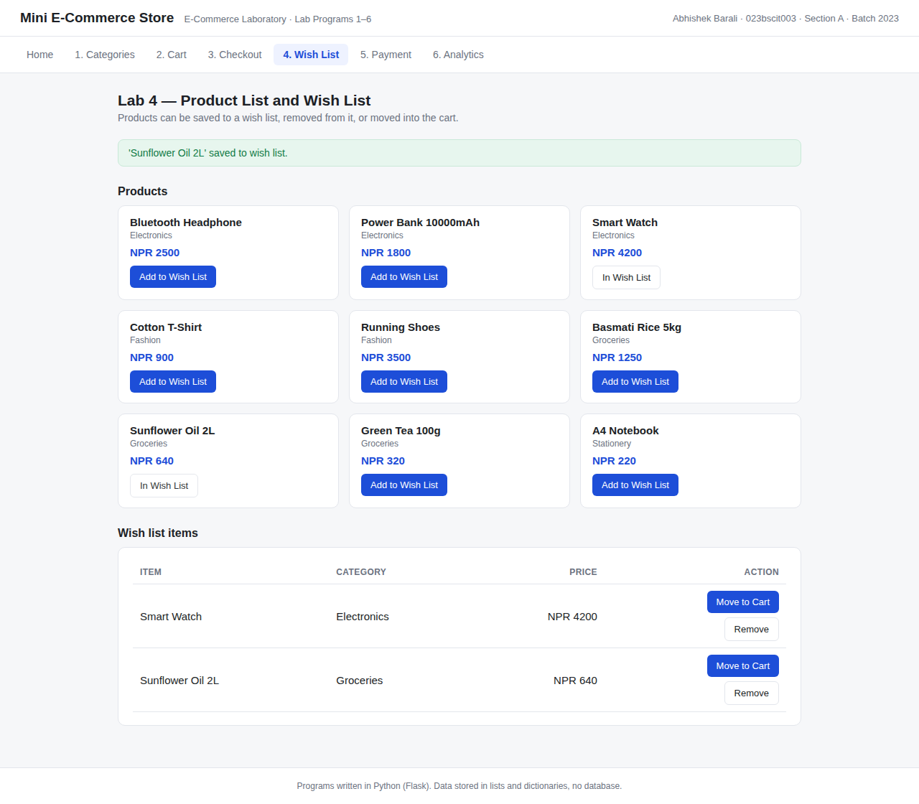
Figure 7: Lab 4 output. Smart Watch and Sunflower Oil 2L are saved in the wish list, and their buttons now read 'In Wish List'.
Lab 5: Payment Gateway Integration (Sandbox)
Objective
Integrate a payment gateway of choice into an e-commerce page. eSewa was chosen, and it is used in test (sandbox) mode.
Logic used
- The payment page shows the order summary: cart subtotal, delivery charge and the amount payable.
- Pressing 'Pay with eSewa' posts the amount and the merchant product code EPAYTEST to the gateway screen, which is how the live integration also starts.
- The gateway screen asks for the eSewa ID, password and token. The values used are the published sandbox test credentials, so no real account and no real money is involved.
- The program verifies the credentials, generates a transaction reference, and records the payment with a status of COMPLETE or FAILED.
- The result page shows the gateway response, and every attempt is kept in a payment log.
Source code
"""Lab 5 - Payment gateway integration (sandbox / test mode).

The flow copies how eSewa's test environment works: the store sends the
amount and a product code to the gateway, the customer confirms with the
published sandbox test credentials, and the gateway sends back a
transaction reference with a status. Nothing here touches real money and no
live API key is used, so the program can be run offline.
"""
import random
import string
from datetime import datetime

from flask import Blueprint, render_template, request, redirect, url_for

from store import data

lab5 = Blueprint("lab5", __name__)

# Published sandbox test credentials (test mode only, not a real account).
SANDBOX = {"merchant_code": "EPAYTEST", "esewa_id": "9806800001",
"password": "Nepal@123", "token": "123456"}

DELIVERY_CHARGE = 100

def reference():
return "TXN-" + "".join(random.choices(string.ascii_uppercase + string.digits,
k=8))

def payable():
"""Amount to pay: cart total plus delivery, or a demo amount if cart is empty."""
subtotal = data.cart_total() or 2500
return subtotal, DELIVERY_CHARGE, subtotal + DELIVERY_CHARGE

@lab5.route("/lab5")
def page():
subtotal, delivery, total = payable()
return render_template("lab5.html", active="lab5", subtotal=subtotal,
delivery=delivery, total=total, sandbox=SANDBOX,
payments=data.payments)

@lab5.route("/lab5/gateway", methods=["POST"])
def gateway():
"""The gateway screen. In a live setup this page is hosted by eSewa."""
return render_template("lab5_gateway.html", active="lab5",
amount=int(request.form.get("amount", 0)),
sandbox=SANDBOX, error=request.args.get("error"))

@lab5.route("/lab5/verify", methods=["POST"])
def verify():
"""Verify the sandbox credentials and record the payment result."""
amount = int(request.form.get("amount", 0))
ok = (request.form.get("esewa_id") == SANDBOX["esewa_id"]
and request.form.get("password") == SANDBOX["password"]
and request.form.get("token") == SANDBOX["token"])

record = {
"ref": reference(),
"amount": amount,
"method": "eSewa (Sandbox)",
"status": "COMPLETE" if ok else "FAILED",
"time": datetime.now().strftime("%Y-%m-%d %H:%M:%S"),
}
data.payments.append(record)
return redirect(url_for("lab5.result", ref=record["ref"]))

@lab5.route("/lab5/result")
def result():
record = next((p for p in data.payments if p["ref"] == request.args.get("ref")),
None)
return render_template("lab5_result.html", active="lab5", record=record,
payments=data.payments)
labs/lab5_payment.py - sandbox payment flow and verification
Output
The order amount was sent to the gateway, the sandbox credentials were verified, and the gateway returned a transaction reference with the status COMPLETE. Since this runs in test mode, no live merchant key is used and no real money is transferred.
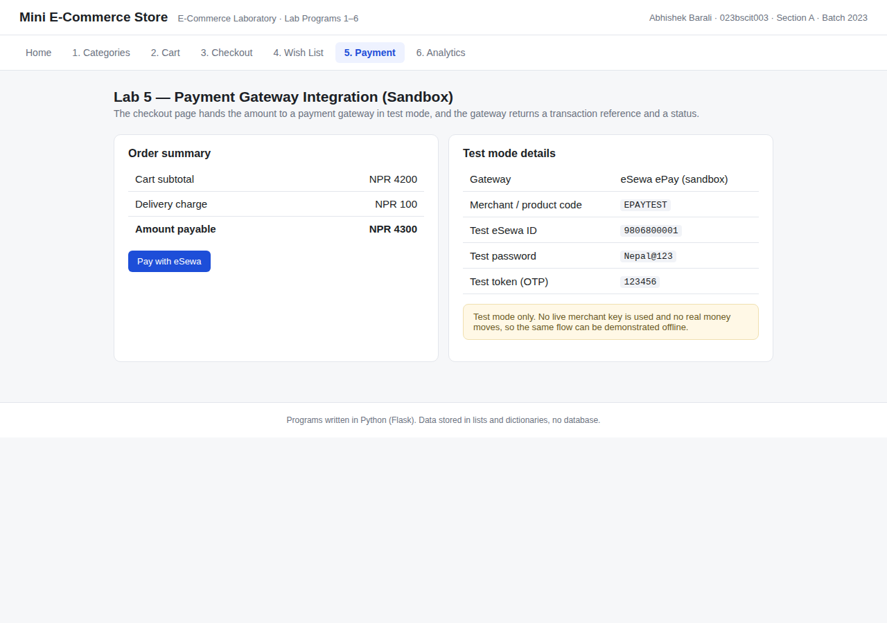
Figure 8: Lab 5. The e-commerce payment page with the order summary and the test mode details.
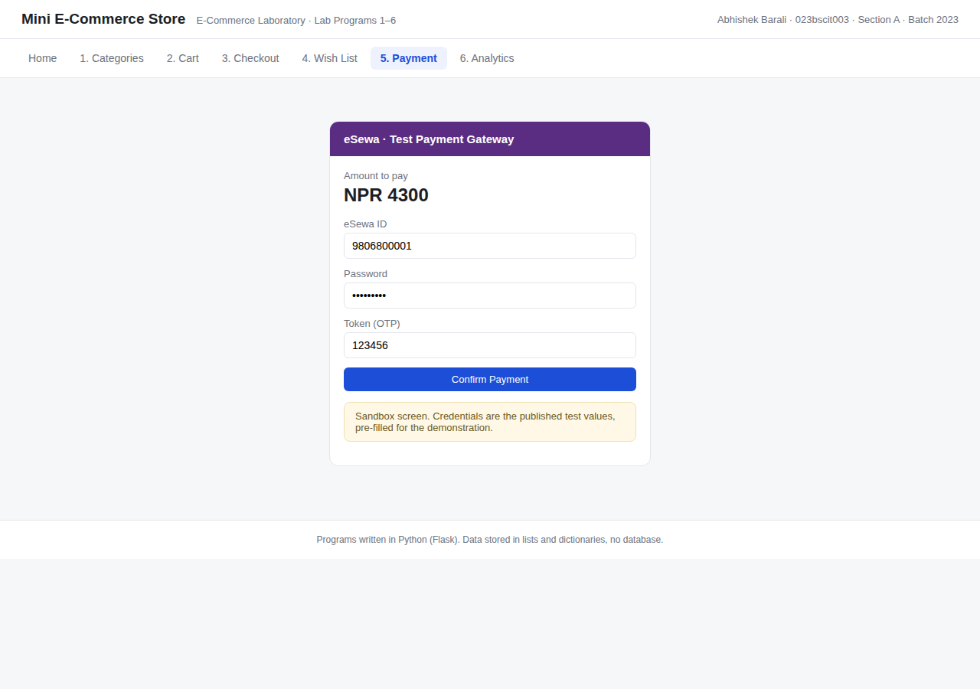
Figure 9: Lab 5. The sandbox gateway screen showing the amount of NPR 4300 to be paid.
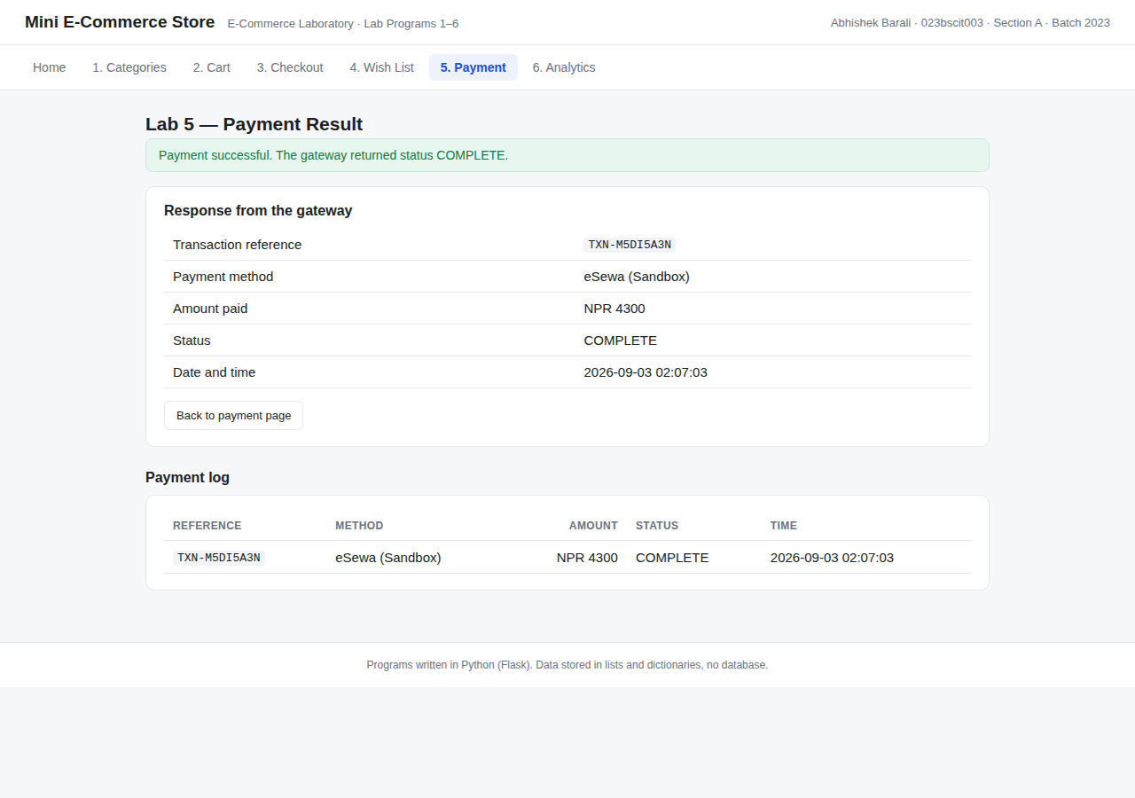
Figure 10: Lab 5 output. The gateway returned status COMPLETE with a transaction reference, and the payment is stored in the payment log.
Lab 6: Google Analytics Setup and Analytics Parameters
Objective
Set up Google Analytics on the store and determine the analytics parameters that should be measured.
Logic used
- A Google Analytics 4 property with a Web data stream gives a Measurement ID of the form G-XXXXXXXXXX.
- The gtag.js tracking snippet is pasted inside the <head> of the shared layout templates/base.html, so all six lab pages report a page view with one copy of the code.
- Enhanced measurement covers page views, scrolls and outbound clicks automatically, so no extra code is needed for those.
- The store also fires the standard e-commerce events view_item, add_to_cart, begin_checkout and purchase, each with parameters such as item_name, value and currency.
- Every fired event is also stored locally and displayed in a table, so the parameters being collected can be seen directly on the page.
- The parameters read from the GA4 reports are listed in the table below.
Source code
"""Lab 6 - Google Analytics setup and analytics parameters.

The GA4 gtag.js snippet lives in templates/base.html, so every page of the
store reports a page_view to the configured Measurement ID. This program
also fires the standard GA4 e-commerce events and keeps a local copy of each
event with its parameters, so the parameters being measured can be seen and
screenshotted without opening the Google Analytics dashboard.
"""
from datetime import datetime

from flask import Blueprint, render_template, request, redirect, url_for

from store import data

lab6 = Blueprint("lab6", __name__)

MEASUREMENT_ID = "G-XXXXXXXXXX" # replace with the real ID from the GA4 property

# GA4 events fired by this store, with the parameters sent along with them.
EVENT_LIBRARY = {
"page_view": {"page_title": "Mini E-Commerce Store", "page_location": "/lab6"},
"view_item": {"item_id": "3", "item_name": "Smart Watch",
"item_category": "Electronics", "value": 4200, "currency": "NPR"},
"add_to_cart": {"item_id": "1", "item_name": "Bluetooth Headphone",
"item_category": "Electronics", "quantity": 1,
"value": 2500, "currency": "NPR"},
"begin_checkout": {"items": 2, "value": 4300, "currency": "NPR"},
"purchase": {"transaction_id": "TXN-DEMO01", "value": 4400,
"shipping": 100, "currency": "NPR", "items": 2},
}

# The parameters that are read from the GA4 reports for this store.
PARAMETERS = [
("Users / Active users",
"How many different people opened the store", "Realtime"),
("Sessions",
"Number of visits, a session ends after 30 minutes idle", "Acquisition"),
("Views (page_view)",
"Pages opened, collected automatically by gtag.js", "Engagement > Pages"),
("Engagement rate",
"Sessions of 10s or more, with 2 views or an event", "Engagement"),
("Average engagement time",
"Time the page was actually in the foreground", "Engagement"),
("Event count",
"How many times each event such as add_to_cart was fired", "Events"),
("Conversions",
"Events marked as key events, purchase in this store", "Admin > Events"),
("Item revenue / value",
"Money value sent with the e-commerce events", "Monetisation"),
("Traffic source / medium",
"Where the visitor came from, e.g. google / organic", "Acquisition"),
("Device, browser, country",
"Dimensions collected automatically for each visitor", "Tech reports"),
]

@lab6.route("/lab6")
def page():
return render_template("lab6.html", active="lab6", measurement_id=MEASUREMENT_ID,
library=EVENT_LIBRARY, parameters=PARAMETERS,
events=list(reversed(data.events)))

@lab6.route("/lab6/track/<event_name>", methods=["POST"])
def track(event_name):
params = EVENT_LIBRARY.get(event_name)
if params:
data.events.append({
"name": event_name,
"params": params,
"time": datetime.now().strftime("%H:%M:%S"),
})
return redirect(url_for("lab6.page"))

@lab6.route("/lab6/clear", methods=["POST"])
def clear():
data.events.clear()
return redirect(url_for("lab6.page"))
labs/lab6_analytics.py - events fired and parameters measured
<!-- Lab 6: Google Analytics 4 (gtag.js) tracking snippet.
G-XXXXXXXXXX is the Measurement ID from the GA4 property. -->
<script async src="https://www.googletagmanager.com/gtag/js?id=G-XXXXXXXXXX"></script>
<script>
window.dataLayer = window.dataLayer || [];
function gtag(){dataLayer.push(arguments);}
gtag('js', new Date());
gtag('config', 'G-XXXXXXXXXX');
</script>
</head>
templates/base.html - the GA4 tracking snippet in the page head
Output
The tracking snippet was installed site wide, the e-commerce events were fired and captured with their parameters, and the parameters to be monitored were written down.
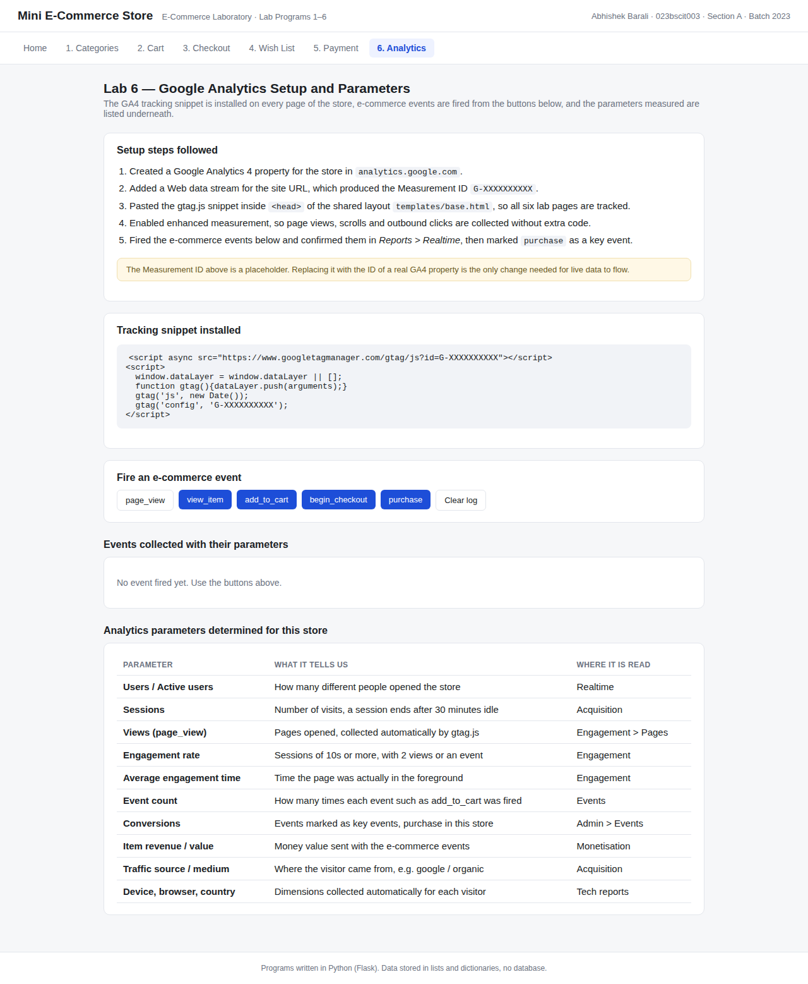
Figure 11: Lab 6. Setup steps and the tracking snippet installed on every page.
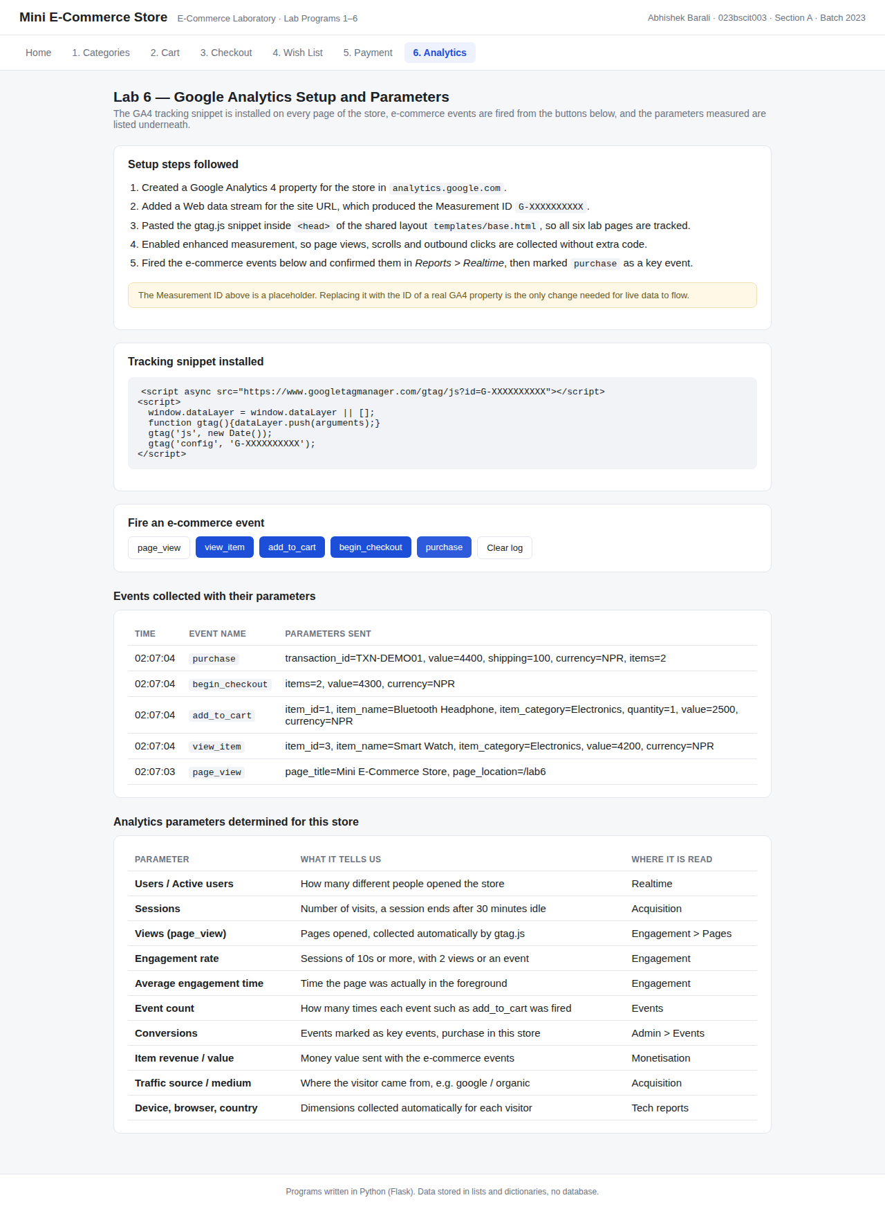
Figure 12: Lab 6 output. Five e-commerce events were fired and each one is listed with the parameters sent, followed by the analytics parameters determined for the store.
Analytics parameters determined
Parameter | What it tells us | GA4 report
Users / Active users | How many different people opened the store | Realtime
Sessions | Number of visits; a session ends after 30 minutes idle | Acquisition
Views (page_view) | Pages opened, collected automatically by gtag.js | Engagement > Pages
Engagement rate | Sessions lasting 10s or more, with 2+ views or an event | Engagement
Average engagement time | Time the page was actually in the foreground | Engagement
Event count | How many times each event such as add_to_cart was fired | Engagement > Events
Conversions | Events marked as key events; purchase in this store | Admin > Events
Item revenue / value | Money value sent with the e-commerce events | Monetisation
Traffic source / medium | Where the visitor came from, e.g. google / organic | Acquisition
Device, browser, country | Dimensions collected automatically for each visitor | Tech, Demographics

Note: the Measurement ID in the code is a placeholder. Replacing it with the ID of a real GA4 property is the only change needed for live data to start flowing into the reports.
Conclusion
All six programs of the E-Commerce Laboratory were completed as one small working store. Labs 1 to 4 covered the catalogue side of an online shop: categories and items, the cart, checkout into an order, and the wish list, all of them using plain lists and dictionaries instead of a database. Lab 5 connected the order amount to a payment gateway running in sandbox mode, and Lab 6 added Google Analytics tracking along with the list of parameters worth measuring for such a store.
Building the labs on shared data made the relationship between them clear: the same product list feeds the cart, the cart feeds the order, the order feeds the payment, and the actions along the way are exactly the events that analytics measures.

