The technologies encompasses domains of Computer Vision and Deep Learning models like CNN, R-CNN, LSTM. The dataset consists of 500+ videos scraped off internet and categorized into violent and non-violent activities.

We tried and tested various architectures for this project. A brief summary and stats for each is given below:

Customised CNN Model: The customised CNN model with optimised parameters performed well on the training and sufficiently good in the test dataset. The architecture is currently being used by the website and test.ipynb file.

Accuracy on training: 0.7990

Loss on training: 0.4292

Val_loss: 0.7605

Val_accuracy: 0.6680

Optimizer: Adam

Loss: BinaryCrossEntropy

Epochs: 50

steps_per_epoch: 50

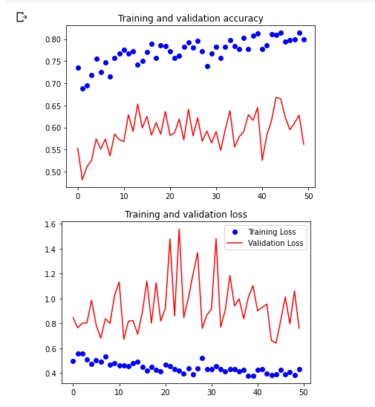

VGG Net: VGGNet Architecture displayed an accuracy of 60% on training and 55% on testing dataset.

Testing Accuracy: 0.5513

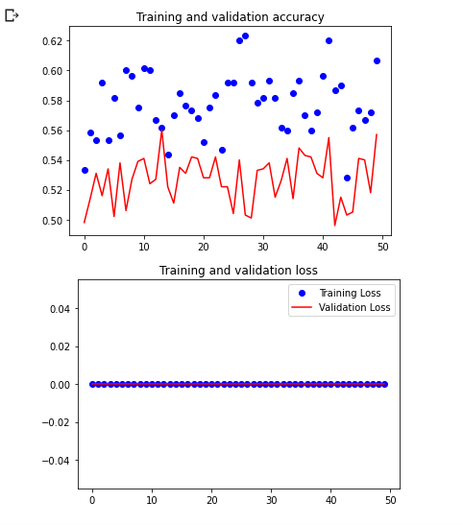

AlexNet: AlexNet showed accuracy of 57% on training and a similar accuracy on the testing dataset.

Testing Accuracy: 0.5729

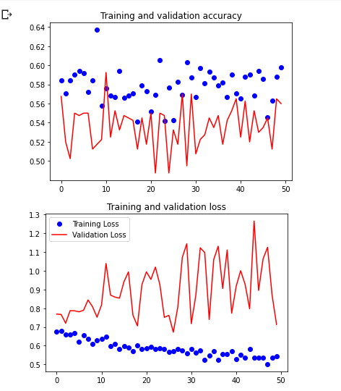

Inception+CustomisedCNN: Using transfer learning of Inception Architecture and passing it to CustomisedCNN trained the model with satisfactory results.

Training_accuracy: 89%

Validation_accuracy: 76%

Epochs: 30

Steps per Epoch: 100

Optimizer: RMSprop with LR 0.0001

Loss: Binarycrossentropy

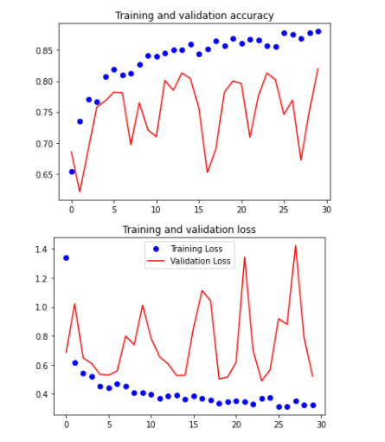

Dataset : https://www.kaggle.com/datasets/webadvisor/real-time-anomaly-detection-in-cctv-surveillance