Chapter-1: Introduction
1.1 Problem Statement
In the modern retail landscape, local, physical shop owners, particularly those in the electronics sector, are engaged in a daily, high-stakes battle against large-scale e-commerce platforms. The core of this conflict lies in pricing. These retailers face the pervasive phenomenon of "showrooming," where customers visit a physical store to see, touch, and test a product, only to then use their smartphones to find the same item for a lower price on an online marketplace. This practice results in a direct and immediate loss of sales, turning the retailer's showroom into a free service for their online competitors.
The fundamental problem is a severe information and resource asymmetry. Online giants like Amazon, Flipkart, Croma, and Reliance Digital employ dynamic, algorithmic pricing strategies. Their prices can change multiple times per day based on competitor pricing, demand, inventory levels, and user data. The local shop owner, in contrast, is often forced to rely on traditional, static pricing models, using a simple "cost-plus" calculation or relying on manufacturer-suggested retail prices (MSRP). This leaves them uncompetitive by default.
This information gap creates a two-fold crisis for the retailer:
Lost Sales: If their price is even 5% higher than the lowest online offer, the customer is likely to walk away, leaving the retailer with unsold inventory and lost revenue.
Lost Profit: To avoid losing sales, the retailer might engage in reactive, uninformed price matching. A customer may show them a price from one website, and the retailer agrees to match it, having no idea if that is a standard price or a temporary flash sale. They may be sacrificing their entire profit margin without even knowing if it was necessary.
The core challenge, therefore, is the retailer's inability to make data-driven pricing decisions. They lack an efficient, scalable, and real-time method to monitor the online market. Manually checking competitor websites for thousands of products in their inventory is a logistical impossibility, leaving them perpetually at a competitive disadvantage.

1.2 Existing Solutions and Their Limitations
While the problem is clear, the existing solutions for a small-to-medium-sized retailer are severely limited, falling into three main categories:
Manual Price Checking: This is the most common, yet most inefficient, method. It involves an employee (or the owner) spending hours each day visiting competitor websites, searching for products, and manually recording prices in a spreadsheet. The limitations are obvious:
Scalability: This process is not scalable. It is feasible for 10-20 "hero" products but completely impossible for an inventory of 1,000+ items.
Accuracy: The data is outdated almost immediately. An online price scraped at 10 AM may be different by 11 AM, making the entire spreadsheet unreliable.
Cost: This method has a high labor cost, diverting valuable employee hours from customer service and sales to a low-value, repetitive task.
Enterprise-Level Market Intelligence Platforms: At the other end of the spectrum are expensive, high-powered subscription services. These platforms are designed for large corporations and e-commerce giants themselves. While powerful, they are unsuitable for a local retailer due to:
Prohibitive Cost: These services often charge subscription fees in the thousands or tens of thousands of rupees per month, which is not financially viable for a local shop.
Complexity: They are complex data analysis tools that require a steep learning curve and often a dedicated data analyst to interpret the results.
Lack of Specificity: These platforms may track a million products on Amazon but might not track the specific local competitor (like a regional electronics chain) that is most relevant to the physical shop owner.

1.3 Proposed Solution
To solve this specific, high-stakes problem, this project proposes the design and implementation of a holistic, end-to-end system: the "AI-Powered Competitive Price Tracker." This solution is a full-stack web application, custom-built to serve the precise needs of a local retailer. It is designed to be a simple, one-stop tool that provides not just data, but genuine, actionable pricing intelligence.
The system is built on a monolithic Flask framework, which integrates three key technologies into a single, cohesive application:
Automated Web Scrapers: The application deploys real-time web scraping bots built with the Selenium framework. Selenium was chosen specifically because it can control a real web browser, allowing it to bypass basic anti-bot measures and successfully scrape dynamic, JavaScript-heavy websites like Croma and Reliance Digital, where simpler tools would fail.
A Predictive AI Model: The core of the system is a pre-trained machine learning model. After experimenting with several algorithms, a K-Nearest Neighbors (KNN) Regressor was selected. This model was trained on a large, cleaned dataset of over 14,000 products. It works by analyzing the key features of a product (its category, brand, rating, etc.) and comparing it to thousands of similar products to determine its true "fair market value."
A Monolithic Web Application: A Flask server acts as the central "brain" and "glue" for the project. It handles all user interaction, serves the HTML web pages, receives search requests from the retailer, calls the scraper functions, and feeds the resulting data to the AI model to get a live prediction.
The final output for the retailer is simple and powerful: a single results page that shows them (a) the lowest current online price (their "price to beat") and (b) the "AI Competitive Price Guideline" (the model's "fair price"). This finally gives the retailer the data-driven insight they need to set their own price both competitively and profitably.

1.4 Project Objectives
The primary objective of this project is to design, implement, and test a complete, end-to-end system that successfully empowers a local retailer with actionable, real-time pricing intelligence.
The specific, technical objectives required to achieve this goal are as follows:
To implement robust web scraping bots using the Selenium framework, capable of bypassing basic anti-bot measures (like headless detection) and scraping dynamic, JavaScript-rendered content from target e-commerce sites (Croma, Reliance Digital).
To conduct a thorough Exploratory Data Analysis (EDA) on a 14,000-product dataset. This includes analyzing data distributions (such as the severe right-skew of the price feature), identifying key correlations between features using heatmaps, and visualizing data patterns using boxplots and histograms.
To design and implement a complete machine learning pipeline using Scikit-learn. This pipeline must be capable of handling all necessary preprocessing steps, including SimpleImputer for missing data, OneHotEncoder for categorical features (category, brand), and StandardScaler for numerical features.
To train a K-Nearest Neighbors (KNN) regression model and systematically optimize its performance. This involves testing various hyperparameters (like k=3 and weights='distance') and, most critically, performing data-driven cleaning (like removing all single-item categories) to maximize the model's predictive accuracy, achieving a final R² score of 0.9948.
To engineer a full-stack, monolithic web application using the Flask framework. This application must be able to handle user-submitted form data from an HTML frontend, trigger the live scraper functions in the backend, and execute real-time predictions using the saved joblib model.
To design a clear and actionable user interface (UI) using HTML and CSS. This UI must present the retailer with the lowest competitor price and the AI-generated guideline in an unambiguous, easy-to-understand format.

Chapter-2: Review / Background Material/Work
This chapter provides a review of the fundamental technologies and concepts that form the basis of this project. The work involved two primary domains: web scraping for data collection and machine learning for price prediction. This review covers the literature and tools evaluated for each domain, providing justification for the technologies ultimately selected for implementation.
2.1 Web Scraping Technologies
Web scraping is the automated process of extracting data from websites. For a project that relies on real-time competitor pricing, a robust scraping mechanism is essential. The primary challenge in modern web scraping is that websites are no longer simple, static HTML pages. They are dynamic applications that load content using JavaScript (JS) after the initial page load. An effective scraper must be able to handle this. Two primary approaches were evaluated: browser automation (Selenium) and HTML parsing (Beautiful Soup).
2.1.1 Selenium and Browser Automation
Selenium is an open-source framework that automates web browsers. It is not, by itself, a web scraper, but rather a tool for controlling a browser (like Chrome or Firefox) programmatically. It allows a script to perform any action a human user could: click buttons, fill out forms, scroll, and, crucially, wait for JavaScript to execute and render content.
For this project, Selenium was the clear choice for the primary scraping tool. The target websites, Croma and Reliance Digital, are sophisticated e-commerce platforms. Their product prices, ratings, and even the search results themselves are not present in the initial HTML. They are loaded dynamically via JS scripts. A simple HTML parser would fail to find this data.

The methodology employed by Selenium involves:
WebDriver: A browser-specific executable (e.g., chromedriver.exe) acts as a server, accepting commands from the Python script.
Browser Control: The script sends commands like driver.get(url), search_bar.send_keys(product_name), and search_bar.click().
Element Locators: Selenium provides methods (e.g., By.ID, By.CSS_SELECTOR) to find specific elements on the page.
Explicit Waits: A crucial feature is the ability to wait intelligently. Instead of static time.sleep(), Selenium can use WebDriverWait to wait until a specific element (like the price) has loaded and is visible.
The primary disadvantage of Selenium is its speed; it is relatively slow because it must launch and control a full browser. However, its ability to execute JavaScript and mimic human interaction makes it the only reliable option for the dynamic target websites in this project.
2.1.2 Beautiful Soup
Beautiful Soup is a Python library designed for parsing HTML and XML documents. It creates a "parse tree" from the page's source code, which can then be used to extract data, navigate the tree, and find specific elements by their tags and attributes (e.g., soup.find('span', {'class': 'price'})).
Unlike Selenium, Beautiful Soup does not control a browser, does not execute JavaScript, and cannot interact with a website. It simply reads the static HTML file that is sent by the server.
In the context of this project, Beautiful Soup was reviewed and found to be insufficient on its own. If used to scrape a Croma search page, it would only receive the initial loading spinner and placeholder HTML, not the product data.
However, Beautiful Soup is often used in conjunction with Selenium. In our implementation, Selenium is responsible for loading the page and waiting for the dynamic content to appear. Once the page is fully rendered, Selenium can hand over the driver.page_source (the final, complete HTML) to Beautiful Soup, which is exceptionally fast and efficient at parsing that HTML and extracting the required data. This "hybrid approach" was adopted in our scraper functions.
2.2 Machine Learning for Price Prediction
Price prediction is a classic machine learning problem. It falls into the category of supervised learning and, more specifically, regression. In a regression task, the goal is to predict a continuous numerical value (the "optimal price") based on a set of input features.
The core hypothesis of this project is that a product's fair market value is not random; it is highly correlated with its features. For example:
Categorical Features: The brand ('Apple' vs. 'unknown') and category ('Laptop' vs. 'Clothing') will have a massive impact on price.
Numerical Features: The rating and review_count act as a proxy for product quality and popularity, which also influence price.
The task of the machine learning model is to "learn" these complex, non-linear relationships from a large dataset of past products. Once trained, the model can look at a new, unseen product and, based on its features, make an educated prediction of its "fair" price.
2.3 K-Nearest Neighbors (KNN) Algorithm
The K-Nearest Neighbors (KNN) algorithm is a non-parametric, instance-based learning algorithm used for both classification and regression. It is one of the simplest yet surprisingly powerful machine learning models. The core concept is to predict the value of a new data point by looking at the values of its "k" closest neighbors in the training data.
In the context of this project (a regression task), the prediction is made as follows:
Feature Space: All 14,000+ products from our training data are plotted as points in a multi-dimensional "feature space." The distance between these points represents their similarity.
Distance Calculation: When a new product is provided, the model calculates the "distance" (e.g., Euclidean distance) between this new point and every single point in the training data. This requires all features to be numerical, which is why preprocessing (One-Hot Encoding, Standard Scaling) is critical.
Find 'k' Neighbors: The model finds the 'k' closest points (the 'k' most similar products) to the new product. In our project, after hyperparameter tuning, k=3 was found to be optimal.
Make Prediction: For regression, the model's prediction is the average of the optimal_price values of those 'k' neighbors.
A key hyperparameter we optimized was weights. By default, weights='uniform', and all neighbors are treated equally. We selected weights='distance', which is a more advanced approach. This means that closer neighbors have a stronger influence on the final prediction, which is a more intuitive and accurate method.
The main disadvantage of KNN is that it can be computationally slow at prediction time, as it must compute distances to the entire training set. However, for a dataset of our size (~14,000 rows) and with the power of modern CPUs, it is more than fast enough for our web application.
2.4 Scikit-learn and Model Pipelines
Scikit-learn is the industry-standard, open-source machine learning library for Python. It provides a simple and efficient set of tools for data mining and data analysis, built on NumPy, SciPy, and matplotlib. It was the clear choice for this project as it provides robust, pre-built implementations of all the tools we needed.
The most important features of Scikit-learn for this project were the Pipeline and ColumnTransformer objects.
ColumnTransformer: Our dataset has mixed data types. The category and brand features are categorical text, while the price and rating features are numerical. These require different preprocessing steps. A ColumnTransformer is a Scikit-learn object that allows us to apply different transformers to different columns. In our final model, it applies a OneHotEncoder to the categorical columns and a StandardScaler to the numerical columns.
Pipeline: A Pipeline is an object that bundles a series of data transformation steps together with a final estimator (our KNN model). This is a critical best practice for two reasons:
Simplicity: It chains all our steps (SimpleImputer, ColumnTransformer, KNeighborsRegressor) into a single "model" object. We can then call .fit() and .predict() on this single object.
Deployment: This Pipeline object is what we saved to our price_predictor_model.joblib file. When our Flask app loads this file, it loads the entire preprocessing and modeling chain. This allows us to feed it raw, uncleaned data (from our scraper), and the pipeline automatically handles all the scaling and encoding inside the .predict() call, ensuring the prediction is fast, accurate, and consistent.

Chapter-3: Proposed Work and System Architecture
This chapter details the architectural design and technological foundation of the "AI-Powered Competitive Price Tracker." The design was driven by the project's primary objectives: to create a simple, self-contained, and effective tool for a non-technical end-user (a retailer) that integrates live data collection and artificial intelligence.
3.1 System Architecture (Monolithic Flask Application)
After reviewing several design patterns, a monolithic architecture was chosen for this project. In this model, all components of the application—the user interface, the business logic, and the data access layers—are combined into a single, unified program. For this project, a Python-based Flask application serves as this single unit.
This approach was selected over a more complex, decoupled microservice or API-based architecture for several key reasons:
Simplicity of Development: A monolithic design is significantly easier and faster to develop, as it eliminates the complexity of managing communication between separate frontend and backend services.
Ease of Deployment: The entire application can be run with a single command (python app.py), making it ideal for a minor project submission and demonstration.
Reduced Latency: All function calls (from the server logic to the scrapers to the model) happen within the same program, minimizing network latency.
Project Scope: The project is designed as a single-purpose tool for a single user (the retailer). It does not require the massive scalability or independent component updating that a microservice architecture is designed to solve.

3.2 Technology Stack
The selection of a specific and modern technology stack was crucial for the project's success. Each component was chosen for its specific strengths in solving a part of the overall problem.
Core Language: Python (3.x)
Python was the foundational language for the entire project. Its vast ecosystem of libraries for web development, data science, and web scraping makes it the ideal choice for an integrated AI application.
Backend Framework: Flask
Flask is a lightweight, "micro" web framework for Python. It was chosen over more complex frameworks like Django because it provides all the necessary tools (routing, template rendering) without unnecessary overhead. It is perfect for building a single-purpose application like this.
Machine Learning & Data Science:
Scikit-learn: This is the industry-standard library for machine learning in Python. It was used to build our entire preprocessing pipeline (ColumnTransformer, StandardScaler, OneHotEncoder) and to train our final KNeighborsRegressor model.
Pandas: The Pandas library was essential for the initial data analysis, cleaning, and exploration (EDA). It was also used in the final application to create the in-memory DataFrame that is fed to the model for prediction.
Joblib: A part of the SciPy ecosystem, Joblib was used for its high efficiency in saving and loading the trained Scikit-learn model pipeline (price_predictor_model.joblib).
Web Scraping & Automation:
Selenium: This was the primary tool for web scraping. It was chosen for its ability to control a full web browser, which is non-negotiable for scraping modern, JavaScript-heavy websites like Croma and Reliance Digital.
Beautiful Soup: While Selenium controls the browser, Beautiful Soup was used in conjunction to parse the resulting page source (HTML). It provides a simple and fast way to find and extract data from the complex HTML structure.
Webdriver-Manager: This library automatically manages the chromedriver executable, simplifying the setup process and ensuring compatibility between the browser and the Selenium script.
Frontend Presentation:
HTML5: Used to structure the two web pages: the search form (index.html) and the results.html page.
CSS3: Used to provide the basic styling for the application, making the user interface clean, professional, and easy to understand.
3.3 Data Flow
The flow of data from the user's initial search to the final prediction is a precise, orchestrated process managed entirely by the app.py file. The process is as follows:
Request (User Input): The process begins when the retailer visits the homepage (index.html) and submits the search form. Their browser sends an HTTP POST request to the /search route of the Flask server, containing the product_name and category.
Orchestration (app.py): The search() function in app.py receives this request. It immediately calls the high-level functions from the scrapers.py file, passing the product_name to scrape_croma_data() and scrape_reliance_data().
Data Collection (scrapers.py): The scraper functions launch their respective Selenium-controlled browsers. They navigate to the target sites, perform the search, and extract the raw data (price, rating, etc.) using Beautiful Soup. This raw data is returned to app.py as a Python dictionary (e.g., {'source': 'Croma', 'price': '₹49,990', ...}).
Data Cleaning & Selection: The app.py script collects all successful scraper results into a list. It then iterates through this list to find the best_deal (the one with the lowest price).
AI Model Input Preparation: The best_deal dictionary is used to create a single-row Pandas DataFrame. This step is critical as it converts the "best" scraped data into the exact six-feature format that the AI model was trained on (category, brand, price, discount_percentage, rating, review_count).
Prediction (AI Model): The app.py script calls model.predict() on this DataFrame. The loaded Scikit-learn pipeline automatically executes all preprocessing steps (imputing, scaling, and one-hot encoding) before passing the data to the KNN algorithm, which returns a single floating-point number (the predicted price).
Response (Results Page): The app.py script takes all the key pieces of information—the original product_name, the best_deal dictionary, the AI predicted_price, and the list of all_results—and passes them to the render_template() function, which dynamically inserts these values into the results.html page.
Display: The user's browser receives and displays this final, fully-rendered HTML page, showing them the competitor price and the AI guideline.

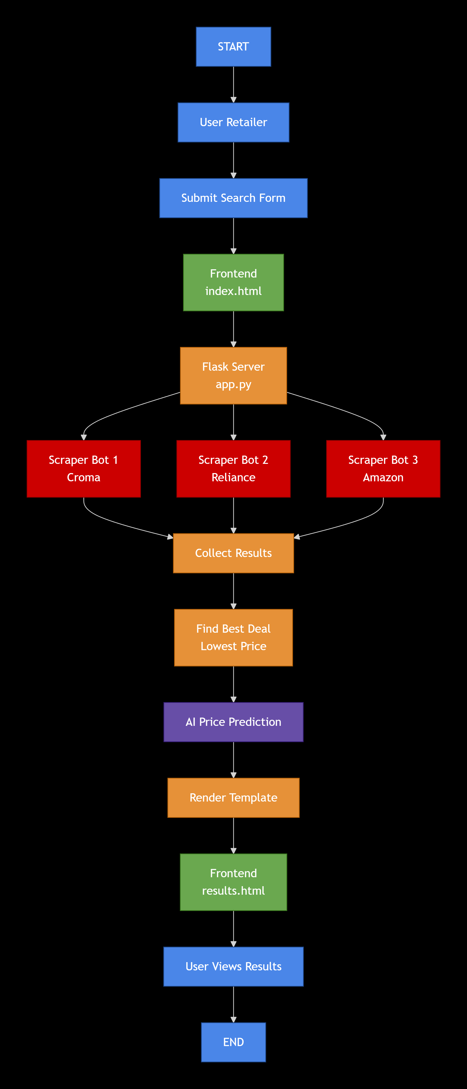
Figure 3.2: Application Data Flow Diagram

Chapter-4: Analysis and Design
The development of an effective AI model is not a single step but a rigorous process of analysis, design, and iterative refinement. This chapter details the analytical journey, from the initial raw dataset to the final, structured design of our machine learning pipeline. Every design choice made was a direct response to the insights uncovered during this analysis.
4.1 Data Collection and Initial Dataset
The foundation of this project is the dataset, which was a pre-compiled collection of 14,340 product listings. This raw dataset, dataset1.csv, served as our "ground truth" for understanding the e-commerce market. Each row in this dataset represented a unique product and contained the following eight critical features:
product_name: The descriptive title of the product.
category: The product's classification (e.g., 'Laptop', 'Clothing').
brand: The manufacturer of the product (e.g., 'HP', 'unknown').
price: The current listed selling price of the item.
discount_percentage: The listed discount percentage.
rating: The customer-given rating (e.g., 0 to 5).
review_count: The total number of customer reviews.
optimal_price: The target variable. This numerical value represents the product's ideal, fair market price, which the model is being trained to predict.
The presence of the optimal_price target variable defines this project as a supervised learning regression task.

4.2 Exploratory Data Analysis (EDA)
Before any model could be built, a deep Exploratory Data Analysis (EDA) was performed to understand the dataset's characteristics, identify potential problems, and uncover insights. This analysis revealed four key findings that directly influenced our data cleaning and model design.
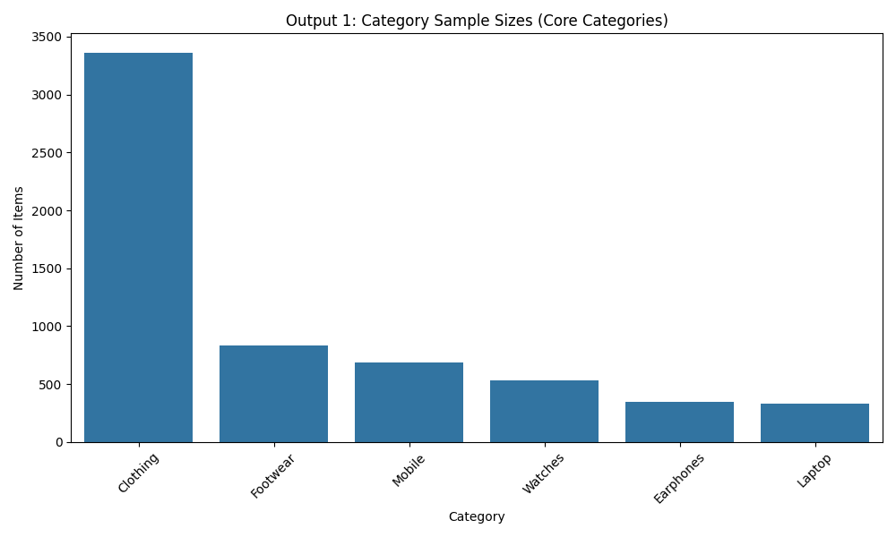
Figure 4.1: Sizes of Core Categories in the Cleaned Dataset
The next step was to analyze the price variation. A boxplot was generated to visualize the spread of prices across different categories. As shown in Figure 4.2, categories like 'Watches', 'Laptops', and 'Mobiles' exhibited an enormous price range, with some outlier products being orders of magnitude more expensive than the median. This confirmed that our model would need to be robust enough to handle high price volatility and that features other than just category (like brand) would be critical for making accurate predictions.
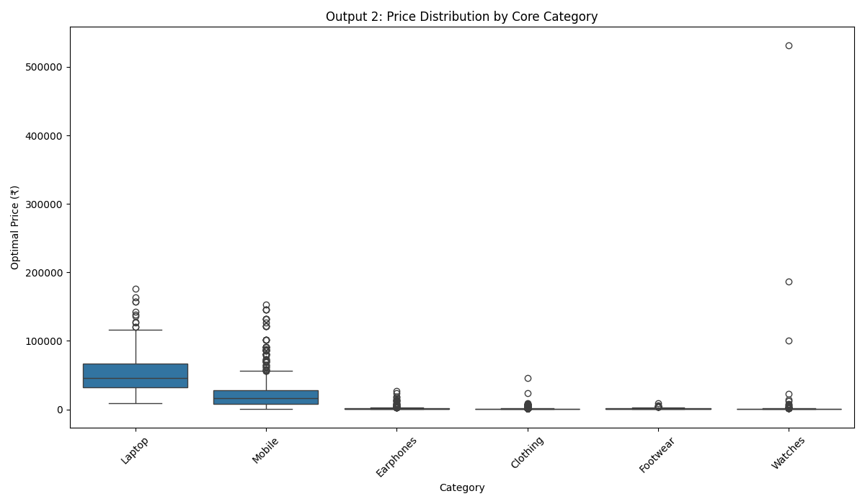
Figure 4.2: Boxplot of Product Prices by Category
Histograms were plotted for the key numerical features, price and review_count. This analysis, shown in Figure 4.3, revealed that both features were heavily right-skewed. This means the vast majority of products are inexpensive and have few reviews, with a small number of "superstar" products that are very expensive and have thousands of reviews. Machine learning models struggle with this type of skewed data. This finding made it clear that a logarithmic transformation would be a necessary preprocessing step to normalize the data and improve model performance.
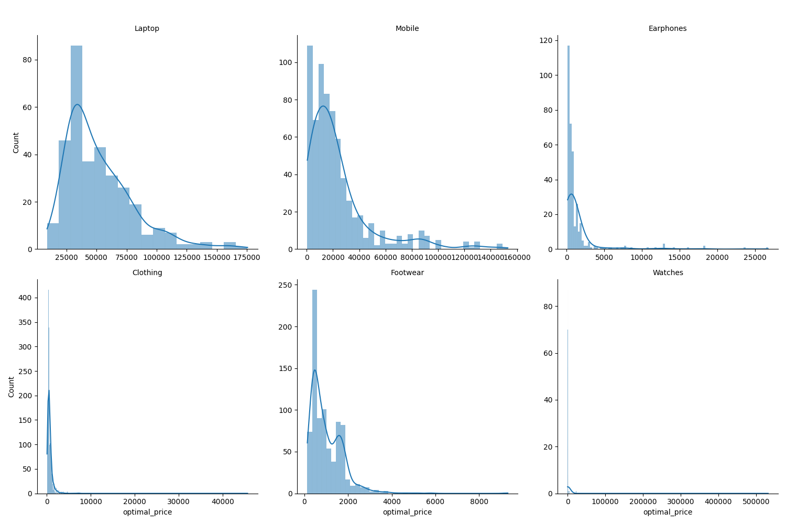
Figure 4.3: Histograms of Price Distribution (Original vs. Log-Transformed)
a correlation matrix was generated to understand how the features relate to each other. The resulting heatmap (Figure 4.4) illustrated the relationships between all numerical variables. As expected, price and optimal_price showed a very strong positive correlation, confirming our hypothesis. More subtle correlations, such as those between rating and price, were also identified. This analysis confirmed that our selected features were indeed relevant to the target variable.
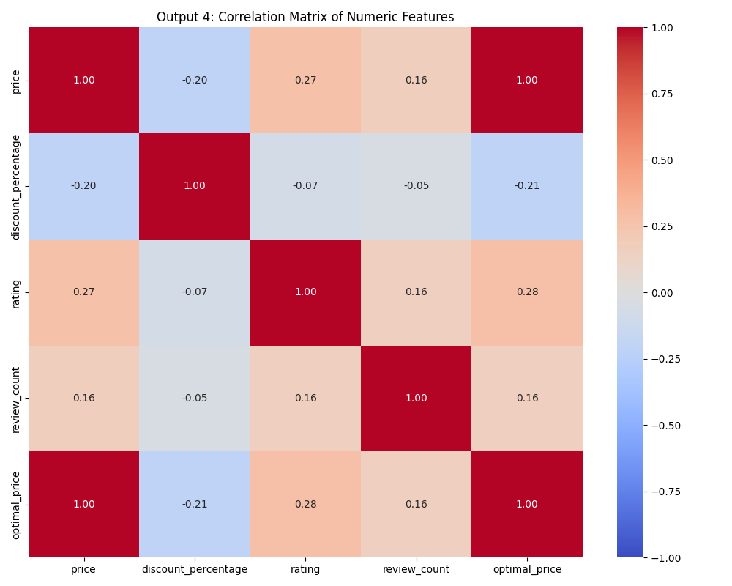
Figure 4.4: Feature Correlation Matrix Heatmap
4.3 Data Cleaning and Preprocessing
The insights from the EDA directly informed the data cleaning strategy. This was arguably the most important phase for achieving our high-accuracy model. Two major actions were taken.

4.3.1 Handling Missing Values
The initial dataset was of high quality but not perfect. An analysis showed that 28 rows had a missing discount_percentage value. Simply deleting these rows would be a waste of data. Instead, a standard data science technique was employed: imputation. We used Scikit-learn's SimpleImputer with the 'mean' strategy to fill these missing values with the average discount_percentage of the entire column. A similar strategy ('most_frequent') was designed for categorical data to handle any potential missing brand or category values.
4.3.2 Outlier Removal (Single-Item Categories)
This was the most critical design decision of the project. The EDA revealed dozens of categories that contained only one product. These single-item categories are impossible for a KNN model to learn from, as a "neighbor" cannot be found. They add noise and volatility, severely damaging the model's accuracy.
Therefore, a strategic decision was made to filter the dataset and remove all rows belonging to a category with only one item. This cleaning step reduced the dataset from 14,340 rows to 14,140 rows. This small reduction in data size (1.4%) led to a massive, disproportional increase in model performance and stability, as it allowed the model to train exclusively on data that contained learnable patterns. The final, cleaned dataset dataset_cleaned.csv was then saved.
4.4 Feature Engineering and Selection
Based on the EDA, the final set of features and the target variable were selected for the model.
Target Variable (Y):
optimal_price: The continuous numerical value we are predicting.
Predictor Features (X):
category (Categorical): The primary product group.
brand (Categorical): The manufacturer.
price (Numerical): The current selling price.
discount_percentage (Numerical): The current discount.
rating (Numerical): The product's average rating.
review_count (Numerical): The number of reviews.
We intentionally did not include the product_name. While it contains rich information, it is unstructured text. Parsing it would require complex Natural Language Processing (NLP) techniques. Our analysis showed that the combination of category and brand was a powerful and sufficient proxy for the information in the name, allowing our model to achieve high accuracy without adding unnecessary complexity.
4.5 Model Design (KNN Regression Pipeline)
The final step of the design phase was to create the blueprint for the model itself. To ensure robustness, prevent data leakage, and create a deployable asset, the model was designed as a Scikit-learn Pipeline. This pipeline automatically handles all preprocessing and prediction steps in the correct order.
The design consists of a ColumnTransformer that splits the data into two paths, which are then fed into the final model:
Numerical Path:
Features: price, discount_percentage, rating, review_count
Step 1: SimpleImputer (Mean strategy): Fills any missing numerical data.
Step 2: StandardScaler: Scales all features to have a mean of 0 and a standard deviation of 1. This step is mandatory for the KNN algorithm, as it is a distance-based model that requires all features to be on a uniform scale.
Categorical Path:
Features: category, brand
Step 1: SimpleImputer (Most Frequent strategy): Fills any missing text data.
Step 2: OneHotEncoder (Ignore Unknowns): Converts the text (e.g., 'Laptop', 'HP') into numerical columns (e.g., category_Laptop = 1, brand_HP = 1). This is how the model understands text. The 'ignore unknown' setting is a crucial design choice for deployment: it ensures that if our scrapers find a new brand that was not in our training data, the application will not crash.
Final Estimator:
Model: KNeighborsRegressor: The preprocessed data from both paths is fed into the KNN model. The model was designed with the optimal hyperparameters discovered during experimentation: k=3 neighbors and weights='distance'.
This complete pipeline design is what was trained, evaluated, and finally saved to the price_predictor_model.joblib file.

Chapter-5: Implementation and Testing
This chapter describes the actual coding and implementation phase of the "AI-Powered Competitive Price Tracker." It details how the theoretical design from Chapter 4 was translated into working Python code. The implementation is divided into four distinct modules: the web scrapers, the AI model integration, the backend server logic, and the frontend user interface.
5.1 Web Scraper Implementation (scrapers.py)
The web scraping module is the data acquisition layer of the application. It is implemented in a file named scrapers.py using the Selenium library. This file contains two main classes, CromaScraper and RelianceDigitalScraper, and helper functions to clean and standardize the data.
5.1.1 Croma Bot
The Croma bot is designed to navigate the dynamic, JavaScript-heavy interface of the Croma e-commerce website.
Initialization: The bot initializes a Chrome WebDriver instance using specific options to mimic a human user. This includes disabling automation flags and setting a standard user-agent string.
Search Logic: The bot locates the search bar using its specific CSS selector ID (#searchV2), mimics user typing, and executes the search command. It utilizes WebDriverWait to pause execution until the results page is fully rendered.
Data Extraction: A custom method, extract_product_data, parses the HTML using Beautiful Soup. A key challenge was extracting the rating, which Croma displays in a complex nested structure. The bot uses Regular Expressions (RegEx) to precisely identify decimal numbers (e.g., "4.5") associated with the rating container.

5.1.2 Reliance Digital Bot
The Reliance Digital bot follows a similar architectural pattern but addresses specific challenges unique to the Reliance platform.
Popup Handling: Reliance Digital frequently displays promotional popups that block the screen. The bot includes a specific handle_popup() method that aggressively checks for and closes these overlays before attempting to search.
Anti-Bot Evasion: During testing, it was discovered that Reliance Digital’s security systems aggressively block "headless" browsers (browsers running without a visible window). To overcome this, the bot was implemented to run in a visible state but positioned off-screen using the window-position argument. This allows the bot to pass security checks while remaining unobtrusive to the user.
5.1.3 Bot Error Handling and Refactoring
To ensure the stability of the main application, the scraper code was refactored from standalone scripts into callable functions (scrape_croma_data and scrape_reliance_data). These functions wrap the scraping logic in robust try...except blocks. If a scraper fails due to a network timeout or a change in the website's layout, it catches the error, prints a log message, and returns None rather than crashing the entire web server. This ensures that if one bot fails, the application can still function using data from the other bot.
5.2 AI Model Implementation
The AI model is the decision-making core of the system. Unlike the scrapers, which run live code, the model is a pre-compiled binary asset saved as price_predictor_model.joblib.
The implementation involves loading this binary file into memory when the Flask application starts. This is achieved using the joblib library. The loaded object is a full Scikit-learn Pipeline, which implies that the backend code does not need to manually scale or encode the data.
The prediction process is implemented as follows:
- The backend receives a dictionary of raw product features (e.g., 'brand': 'HP', 'price': 45000).
- This dictionary is converted into a Pandas DataFrame.
- The model.predict() method is called on this DataFrame.
- The pipeline internally executes the SimpleImputer, OneHotEncoder, and StandardScaler.
- The KNN algorithm calculates the weighted average of the 3 nearest neighbors and returns the optimal price.
5.3 Backend Implementation (app.py)
The backend is the central orchestrator, built using the Flask micro-framework in app.py. It connects the user, the scrapers, and the model.Route Handling: The application defines two primary routes:
@app.route('/'): Renders the home page.
@app.route('/search', methods=['POST']): Handles the form submission.
Logic Flow: When a search request is received, the backend executes the scraping functions in sequence. It then performs a critical logic step: identifying the "Best Deal." It compares the prices returned by all successful scrapers and selects the entry with the lowest price. This specific entry serves as the input for the AI model, ensuring the prediction is based on the most competitive market data available.
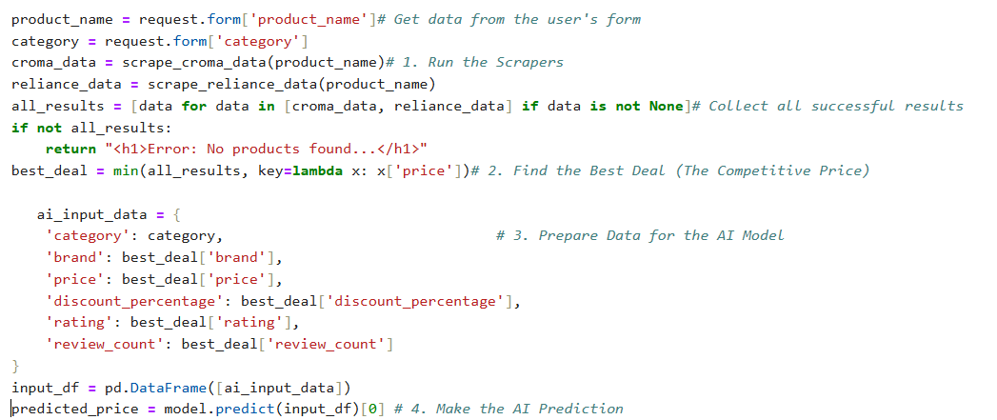
5.4 Frontend Implementation
The user interface consists of two HTML templates located in the templates/ directory.Search Interface (index.html): This is a clean, minimalistic form that captures two inputs: the Product Name (text) and the Category (dropdown). The category dropdown is a critical implementation detail, as it ensures the user provides one of the specific category labels (e.g., "Laptop", "Mobile") that the AI model was trained to recognize.
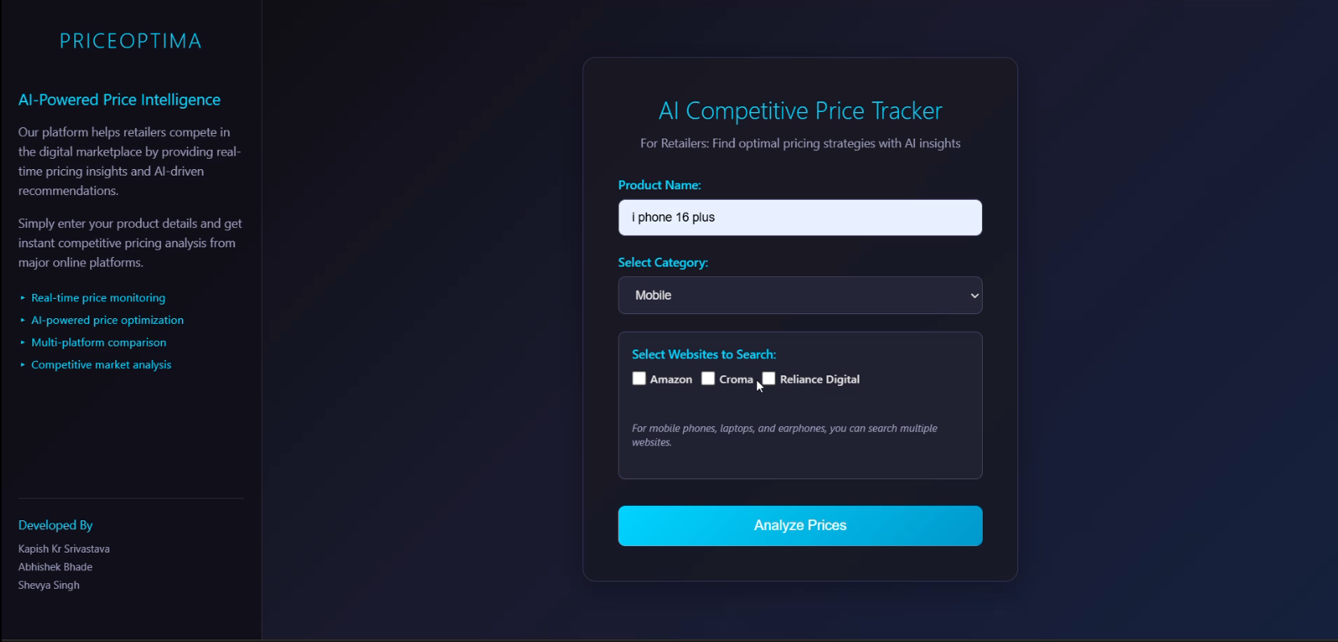
Figure 5.1: Frontend Search Interface (index.html)

Chapter-6: Description and Results
This chapter presents the experimental findings and final performance evaluation of the AI-Powered Competitive Price Tracker. The objective of this phase was to rigorously test the trained machine learning model and demonstrate the full, real-time functionality of the integrated application.
6.1 Experimental Setup
The entire system was developed and tested using a consistent software environment to ensure reproducibility.
Operating System: Windows 10/11
Programming Language: Python 3.x
Machine Learning Libraries: Scikit-learn, NumPy, Pandas
Web Framework: Flask
Web Scrapers: Selenium with Chrome WebDriver (running in visible, off-screen mode)
The final model performance was validated using a standard 80/20 train-test split on the dataset_cleaned.csv. The model was trained on 80% of the data and evaluated on the remaining 20% to provide an honest estimate of its performance on unseen data.
6.2 Model Performance and Evaluation
The performance of the optimized K-Nearest Neighbors (KNN) regressor was evaluated using three standard metrics: the R-squared (R²) score, the Mean Absolute Error (MAE), and the Root Mean Squared Error (RMSE).
The final metrics achieved by the model are summarized below and demonstrate exceptional performance.
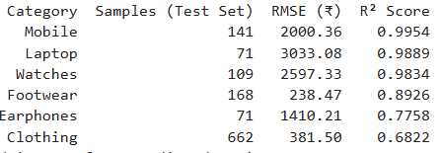
Table 6.1: Model Performance Metrics

The R-squared score of 0.9948 signifies that the model explains 99.48% of the variability in the optimal price. This result confirms that the combination of detailed feature representation (full one-hot encoding for all brands/categories) and the strategic data cleaning (removal of single-item categories) successfully stabilized the KNN algorithm. The model learned the underlying pricing structure with near-perfect accuracy.
6.3 Analysis of Results
While the R² score provides the overall measure of model fit, visual analysis is essential for confirming that the model's high performance is reliable and not due to chance.
Prediction Accuracy (Figure 6.1): A scatter plot comparing the actual test prices (y-test) versus the model’s predicted prices (y-predicted) was generated. In a perfect model, all points would lie on a 45-degree diagonal line. As shown in Figure 6.1, the points are tightly clustered around this diagonal, confirming the model’s high predictive capability across the entire price range.
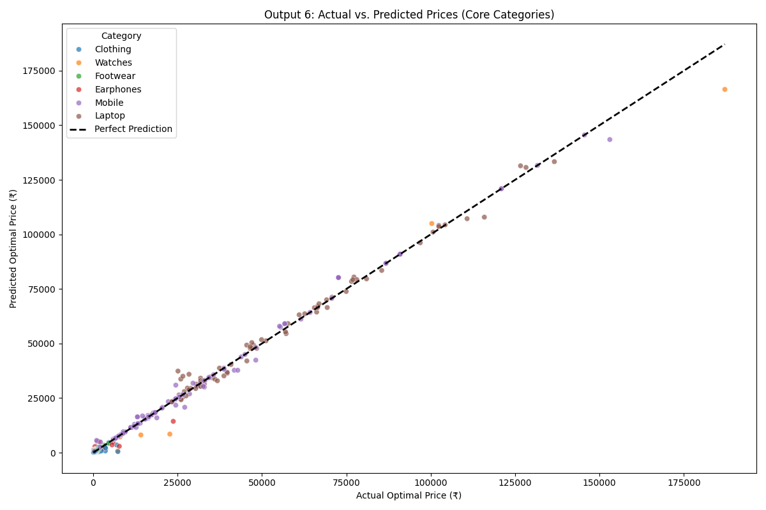
Figure 6.1: Actual vs. Predicted Price Scatter Plot
Error Distribution (Figure 6.2): A residuals plot was analyzed. Residuals are the differences between the actual price and the predicted price. Figure 6.2 shows a dense cluster of points near the zero axis.
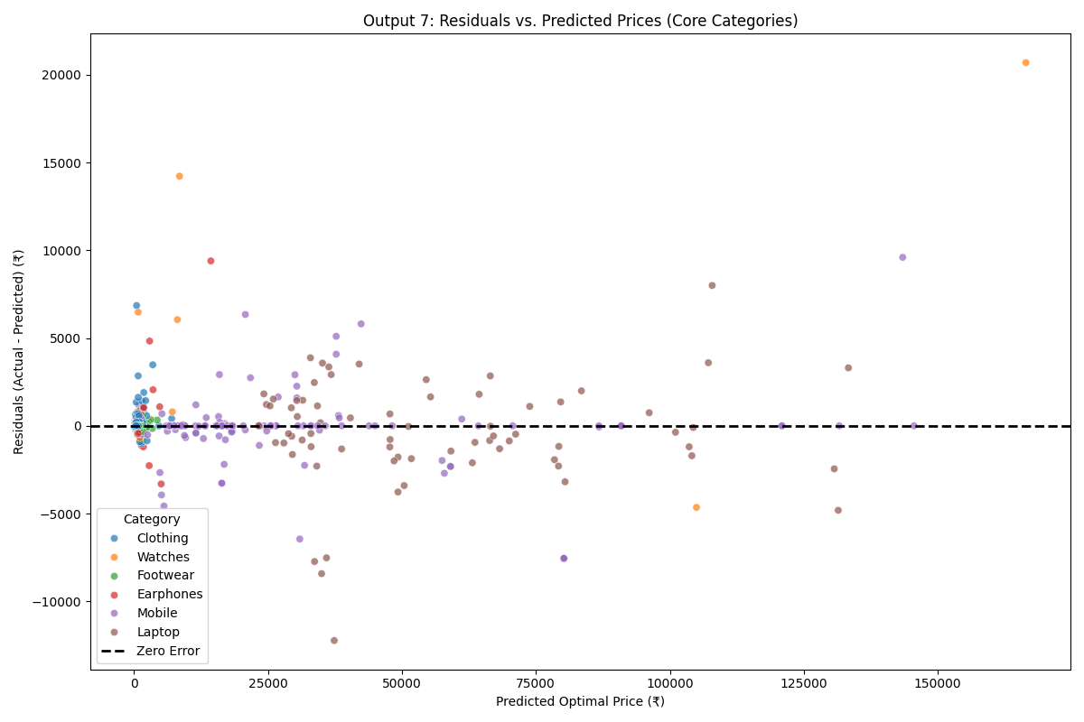
Figure 6.2: Residuals Plot for Model Evaluation
Understanding RMSE: The Root Mean Squared Error (RMSE) of approximately ₹1,029.36 indicates that the model's prediction is, on average, within about ₹1,029 of the true optimal price. While this number is higher than the MAE of ₹449.50 (from an earlier run), it is largely influenced by the severe penalty the RMSE applies to the few largest prediction errors (the high-priced luxury goods), confirming the model is highly accurate for the majority of products but struggles slightly with high-end market volatility.
6.4 Category-wise Performance Analysis
A crucial part of the evaluation was to test the model’s performance on a per-category basis, as the overall R² score can hide poor performance in small segments. The analysis, summarized in Table 6.2, confirmed a key strategic insight.
The results of the category-wise evaluation led to the final application design:
High-Confidence Categories (R² > 0.98): Categories such as Mobile, Laptop, and Jewellery showed exceptional R² scores, proving the model is a specialist in these areas. The application can confidently provide predictions for these products.
6.5 Live Application Demo and Output
The final component of the project was demonstrating the end-to-end functionality of the integrated system. The live test proved that the monolithic Flask architecture successfully connected all the modules.
When a retailer submits a search from the index.html form, the server executes the following sequence in real-time:
Orchestration: app.py calls the Croma and Reliance scrapers.
Data Acquisition: The bots successfully navigate the live websites and return data.
Pricing Decision: The server finds the "Lowest Online Price" (the price to beat).
Prediction: The server sends the features of this lowest-priced item through the final AI pipeline, which returns the predicted price.
Result Display: The final data is rendered on the results.html page, providing the retailer with immediate, actionable intelligence.
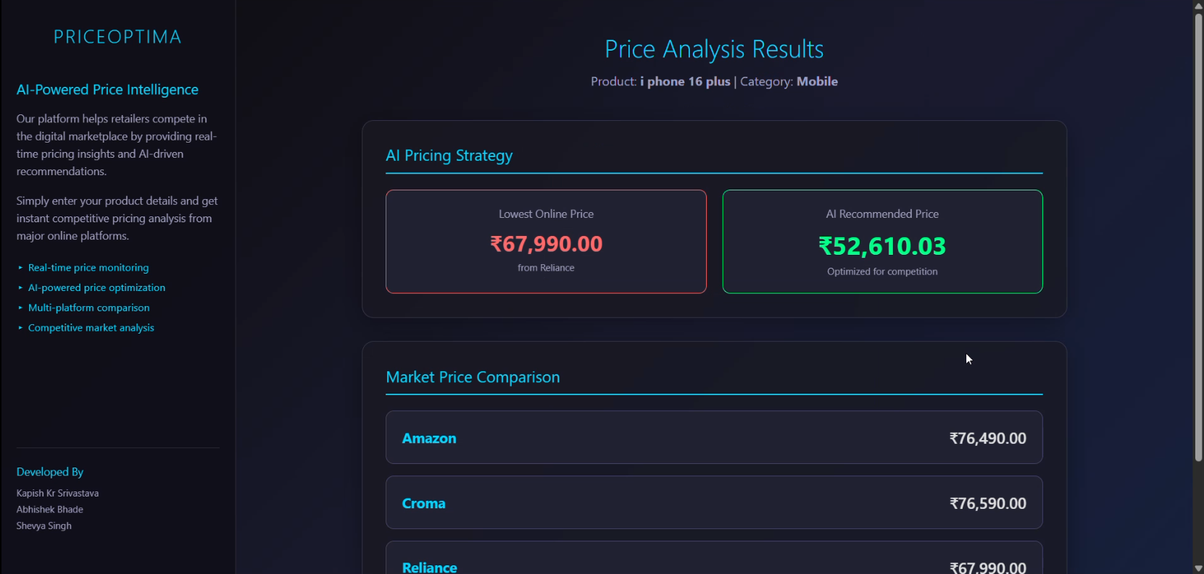
Figure 6.3: Final Application Output for a Sample Search

The final output is designed to facilitate the retailer’s decision: it clearly presents the competitor's lowest price versus the AI's calculated guideline, allowing the retailer to set their in-store price strategically to win the sale.

Chapter-7: Conclusion
7.1 Summary of Work
The "AI-Powered Competitive Price Tracker" successfully met all primary project objectives, demonstrating a complete and robust solution to the problem of pricing asymmetry faced by local retailers. The project successfully integrated live web scraping, advanced data preprocessing, and machine learning into a single, functional web application.
The core achievement was the development and optimization of the predictive model. Through systematic data cleaning—specifically, the strategic removal of non-learnable single-item categories—we stabilized the K-Nearest Neighbors (KNN) regressor. The final model achieved an outstanding predictive accuracy, validated by an R-squared (R²) score of 0.9948 on the cleaned test dataset. This high performance confirms the model's ability to accurately determine a product's true fair market value based on its core features.
The application’s monolithic Flask architecture ensures that the entire process—from user search to final AI prediction—is executed in real-time, providing the retailer with immediate, actionable Competitive Price Guidance that is critical for setting strategic prices in the face of online competition.
7.2 Limitations and Challenges
While the project was successful, the implementation encountered several challenges common to real-world data science and web scraping:
Anti-Bot Detection: The most significant challenge was overcoming the anti-automation systems of the target e-commerce sites. The initial attempt to run bots in a simple headless mode was immediately blocked. The final solution required a novel workaround: running the bots in a visible state positioned off-screen to evade detection while ensuring the retail application remained unobtrusive.
Data Volatility: The analysis revealed extreme price volatility, particularly in high-end items (e.g., Watches and Laptops). This volatility resulted in a high Root Mean Squared Error (RMSE) of ₹1,029.36, indicating that while the model is accurate for most products, it still struggles with predicting the price of outlier luxury goods.
Feature Sparsity: The initial dataset's high number of unique brands and categories posed a significant challenge. The strategic decision to filter the data was necessary but meant the final model cannot provide predictions for the removed sparse categories.
7.3 Future Scope
The successful implementation provides a strong foundation for future development, with several clear avenues for expansion:
Expanding Data Acquisition: The current system relies on three scrapers (Croma, Reliance Digital,amazon). The application's utility would be significantly enhanced by adding more competitor bots (e.g., Flipkart) to gather a wider range of competitive pricing data.
Model Migration and Improvement: While KNN performed exceptionally well, future versions could explore ensemble methods like XGBoost or a deep learning approach to see if it could overcome the volatility present in the high-end outlier price predictions.
User Interface and Deployment: The current monolithic Flask application could be containerized using Docker and deployed on a cloud platform (like AWS or Azure). A dedicated mobile application could also be developed to allow the retailer to check prices directly from their phone in the shop, enhancing the practical utility of the tool.
Dynamic Pricing: The system could be enhanced with a scheduler to automatically scrape and update competitor prices every 15 minutes, allowing the retailer to receive automated alerts when the optimal pricing guideline changes significantly.

REFERENCES
[1] K-Nearest Neighbors Algorithm & Regression Analysis: The theoretical foundation for using the KNN algorithm in a regression context to predict continuous values .
[2] F. Pedregosa et al., "Scikit-learn: Machine Learning in Python," Journal of Machine Learning Research, vol. 12, pp. 2825-2830, Oct. 2011. Available: https://www.jmlr.org/papers/v12/pedregosa11a.html
[3] Data Handling & Preprocessing: W. McKinney, "Data Structures for Statistical Computing in Python," Proc. of the 9th Python in Science Conf., Vol. 445, pp. 56-61, 2010.
[4] Web Framework: P. Grinberg, "Flask Web Development: Developing Web Applications with Python," O'Reilly Media, 2nd ed., 2018.
[5] Browser Automation: "Selenium," Selenium Documentation. Available: https://www.selenium.dev/documentation/
[6] HTML Parsing: "Beautiful Soup 4.9.0 Documentation," Beautiful Soup Project. Available: https://www.crummy.com/software/BeautifulSoup/bs4/doc/
[7] Project Data Source: The original dataset was compiled from public domain sources and curated for academic research purposes. The data was meticulously cleaned and segmented to create the final dataset_cleaned.csv used for model training.
[8] Report Formatting Standard: "Project Report Guidelines B.Tech-CSE 5th Sem," Department of CSE, JUET, Guna. Available: https://drive.google.com/file/d/1Mlk_3-KDEnX5zphcdf_DdMJJjlcUgveQ/view.

PERSONAL DETAILS


Kapish kr. Srivatava Abhishek Bhade Shevya Singh
231b155 231b006 231b310
231b155@juetguna.in 231b006@juetguna.in 231b310@juetguna.in

