Brain Stroke Data
1)Data Summary:
- Feature columns we have in data are gender, age, hypertension, heart disease, married, Residence, glucose level, BMI, smoking status and target variable is stroke
- Data is in shape of 4982*11
- Data contains both Numeric and Object type features
- It’s a classification Problem
2)Data Pre-processing
- Data Contain No Null values but has outliers in some feature columns.
3)EDA:
1.Univariate Analysis
1.1Object Columns:
Inference:
1)The data contains more records of Females than Males.
2) The data contains more records of people ever married than never married.
3) The data contains most records of private employs than any other in work type category others are almost equally distributed.
4) we have almost equal distribution in residence type.
5) We have more data of people who never smoked than to any other category in smoking status Feature.

1.2) Numeric Columns:

Inference:
1)we have data more distributed between people of age group between 40 to 58 years
2) No of people with no hypertension is more than people with hypertension.
3) Most of people are with no heart disease.
4) The average Glucose level of maximum people is between 84 to 100.
5) The BMI of most people is between 26 to 30.
6) The data Collected Contains more Records of People with no stroke then with stroke.

2.Bi-Variate Analysis:
2.1 Feature Columns with Smoking Status

Inference:
According To Data:
1) Females Smoke more than males also the females who don’t smoke is more than males (As No. of females in record is more than no. of males)
2) People with no hypertension smoke more than people with hypertension.
3) People with No heart disease Smoke more than people with heart disease.
4) People in private jobs smoke a lot and children’s don’t smoke at all.
5)Residence type has no effect on smoking.
6)People with no stroke smoke more than people with stroke.

2.2Feature Columns Relation with Target Variable

Inference:
1)Females Get more strokes compared to male.
2)Age and Stroke has positive relation(as age increase no of stroke are increasing).
3)People with no hypertension are getting more strokes than people with no hypertension.
4)People with no heart disease are getting more stroke than people with no heart disease.
5)people who ever married are getting more stroke than people who never married.
6)people in private jobs are getting more strokes followed by self-employed and, govt jobs as least and children’s with no strokes.
7)People living in Urban are getting slight higher count of strokes then people living in rural.
8)people who never smoked recorded higher strokes than people who do smoke.

2.3) Feature Columns Relation with Each Other

Inference:
1) People with age more than 20 years are getting hypertension
2) People with age more than 25 years are getting heart disease.
3) People with age more than 38 years are getting strokes.
4) A person with heart disease and high glucose level has chances of stroke.
5) A person with high glucose level and BMI has chances of stroke.
6) A person with old age and high BMI has chances of stroke.

2.4) Correlation in columns

Inference:
- columns have no or low correlation

6.Feature Engineering:
- For Object Data Types we have Used Label Encoder
- In outlier Treatment We have used Clip Method
- Data Contains No Missing Values so we did nothing in missing value treatment.

7.For Feature Selection and Feature Importance We Used Random Forest

8.Balancing Class:
- Using Counter, we observed our data is imbalanced it contains records as (0:2839, 1:780)
- For Balancing our data, we have Used SMOTE

9.Model Development and Tabulation
- We have Applied Various Models on our Data and the results are as follows.

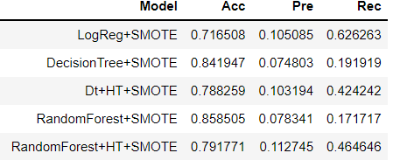

As you can see in tabulation accuracy of Random Forest is the Most but in Random Forest with Hyper parameter Tunning, we have better recall and precision by losing a few percentages in our accuracy.

10.Model_Deployment
To run web app of model
go to the path where your web code is >> open windows power shell here >> type command as >> streamlit run web_deployment.py>>press enter

The web Deployment of Model looks like this
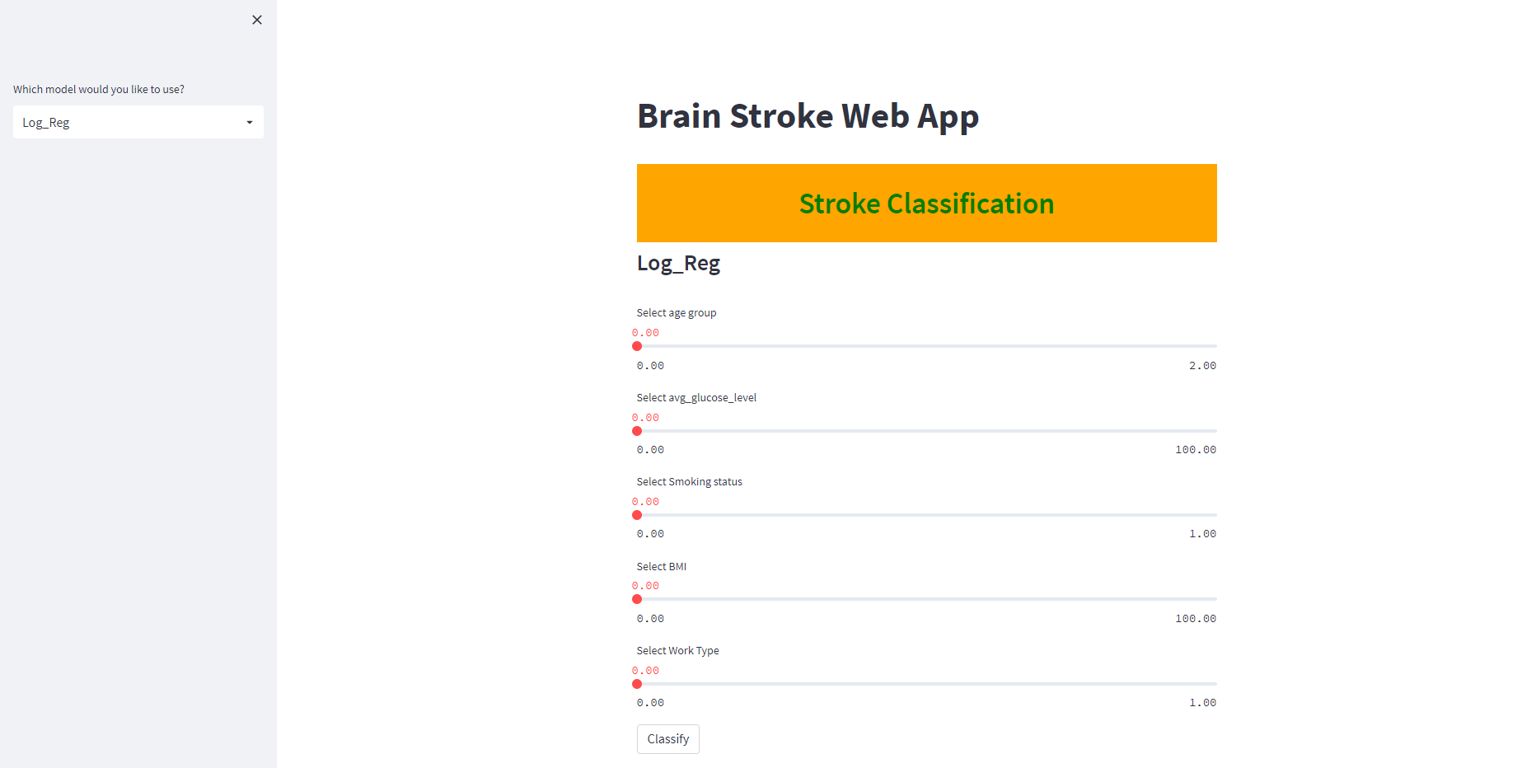

Tableau Dashboard

The Tableau Dashboard presentation of data looks like this
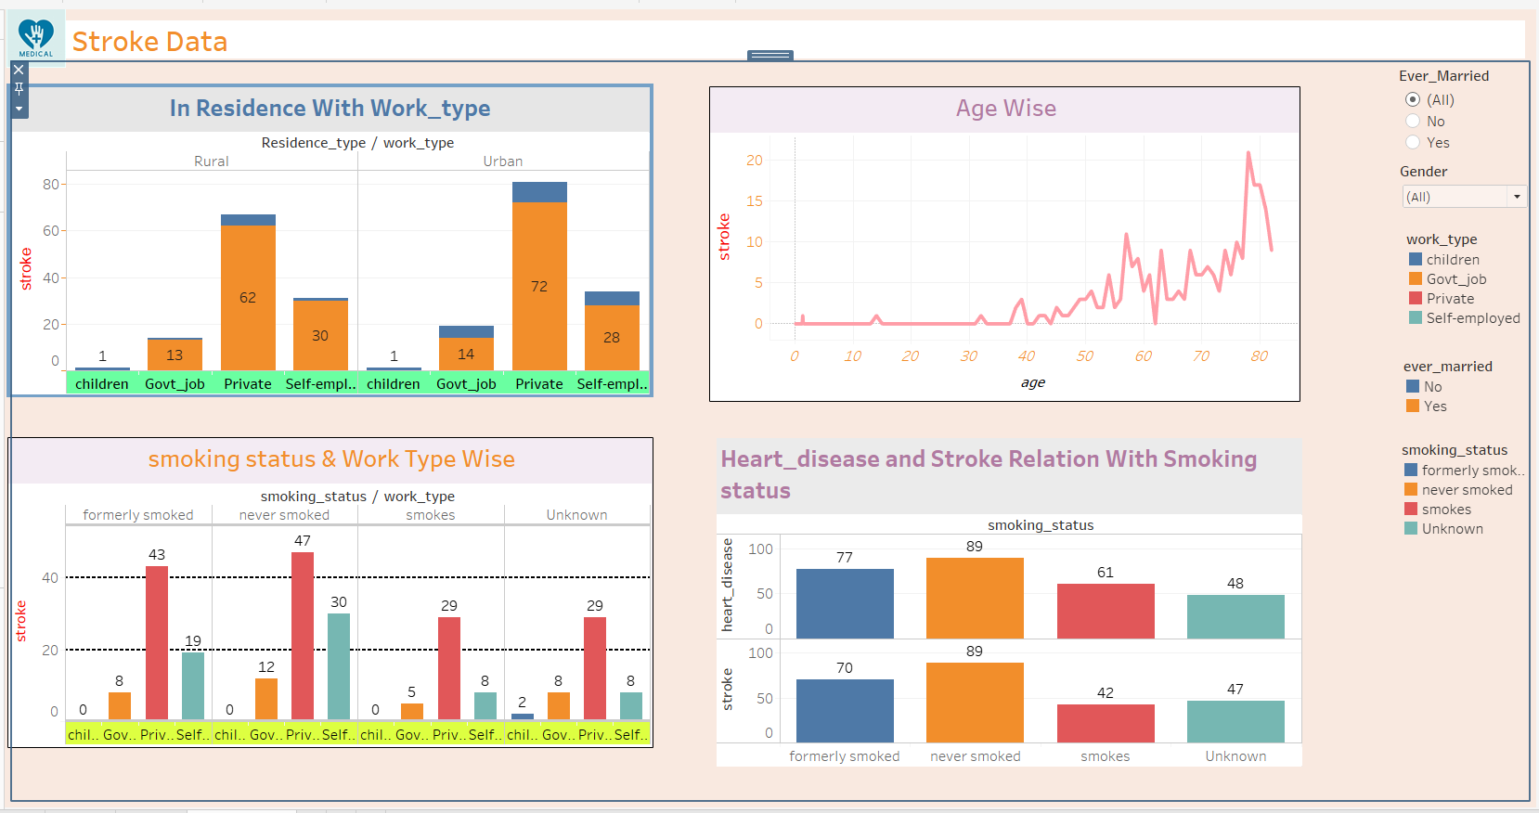

- This is a Dynamic Dashboard with every necessary filtration required to make dashboard easy to use
- You can See data of various Feature in relation to Our target variable with the ability of filtration over Gender selection and People Married or not using Ever Married Columns and
- If You click on any category appearing in legends it will highlight the category on every chart, wherever it is used in dashboard.

